1.

* driver.findElement(By.id("navigation-sidebar"))



* driver.findElement(By.name("query"))

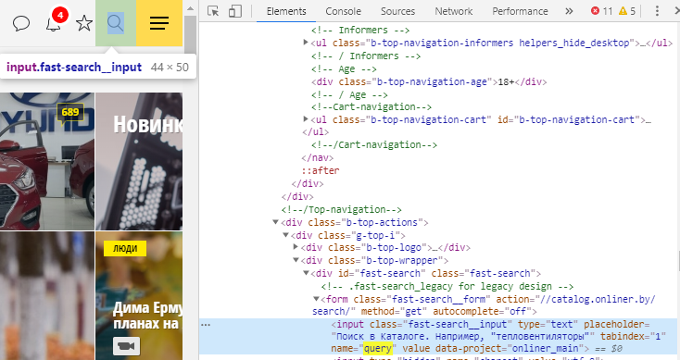

* driver.findElement(By.className("footer-style__copy"))

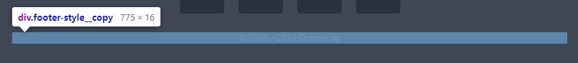

* driver.findElement(By.tagName("form"))

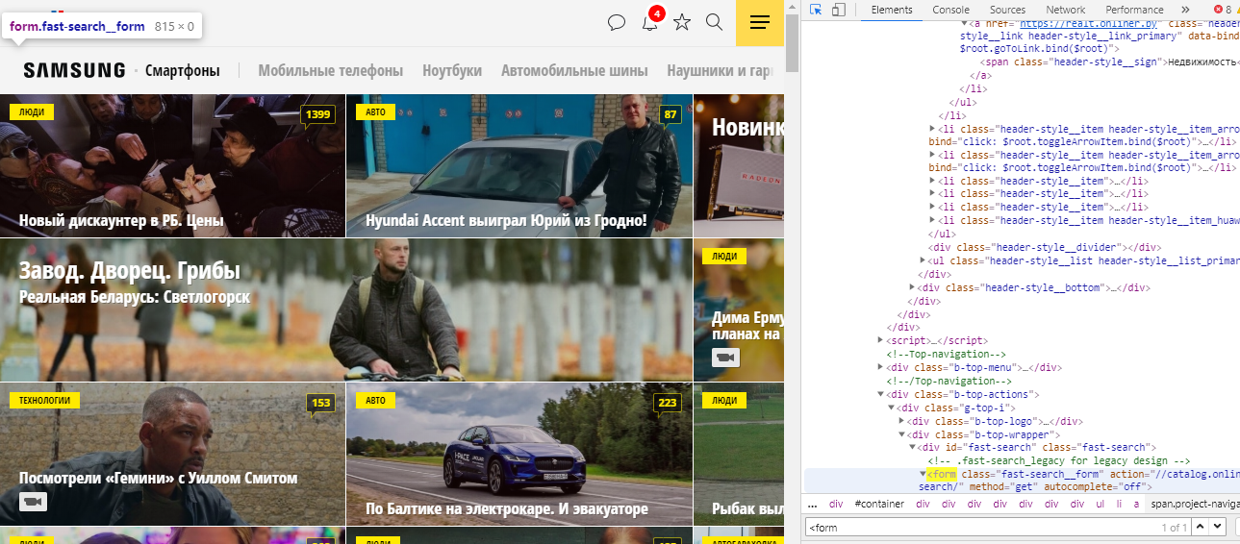

* driver.findElement(By.linkText("Мобильные телефоны"))

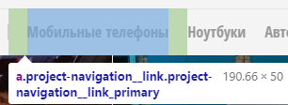

* driver.findElement(By.partialLinkText("Ноут"))

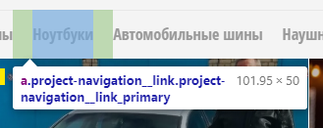

* driver.findElement(By.cssSelector("input.fast-search__input"))

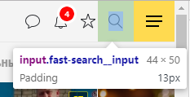

2. //td[count(//span[text()="Description"]/../preceding-sibling::th)+1][..//a="PR_Demo_Dataset"]  
