**Отчёт по Лабораторной работе №2  
«Настройка L2-коммутаторов с избыточными подключениями и VLAN»  
по курсу «Вычислительные сети и телекоммуникации»**

Выполнил Лисин Роман, М8О-406Б-20

**Цель работы -** научиться конфигурировать многоуровневые коммутаторы L2/L3 с VLAN, RSTP, LACP, использовать inter-VLAN routing, настраивать статическую маршрутизацию и конечный пользовательский NAT на Cisco.

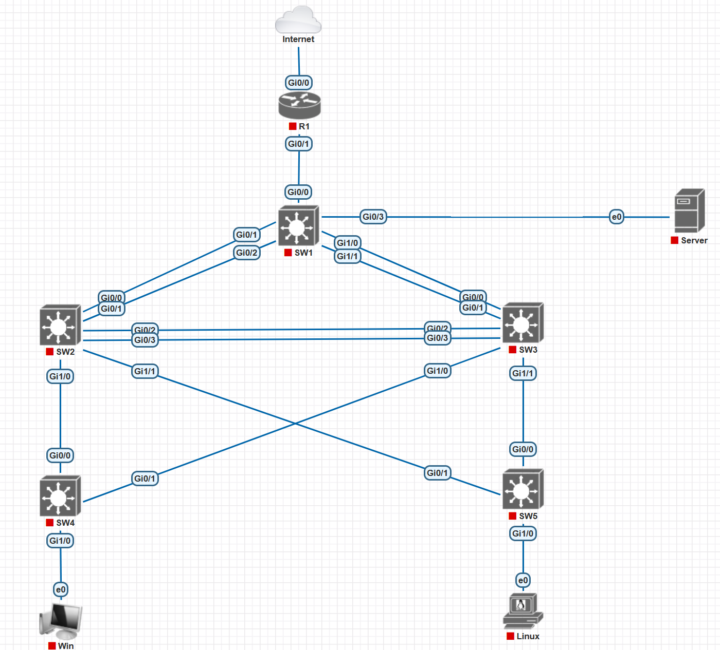

**Конфиг SW1**

SW1#sh conf

Using 2717 out of 262144 bytes, uncompressed size = 5142 bytes

!

! Last configuration change at 11:10:46 UTC Thu Mar 7 2024 by admin

!

version 15.2

service timestamps debug datetime msec

service timestamps log datetime msec

no service password-encryption

service compress-config

!

hostname SW1

!

boot-start-marker

boot-end-marker

!

!

enable secret 5 $1$6Ekw$ojikg0kob.rWzjOe8R9F1/

!

username admin privilege 15 secret 5 $1$rSlv$CpxqJrxIkuplQFs0.Kueu0

username checker privilege 15 secret 5 $1$pZds$i/XpcGt/7YFUw6d9qaI730

aaa new-model

!

!

aaa authentication login default local

!

!

!

!

!

!

aaa session-id common

!

!

!

!

!

!

ip dhcp excluded-address 192.168.212.1

ip dhcp excluded-address 192.168.212.201

ip dhcp excluded-address 192.168.212.202

ip dhcp excluded-address 192.168.212.203

ip dhcp excluded-address 192.168.212.204

ip dhcp excluded-address 192.168.212.205

ip dhcp excluded-address 192.168.12.1

ip dhcp excluded-address 192.168.12.201

ip dhcp excluded-address 192.168.12.202

ip dhcp excluded-address 192.168.12.203

ip dhcp excluded-address 192.168.12.204

ip dhcp excluded-address 192.168.12.205

!

ip dhcp pool vlan212

network 192.168.212.0 255.255.255.0

default-router 192.168.212.201

dns-server 192.168.212.1

!

ip dhcp pool vlan312

network 192.168.12.0 255.255.255.0

default-router 192.168.12.201

dns-server 192.168.12.1

!

!

ip domain-name labaz.org

ip name-server 192.168.212.1

ip cef

no ipv6 cef

!

!

!

spanning-tree mode pvst

spanning-tree extend system-id

spanning-tree vlan 1-400 priority 24576

!

!

!

!

!

!

!

!

!

!

!

!

!

!

!

interface Port-channel1

switchport trunk allowed vlan 112,212,312

switchport trunk encapsulation dot1q

switchport mode trunk

!

interface Port-channel2

switchport trunk allowed vlan 112,212,312

switchport trunk encapsulation dot1q

switchport mode trunk

!

interface GigabitEthernet0/0

switchport trunk allowed vlan 112,212

switchport trunk encapsulation dot1q

switchport mode trunk

--More--

!

interface GigabitEthernet0/1

switchport trunk allowed vlan 112,212,312

switchport trunk encapsulation dot1q

switchport mode trunk

negotiation auto

channel-group 1 mode active

!

interface GigabitEthernet0/2

switchport trunk allowed vlan 112,212,312

switchport trunk encapsulation dot1q

switchport mode trunk

negotiation auto

channel-group 1 mode active

!

interface GigabitEthernet0/3

switchport trunk allowed vlan 112,212,312

switchport trunk encapsulation dot1q

switchport mode trunk

negotiation auto

!

interface GigabitEthernet1/0

switchport trunk allowed vlan 112,212,312

switchport trunk encapsulation dot1q

switchport mode trunk

negotiation auto

channel-group 2 mode active

!

interface GigabitEthernet1/1

switchport trunk allowed vlan 112,212,312

switchport trunk encapsulation dot1q

switchport mode trunk

negotiation auto

channel-group 2 mode active

!

interface GigabitEthernet1/2

negotiation auto

!

interface GigabitEthernet1/3

negotiation auto

!

interface Vlan112

ip address 192.168.112.201 255.255.255.0

!

interface Vlan212

ip address 192.168.212.201 255.255.255.0

!

interface Vlan312

ip address 192.168.12.201 255.255.255.0

!

ip forward-protocol nd

!

no ip http server

no ip http secure-server

!

ip route 0.0.0.0 0.0.0.0 192.168.212.1

ip ssh server algorithm encryption aes128-ctr aes192-ctr aes256-ctr

ip ssh client algorithm encryption aes128-ctr aes192-ctr aes256-ctr

!

!

!

!

!

!

!

!

control-plane

!

!

line con 0

line aux 0

line vty 0 4

transport input ssh

!

!

end

**Конфиг SW2**

SW2#sh conf

Using 2335 out of 262144 bytes, uncompressed size = 4266 bytes

!

! Last configuration change at 10:27:19 UTC Thu Mar 7 2024 by admin

!

version 15.2

service timestamps debug datetime msec

service timestamps log datetime msec

no service password-encryption

service compress-config

!

hostname SW2

!

boot-start-marker

boot-end-marker

!

!

enable secret 5 $1$UY.M$abYV2rbSW1N8lFTRKTq7I/

!

username admin privilege 15 secret 5 $1$i7p2$8zaSGfWkC/nZ.IsF4y6SZ0

username checker privilege 15 secret 5 $1$StZ9$fFyOKqtAxr52H9V4wigPT0

aaa new-model

!

!

aaa authentication login default local

!

!

!

!

!

!

aaa session-id common

!

!

!

!

!

!

!

!

ip domain-name labaz.org

ip name-server 192.168.212.1

ip cef

no ipv6 cef

!

!

!

spanning-tree mode pvst

spanning-tree extend system-id

!

!

!

!

!

!

!

!

!

!

!

!

!

!

!

interface Port-channel1

switchport trunk allowed vlan 112,212,312

switchport trunk encapsulation dot1q

switchport mode trunk

!

interface Port-channel2

switchport trunk allowed vlan 112,212,312

switchport trunk encapsulation dot1q

switchport mode trunk

!

interface GigabitEthernet0/0

switchport trunk allowed vlan 112,212,312

switchport trunk encapsulation dot1q

switchport mode trunk

negotiation auto

channel-group 1 mode active

!

interface GigabitEthernet0/1

switchport trunk allowed vlan 112,212,312

switchport trunk encapsulation dot1q

switchport mode trunk

negotiation auto

channel-group 1 mode active

!

interface GigabitEthernet0/2

switchport trunk allowed vlan 112,212,312

switchport trunk encapsulation dot1q

switchport mode trunk

negotiation auto

channel-group 2 mode active

!

interface GigabitEthernet0/3

switchport trunk allowed vlan 112,212,312

switchport trunk encapsulation dot1q

switchport mode trunk

negotiation auto

channel-group 2 mode active

!

interface GigabitEthernet1/0

switchport trunk allowed vlan 112,212,312

switchport trunk encapsulation dot1q

switchport mode trunk

negotiation auto

!

interface GigabitEthernet1/1

switchport trunk allowed vlan 112,212,312

switchport trunk encapsulation dot1q

switchport mode trunk

negotiation auto

!

interface GigabitEthernet1/2

negotiation auto

!

interface GigabitEthernet1/3

negotiation auto

!

interface Vlan112

ip address 192.168.112.202 255.255.255.0

!

ip forward-protocol nd

!

no ip http server

no ip http secure-server

!

ip route 0.0.0.0 0.0.0.0 192.168.112.201

ip ssh server algorithm encryption aes128-ctr aes192-ctr aes256-ctr

ip ssh client algorithm encryption aes128-ctr aes192-ctr aes256-ctr

!

!

!

!

!

!

!

!

control-plane

!

!

line con 0

line aux 0

line vty 0 4

transport input ssh

!

!

end

**Конфиг SW3**

SW3#sh conf

Using 2331 out of 262144 bytes, uncompressed size = 4266 bytes

!

! Last configuration change at 16:55:39 UTC Fri Mar 1 2024 by admin

!

version 15.2

service timestamps debug datetime msec

service timestamps log datetime msec

no service password-encryption

service compress-config

!

hostname SW3

!

boot-start-marker

boot-end-marker

!

!

enable secret 5 $1$ZryZ$fzkUbAaz2Dol2xPKREkkY0

!

username admin privilege 15 secret 5 $1$R6za$Dg8Lkvf2RAKrh8UmTeg8d/

username checker privilege 15 secret 5 $1$S1kA$CzwWSBRVpnEVGkkOeE4BB.

aaa new-model

!

!

aaa authentication login default local

!

!

!

!

!

!

aaa session-id common

!

!

!

!

!

!

!

!

ip domain-name labaz.org

ip name-server 192.168.212.1

ip cef

no ipv6 cef

!

!

!

spanning-tree mode pvst

spanning-tree extend system-id

!

!

!

!

!

!

!

!

!

!

!

!

!

!

!

interface Port-channel1

switchport trunk allowed vlan 112,212,312

switchport trunk encapsulation dot1q

switchport mode trunk

!

interface Port-channel2

switchport trunk allowed vlan 112,212,312

switchport trunk encapsulation dot1q

switchport mode trunk

!

interface GigabitEthernet0/0

switchport trunk allowed vlan 112,212,312

switchport trunk encapsulation dot1q

switchport mode trunk

negotiation auto

channel-group 1 mode active

!

interface GigabitEthernet0/1

switchport trunk allowed vlan 112,212,312

switchport trunk encapsulation dot1q

switchport mode trunk

negotiation auto

channel-group 1 mode active

!

interface GigabitEthernet0/2

switchport trunk allowed vlan 112,212,312

switchport trunk encapsulation dot1q

switchport mode trunk

negotiation auto

channel-group 2 mode active

!

interface GigabitEthernet0/3

switchport trunk allowed vlan 112,212,312

switchport trunk encapsulation dot1q

switchport mode trunk

negotiation auto

channel-group 2 mode active

!

interface GigabitEthernet1/0

switchport trunk allowed vlan 112,212,312

switchport trunk encapsulation dot1q

switchport mode trunk

negotiation auto

!

interface GigabitEthernet1/1

switchport trunk allowed vlan 112,212,312

switchport trunk encapsulation dot1q

switchport mode trunk

negotiation auto

!

interface GigabitEthernet1/2

negotiation auto

!

interface GigabitEthernet1/3

negotiation auto

!

interface Vlan112

ip address 192.168.112.203 255.255.255.0

!

ip forward-protocol nd

!

no ip http server

no ip http secure-server

!

ip route 0.0.0.0 0.0.0.0 192.168.112.201

ip ssh server algorithm encryption aes128-ctr aes192-ctr aes256-ctr

ip ssh client algorithm encryption aes128-ctr aes192-ctr aes256-ctr

!

!

!

!

!

!

!

!

control-plane

!

line con 0

line aux 0

line vty 0 4

transport input ssh

!

!

end

**Конфиг SW4**

SW4#sh conf

Using 2135 out of 262144 bytes, uncompressed size = 3654 bytes

!

! Last configuration change at 11:39:46 UTC Mon Mar 11 2024 by admin

!

version 15.2

service timestamps debug datetime msec

service timestamps log datetime msec

no service password-encryption

service compress-config

!

hostname SW4

!

boot-start-marker

boot-end-marker

!

!

enable secret 5 $1$2Wke$KNDdpdgjOiXadX4ed.eYx0

!

username admin privilege 15 secret 5 $1$y1HT$KnHOijkuw1mKrD1Kq/Cs5/

username checker privilege 15 secret 5 $1$95Z8$nSdcZAYEAqYeM5XtLzuxj.

aaa new-model

!

!

aaa authentication login default local

!

!

!

!

!

!

aaa session-id common

!

!

!

!

!

!

!

!

ip domain-name labaz.org

ip name-server 192.168.212.1

ip cef

no ipv6 cef

!

!

!

spanning-tree mode pvst

spanning-tree extend system-id

!

!

!

!

!

!

!

!

!

!

!

!

!

!

!

interface GigabitEthernet0/0

switchport trunk allowed vlan 112,212,312

switchport trunk encapsulation dot1q

switchport mode trunk

negotiation auto

spanning-tree cost 3

!

interface GigabitEthernet0/1

switchport trunk allowed vlan 112,212,312

switchport trunk encapsulation dot1q

switchport mode trunk

negotiation auto

!

interface GigabitEthernet0/2

negotiation auto

!

interface GigabitEthernet0/3

negotiation auto

!

interface GigabitEthernet1/0

switchport access vlan 212

switchport trunk allowed vlan 112,212,312

switchport mode access

negotiation auto

!

interface GigabitEthernet1/1

negotiation auto

!

interface GigabitEthernet1/2

negotiation auto

!

interface GigabitEthernet1/3

negotiation auto

!

interface Vlan112

ip address 192.168.112.204 255.255.255.0

!

interface Vlan212

ip address 192.168.212.204 255.255.255.0

!

ip forward-protocol nd

!

no ip http server

no ip http secure-server

!

ip route 0.0.0.0 0.0.0.0 192.168.212.201

ip ssh server algorithm encryption aes128-ctr aes192-ctr aes256-ctr

ip ssh client algorithm encryption aes128-ctr aes192-ctr aes256-ctr

!

!

!

!

!

!

!

!

control-plane

!

!

line con 0

line aux 0

line vty 0 4

transport input ssh

!

!

end

**Конфиг SW5**

SW5#sh conf

Using 2130 out of 262144 bytes, uncompressed size = 3652 bytes

!

! Last configuration change at 11:01:01 UTC Thu Mar 7 2024 by admin

!

version 15.2

service timestamps debug datetime msec

service timestamps log datetime msec

no service password-encryption

service compress-config

!

hostname SW5

!

boot-start-marker

boot-end-marker

!

!

enable secret 5 $1$Z9JV$o0WZuZXa1nwLffwTZdq1i1

!

username admin privilege 15 secret 5 $1$fC5p$Bxdt5NQubVbSfmJwGSqmS1

username checker privilege 15 secret 5 $1$f4fD$jDaIO.gtXA42EG1SZU/lA1

aaa new-model

!

!

aaa authentication login default local

!

!

!

!

!

!

aaa session-id common

!

!

!

!

!

!

!

!

ip domain-name labaz.org

ip name-server 192.168.212.1

ip cef

no ipv6 cef

!

!

!

spanning-tree mode pvst

spanning-tree extend system-id

!

!

!

!

!

!

!

!

!

!

!

!

!

!

!

interface GigabitEthernet0/0

switchport trunk allowed vlan 112,212,312

switchport trunk encapsulation dot1q

switchport mode trunk

negotiation auto

spanning-tree cost 3

!

interface GigabitEthernet0/1

switchport trunk allowed vlan 112,212,312

switchport trunk encapsulation dot1q

switchport mode trunk

negotiation auto

!

interface GigabitEthernet0/2

negotiation auto

!

interface GigabitEthernet0/3

negotiation auto

!

interface GigabitEthernet1/0

switchport access vlan 312

switchport trunk allowed vlan 112,212,312

switchport mode access

negotiation auto

!

interface GigabitEthernet1/1

negotiation auto

!

interface GigabitEthernet1/2

negotiation auto

!

interface GigabitEthernet1/3

negotiation auto

!

interface Vlan112

ip address 192.168.112.205 255.255.255.0

!

interface Vlan312

ip address 192.168.12.205 255.255.255.0

!

ip forward-protocol nd

!

no ip http server

no ip http secure-server

!

ip route 0.0.0.0 0.0.0.0 192.168.112.201

ip ssh server algorithm encryption aes128-ctr aes192-ctr aes256-ctr

ip ssh client algorithm encryption aes128-ctr aes192-ctr aes256-ctr

!

!

!

!

!

!

!

!

control-plane

!

!

line con 0

line aux 0

line vty 0 4

transport input ssh

!

!

end

**Конфиг R1**

R1#sh conf

Using 4057 out of 262144 bytes

!

! Last configuration change at 15:12:11 UTC Wed Mar 6 2024 by admin

!

version 15.7

service timestamps debug datetime msec

service timestamps log datetime msec

no service password-encryption

!

hostname R1

!

boot-start-marker

boot-end-marker

!

!

enable secret 5 $1$pzwN$czkOAhcHcaODGM1clbZVP.

!

aaa new-model

!

!

aaa authentication login default local

!

!

!

!

!

aaa session-id common

!

!

!

mmi polling-interval 60

no mmi auto-configure

no mmi pvc

mmi snmp-timeout 180

!

!

!

!

!

no ip icmp rate-limit unreachable

!

!

!

!

!

!

ip domain name labaz.org

ip name-server 9.9.9.9

ip cef

no ipv6 cef

!

multilink bundle-name authenticated

!

!

!

!

username admin privilege 15 secret 5 $1$y9P6$Dg8m7b/mOpKPlNZf.xaAg1

username checker privilege 15 secret 5 $1$amjM$UdD86N.JVHpPqknHup5dI/

!

redundancy

!

no cdp log mismatch duplex

!

ip tcp synwait-time 5

!

!

!

!

!

!

!

!

!

!

!

!

!

interface GigabitEthernet0/0

ip address dhcp hostname R1

ip nat outside

ip virtual-reassembly in

duplex auto

speed auto

media-type rj45

!

interface GigabitEthernet0/1

no ip address

ip virtual-reassembly in

duplex auto

speed auto

media-type rj45

!

interface GigabitEthernet0/1.112

encapsulation dot1Q 112

ip address 192.168.112.1 255.255.255.0

!

interface GigabitEthernet0/1.212

encapsulation dot1Q 212

ip address 192.168.212.1 255.255.255.0

ip nat inside

ip virtual-reassembly in

!

interface GigabitEthernet0/1.312

encapsulation dot1Q 312

ip address 192.168.12.1 255.255.255.0

!

interface GigabitEthernet0/2

no ip address

shutdown

duplex auto

speed auto

media-type rj45

!

interface GigabitEthernet0/3

no ip address

shutdown

duplex auto

speed auto

media-type rj45

!

ip forward-protocol nd

!

!

no ip http server

no ip http secure-server

ip dns server

ip nat inside source list VLAN212_NAT interface GigabitEthernet0/0 overload

!

ip access-list standard VLAN212_NAT

permit 192.168.212.0 0.0.0.255

!

ipv6 ioam timestamp

!

!

!

!

!

control-plane

!

!

line con 0

exec-timeout 0 0

privilege level 15

logging synchronous

line aux 0

exec-timeout 0 0

privilege level 15

logging synchronous

line vty 0 4

transport input ssh

!

no scheduler allocate

!

end

**Конфиг сервера с Ubuntu**

root@kvm:~# sudo cat /etc/netplan/01-netcfg.yaml

# This file describes the network interfaces available on your system

# For more information, see netplan(5).

network:

version: 2

renderer: networkd

ethernets:

eth0:

dhcp4: yes

vlans:

vlan112:

id: 112

link: eth0

addresses: [192.168.112.2/24]

gateway4: 192.168.112.201

vlan212:

id: 212

link: eth0

addresses: [192.168.212.2/24]

nameservers:

addresses: [192.168.212.1]

gateway4: 192.168.212.201

vlan312:

id: 312

link: eth0

addresses: [192.168.12.2/24]

gateway4: 192.168.12.201

Запуск изменений netplan — sudo netplan apply

**Вывод**

В данной работе я научился настраивать интернет и сетевую коммуникацию в сложной топологии с помощью VLAN. Также я познакомился с STP для построения топологий. Данный опыт будет полезен при работе системным администратором.