**Global Significance of Gardening and Animal Domestication**

Student's Name

Institution

**Author Note**

**Global Significance of Gardening and Animal Domestication**

It might be impossible to exhaust all the impacts domesticating plants and animals has had on life, but some significances are more massive and more critical for the current generation to note than others (Boivin et al., 2016). Gardening and domesticating animals have contributed to shaping human evolution and writing the history that followed that change of culture and lifestyles. The shift from hunting and gathering to sedentary lifestyles meant the creation of wealth, and it was out of that that empires, urban areas, and complex societies started sprouting across the world (Roberts et al., 2017). It is indeed bold and safe to say that the globalization that societies are enjoying today, and whatever shape it may take in the long run, is rooted in that era. One of the most remarkable consequences of gardening and animal rearing is perhaps the enormous change in demographics.

**Demographic Changes**

According to Harris and Fuller (2014), the few millennia that followed the domestication of animals and plants witnessed the emergence of agriculturally oriented societies that engaged in extreme displacement, infecting, conquering, and even exterminating hunter-gatherer societies globally as they sought fertile lands on which to start plantations. That came with myriad changes in social and spiritual aspects, which have implications for the civilization being experienced today. In Teletchea's (2019) words, the global human population that the UN estimated at 7.9 billion this year was just around 900,000 before domestication started, and the current figure has grown by about 4 billion in the last 6 decades (since 1960; figure 1). For America, the population has doubled since 1960, from 179 million to about 350 million today (figure 2) (Klefoth et al., 2013). Statistics always point to the possibility of direct proportionality between the rate of agricultural productivity and population growth in the world.

***Figure 1: Global Population Patterns Since Gardening And Animal Domestication Began***

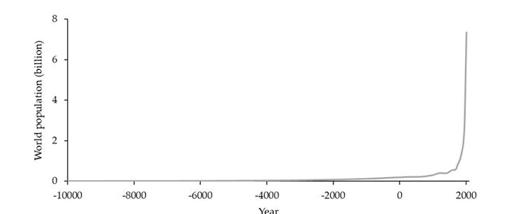

Source: (Turcotte et al, 2017)

***Figure 2: America's Population Pattern Since 1600***

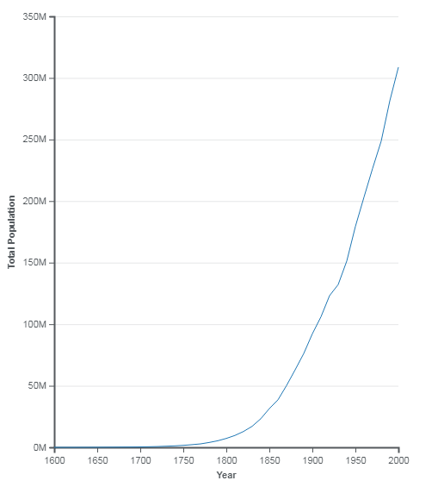

Statista assessed that agricultural production in the world reached 7.6 billion dollars in 2010, three times where productivity was in 1960, as shown in figure 3 below. More than 60% of crops produced worldwide are for human use, around 30% for animals, while most of the remainder is for bioenergy and other industrial purposes (Klefoth et al., 2013). And when there are thousands of species for both crops and animals, it must be noted that very few species (about 0.01%) of the species were domesticated in the last 2,000 years. As of today, only about 18 food crops and 14 large animals are domesticated in America, and about four of the crop species serve more food than all the others combined (Pironon et al., 2020). But when hunter-gather lifestyles were so much overshadowed by the domestication of animals and plants, they remained in some places for economic purposes and recreation.

***Figure 3: Global Agricultural Productivity Since 1960***

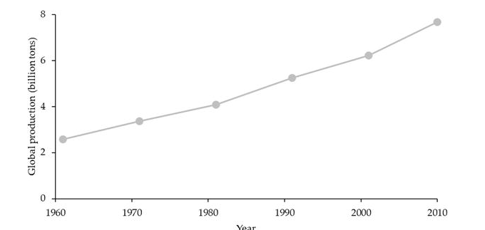

Source: (Turcotte et al, 2017)

Domestication of plants and animals led to what is called agriculture today, and agriculture was among the foundations of trading. These developments led to competition, and at some point, some societies realized that they had vast amounts of land that they needed to cultivate but did not have enough labor (Wuerthner et al., 2014). They learned that if they did not generate enough wealth from agriculture at the time, other societies would do that, become powerful and gain higher diplomatic strengths on the international stage. This act birthed slavery, and many estimate that slavery started about 9,500 hundred years ago in Mesopotamia, where the first crops were domesticated. Mesopotamia is the region where the likes of Turkey and Iran are located today (Larson & Fuller, 2014). Slavery entailed shipping people from distant places to various localities and against their will such that they could provide free or cheap labor to firms. From slavery, the basis of most of the modern multiracial and multicultural environments emerged. It is from the same that most of the minority groups that history tells about today came from.

America is no saint when it comes to slavery, and indeed more detailed information on slavery in the world dates back to 1619 in America (Bringhurst, 2018). Around that time, America was less inhabited, and sugar was suddenly seen as a more viable product over even tobacco which was the most reliable crop. The Americans needed vast amounts of labor, and this triggered slavery leading to race-based bondage of Africans who were transported, albeit in low numbers, through several routes over the seas and under deplorable conditions to uncertain places (Klefoth et al., 2013). By the 18th century, routes for shipping enslaved people had been improved. The rates at which Africans were shipped from their continent increased exponentially, leading to the infamous Trans-Atlantic slave trade (Turcotte et al., 2017). When many advantages may be counted on gardening and animal domestication, it can be indirectly blamed for one of the worst forms of human rights abuses ever.

Inter-racial children were born by the first African arrivals and Americans of the time, and their descendants continued the trend leading to the high numbers of African Americans today. In 2020, African Americans accounted for 41.05 million of the American population, 12.3% of all US residents (Turcotte et al., 2021). When a fraction of this population has voluntarily migrated much later in search of jobs and better lives, the largest of the population remains representative of the vestiges of the dark days of the slave trade. Africans have never fully settled in America as late as now since they continue to fight for equality on matters such as equal voting rights, protection from police brutality, and equal consideration for job opportunities, among others. According toWeide (2015), health disparities based on race remain thorny even when campaigns such as the Civil Rights Movement (CRM) and Black Lives Matter have achieved much. Some African Americans are too segregated residentially in the country, and successive authorities have always turned deaf ears for them. Most of them are less likely to afford insurance cover compared to their white counterparts, who were favored by the absence of order that followed post-independence years (Matthew et al., 2021). However, things are changing, and a range of initiatives are being supported by successive governments leading to better lives for Africans, and anyone can imagine a massively equal America in the next few decades.

**Ecological Impacts**

As seen earlier, the domestication of plants and animals led to a bulging global human population, and that made it necessary for global productivity to increase to sustain the population. This meant that more and more of the unutilized land on earth had to encroach. According toGeorghiou (2012), around 40 percent of the earth's forests, grasslands, and savannahs have been converted into agricultural land. The unnatural new earth lacks enough forest cover that originally helped serve the world with fresh water. Forests remain subject to constant logging despite frantic efforts by governments and agencies, which has seen rivers and lakes drying up (Teletchea, 2019). The outcomes are scathing water shortages, and for some under-developed, fragile economies that cannot maintain sufficient water supplies for their people, famine and drought-related disease outbreaks kill in their numbers.

Agriculture also accounts for approximately 33% of carbon emissions globally, and it is, therefore, one of the prime contributors to the current climate crisis (Houghton et al., (2012). Global warming has seen the average temperatures for land and water masses approaching 2 Degrees Celsius, and the impacts are dire. One of the impacts of global warming is that it causes heavy rainfalls that flood across societies destroying crops, animals, property, and human beings. Due to the increased heating of the atmosphere, evaporation of water from oceans and seas has increased over the years that followed industrialization. The sad coincidence is that the same atmosphere has the capacity to hold more water due to the excess heat (Turcotte et al., 2017). Every long spell of drought, especially for highly industrialized places, is, therefore, a time bomb, particularly for plain lands, and it is for this reason that countries like China have been witnessing gravely destructive downpours in recent years.

America is not spared, and according toMatthew (2021), wildfires have an intricate relationship with climate crises. Global warming leads to increased temperatures, and Americans have to look for ways of cooling their environments in a country that is extremely snowy some of the time. California is the latest victim, and it endured a season of deadly wildfires last year that hit vulnerable communities living in hot, dry regions. In total, 240 acres of land burnt down in 2021, leaving a lot of families hopeless, crops exterminated, and properties in ruins. This incidence led to losses for the authorities that dealt with the crisis while also compensating the citizens (Pironon et al., 2020). Last year was not the first one, and in total, national statistics indicate that America has experienced 18,085 wildfires that have burnt 777,406 acres of land.

Global warming leads to incessant droughts and rises in temperatures that heat the earth and leave it sensitive to any catalysts of fire. When heat waves occur, they start fires, and such fires are problematic for the authorities to halt. When the atmosphere absorbs excess water from the earth and holds it, it causes massive water shortages that consequently lead to reduced agricultural yields. This again leads to food shortages for both animals and humans. As can be seen, the rainfall patterns are therefore disastrous when there is rain and on the dry days, and there is an urgent need for action now more than ever. Global warming also leads to pest invasions since pests usually cannot survive in unusually high temperatures. They migrate in such situations in search of cooler places and often end up invading crop plantations, leaving a trail of losses for farmers.

However, the current generation can be commended in as much as there is a need for humanity to step up its initiatives in its attempt to tame the climate crisis. The UN, for instance, came up with the Sustainable Development Goals (SDGs) in 2015, which are aimed at making societies adopt sustainable approaches to various aspects of life to lower the temperatures (SDG, 2019). At the core of the 17 goals is the recognition that different areas often affect outcomes in other areas, and developing the world needs to consider balancing social, economic, and environmental sustainability. Today's sustainability approaches aim to ensure that the global society of today satisfies its needs and interests without upending the capacity for the next generations to satisfy theirs (Turcotte et al., 2017). While impacts are being felt by the world today, the approaches are more concerned with the lives of those who will come later. This is inspired by the brutal nature of the climate crisis, which makes it impossible for humanity to reverse it in the short run. Signatory countries to the SDGs are expected to develop their annual blueprints on what they intend to do to assist in reducing global temperatures. They should then report on what their actual results were for comparison with their targets.

**Evolution of Animal and Crop Species**

Domestication also came with profound modifications for both plants and animals. Inbreeding and genetic drift are some of the prominent, uncontrolled processes that acted as key drivers of evolution. While captives, species also went through periods of natural selection that were partially controlled and active selection, which is one of the controlled processes that played a part in enabling this evolution. Evolution has evenly occurred as the long walk in domestication diversified genes, behaviors, physiological traits, and morphoanatomy alongside many other traits (Teletchea, 2019). Behavioral shifts are some of the initial changes that appeared in species as they tried to adapt to new ways of life. Animals started tolerating living close to human beings, and some started great friendships with people. The dog, the first animal to be domesticated, remains one of the closest friends to man to date (Pironon et al., 2020). Due to the protection, food, and shelter offered by human beings, domesticated animals became less apprehensive of predators and also stopped foraging since they had found providers.

A range of agricultural practices has led to the evolution of species as the species sometimes naturally changed structurally to adapt to the practices (Turcotte et al., 2017). Approaches at the level of a firm as well as management strategies in different settings have caused numerous changes to the global ecosystem, and when there are many resultant advantages, there are demerits too. Over the years, people have invented various types of pesticides in response to the emergence of multiple pests. The pathogens, parasites, and even weeds often evolve as a way of developing immunity against these pesticides leading to permanent structural changes in them. The speed and volumes in which such evolution happens to depend on a range of factors, and the scope in which the pesticides are used by farmers are one of them (Spengler & Mueller, 2019). Extensive use of pesticides makes it possible for the evolution to be fast, and the size of the population to which they are applied increases the possibility of there being resistant genotypes in existence already.

Drawing on examples, the Colorado beetle has been an enormous dilemma for farmers across societies, especially because potatoes are some of the significant sources of food from plants. The stubborn beetle has eluded scientists over 50 times by evolving to resist any new ingredient set up against it using pesticides (Spengler & Mueller, 2019). The last 20 years have seen countless other forms of evolutions, especially for pests attacking cotton and corn, and the scientists have been unable to come up with a one-size-fits-all solution. There has also been exponential growth in the number of herbicides in use today, and so far, the US is said to have encountered the evolution of over 500 weeds to resist herbicides (Pironon et al., 2020). The various treatments on animals have led to parallel evolutions, with a good example being the structural changes recorded on nematodes found in the gastrointestinal section of cows in resistance.

A range of other cultural practices has been known to cause evolutions in both animals and crops in the past few millennia, even when chemical pesticides were not used. Some plants, for instance, have been evolving to mimic crops that they know as valued by people to avoid incidences such as being weeded out by hands (Harris & Fuller, 2014). In Eastern Asia, for example, there is barnyard grass that has evolved to look like rice such that farmers do not hand-weed it, and it has always been a big headache for farmers. The funny part is that it has close relatives, but it evolved to look like rice which is not relative. These evolutions cause a reduction in agricultural yields, mainly when the pests attack crops that societies heavily rely on in satisfying their needs.

Lately, the world has seen scientists modifying genes for crops and animals to achieve benefits such as fast productivity, desired traits, high volumes, and a range of others in a bid to address various issues affecting the world (Teletchea, 2019). Genetic modifications result in structurally edited crops and animals, and this could not have happened if gardening and animal domestication did not start in the first place. The modifications have seen people producing food products in sufficient amounts that strengthened food supply across societies, and scientists are still in the labs experimenting with ways through which the field can be widened for more efficiency in productivity to address hindrances such as droughts which often upend productivity to **(**Matthew, 2021). And when the modifications have achieved significant gains, they are not without drawbacks. Scientists have rightly blamed them for the exponential rise in lifestyle diseases such as cancer, obesity, and diabetes which account for a good fraction of global deaths every day.

The evolutions seen above have the potential of causing enormous impacts on humanity even when they directly happen to animals and plants. Sustainable agriculture requires stable ecosystems, solid economies, and health stability for human beings. The evolutions above pose a danger to the three elements. When they evolve, species can have direct and indirect impacts on the capacity of societies to provide the various ecosystem services needed at any given time. As seen earlier, evolutions by pests lead to scathing reductions in agricultural yields. At present, an average of 35% of global losses in agriculture are attributed to the evolution of pests, pathogens, and weeds to resist pesticides. In 1971, Texas and a region of North Mexico had to abandon 240,000 hectares of tobacco after a stubborn budworm resisted a pesticide (Harris & Fuller, 2014). The losses were valued at billions of dollars. Such losses upend the capacity to sustain a smooth supply chain of food and lead to malnutrition.

As a response to these resistances, farmers often elect to rely on additional pesticides that are hazardous to the overall global ecosystem. Pesticides participate in compromise the quality of water, which in turn negatively impacts the health of human beings, animals, and crops. Natural pollination is also affected, and the overall biodiversity suffers (Turcotte et al., 2017). Scientists have also concluded that biological pest control does not work well when humanity engages in a variety of artificial pest control procedures. It always takes a back seat, yet it has always been more effective than modern artificial ones. In 1980, for instance, a pest species started to devastate Indonesian rice fields, and when pesticide interventions were made, natural control mechanisms vanished, and the pest caused untold losses to the farmers. The government required that 58 of the 65 pesticides be withdrawn from the industry and when that was done, natural control resurfaced (Teletchea, 2019). The scenario is a reliable exemplification of the counterproductive nature pesticides can have on agriculture.

Therefore, the evolution of plants and animals has a variety of economic impacts on the global economy, either by forcing farmers to incur heavy costs in addressing the effects or by exterminating what suitable other species have to offer to humanity (Harris & Fuller, 2014). The evolution of specific types of pests can increase their numbers into uncontrollable groups or even come up with additional species, and all of these lead to paralyzed economies that cannot sustain their people. Economies are investing heavily in research and development (R&D) to come up with better solutions for pests and other evolutionary setbacks, and that does not auger very well for a global society plagued by other nightmares such as pandemics and environmental disasters rooted in the aspects associated with domestication of plants and animals as seen evenly throughout this work. Boivin (2016) opines that breeding a new pesticide after the current one has resisted costs much in time and money and that the outcomes might be a tradeoff between the crop yields and the expenses. This, most of the time dissuades researchers from working on better pesticides. The risks get higher as a result of an aspect where it has been found that when a pesticide is resisted, another will be resisted partially or fully.

Human beings are the net gainers of what the world has to offer, and it makes sense to expound on the health impacts that the change in question may have on them (Weide, 2015). One of the core impacts that the resistance to pesticides has on humanity is that human pathogens may be made to evolve too. It has already happened where pathogens for some domesticated animals resisted some anti-microbials and afterward infected humans or transferred the resistance through horizontal gene transfer to human pathogens (Spengler & Mueller, 2019). The other way the resistance may impact people is that people are intricately related to domesticated animals through even butchery and eating different kinds of meat. This has been proven to assist pests in migrating to human bodies for hosts (Klefoth et al., 2013). The swine flu is a classic example of that scenario. Theories also suggest compromise on the farmers' well-being in other forms such as reduced IQ, poor memory, and low reasoning capacities for children belonging to farmers.

**References**

Boivin, N. L., Zeder, M. A., Fuller, D. Q., Crowther, A., Larson, G., Erlandson, J. M., ... & Petraglia, M. D. (2016). Ecological consequences of human niche construction: Examining long-term anthropogenic shaping of global species distributions. *Proceedings of the National Academy of Sciences*, *113*(23), 6388-6396.

Bringhurst, N. G. (2018). *Saints, Slaves, and Blacks: the changing place of Black people within Mormonism*. Greg Kofford Books.

Georghiou, G. P. (Ed.). (2012). *Pest resistance to pesticides*. Springer Science & Business Media.

Harris, D. R., & Fuller, D. Q. (2014). Agriculture: definition and overview. *Encyclopedia of global archaeology*, 104-113.

Houghton, R. A., House, J. I., Pongratz, J., Van Der Werf, G. R., Defries, R. S., Hansen, M. C., ... & Ramankutty, N. (2012). Carbon emissions from land-use and land-cover change. *Biogeosciences*, *9*(12), 5125-5142.

Klefoth, T., Pieterek, T., & Arlinghaus, R. (2013). Impacts of domestication on angling vulnerability of common carp, C yprinus Carpio: the role of learning, foraging behavior and food preferences. *Fisheries Management and Ecology*, *20*(2-3), 174-186.

Larson, G., & Fuller, D. Q. (2014). The evolution of animal domestication. *Annual Review of Ecology, Evolution, and Systematics*, *45*, 115-136.

Matthew, A. J., Clark, M. A., & McDavid, L. M. (2021). Combating racism: the role of the pediatrician. *Pediatric Research*, *90*(4), 708-710.

Pironon, S., Borrell, J. S., Ondo, I., Douglas, R., Phillips, C., Khoury, C. K., ... & Antonelli, A. (2020). Toward unifying global hotspots of wild and domesticated biodiversity. *Plants*, *9*(9), 1128.

Roberts, P., Hunt, C., Arroyo-Kalin, M., Evans, D., & Boivin, N. (2017). The deep human prehistory of global tropical forests and its relevance for modern conservation. *Nature plants*, *3*(8), 1-9.

SDG, U. (2019). Sustainable development goals. *The energy progress report. Tracking SDG*, *7*. Spengler, R. N., & Mueller, N. G. (2019). Grazing animals drove the domestication of grain crops. *Nature Plants*, *5*(7), 656-662.

Teletchea, F. (2019). *Animal domestication: A brief overview*. IntechOpen.

Turcotte, M. M., Araki, H., Karp, D. S., Poveda, K., & Whitehead, S. R. (2017). The eco- evolutionary impacts of domestication and agricultural practices on wild species. *Philosophical Transactions of the Royal Society B: Biological Sciences*, *372*(1712), 20160033.

Weide, R. D. (2015). *Race war? The inter-racial conflict between black and Latino gang members in Los Angeles County* (Doctoral dissertation, New York University). Wuerthner, G., Crist, E., & Butler, T. (Eds.). (2014). *Keeping the Wild: Against the domestication of earth*. Island Press/Center for Resource Economics.