Лабораторна робота №8

Тема. Простори імен, псевдоніми, функції розширення, виключення, часткові класи та методи в C#.

Мета. Одержати практичні навички роботи із просторами імен, псевдонімами, функціями розширення, частковими класами та методами. Одержати практичні навички обробки винятків в C#.
Завдання: модифікувати проект із ЛР7, використовуючи простори імен, псевдоніми, функції розширення, виключення, часткові класи та методи в C#.
Об’єктна модель:
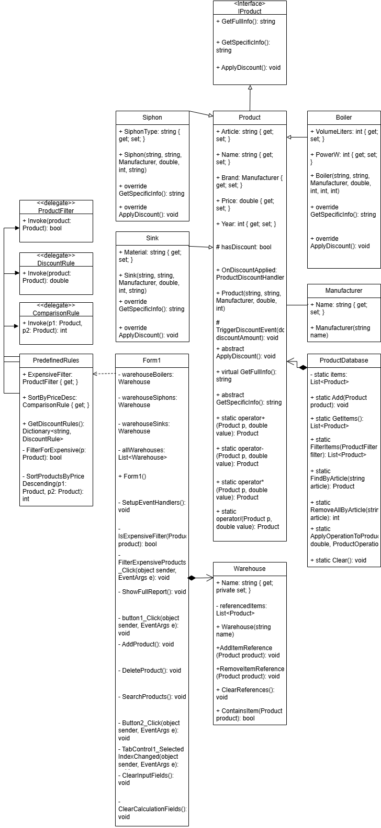
Розділено класи, які описують товари, для зручного відображення властивостей та методів, в класах використано псевдоніми просторів імен та статичне підключення просторів імен:
myLibrary manufacturer:
using System;

namespace MyLibrary
{
[Serializable]
public class Manufacturer
{
public string Name { get; set; }

public Manufacturer() { }

public Manufacturer(string name)
{
Name = name;
}

public override string ToString()
{
return Name;
}
}
}
using System.Drawing;
using System.Windows.Forms;

namespace lab6C_
{
partial class Form1
{
private System.ComponentModel.IContainer components = null;

protected override void Dispose(bool disposing)
{
if (disposing && (components != null))
{
components.Dispose();
}
base.Dispose(disposing);
}

#region Windows Form Designer generated code

private void InitializeComponent()
{
menuStrip1 = new MenuStrip();
файлToolStripMenuItem = new ToolStripMenuItem();
відкритиToolStripMenuItem = new ToolStripMenuItem();
зберегтиToolStripMenuItem = new ToolStripMenuItem();
tabControl1 = new TabControl();
tabAdd = new TabPage();
tabDelete = new TabPage();
tabSearch = new TabPage();
tabcalculate = new TabPage();
textBox1 = new TextBox();
textBox2 = new TextBox();
textBox3 = new TextBox();
textBox4 = new TextBox();
textBox5 = new TextBox();
label1 = new Label();
label2 = new Label();
label3 = new Label();
label4 = new Label();
label5 = new Label();
button1 = new Button();
dataGridView1 = new DataGridView();
dataGridViewTextBoxColumn1 = new DataGridViewTextBoxColumn();
dataGridViewTextBoxColumn2 = new DataGridViewTextBoxColumn();
dataGridViewTextBoxColumn3 = new DataGridViewTextBoxColumn();
dataGridViewTextBoxColumn4 = new DataGridViewTextBoxColumn();
dataGridViewTextBoxColumn5 = new DataGridViewTextBoxColumn();
AdditionalInfo = new DataGridViewTextBoxColumn();
dataGridView2 = new DataGridView();
dataGridViewTextBoxColumn6 = new DataGridViewTextBoxColumn();
dataGridViewTextBoxColumn7 = new DataGridViewTextBoxColumn();
dataGridViewTextBoxColumn8 = new DataGridViewTextBoxColumn();
dataGridViewTextBoxColumn9 = new DataGridViewTextBoxColumn();
dataGridViewTextBoxColumn10 = new DataGridViewTextBoxColumn();
AdditionalInfo2 = new DataGridViewTextBoxColumn();
label6 = new Label();
label7 = new Label();
label8 = new Label();
label9 = new Label();
textBox6 = new TextBox();
textBox7 = new TextBox();
textBox8 = new TextBox();
textBox9 = new TextBox();
button2 = new Button();
labelType = new Label();
comboBoxType = new ComboBox();
panelBoiler = new Panel();
textBoxPower = new TextBox();
labelPower = new Label();
textBoxVolume = new TextBox();
labelVolume = new Label();
panelSiphon = new Panel();
textBoxSiphonType = new TextBox();
labelSiphonType = new Label();
panelSink = new Panel();
textBoxMaterial = new TextBox();
labelMaterial = new Label();
lblWarehouseBoilers = new Label();
lblWarehouseSiphons = new Label();
lblWarehouseSinks = new Label();
btnFilterExpensive = new Button();
btnSortSelected = new Button();
cmbDiscountRule = new ComboBox();
btnApplyDiscount = new Button();
labelDiscount = new Label();
menuStrip1.SuspendLayout();
tabControl1.SuspendLayout();
((System.ComponentModel.ISupportInitialize)dataGridView1).BeginInit();
((System.ComponentModel.ISupportInitialize)dataGridView2).BeginInit();
panelBoiler.SuspendLayout();
panelSiphon.SuspendLayout();
panelSink.SuspendLayout();
SuspendLayout();
//
// menuStrip1
//
menuStrip1.ImageScalingSize = new Size(20, 20);
menuStrip1.Items.AddRange(new ToolStripItem[] { файлToolStripMenuItem });
menuStrip1.Location = new Point(0, 0);
menuStrip1.Name = "menuStrip1";
menuStrip1.Size = new Size(1425, 28);
menuStrip1.TabIndex = 0;
menuStrip1.Text = "menuStrip1";
//
// файлToolStripMenuItem
//
файлToolStripMenuItem.DropDownItems.AddRange(new ToolStripItem[] { відкритиToolStripMenuItem, зберегтиToolStripMenuItem });
файлToolStripMenuItem.Name = "файлToolStripMenuItem";
файлToolStripMenuItem.Size = new Size(59, 24);
файлToolStripMenuItem.Text = "Файл";
//
// відкритиToolStripMenuItem
//
відкритиToolStripMenuItem.Name = "відкритиToolStripMenuItem";
відкритиToolStripMenuItem.Size = new Size(155, 26);
відкритиToolStripMenuItem.Text = "Відкрити";
//
// зберегтиToolStripMenuItem
//
зберегтиToolStripMenuItem.Name = "зберегтиToolStripMenuItem";
зберегтиToolStripMenuItem.Size = new Size(155, 26);
зберегтиToolStripMenuItem.Text = "Зберегти";
//
// tabControl1
//
tabControl1.Controls.Add(tabAdd);
tabControl1.Controls.Add(tabDelete);
tabControl1.Controls.Add(tabSearch);
tabControl1.Controls.Add(tabcalculate);
tabControl1.Location = new Point(12, 45);
tabControl1.Name = "tabControl1";
tabControl1.SelectedIndex = 0;
tabControl1.Size = new Size(353, 30);
tabControl1.TabIndex = 1;
//
// tabAdd
//
tabAdd.Location = new Point(4, 29);
tabAdd.Name = "tabAdd";
tabAdd.Size = new Size(345, 0);
tabAdd.TabIndex = 0;
tabAdd.Text = "додавання";
//
// tabDelete
//
tabDelete.Location = new Point(4, 29);
tabDelete.Name = "tabDelete";
tabDelete.Size = new Size(345, 0);
tabDelete.TabIndex = 1;
tabDelete.Text = "Видалення";
//
// tabSearch
//
tabSearch.Location = new Point(4, 29);
tabSearch.Name = "tabSearch";
tabSearch.Size = new Size(345, 0);
tabSearch.TabIndex = 2;
tabSearch.Text = "Пошук";
//
// tabcalculate
//
tabcalculate.Location = new Point(4, 29);
tabcalculate.Name = "tabcalculate";
tabcalculate.Size = new Size(345, 0);
tabcalculate.TabIndex = 3;
tabcalculate.Text = "обрахувати";
//
// textBox1
//
textBox1.Location = new Point(129, 132);
textBox1.Name = "textBox1";
textBox1.Size = new Size(220, 27);
textBox1.TabIndex = 2;
//
// textBox2
//
textBox2.Location = new Point(129, 172);
textBox2.Name = "textBox2";
textBox2.Size = new Size(220, 27);
textBox2.TabIndex = 3;
//
// textBox3
//
textBox3.Location = new Point(129, 212);
textBox3.Name = "textBox3";
textBox3.Size = new Size(220, 27);
textBox3.TabIndex = 4;
//
// textBox4
//
textBox4.Location = new Point(129, 252);
textBox4.Name = "textBox4";
textBox4.Size = new Size(220, 27);
textBox4.TabIndex = 5;
//
// textBox5
//
textBox5.Location = new Point(129, 292);
textBox5.Name = "textBox5";
textBox5.Size = new Size(220, 27);
textBox5.TabIndex = 6;
//
// label1
//
label1.AutoSize = true;
label1.Location = new Point(35, 135);
label1.Name = "label1";
label1.Size = new Size(65, 20);
label1.TabIndex = 34;
label1.Text = "Артикул";
//
// label2
//
label2.AutoSize = true;
label2.Location = new Point(35, 175);
label2.Name = "label2";
label2.Size = new Size(51, 20);
label2.TabIndex = 33;
label2.Text = "Назва";
//
// label3
//
label3.AutoSize = true;
label3.Location = new Point(35, 215);
label3.Name = "label3";
label3.Size = new Size(52, 20);
label3.TabIndex = 32;
label3.Text = "Бренд";
//
// label4
//
label4.AutoSize = true;
label4.Location = new Point(35, 255);
label4.Name = "label4";
label4.Size = new Size(41, 20);
label4.TabIndex = 31;
label4.Text = "Ціна";
//
// label5
//
label5.AutoSize = true;
label5.Location = new Point(35, 295);
label5.Name = "label5";
label5.Size = new Size(86, 20);
label5.TabIndex = 30;
label5.Text = "Рік випуску";
//
// button1
//
button1.Location = new Point(135, 445);
button1.Name = "button1";
button1.Size = new Size(94, 29);
button1.TabIndex = 10;
button1.Text = "OK";
button1.UseVisualStyleBackColor = true;
//
// dataGridView1
//
dataGridView1.AllowUserToAddRows = false;
dataGridView1.ColumnHeadersHeightSizeMode = DataGridViewColumnHeadersHeightSizeMode.AutoSize;
dataGridView1.Columns.AddRange(new DataGridViewColumn[] { dataGridViewTextBoxColumn1, dataGridViewTextBoxColumn2, dataGridViewTextBoxColumn3, dataGridViewTextBoxColumn4, dataGridViewTextBoxColumn5, AdditionalInfo });
dataGridView1.Location = new Point(400, 75);
dataGridView1.Name = "dataGridView1";
dataGridView1.ReadOnly = true;
dataGridView1.RowHeadersWidth = 51;
dataGridView1.SelectionMode = DataGridViewSelectionMode.FullRowSelect;
dataGridView1.Size = new Size(1003, 229);
dataGridView1.TabIndex = 11;
//
// dataGridViewTextBoxColumn1
//
dataGridViewTextBoxColumn1.HeaderText = "Артикул";
dataGridViewTextBoxColumn1.MinimumWidth = 6;
dataGridViewTextBoxColumn1.Name = "dataGridViewTextBoxColumn1";
dataGridViewTextBoxColumn1.ReadOnly = true;
dataGridViewTextBoxColumn1.Width = 125;
//
// dataGridViewTextBoxColumn2
//
dataGridViewTextBoxColumn2.HeaderText = "Назва";
dataGridViewTextBoxColumn2.MinimumWidth = 6;
dataGridViewTextBoxColumn2.Name = "dataGridViewTextBoxColumn2";
dataGridViewTextBoxColumn2.ReadOnly = true;
dataGridViewTextBoxColumn2.Width = 125;
//
// dataGridViewTextBoxColumn3
//
dataGridViewTextBoxColumn3.HeaderText = "Бренд";
dataGridViewTextBoxColumn3.MinimumWidth = 6;
dataGridViewTextBoxColumn3.Name = "dataGridViewTextBoxColumn3";
dataGridViewTextBoxColumn3.ReadOnly = true;
dataGridViewTextBoxColumn3.Width = 125;
//
// dataGridViewTextBoxColumn4
//
dataGridViewTextBoxColumn4.HeaderText = "Ціна";
dataGridViewTextBoxColumn4.MinimumWidth = 6;
dataGridViewTextBoxColumn4.Name = "dataGridViewTextBoxColumn4";
dataGridViewTextBoxColumn4.ReadOnly = true;
dataGridViewTextBoxColumn4.Width = 125;
//
// dataGridViewTextBoxColumn5
//
dataGridViewTextBoxColumn5.HeaderText = "Рік випуску";
dataGridViewTextBoxColumn5.MinimumWidth = 6;
dataGridViewTextBoxColumn5.Name = "dataGridViewTextBoxColumn5";
dataGridViewTextBoxColumn5.ReadOnly = true;
dataGridViewTextBoxColumn5.Width = 125;
//
// AdditionalInfo
//
AdditionalInfo.AutoSizeMode = DataGridViewAutoSizeColumnMode.Fill;
AdditionalInfo.HeaderText = "Додаткова інформація";
AdditionalInfo.MinimumWidth = 6;
AdditionalInfo.Name = "AdditionalInfo";
AdditionalInfo.ReadOnly = true;
//
// dataGridView2
//
dataGridView2.AllowUserToAddRows = false;
dataGridView2.ColumnHeadersHeightSizeMode = DataGridViewColumnHeadersHeightSizeMode.AutoSize;
dataGridView2.Columns.AddRange(new DataGridViewColumn[] { dataGridViewTextBoxColumn6, dataGridViewTextBoxColumn7, dataGridViewTextBoxColumn8, dataGridViewTextBoxColumn9, dataGridViewTextBoxColumn10, AdditionalInfo2 });
dataGridView2.Location = new Point(400, 340);
dataGridView2.Name = "dataGridView2";
dataGridView2.ReadOnly = true;
dataGridView2.RowHeadersWidth = 51;
dataGridView2.Size = new Size(1003, 261);
dataGridView2.TabIndex = 12;
//
// dataGridViewTextBoxColumn6
//
dataGridViewTextBoxColumn6.HeaderText = "Артикул";
dataGridViewTextBoxColumn6.MinimumWidth = 6;
dataGridViewTextBoxColumn6.Name = "dataGridViewTextBoxColumn6";
dataGridViewTextBoxColumn6.ReadOnly = true;
dataGridViewTextBoxColumn6.Width = 125;
//
// dataGridViewTextBoxColumn7
//
dataGridViewTextBoxColumn7.HeaderText = "Назва";
dataGridViewTextBoxColumn7.MinimumWidth = 6;
dataGridViewTextBoxColumn7.Name = "dataGridViewTextBoxColumn7";
dataGridViewTextBoxColumn7.ReadOnly = true;
dataGridViewTextBoxColumn7.Width = 125;
//
// dataGridViewTextBoxColumn8
//
dataGridViewTextBoxColumn8.HeaderText = "Бренд";
dataGridViewTextBoxColumn8.MinimumWidth = 6;
dataGridViewTextBoxColumn8.Name = "dataGridViewTextBoxColumn8";
dataGridViewTextBoxColumn8.ReadOnly = true;
dataGridViewTextBoxColumn8.Width = 125;
//
// dataGridViewTextBoxColumn9
//
dataGridViewTextBoxColumn9.HeaderText = "Ціна";
dataGridViewTextBoxColumn9.MinimumWidth = 6;
dataGridViewTextBoxColumn9.Name = "dataGridViewTextBoxColumn9";
dataGridViewTextBoxColumn9.ReadOnly = true;
dataGridViewTextBoxColumn9.Width = 125;
//
// dataGridViewTextBoxColumn10
//
dataGridViewTextBoxColumn10.HeaderText = "Рік випуску";
dataGridViewTextBoxColumn10.MinimumWidth = 6;
dataGridViewTextBoxColumn10.Name = "dataGridViewTextBoxColumn10";
dataGridViewTextBoxColumn10.ReadOnly = true;
dataGridViewTextBoxColumn10.Width = 125;
//
// AdditionalInfo2
//
AdditionalInfo2.AutoSizeMode = DataGridViewAutoSizeColumnMode.Fill;
AdditionalInfo2.HeaderText = "Додаткова інформація";
AdditionalInfo2.MinimumWidth = 6;
AdditionalInfo2.Name = "AdditionalInfo2";
AdditionalInfo2.ReadOnly = true;
//
// label6
//
label6.Location = new Point(12, 483);
label6.Name = "label6";
label6.Size = new Size(100, 23);
label6.TabIndex = 29;
label6.Text = "+";
//
// label7
//
label7.Location = new Point(12, 513);
label7.Name = "label7";
label7.Size = new Size(100, 23);
label7.TabIndex = 28;
label7.Text = "-";
//
// label8
//
label8.Location = new Point(12, 543);
label8.Name = "label8";
label8.Size = new Size(100, 23);
label8.TabIndex = 27;
label8.Text = "*";
//
// label9
//
label9.Location = new Point(12, 573);
label9.Name = "label9";
label9.Size = new Size(100, 23);
label9.TabIndex = 26;
label9.Text = "/";
//
// textBox6
//
textBox6.Location = new Point(51, 480);
textBox6.Name = "textBox6";
textBox6.Size = new Size(100, 27);
textBox6.TabIndex = 25;
//
// textBox7
//
textBox7.Location = new Point(51, 510);
textBox7.Name = "textBox7";
textBox7.Size = new Size(100, 27);
textBox7.TabIndex = 24;
//
// textBox8
//
textBox8.Location = new Point(51, 540);
textBox8.Name = "textBox8";
textBox8.Size = new Size(100, 27);
textBox8.TabIndex = 23;
//
// textBox9
//
textBox9.Location = new Point(51, 570);
textBox9.Name = "textBox9";
textBox9.Size = new Size(100, 27);
textBox9.TabIndex = 22;
//
// button2
//
button2.Location = new Point(46, 610);
button2.Name = "button2";
button2.Size = new Size(105, 31);
button2.TabIndex = 21;
button2.Text = "Обрахувати";
button2.UseVisualStyleBackColor = true;
//
// labelType
//
labelType.AutoSize = true;
labelType.Location = new Point(35, 95);
labelType.Name = "labelType";
labelType.Size = new Size(86, 20);
labelType.TabIndex = 20;
labelType.Text = "Тип товару";
//
// comboBoxType
//
comboBoxType.DropDownStyle = ComboBoxStyle.DropDownList;
comboBoxType.FormattingEnabled = true;
comboBoxType.Location = new Point(129, 92);
comboBoxType.Name = "comboBoxType";
comboBoxType.Size = new Size(220, 28);
comboBoxType.TabIndex = 1;

//
// panelBoiler
//
panelBoiler.Controls.Add(textBoxPower);
panelBoiler.Controls.Add(labelPower);
panelBoiler.Controls.Add(textBoxVolume);
panelBoiler.Controls.Add(labelVolume);
panelBoiler.Location = new Point(12, 335);
panelBoiler.Name = "panelBoiler";
panelBoiler.Size = new Size(350, 80);
panelBoiler.TabIndex = 7;
//
// textBoxPower
//
textBoxPower.Location = new Point(117, 42);
textBoxPower.Name = "textBoxPower";
textBoxPower.Size = new Size(220, 27);
textBoxPower.TabIndex = 0;
//
// labelPower
//
labelPower.AutoSize = true;
labelPower.Location = new Point(4, 49);
labelPower.Name = "labelPower";
labelPower.Size = new Size(116, 20);
labelPower.TabIndex = 1;
labelPower.Text = "Потужність (Вт)";
//
// textBoxVolume
//
textBoxVolume.Location = new Point(117, 7);
textBoxVolume.Name = "textBoxVolume";
textBoxVolume.Size = new Size(220, 27);
textBoxVolume.TabIndex = 2;
//
// labelVolume
//
labelVolume.AutoSize = true;
labelVolume.Location = new Point(23, 10);
labelVolume.Name = "labelVolume";
labelVolume.Size = new Size(72, 20);
labelVolume.TabIndex = 3;
labelVolume.Text = "Об'єм (л)";
//
// panelSiphon
//
panelSiphon.Controls.Add(textBoxSiphonType);
panelSiphon.Controls.Add(labelSiphonType);
panelSiphon.Location = new Point(12, 335);
panelSiphon.Name = "panelSiphon";
panelSiphon.Size = new Size(350, 40);
panelSiphon.TabIndex = 8;
panelSiphon.Visible = false;
//
// textBoxSiphonType
//
textBoxSiphonType.Location = new Point(117, 7);
textBoxSiphonType.Name = "textBoxSiphonType";
textBoxSiphonType.Size = new Size(220, 27);
textBoxSiphonType.TabIndex = 0;
//
// labelSiphonType
//
labelSiphonType.AutoSize = true;
labelSiphonType.Location = new Point(23, 10);
labelSiphonType.Name = "labelSiphonType";
labelSiphonType.Size = new Size(91, 20);
labelSiphonType.TabIndex = 1;
labelSiphonType.Text = "Тип сифона";
//
// panelSink
//
panelSink.Controls.Add(textBoxMaterial);
panelSink.Controls.Add(labelMaterial);
panelSink.Location = new Point(12, 335);
panelSink.Name = "panelSink";
panelSink.Size = new Size(350, 40);
panelSink.TabIndex = 9;
panelSink.Visible = false;
//
// textBoxMaterial
//
textBoxMaterial.Location = new Point(117, 7);
textBoxMaterial.Name = "textBoxMaterial";
textBoxMaterial.Size = new Size(220, 27);
textBoxMaterial.TabIndex = 0;
//
// labelMaterial
//
labelMaterial.AutoSize = true;
labelMaterial.Location = new Point(15, 10);
labelMaterial.Name = "labelMaterial";
labelMaterial.Size = new Size(73, 20);
labelMaterial.TabIndex = 1;
labelMaterial.Text = "Матеріал";
//
// lblWarehouseBoilers
//
lblWarehouseBoilers.AutoSize = true;
lblWarehouseBoilers.Font = new Font("Segoe UI", 9F, FontStyle.Bold);
lblWarehouseBoilers.Location = new Point(400, 45);
lblWarehouseBoilers.Name = "lblWarehouseBoilers";
lblWarehouseBoilers.Size = new Size(139, 20);
lblWarehouseBoilers.TabIndex = 19;
lblWarehouseBoilers.Text = "Склад бойлерів: 0";
//
// lblWarehouseSiphons
//
lblWarehouseSiphons.AutoSize = true;
lblWarehouseSiphons.Font = new Font("Segoe UI", 9F, FontStyle.Bold);
lblWarehouseSiphons.Location = new Point(650, 45);
lblWarehouseSiphons.Name = "lblWarehouseSiphons";
lblWarehouseSiphons.Size = new Size(132, 20);
lblWarehouseSiphons.TabIndex = 18;
lblWarehouseSiphons.Text = "Склад сифонів: 0";
//
// lblWarehouseSinks
//
lblWarehouseSinks.AutoSize = true;
lblWarehouseSinks.Font = new Font("Segoe UI", 9F, FontStyle.Bold);
lblWarehouseSinks.Location = new Point(900, 45);
lblWarehouseSinks.Name = "lblWarehouseSinks";
lblWarehouseSinks.Size = new Size(120, 20);
lblWarehouseSinks.TabIndex = 17;
lblWarehouseSinks.Text = "Склад мийок: 0";
//
// btnFilterExpensive
//
btnFilterExpensive.Location = new Point(400, 610);
btnFilterExpensive.Name = "btnFilterExpensive";
btnFilterExpensive.Size = new Size(180, 29);
btnFilterExpensive.TabIndex = 13;
btnFilterExpensive.Text = "Знайти дорожчі за 500";
btnFilterExpensive.UseVisualStyleBackColor = true;
//
// btnSortSelected
//
btnSortSelected.Location = new Point(590, 610);
btnSortSelected.Name = "btnSortSelected";
btnSortSelected.Size = new Size(250, 29);
btnSortSelected.TabIndex = 14;
btnSortSelected.Text = "Сортувати обране (за спаданням ціни)";
btnSortSelected.UseVisualStyleBackColor = true;
//
// cmbDiscountRule
//
cmbDiscountRule.DropDownStyle = ComboBoxStyle.DropDownList;
cmbDiscountRule.FormattingEnabled = true;
cmbDiscountRule.Location = new Point(180, 480);
cmbDiscountRule.Name = "cmbDiscountRule";
cmbDiscountRule.Size = new Size(200, 28);
cmbDiscountRule.TabIndex = 15;
//
// btnApplyDiscount
//
btnApplyDiscount.Location = new Point(180, 514);
btnApplyDiscount.Name = "btnApplyDiscount";
btnApplyDiscount.Size = new Size(200, 29);
btnApplyDiscount.TabIndex = 16;
btnApplyDiscount.Text = "Застосувати знижку";
btnApplyDiscount.UseVisualStyleBackColor = true;
//
// labelDiscount
//
labelDiscount.AutoSize = true;
labelDiscount.Location = new Point(176, 457);
labelDiscount.Name = "labelDiscount";
labelDiscount.Size = new Size(130, 20);
labelDiscount.TabIndex = 0;
labelDiscount.Text = "Правило знижки:";
//
// Form1
//
ClientSize = new Size(1425, 653);
Controls.Add(labelDiscount);
Controls.Add(btnApplyDiscount);
Controls.Add(cmbDiscountRule);
Controls.Add(btnSortSelected);
Controls.Add(btnFilterExpensive);
Controls.Add(lblWarehouseSinks);
Controls.Add(lblWarehouseSiphons);
Controls.Add(lblWarehouseBoilers);
Controls.Add(panelSink);
Controls.Add(panelSiphon);
Controls.Add(panelBoiler);
Controls.Add(comboBoxType);
Controls.Add(labelType);
Controls.Add(button2);
Controls.Add(textBox9);
Controls.Add(textBox8);
Controls.Add(textBox7);
Controls.Add(textBox6);
Controls.Add(label9);
Controls.Add(label8);
Controls.Add(label7);
Controls.Add(label6);
Controls.Add(dataGridView2);
Controls.Add(dataGridView1);
Controls.Add(button1);
Controls.Add(label5);
Controls.Add(label4);
Controls.Add(label3);
Controls.Add(label2);
Controls.Add(label1);
Controls.Add(textBox5);
Controls.Add(textBox4);
Controls.Add(textBox3);
Controls.Add(textBox2);
Controls.Add(textBox1);
Controls.Add(tabControl1);
Controls.Add(menuStrip1);
MainMenuStrip = menuStrip1;
Name = "Form1";
Text = "Магазин сантехніки";
Load += Form1_Load;
menuStrip1.ResumeLayout(false);
menuStrip1.PerformLayout();
tabControl1.ResumeLayout(false);
((System.ComponentModel.ISupportInitialize)dataGridView1).EndInit();
((System.ComponentModel.ISupportInitialize)dataGridView2).EndInit();
panelBoiler.ResumeLayout(false);
panelBoiler.PerformLayout();
panelSiphon.ResumeLayout(false);
panelSiphon.PerformLayout();
panelSink.ResumeLayout(false);
panelSink.PerformLayout();
ResumeLayout(false);
PerformLayout();
}

#endregion

private System.Windows.Forms.MenuStrip menuStrip1;
private System.Windows.Forms.ToolStripMenuItem файлToolStripMenuItem;
private System.Windows.Forms.ToolStripMenuItem відкритиToolStripMenuItem;
private System.Windows.Forms.ToolStripMenuItem зберегтиToolStripMenuItem;
private System.Windows.Forms.TabControl tabControl1;
private System.Windows.Forms.TabPage tabAdd;
private System.Windows.Forms.TabPage tabDelete;
private System.Windows.Forms.TabPage tabSearch;
private System.Windows.Forms.TabPage tabcalculate;
private System.Windows.Forms.TextBox textBox1;
private System.Windows.Forms.TextBox textBox2;
private System.Windows.Forms.TextBox textBox3;
private System.Windows.Forms.TextBox textBox4;
private System.Windows.Forms.TextBox textBox5;
private System.Windows.Forms.Label label1;
private System.Windows.Forms.Label label2;
private System.Windows.Forms.Label label3;
private System.Windows.Forms.Label label4;
private System.Windows.Forms.Label label5;
private System.Windows.Forms.Button button1;
private System.Windows.Forms.DataGridView dataGridView1;
private System.Windows.Forms.DataGridViewTextBoxColumn dataGridViewTextBoxColumn1;
private System.Windows.Forms.DataGridViewTextBoxColumn dataGridViewTextBoxColumn2;
private System.Windows.Forms.DataGridViewTextBoxColumn dataGridViewTextBoxColumn3;
private System.Windows.Forms.DataGridViewTextBoxColumn dataGridViewTextBoxColumn4;
private System.Windows.Forms.DataGridViewTextBoxColumn dataGridViewTextBoxColumn5;
private System.Windows.Forms.DataGridViewTextBoxColumn AdditionalInfo;
private System.Windows.Forms.DataGridView dataGridView2;
private System.Windows.Forms.DataGridViewTextBoxColumn dataGridViewTextBoxColumn6;
private System.Windows.Forms.DataGridViewTextBoxColumn dataGridViewTextBoxColumn7;
private System.Windows.Forms.DataGridViewTextBoxColumn dataGridViewTextBoxColumn8;
private System.Windows.Forms.DataGridViewTextBoxColumn dataGridViewTextBoxColumn9;
private System.Windows.Forms.DataGridViewTextBoxColumn dataGridViewTextBoxColumn10;
private System.Windows.Forms.DataGridViewTextBoxColumn AdditionalInfo2;
private System.Windows.Forms.Label label6;
private System.Windows.Forms.Label label7;
private System.Windows.Forms.Label label8;
private System.Windows.Forms.Label label9;
private System.Windows.Forms.TextBox textBox6;
private System.Windows.Forms.TextBox textBox7;
private System.Windows.Forms.TextBox textBox8;
private System.Windows.Forms.TextBox textBox9;
private System.Windows.Forms.Button button2;
private System.Windows.Forms.Label labelType;
private System.Windows.Forms.ComboBox comboBoxType;
private System.Windows.Forms.Panel panelBoiler;
private System.Windows.Forms.TextBox textBoxPower;
private System.Windows.Forms.Label labelPower;
private System.Windows.Forms.TextBox textBoxVolume;
private System.Windows.Forms.Label labelVolume;
private System.Windows.Forms.Panel panelSiphon;
private System.Windows.Forms.TextBox textBoxSiphonType;
private System.Windows.Forms.Label labelSiphonType;
private System.Windows.Forms.Panel panelSink;
private System.Windows.Forms.TextBox textBoxMaterial;
private System.Windows.Forms.Label labelMaterial;

private Label lblWarehouseBoilers;
private Label lblWarehouseSiphons;
private Label lblWarehouseSinks;
private Button btnFilterExpensive;
private Button btnSortSelected;
private ComboBox cmbDiscountRule;
private Button btnApplyDiscount;
private Label labelDiscount;
}
} using lab6C_;
using MyLibrary;
using Newtonsoft.Json;
using System;
using System.Collections.Generic;
using System.Globalization;
using System.IO;
using System.Linq;
using System.Text;
using System.Windows.Forms;
// ПСЕВДОНІМ (ALIAS)

using MyManuf = MyLibrary.Manufacturer;

namespace lab6C_
{
public partial class Form1 : Form
{
private Warehouse warehouseBoilers;
private Warehouse warehouseSiphons;
private Warehouse warehouseSinks;
private List<Warehouse> allWarehouses;

private Dictionary<string, DiscountRule> discountRules;

public Form1()
{
InitializeComponent();
SetupEventHandlers();

warehouseBoilers = new Warehouse("Склад бойлерів");
warehouseSiphons = new Warehouse("Склад сифонів");
warehouseSinks = new Warehouse("Склад мийок");
allWarehouses = new List<Warehouse> { warehouseBoilers, warehouseSiphons, warehouseSinks };

warehouseBoilers.WarehouseChanged += OnWarehouseChanged;
warehouseSiphons.WarehouseChanged += OnWarehouseChanged;
warehouseSinks.WarehouseChanged += OnWarehouseChanged;

discountRules = PredefinedRules.GetDiscountRules();

cmbDiscountRule.Items.AddRange(discountRules.Keys.ToArray());
cmbDiscountRule.SelectedIndex = 0;

UpdateWarehouseCounters();
}

private void SetupEventHandlers()
{
this.Load += Form1_Load;
tabControl1.SelectedIndexChanged += TabControl1_SelectedIndexChanged;
comboBoxType.SelectedIndexChanged += ComboBoxType_SelectedIndexChanged;
button1.Click += button1_Click;
button2.Click += Button2_Click;

зберегтиToolStripMenuItem.Click += зберегтиToolStripMenuItem_Click;
відкритиToolStripMenuItem.Click += відкритиToolStripMenuItem_Click;

ToolStripMenuItem reportMenuItem = new ToolStripMenuItem("Повний звіт");
reportMenuItem.Click += (sender, e) => ShowFullReport();
файлToolStripMenuItem.DropDownItems.Add(reportMenuItem);

textBox1.KeyPress += Article_KeyPress;
textBox3.KeyPress += Brand_KeyPress;
textBox4.KeyPress += Price_KeyPress;
textBox5.KeyPress += Year_KeyPress;

btnFilterExpensive.Click += BtnFilterExpensive_Click;
btnSortSelected.Click += BtnSortSelected_Click;
btnApplyDiscount.Click += BtnApplyDiscount_Click;
}

private void OnWarehouseChanged(object sender, EventArgs e)
{
UpdateWarehouseCounters();
}

private void UpdateWarehouseCounters()
{
lblWarehouseBoilers.Text = $"Склад бойлерів: {warehouseBoilers.GetItemCount()}";
lblWarehouseSiphons.Text = $"Склад сифонів: {warehouseSiphons.GetItemCount()}";
lblWarehouseSinks.Text = $"Склад мийок: {warehouseSinks.GetItemCount()}";
}

private void ShowFullReport()
{
List<Product> allProducts = ProductDatabase.GetItems();
List<Warehouse> allWarehouses = this.allWarehouses;

StringBuilder report = new StringBuilder();
report.AppendLine($"--- ПОВНИЙ ЗВІТ ПО ТОВАРАХ ---");
report.AppendLine($"Всього у базі: {allProducts.Count} позицій.\n");

foreach (var product in allProducts)
{
report.Append($"[Товар]: {product.GetFullInfo()}\n");

string warehouseInfo = " -> Знаходиться на складах: ";
int count = 0;
foreach (var warehouse in allWarehouses)
{
if (warehouse.ContainsItem(product))
{
warehouseInfo += $"{warehouse.Name}; ";
count++;
}
}

if (count == 0) warehouseInfo += "Немає на жодному складі.";

report.AppendLine(warehouseInfo + "\n");
}

Form reportForm = new Form();
reportForm.Text = "Повний звіт";
reportForm.Size = new System.Drawing.Size(600, 400);

TextBox reportTextBox = new TextBox();

reportTextBox.Multiline = true;
reportTextBox.ScrollBars = ScrollBars.Vertical;
reportTextBox.Dock = DockStyle.Fill;
reportTextBox.Font = new System.Drawing.Font("Consolas", 10F);
reportTextBox.Text = report.ToString();
reportForm.Controls.Add(reportTextBox);
reportForm.ShowDialog();
}

private void button1_Click(object sender, EventArgs e)
{
string selectedTab = tabControl1.SelectedTab.Text;

if (selectedTab == "додавання") AddProduct();
else if (selectedTab == "Видалення") DeleteProduct();
else if (selectedTab == "Пошук") SearchProducts();

this.ClearAllInputs();
}

private void AddProduct()
{
if (textBox1.IsEmpty() || textBox3.IsEmpty())
{
MessageBox.Show("Заповніть Артикул та Бренд!", "Помилка", MessageBoxButtons.OK, MessageBoxIcon.Warning);
return;
}

try
{
if (!double.TryParse(textBox4.Text.Trim().Replace(',', '.'), NumberStyles.Any, CultureInfo.InvariantCulture, out double price))
throw new FormatException("Некоректна ціна");

if (!int.TryParse(textBox5.Text.Trim(), out int year))
throw new FormatException("Некоректний рік");

// --- ВИКОРИСТАННЯ ПСЕВДОНІМУ (ALIAS) ---
// Замість повного імені класу використовуємо наш псевдонім "MyManuf"
MyManuf manufacturer = new MyManuf(textBox3.Text);

Product newProduct = null;
Warehouse targetWarehouse = null;

switch (comboBoxType.SelectedItem.ToString())
{
case "Бойлер":
newProduct = new Boiler(textBox1.Text, textBox2.Text, manufacturer, price, year, int.Parse(textBoxVolume.Text), int.Parse(textBoxPower.Text));
targetWarehouse = warehouseBoilers;
break;
case "Сифон":
newProduct = new Siphon(textBox1.Text, textBox2.Text, manufacturer, price, year, textBoxSiphonType.Text);
targetWarehouse = warehouseSiphons;
break;
case "Мийка":
newProduct = new Sink(textBox1.Text, textBox2.Text, manufacturer, price, year, textBoxMaterial.Text);
targetWarehouse = warehouseSinks;
break;
}

if (newProduct != null)
{
ProductDatabase.Add(newProduct);
targetWarehouse.AddItemReference(newProduct);
UpdateDataGridView(ProductDatabase.GetItems());
}
}
catch (FormatException)
{
MessageBox.Show("Будь ласка, введіть коректні числові значення для ціни та року.", "Помилка формату", MessageBoxButtons.OK, MessageBoxIcon.Error);
}
catch (Exception ex)
{
MessageBox.Show($"Виникла помилка: {ex.Message}", "Помилка", MessageBoxButtons.OK, MessageBoxIcon.Error);
}
}

private void DeleteProduct()
{
string article = textBox1.Text.Trim();
if (string.IsNullOrWhiteSpace(article))
{
MessageBox.Show("Введіть артикул для видалення.", "Інформація", MessageBoxButtons.OK, MessageBoxIcon.Information);
return;
}

Product productToRemove = ProductDatabase.FindByArticle(article);

if (productToRemove != null)
{
foreach (var warehouse in allWarehouses)
{
warehouse.RemoveItemReference(productToRemove);
}

ProductDatabase.RemoveAllByArticle(article);

UpdateDataGridView(ProductDatabase.GetItems());
MessageBox.Show("Товар успішно видалено.", "Успіх", MessageBoxButtons.OK, MessageBoxIcon.Information);
}
else
{
MessageBox.Show("Товар з таким артикулом не знайдено.", "Помилка", MessageBoxButtons.OK, MessageBoxIcon.Warning);
}
}

private List<Product> FindProducts(ProductFilter filter)
{
List<Product> results = new List<Product>();
foreach (Product p in ProductDatabase.GetItems())
{
if (filter(p))
{
results.Add(p);
}
}
return results;
}

private void SearchProducts()
{
string article = textBox1.Text.Trim();
string name = textBox2.Text.Trim();

List<Product> results = new List<Product>();

foreach (Product p in ProductDatabase.GetItems())
{
if ((string.IsNullOrWhiteSpace(article) || p.Article.StartsWith(article, StringComparison.OrdinalIgnoreCase)) &&
(string.IsNullOrWhiteSpace(name) || p.Name.Contains(name, StringComparison.OrdinalIgnoreCase)))
{
results.Add(p);
}
}

UpdateDataGridView(results, isSearchResult: true);
}

private void BtnFilterExpensive_Click(object sender, EventArgs e)
{
var results = FindProducts(PredefinedRules.ExpensiveFilter);

UpdateDataGridView(results, isSearchResult: true);
MessageBox.Show($"Знайдено {results.Count} товарів дорожчих за 500 грн.", "Результат фільтрації");
}

private void BtnSortSelected_Click(object sender, EventArgs e)
{
if (dataGridView1.SelectedRows.Count == 0)
{
MessageBox.Show("Оберіть один або декілька рядків у головній таблиці.", "Інформація", MessageBoxButtons.OK, MessageBoxIcon.Information);
return;
}

List<Product> selectedProducts = new List<Product>();
foreach (DataGridViewRow row in dataGridView1.SelectedRows)
{
string article = row.Cells[0].Value.ToString();
Product product = ProductDatabase.FindByArticle(article);
if (product != null)
{
selectedProducts.Add(product);
}
}

ComparisonRule customRule = PredefinedRules.SortByPriceDesc;
Comparison<Product> netComparison = new Comparison<Product>(customRule);

selectedProducts.Sort(netComparison);

UpdateDataGridView(selectedProducts, isSearchResult: true);
MessageBox.Show("Обрані товари відсортовано за спаданням ціни.", "Результат сортування");
}

private void BtnApplyDiscount_Click(object sender, EventArgs e)
{
if (dataGridView1.SelectedRows.Count == 0)
{
MessageBox.Show("Оберіть один або декілька рядків у головній таблиці.", "Інформація", MessageBoxButtons.OK, MessageBoxIcon.Information);
return;
}

string selectedRuleName = cmbDiscountRule.SelectedItem.ToString();
DiscountRule selectedRule = discountRules[selectedRuleName];

foreach (DataGridViewRow row in dataGridView1.SelectedRows)
{
string article = row.Cells[0].Value.ToString();
Product product = ProductDatabase.FindByArticle(article);
if (product != null)
{
product.Price = selectedRule(product);
}
}

UpdateDataGridView(ProductDatabase.GetItems());
MessageBox.Show($"Знижку '{selectedRuleName}' застосовано.", "Ціни оновлено");
}

private void Button2_Click(object sender, EventArgs e)
{
if (dataGridView1.SelectedRows.Count == 0)
{
MessageBox.Show("Оберіть один або декілька рядків у таблиці для обрахунку.", "Інформація", MessageBoxButtons.OK, MessageBoxIcon.Information);
return;
}

foreach (DataGridViewRow row in dataGridView1.SelectedRows)
{
string article = row.Cells[0].Value.ToString();
Product product = ProductDatabase.FindByArticle(article);
if (product == null) continue;

if (double.TryParse(textBox6.Text.Replace(',', '.'), NumberStyles.Any, CultureInfo.InvariantCulture, out double valPlus)) product += valPlus;
if (double.TryParse(textBox7.Text.Replace(',', '.'), NumberStyles.Any, CultureInfo.InvariantCulture, out double valMinus)) product -= valMinus;
if (double.TryParse(textBox8.Text.Replace(',', '.'), NumberStyles.Any, CultureInfo.InvariantCulture, out double valMul)) product *= valMul;
if (double.TryParse(textBox9.Text.Replace(',', '.'), NumberStyles.Any, CultureInfo.InvariantCulture, out double valDiv)) product /= valDiv;
}

UpdateDataGridView(ProductDatabase.GetItems());
ClearCalculationFields();
}

private void зберегтиToolStripMenuItem_Click(object sender, EventArgs e)
{
SaveFileDialog sfd = new SaveFileDialog { Filter = "JSON Files|*.json|All Files|*.*" };

if (sfd.ShowDialog() == DialogResult.OK)
{
try
{
List<Product> products = ProductDatabase.GetItems();

var settings = new JsonSerializerSettings
{
TypeNameHandling = TypeNameHandling.Auto,
Formatting = Formatting.Indented
};

string jsonString = JsonConvert.SerializeObject(products, settings);
File.WriteAllText(sfd.FileName, jsonString);

MessageBox.Show("Дані успішно збережено у JSON!", "Успіх", MessageBoxButtons.OK, MessageBoxIcon.Information);
}
catch (Exception ex)
{
MessageBox.Show($"Помилка при збереженні: {ex.Message}", "Помилка", MessageBoxButtons.OK, MessageBoxIcon.Error);
}
}
}

private void відкритиToolStripMenuItem_Click(object sender, EventArgs e)
{
OpenFileDialog ofd = new OpenFileDialog { Filter = "JSON Files|*.json|All Files|*.*" };

if (ofd.ShowDialog() == DialogResult.OK)
{
try
{
string jsonString = File.ReadAllText(ofd.FileName);

var settings = new JsonSerializerSettings
{
TypeNameHandling = TypeNameHandling.Auto
};

List<Product> loadedProducts = JsonConvert.DeserializeObject<List<Product>>(jsonString, settings);

if (loadedProducts != null)
{
ProductDatabase.Clear();
foreach (var wh in allWarehouses) wh.ClearReferences();

foreach (var p in loadedProducts)
{
ProductDatabase.Add(p);

if (p is Boiler) warehouseBoilers.AddItemReference(p);
else if (p is Siphon) warehouseSiphons.AddItemReference(p);
else if (p is Sink) warehouseSinks.AddItemReference(p);
}

UpdateDataGridView(ProductDatabase.GetItems());
MessageBox.Show("Дані успішно завантажено з JSON!", "Успіх", MessageBoxButtons.OK, MessageBoxIcon.Information);
}
}
catch (Exception ex)
{
MessageBox.Show($"Помилка при читанні файлу: {ex.Message}", "Помилка", MessageBoxButtons.OK, MessageBoxIcon.Error);
}
}
}

private void Form1_Load(object sender, EventArgs e)
{
comboBoxType.Items.Clear();
comboBoxType.Items.AddRange(new string[] { "Бойлер", "Сифон", "Мийка" });
comboBoxType.SelectedIndex = 0;
TabControl1_SelectedIndexChanged(null, null);
}

private void TabControl1_SelectedIndexChanged(object sender, EventArgs e)
{
string selectedTab = tabControl1.SelectedTab.Text;
bool isCalculationTab = selectedTab == "обрахувати";

ShowHideMainControls(!isCalculationTab);
ShowHideArithmetic(isCalculationTab);
}

private void ComboBoxType_SelectedIndexChanged(object sender, EventArgs e)
{
string selectedType = comboBoxType.SelectedItem.ToString();
panelBoiler.Visible = selectedType == "Бойлер";
panelSiphon.Visible = selectedType == "Сифон";
panelSink.Visible = selectedType == "Мийка";
}

private void UpdateDataGridView(List<Product> products, bool isSearchResult = false)
{
DataGridView dgv = isSearchResult ? dataGridView2 : dataGridView1;
dgv.Rows.Clear();
foreach (Product p in products)
{
dgv.Rows.Add(p.Article, p.Name, p.Brand.Name, p.Price, p.Year, p.GetSpecificInfo());
}
}
private void ShowHideArithmetic(bool show)
{
label6.Visible = label7.Visible = label8.Visible = label9.Visible = show;
textBox6.Visible = textBox7.Visible = textBox8.Visible = textBox9.Visible = show;
button2.Visible = show;

labelDiscount.Visible = show;
cmbDiscountRule.Visible = show;
btnApplyDiscount.Visible = show;
}

private void ShowHideMainControls(bool show)
{
label1.Visible = label2.Visible = label3.Visible = label4.Visible = label5.Visible = show;
textBox1.Visible = textBox2.Visible = textBox3.Visible = textBox4.Visible = textBox5.Visible = show;
button1.Visible = show;
labelType.Visible = comboBoxType.Visible = show;
panelBoiler.Visible = show && comboBoxType.SelectedItem?.ToString() == "Бойлер";
panelSiphon.Visible = show && comboBoxType.SelectedItem?.ToString() == "Сифон";
panelSink.Visible = show && comboBoxType.SelectedItem?.ToString() == "Мийка";
}

private void ClearCalculationFields()
{
textBox6.Clear();
textBox7.Clear();
textBox8.Clear();
textBox9.Clear();
}

private void Article_KeyPress(object sender, KeyPressEventArgs e)
{
if (!char.IsControl(e.KeyChar) && !char.IsDigit(e.KeyChar)) e.Handled = true;
}
private void Brand_KeyPress(object sender, KeyPressEventArgs e)
{
if (!char.IsControl(e.KeyChar) && !char.IsLetter(e.KeyChar) && e.KeyChar != ' ') e.Handled = true;
}
private void Price_KeyPress(object sender, KeyPressEventArgs e)
{
if (!char.IsControl(e.KeyChar) && !char.IsDigit(e.KeyChar) && e.KeyChar != ',' && e.KeyChar != '.') e.Handled = true;
if ((e.KeyChar == ',' || e.KeyChar == '.') && (sender as TextBox).Text.Contains(",")) e.Handled = true;
}
private void Year_KeyPress(object sender, KeyPressEventArgs e)
{
if (!char.IsControl(e.KeyChar) && !char.IsDigit(e.KeyChar)) e.Handled = true;
}
}
}

using lab6C_;
using MyLibrary;
namespace lab6C_
{
public class Boiler : Product
{
public int VolumeLiters { get; set; }
public int PowerW { get; set; }

public Boiler(string article, string name, Manufacturer brand, double price, int year, int volume, int power)
: base(article, name, brand, price, year)
{
VolumeLiters = volume;
PowerW = power;
}

public override string GetSpecificInfo()
{
return $"Об'єм: {VolumeLiters} л, Потужність: {PowerW} Вт";
}
}
}
using System;
using System.Collections.Generic;

namespace lab6C_
{

// 1
public delegate bool ProductFilter(Product product);
// 2
public delegate double DiscountRule(Product product);
// 3
public delegate int ComparisonRule(Product p1, Product p2);

public static class PredefinedRules
{

// 1
public static ProductFilter ExpensiveFilter { get; }

// 2
public static Dictionary<string, DiscountRule> GetDiscountRules()
{
return new Dictionary<string, DiscountRule>
{
{ "Знижка 10% на все", ApplyDiscount_10_Percent_All },
{ "Знижка 15% на Бойлери", ApplyDiscount_15_Percent_Boilers },
{ "Знижка 5% на Мийки", ApplyDiscount_5_Percent_Sinks }
};
}

// 3
public static ComparisonRule SortByPriceDesc { get; }

static PredefinedRules()
{
ExpensiveFilter = FilterForExpensive;

SortByPriceDesc = SortProductsByPriceDescending;
}

// 1
private static bool FilterForExpensive(Product p)
{
if (p.Price > 500)
{
return true;
}
else
{
return false;
}
}

// 2
private static double ApplyDiscount_10_Percent_All(Product p)
{
return p.Price * 0.90;
}

private static double ApplyDiscount_15_Percent_Boilers(Product p)
{
if (p is Boiler)
{
return p.Price * 0.85;
}
else
{
return p.Price;
}
}

private static double ApplyDiscount_5_Percent_Sinks(Product p)
{
if (p is Sink)
{
return p.Price * 0.95;
}
else
{
return p.Price;
}
}

private static int SortProductsByPriceDescending(Product p1, Product p2)
{
return p2.Price.CompareTo(p1.Price);
}
}
}
using System.Windows.Forms;

namespace lab6C_
{
public static class FormExtensions
{

public static void ClearAllInputs(this Control parent)
{
foreach (Control c in parent.Controls)
{
if (c is TextBox tb)
{
tb.Clear();
}
else if (c is Panel p)
{
p.ClearAllInputs();
}
}
}

public static bool IsEmpty(this TextBox tb)
{
return string.IsNullOrWhiteSpace(tb.Text);
}
}
}
namespace lab6C_
{
public interface IProduct
{

public string GetFullInfo();
public string GetSpecificInfo();

}
}
using MyLibrary;

namespace lab6C_
{

public abstract partial class Product : IProduct
{
public string Article { get; set; }
public string Name { get; set; }
public Manufacturer Brand { get; set; }
public double Price { get; set; }
public int Year { get; set; }

public Product(string article, string name, Manufacturer brand, double price, int year)
{
Article = article;
Name = name;
Brand = brand;
Price = price;
Year = year;

OnProductCreated();
}

partial void OnProductCreated();
}
}
using MyLibrary;

namespace lab6C_
{

public abstract partial class Product
{

partial void OnProductCreated()
{

}

public virtual string GetFullInfo()
{
return $"Артикул: {Article}, Назва: {Name}, Бренд: {Brand.Name}, Ціна: {Price:F2} грн, Рік: {Year}";
}

public abstract string GetSpecificInfo();

public static Product operator +(Product p, double value)
{
p.Price += value;
return p;
}
public static Product operator -(Product p, double value)
{
p.Price = (p.Price - value > 0) ? p.Price - value : 0;
return p;
}
public static Product operator *(Product p, double value)
{
p.Price *= value;
return p;
}
public static Product operator /(Product p, double value)
{
if (value != 0) p.Price /= value;
return p;
}
}
}

using lab6C_;
using System.Collections.Generic;
using System.Linq;

namespace lab6C_
{
public static class ProductDatabase
{
private static List<Product> items = new List<Product>();

public static void Add(Product product)
{
items.Add(product);
}

public static List<Product> GetItems()
{
return new List<Product>(items);
}

public static Product FindByArticle(string article)
{
return items.FirstOrDefault(p => p.Article.Equals(article, System.StringComparison.OrdinalIgnoreCase));
}

public static int RemoveAllByArticle(string article)
{
return items.RemoveAll(p => p.Article.Equals(article, System.StringComparison.OrdinalIgnoreCase));
}

public static void Clear()
{
items.Clear();
}
}
}

using MyLibrary;
using lab6C_;

namespace lab6C_
{
public class Sink : Product
{
public string Material { get; set; }

public Sink(string article, string name, Manufacturer brand, double price, int year, string material)
: base(article, name, brand, price, year)
{
Material = material;
}

public override string GetSpecificInfo()
{
return $"Матеріал: {Material}";
}
}
}
using MyLibrary;
using lab6C_;

namespace lab6C_
{
public class Siphon : Product
{
public string SiphonType { get; set; }

public Siphon(string article, string name, Manufacturer brand, double price, int year, string type)
: base(article, name, brand, price, year)
{
SiphonType = type;
}

public override string GetSpecificInfo()
{
return $"Тип сифона: {SiphonType}";
}
}
}

using lab6C_;
using System;
using System.Collections.Generic;

namespace lab6C_
{
public class Warehouse
{
public string Name { get; private set; }
private List<Product> referencedItems;

public event EventHandler WarehouseChanged;

public Warehouse(string name)
{
Name = name;
referencedItems = new List<Product>();
}

public void AddItemReference(Product product)
{
if (product != null && !referencedItems.Contains(product))
{
referencedItems.Add(product);

WarehouseChanged?.Invoke(this, EventArgs.Empty);
}
}

public void RemoveItemReference(Product product)
{
if (product != null)
{

if (referencedItems.Remove(product))
{

WarehouseChanged?.Invoke(this, EventArgs.Empty);
}
}
}

public void ClearReferences()
{
if (referencedItems.Count > 0)
{
referencedItems.Clear();

WarehouseChanged?.Invoke(this, EventArgs.Empty);
}
}

public bool ContainsItem(Product product)
{
return referencedItems.Contains(product);
}

public int GetItemCount()
{
return referencedItems.Count;
}
}
}
Протестовано повну роботу програми після всіх змін:
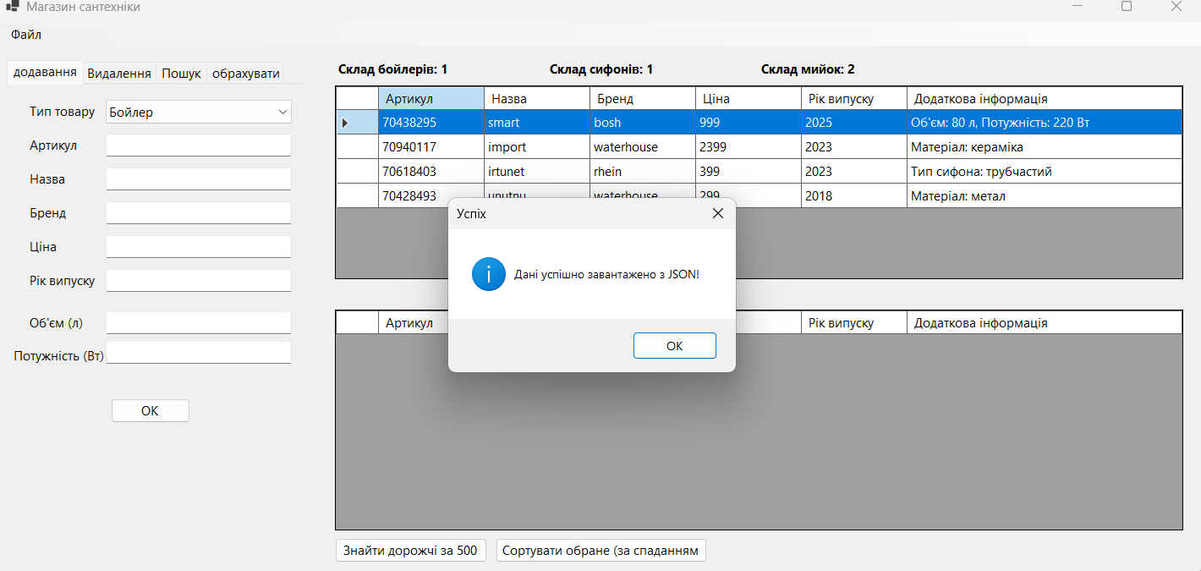

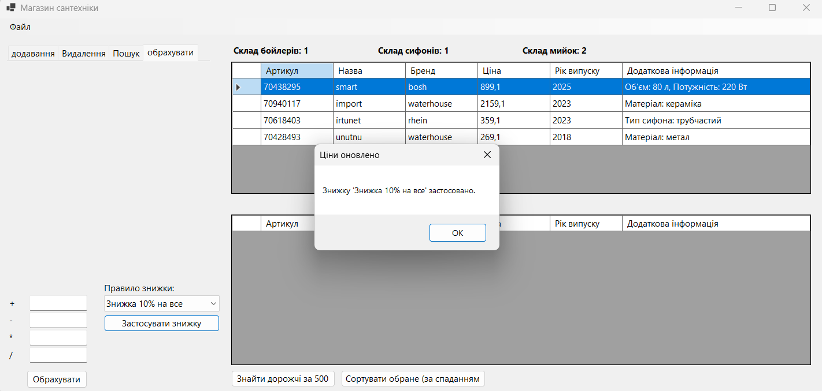
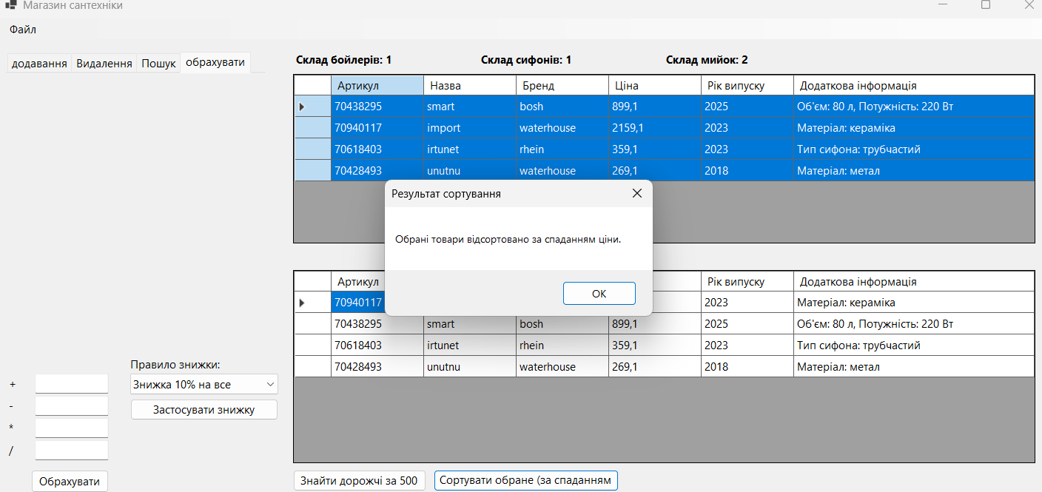
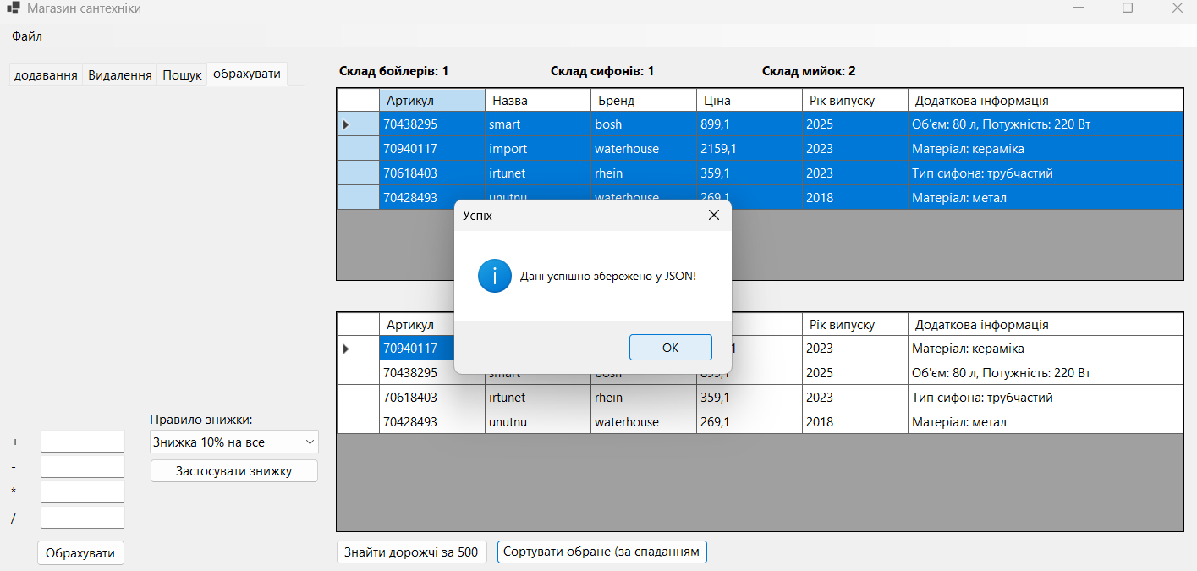

Висновок: вивчено використання просторів імен, підключення просторів імен та використання для них псевдонімів. Ознайомлено та вивчено використання функцій розширення, часткових класів та часткових методів. Вивчено обробку винятків.

