Лаболаторна робота №6

Тема. Делегати.

Мета. Одержати практичні навички створення та роботи з делегатами.

Делегат – особливий вид класу, який зберігає посилання на методи

Делегат – клас (контрольний тип), який інкапсулює (містить в собі) метод з вказаною сигнатурою і повертаємим типом

Завдання: Розширити програму із ЛР5 використовуючи делегати.
Об’єктна модель:

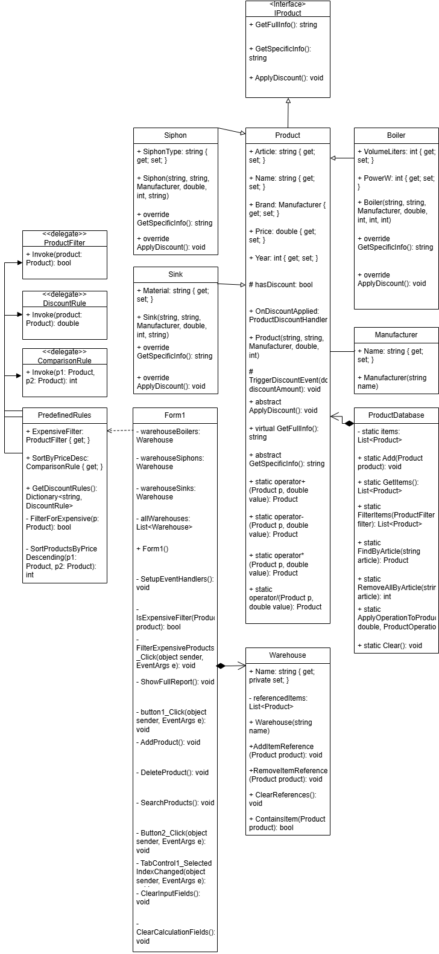
Лістинг:
using lab6C_;
using System;
using System.Collections.Generic;
using System.Globalization;
using System.IO;
using System.Linq;
using System.Reflection.Emit;
using System.Text;
using System.Windows.Forms;
using static System.Windows.Forms.VisualStyles.VisualStyleElement;

namespace lab6C_
{
public partial class Form1 : Form
{
private Warehouse warehouseBoilers;
private Warehouse warehouseSiphons;
private Warehouse warehouseSinks;
private List<Warehouse> allWarehouses;

private Dictionary<string, DiscountRule> discountRules;

public Form1()
{
InitializeComponent();
SetupEventHandlers();

warehouseBoilers = new Warehouse("Склад бойлерів");
warehouseSiphons = new Warehouse("Склад сифонів");
warehouseSinks = new Warehouse("Склад мийок");
allWarehouses = new List<Warehouse> { warehouseBoilers, warehouseSiphons, warehouseSinks };

warehouseBoilers.WarehouseChanged += OnWarehouseChanged;
warehouseSiphons.WarehouseChanged += OnWarehouseChanged;
warehouseSinks.WarehouseChanged += OnWarehouseChanged;

discountRules = PredefinedRules.GetDiscountRules();

cmbDiscountRule.Items.AddRange(discountRules.Keys.ToArray());
cmbDiscountRule.SelectedIndex = 0;

UpdateWarehouseCounters();
}

private void SetupEventHandlers()
{
this.Load += Form1_Load;
tabControl1.SelectedIndexChanged += TabControl1_SelectedIndexChanged;
comboBoxType.SelectedIndexChanged += ComboBoxType_SelectedIndexChanged;
button1.Click += button1_Click;
button2.Click += Button2_Click;

зберегтиToolStripMenuItem.Click += зберегтиToolStripMenuItem_Click;
відкритиToolStripMenuItem.Click += відкритиToolStripMenuItem_Click;

ToolStripMenuItem reportMenuItem = new ToolStripMenuItem("Повний звіт");
reportMenuItem.Click += (sender, e) => ShowFullReport();
файлToolStripMenuItem.DropDownItems.Add(reportMenuItem);

textBox1.KeyPress += Article_KeyPress;
textBox3.KeyPress += Brand_KeyPress;
textBox4.KeyPress += Price_KeyPress;
textBox5.KeyPress += Year_KeyPress;

btnFilterExpensive.Click += BtnFilterExpensive_Click;
btnSortSelected.Click += BtnSortSelected_Click;
btnApplyDiscount.Click += BtnApplyDiscount_Click;
}

private void OnWarehouseChanged(object sender, EventArgs e)
{
UpdateWarehouseCounters();
}

private void UpdateWarehouseCounters()
{
lblWarehouseBoilers.Text = $"Склад бойлерів: {warehouseBoilers.GetItemCount()}";
lblWarehouseSiphons.Text = $"Склад сифонів: {warehouseSiphons.GetItemCount()}";
lblWarehouseSinks.Text = $"Склад мийок: {warehouseSinks.GetItemCount()}";
}

private void ShowFullReport()
{
List<Product> allProducts = ProductDatabase.GetItems();
List<Warehouse> allWarehouses = this.allWarehouses;

StringBuilder report = new StringBuilder();
report.AppendLine($"--- ПОВНИЙ ЗВІТ ПО ТОВАРАХ ---");
report.AppendLine($"Всього у базі: {allProducts.Count} позицій.\n");

foreach (var product in allProducts)
{
report.Append($"[Товар]: {product.GetFullInfo()}\n");

string warehouseInfo = " -> Знаходиться на складах: ";
int count = 0;
foreach (var warehouse in allWarehouses)
{
if (warehouse.ContainsItem(product))
{
warehouseInfo += $"{warehouse.Name}; ";
count++;
}
}

if (count == 0) warehouseInfo += "Немає на жодному складі.";

report.AppendLine(warehouseInfo + "\n");
}

Form reportForm = new Form();
reportForm.Text = "Повний звіт";
reportForm.Size = new System.Drawing.Size(600, 400);

System.Windows.Forms.TextBox reportTextBox = new System.Windows.Forms.TextBox();

reportTextBox.Multiline = true;
reportTextBox.ScrollBars = ScrollBars.Vertical;
reportTextBox.Dock = DockStyle.Fill;
reportTextBox.Font = new System.Drawing.Font("Consolas", 10F);
reportTextBox.Text = report.ToString();
reportForm.Controls.Add(reportTextBox);
reportForm.ShowDialog();
}

private void button1_Click(object sender, EventArgs e)
{
string selectedTab = tabControl1.SelectedTab.Text;

if (selectedTab == "додавання") AddProduct();
else if (selectedTab == "Видалення") DeleteProduct();
else if (selectedTab == "Пошук") SearchProducts();
ClearInputFields();
}

private void AddProduct()
{
if (!double.TryParse(textBox4.Text.Trim().Replace(',', '.'), NumberStyles.Any, CultureInfo.InvariantCulture, out double price) ||
!int.TryParse(textBox5.Text.Trim(), out int year))
{
MessageBox.Show("Заповніть коректно ціну та рік!", "Помилка валідації", MessageBoxButtons.OK, MessageBoxIcon.Warning);
return;
}

Product newProduct = null;
Warehouse targetWarehouse = null;

try
{
string brandName = textBox3.Text;
if (string.IsNullOrWhiteSpace(brandName))
{
MessageBox.Show("Поле 'Бренд' не може бути порожнім.", "Помилка валідації", MessageBoxButtons.OK, MessageBoxIcon.Warning);
return;
}
Manufacturer manufacturer = new Manufacturer(brandName);

switch (comboBoxType.SelectedItem.ToString())
{
case "Бойлер":
newProduct = new Boiler(textBox1.Text, textBox2.Text, manufacturer, price, year, int.Parse(textBoxVolume.Text), int.Parse(textBoxPower.Text));
targetWarehouse = warehouseBoilers;
break;
case "Сифон":
newProduct = new Siphon(textBox1.Text, textBox2.Text, manufacturer, price, year, textBoxSiphonType.Text);
targetWarehouse = warehouseSiphons;
break;
case "Мийка":
newProduct = new Sink(textBox1.Text, textBox2.Text, manufacturer, price, year, textBoxMaterial.Text);
targetWarehouse = warehouseSinks;
break;
}

if (newProduct != null)
{
ProductDatabase.Add(newProduct);
targetWarehouse.AddItemReference(newProduct);
UpdateDataGridView(ProductDatabase.GetItems());
}
}
catch (Exception ex)
{
MessageBox.Show("Помилка даних: " + ex.Message, "Помилка", MessageBoxButtons.OK, MessageBoxIcon.Error);
}
}

private void DeleteProduct()
{
string article = textBox1.Text.Trim();
if (string.IsNullOrWhiteSpace(article))
{
MessageBox.Show("Введіть артикул для видалення.", "Інформація", MessageBoxButtons.OK, MessageBoxIcon.Information);
return;
}

Product productToRemove = ProductDatabase.FindByArticle(article);

if (productToRemove != null)
{
foreach (var warehouse in allWarehouses)
{
warehouse.RemoveItemReference(productToRemove);
}

ProductDatabase.RemoveAllByArticle(article);

UpdateDataGridView(ProductDatabase.GetItems());
MessageBox.Show("Товар успішно видалено.", "Успіх", MessageBoxButtons.OK, MessageBoxIcon.Information);
}
else
{
MessageBox.Show("Товар з таким артикулом не знайдено.", "Помилка", MessageBoxButtons.OK, MessageBoxIcon.Warning);
}
}

// 1
private List<Product> FindProducts(ProductFilter filter)
{
List<Product> results = new List<Product>();
foreach (Product p in ProductDatabase.GetItems())
{

if (filter(p))
{
results.Add(p);
}
}
return results;
}

private void BtnFilterExpensive_Click(object sender, EventArgs e)
{
// 1
var results = FindProducts(PredefinedRules.ExpensiveFilter);

UpdateDataGridView(results, isSearchResult: true);
MessageBox.Show($"Знайдено {results.Count} товарів дорожчих за 500 грн.", "Результат фільтрації");
}
private void SearchProducts()
{
string article = textBox1.Text.Trim();
string name = textBox2.Text.Trim();

List<Product> results = new List<Product>();

foreach (Product p in ProductDatabase.GetItems())
{
if ((string.IsNullOrWhiteSpace(article) || p.Article.StartsWith(article, StringComparison.OrdinalIgnoreCase)) &&
(string.IsNullOrWhiteSpace(name) || p.Name.Contains(name, StringComparison.OrdinalIgnoreCase)))
{
results.Add(p);
}
}

UpdateDataGridView(results, isSearchResult: true);
}

// 3
private void BtnSortSelected_Click(object sender, EventArgs e)
{
if (dataGridView1.SelectedRows.Count == 0)
{
MessageBox.Show("Оберіть один або декілька рядків у головній таблиці.", "Інформація", MessageBoxButtons.OK, MessageBoxIcon.Information);
return;
}

List<Product> selectedProducts = new List<Product>();
foreach (DataGridViewRow row in dataGridView1.SelectedRows)
{
string article = row.Cells[0].Value.ToString();
Product product = ProductDatabase.FindByArticle(article);
if (product != null)
{
selectedProducts.Add(product);
}
}

// 3
ComparisonRule customRule = PredefinedRules.SortByPriceDesc;

Comparison<Product> netComparison = new Comparison<Product>(customRule);

selectedProducts.Sort(netComparison);

UpdateDataGridView(selectedProducts, isSearchResult: true);
MessageBox.Show("Обрані товари відсортовано за спаданням ціни.", "Результат сортування");
}

// 2
private void BtnApplyDiscount_Click(object sender, EventArgs e)
{
if (dataGridView1.SelectedRows.Count == 0)
{
MessageBox.Show("Оберіть один або декілька рядків у головній таблиці.", "Інформація", MessageBoxButtons.OK, MessageBoxIcon.Information);
return;
}

string selectedRuleName = cmbDiscountRule.SelectedItem.ToString();

// 2
DiscountRule selectedRule = discountRules[selectedRuleName];

foreach (DataGridViewRow row in dataGridView1.SelectedRows)
{
string article = row.Cells[0].Value.ToString();
Product product = ProductDatabase.FindByArticle(article);
if (product != null)
{
// 2
product.Price = selectedRule(product);
}
}

UpdateDataGridView(ProductDatabase.GetItems());
MessageBox.Show($"Знижку '{selectedRuleName}' застосовано.", "Ціни оновлено");
}

private void Button2_Click(object sender, EventArgs e)
{
if (dataGridView1.SelectedRows.Count == 0)
{
MessageBox.Show("Оберіть один або декілька рядків у таблиці для обрахунку.", "Інформація", MessageBoxButtons.OK, MessageBoxIcon.Information);
return;
}

foreach (DataGridViewRow row in dataGridView1.SelectedRows)
{
string article = row.Cells[0].Value.ToString();
Product product = ProductDatabase.FindByArticle(article);
if (product == null) continue;

if (double.TryParse(textBox6.Text.Replace(',', '.'), NumberStyles.Any, CultureInfo.InvariantCulture, out double valPlus)) product += valPlus;
if (double.TryParse(textBox7.Text.Replace(',', '.'), NumberStyles.Any, CultureInfo.InvariantCulture, out double valMinus)) product -= valMinus;
if (double.TryParse(textBox8.Text.Replace(',', '.'), NumberStyles.Any, CultureInfo.InvariantCulture, out double valMul)) product *= valMul;
if (double.TryParse(textBox9.Text.Replace(',', '.'), NumberStyles.Any, CultureInfo.InvariantCulture, out double valDiv)) product /= valDiv;
}

UpdateDataGridView(ProductDatabase.GetItems());
ClearCalculationFields();
}

private void зберегтиToolStripMenuItem_Click(object sender, EventArgs e)
{
SaveFileDialog sfd = new SaveFileDialog { Filter = "CSV Files|*.csv|All Files|*.*" };
if (sfd.ShowDialog() == DialogResult.OK)
{
using (StreamWriter sw = new StreamWriter(sfd.FileName))
{
foreach (Product p in ProductDatabase.GetItems())
{
string type = p.GetType().Name;
string line = $"{type};{p.Article};{p.Name};{p.Brand.Name};{p.Price};{p.Year}";
if (p is Boiler b) line += $";{b.VolumeLiters};{b.PowerW}";
if (p is Siphon s) line += $";{s.SiphonType}";
if (p is Sink sk) line += $";{sk.Material}";
sw.WriteLine(line);
}
}
}
}

private void відкритиToolStripMenuItem_Click(object sender, EventArgs e)
{
OpenFileDialog ofd = new OpenFileDialog { Filter = "CSV Files|*.csv|All Files|*.*" };
if (ofd.ShowDialog() == DialogResult.OK)
{
ProductDatabase.Clear();
foreach (var wh in allWarehouses) wh.ClearReferences();

string[] lines = File.ReadAllLines(ofd.FileName);
foreach (string line in lines)
{
string[] parts = line.Split(';');
if (parts.Length < 6) continue;

try
{
string type = parts[0];
string article = parts[1];
string name = parts[2];
string brandName = parts[3];
double price = double.Parse(parts[4], CultureInfo.InvariantCulture);
int year = int.Parse(parts[5]);

Manufacturer manufacturer = new Manufacturer(brandName);

Product p = null;
if (type == "Boiler" && parts.Length >= 8) p = new Boiler(article, name, manufacturer, price, year, int.Parse(parts[6]), int.Parse(parts[7]));
else if (type == "Siphon" && parts.Length >= 7) p = new Siphon(article, name, manufacturer, price, year, parts[6]);
else if (type == "Sink" && parts.Length >= 7) p = new Sink(article, name, manufacturer, price, year, parts[6]);

if (p != null)
{
ProductDatabase.Add(p);

if (p is Boiler) warehouseBoilers.AddItemReference(p);
else if (p is Siphon) warehouseSiphons.AddItemReference(p);
else if (p is Sink) warehouseSinks.AddItemReference(p);
}
}
catch (Exception ex)
{
MessageBox.Show($"Помилка читання рядка: {line}\nДеталі: {ex.Message}", "Помилка файлу");
}
}
UpdateDataGridView(ProductDatabase.GetItems());
}
}

#region Helper and UI Methods
private void Form1_Load(object sender, EventArgs e)
{
comboBoxType.Items.Clear();
comboBoxType.Items.AddRange(new string[] { "Бойлер", "Сифон", "Мийка" });
comboBoxType.SelectedIndex = 0;
TabControl1_SelectedIndexChanged(null, null);
}

private void TabControl1_SelectedIndexChanged(object sender, EventArgs e)
{
string selectedTab = tabControl1.SelectedTab.Text;
bool isCalculationTab = selectedTab == "обрахувати";

ShowHideMainControls(!isCalculationTab);
ShowHideArithmetic(isCalculationTab);
}

private void ComboBoxType_SelectedIndexChanged(object sender, EventArgs e)
{
string selectedType = comboBoxType.SelectedItem.ToString();
panelBoiler.Visible = selectedType == "Бойлер";
panelSiphon.Visible = selectedType == "Сифон";
panelSink.Visible = selectedType == "Мийка";
}

private void UpdateDataGridView(List<Product> products, bool isSearchResult = false)
{
DataGridView dgv = isSearchResult ? dataGridView2 : dataGridView1;
dgv.Rows.Clear();
foreach (Product p in products)
{
dgv.Rows.Add(p.Article, p.Name, p.Brand.Name, p.Price, p.Year, p.GetSpecificInfo());
}
}
private void ShowHideArithmetic(bool show)
{
label6.Visible = label7.Visible = label8.Visible = label9.Visible = show;
textBox6.Visible = textBox7.Visible = textBox8.Visible = textBox9.Visible = show;
button2.Visible = show;

labelDiscount.Visible = show;
cmbDiscountRule.Visible = show;
btnApplyDiscount.Visible = show;
}

private void ShowHideMainControls(bool show)
{
label1.Visible = label2.Visible = label3.Visible = label4.Visible = label5.Visible = show;
textBox1.Visible = textBox2.Visible = textBox3.Visible = textBox4.Visible = textBox5.Visible = show;
button1.Visible = show;
labelType.Visible = comboBoxType.Visible = show;
panelBoiler.Visible = show && comboBoxType.SelectedItem?.ToString() == "Бойлер";
panelSiphon.Visible = show && comboBoxType.SelectedItem?.ToString() == "Сифон";
panelSink.Visible = show && comboBoxType.SelectedItem?.ToString() == "Мийка";
}

private void ClearInputFields()
{
textBox1.Clear();
textBox2.Clear();
textBox3.Clear();
textBox4.Clear();
textBox5.Clear();
textBoxVolume.Clear();
textBoxPower.Clear();
textBoxSiphonType.Clear();
textBoxMaterial.Clear();
}

private void ClearCalculationFields()
{
textBox6.Clear();
textBox7.Clear();
textBox8.Clear();
textBox9.Clear();
}
#endregion

#region KeyPress Validation
private void Article_KeyPress(object sender, KeyPressEventArgs e)
{
if (!char.IsControl(e.KeyChar) && !char.IsDigit(e.KeyChar)) e.Handled = true;
}
private void Brand_KeyPress(object sender, KeyPressEventArgs e)
{
if (!char.IsControl(e.KeyChar) && !char.IsLetter(e.KeyChar) && e.KeyChar != ' ') e.Handled = true;
}
private void Price_KeyPress(object sender, KeyPressEventArgs e)
{
if (!char.IsControl(e.KeyChar) && !char.IsDigit(e.KeyChar) && e.KeyChar != ',' && e.KeyChar != '.') e.Handled = true;
if ((e.KeyChar == ',' || e.KeyChar == '.') && (sender as System.Windows.Forms.TextBox).Text.Contains(",")) e.Handled = true;
}
private void Year_KeyPress(object sender, KeyPressEventArgs e)
{
if (!char.IsControl(e.KeyChar) && !char.IsDigit(e.KeyChar)) e.Handled = true;
}
#endregion
}
}
Delegates.cs:
using System;
using System.Collections.Generic;

namespace lab6C_
{

// 1
public delegate bool ProductFilter(Product product);
// 2
public delegate double DiscountRule(Product product);
// 3
public delegate int ComparisonRule(Product p1, Product p2);

public static class PredefinedRules
{

// 1
public static ProductFilter ExpensiveFilter { get; }

// 2
public static Dictionary<string, DiscountRule> GetDiscountRules()
{
return new Dictionary<string, DiscountRule>
{
{ "Знижка 10% на все", ApplyDiscount_10_Percent_All },
{ "Знижка 15% на Бойлери", ApplyDiscount_15_Percent_Boilers },
{ "Знижка 5% на Мийки", ApplyDiscount_5_Percent_Sinks }
};
}

// 3
public static ComparisonRule SortByPriceDesc { get; }

static PredefinedRules()
{
ExpensiveFilter = FilterForExpensive;

SortByPriceDesc = SortProductsByPriceDescending;
}

// 1
private static bool FilterForExpensive(Product p)
{
if (p.Price > 500)
{
return true;
}
else
{
return false;
}
}

// 2
private static double ApplyDiscount_10_Percent_All(Product p)
{
return p.Price * 0.90;
}

private static double ApplyDiscount_15_Percent_Boilers(Product p)
{
if (p is Boiler)
{
return p.Price * 0.85;
}
else
{
return p.Price;
}
}

private static double ApplyDiscount_5_Percent_Sinks(Product p)
{
if (p is Sink)
{
return p.Price * 0.95;
}
else
{
return p.Price;
}
}

// 3
private static int SortProductsByPriceDescending(Product p1, Product p2)
{
return p2.Price.CompareTo(p1.Price);
}
}
}
Warehouse.cs:

using lab6C_;
using System;
using System.Collections.Generic;

namespace lab6C_
{
public class Warehouse
{
public string Name { get; private set; }
private List<Product> referencedItems;

public event EventHandler WarehouseChanged;

public Warehouse(string name)
{
Name = name;
referencedItems = new List<Product>();
}

public void AddItemReference(Product product)
{
if (product != null && !referencedItems.Contains(product))
{
referencedItems.Add(product);

WarehouseChanged?.Invoke(this, EventArgs.Empty);
}
}

public void RemoveItemReference(Product product)
{
if (product != null)
{

if (referencedItems.Remove(product))
{

WarehouseChanged?.Invoke(this, EventArgs.Empty);
}
}
}

public void ClearReferences()
{
if (referencedItems.Count > 0)
{
referencedItems.Clear();

WarehouseChanged?.Invoke(this, EventArgs.Empty);
}
}

public bool ContainsItem(Product product)
{
return referencedItems.Contains(product);
}

public int GetItemCount()
{
return referencedItems.Count;
}
}
}
Siphon.cs:

using lab6C_;

namespace lab6C_
{
public class Siphon : Product
{
public string SiphonType { get; set; }

public Siphon(string article, string name, Manufacturer brand, double price, int year, string type)
: base(article, name, brand, price, year)
{
SiphonType = type;
}

public override string GetSpecificInfo()
{
return $"Тип сифона: {SiphonType}";
}
}
}
Sink.cs:

using lab6C_;

namespace lab6C_
{
public class Sink : Product
{
public string Material { get; set; }

public Sink(string article, string name, Manufacturer brand, double price, int year, string material)
: base(article, name, brand, price, year)
{
Material = material;
}

public override string GetSpecificInfo()
{
return $"Матеріал: {Material}";
}
}
}
Boiler.cs:

using lab6C_;

namespace lab6C_
{
public class Boiler : Product
{
public int VolumeLiters { get; set; }
public int PowerW { get; set; }

public Boiler(string article, string name, Manufacturer brand, double price, int year, int volume, int power)
: base(article, name, brand, price, year)
{
VolumeLiters = volume;
PowerW = power;
}

public override string GetSpecificInfo()
{
return $"Об'єм: {VolumeLiters} л, Потужність: {PowerW} Вт";
}
}
}
ProductDatabase.cs:

using lab6C_;
using System.Collections.Generic;
using System.Linq;

namespace lab6C_
{
public static class ProductDatabase
{
private static List<Product> items = new List<Product>();

public static void Add(Product product)
{
items.Add(product);
}

public static List<Product> GetItems()
{
return new List<Product>(items);
}

public static Product FindByArticle(string article)
{
return items.FirstOrDefault(p => p.Article.Equals(article, System.StringComparison.OrdinalIgnoreCase));
}

public static int RemoveAllByArticle(string article)
{
return items.RemoveAll(p => p.Article.Equals(article, System.StringComparison.OrdinalIgnoreCase));
}

public static void Clear()
{
items.Clear();
}
}
}
Product.cs:

using lab6C_;

namespace lab6C_
{
public abstract class Product : IProduct
{
public string Article { get; set; }
public string Name { get; set; }
public Manufacturer Brand { get; set; }
public double Price { get; set; }
public int Year { get; set; }

public Product(string article, string name, Manufacturer brand, double price, int year)
{
Article = article;
Name = name;
Brand = brand;
Price = price;
Year = year;
}

public virtual string GetFullInfo()
{
return $"Артикул: {Article}, Назва: {Name}, Бренд: {Brand.Name}, Ціна: {Price:F2} грн, Рік: {Year}";
}

public abstract string GetSpecificInfo();

public static Product operator +(Product p, double value)
{
p.Price += value;
return p;
}
public static Product operator -(Product p, double value)
{
p.Price = (p.Price - value > 0) ? p.Price - value : 0;
return p;
}
public static Product operator *(Product p, double value)
{
p.Price *= value;
return p;
}
public static Product operator /(Product p, double value)
{
if (value != 0) p.Price /= value;
return p;
}
}
}
Manafacturer.cs:
namespace lab6C_
{
public class Manufacturer
{
public string Name { get; set; }
public Manufacturer(string name)
{
Name = name;
}
}
}
IProduct.cs:
namespace lab6C_
{
public interface IProduct
{

public string GetFullInfo();
public string GetSpecificInfo();

}
}
Контрольний тестовий набір:
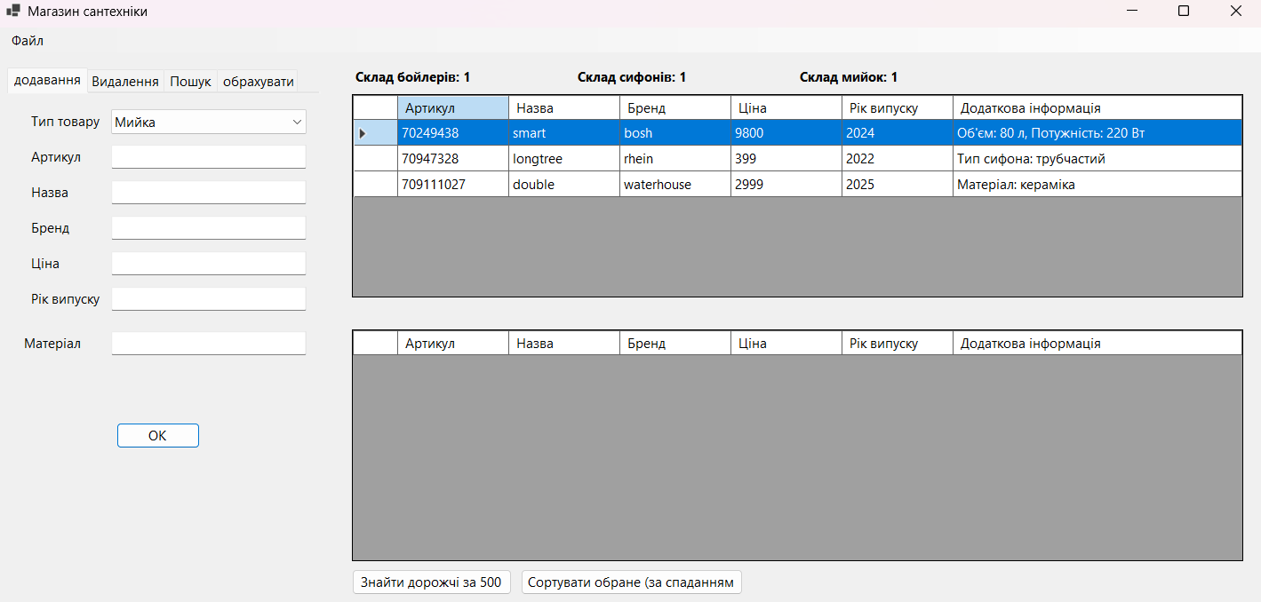
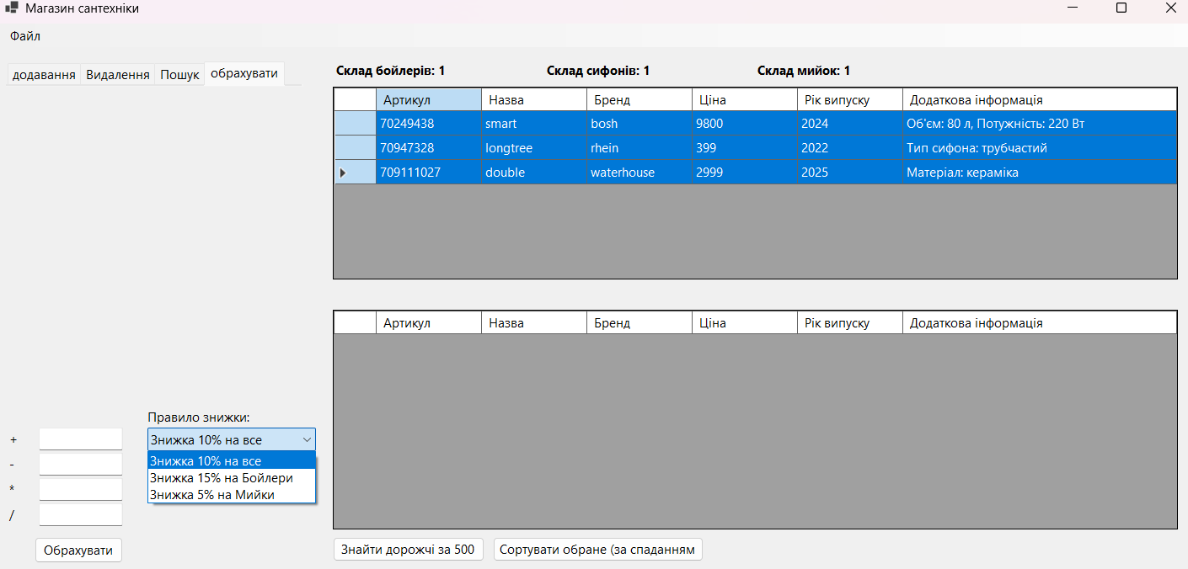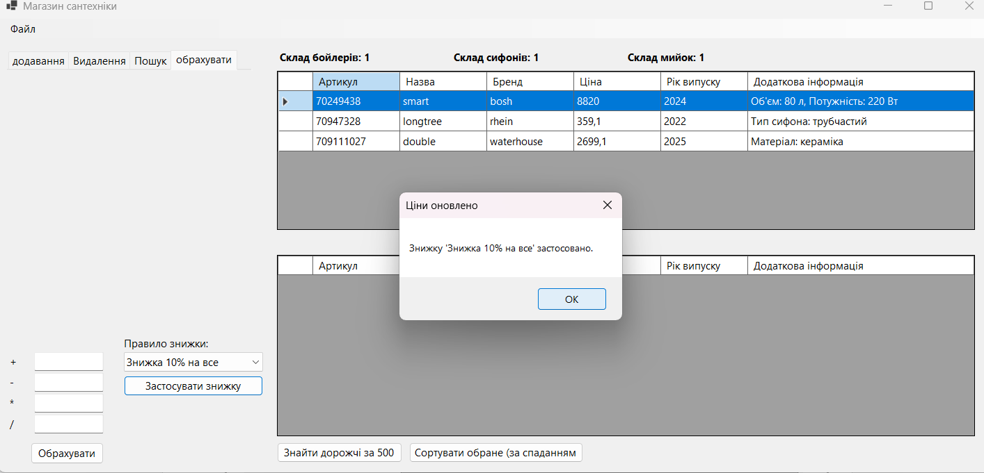
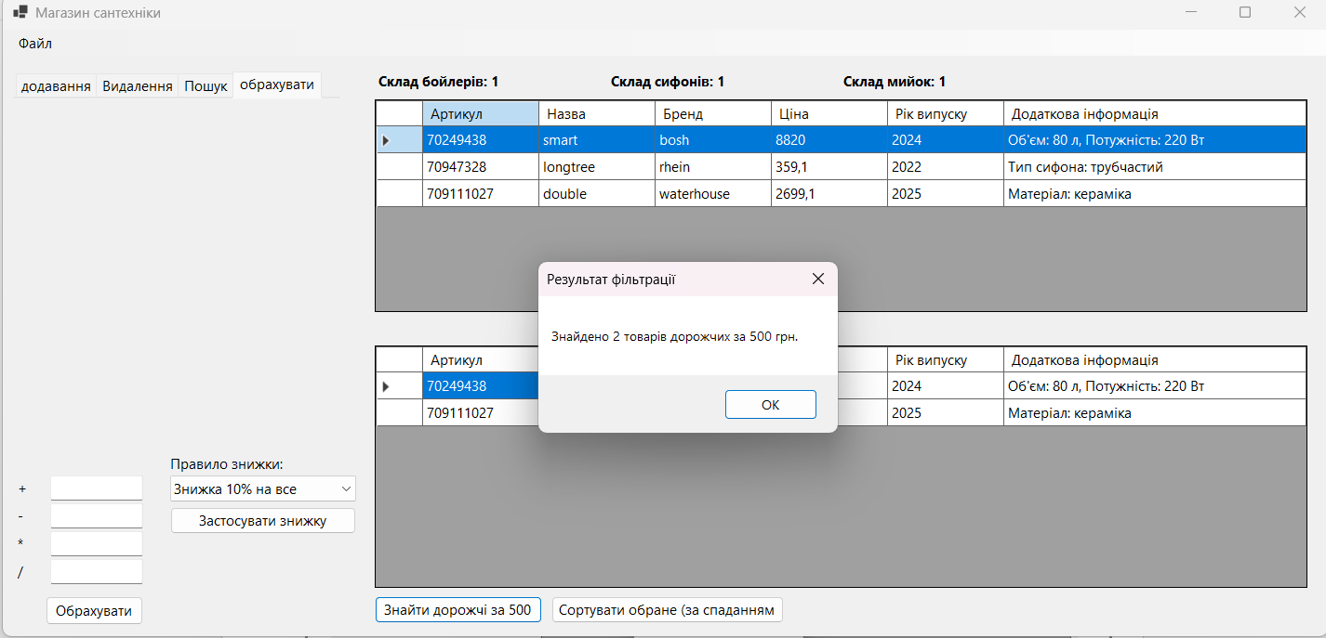
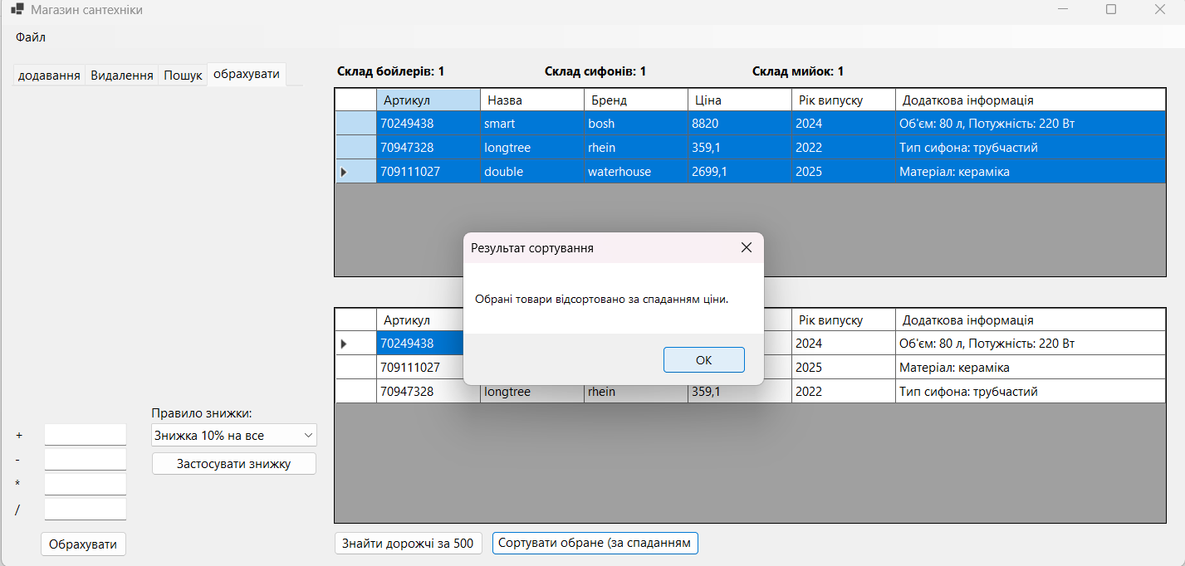

Висновок:
Засвоєно роботу із делегатами та їх використання, а саме реалізація патерну “Спостерігач”, використання мультиделегата, делегата для вибору методів делегування, делегата, як обробника подій та делегату, як зворотній виклик функції а також засвоєно використання стандартних делегатів.

