# **MICHAEL RITCHIE:** 2.0 Professional Spotlight

**Degree:** Web Design & Development

**Class Number:** 201510-13

## **VIDEO #1:** The next web

**Degree:** Web Design & Development

**URL:** <http://www.ted.com/talks/tim_berners_lee_on_the_next_web>

Having not previously known of Tim Beners-Lee I was taken aback by his neurotic and excited jaunt performed across the stage. I then came to register that he is the founding father for the World Wide Web, commonly known as www. Settling into his fast pace I realized that this was a brilliant man sharing important data. He was originally faced with the challenge of multiple computing languages, Tim then met this challenge with the first communication of data using a hypertext transfer protocol, abbreviated as HTTP. Using these hyperlinks raw data then began to compile and form the internet. The World Wide Web has grown into a giant mass of multiple types of data that link within each other. This network comprises enterprising data, government data, weather data, personal data, scientific data and so many other forms of data. Hearing this explanation of the creation of the World Wide Web was very informative, as I plan to progress into the field of web design & development.

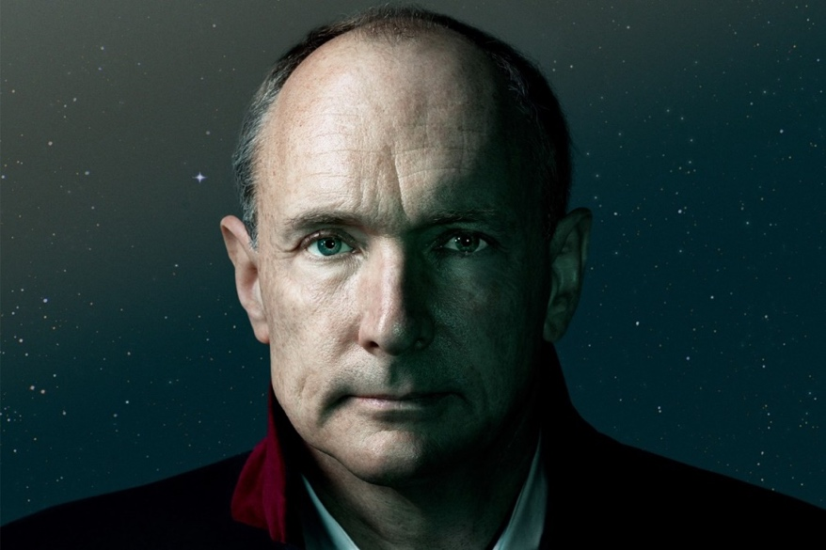

## **VIDEO #2:** How to "sketch" with electronics

**Degree:** Graphic Design

**URL:** <http://www.ted.com/talks/leah_buechley_how_to_sketch_with_electronics>

Leah Buechley is an electrical engineer in search of a fluid way to design electronics. Her response to this challenge was met through the use of magnetic electronic pieces, ferrous paper and an electronic pen. With these tools she sketched whimsical lines that created a circuit for a LED light, a piano-like note player, and numerous electronic popables, which in a sense are interactive popup circuits. I found this to be an excellent use of ingenuity, incorporating graphic design & electrical engineering. Contrasting and marrying these two disciplines has created a progressive way of tackling electronics and circuits. Making this type of technology readily available is an enjoyable and enticing way to generate interest in design. Moving forward I would enjoy attending one of these held workshops and trying first hand this innovate technology.

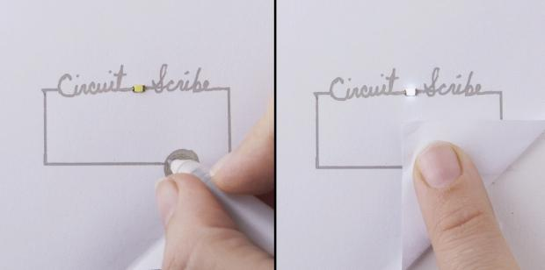

## **VIDEO #3:** Doodlers, unite!

**Degree:** Digital Arts and Design

**URL:** <http://www.ted.com/talks/sunni_brown#t-12015>

Sunni Brown delves deep into the history and definition of doodling. What she has stumbled upon was a long legacy of negative connotations akin to doing nothing. She counters this definition with the idea of doodling being spontaneous marks that help you process thoughts. She then further dismantles and demystifies this myth of doodles being nonfunctional and nonproductive using the explanation of our society being focused on verbal data. I found her presentation resonating, as I consider myself a serial doodler since childhood. Since youth during class and similar activities I found myself doodling, it was a way to help my brain process information. To this day I still doodle but have since upgraded from just paper and pen, while I still use these old mediums I have since expanded to graphic programs such as Illustrator. Using this tool of doodling I not only process information more efficiently but I get inspired from the free flow of thought produced while creating and drawing. Below is a simple doodle I created in illustrator recently, there is not a purpose for the drawing but it was an excellent form of nonverbal communication.



## **VIDEO #4:** How we see color

**Degree:** Graphic Design

**URL:** <http://ed.ted.com/lessons/how-we-see-color-colm-kelleher#review>

Colm Kelleher does an excellent job of explaining light waves and the physical properties that belong to them and how our eyes view these properties. Human eyes contain cones which react to different light waves and signal the correspondent colors to the brain when triggered. The human eye also contains rods which can only send a signal of light or no light, thus in low light settings these rods take over and no color is visible. Colm then further physically explains how we view mixed colors such as yellow, when the green and red cones are both signaling colors to the brain. I found this to be a very enlightening presentation as the way colors and light waves are physically perceived was explained in simple terms and I have now a better grasp of color theory and color interactions, which I can put to use in my further endeavors.

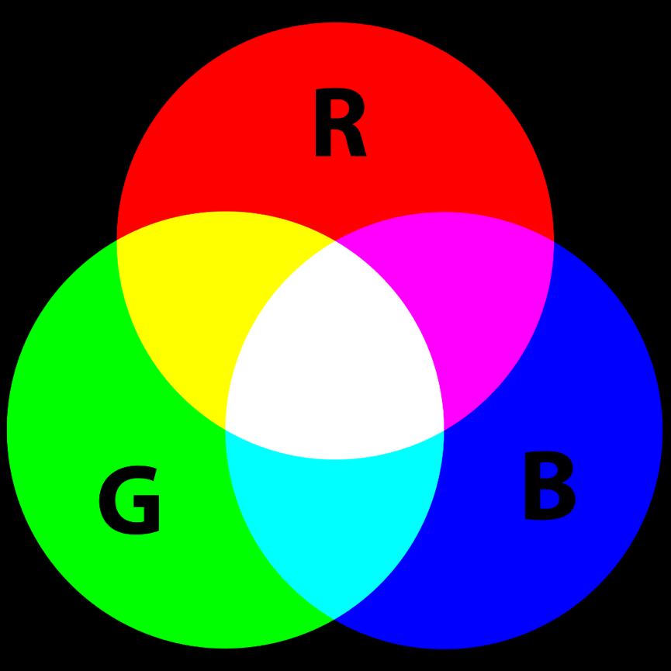

# **apa sources**

Tim Berners-Lee Photograph. Retrieved from <http://www.wired.co.uk/magazine/archive/2014/03/web-at-25/tim-berners-lee>

Conductive Pen Photograph. Retrieved from <http://www.tweaktown.com/news/34119/circuit-scribe-is-a-rollerball-pen-that-writes-in-conductive-ink/index.html>

Primary Color Interactions. Retrieved from <https://en.wikipedia.org/wiki/Color_theory>