Visual Analysis

*Michael Ritchie*

*Art History – Online*

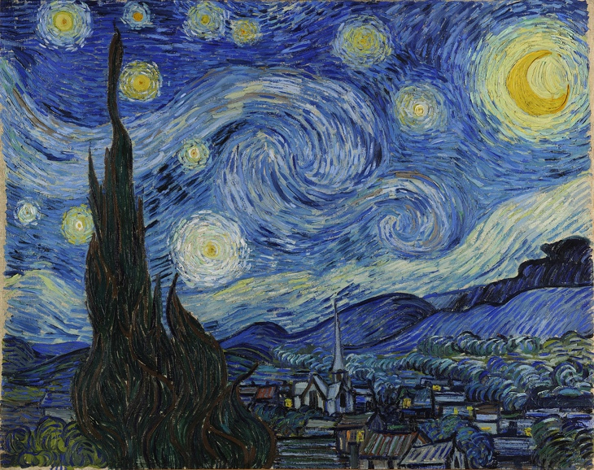

The Starry Night was painted by Vincent Van Gogh in 1889 during the Post-Impressionism movement. The medium for this painting was oil on canvas with the physical dimensions of 921 x 737 mm. The subject of this painting depicts the night sky illuminated with stars basking over rolling hills, a cypress tree, and a village.

The key formal elements within The Starry Night are line and color. Van Gogh painted smooth brush strokes throughout this work creating many fluid lines. These lines are thick, rounded, and smooth, and give the impression of motion. A viewer’s eye is constantly shifting, tracking these lines to their final destination, only to be kept in continual motion. Assisting the smooth lines within this painting is Van Gogh’s choice of color. The bright yellows and whites draw attention to an energetic and bustling night sky, while below the village is basked in darker blues and greys signifying a peaceful and silent town. Connecting these two elements is the dark grey, yet almost black cypress tree.

The prominent principles of design of this painting are movement and unity. The movement of this piece starts at the cypress tree. The viewer is then lead up to the swirling clouds and stars of the night sky and then follows the aquatic-like lines back down to the rolling hills of the village, only to follow the cypress tree back up to the night sky creating an infinite continuum. The principle of unity is harmonious within this piece due to this constant motion, uniform line thickness, and colors used throughout the painting.

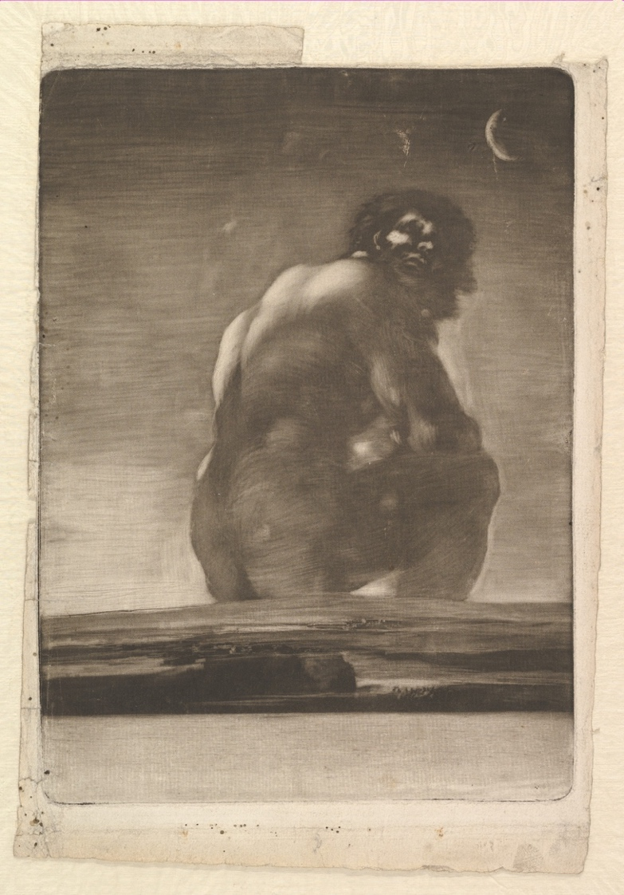

A Giant Seated in a Landscape was created by Francisco de Goya in 1818. The medium for this print was burnished aquatint that contains strokes of lavis that are both on top of, and within the landscape. The physical dimensions of this print are 28.4 x 20.8 cm. Depicted is a colossal man seated on top of a flat landscape, with head affixed backwards. The other notable feature within this piece is the crescent moon above the giant’s head.

The key formal elements within this print are color and line. There are no primary colors present within this print, only numerous tints and shades of black and white. Through the absence of color, the mood and tone of the piece is made heavy and serious. Half of the giant’s face is illuminated, revealing a somewhat perplexing complexion. His body and the moon are crafted from curved organic lines that stand out amongst the horizontal lines of the sky. Continuing his use of horizontal lines Francisco crafted the land that the giant sits upon closer to the viewer using both color and choppy horizontal lines.

The main principles of design within A Giant Seated in a Landscape are emphasis and rhythm. The giant is emphasized to the viewer’s eye being the only organic figure within the print. He is the dominant visual element within the piece, standing out against the blank horizontal sky. The land beneath the giant is emphasized as being closer to the viewer, while the sky and moon are recessed within the background. The use of the repeated horizontal lines creates a flat movement to the sky and land generating a rhythm within the piece. This rhythm further allows the emphasis to be placed upon the giant.

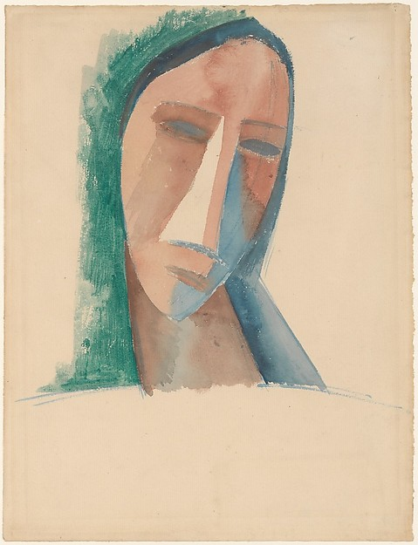

Head of a Woman was created by Pablo Picasso in 1908. The medium for this drawing was watercolor on paper. The physical dimensions of this drawing are 31.8 x 24.1 cm. The subject for this abstract drawing is of a woman’s head and eventually served as the study for the painting The Dryad.

The prominent formal elements of this drawing are color and shape. The colors employed by Picasso are drab, conveying the emotion of sadness. The peachy skin of the women is juxtaposed with greenish hair surrounding her head. A blue-green stain on the right side of her face is tear-like in color, further solidifying the somber mood of the drawing. The woman’s face is composed of numerous abstract geometric shapes. The highlight of her nose is in the shape of a triangle, and her eyes and mouth are both slanted down and meet with the tear-like blot, assisting in the gloomy atmosphere of the piece.

The key principles of design within Head of a Woman are balance and unity. An asymmetrical balance is shown within this piece with the woman’s head slightly skewed to the right. This asymmetry emphasizes the woman’s large abstract nose as the focal point of the drawing. While the woman is torso-less, there is still a sense of unity amongst the shapes and colors of the drawing. The solemn mood is completed by these abstract elements.

**References**

van Gogh, V. (1889). The Starry Night [painting]. Retrieved from <https://www.google.com/culturalinstitute/asset-viewer/the-starry-night/bgEuwDxel93-Pg?projectId=art-project>

de Goya, F. (1818). A Giant Seated in a Landscape [print]. Retrieved from [http://www.metmuseum.org/collection/the-collection-online/search/334002?pos=23&rpp=30&pg=1&rndkey=20160117&ft=*&who=Goya+(Francisco+de+Goya+y+Lucientes)%24Goya+(Francisco+de+Goya+y+Lucient%20es)](http://www.metmuseum.org/collection/the-collection-online/search/334002?pos=23&rpp=30&pg=1&rndkey=20160117&ft=*&who=Goya+(Francisco+de+Goya+y+Lucientes)%24Goya+(Francisco+de+Goya+y+Lucient%20es))

Picasso, P. (1908). Head of a Woman [drawing]. Retrieved from <http://www.metmuseum.org/collection/the-collection-online/search/490015?rpp=30&pg=4&ft=picasso&pos=91>