**Лабораторна робота №9**

**"Обробка БД в Visual Studio за допомогою OLEDBC (С++) "**

**Мета роботи**: навчитись розробляти інтерфейс для доступу до БД

Код:

namespace Project22 {

using namespace System;

using namespace System::ComponentModel;

using namespace System::Collections;

using namespace System::Windows::Forms;

using namespace System::Data;

using namespace System::Drawing;

using namespace System::Data::OleDb;

/// <summary>

/// Сводка для MyForm

/// </summary>

public ref class MyForm : public System::Windows::Forms::Form

{

public:

MyForm(void)

{

InitializeComponent();

//

//TODO: добавьте код конструктора

//

}

protected:

/// <summary>

/// Освободить все используемые ресурсы.

/// </summary>

~MyForm()

{

if (components)

{

delete components;

}

}

private: System::Windows::Forms::DataGridView^ dataGridView1;

protected:

private: System::Windows::Forms::GroupBox^ groupBox1;

private: System::Windows::Forms::Button^ button4;

private: System::Windows::Forms::Button^ button3;

private: System::Windows::Forms::Button^ button2;

private: System::Windows::Forms::Button^ button1;

private: System::Windows::Forms::ContextMenuStrip^ contextMenuStrip1;

private: System::Windows::Forms::MenuStrip^ menuStrip1;

private: System::Windows::Forms::ToolStripMenuItem^ діїToolStripMenuItem;

private: System::Windows::Forms::ToolStripMenuItem^ додатиToolStripMenuItem;

private: System::Windows::Forms::ToolStripMenuItem^ завантажитиToolStripMenuItem;

private: System::Windows::Forms::ToolStripMenuItem^ оновитиToolStripMenuItem;

private: System::Windows::Forms::ToolStripMenuItem^ видалитиToolStripMenuItem;

private: System::Windows::Forms::ToolStripMenuItem^ проПрограмуToolStripMenuItem;

private: System::Windows::Forms::ToolStripMenuItem^ вихідToolStripMenuItem;

private: System::Windows::Forms::DataGridViewTextBoxColumn^ Column1;

private: System::Windows::Forms::DataGridViewTextBoxColumn^ Column2;

private: System::Windows::Forms::DataGridViewTextBoxColumn^ Column3;

private: System::Windows::Forms::DataGridViewTextBoxColumn^ Column4;

private: System::Windows::Forms::DataGridViewTextBoxColumn^ Column5;

private: System::ComponentModel::IContainer^ components;

private:

/// <summary>

/// Обязательная переменная конструктора.

/// </summary>

#pragma region Windows Form Designer generated code

/// <summary>

/// Требуемый метод для поддержки конструктора — не изменяйте

/// содержимое этого метода с помощью редактора кода.

/// </summary>

void InitializeComponent(void)

{

this->components = (gcnew System::ComponentModel::Container());

this->dataGridView1 = (gcnew System::Windows::Forms::DataGridView());

this->Column1 = (gcnew System::Windows::Forms::DataGridViewTextBoxColumn());

this->Column2 = (gcnew System::Windows::Forms::DataGridViewTextBoxColumn());

this->Column3 = (gcnew System::Windows::Forms::DataGridViewTextBoxColumn());

this->Column4 = (gcnew System::Windows::Forms::DataGridViewTextBoxColumn());

this->Column5 = (gcnew System::Windows::Forms::DataGridViewTextBoxColumn());

this->groupBox1 = (gcnew System::Windows::Forms::GroupBox());

this->button4 = (gcnew System::Windows::Forms::Button());

this->button3 = (gcnew System::Windows::Forms::Button());

this->button2 = (gcnew System::Windows::Forms::Button());

this->button1 = (gcnew System::Windows::Forms::Button());

this->contextMenuStrip1 = (gcnew System::Windows::Forms::ContextMenuStrip(this->components));

this->menuStrip1 = (gcnew System::Windows::Forms::MenuStrip());

this->діїToolStripMenuItem = (gcnew System::Windows::Forms::ToolStripMenuItem());

this->додатиToolStripMenuItem = (gcnew System::Windows::Forms::ToolStripMenuItem());

this->завантажитиToolStripMenuItem = (gcnew System::Windows::Forms::ToolStripMenuItem());

this->оновитиToolStripMenuItem = (gcnew System::Windows::Forms::ToolStripMenuItem());

this->видалитиToolStripMenuItem = (gcnew System::Windows::Forms::ToolStripMenuItem());

this->проПрограмуToolStripMenuItem = (gcnew System::Windows::Forms::ToolStripMenuItem());

this->вихідToolStripMenuItem = (gcnew System::Windows::Forms::ToolStripMenuItem());

(cli::safe_cast<System::ComponentModel::ISupportInitialize^>(this->dataGridView1))->BeginInit();

this->groupBox1->SuspendLayout();

this->menuStrip1->SuspendLayout();

this->SuspendLayout();

//

// dataGridView1

//

this->dataGridView1->ColumnHeadersHeightSizeMode = System::Windows::Forms::DataGridViewColumnHeadersHeightSizeMode::AutoSize;

this->dataGridView1->Columns->AddRange(gcnew cli::array< System::Windows::Forms::DataGridViewColumn^ >(5) {

this->Column1,

this->Column2, this->Column3, this->Column4, this->Column5

});

this->dataGridView1->Location = System::Drawing::Point(12, 49);

this->dataGridView1->Name = L"dataGridView1";

this->dataGridView1->RowHeadersWidth = 51;

this->dataGridView1->RowTemplate->Height = 24;

this->dataGridView1->Size = System::Drawing::Size(1056, 508);

this->dataGridView1->TabIndex = 0;

this->dataGridView1->CellContentClick += gcnew System::Windows::Forms::DataGridViewCellEventHandler(this, &MyForm::dataGridView1_CellContentClick);

//

// Column1

//

this->Column1->HeaderText = L" ID";

this->Column1->MinimumWidth = 6;

this->Column1->Name = L"Column1";

this->Column1->Width = 125;

//

// Column2

//

this->Column2->HeaderText = L"ПІБ";

this->Column2->MinimumWidth = 6;

this->Column2->Name = L"Column2";

this->Column2->Width = 125;

//

// Column3

//

this->Column3->HeaderText = L"Посада";

this->Column3->MinimumWidth = 6;

this->Column3->Name = L"Column3";

this->Column3->Width = 240;

//

// Column4

//

this->Column4->HeaderText = L"З/П";

this->Column4->MinimumWidth = 6;

this->Column4->Name = L"Column4";

this->Column4->Width = 125;

//

// Column5

//

this->Column5->HeaderText = L"Дата працевлаштування";

this->Column5->MinimumWidth = 6;

this->Column5->Name = L"Column5";

this->Column5->Width = 125;

//

// groupBox1

//

this->groupBox1->Controls->Add(this->button4);

this->groupBox1->Controls->Add(this->button3);

this->groupBox1->Controls->Add(this->button2);

this->groupBox1->Controls->Add(this->button1);

this->groupBox1->Location = System::Drawing::Point(1086, 129);

this->groupBox1->Name = L"groupBox1";

this->groupBox1->Size = System::Drawing::Size(147, 293);

this->groupBox1->TabIndex = 1;

this->groupBox1->TabStop = false;

this->groupBox1->Text = L"Дії";

this->groupBox1->Enter += gcnew System::EventHandler(this, &MyForm::groupBox1_Enter);

//

// button4

//

this->button4->Location = System::Drawing::Point(20, 211);

this->button4->Name = L"button4";

this->button4->Size = System::Drawing::Size(112, 38);

this->button4->TabIndex = 3;

this->button4->Text = L"Видалити";

this->button4->UseVisualStyleBackColor = true;

this->button4->Click += gcnew System::EventHandler(this, &MyForm::button4_Click);

//

// button3

//

this->button3->Location = System::Drawing::Point(20, 151);

this->button3->Name = L"button3";

this->button3->Size = System::Drawing::Size(112, 39);

this->button3->TabIndex = 2;

this->button3->Text = L"Завантажити";

this->button3->UseVisualStyleBackColor = true;

this->button3->Click += gcnew System::EventHandler(this, &MyForm::button3_Click);

//

// button2

//

this->button2->Location = System::Drawing::Point(20, 91);

this->button2->Name = L"button2";

this->button2->Size = System::Drawing::Size(112, 37);

this->button2->TabIndex = 1;

this->button2->Text = L"Оновити";

this->button2->UseVisualStyleBackColor = true;

this->button2->Click += gcnew System::EventHandler(this, &MyForm::button2_Click);

//

// button1

//

this->button1->Location = System::Drawing::Point(20, 35);

this->button1->Name = L"button1";

this->button1->Size = System::Drawing::Size(112, 39);

this->button1->TabIndex = 0;

this->button1->Text = L"Додати";

this->button1->UseVisualStyleBackColor = true;

this->button1->Click += gcnew System::EventHandler(this, &MyForm::button1_Click);

//

// contextMenuStrip1

//

this->contextMenuStrip1->ImageScalingSize = System::Drawing::Size(20, 20);

this->contextMenuStrip1->Name = L"contextMenuStrip1";

this->contextMenuStrip1->Size = System::Drawing::Size(61, 4);

//

// menuStrip1

//

this->menuStrip1->ImageScalingSize = System::Drawing::Size(20, 20);

this->menuStrip1->Items->AddRange(gcnew cli::array< System::Windows::Forms::ToolStripItem^ >(3) {

this->діїToolStripMenuItem,

this->проПрограмуToolStripMenuItem, this->вихідToolStripMenuItem

});

this->menuStrip1->Location = System::Drawing::Point(0, 0);

this->menuStrip1->Name = L"menuStrip1";

this->menuStrip1->Size = System::Drawing::Size(1256, 28);

this->menuStrip1->TabIndex = 3;

this->menuStrip1->Text = L"menuStrip1";

//

// діїToolStripMenuItem

//

this->діїToolStripMenuItem->DropDownItems->AddRange(gcnew cli::array< System::Windows::Forms::ToolStripItem^ >(4) {

this->додатиToolStripMenuItem,

this->завантажитиToolStripMenuItem, this->оновитиToolStripMenuItem, this->видалитиToolStripMenuItem

});

this->діїToolStripMenuItem->Name = L"діїToolStripMenuItem";

this->діїToolStripMenuItem->Size = System::Drawing::Size(41, 24);

this->діїToolStripMenuItem->Text = L"Дії";

//

// додатиToolStripMenuItem

//

this->додатиToolStripMenuItem->Name = L"додатиToolStripMenuItem";

this->додатиToolStripMenuItem->Size = System::Drawing::Size(182, 26);

this->додатиToolStripMenuItem->Text = L"Додати";

this->додатиToolStripMenuItem->Click += gcnew System::EventHandler(this, &MyForm::додатиToolStripMenuItem_Click);

//

// завантажитиToolStripMenuItem

//

this->завантажитиToolStripMenuItem->Name = L"завантажитиToolStripMenuItem";

this->завантажитиToolStripMenuItem->Size = System::Drawing::Size(182, 26);

this->завантажитиToolStripMenuItem->Text = L"Завантажити";

this->завантажитиToolStripMenuItem->Click += gcnew System::EventHandler(this, &MyForm::завантажитиToolStripMenuItem_Click);

//

// оновитиToolStripMenuItem

//

this->оновитиToolStripMenuItem->Name = L"оновитиToolStripMenuItem";

this->оновитиToolStripMenuItem->Size = System::Drawing::Size(182, 26);

this->оновитиToolStripMenuItem->Text = L"Оновити";

this->оновитиToolStripMenuItem->Click += gcnew System::EventHandler(this, &MyForm::оновитиToolStripMenuItem_Click);

//

// видалитиToolStripMenuItem

//

this->видалитиToolStripMenuItem->Name = L"видалитиToolStripMenuItem";

this->видалитиToolStripMenuItem->Size = System::Drawing::Size(182, 26);

this->видалитиToolStripMenuItem->Text = L"Видалити";

this->видалитиToolStripMenuItem->Click += gcnew System::EventHandler(this, &MyForm::видалитиToolStripMenuItem_Click);

//

// проПрограмуToolStripMenuItem

//

this->проПрограмуToolStripMenuItem->Name = L"проПрограмуToolStripMenuItem";

this->проПрограмуToolStripMenuItem->Size = System::Drawing::Size(124, 24);

this->проПрограмуToolStripMenuItem->Text = L"Про програму";

this->проПрограмуToolStripMenuItem->Click += gcnew System::EventHandler(this, &MyForm::проПрограмуToolStripMenuItem_Click);

//

// вихідToolStripMenuItem

//

this->вихідToolStripMenuItem->Name = L"вихідToolStripMenuItem";

this->вихідToolStripMenuItem->Size = System::Drawing::Size(60, 24);

this->вихідToolStripMenuItem->Text = L"Вихід";

this->вихідToolStripMenuItem->Click += gcnew System::EventHandler(this, &MyForm::вихідToolStripMenuItem_Click);

//

// MyForm

//

this->AutoScaleDimensions = System::Drawing::SizeF(8, 16);

this->AutoScaleMode = System::Windows::Forms::AutoScaleMode::Font;

this->ClientSize = System::Drawing::Size(1256, 569);

this->Controls->Add(this->menuStrip1);

this->Controls->Add(this->groupBox1);

this->Controls->Add(this->dataGridView1);

this->MainMenuStrip = this->menuStrip1;

this->Name = L"MyForm";

this->Text = L"MyForm";

(cli::safe_cast<System::ComponentModel::ISupportInitialize^>(this->dataGridView1))->EndInit();

this->groupBox1->ResumeLayout(false);

this->menuStrip1->ResumeLayout(false);

this->menuStrip1->PerformLayout();

this->ResumeLayout(false);

this->PerformLayout();

}

#pragma endregion

private: System::Void groupBox1_Enter(System::Object^ sender, System::EventArgs^ e) {

}

// Кнопки додавання

private: System::Void button1_Click(System::Object^ sender, System::EventArgs^ e) {

CommonButtonClick();

}

private: System::Void додатиToolStripMenuItem_Click(System::Object^ sender, System::EventArgs^ e) {

CommonButtonClick();

}

private: void CommonButtonClick() {

if (dataGridView1->SelectedRows->Count != 1)

{

MessageBox::Show("Потрібно обрати один рядок", "Зверніть увагу");

return;

}

int index = dataGridView1->SelectedRows[0]->Index;

if (dataGridView1->Rows[index]->Cells[0]->Value == nullptr ||

dataGridView1->Rows[index]->Cells[1]->Value == nullptr ||

dataGridView1->Rows[index]->Cells[2]->Value == nullptr ||

dataGridView1->Rows[index]->Cells[3]->Value == nullptr ||

dataGridView1->Rows[index]->Cells[4]->Value == nullptr) {

MessageBox::Show("Не всі дані є", "Зверніть увагу");

return;

}

String^ id = dataGridView1->Rows[index]->Cells[0]->Value->ToString();

String^ name = dataGridView1->Rows[index]->Cells[1]->Value->ToString();

String^ ing = dataGridView1->Rows[index]->Cells[2]->Value->ToString();

String^ type = dataGridView1->Rows[index]->Cells[3]->Value->ToString();

String^ time = dataGridView1->Rows[index]->Cells[4]->Value->ToString();

String^ connectionString = "provider=Microsoft.Jet.OLEDB.4.0;Data Source=Database_my.mdb";

OleDbConnection^ dbConnection = gcnew OleDbConnection(connectionString);

dbConnection->Open();

String^ query = "INSERT INTO [Recipes] VALUES (" + id + ",'" + name + "','" + ing + "','" + type + "','" + time + "')";

OleDbCommand^ dbCommand = gcnew OleDbCommand(query, dbConnection);

if (dbCommand->ExecuteNonQuery() != 1)

MessageBox::Show("Помилка у виконанні", "Помилка");

else

MessageBox::Show("Дані додані", "Ок");

dbConnection->Close();

}

// Кнопки оновлення

private: System::Void button2_Click(System::Object^ sender, System::EventArgs^ e) {

CommonButtonClick1();

}

private: System::Void оновитиToolStripMenuItem_Click(System::Object^ sender, System::EventArgs^ e) {

CommonButtonClick1();

}

private: void CommonButtonClick1() {

if (dataGridView1->SelectedRows->Count != 1) {

MessageBox::Show("Потрібно обрати один рядок", "Зверніть увагу");

return;

}

int index = dataGridView1->SelectedRows[0]->Index;

if (dataGridView1->Rows[index]->Cells[0]->Value == nullptr ||

dataGridView1->Rows[index]->Cells[1]->Value == nullptr ||

dataGridView1->Rows[index]->Cells[2]->Value == nullptr ||

dataGridView1->Rows[index]->Cells[3]->Value == nullptr ||

dataGridView1->Rows[index]->Cells[4]->Value == nullptr) {

MessageBox::Show("Не всі дані є", "Зверніть увагу");

return;

}

String^ id = dataGridView1->Rows[index]->Cells[0]->Value->ToString();

String^ name = dataGridView1->Rows[index]->Cells[1]->Value->ToString();

String^ ing = dataGridView1->Rows[index]->Cells[2]->Value->ToString();

String^ type = dataGridView1->Rows[index]->Cells[3]->Value->ToString();

String^ time = dataGridView1->Rows[index]->Cells[4]->Value->ToString();

String^ connectionString = "provider=Microsoft.Jet.OLEDB.4.0;Data Source=Database_my.mdb";

OleDbConnection^ dbConnection = gcnew OleDbConnection(connectionString);

try {

dbConnection->Open();

String^ query = "UPDATE [Recipes] SET Назва=?, Інгрідієнти=?, [Тип страви]=?, [Час виконання (хв)]=? WHERE Код = ?";

OleDbCommand^ dbCommand = gcnew OleDbCommand(query, dbConnection);

// Використовуємо параметри, щоб уникнути впровадження SQL і обробляти типи даних

dbCommand->Parameters->AddWithValue("@Name", name);

dbCommand->Parameters->AddWithValue("@Ingredients", ing);

dbCommand->Parameters->AddWithValue("@Type", type);

dbCommand->Parameters->AddWithValue("@Time", time);

dbCommand->Parameters->AddWithValue("@ID", id);

if (dbCommand->ExecuteNonQuery() != 1)

MessageBox::Show("Помилка у виконанні", "Помилка");

else

MessageBox::Show("Дані змінені", "Ок");

}

catch (OleDbException^ ex) {

// Обробка винятку

MessageBox::Show("Помилка бази даних: " + ex->Message, "Помилка");

}

finally {

dbConnection->Close();

}

}

//Кнопки завантаження

private: System::Void button3_Click(System::Object^ sender, System::EventArgs^ e) {

CommonButtonClick2();

}

private: System::Void завантажитиToolStripMenuItem_Click(System::Object^ sender, System::EventArgs^ e) {

CommonButtonClick2();

}

private: void CommonButtonClick2() {

String^ connectionString = "provider=Microsoft.Jet.OLEDB.4.0;Data Source=Database7.mdb";

OleDbConnection^ dbConnection = gcnew OleDbConnection(connectionString);

dbConnection->Open();

String^ query = "SELECT * FROM [Agency]";

OleDbCommand^ dbCommand = gcnew OleDbCommand(query, dbConnection);

OleDbDataReader^ dbReader = dbCommand->ExecuteReader();

if (dbReader->HasRows == false) {

MessageBox::Show("Дані відсутні", "Помилка");

}

else {

while (dbReader->Read())

dataGridView1->Rows->Add(dbReader["ID"], dbReader["Ім'я"], dbReader["Посада"], dbReader["З/П"], dbReader["Дата працевлаштування"]);

}

dbReader->Close();

dbConnection->Close();

}

//Кнопки видалення

private: System::Void button4_Click(System::Object^ sender, System::EventArgs^ e) {

CommonButtonClick3();

}

private: System::Void видалитиToolStripMenuItem_Click(System::Object^ sender, System::EventArgs^ e) {

CommonButtonClick3();

}

private: void CommonButtonClick3() {

if (dataGridView1->SelectedRows->Count != 1)

{

MessageBox::Show("Потрібно обрати один рядок", "Зверніть увагу");

return;

}

int index = dataGridView1->SelectedRows[0]->Index;

if (dataGridView1->Rows[index]->Cells[0]->Value == nullptr ||

dataGridView1->Rows[index]->Cells[1]->Value == nullptr ||

dataGridView1->Rows[index]->Cells[2]->Value == nullptr ||

dataGridView1->Rows[index]->Cells[3]->Value == nullptr ||

dataGridView1->Rows[index]->Cells[4]->Value == nullptr) {

MessageBox::Show("Не всі дані є", "Зверніть увагу");

return;

}

String^ id = dataGridView1->Rows[index]->Cells[0]->Value->ToString();

String^ connectionString = "provider=Microsoft.Jet.OLEDB.4.0;Data Source=Database_my.mdb";

OleDbConnection^ dbConnection = gcnew OleDbConnection(connectionString);

dbConnection->Open();

String^ query = "DELETE FROM [Recipes] WHERE Код=" + id;

OleDbCommand^ dbCommand = gcnew OleDbCommand(query, dbConnection);

if (dbCommand->ExecuteNonQuery() != 1)

MessageBox::Show("Помилка у виконанні", "Помилка");

else {

MessageBox::Show("Дані видалені", "Ок");

dataGridView1->Rows->RemoveAt(index);

}

dbConnection->Close();

}

private: System::Void проПрограмуToolStripMenuItem_Click(System::Object^ sender, System::EventArgs^ e) {

System::Windows::Forms::MessageBox::Show("Програма з роботою БД \"Агенція з працевлаштування\"", "Увага", System::Windows::Forms::MessageBoxButtons::OK, System::Windows::Forms::MessageBoxIcon::Exclamation);

}

private: System::Void вихідToolStripMenuItem_Click(System::Object^ sender, System::EventArgs^ e) {

Close();

}

private: System::Void dataGridView1_CellContentClick(System::Object^ sender, System::Windows::Forms::DataGridViewCellEventArgs^ e) {

}

};

}

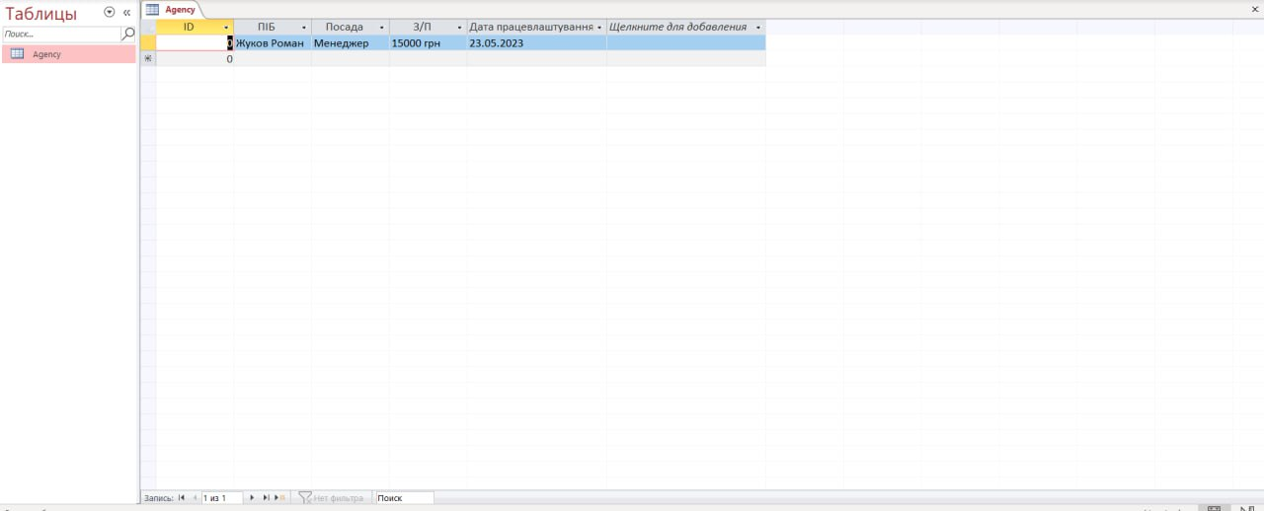

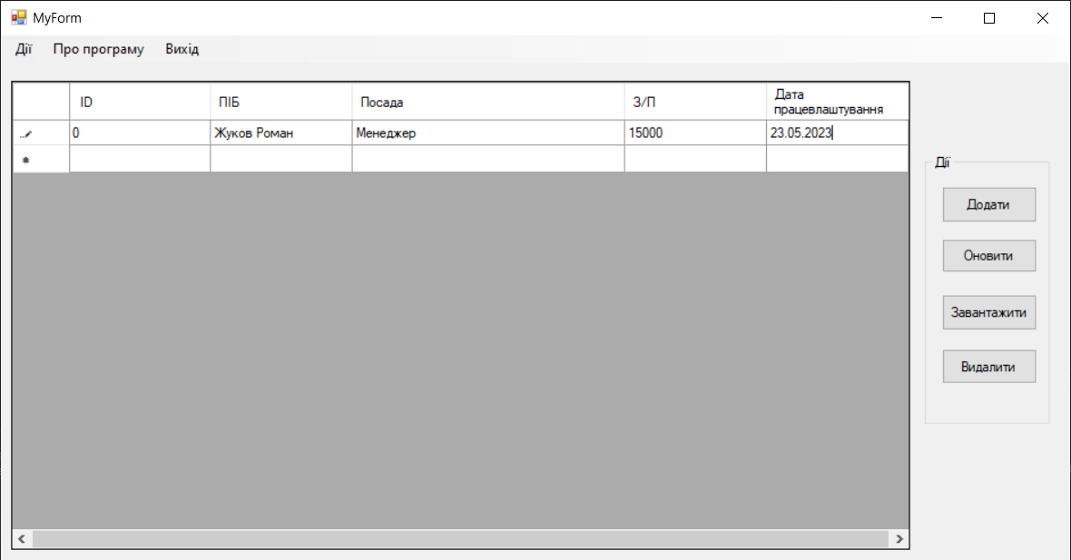

Посилання на GitHub: