Create Firebase Project
Firebase is used to store data in the Cloud. You can also refer to this official tutorial : https://firebase.google.com/docs/flutter/setup

Create the Firebase Project
1. Go to https://console.firebase.google.com/ and sign in with the account that will be used to create the project
2. Create a new Firebase Project
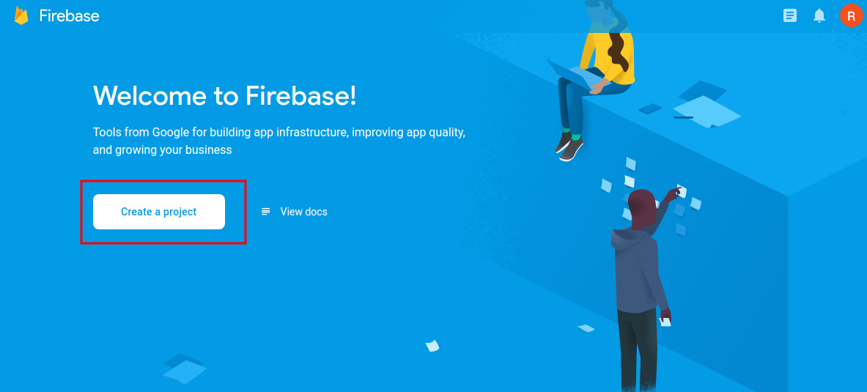
3. Fill the form to create the project
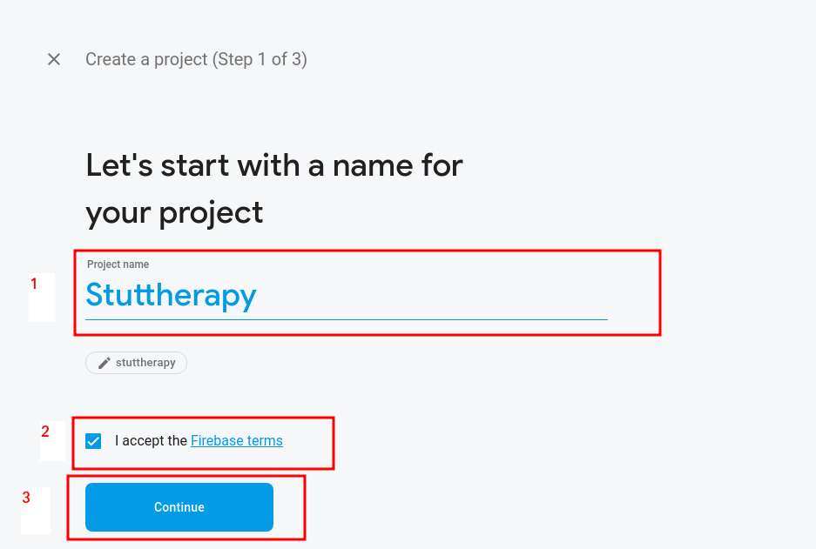
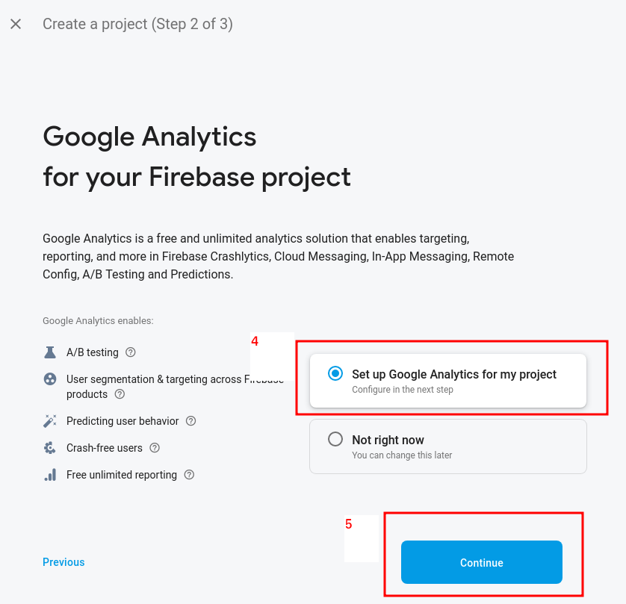

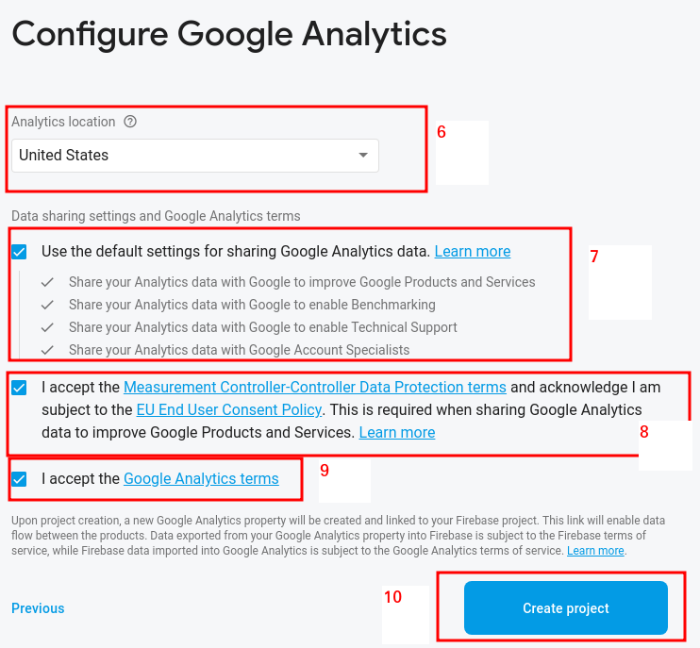
Now the project is created !
Spark Plan is the default plan

4. Now you have to add an android app autorized to access this Firebase project
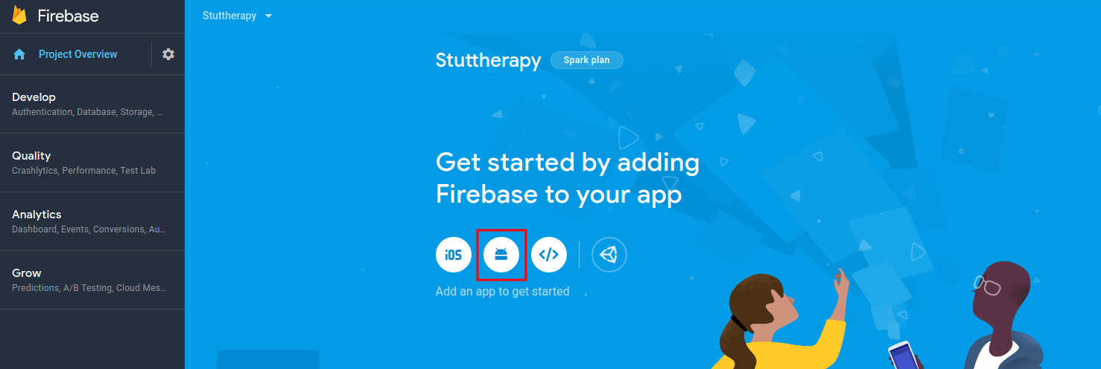
5. Fill the form with :
1. package name : com.example.stutterapy
2. Click on “Register app”
3. Download google-services.json
4. Click on “Next
5. The step “Add Firebase SDK” is already done, nothing to do here, just click on “Next”
6. You can click on “Skip this step”
6. Go to the source code application directory on your File Explorer
and paste the file previously downloaded (google-services.json) into <app directory>/android/app:
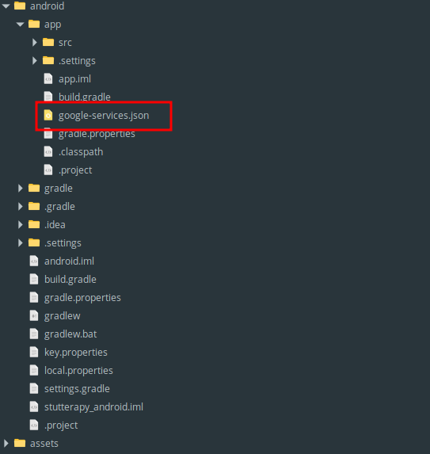

7. Create the database into the Firebase project and chose the server location
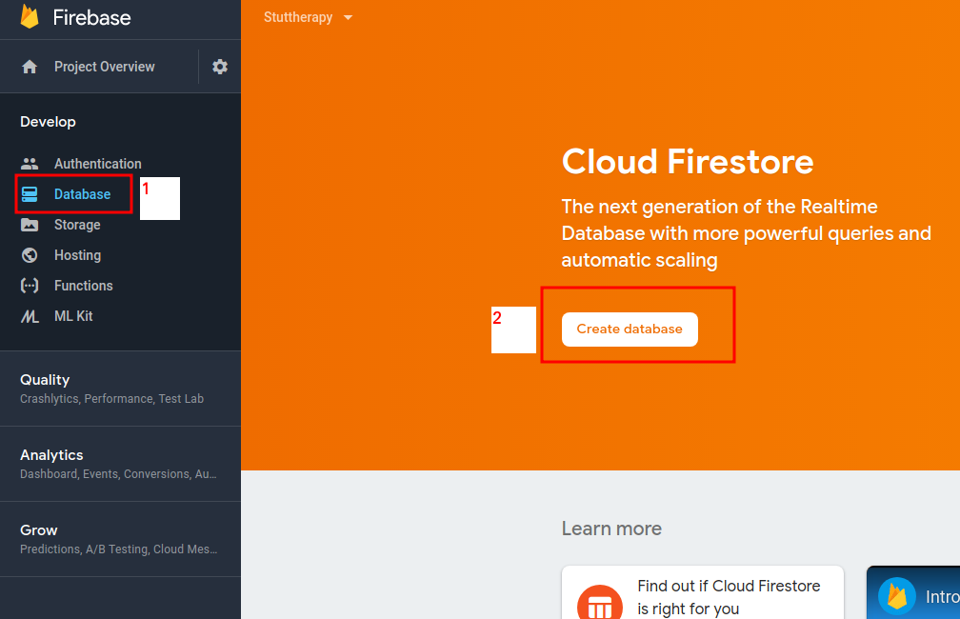
(you can start in test mode or locked mode whatever, we will change security rules in the next step)
It can takes some times
8. Change the database security rules
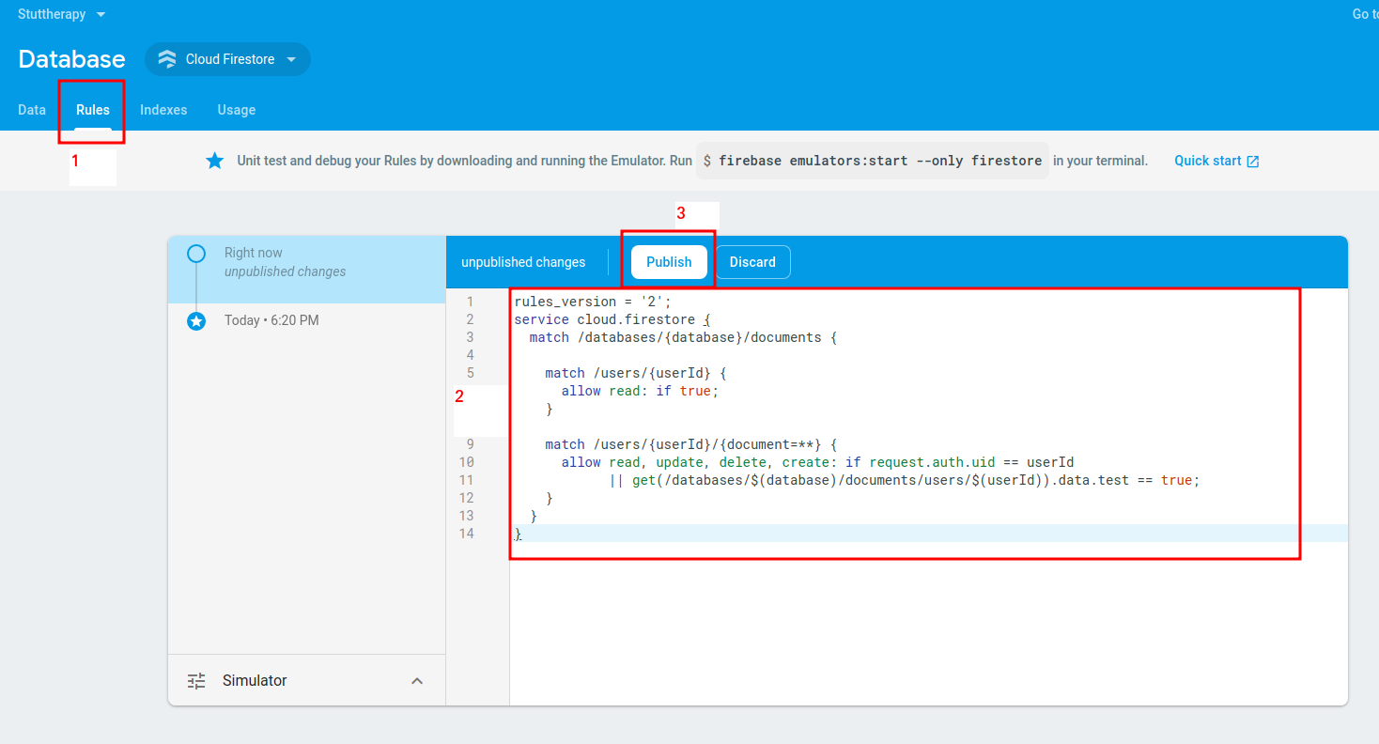
First go to the rule tab,
Then Change the security rule with following rules :

rules_version = '2';
service cloud.firestore {
match /databases/{database}/documents {
match /users/{userId} {
allow read: if true;
}
match /users/{userId}/{document=**} {
allow read, update, delete, create: if request.auth.uid == userId
|| get(/databases/$(database)/documents/users/$(userId)).data.test == true;
}
}
}
Finally publish these new rules !
9. Add the email/password authentication method :
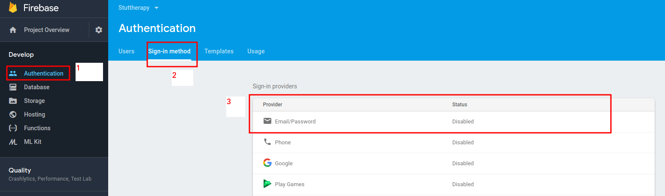
Go to the authentication, then open the “Sign-in method” tab, then click on “Email / password” item, to enable this sign-in method.
10. Now you need to redeploy the application (launch the script ./deploy.sh)

Change plan
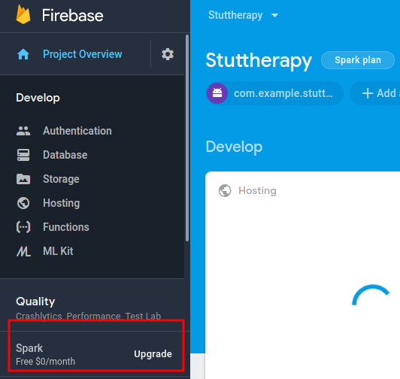
You can change your plan with this button

