Question 1 :
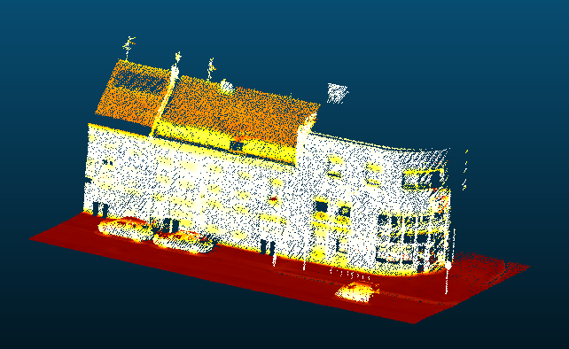
Radius = 0,5

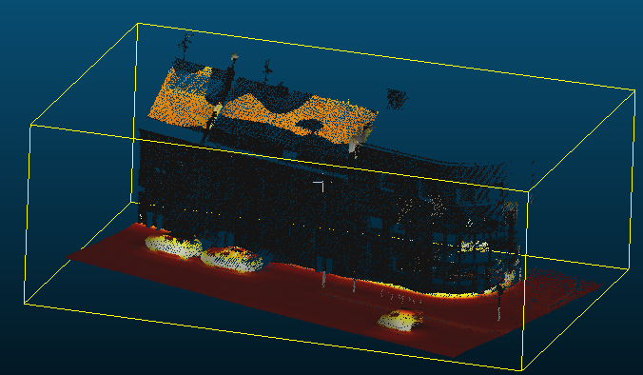
Radius = 2,0

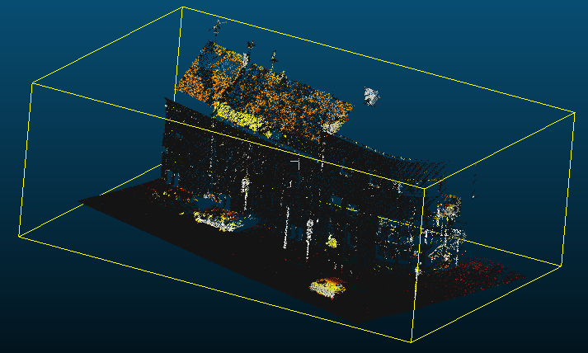
Radius = 0,1

If the radius is too small, the normals appear very noisy.
When the radius is too big, the normals are too smoothed, and details don’t appear : for example, the entire wall appears to have the same normal.

Question 2 :
We need to pick the most suited radius for the normal we want to estimate : it is a trade-off between the smallest details we want to observe and how reliable we want the normals to be.
It isn’t possible to have an exact answer to this question.

Question 3 :
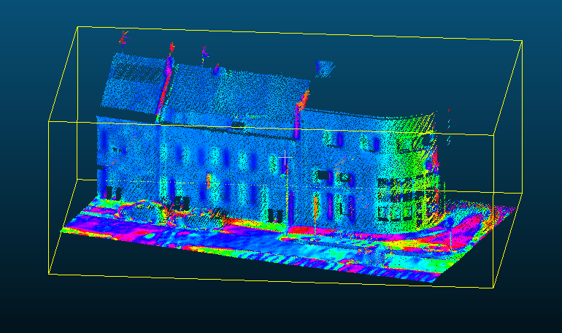
Question 4 : Using kNN
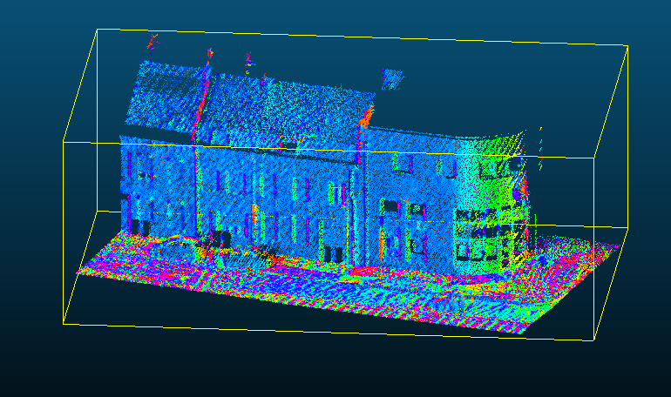
The main differences are seen on the ground, where we go further to find the 30 closest points. In that case, the result appears noisier. Other than that, the point cloud is almost the same.

Question 5 :
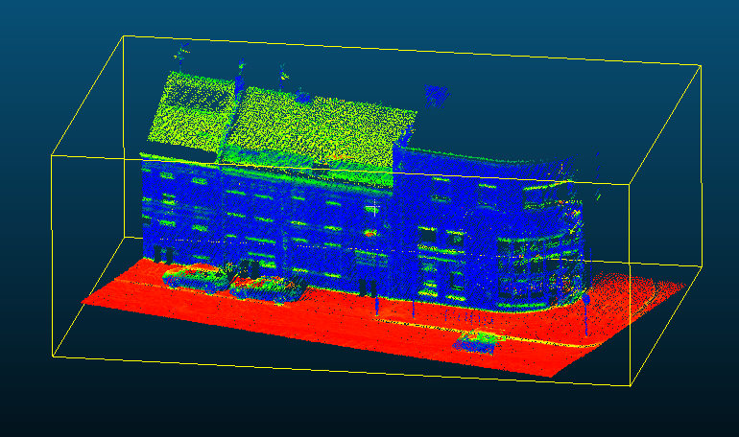
Verticality :

Linearity :
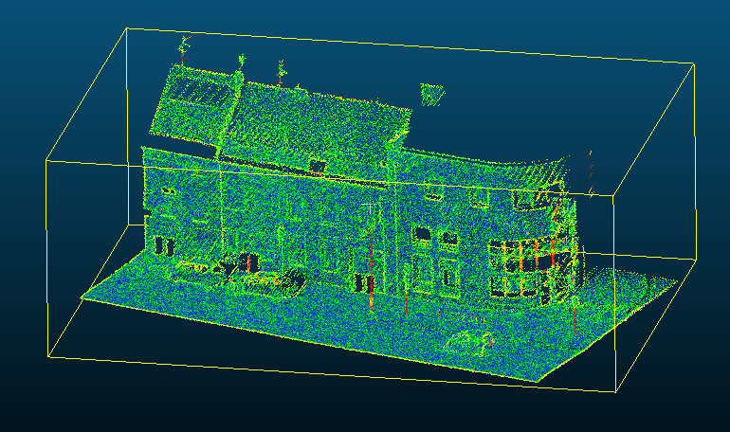

Planarity :
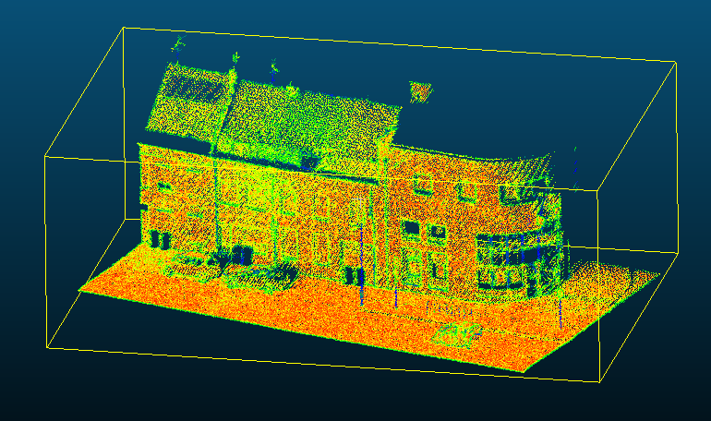

Sphericity :
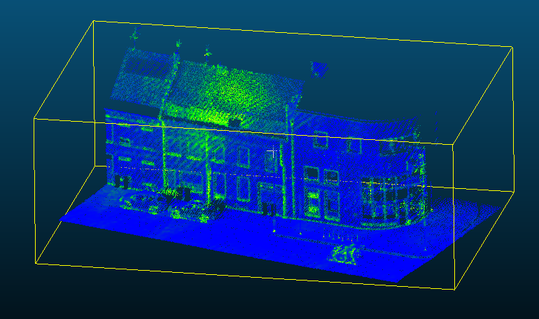
Linearity is the diffusion along the second most important eigenvalue compared to the first one.
Planarity is whether the data is on plane or not (whether it is along the third PCA axis or not).
Sphericity is whether the data is on a sphere or not (if λ₃ ≈ λ₁, then points aren’t distributed particularily in one direction).

