# Dragon Dune

A game for 4 players, inspired by Avalon-Hill's Dune board game.

Formally Dragons, Usurpers, and Empires (DU&E),

but the Internet hates ampersands in your project name.

So, let’s justify this things existence. Dune is a great game, but it has it’s drawbacks. The rules are kind of ambiguous. It can take a while to play. It can be a little cutthroat for beginners. Actually, it can be cutthroat for everyone. Rex attempted to iron out some of these idiosyncrasies, but they got rid of things like binding agreements, which seem fundamentally important to the game dune.

This is an attempt to make a resource light game in the style of Dune, that is friendlier to beginners, easier logistically (4 players instead of 6), with greater rule clarity, and with a strong sense of theme (taking place in a fantasy setting).

## About This Game

This game is licensed Creative Commons Share-Alike 4.0.

Contact: dragon.dune.game@gmail.com

Github: dragon-dune

## What You Need to Play:

1. The Board
2. Faction Tokens (20 per faction)
3. Gold Tokens (approximately 100)
4. Deck of Standard Playing Cards
5. One Six-Sided Die

# Board:

See “dragon-dune board.png” or “dragon-dune text board.txt”.

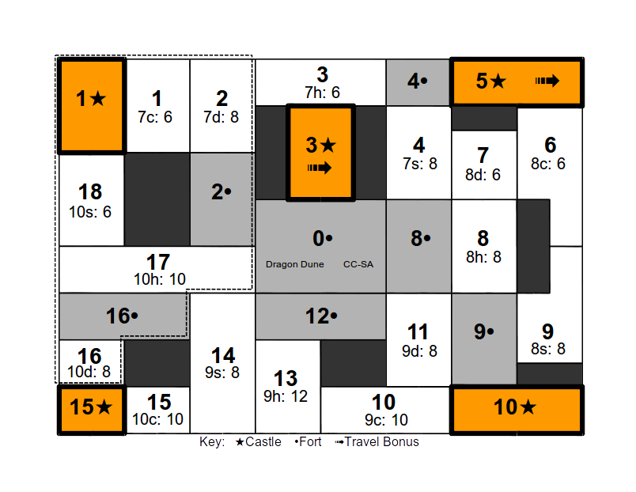

## Special Rules:

1. Territory 0• is the Imperial palace and is neutral territory. Players will never battle in territory 0•.
2. A player controls a city if they alone have tokens there.
3. Players in control of 3★ or 5★ have access to griffins and receive a travel bonus. They may move through four territories in the movement round (instead of 2).
4. Players may never have more than 20 player tokens between on the board and the player's graveyard at any one time.
5. No more than two players may have tokens in a castle at one time. This does not count hidden tokens.

# Factions:

## Dwarves (King of Diamonds):

The Dwarves empire has fallen. The are forced to sell artifacts from their treasuries with the hope of one day reclaiming their birthright.

Start With: 10 Gold, 1 artifact.

Starting Tokens: None.

Special:

1. The Dwarves collect all gold spent by other players on on artifact cards. Gold spent by the Dwarves on artifact cards goes to the bank.
2. The Dwarves are fierce warriors. They have two special tokens, which act as normal tokens in every way except that each token counts as two tokens for the purpose of combat.
3. Special Card (Ace): You may use an ace as a Sabotaged Artifact (Jack) of the same suit.
4. Alliance Power: The Dwarves may use their traitor and sabotaged artifact cards on their allies behalf in battle.

## Elves (King of Hearts):

The ancient Elves have vast arcane knowledge, but they will need to be clever to turn knowledge into gain.

Start With: 10 Gold, 1 artifact.

Starting Tokens: 10 tokens in 5c.

Special:

1. The Elves may see the artifact that is up for bid before bidding begins.
2. In battle with the Elves (or their allies), the Elves may ask the color of their opponents artifact card, the value of the artifact card, or to know how many tokens they are sending in to battle before selecting their own card and tokens.
3. At the beginning of the Recruitment and Movement Round, the Elves may see what the next event card will be.
4. Elven units may go into hiding in a territory in order to escape conflict. Hidden units act in every way as though they did not exist. Hidden units may only come out of hiding if they move into a new territory or at the beginning of a turn.
5. Special Card (Ace): You may place up to five tokens on any one territory for free.
6. Alliance Power: Elves may ask a battle question on their allies behalf.

## Goblins (King of Clubs):

The Goblins are ruthless mercenaries who fight for coin, even against their own king. Their thirst for treasure finds them with a trove of artifacts.

Start With: 5 Gold, 2 artifacts.

Starting Tokens: 5 tokens in 10c.

Special:

1. Goblins collect all gold spent on hiring Goblin mercenaries. Gold spent by the Goblins on mercenaries goes to the bank.
2. The Goblins (and their allies) pay half price (rounded up) for Goblin mercenaries.
3. When the Goblins win an artifact cards, they get a second artifact card that is hidden from the Elves.
4. The Goblins may have up to 8 artifact cards (instead of 4).
5. The Goblins may disband tokens at the beginning of the movement round (instead of at the end).
6. Special Card (Ace): You may stop a player from hiring Goblin mercenaries.
7. Alliance Power: You pay half price (rounded up) for Goblin mercenaries.

## Orcs (King of Spades):

The Orcs control the wild territories of the west. They worship the mighty Red Dragon.

Start With: 5 Gold, 1 artifact.

Starting Tokens: 10 tokens split between 1★, 9• & 16•.

Special:

1. Orcs may not hire mercenaries. Instead, they my raise armies in Orcish territories (16, 16• , 17, 18, 1, 1★, 2, & 2s) at no cost.
2. When you win a battle, you may steal one of your opponents artifacts (randomly chosen), which you may then keep or sell for its value in gold.
3. The Orcs may move tokens three territories in the movement round (instead of 2).
4. The Orcs take only half losses (rounded up) against Wild Dragons.
5. The Orcs may conscript 4 tokens (instead of 2).
6. The Orcs may ride the Red Dragon when it appears, if they are in the same location.
7. If no player has won at the end of the game, then Orcs are the default winner.
8. Special Card (Ace): In the Dragon round, you may move one stack of tokens to any location.
9. Alliance Power: You may share your default victory.

# Cards:

* Dwarves (King of Diamonds)
* Elves (King of Hearts)
* Goblins (King of Clubs)
* Orcs (King of Spades)
* Orc Usurper (Queen of Spades)
* Dwarven Usurper (Queen of Diamonds)
* Elven Usurper (Queen of Hearts)
* Goblin Usurper (Queen of Clubs)
* Sabotaged Clubs Artifact (Jack of Clubs)
* Sabotaged Diamond Artifact (Jack of Diamonds)
* Sabotaged Heart Artifact (Jack of Hearts)
* Sabotaged Spade Artifact (Jack of Spades)
* Special Card (Aces, All Suits)
* Artifacts (2 to 6, All Suits)

## Special Card Actions:

Players may use Special Cards to:

1. Not pay for an artifact card.
2. Pay half of regular price for mercenaries.
3. Make one extra movement in the Movement Round.
4. May be played as an artifact in battle with a value of 1.

# Rounds:

## Setup:

1. The board is set up. Players place their starting tokens.
2. One player is picked at random to be the Emperor.
3. Each player is given the King of their faction from the deck.
4. Each player is dealt one of the Queens face down. Players may look at them.
5. Each player is dealt one of the Jacks face down. Players may look at them.
6. Each player is dealt one artifact card face down. Players may look at them.
7. The Goblins are given a second artifact card face down, which they may look at.

## Wild Dragon Round:

1. A six-sided dice is rolled, and the Wild Dragon marker is moved from its starting position that amount through the board, in numerical order. Any player or gold tokens the wild dragons encounter are are not in a castle or fortress are removed form the game.
2. Note that Orcs only take half losses, rounded up.

## Event Round:

1. An event card is flipped over.
2. Gold is placed on that location, unless the Wild Dragon marker is at that location. If the Wild Dragon marker is at that location, then no gold is placed this turn.
3. If the event card is the same color as the games current Emperor, then the Red Dragon has attacked the previous event territory. All units and gold in that territory are lost.
4. If the Orcs are in the same territory as the Red Dragon, they may move some or all of their tokens at that location to any other location.
5. In response to the appearance of the Red Dragon, a Great Council is called immediately. This is the only time players may form or break alliances. The Geat Council continues until

## Bidding Round:

One card is placed up for bid for each player that does not have their maximum number of cards. For each card up for bid, one at a time.

1. The Elves, and only the Elves are shown the card.
2. Players, starting with the Emperor, bid on card.
3. The winner receives the card and pays the Dwarves.
4. If the Dwarves win the artifact, their payment is payed to the bank.
5. The winner may play a Special Card to avoid paying.
6. Then the whole process repeats for the next player in player order.

## Recruitment and Movement Rounds:

Starting with the Emperor, and the proceeding in player order, all players may (in the following order):

1. If they current player is the Goblins, they may disband some or all of one stack of tokens.
2. The current player may remove five tokens from the players graveyard.
3. The current player may conscript up to 2 tokens onto any territory where they already have tokens. This action is free.
4. The current player may hire Goblin mercenaries at a cost of 1 gold per mercenary if it is in a city, or 2 gold per mercenary if it is into any other territory. The payment is made directly to the Goblins.
   * Payments made by the Goblins are half price, rounded up.
   * Payments made by the Goblins are paid to the bank
   * The player may play a Special Card to pay half price, rounded up.
5. The current player may move one stack of tokens through two territories.
   * The Orcs may move through three territories.
   * If the player has access to griffins (If they control of 3★ or 5★) then they may move through four territories.
   * The player may play a Special Card to make a second movement this round.
6. If the current player is not the Goblins, they may disband some or all of one stack of tokens.
7. Then the whole process repeats for the next player in player order.

## Battle Round:

Starting with the Emperor, and the proceeding in player order, if a player has tokens in the same territory another player, they shall do the following (in the following order):

1. The player whose turn it is is the attacking player.
2. If the Elves are taking part in the battle, they may ask what one of the artifacts is that their opponent will play, or ask the size of the army they will send into battle. The answers to these questions are binding.
3. Each player secretly records how many tokens they will send as an army into battle, and they may select one artifact to use in the battle.
4. Players reveal the size of their armies and their artifacts selected.
5. For each color (red and black), whomever played the lower numbered artifact of that color, gets that amount added to their armies value.
6. The player with the highest army value wins the battle. In the case of a tie, the attacker wins.
7. If a player who took part in the battle has a their opponent as their usurper, and has a sabotaged artifact of the same suit as the artifact their opponent played, then they may declare their treachery and automatically win the battle, taking no losses. The loser removes all tokens from the territory (even those not used in the battle), and discards any artifacts used in the battle.
8. The winner removes any tokens used in the battle from the territory, and can choose to discard artifacts used in the battle.
9. This process continues until all battles for a player are resolved.
10. Then the whole process repeats for the next player in player order.

## Collection Round:

1. All players receive two gold.
2. Players collect gold from any territories they control. They can collect two gold for every token in the territory, up to the amount of gold in the territory.
3. If any lone player controls three castles, or if any alliance controls 4 castles, then they have won the game.
4. If six turns have passed without a winner, then the Orcs win.

# **Balancing Options:**

* Give players more conscription to weaken the Goblins.
* Take away special tokens or starting gold to weaken the Dwarves
* Give players (more) special tokens.
* Give players (more) gold.

# Special Thanks:

* https://opengameart.org/content/jinns-icons
* https://opengameart.org/content/wyvern-and-girl

# Board: