# MUSIQUES

Spying Jackalope

* <https://www.jamendo.com/en/track/1094499/spying-jackalope>
* 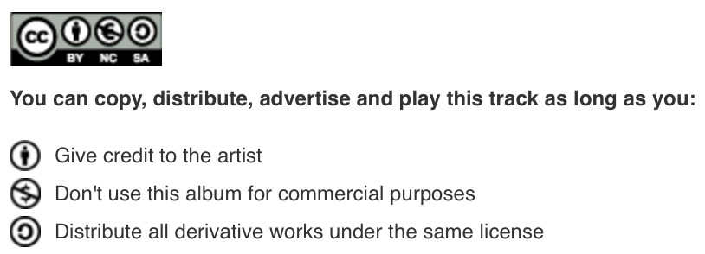

Cool Guys

* <https://www.jamendo.com/en/track/1232017/cool-guys>
* 

RIght Now

* <https://www.jamendo.com/en/track/1213925/right-now>
* 

Penguin Party

* <https://www.jamendo.com/en/track/820004/penguin-party>
* 

Night Street

* <https://www.jamendo.com/en/track/1236577/night-street>
* 

Igazi Jazz

* <https://www.jamendo.com/en/track/369911/igazi-jazz>
* 