Name:

Introduction to Java: EXAM
For multiple choice questions: right answer = +1, no answer or incomplete answer = 0
Questions 1 point 1-20 total 20
Questions 2 points 21-33 total 13
Questions 3 points 34-45 tota 12
Question 8 points 46 total 1
Total points = 20+2*(10)+3*12+8 = 90 pts
Don’t forget your Name

Which environment is required to: (1 point)
- run Java applications

- develop Java applications

Which company has developed Java? (1 point)

Java programming language is: (1 point)
- a) Dynamically typed | - b) strongly typed | - c) Compiled and Interpreted
- d)Machine specific | - e) Portable/Platform independent
- f) Object-Oriented | - g) Procedure-Oriented

Which tools is used to: (1 point)
- compile Java code

- execute Java application

Java Interfaces: (1 point)

- a) Can contain implementation of methods | - b) Do not contain Implementation of methods

What is the output of the compilation phase? (1 point)

What does “JVM” stand for? What is the role of the JVM?: (1 point)

What is a Native Method? (1 point)

What is the Encapsulation? (1 point)

What is a Java Package? (1 point)

Which of the following code lines are correct? (1 point)
  - a) int [] myArray = {10, 11, 17};
  - b) int myArray2 [] = {"1", "2", "0"};
  - c) int myArray3 [] = (1, 2, 45);
  - d) int myArray4 [] = {4, 5, 7};
  - e) int [][] myArray5 = {17, 18, 19};

What is the result of following code lines? (1 point)

int [] a = {2, 4, 9};  System.out.println(a[3]);
  - a) 9 | - b) Compilation error
  - c) Execution error | - d) 3
int [][] a = {{1, 2, 7},{2,3}};  System.out.println(a.length);
  - e) 5 | - f) 6
  - g) 3 | - h) 2

What do we use to access to private Class Field? (1 point)

What is the Bytecode Verifier? (1 point)

What is instanceof? (1 point)

Java has 3 mains type of memory area List them (1 point)

What is the usage of assert statements? (1 point)

Does Const Keyword exist in Java? (1 point)

What is the content of mycarObj? (1 point)
CarClass is a Class
CarClass mycarObj;
- a) NUL | - b) Memory address of the allocated object
- c) Pointer | - d) Garbage

Object declaration Select the correct ones (1 point)

- a) CarClass obj = new CarClass (); | - b) obj = new CarClass ();
- c) CarClass obj = new CarClass; | - d) new CarClass obj;

Do we have pointers in Java? Explain (2 point)

Why Java is in the top 5 of programing Languages? (2 points)

What is “JIT compilation” in Java? (2 points)

What is the Polymorphism? (2 points)

Is Java a pure Object Oriented Language, Explain? (2 points)

Which of the following code lines are correct? (2 points

- a) class A extends B, C, D
- b) class A implements B, C, D
- c) class A extends B implements C
- d) class A extends B implements C, D

What is the result of following code? (2 points)
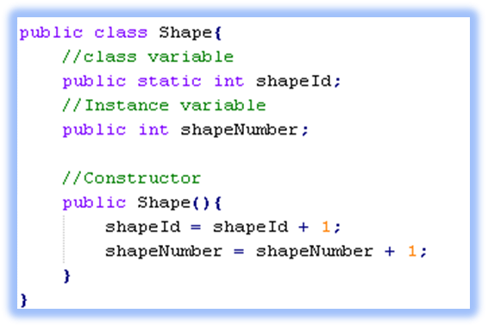
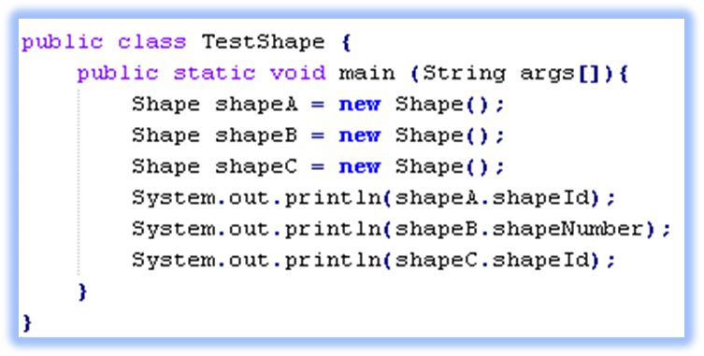

What is the concept name of combining method and attribute of a class? (2 point)

What are the differences between Interfaces and Abstract classes? (2 points)

How do we make an infinite loop with for command? (2 points)

Explain the type of SpeedofSound variable (2 points)

final int speedOfSound;
speedOfSoond = 3;

Can a class be static in Java ? Explain (2 points)

Which is the Regular expression pattern to detect the following words in a text 1to 4 and not expression 5 (2 points)
- World
- Worldd
- Worlddd
- Worlddd
- Not Worddddd

How many instances of the class “M” are created in below code? (3 points)
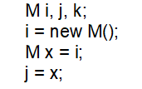  Which of the following lines are correct? (3 points)
   | a) a class can implement several interfaces but extends one single class
   | b) a class can implement several classes but must but extends one single interface
   | c) a class can implement several classes and can extends several interfaces
   | d) a class must implement single interface and extends one single class
  - 1 | - 2
  - 3 | - 4

What will be printed on the standard output? (3 points)
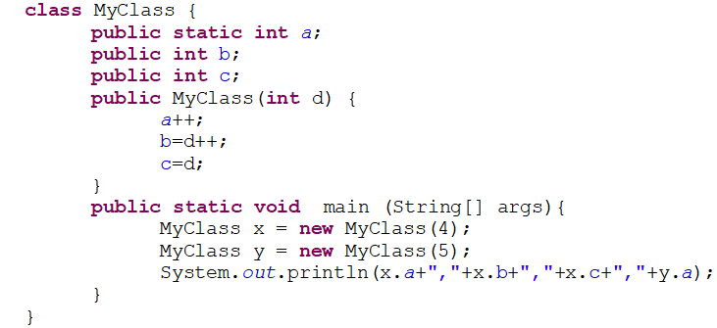

What will be printed to the standard output ? (3 points)
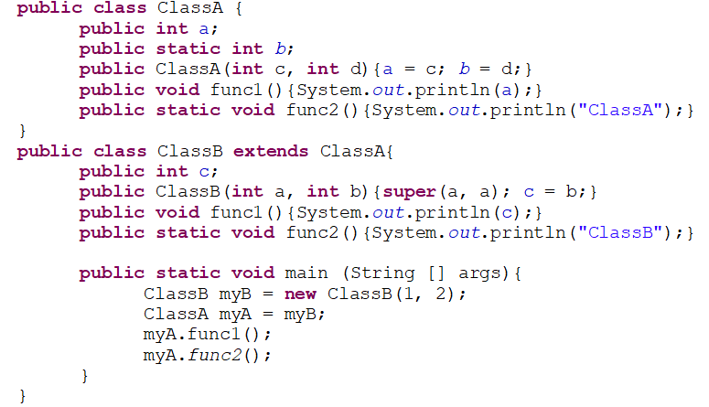

Which of the following class definitions are correct? (3 points)

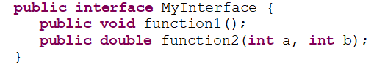
public class MyClass implements MyInterface{  public MyClass(){...}  public void function1() {...}  } | - a)
public class MyClass implements MyInterface{  public int a;  public MyClass(int b){a = b;}  } | - b)
public class MyClass implements MyInterface{  public MyClass(){...}  public void function1() {...}  public double function2(int c, int d) {... ;return 5.5;}  } | - c)
public class MyClass implements MyInterface{  public int a;  public MyClass(int b){a = b;}  public void function1() {...}  public double function2(int c) {... ;return 5.5;}  } | - d)
public class MyClass implements MyInterface{  public void function1() {...}  public double function2(int c, int d) {... ;return 5.5;}  } | - e)

Which of the following code lines are correct? (3 points)

ClassA myA = new ClassB(2, 4); | - a)
ClassB myB = new ClassA(2, 4); | - b)
MyInterface myI = new MyInterface(); | - c)
MyInterface myI = new ClassB(2,3); | - d)

Which of the following code lines are correct? (3 points)

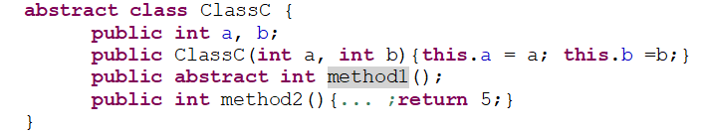

public class ClassD extends ClassC{  public ClassD(int a, int b) { super(a, b); }  public int method1() {... ;return 7;}  } | - a)
public class ClassD extends ClassC{  int c;  public ClassD(int a){this.c = a;}  public int method1() {... ;return c;}  } | - b)
public class ClassD extends ClassC{  public ClassD(int a){ super(a, a); }  public int method1(int a) {int b = 2; ... ;return a*b;}  public int method2() {int a = 0; ... ;return a;}  } | - c)
public class ClassD extends ClassC{  public ClassD(int a){ super(a, a); }  public int method1() {... ;return 5;}  public float method2() {... ;return 2.5;}  } | - d)
ClassC myC = new ClassC(…); | - e)
ClassC myC = new ClassD(…); | - f)

Why I got this warning in the following code? (3 points)

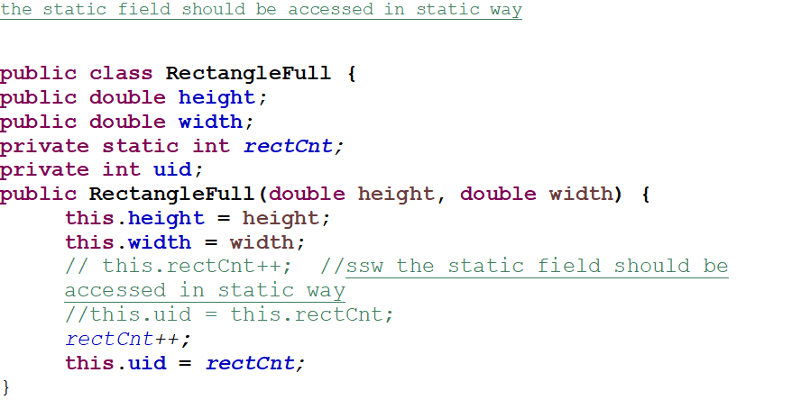

What is a Java Frame? (3 points)

What is a Static method? How do we use it? (3 points)

How do we exit from nested loop? (3 points)

Explain those terms: Class, Object, Instance, reference (3 points)

Write a Java class that allows to check that a word has Unique char (8 points)
- Ex: java => no unique char => a letter is used 2 times
- sharp => yes - each char is unique

The length of word to be tested has a length limited to 25

What is checked:
- Code giving the correct result
- Java Coding convention are respected
- Type selection
- Global structure of the code

