UML Lab 2 modeling a railroad crossing system

# objecive

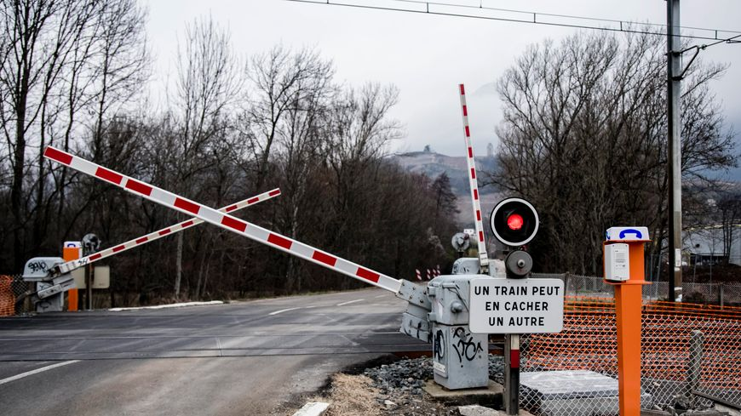

# requirements

# use case

# activity diagram

# block diagram