Levitaz vs Chubanga

Introduction

Context
This document presents an analysis of straight-line sailing exercises performed simultaneously by Gian Stragiotti and Max Maeder on November 25, 26, and 27, 2025. During these sessions, the riders alternated foil masts between Levitaz and Chubanga, allowing for direct performance comparisons under closely matched conditions.

The objective of this study is to assess the performance impact of the foil mast while controlling as much as possible for environmental and configuration-related factors.

Methodology
The python analysis is available on LeviVSChub.html. It relies on pre-extracted sailing intervals, ensuring that both riders were exposed to the same wind and sea-state conditions during each comparison. Full details on the interval extraction process and the content of the analyzed runs are provided in the files interval_selection.html and report.html.

Two complementary analytical approaches are explored:
- Paired-difference analysis.
The first approach focuses on the performance difference between the two foil masts by directly analyzing, for each interval, the difference in speed over ground (SOG) between Levitaz and Chubanga. This paired structure allows for a clean comparison under matched conditions.
- Rider-specific analysis.
The second approach separates the observations by rider and examines performance when sailing with the Levitaz mast versus the Chubanga mast. This perspective allows rider-specific responses to the foil masts to be examined explicitly.

For each approach, the analysis proceeds in two steps. First, an exploratory analysis based on mean comparisons and t-tests is conducted to provide an initial, descriptive view of the differences. Second, ordinary least squares (OLS) regressions are applied to quantify the effect of the foil mast while controlling for relevant sailing conditions and configurations.

Results

Approach I: Paired-Difference Analysis
This first approach focuses on paired comparisons between the Levitaz and Chubanga foil masts. For each extracted interval, the difference in speed over ground is computed as SOG_Levi − SOG_Chub, ensuring that both riders are compared under identical wind and sea-state conditions.

Descriptive statistics and exploratory analysis

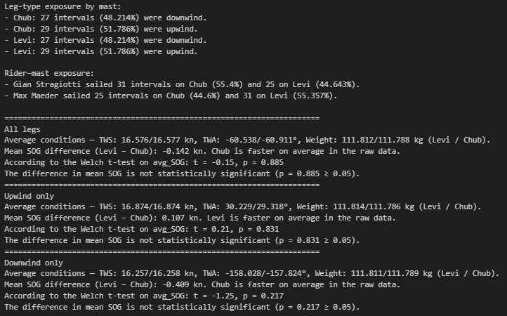

Exposure is well balanced across sailing regimes and riders. For both masts, approximately half of the intervals are upwind and half are downwind, and both riders sail a comparable number of intervals on each mast.
Across all legs, sailing conditions are identical between Levitaz and Chubanga: this is the interest of working on paired difference, as both masts are compared exactly at the same time, with the same conditions. Gian’s weight variations (112.1 / 112.2) and Max’s weight variations (111.4 and 111.5) are negligible, and the wind conditions (TWA / TWS) are identical as they are interpolated from the coach’s boat.
The raw mean SOG difference is small (−0.14 kn in favor of Chubanga) and not statistically significant. When separating by sailing regime, Levitaz is slightly faster upwind (0.107 kn) and Chubanga slightly faster downwind (0.409kn), but none of these differences are statistically significant.

Regression analysis: OLS on ${\text{SOG}}_{\text{Levitaz}}-{\text{SOG}}_{\text{Chubanga}}$

All legs:
The model estimates the paired SOG difference between Levitaz and Chubanga, controlling sailing regime, master/leeward configuration, and which rider is sailing the Levitaz mast. The indicator function $1(⋅)$ equals one when the specified condition holds and zero otherwise:
${\text{SOG}}_{\text{Levitaz},i}-{\text{SOG}}_{\text{Chubanga},i}=β_{0}+β_{1}1\left({\text{Upwind}}_{i}\right)+β_{2}1\left({\text{Master}}_{i}\right)+β_{3}1\left(\text{Max on }{\text{Levi}}_{i}\right)+ε_{i}$

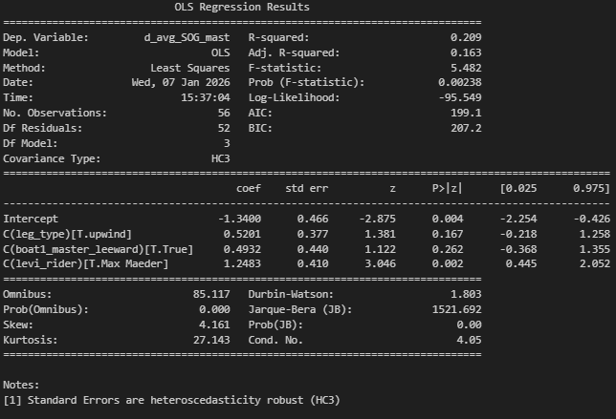
The intercept represents the Levi–Chub SOG difference when Gian Stragiotti is sailing Levitaz, in downwind conditions and master role.

The intercept is negative and statistically significant (−1.34 kn, p = 0.004), indicating that when Gian Stragiotti sails Levitaz, Levi is on average 1.34 knots slower than Chubanga under the reference conditions. The rider coefficient is large and positive (+1.25 kn, p = 0.002), implying that when Max Maeder sails Levitaz, the Levi–Chub performance gap is reduced by about 1.25 knots, bringing it close to zero (-1.34+1.25 = -0.09 kn).

Upwind
$${\text{SOG}}_{\text{Levitaz},i}-{\text{SOG}}_{\text{Chubanga},i}=β_{0}+β_{1}1\left({\text{Master}}_{i}\right)+β_{2}1\left(\text{Max on }{\text{Levi}}_{i}\right)+ε_{i}$$
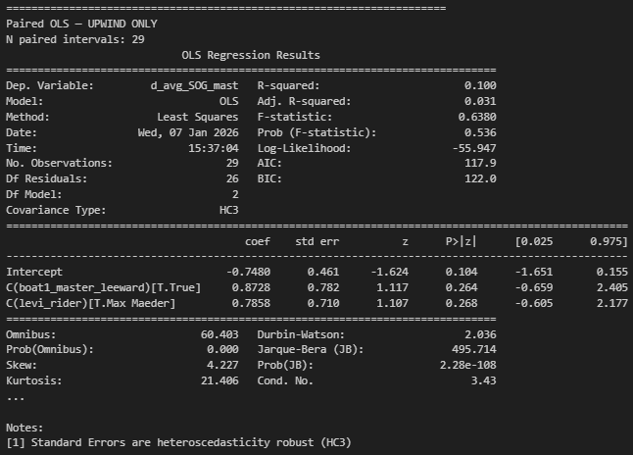
In the upwind-only regression, the intercept is negative (−0.75 kn) but not statistically significant (p = 0.104), indicating that Levi tends to be slower than Chub when Gian Stragiotti sails Levitaz, though this effect is not precisely identified. The rider coefficient is positive (+0.79 kn) but not statistically significant (p = 0.268), but this suggests again a smaller Levi–Chub gap when Max Maeder sails Levitaz, bringing the difference close to zero again.
Overall, upwind results are noisy and do not support clear conclusions on mast performance, but they are showing similar trends as the all legs case.

Downwind
$${\text{SOG}}_{\text{Levitaz},i}-{\text{SOG}}_{\text{Chubanga},i}=β_{0}+β_{1}1\left({\text{Master}}_{i}\right)+β_{2}1\left(\text{Max on }{\text{Levi}}_{i}\right)+ε_{i}$$

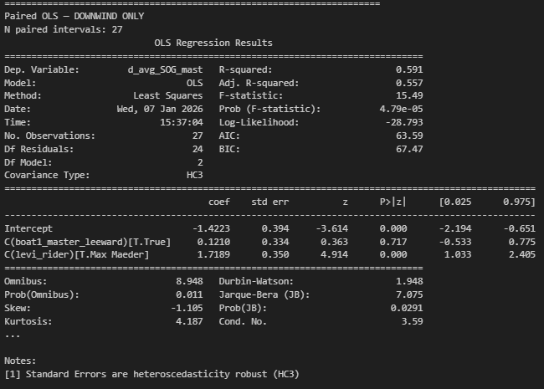
In the downwind-only regression, the intercept is negative and statistically significant (−1.42 kn, p < 0.001), indicating that when Gian Stragiotti sails Levitaz, Levi is on average 1.42 knots slower than Chubanga downwind. The rider coefficient is large and highly significant (+1.72 kn, p < 0.001), showing that when Max Maeder sails Levitaz, the Levi–Chub performance gap is strongly reduced and nearly eliminated. By contrast, the master/leeward configuration has no meaningful effect.
Overall, downwind performance differences are large, well identified, and primarily driven by rider-specific responses to the foil mast.

Conclusion:
The paired-difference analysis shows that Levi underperforms Chub when sailed by Gian Stragiotti, while this performance gap is largely eliminated when sailed by Max Maeder. There is no reversal of the gap: Max performs consistently well with both foils, whereas Gian performs noticeably better with Chubanga. This rider-specific pattern is weakly identified upwind due to higher variability, but emerges clearly and robustly downwind, where the Levi–Chub difference is large and statistically significant.

Approach II : Rider-Specific Analysis
The paired-difference analysis shows that rider identity plays a major role in the observed mast performance differences. This motivates a rider-specific analysis, which examines each rider separately to better understand how individual riders respond to the different foil masts.

Descriptive statistics and exploratory analysis
For Gian:
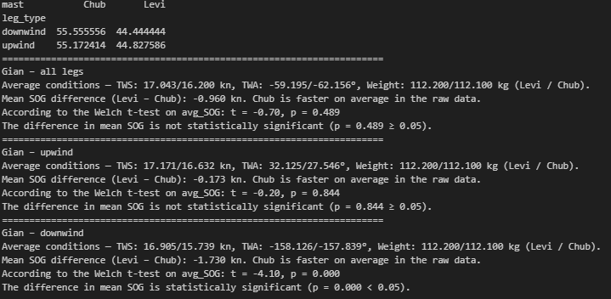
For Max:
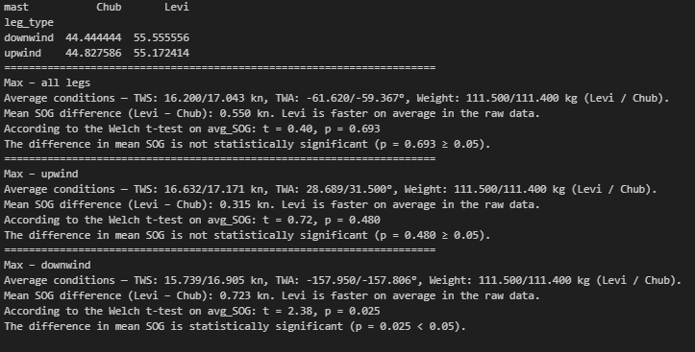
For both riders, mast exposure is well balanced across sailing regimes, with similar proportions of upwind and downwind intervals sailed on Levitaz and Chubanga. Average wind conditions and total weight are also comparable across masts within each rider, ensuring that observed differences are not driven by systematic condition imbalances.
For Gian Stragiotti, raw mean comparisons show that Chubanga consistently outperforms Levitaz. Across all legs, the mean SOG difference (Levi − Chub) is −0.96 kn, although this difference is not statistically significant. When separating by sailing regime, the gap is small and insignificant upwind (−0.17 kn), but becomes large and highly significant downwind (−1.73 kn, p < 0.001), indicating a substantial downwind performance advantage of Chubanga for Gian.
For Max Maeder, the pattern is reversed. Across all legs, Levitaz is faster on average (+0.55 kn), though this difference is not statistically significant. Upwind, the Levi advantage remains modest and insignificant (+0.32 kn). Downwind, however, Levitaz shows a clear and statistically significant advantage (+0.72 kn, p = 0.025), indicating better downwind performance for Max with Levitaz.
Overall, the rider-specific exploratory analysis reveals a strong contrast in rider–foil interactions: Gian performs significantly better downwind with Chubanga, while Max performs a bit better downwind with Levitaz. Upwind differences are small and not statistically significant for either rider. These patterns strongly suggest that foil mast performance depends on rider-specific responses, particularly in downwind conditions.

Regression analysis: OLS on SOG

Gian
Gian all legs:
$${\text{avg}\text{_}\text{SOG}}_{i}=β_{0}+β_{1} 1\left({\text{Levi}}_{i}\right)+β_{2} 1\left({\text{Upwind}}_{i}\right)+β_{3} {\text{TWS}}_{i}+β_{4} 1\left({\text{Master}}_{i}\right)+ε_{i}$$
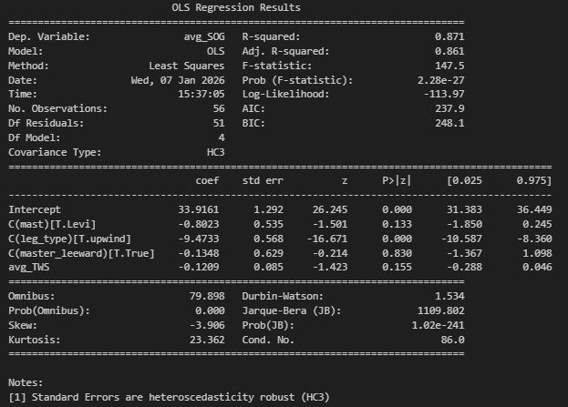
Gian upwind:
$${\text{avg}\text{_}\text{SOG}}_{i}=β_{0}+β_{1} 1\left({\text{Levi}}_{i}\right)+β_{2} {\text{TWS}}_{i}+β_{3} 1\left({\text{Master}}_{i}\right)+ε_{i}$$

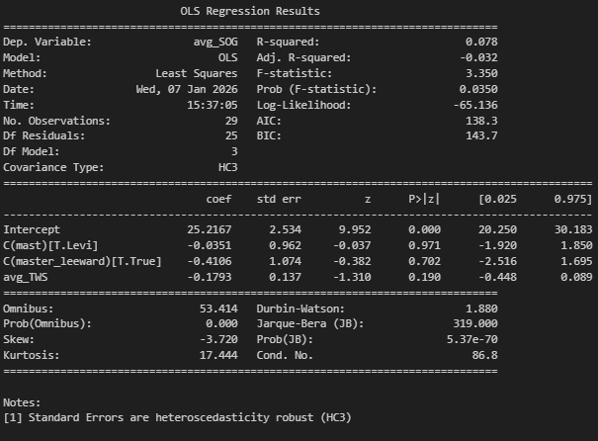
Gian downwind:
$${\text{avg}\text{_}\text{SOG}}_{i}=β_{0}+β_{1} 1\left({\text{Levi}}_{i}\right)+β_{2} {\text{TWS}}_{i}+β_{3} 1\left({\text{Master}}_{i}\right)+ε_{i}$$
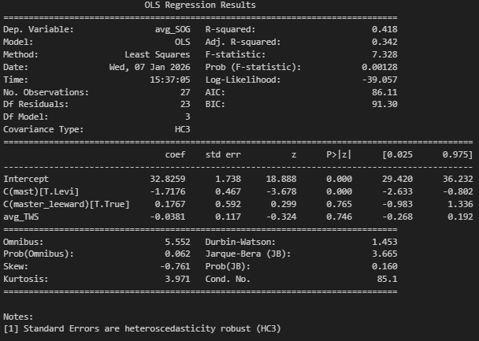
The reference category corresponds to Chubanga, non-master configuration, and Gian Stragiotti, and downwind conditions for the all legs analysis.
In the pooled regression, the Levitaz mast coefficient is negative (−0.80 kn) but not statistically significant (p = 0.133), indicating that after controlling for wind strength and sailing regime, the average Levi–Chub performance gap for Gian is not precisely identified. Sailing regime is the main driver of SOG, with a large and highly significant reduction in speed upwind relative to downwind.
Downwind, the OLS results are much clearer: the Levitaz mast is associated with a large and statistically significant SOG loss (−1.72 kn, p < 0.001), even after controlling for wind and configuration. This confirms that the downwind performance gap is a genuine mast effect for Gian, not driven by condition differences.
Upwind, the mast coefficient remains negative (-0.035 kn) but statistically insignificant (p = 0.971), indicating weak and poorly identified mast effects. Overall, OLS results confirm a strong, rider-specific downwind advantage of Chubanga for Gian, with limited evidence of meaningful mast effects upwind.

Max
Max all legs:
$${\text{avg}\text{_}\text{SOG}}_{i}=β_{0}+β_{1} 1\left({\text{Levi}}_{i}\right)+β_{2} 1\left({\text{Upwind}}_{i}\right)+β_{3} {\text{TWS}}_{i}+β_{4} 1\left({\text{Master}}_{i}\right)+ε_{i}$$
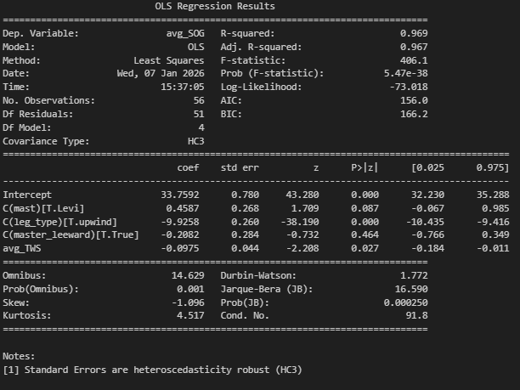

Max upwind:
$${\text{avg}\text{_}\text{SOG}}_{i}=β_{0}+β_{1} 1\left({\text{Levi}}_{i}\right)+β_{2} {\text{TWS}}_{i}+β_{3} 1\left({\text{Master}}_{i}\right)+ε_{i}$$
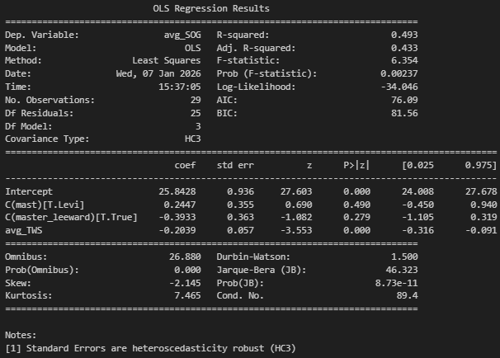
Max downwind:
$${\text{avg}\text{_}\text{SOG}}_{i}=β_{0}+β_{1} 1\left({\text{Levi}}_{i}\right)+β_{2} {\text{TWS}}_{i}+β_{3} 1\left({\text{Master}}_{i}\right)+ε_{i}$$
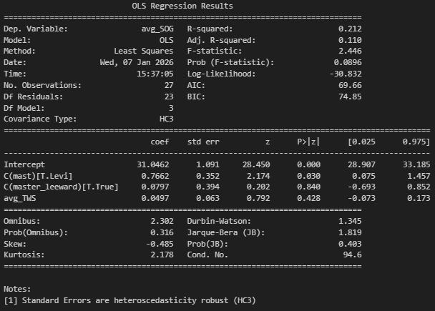

In the pooled regression across all conditions, the coefficient on the Levitaz mast is positive (+0.46 kn) and marginally insignificant (p = 0.087), indicating that Max tends to sail slightly faster with Levitaz than with Chubanga once sailing regime, wind strength, and configuration are controlled for. As for Gian, sailing regime is the dominant driver of SOG, with a large and highly significant reduction in speed upwind relative to downwind.
Upwind, the Levitaz mast coefficient is small (+0.24 kn) and not statistically significant (p = 0.49), suggesting no meaningful difference in Max’s upwind performance between the two foils. Wind strength remains the primary explanatory factor in this regime.
Downwind, by contrast, the Levitaz mast is associated with a positive and statistically significant SOG effect (+0.77 kn, p = 0.030). This indicates that Max sails significantly faster with Levitaz than with Chubanga downwind, even after controlling wind strength and configuration. Configuration effects remain negligible.
Overall, the OLS results show that Max’s performance is largely insensitive to mast choice upwind, but that Levitaz provides a clear and statistically significant downwind advantage.

Conclusion
Both approaches gave us the same conclusions, foil mast performance is shown to depend strongly on rider-specific responses rather than on a uniform intrinsic advantage of one mast over the other. Gian exhibits a large and robust downwind advantage with Chubanga, whereas Max performs consistently well with both foils and shows a modest but statistically significant downwind advantage with Levitaz. Upwind effects are weak and imprecisely identified for both riders.

