**TECHNICAL DESIGN DOCUMENT**

1. **Features List**

The game will be an Arena shooter from top view on a limited choice of maps.

Player will not see the entire map at once, he will have to move.

The goal is to survive the longest time and mark the biggest score.

Waves of enemies will come to the player and he will have weapons to fight with.

Player win virtual money at the end of each game, allowing him to unlock maps and characters and ameliorate them.

There will be multiple achievements, allowing to gain virtual money once unlocked.

The game will have the following features:

* 1. Register & Login
  2. Multiplayer
  3. Personalize character
  4. Run game (endless)
  5. Unlocked characters
  6. Achievements screen
  7. Leaderboards

1. **Technology**

The game will be developed with Unity C#. Targeted platforms are Windows, then Linux but it is not a priority. Server-side database with MySQL on Unity and client-side database for local game with MySQL too.

1. **Diagrams**

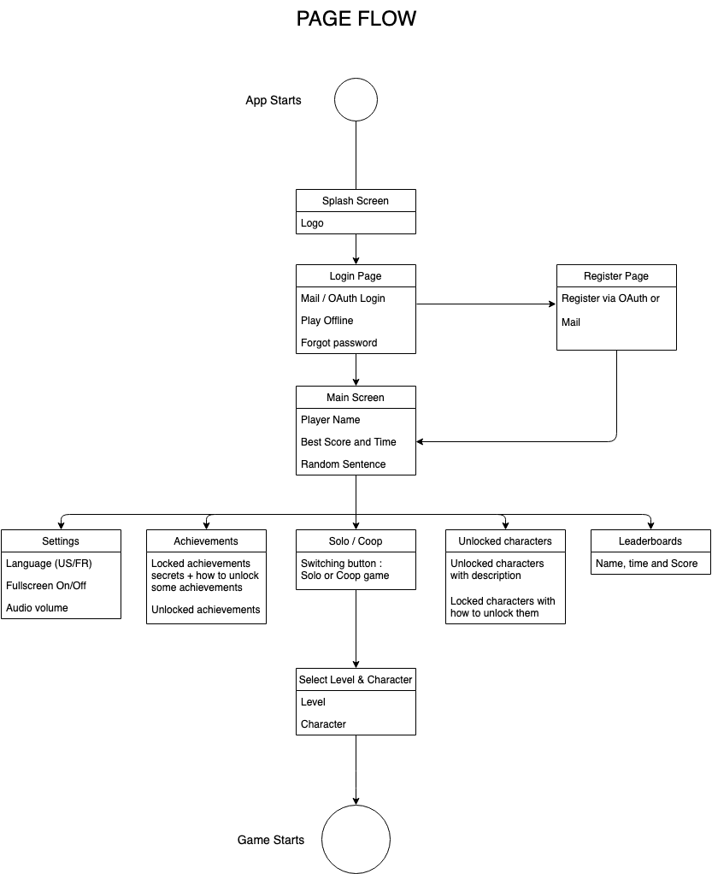

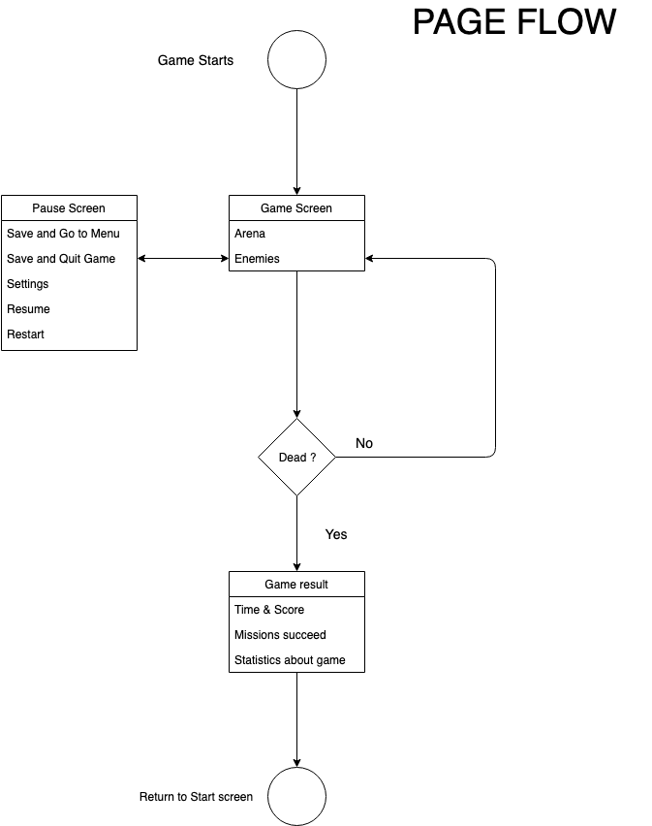

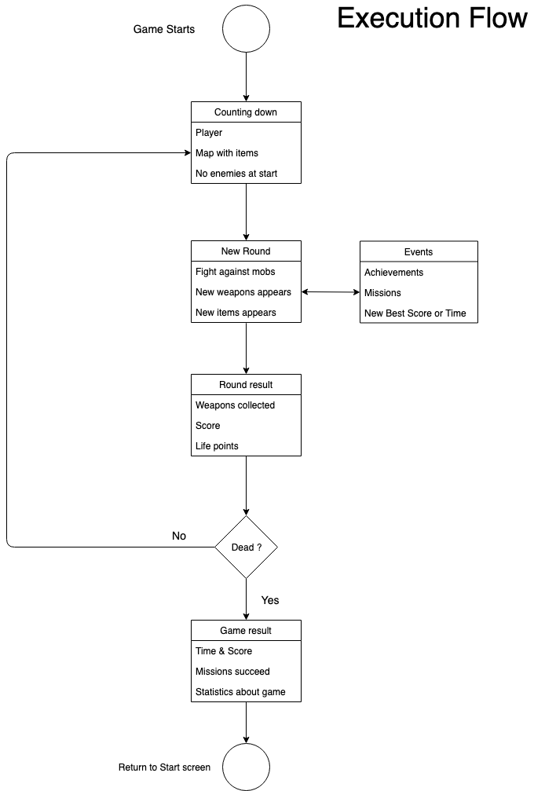

1. **Database design**

|  |  |
| --- | --- |
| **Table : Player** | |
| Player ID | Integer |
| Player Name | Varchar 20 |
| FB ID | Varchar 64 |
| Google ID | Varchar 64 |
| Current Gold | Integer |
| Mission Done | Integer |
| Highest Score | Integer |
| Longest Time | Integer |

|  |  |
| --- | --- |
| **Table : Character** | |
| Character Name | Varchar 20 |
| Total HP | Integer |
| Speed | Integer |
| Max Level | Integer |

|  |  |
| --- | --- |
| **Table : Weapons** | |
| Weapon ID | Integer |
| Weapon Name | Varchar 20 |
| Low Damage | Integer |
| High Damage | Integer |
| DPS | Integer |

|  |  |
| --- | --- |
| **Table : Challenges** | |
| Challenge ID | Integer |
| Challenge Name | Varchar 50 |
| Challenge Brief | Text |
| Is Completed | Boolean |
| Is Repeatable | Boolean |
| Is Unlocked | Boolean |

|  |  |
| --- | --- |
| **Table : Items** | |
| Item ID | Integer |
| Item Name | Varchar 50 |
| Destroyable | Boolean |
| Starting HP | Integer |

|  |  |
| --- | --- |
| **Table : Enemy** | |
| Enemy ID | Integer |
| Enemy Name | Varchar 50 |
| Starting HP | Integer |
| Difficulty Class | Integer |
| Low Damage | Integer |
| High Damage | Integer |

|  |  |
| --- | --- |
| **Table : Enemy Action** | |
| Action ID | Integer |
| Action Name | Varchar 50 |
| Enemy ID | Integer |
| Trigger Chance | Integer |
| Effect ID | Integer |

1. **Features breakdown & functions list**

In this game you will play a character in the middle of an arena. The player starts with a basic weapon and waves of enemies arrive. When the player succeeds a wave, a new weapon appears on the screen and new items as life points and ammunitions.

It is an endless game with infinite number of rounds. Player can unlock several achievements during games and but there are also ‘meta-achievements’.

* 1. **Register & Login**

When app starts, check if a user is already registered locally, else login with FB / Google / Mail (OAuth).

User can register via FB, Google, Mail or locally.

* 1. **Multiplayer**

On the main screen, player can choose if he wants to play solo / coop. It appears as a switching button

* 1. **Personalize character**

Ameliorate character specs and look with virtual money.

You can see best score (time and score)

* 1. **Run game (endless)**

A button on the bottom-center to run the game. Player starts in the middle of the screen with his selected weapon. Ammunitions and new weapons frequently pop on the screen.

* 1. **Unlocked characters**

Player can see unlocked characters and a little description about them.

He can also see how many characters he can still unlock.

Characters have specific specs which are ameliorable with virtual money.

Player can unlock some with virtual money won with achievements.

* 1. **Achievements screen**

Secret locked achievements and normal achievements with an explanation on how to unlock them.

Unlocked achievements on top of the list.

They are related to the gameplay but also there are also “meta successes”.

* 1. **Leaderboards**

This screen shows the name, time and score as a list.

1. **Convention**

The team will use exclusively English and will use CamelCase as naming convention.