Domotic v2
Documentation
Modular home dashboard: live measurements, automation scenarios, and optimisation based on solar production and electricity tariffs.
27 July 2026

Contents
Contents empty on opening? Press Ctrl+A then F9 to update the fields (Word only computes page numbers on demand).

Installation

Requirements
- Python 3.10 or later (the project runs on 3.14)
- Windows on the current machine, though nothing is Windows-specific apart from the commands below
- Local network access to the equipment (Enphase gateway, Tuya plugs) and Internet access for the APIs (Solcast, RTE Tempo, Cozytouch, Hi-Kumo)

Setting up
cd C:\Dev\Domotic\v2
..\.venv\Scripts\activate
pip install -r requirements.txt
python manage.py migrate
requirements.txt installs:
Package | Purpose
django | the web framework
requests | HTTP calls to the APIs
apscheduler | the scheduler: periodic tasks and time-based scenarios
pyoverkiz | Cozytouch water heater and Hi-Kumo air conditioners

APScheduler is not optional. Without it the application starts and displays normally, but no scenario fires and no data refreshes in the background. It is the quietest failure in the project: see *Troubleshooting*.

Starting the application
cd C:\Dev\Domotic\v2
..\.venv\Scripts\activate
python manage.py runserver 0.0.0.0:8100
Then open http://localhost:8100/.
Listening on 0.0.0.0 makes the application reachable from other devices on the local network (phone, tablet) at http://<pc-ip>:8100/.
Port 8100 lets it coexist with v1, which uses the default port.
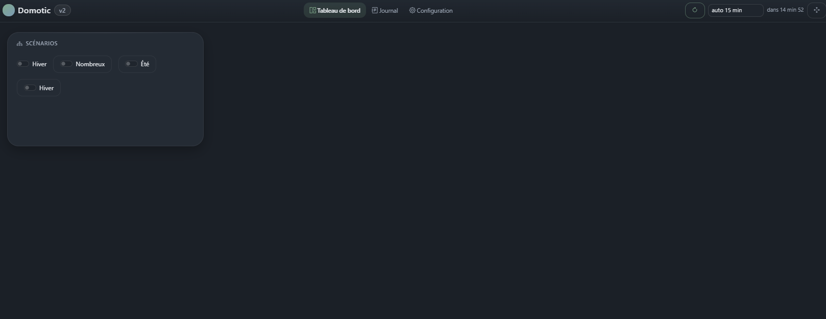
Home screen on first start

What happens at start-up
- Django loads the core framework and the enabled modules — modules ticked in the Configuration tab become full Django apps (see domotic/settings.py).
- The scheduler starts and registers the periodic tasks declared by the active modules, and the scenarios triggered by time, computed time, interval or value change.
- A line "Scheduler démarré: N task(s), M scenario(s)" is written to the Log. Its absence means it did not start.
The scheduler only starts with runserver: migrate, shell and makemigrations do not launch it, by design.

Updating the project
After pulling a new version of the code:
..\.venv\Scripts\activate
pip install -r requirements.txt
python manage.py migrate
python manage.py runserver 0.0.0.0:8100
migrate is required whenever a data model changes (a new block field, a new setting). When in doubt, running it costs nothing: it does nothing if there is nothing to do.

Backups
The entire state of the application lives in `db.sqlite3`: settings, API keys, controls, scenarios, variables, dashboard layout, log. Copying that file is a complete backup.
API keys are stored in the database and masked in the interface, but not encrypted: the database file deserves the same care as a password file.

Getting started — the Configuration tab
Everything is set up from the Configuration tab, organised into five sections: buttons & switches, modules, global variables, scheduler, scenarios.
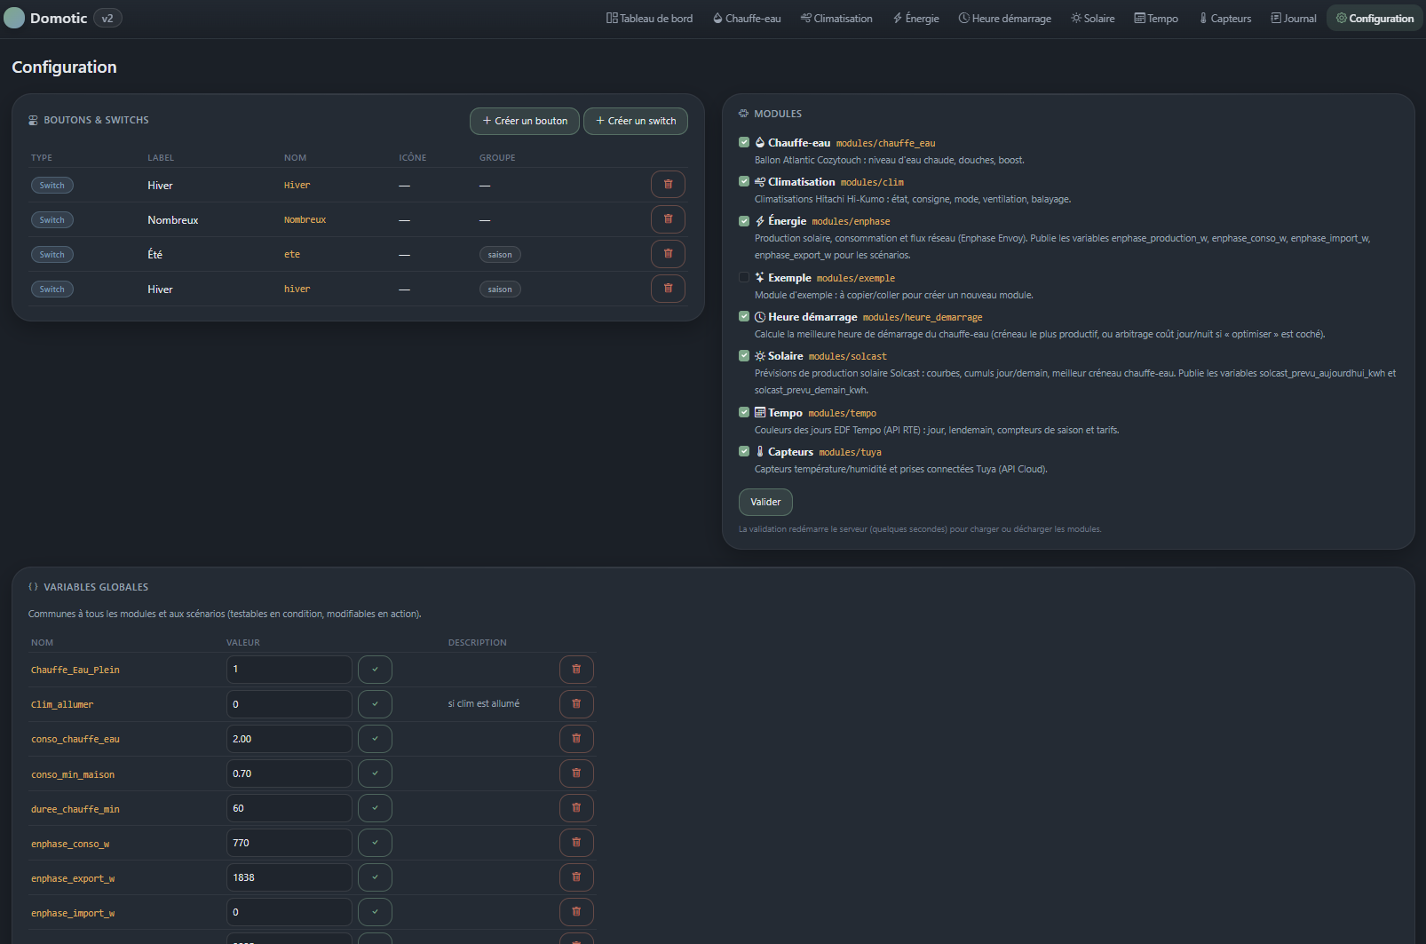
Configuration tab

Enabling modules
The Modules section lists what is present in the modules/ directory. Tick a module then click Valider:
- the module is registered in the database;
- the server restarts automatically;
- its tab appears in the navigation bar, and its block on the dashboard if it provides one.
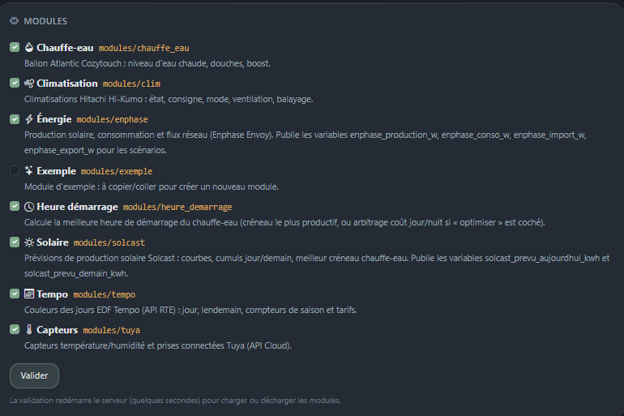
Detected modules
Unticking and validating removes the tab and the block without deleting the module's settings: ticking it again later restores the configuration.
A module with an invalid conf.py stays listed with its error message rather than preventing the whole application from starting.

Push buttons and switches
These are the controls shown in the Scénarios block of the dashboard, and the simplest triggers for a scenario.
Type | Behaviour | Typical use
Push button | a single impulse, no state kept | "Start heating now"
Switch | stays ON or OFF | "Many showers" mode, "Summer / Winter"

A switch can belong to an exclusive group: turning one on automatically turns off the others in the group. That is what links the "Été" and "Hiver" switches of the Start time module.
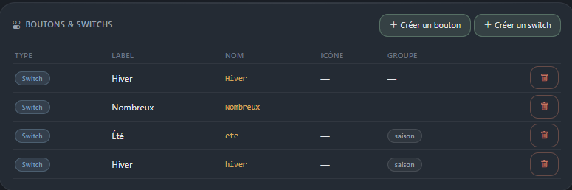
Creating a button or a switch
Beware of duplicates: a control's internal name is what scenarios and modules read. Two switches both displaying "Hiver" but named hiver and Hiver are two different objects, and only one will be read.

Global variables
A variable is a named value shared by every module and every scenario. It can be tested in a condition, changed by an action, and edited by hand from this page.
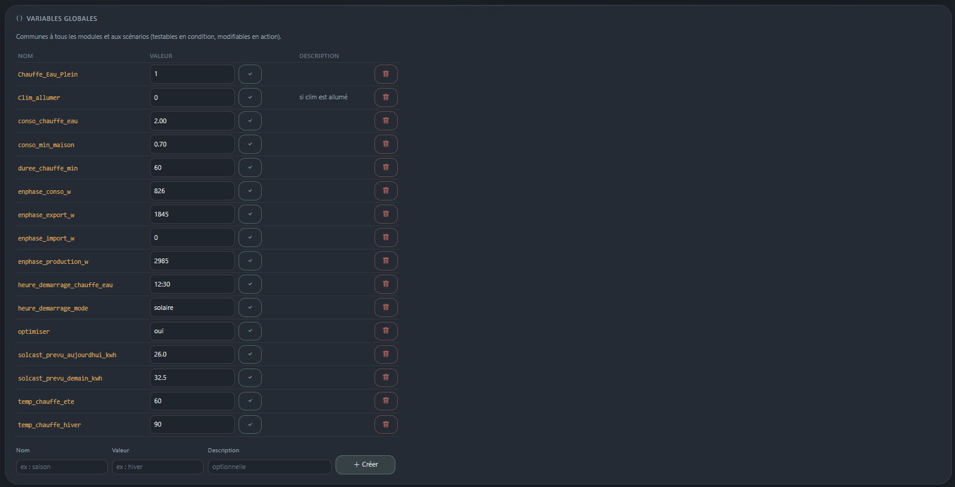
Global variables
They serve three purposes:
- publishing a measurement for scenarios — modules feed enphase_production_w, solcast_prevu_aujourdhui_kwh;
- remembering a state between runs — Clim_allumer, Chauffe_Eau_Plein;
- holding a setpoint that can be changed without touching the code — heure_demarrage_chauffe_eau.
The ✓ button to the right of a variable saves the value typed. That is how you force a value by hand, for example correcting a computed start time.

Scheduler
The Scheduler card is the diagnostic view of background execution:
- running / stopped, with the start-up error if any;
- the list of registered tasks and scenarios, in order of execution, with their next run.
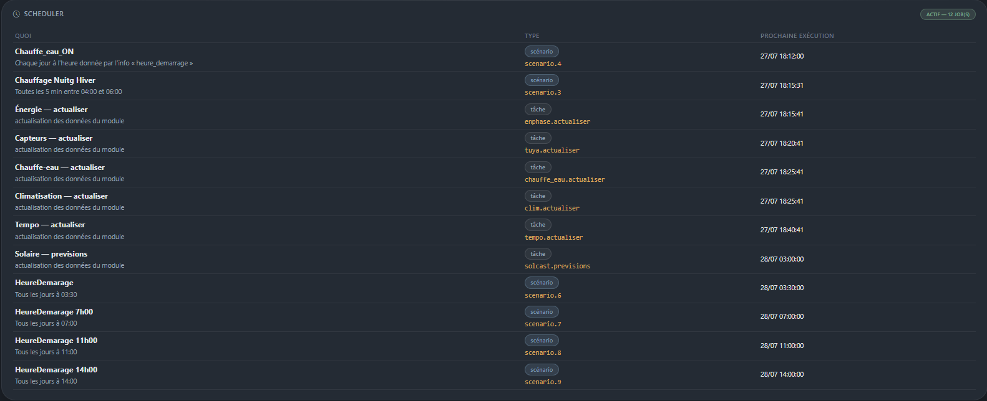
Scheduler card
The names shown are those of the scenarios and modules; the technical identifier (scenario.4, solcast.previsions) is recalled underneath for troubleshooting.
If this card says stopped, nothing runs automatically: start there before investigating why a scenario does not fire.

Log
The Journal tab records everything the application does: scenario runs, API errors, setting changes. It can be filtered by module and by level (info, warning, error).
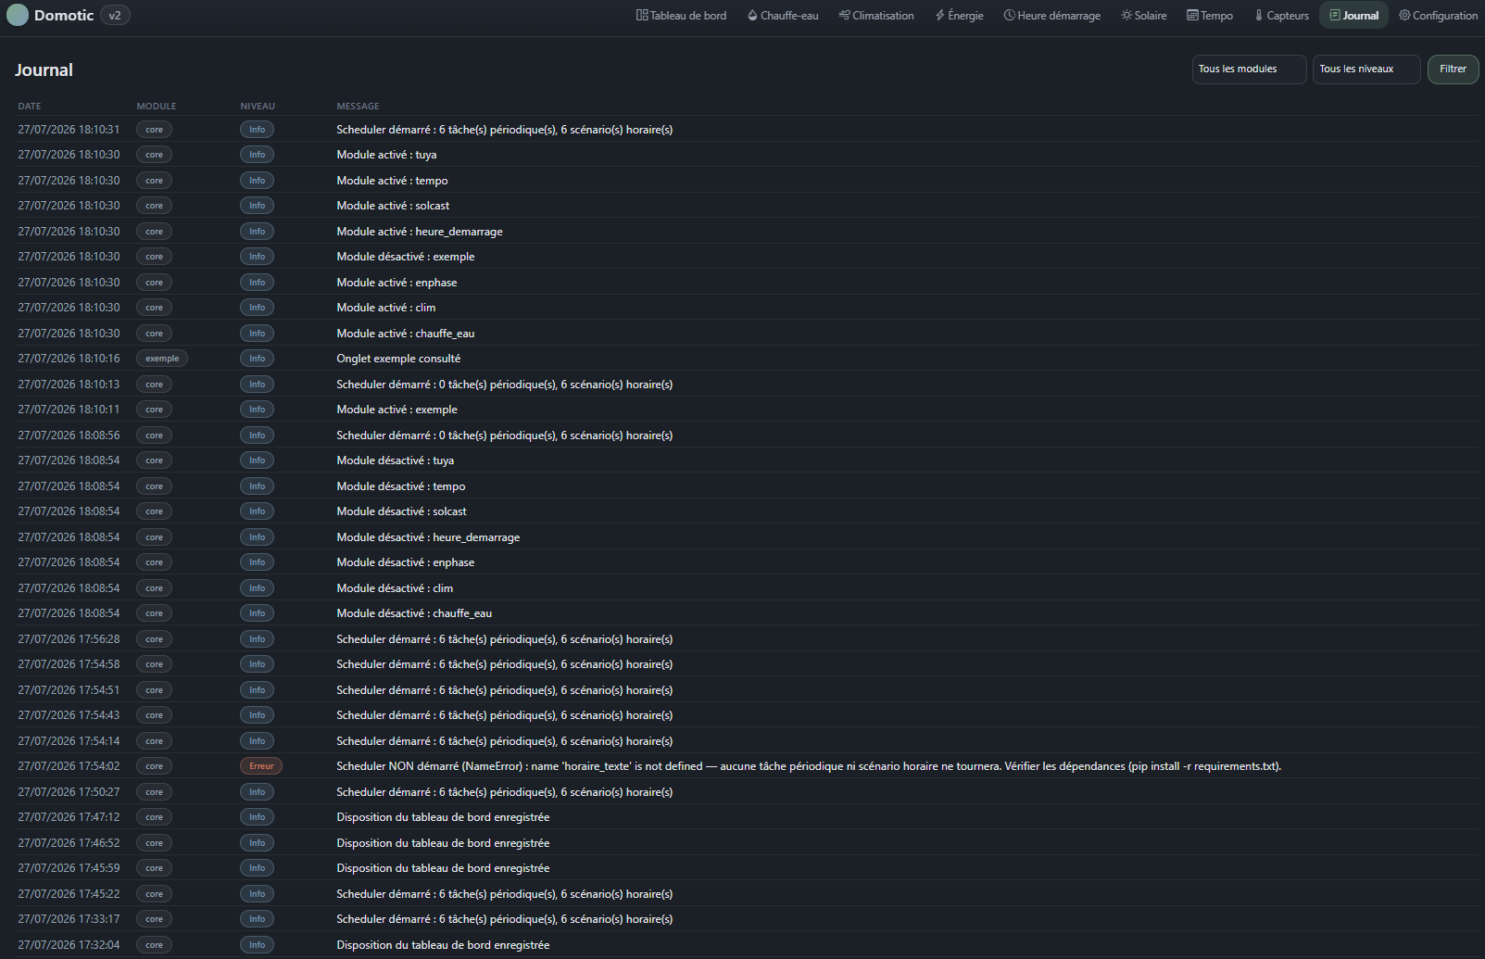
Log
It is the first place to look when a behaviour is surprising: scenarios write the origin of their trigger there, and on failure, the condition that was not met.

The dashboard
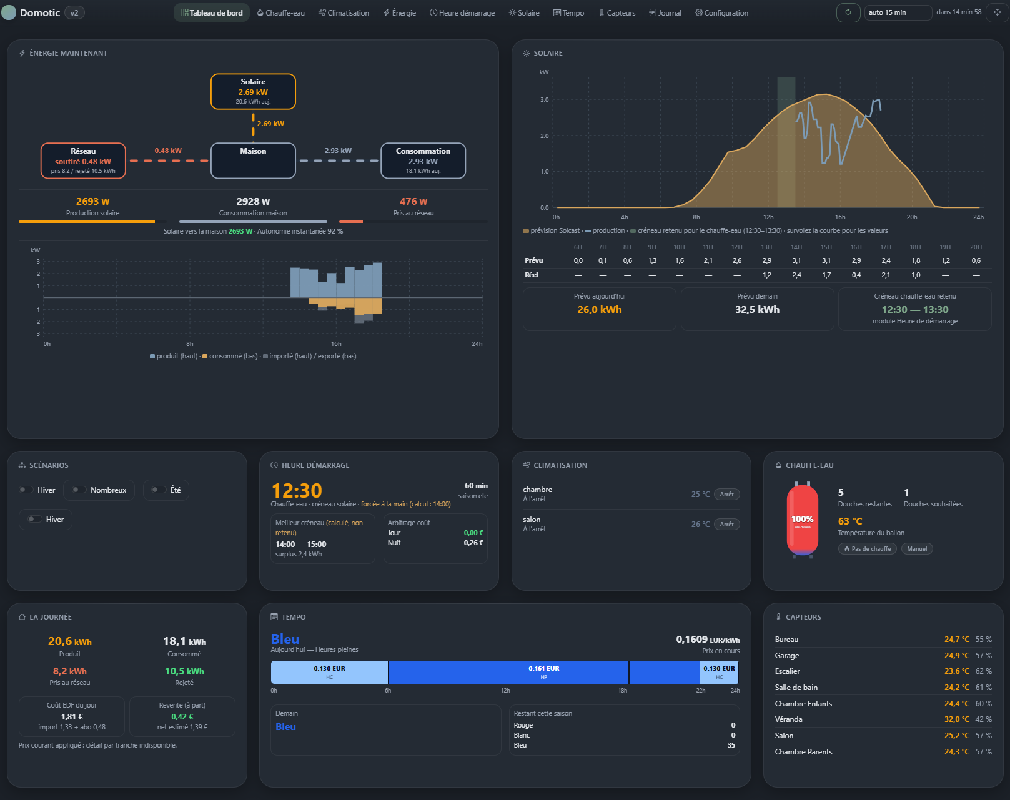
Dashboard
The dashboard assembles:
- the Scénarios block — the push buttons and switches created in Configuration;
- one or more blocks per active module: each module decides what it displays.
A module may provide several blocks (the Energy module offers two: "Énergie maintenant" and "La journée").

Action bar
The dashboard commands sit in the navigation bar, to the right of the tabs:
Command | Effect
⟳ | Reloads the page immediately
auto N min | Automatic refresh, with a countdown
✥ | Switches to Organise mode

The automatic refresh is a setting stored in the database, so it behaves the same from the PC and the phone. The countdown resets when the tab goes to the background, so the page does not reload the moment you come back to it.
The Refresh button reloads the page; it does not re-run any calculation and does not trigger any quota-bound API call. It refreshes local measurements (Enphase, Tuya, water heater). The water-heater start time and the solar forecast do not move — see *Scenarios* and *Bundled modules*.

Organise mode
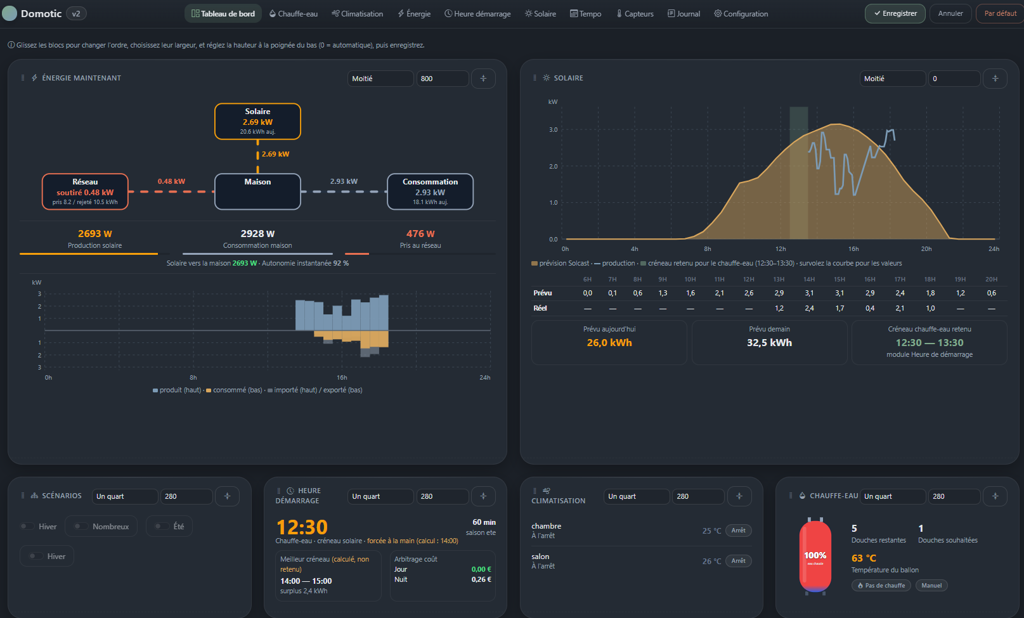
Organise mode
In Organise mode, each block can be:
- moved by drag and drop, to change the order;
- resized in width with the selector: a quarter, a third, a half, two thirds, full width;
- resized in height with the handle at the bottom of the block, or by typing a value in pixels.
The ⤡ button next to the field sets the height back to automatic.
Three points about height:
- Automatic (0): the block takes the height of its content, and lines up with the tallest block on its row.
- Fixed height: the block is exactly that size. Taller than its content, it creates space and lets you align a row; shorter, its content scrolls inside.
- A block with a fixed height is no longer stretched by the tallest block on its row: that is what lets you take back control of an unbalanced row.
Automatic refresh is suspended in Organise mode: a reload in the middle of a drag would lose the layout.
Enregistrer saves the layout, Annuler leaves without changes, Par défaut clears the custom layout and returns to the original placement.

Blocks and modules
A failing block does not prevent the dashboard from displaying: the framework catches the exception, writes the line to the Log and moves on to the next block. A block missing while its module is active is therefore often a rendering error to look for in the Log.

Scenarios
A scenario is three things:
TRIGGER → CONDITIONS → ACTIONS
when? if? do what?
It is created from Configuration → Nouveau scénario.
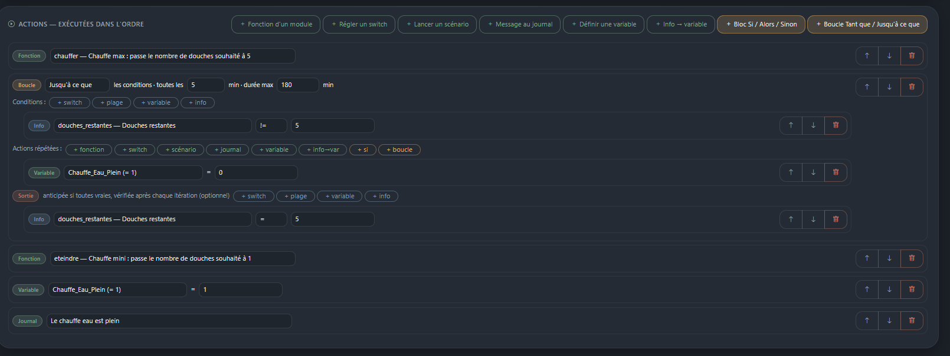
Scenario editor

Triggers — when should the scenario run?
Trigger | When | Notes
Manual | ▶ Test button, or called by another scenario | The only one that never fires on its own
Every day at a fixed time | At the time given | Cron job
Every day at a computed time | At the time read from a variable or a module info | One run per day only
On a value change | When a variable or an info changes | Adjustable polling, optional filter on the resulting value
Every X minutes | Periodic, with an optional time window | Acts as "while" / "until"
Button press | Immediate
Switch toggle | When the switch goes ON or OFF

Computed time
The time is re-read at every check from a global variable or a module info. It may therefore change during the day, but the scenario fires only once per day.
A 10-minute catch-up is built in: if the exact minute is missed (busy server, restart, momentarily unreadable source), the trigger still fires within the following ten minutes. Without it, a single missed minute cancelled the day's heating. The delay is set by the rattrapage_min setting of the scenarios module.
Pitfall: pointing this trigger at an info that recomputes on every read gives a moving target. The water-heater start time calculation only keeps future slots: at 12:30 the 12:30 slot is no longer a candidate and the time retreats ahead of the clock. Point the trigger at a variable, fed when you decide.

On a value change
Compares the current value to the previous one, stored in the database — so monitoring survives a restart. Three safeguards:
- an unreadable source fires nothing and does not overwrite the reference: an unreachable API must not look like a change;
- the first reading becomes the reference without firing, otherwise every server start would run the scenario;
- if you edit the scenario to watch something else, the reference starts afresh instead of comparing two unrelated values.
The "only if the value becomes" field restricts firing to a specific arrival value (for example the Tempo colour turning rouge).
The check interval is adjustable, because a module info may query a device or an API.

Conditions — under what reservations?
Four types: switch state, time range (inside / outside), variable (with operators), module info (with operators).
No condition means the scenario always runs.

AND / OR
From the second condition onwards, an ET / OU selector links each line to the previous one. AND binds tighter than OR, as in boolean algebra:
A AND B OR C AND D reads as (A AND B) OR (C AND D)
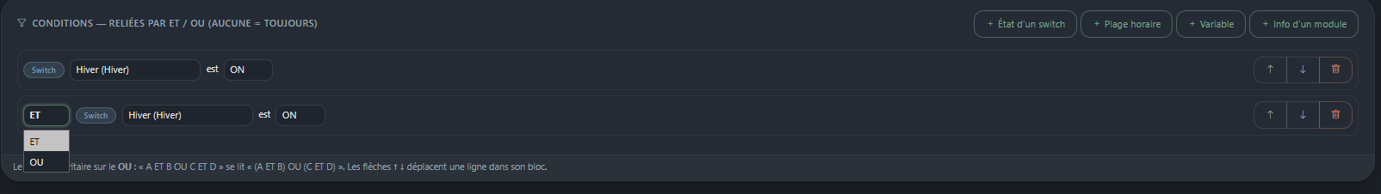
Conditions with AND and OR
When no branch is satisfied, the Log details why each one failed, instead of giving a single reason.

Actions — what to do?
Action | Effect
Module function | Calls a function exposed by a module (with parameters if it declares any)
Set a switch | Sets a switch to ON or OFF
Run a scenario | Chains to another scenario (3 levels maximum)
Log message | Records a step
Set a variable | Assigns a value
Info → variable | Stores the result of a module info into a variable
If / Then / Else block | Conditional branch
While / Until loop | Repetition with interval, maximum duration and early exits

Actions run in order, and stop at the first error. If blocks and loops nest 3 levels deep.
A "set a switch" action does not re-trigger the scenarios of that switch: this is deliberate, to avoid accidental loops. To chain, use "run a scenario" explicitly.

Reordering lines
Every condition and every action has ↑ ↓ arrows to move it within its block. Movement stays confined: an action in a *Then* cannot jump into the *Else*.

Testing
The ▶ button in the scenario list runs the scenario immediately, conditions included. The Log shows the result, and for a failure, the condition that blocked it.

Full example — water heater at the best moment
Two complementary scenarios:
1. Compute the time (named HeureDemarage)
- Trigger: every day at 03:00 — just after the 3 a.m. Solcast refresh
- Action: *Module function* → Heure démarrage → recalculer
recalculer writes the heure_demarrage_chauffe_eau variable and logs the details of the calculation (slot chosen, day/night cost comparison).
2. Start heating (named Chauffe_eau_ON)
- Trigger: *computed time* → a global variable → heure_demarrage_chauffe_eau
- Condition (optional but recommended): info calcul_du_jour = oui, so heating does not start on a time computed the day before
- Action: *Module function* → Chauffe-eau → chauffer
Going further, a third scenario on the change of solcast_prevu_aujourdhui_kwh can re-run recalculer when the day's forecast moves significantly.

Bundled modules
Each module is configured in its own tab, "Paramétrage" section.
Module | Tab | What it provides
chauffe_eau | Chauffe-eau | Atlantic tank via Cozytouch: state, remaining showers, forced heating
clim | Climatisation | Hitachi Hi-Kumo air conditioners: on/off, mode, setpoint
enphase | Énergie | Local Envoy gateway: production, consumption, grid, daily chart
solcast | Solaire | Production forecast, best heating slot
tempo | Tempo | EDF Tempo day colours and tariffs
tuya | Capteurs | Tuya sensors and plugs
heure_demarrage | Heure démarrage | Computes the best time to heat the tank

Energy (Enphase)
Queries the Envoy gateway locally — no quota, no cloud.
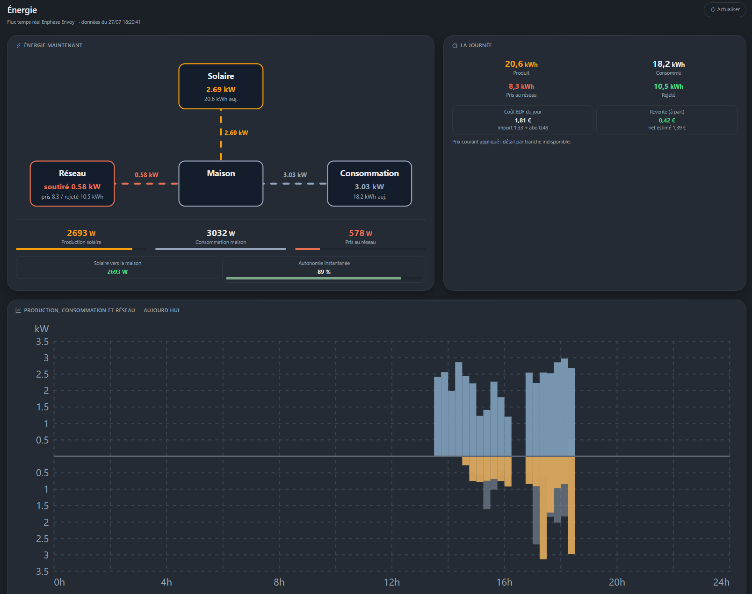
Energy tab
The dashboard block combines the flow diagram, the instantaneous power figures and the daily chart:
- blue: production, above the axis
- orange: consumption, below the axis
- grey: grid, in the background — above if imported, below if exported
The axis shows no sign: an orange bar pointing down is still a consumption of 1.8 kW, not "−1.8 kW".
This chart is built from a local history: every reading of the Envoy records a point (production, consumption, grid) in 5-minute slots, reset each night. No external call, no quota. It therefore fills up during the day, and is only complete if the scheduler is running.
Publishes the variables enphase_production_w, enphase_conso_w, enphase_import_w, enphase_export_w.

Solar (Solcast)
Photovoltaic production forecast, and the best slot to heat the tank.
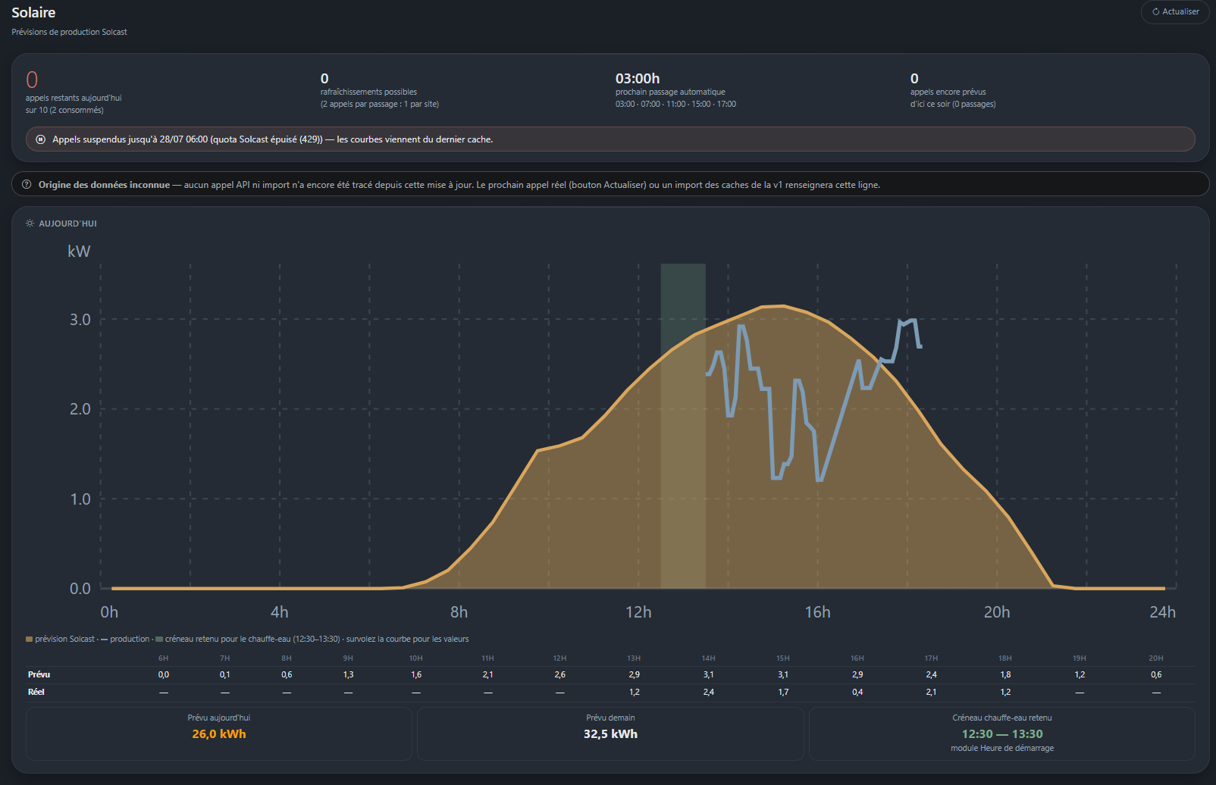
Solar tab

The quota, to understand first
The free Solcast plan grants 10 calls per day for the account, and each request costs one call per site. With two roof planes, one refresh therefore costs 2 calls — at most 5 refreshes a day.
Three cumulative safeguards:
- Page views never call the API. Only the scheduled refresh and the Refresh button may. Otherwise the number of calls would depend on how often you look at the dashboard.
- A daily counter with a ceiling (setting quota_jour, 10 by default), reset every day, and aligned with the truth as soon as a 429 arrives: Solcast counted 10 calls, so we believe it rather than our local tally.
- A backoff: a network error suspends calls for 30 minutes, a 429 suspends them until 6 a.m. the next day. Without it, a failure writing no cache meant every page view launched another call — hence bursts of dozens of refused calls.
The tab permanently shows the remaining calls, the refreshes still affordable, the next run and what is planned before the evening.

Choosing the times
The Paramétrage section lets you add and remove refreshes one by one. Minutes are free (07:30 is valid). The cost is displayed live below the list, in orange if the total exceeds the quota.
No times at all means no automatic call; only the Refresh button acts. Taken into account at the next server start.

Start time
A calculation module with no equipment of its own: it combines the solar forecast, the baseline consumption of the house and the Tempo tariffs to propose the best moment to heat the tank.
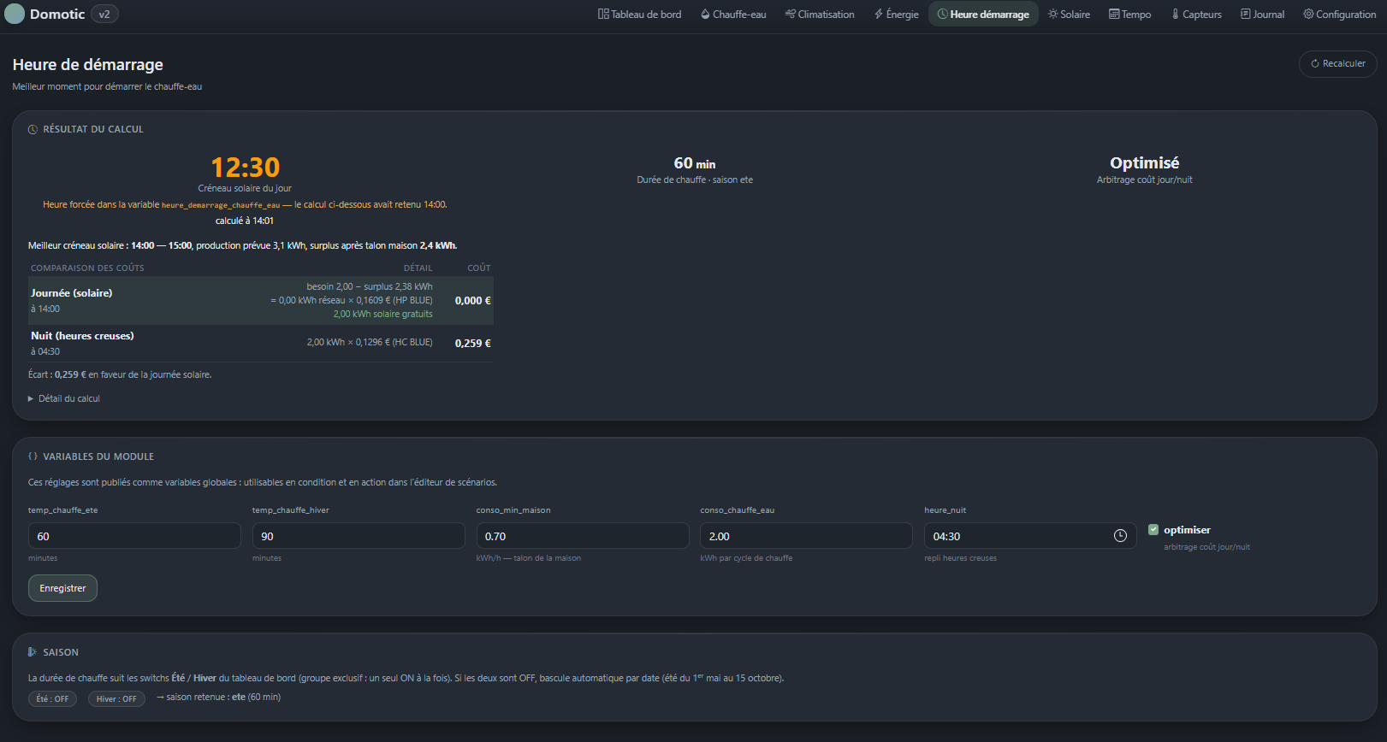
Start time tab
The calculation is never automatic. It only happens on demand: the recalculer scenario action, or the Recalculer button on the tab. Its result is stored, and it is that snapshot which the dashboard, the module infos and the triggers read.
This is deliberate: the calculation only keeps future slots, so an info that recomputed on every read produced a time that retreated ahead of the clock, one the trigger never caught.
The `heure_demarrage_chauffe_eau` variable is authoritative. It is written by recalculer, editable by hand in Configuration, and takes precedence over the stored calculation: if the two differ, the interface shows the forced time with a note saying so.
Season: the Hiver switch decides. If it is off — whether "Été" is on or both are off — it is summer, hence the short heating duration. No automatic switching by date.
Infos useful in conditions: heure_demarrage, mode_retenu, calcul_du_jour (is the last calculation from today?), heure_calcul, gain_estime_eur, surplus_creneau_kwh.

Tempo
EDF Tempo day colours through the RTE API, peak/off-peak tariffs by colour, season counters. Feeds the cost arbitration of the Start time module.

Water heater, Air conditioning, Sensors
Equipment modules: they expose their state as infos and their commands as scenario actions. Configuration (Cozytouch, Hi-Kumo, Tuya credentials) is done in the module's tab.
The Atlantic water heater has no direct "heat" command: forcing a full heating cycle amounts to setting the number of desired showers to the maximum, and returning to normal operation to setting it back to the minimum. That is what the chauffer and eteindre functions do.

Creating a module
A module is a directory under modules/. The framework knows nothing about its contents: it reads its conf.py and calls the entry points the module declares. Adding a capability to the application therefore requires no change to the framework.

Structure
modules/mon_module/
├── __init__.py
├── conf.py manifest — the only mandatory file
├── fonctions/
│ ├── __init__.py
│ ├── api.py talks to the device or the API
│ ├── info.py readings exposed to scenarios (INFOS)
│ ├── scenario.py actions exposed to scenarios (SCENARIO)
│ └── affichage.py chart building (optional)
├── onglet/
│ ├── __init__.py
│ └── views.py onglet(request) function
├── dashboard/
│ ├── __init__.py
│ └── views.py bloc(request) or blocs(request) function
└── templates/mon_module/
├── onglet.html
└── _bloc.html
Only conf.py is mandatory. A module may have only a tab, or only a dashboard block, or neither (the Start time module is essentially a calculation module).
The simplest approach is to copy `modules/exemple/` and rename it.

The manifest — conf.py
"""Manifest of My Module."""

ONGLET = "Mon module" # mandatory: tab name
ICONE = "thermometer-half" # Bootstrap Icons name
DESCRIPTION = "What this module does, in one sentence."

# Background tasks, run by the framework scheduler
TACHES = [
{"nom": "actualiser", "fonction": "fonctions.api.tache_actualiser", "minutes": 10},
]

# Actions offered in the scenario editor
SCENARIO = [
{"nom": "allumer", "fonction": "fonctions.scenario.allumer",
"description": "Turns the device on"},
]

# Readings offered in conditions and in "Info → variable"
INFOS = [
{"nom": "temperature", "fonction": "fonctions.info.temperature",
"description": "Measured temperature (°C)"},
]
ONGLET is used as the tab label; ICONE must be a Bootstrap Icons name without the `bi-` prefix.
Each contract is detailed in *Contract reference*.

The tab — onglet/views.py
The framework calls the onglet(request) function when the tab is clicked. It is an ordinary Django view.
from django.shortcuts import render

from core.services import get_setting, journal

from ..fonctions import api

def onglet(request):
if request.method == "POST" and request.POST.get("action") == "params":
# save the configuration entered
...

return render(request, "mon_module/onglet.html", {
"active_tab": "module:mon_module", # highlights the tab
"mesure": api.lire(),
})
active_tab must be "module:<directory_name>" for the tab to appear active in the navigation bar.

The dashboard block — dashboard/views.py
Two possible contracts:
from django.template.loader import render_to_string

from ..fonctions import api

def bloc(request):
"""A single block: returns HTML (or an empty string to show no block)."""
return render_to_string("mon_module/_bloc.html", {"mesure": api.lire()})
def blocs(request):
"""Several blocks: a list of dictionaries."""
return [
{"titre": "Live view", "icone": "speedometer", "html": "<p>…</p>"},
{"titre": "The day", "icone": "calendar", "html": "<p>…</p>"},
]
The framework already wraps the block in a card with its title: the module only supplies the content.
An exception raised in a block does not prevent the dashboard from displaying: it is logged and the block is skipped.

Framework services
from core.services import (
journal, get_setting, set_setting,
get_variable, set_variable, set_control_state,
)

journal("Heating started", module="mon_module")
set_setting("api_key", "xxx", module="mon_module", secret=True)
get_setting("api_key", module="mon_module", default="")
set_variable("mon_module_temperature", "21.5")
- Settings (get_setting / set_setting): the module's configuration, partitioned by module=. secret=True masks the value in the interface.
- Variables (get_variable / set_variable): public values shared with scenarios and other modules.
- Log (journal): level INFO by default, LogEntry.WARNING or LogEntry.ERROR otherwise.

Attaching the module to the framework
- Place the directory in modules/.
- Configuration tab → Modules section → tick the module → Valider.
- The server restarts: the tab appears, so does the block, tasks are registered and the declared functions become available in the scenario editor.
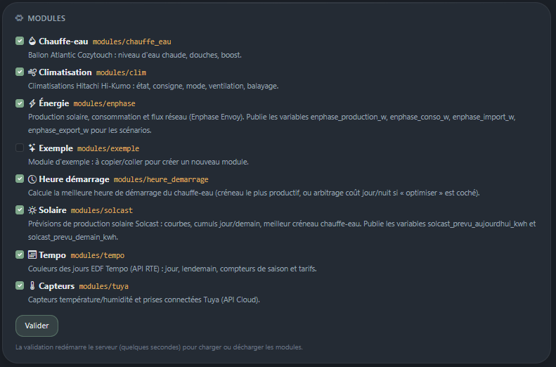
Enabling a module
An enabled module becomes a full Django app: it can have its own templates, models and migrations.

Checking
What to check | Where
The module is detected | Configuration → Modules
The tab is shown | navigation bar
The block is shown | Dashboard
The tasks are registered | Configuration → Scheduler
Actions and infos are offered | scenario editor
No errors | Log, filtered on the module

Common mistakes
- Invalid `conf.py` — the module stays listed with its error message. Beware of top-level imports: conf.py is loaded very early, and a heavy or failing import breaks detection. The bundled modules wrap their dynamic imports in a try/except.
- Tab not highlighted — active_tab is wrong.
- Template not found — templates must live in modules/<name>/templates/<name>/; the subdirectory named after the module avoids collisions between modules.
- A task does not run — check the Scheduler card, and that the fonction path is relative to the module directory (fonctions.api.tache_actualiser, with no modules.<name>. prefix).
- A disabled module stays in the bar — the restart did not happen; relaunch runserver.

Contract reference
Everything a module can declare, and what the framework does with it.

conf.py
Constant | Type | Mandatory | Purpose
ONGLET | str | yes | Tab label
ICONE | str | no | Bootstrap Icons name, without bi- (default: puzzle)
DESCRIPTION | str | no | Shown in the module list
TACHES | list | no | Background tasks
SCENARIO | list | no | Actions offered in the editor
INFOS | list | no | Readings offered in the editor

TACHES — background tasks
Two possible schedules.

Every X minutes
TACHES = [
{"nom": "actualiser", "fonction": "fonctions.api.tache_actualiser", "minutes": 10},
]
- Overridable in the database by the module's tache_<name>_minutes setting
- 0 = task disabled
- First run about 10 seconds after start-up

At fixed times
TACHES = [
{"nom": "previsions", "fonction": "fonctions.api.tache_actualiser",
"heures": ["03:00", "07:00", "11:00", "15:00", "17:00"]},
]
- Accepts whole hours (7) or times ("07:30")
- Overridable by the tache_<name>_heures setting ("3,7:30,11"), empty = disabled
- No run at start-up: the number of runs per day is exactly the length of the list — essential against a quota-bound API
- Times with different minutes produce several cron jobs (module.task, module.task.1)
In both cases, fonction is a path relative to the module directory, without the modules.<name>. prefix.
Only errors are logged, not successful runs.

SCENARIO — exposed actions
SCENARIO = [
{"nom": "allumer",
"fonction": "fonctions.scenario.allumer",
"description": "Turns the device on",
"params": [
{"nom": "mode", "label": "Mode", "options": [
["", "(unchanged)"], ["auto", "Auto"], ["heating", "Heating"]]},
]},
]
- params is optional: each entry becomes a dropdown in the editor, and its value is passed to the function as a keyword argument
- An empty value is not passed, which allows "(unchanged)" options
- The return value is logged: returning a short string describing what was done is good practice
For dynamic entries (one action per plug, per air conditioner), build the list in the module and expose it through a function:
try:
from modules.mon_module.fonctions.scenario import build_scenario_entries
SCENARIO = build_scenario_entries()
except Exception:
SCENARIO = []
The try/except matters: a conf.py that raises makes the module undetectable.

INFOS — exposed readings
INFOS = [
{"nom": "temperature",
"fonction": "fonctions.info.temperature",
"description": "Measured temperature (°C)"},
]
An info is a function with no argument returning a simple value (number, text, None). It can be used:
- in a condition, with the operators =, ≠, <, ≤, >, ≥;
- in the Info → variable action;
- as the source of a computed time trigger (it must then return HH:MM) or a value change trigger.
An info may be read very often — every minute for a trigger, on every page view for a block. It must therefore be cheap: read a cache, do not query a quota-bound API. And it must be stable: an info that recomputes on every call makes triggers unpredictable.

Display entry points
File | Function | Returns
onglet/views.py | onglet(request) | Django response (render(...))
dashboard/views.py | bloc(request) | The block HTML, or ""
dashboard/views.py | blocs(request) | [{"titre", "icone", "html"}]

If both exist, blocs wins.

Framework services — core.services
Function | Signature | Purpose
journal | journal(message, module="core", level=LogEntry.INFO) | Writes to the Log
get_setting | get_setting(key, module="core", default=None) | Reads a setting
set_setting | set_setting(key, value, module="core", secret=False) | Writes a setting
get_variable | get_variable(name, default=None) | Reads a global variable
set_variable | set_variable(name, value) | Writes a global variable
set_control_state | set_control_state(control, on) | Toggles a switch, honouring its exclusive group

Log levels: LogEntry.INFO, LogEntry.WARNING, LogEntry.ERROR.

Framework settings
Key | Module | Purpose
dashboard_refresh_minutes | core | Dashboard auto-refresh (0 = off)
rattrapage_min | scenarios | Catch-up window for "computed time" triggers (10 by default)
declenche_<pk> | scenarios | Date a time-based scenario last fired
valeur_<pk> | scenarios | Last value seen by a "value change" trigger
tache_<name>_minutes | *module* | A task's interval
tache_<name>_heures | *module* | A task's fixed times

Data models
Model | Purpose
Module | A detected module, enabled or not
Setting | Key/value setting, partitioned by module
Variable | Shared global value
Control | Push button or switch, with exclusive group
Scenario | JSON definition: trigger, conditions, actions
DashboardBlock | Order, width and height of a block
LogEntry | One log line

Troubleshooting

No scenario fires, no data refreshes
The scheduler is not running. This is the most frequent and the most discreet failure: the application displays normally, pages compute their values on the fly, and nothing betrays the problem.
Check in order:
- Configuration → Scheduler card: it shows "à l'arrêt" and the start-up error.
- Log: search for "Scheduler". A line "Scheduler démarré: N task(s), M scenario(s)" must appear at every launch. Its absence confirms the diagnosis.
Possible causes:
Cause | Fix
APScheduler missing from the environment | pip install -r requirements.txt
Launched by something other than runserver | The scheduler only starts with runserver, by design
Error while starting a task | The message is in the Log and on the Scheduler card

A "computed time" scenario never fires
Three causes, in order of frequency:
- The source recomputes on every read. If the trigger reads an info that redoes its calculation, the target time may drift through the day and never be reached. Point the trigger at a variable, fed when you decide.
- The target time has already passed when the scenario is created or the server restarted. The catch-up only covers 10 minutes; beyond that, firing is postponed to the next day.
- Already fired today: one run per day, even if the time changes afterwards.
The ▶ button lets you check that conditions and actions are correct, independently of the trigger.

Error 429 from Solcast
The free quota is 10 calls per day for the account, and each request consumes one call per site.
- The Solar tab shows the remaining calls and the resume time.
- After a 429, calls are suspended until 6 a.m. the next day: deliberately so, since retrying would only multiply refusals.
- Check that no other client is using the same key. v1 shared the key and consumed the same quota; its calls have been disabled (APPELS_API_AUTORISES = False in v1's solcast/forecast.py) and its update_heater_schedule Windows tasks removed.
- Reduce the number of times in the tab's settings: the cost is displayed live below the list.

The call counter looks wrong
It only sees the calls made by v2. If it reports remaining calls while Solcast already refuses, another client has consumed the quota. As soon as a 429 arrives, the counter aligns with that reality and shows 0 remaining.

A curve stops in the middle of the day
The "real" curve of the Solar module and the Energy module chart are fed by the local Envoy history, one point every 5 minutes.
- If the scheduler is not running, the history only advances when a page is displayed.
- The history is reset every day: an empty curve early in the morning is normal.

A module does not appear
Symptom | Likely cause
Missing from the module list | No conf.py, or a directory starting with _ or .
Listed with an error message | Invalid conf.py — the message gives the exception
Ticked but no tab | The server did not restart: relaunch runserver
Tab present, no block | No dashboard/views.py, or a rendering error (see the Log)

A dashboard block has disappeared
An exception in a block is caught by the framework: the block is skipped and the error written to the Log, filtered on the module concerned. The rest of the dashboard keeps displaying.

Strange text appears in a page
Something like {# … #} visible on screen: a multi-line Django comment. The {# … #} syntax only works on a single line; for a multi-line comment, use {% comment %} … {% endcomment %}.

A change to conf.py has no effect
Tasks and their schedules are read when the scheduler starts. Restart the server. Action and info catalogues, however, are re-read each time the scenario editor is opened.

Resetting the dashboard layout
Organise mode → Par défaut button. This only clears the order, widths and heights of the blocks.

Starting from a clean database
Stop the server, rename db.sqlite3, then:
python manage.py migrate
python manage.py runserver 0.0.0.0:8100
Everything has to be configured again: modules, API keys, controls, scenarios. Keeping the old file allows a rollback.

Appendix — screenshots
Drop the images in docs/images/, in PNG, keeping exactly the file names below: they are already referenced by the documentation.
A placeholder without an image shows an empty frame in the Markdown rendering without breaking the page — the documentation stays readable while the screenshots are being taken.
File | Expected content | Used in
01-premier-demarrage.png | The application on first launch, empty dashboard | Installation
02-configuration.png | The whole Configuration tab | Getting started
02-modules.png | The Modules section, several modules ticked | Getting started
02-controles.png | The Buttons & switches section, or the creation dialog | Getting started
02-variables.png | The Global variables section | Getting started
02-scheduler.png | The Scheduler card with jobs and their next run | Getting started
02-journal.png | The Log tab, ideally with a filter applied | Getting started
03-tableau-de-bord.png | The full dashboard, during the day | The dashboard
03-organiser.png | Organise mode, selectors and height handle visible | The dashboard
04-editeur.png | The scenario editor, one complete scenario on screen | Scenarios
04-conditions.png | Several conditions linked by AND and OR | Scenarios
05-energie.png | The Energy tab with the daily chart | Bundled modules
05-solaire.png | The Solar tab, quota counter and times visible | Bundled modules
05-heure-demarrage.png | The Start time tab with the calculation details | Bundled modules
06-activation.png | The Modules section while ticking a new module | Creating a module

Tips
- Frame the useful area rather than the whole screen: a screenshot of the relevant block alone ages better and stays readable on a phone.
- A width of about 1400 px is enough; beyond that the file grows for no gain.
- Hide sensitive values before publishing: API keys, credentials, the e-mail address in the Enphase settings.
- To add an unplanned screenshot, insert it in the document with ![Description](images/file-name.png) and complete this table.

