Search

[Write](https://medium.com/new-story?source=---two_column_layout_nav----------------------------------)

Romain Pintore

Last chance! 6 days left!

[Get 20% off membership now](https://medium.com/plans?source=upgrade_membership---post_top_nav_upsell----------------------------------)

Romain Pintore

**[This member-only story is on us.](https://medium.com/plans?source=upgrade_membership---post_counter--2b9caad41520--------------------------------)**[Upgrade to access all of Medium.](https://medium.com/plans?source=upgrade_membership---post_counter--2b9caad41520--------------------------------)

Member-only story

**Explaining quality of Arabica coffee beans with Machine Learning**

SHAP values of country, processing method, and other factors

[[](https://medium.com/@dima806?source=post_page-----2b9caad41520--------------------------------)](https://medium.com/@dima806?source=post_page-----2b9caad41520--------------------------------)

[[Data And Beyond](https://medium.com/data-and-beyond?source=post_page-----2b9caad41520--------------------------------)](https://medium.com/data-and-beyond?source=post_page-----2b9caad41520--------------------------------)

[Dmytro Iakubovskyi](https://medium.com/@dima806?source=post_page-----2b9caad41520--------------------------------)

·

Follow

Published in

[Data And Beyond](https://medium.com/data-and-beyond?source=post_page-----2b9caad41520--------------------------------)

·

4 min read

·

Sep 22, 2022

646

2

In this article, I study the factors staying behind the quality of Arabica coffee beans. For this analysis, I used [the dataset available on Kaggle](https://www.kaggle.com/datasets/ankurchavda/coffee-beans-reviews-by-coffee-quality-institute) which contains data on coffee beans reviewed by [Coffee Quality Institute](https://www.coffeeinstitute.org/) and **scored by 10 different criteria:**

* **Aroma**;
* **Flavour**;
* **Aftertaste**;
* **Acidity**;
* **Body**;
* **Balance**;
* **Uniformity**;
* **Clean Cup**;
* **Sweetness**;
* **Cupper Points**.

The individual scores are between 0 and 10 (the higher the better), thus the total score varies from 0 to 100. Full details of the analysis can be found [in this public Kaggle notebook](https://www.kaggle.com/code/dima806/coffee-quality-explain).



Photo by [Mike Kenneally](https://unsplash.com/@asthetik?utm_source=unsplash&utm_medium=referral&utm_content=creditCopyText) on [Unsplash](https://unsplash.com/s/photos/coffee-cup?utm_source=unsplash&utm_medium=referral&utm_content=creditCopyText" \t "_blank)

**Step 1 — data preprocessing**

Here, data preprocessing consists of the following steps:

* dropping reviews without final scores;
* selecting reviews from countries that have at least 10 records in the dataset;
* rescaling mean altitudes to meters;
* replacing null values;
* finally, removing unused columns.

**Step 2 — setting a Machine Learning model to predict the total review scores**

The data prepared with the previous step are randomly split between training and test samples, and modelled with the [CatBoostRegressor](https://catboost.ai/en/docs/concepts/python-reference_catboostregressor" \t "_blank) model that explicitly takes into account categorical features. The [root mean squared error](https://scikit-learn.org/stable/modules/generated/sklearn.metrics.mean_squared_error.html) (RMSE) of the resulting model is **about 4.24 points**, an **improvement compared to the baseline model RMSE of about 4.38 points**(assuming the same **score of about 82.1**for **every** review).

**Step 3 — explanation of the obtained Machine Learning model**

Here, we are using the [SHapley Additive exPlanations (SHAP)](https://shap-lrjball.readthedocs.io/en/latest/index.html" \t "_blank) method, one of the most common to explore the explainability of Machine Learning models. The units of SHAP value are hence in **percentage points**.

First, we look into the span of SHAP values for every feature of our interest:

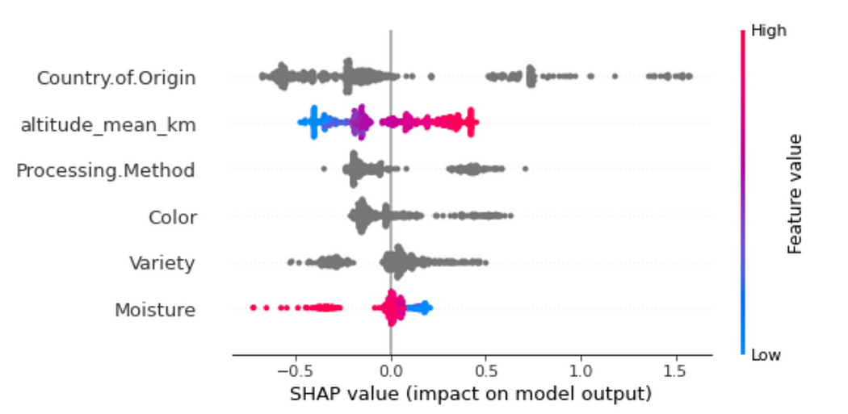

Source: author, [coffee\_quality\_explain | Kaggle](https://www.kaggle.com/code/dima806/coffee-quality-explain" \t "_blank)

*As we see, the most important features for our model are the****country of origin****,****mean altitude****, and****processing method****.*

First, looking for countries of origin, we see that the best quality coffee beans (on average) come from **Ethiopia**, **Uganda**, and **Kenya, with 1–1.5 percentage points better than average reviews**:

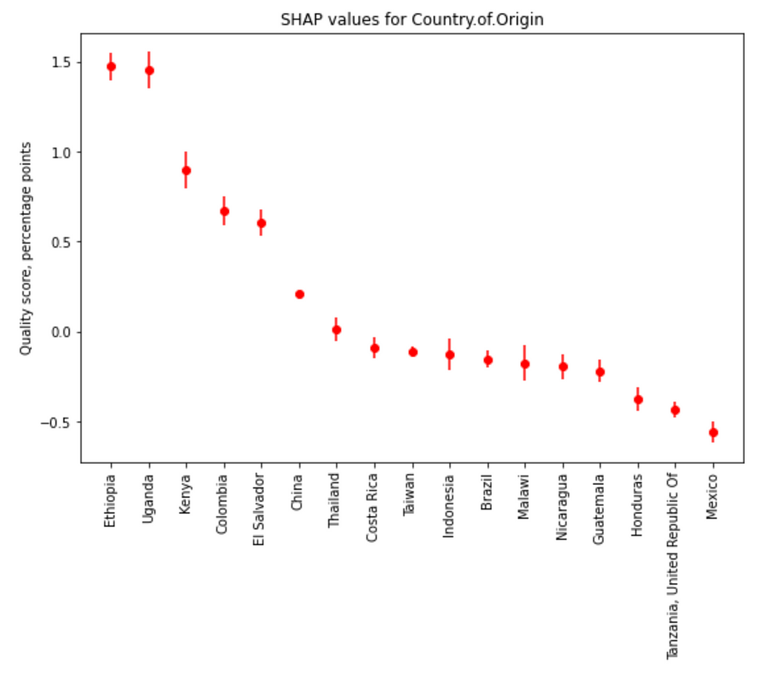

Source: author, [coffee\_quality\_explain | Kaggle](https://www.kaggle.com/code/dima806/coffee-quality-explain" \t "_blank)

*Remarkably, the****best quality coffee beans are grown at altitudes starting from approximately 1.9 kilometres****:*

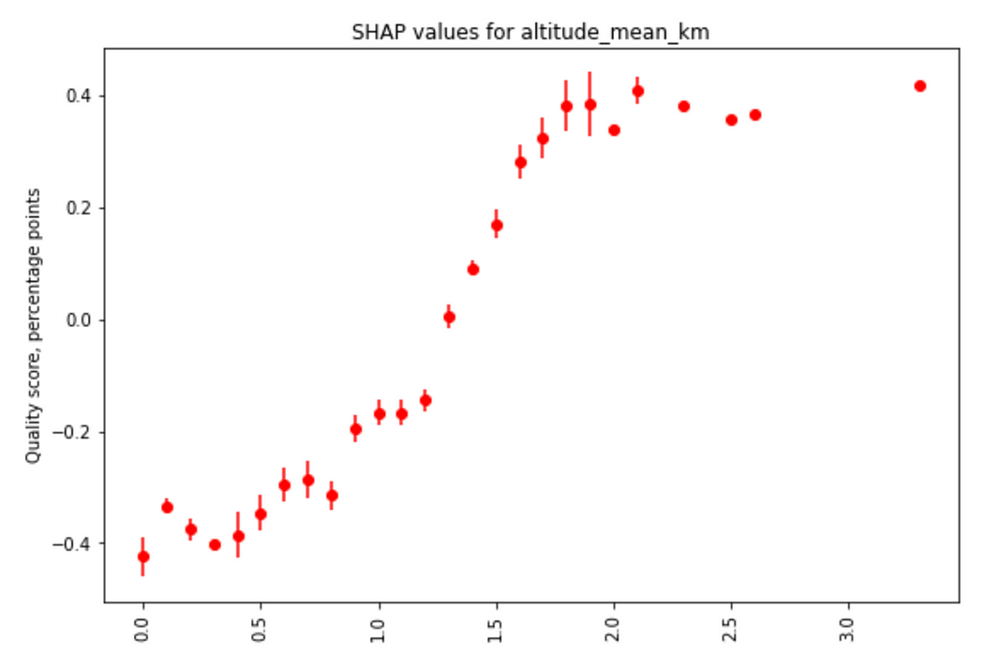

Source: author, [coffee\_quality\_explain | Kaggle](https://www.kaggle.com/code/dima806/coffee-quality-explain" \t "_blank)

Interestingly, according to these reviews, the **best processing methods for coffee beans are**[**Natural / Dry**](https://www.movingbeans.com/blogs/news/what-is-the-natural-dry-process)**and**[**Semi-washed / Semi-pulped**](https://k-agriculture.com/semi-washed-coffee/):

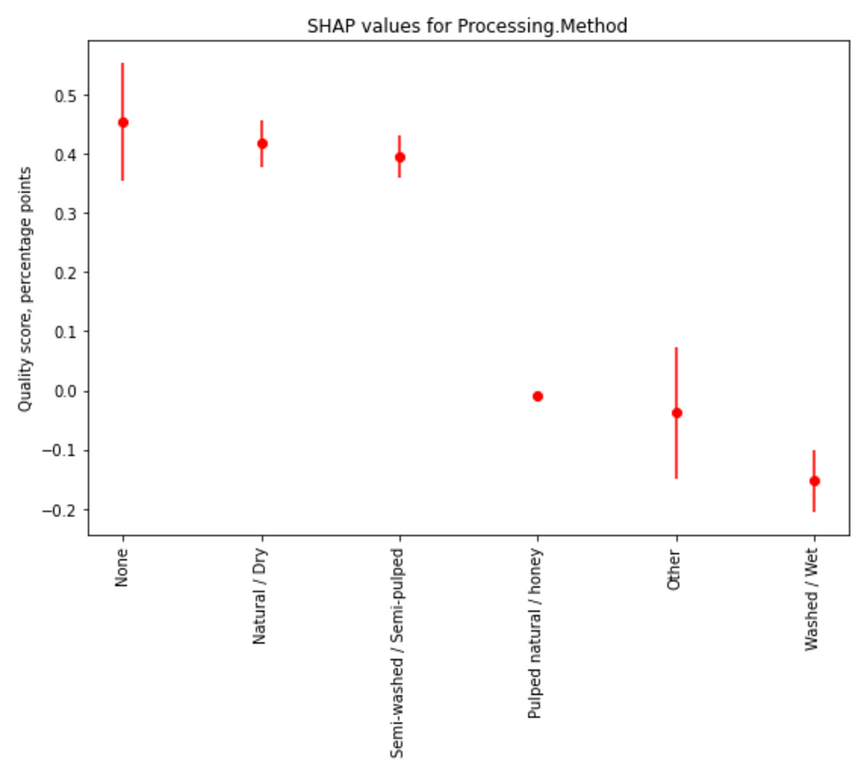

Source: author, [coffee\_quality\_explain | Kaggle](https://www.kaggle.com/code/dima806/coffee-quality-explain" \t "_blank)

while the preferred bean colours are **Bluish-Green** and **Blue-Green**:

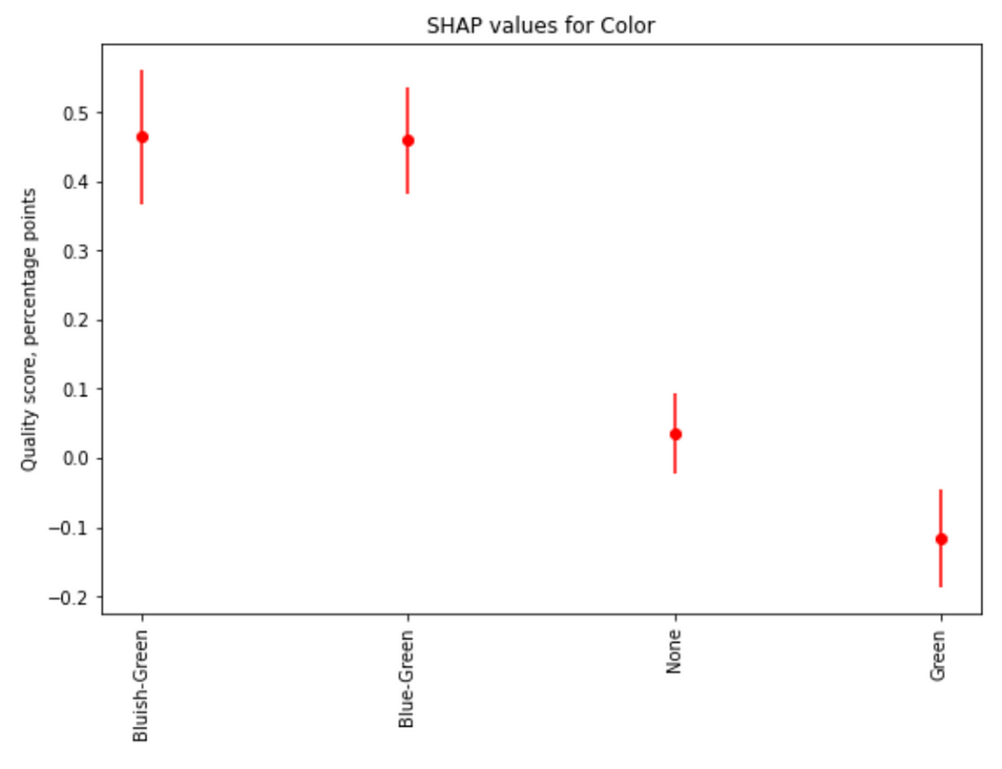

Source: author, [coffee\_quality\_explain | Kaggle](https://www.kaggle.com/code/dima806/coffee-quality-explain" \t "_blank)

The highest scores are assigned to coffee beans varieties [SL28](https://varieties.worldcoffeeresearch.org/varieties/sl28), [Sulawesi](https://coffeefactories.com/sulawesi-coffee/), and [Mandheling](https://espressocoffeeguide.com/gourmet-coffee/asian-indonesian-and-pacific-coffees/indonesia-coffee/sumatra-coffee/sumatra-mandheling-coffee/):

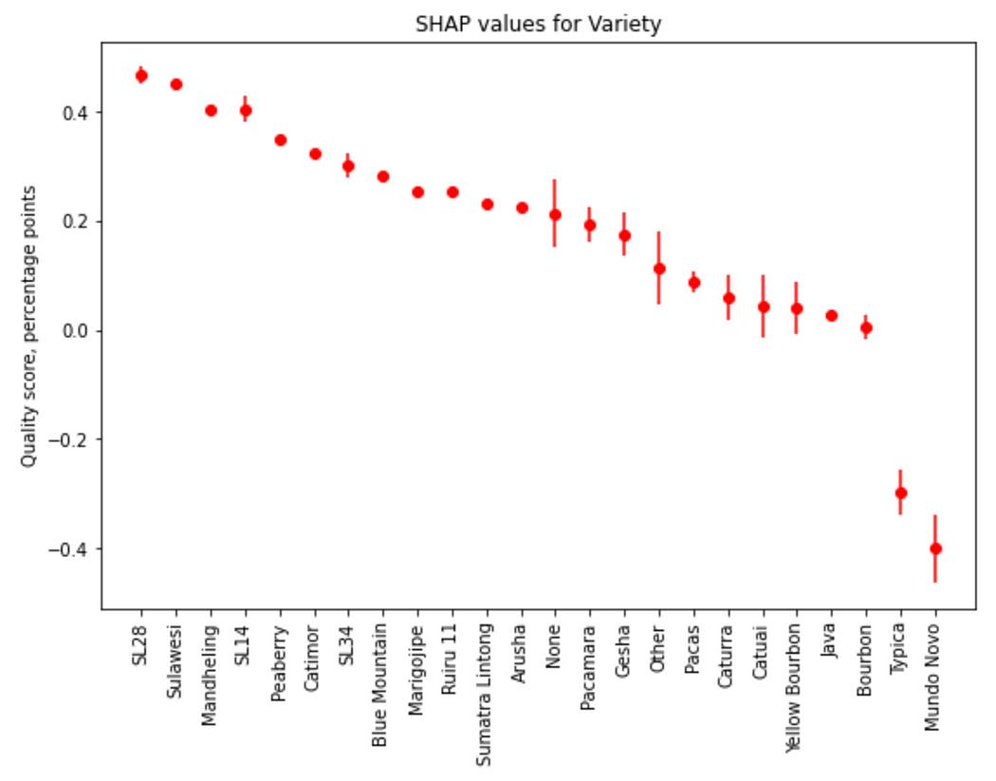

Source: author, [coffee\_quality\_explain | Kaggle](https://www.kaggle.com/code/dima806/coffee-quality-explain" \t "_blank)

Finally, beans with **small and moderate moisture** have the highest average quality scores:

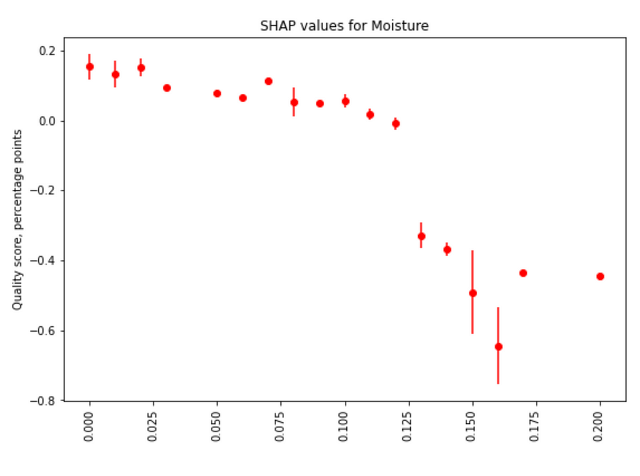

Source: author, [coffee\_quality\_explain | Kaggle](https://www.kaggle.com/code/dima806/coffee-quality-explain" \t "_blank)

**Step 4— modelling of individual scores and their explanations in terms of SHAP values**

Here, I present only the most remarkable differences of individual scores modelling from the behaviour of combined scores. Full details can be found in [a public notebook on Kaggle](https://www.kaggle.com/code/dima806/coffee-quality-explain).

For the **Aroma** score, the **top scored variety is**[**SL14**](https://varieties.worldcoffeeresearch.org/varieties/sl14)**followed by**[**SL28**](https://varieties.worldcoffeeresearch.org/varieties/sl28)**and**[**SL34**](https://varieties.worldcoffeeresearch.org/varieties/sl34):

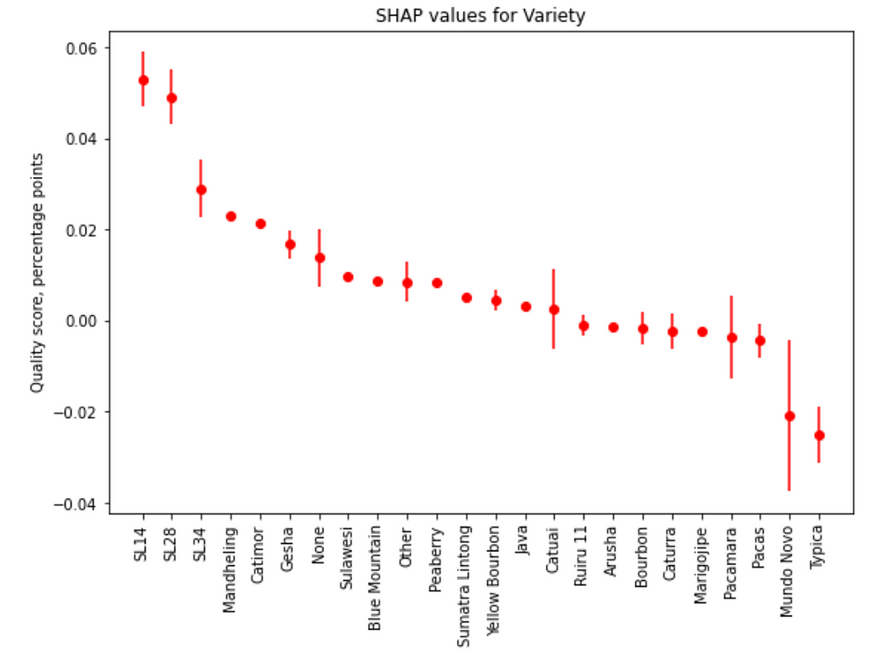

Source: author, [coffee\_quality\_explain | Kaggle](https://www.kaggle.com/code/dima806/coffee-quality-explain" \t "_blank)

Among countries with the best **Flavour** score, **Ethiopian coffee beans are well ahead, followed by beans from Kenya and Uganda**:

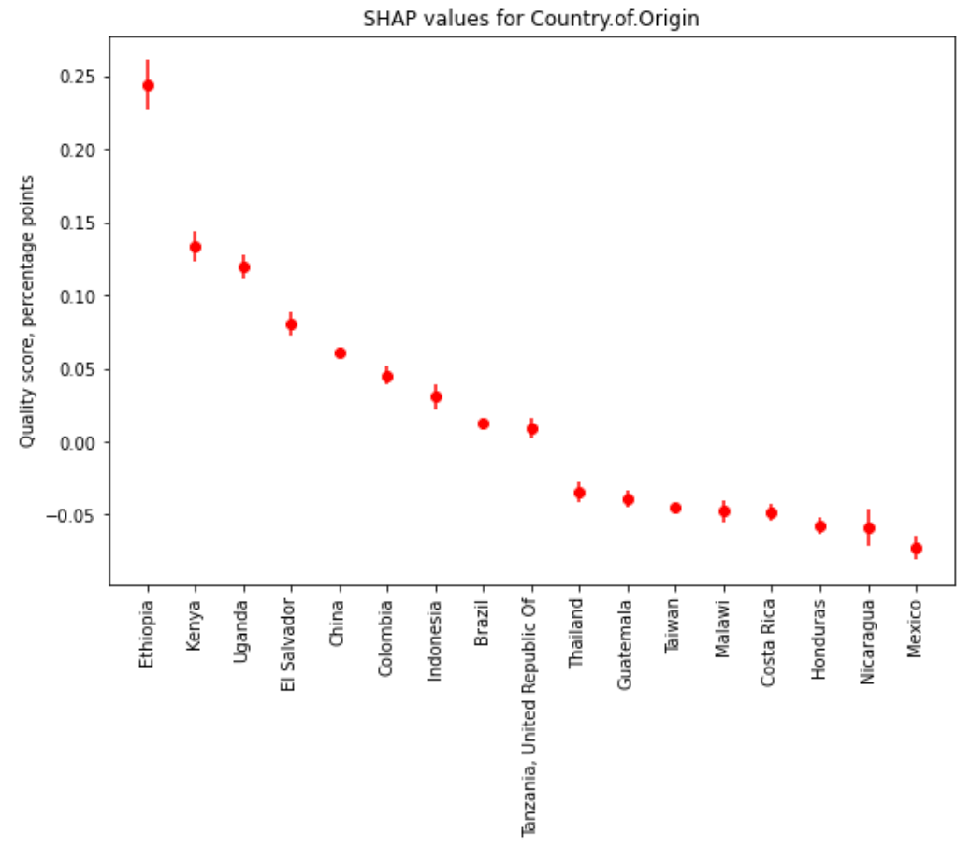

Source: author, [coffee\_quality\_explain | Kaggle](https://www.kaggle.com/code/dima806/coffee-quality-explain" \t "_blank)

and the top-3 varieties for **Flavour are**[**SL28**](https://varieties.worldcoffeeresearch.org/varieties/sl28)**, [Catimor](https://varieties.worldcoffeeresearch.org/varieties/catimor-129" \t "_blank), and [Pacamara](https://varieties.worldcoffeeresearch.org/varieties/pacamara" \t "_blank)**:

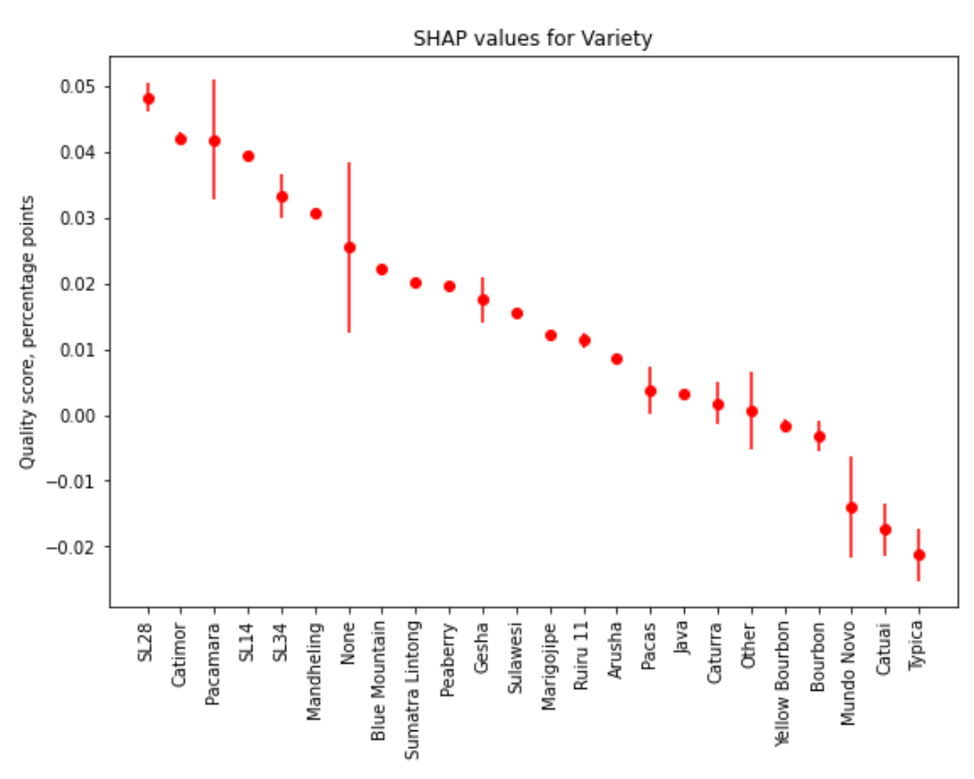

Source: author, [coffee\_quality\_explain | Kaggle](https://www.kaggle.com/code/dima806/coffee-quality-explain" \t "_blank)

In terms of **Aftertaste**, **Ethiopian coffee beans are also scored well ahead of the beans from other countries, followed by beans from Uganda and Kenya**:

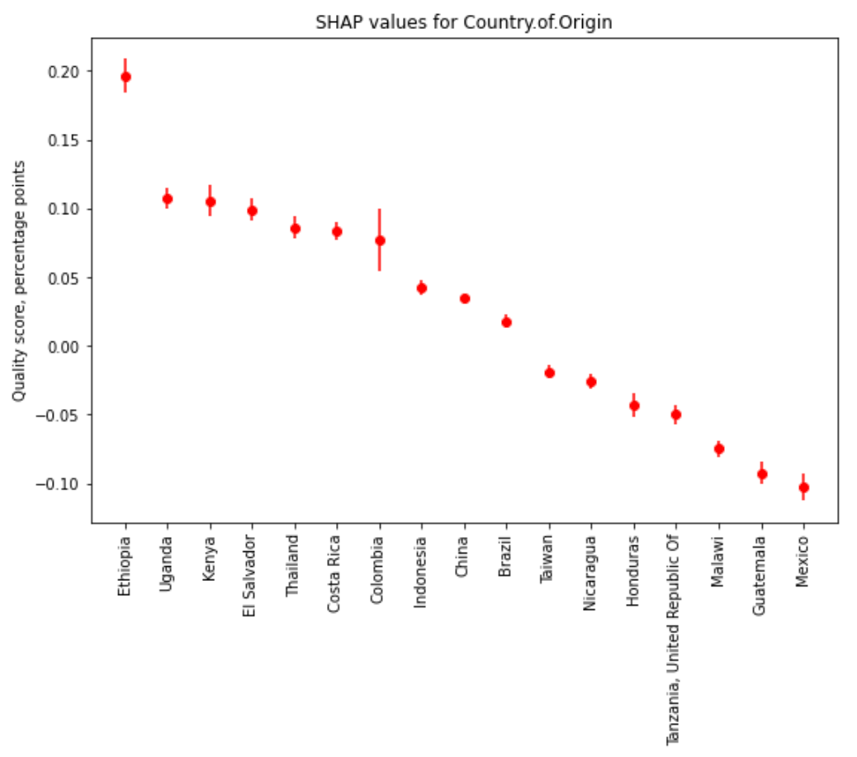

Source: author, [coffee\_quality\_explain | Kaggle](https://www.kaggle.com/code/dima806/coffee-quality-explain" \t "_blank)

In terms of **Uniformity**, **coffee beans from Mexico have score well below beans from other countries**:

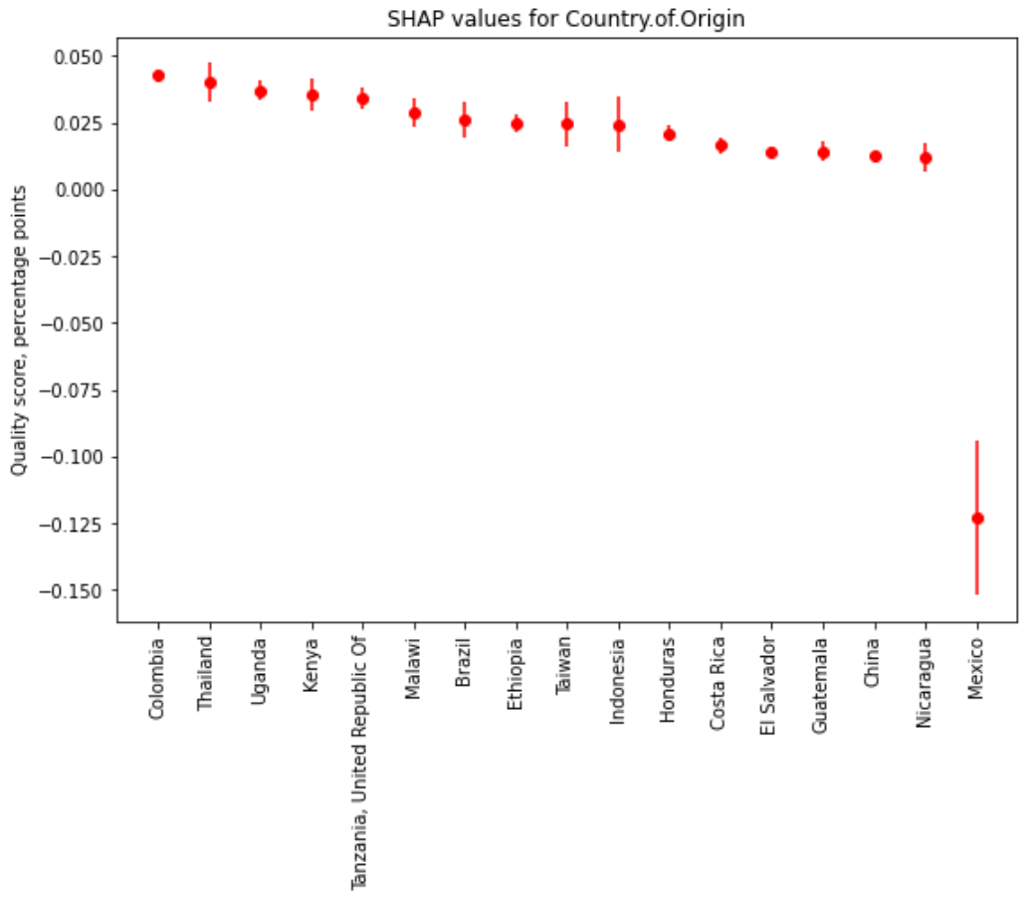

Source: author, [coffee\_quality\_explain | Kaggle](https://www.kaggle.com/code/dima806/coffee-quality-explain" \t "_blank)

In terms of **Clean Cup** score, **the highest scores on average received coffee beans from Brazil, Kenya and Taiwan**:

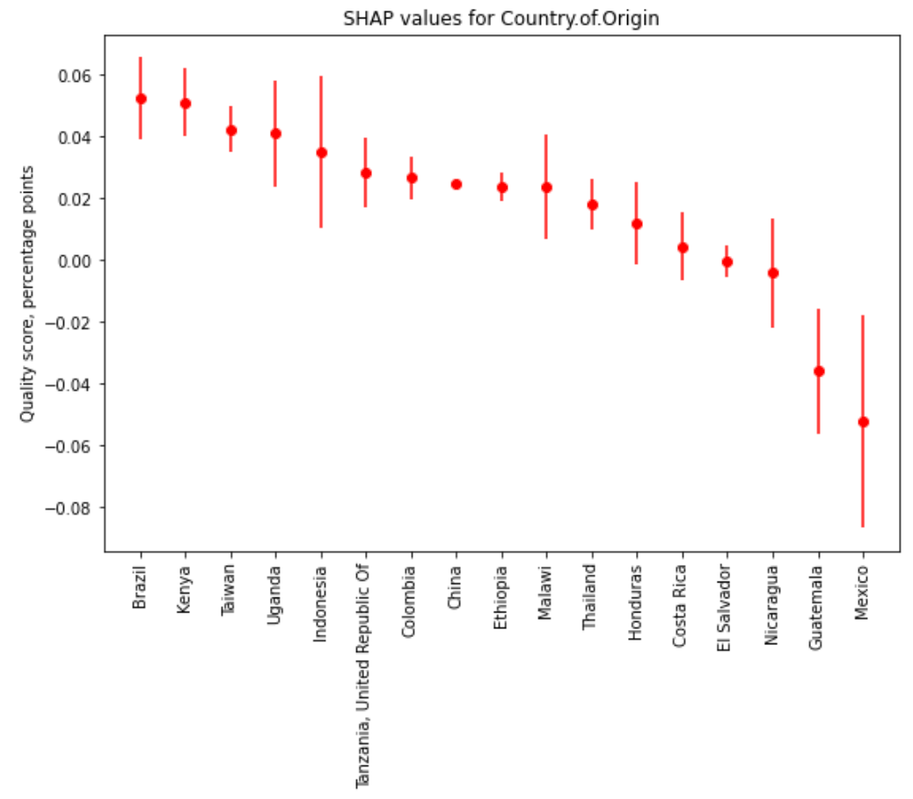

Source: author, [coffee\_quality\_explain | Kaggle](https://www.kaggle.com/code/dima806/coffee-quality-explain" \t "_blank)

and **there is almost no trend of Clean Cup score on moisture**:

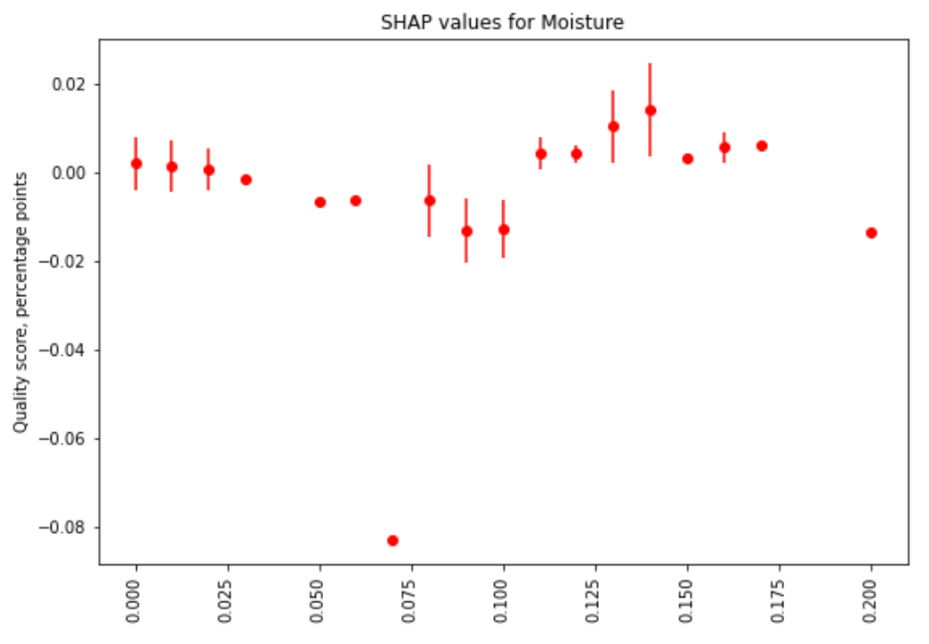

Source: author, [coffee\_quality\_explain | Kaggle](https://www.kaggle.com/code/dima806/coffee-quality-explain" \t "_blank)

Also, coffee beans with the largest **Sweetness** score **come from Mexico, Taiwan, and Colombia**:

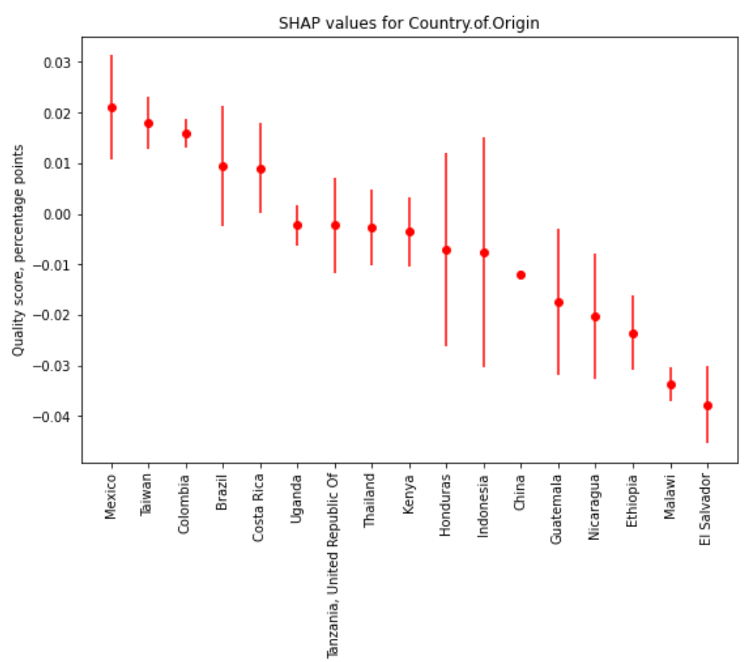

Source: author, [coffee\_quality\_explain | Kaggle](https://www.kaggle.com/code/dima806/coffee-quality-explain" \t "_blank)

while beans with **higher moisture have received higher Sweetness scores**:

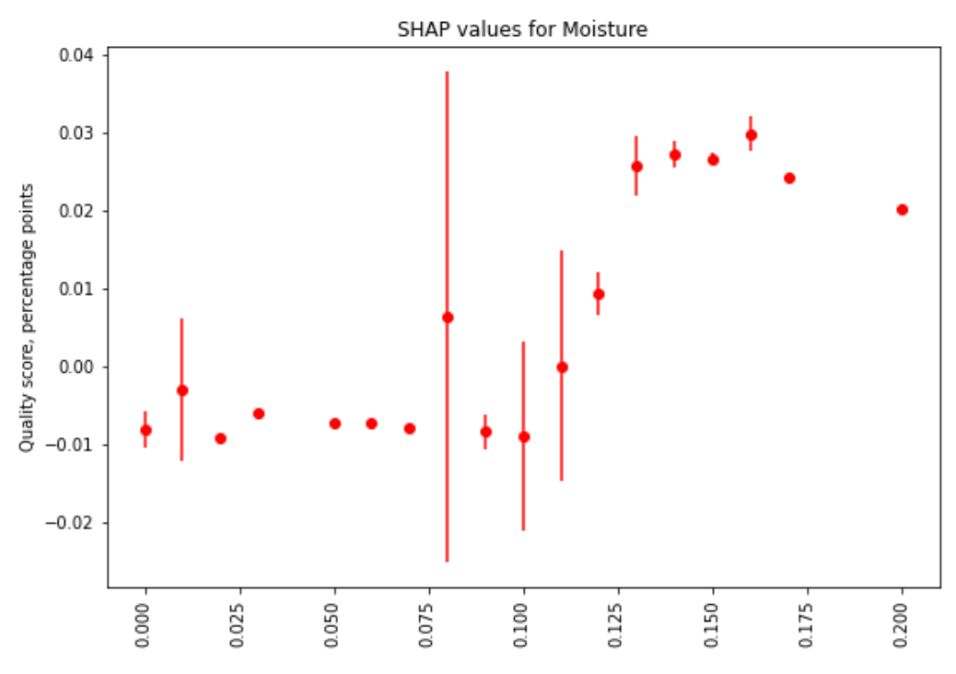

Source: author, [coffee\_quality\_explain | Kaggle](https://www.kaggle.com/code/dima806/coffee-quality-explain" \t "_blank)

I hope these results can be useful for you. In case of questions/comments, do not **hesitate to write in the comments below** or **reach me directly** through [LinkedIn](https://www.linkedin.com/in/dima806/) or [Twitter](https://twitter.com/dima806_dima).

[Data Science](https://medium.com/tag/data-science?source=post_page-----2b9caad41520---------------data_science-----------------)

[Machine Learning](https://medium.com/tag/machine-learning?source=post_page-----2b9caad41520---------------machine_learning-----------------)

[Artificial Intelligence](https://medium.com/tag/artificial-intelligence?source=post_page-----2b9caad41520---------------artificial_intelligence-----------------)

[Explainable Ai](https://medium.com/tag/explainable-ai?source=post_page-----2b9caad41520---------------explainable_ai-----------------)

[Coffee](https://medium.com/tag/coffee?source=post_page-----2b9caad41520---------------coffee-----------------)

646

2

[[](https://medium.com/@dima806?source=post_page-----2b9caad41520--------------------------------)](https://medium.com/@dima806?source=post_page-----2b9caad41520--------------------------------)

[[Data And Beyond](https://medium.com/data-and-beyond?source=post_page-----2b9caad41520--------------------------------)](https://medium.com/data-and-beyond?source=post_page-----2b9caad41520--------------------------------)

[Written by Dmytro Iakubovskyi](https://medium.com/@dima806?source=post_page-----2b9caad41520--------------------------------)

[5.9K Followers](https://medium.com/@dima806/followers?source=post_page-----2b9caad41520--------------------------------)

·Editor for

[Data And Beyond](https://medium.com/data-and-beyond?source=post_page-----2b9caad41520--------------------------------)

Top writer in AI, Movies | Senior data scientist | Editor in Data And Beyond | <https://www.linkedin.com/in/dima806/>

Follow

More from Dmytro Iakubovskyi and Data And Beyond



[[Dmytro Iakubovskyi](https://medium.com/@dima806?source=author_recirc-----2b9caad41520----0---------------------d9475e22_9971_4367_8f3c_d6857186a5fc-------)](https://medium.com/@dima806?source=author_recirc-----2b9caad41520----0---------------------d9475e22_9971_4367_8f3c_d6857186a5fc-------)

[Dmytro Iakubovskyi](https://medium.com/@dima806?source=author_recirc-----2b9caad41520----0---------------------d9475e22_9971_4367_8f3c_d6857186a5fc-------)

in

[Data And Beyond](https://medium.com/data-and-beyond?source=author_recirc-----2b9caad41520----0---------------------d9475e22_9971_4367_8f3c_d6857186a5fc-------)

**[Text to SQL translation example with Huggingface transformers](https://medium.com/data-and-beyond/text-to-sql-translation-example-with-huggingface-transformers-bfccf86f7d9b?source=author_recirc-----2b9caad41520----0---------------------d9475e22_9971_4367_8f3c_d6857186a5fc-------)**

[Retraining T5 base model with WikiSQL dataset on Kaggle’s NVIDIA TESLA P100 GPU](https://medium.com/data-and-beyond/text-to-sql-translation-example-with-huggingface-transformers-bfccf86f7d9b?source=author_recirc-----2b9caad41520----0---------------------d9475e22_9971_4367_8f3c_d6857186a5fc-------)

Apr 30, 2023

[292](https://medium.com/data-and-beyond/text-to-sql-translation-example-with-huggingface-transformers-bfccf86f7d9b?source=author_recirc-----2b9caad41520----0---------------------d9475e22_9971_4367_8f3c_d6857186a5fc-------)

[1](https://medium.com/data-and-beyond/text-to-sql-translation-example-with-huggingface-transformers-bfccf86f7d9b?source=author_recirc-----2b9caad41520----0---------------------d9475e22_9971_4367_8f3c_d6857186a5fc-------)



[[Sze Zhong LIM](https://medium.com/@limszezhong?source=author_recirc-----2b9caad41520----1---------------------d9475e22_9971_4367_8f3c_d6857186a5fc-------)](https://medium.com/@limszezhong?source=author_recirc-----2b9caad41520----1---------------------d9475e22_9971_4367_8f3c_d6857186a5fc-------)

[Sze Zhong LIM](https://medium.com/@limszezhong?source=author_recirc-----2b9caad41520----1---------------------d9475e22_9971_4367_8f3c_d6857186a5fc-------)

in

[Data And Beyond](https://medium.com/data-and-beyond?source=author_recirc-----2b9caad41520----1---------------------d9475e22_9971_4367_8f3c_d6857186a5fc-------)

**[Mastering Exploratory Data Analysis (EDA): Everything You Need To Know](https://medium.com/data-and-beyond/mastering-exploratory-data-analysis-eda-everything-you-need-to-know-7e3b48d63a95?source=author_recirc-----2b9caad41520----1---------------------d9475e22_9971_4367_8f3c_d6857186a5fc-------)**

[A systematic approach to EDA your data and prep it for machine learning.](https://medium.com/data-and-beyond/mastering-exploratory-data-analysis-eda-everything-you-need-to-know-7e3b48d63a95?source=author_recirc-----2b9caad41520----1---------------------d9475e22_9971_4367_8f3c_d6857186a5fc-------)

Apr 6

[747](https://medium.com/data-and-beyond/mastering-exploratory-data-analysis-eda-everything-you-need-to-know-7e3b48d63a95?source=author_recirc-----2b9caad41520----1---------------------d9475e22_9971_4367_8f3c_d6857186a5fc-------)

[6](https://medium.com/data-and-beyond/mastering-exploratory-data-analysis-eda-everything-you-need-to-know-7e3b48d63a95?source=author_recirc-----2b9caad41520----1---------------------d9475e22_9971_4367_8f3c_d6857186a5fc-------)

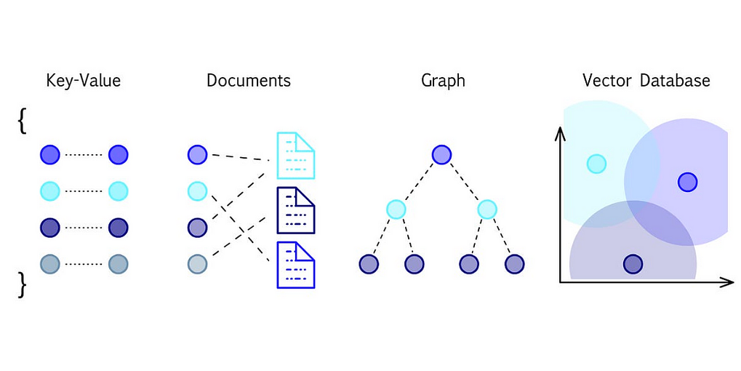

[[Pavan Belagatti](https://medium.com/@pavanbelagatti?source=author_recirc-----2b9caad41520----2---------------------d9475e22_9971_4367_8f3c_d6857186a5fc-------)](https://medium.com/@pavanbelagatti?source=author_recirc-----2b9caad41520----2---------------------d9475e22_9971_4367_8f3c_d6857186a5fc-------)

[Pavan Belagatti](https://medium.com/@pavanbelagatti?source=author_recirc-----2b9caad41520----2---------------------d9475e22_9971_4367_8f3c_d6857186a5fc-------)

in

[Data And Beyond](https://medium.com/data-and-beyond?source=author_recirc-----2b9caad41520----2---------------------d9475e22_9971_4367_8f3c_d6857186a5fc-------)

**[Vector Databases: A Beginner’s Guide!](https://medium.com/data-and-beyond/vector-databases-a-beginners-guide-b050cbbe9ca0?source=author_recirc-----2b9caad41520----2---------------------d9475e22_9971_4367_8f3c_d6857186a5fc-------)**

[In the age of burgeoning data complexity and high-dimensional information, traditional databases often fall short when it comes to…](https://medium.com/data-and-beyond/vector-databases-a-beginners-guide-b050cbbe9ca0?source=author_recirc-----2b9caad41520----2---------------------d9475e22_9971_4367_8f3c_d6857186a5fc-------)

Aug 25, 2023

[1K](https://medium.com/data-and-beyond/vector-databases-a-beginners-guide-b050cbbe9ca0?source=author_recirc-----2b9caad41520----2---------------------d9475e22_9971_4367_8f3c_d6857186a5fc-------)

[6](https://medium.com/data-and-beyond/vector-databases-a-beginners-guide-b050cbbe9ca0?source=author_recirc-----2b9caad41520----2---------------------d9475e22_9971_4367_8f3c_d6857186a5fc-------)



[[Dmytro Iakubovskyi](https://medium.com/@dima806?source=author_recirc-----2b9caad41520----3---------------------d9475e22_9971_4367_8f3c_d6857186a5fc-------)](https://medium.com/@dima806?source=author_recirc-----2b9caad41520----3---------------------d9475e22_9971_4367_8f3c_d6857186a5fc-------)

[Dmytro Iakubovskyi](https://medium.com/@dima806?source=author_recirc-----2b9caad41520----3---------------------d9475e22_9971_4367_8f3c_d6857186a5fc-------)

in

[Data And Beyond](https://medium.com/data-and-beyond?source=author_recirc-----2b9caad41520----3---------------------d9475e22_9971_4367_8f3c_d6857186a5fc-------)

**[Chirp to Classification: Identifying 50 Bird Species by Sound with Transformer-Based Machine…](https://medium.com/data-and-beyond/chirp-to-classification-identifying-50-bird-species-by-sound-with-transformer-based-machine-dfd46979847a?source=author_recirc-----2b9caad41520----3---------------------d9475e22_9971_4367_8f3c_d6857186a5fc-------)**

[A step-by-step guide for building the transformer-based Machine Learning audio classification model for the bird sounds and making it live…](https://medium.com/data-and-beyond/chirp-to-classification-identifying-50-bird-species-by-sound-with-transformer-based-machine-dfd46979847a?source=author_recirc-----2b9caad41520----3---------------------d9475e22_9971_4367_8f3c_d6857186a5fc-------)

Oct 29, 2023

[104](https://medium.com/data-and-beyond/chirp-to-classification-identifying-50-bird-species-by-sound-with-transformer-based-machine-dfd46979847a?source=author_recirc-----2b9caad41520----3---------------------d9475e22_9971_4367_8f3c_d6857186a5fc-------)

[See all from Dmytro Iakubovskyi](https://medium.com/@dima806?source=post_page-----2b9caad41520--------------------------------)

[See all from Data And Beyond](https://medium.com/data-and-beyond?source=post_page-----2b9caad41520--------------------------------)

Recommended from Medium

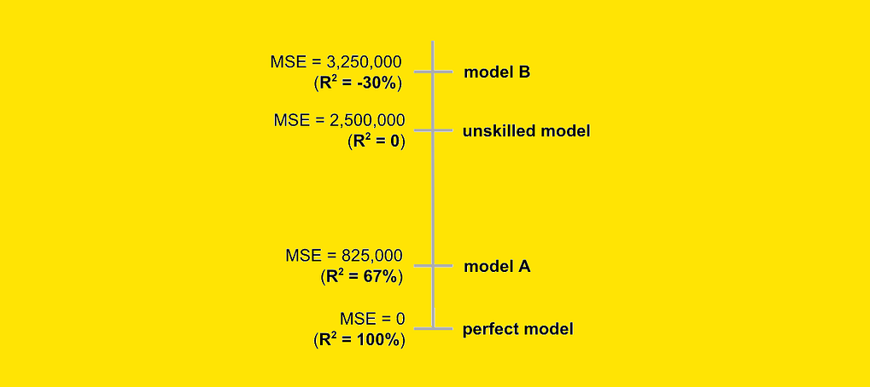

[[Samuele Mazzanti](https://medium.com/@mazzanti.sam?source=read_next_recirc-----2b9caad41520----0---------------------ee22d643_9ccb_4d40_b5e6_685efa379170-------)](https://medium.com/@mazzanti.sam?source=read_next_recirc-----2b9caad41520----0---------------------ee22d643_9ccb_4d40_b5e6_685efa379170-------)

[Samuele Mazzanti](https://medium.com/@mazzanti.sam?source=read_next_recirc-----2b9caad41520----0---------------------ee22d643_9ccb_4d40_b5e6_685efa379170-------)

in

[Towards Data Science](https://medium.com/towards-data-science?source=read_next_recirc-----2b9caad41520----0---------------------ee22d643_9ccb_4d40_b5e6_685efa379170-------)

**[What’s Wrong With R-Squared (And How to Fix It)](https://medium.com/towards-data-science/whats-wrong-with-r-squared-and-how-to-fix-it-7362c5f26c53?source=read_next_recirc-----2b9caad41520----0---------------------ee22d643_9ccb_4d40_b5e6_685efa379170-------)**

[Even if you think you are using R-Squared out-of-sample, you are not. Here is why](https://medium.com/towards-data-science/whats-wrong-with-r-squared-and-how-to-fix-it-7362c5f26c53?source=read_next_recirc-----2b9caad41520----0---------------------ee22d643_9ccb_4d40_b5e6_685efa379170-------)

4d ago

[485](https://medium.com/towards-data-science/whats-wrong-with-r-squared-and-how-to-fix-it-7362c5f26c53?source=read_next_recirc-----2b9caad41520----0---------------------ee22d643_9ccb_4d40_b5e6_685efa379170-------)

[9](https://medium.com/towards-data-science/whats-wrong-with-r-squared-and-how-to-fix-it-7362c5f26c53?source=read_next_recirc-----2b9caad41520----0---------------------ee22d643_9ccb_4d40_b5e6_685efa379170-------)

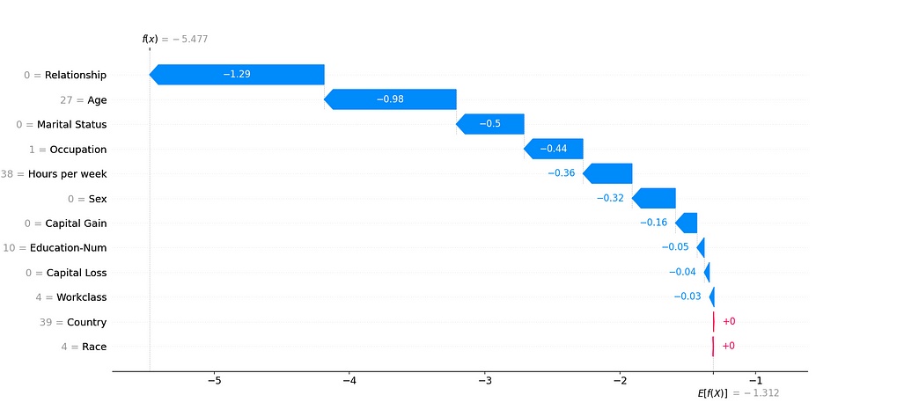

[[Jakub Polec](https://medium.com/@jpolec_72972?source=read_next_recirc-----2b9caad41520----1---------------------ee22d643_9ccb_4d40_b5e6_685efa379170-------)](https://medium.com/@jpolec_72972?source=read_next_recirc-----2b9caad41520----1---------------------ee22d643_9ccb_4d40_b5e6_685efa379170-------)

[Jakub Polec](https://medium.com/@jpolec_72972?source=read_next_recirc-----2b9caad41520----1---------------------ee22d643_9ccb_4d40_b5e6_685efa379170-------)

**[Python: Demystifying SHAP Values in Machine Learning Interpretability](https://medium.com/@jpolec_72972/python-demystifying-shap-values-in-machine-learning-interpretability-66383c7a5140?source=read_next_recirc-----2b9caad41520----1---------------------ee22d643_9ccb_4d40_b5e6_685efa379170-------)**

[SHAP (SHapley Additive exPlanations) values are a powerful tool for interpreting machine learning models, providing insights into how each…](https://medium.com/@jpolec_72972/python-demystifying-shap-values-in-machine-learning-interpretability-66383c7a5140?source=read_next_recirc-----2b9caad41520----1---------------------ee22d643_9ccb_4d40_b5e6_685efa379170-------)

Feb 29

[3](https://medium.com/@jpolec_72972/python-demystifying-shap-values-in-machine-learning-interpretability-66383c7a5140?source=read_next_recirc-----2b9caad41520----1---------------------ee22d643_9ccb_4d40_b5e6_685efa379170-------)

Lists

[[](https://medium.com/@ben.putney/list/predictive-modeling-w-python-e3668ea008e1?source=read_next_recirc-----2b9caad41520--------------------------------)](https://medium.com/@ben.putney/list/predictive-modeling-w-python-e3668ea008e1?source=read_next_recirc-----2b9caad41520--------------------------------)

[[](https://medium.com/@ben.putney/list/predictive-modeling-w-python-e3668ea008e1?source=read_next_recirc-----2b9caad41520--------------------------------)](https://medium.com/@ben.putney/list/predictive-modeling-w-python-e3668ea008e1?source=read_next_recirc-----2b9caad41520--------------------------------)

[[](https://medium.com/@ben.putney/list/predictive-modeling-w-python-e3668ea008e1?source=read_next_recirc-----2b9caad41520--------------------------------)](https://medium.com/@ben.putney/list/predictive-modeling-w-python-e3668ea008e1?source=read_next_recirc-----2b9caad41520--------------------------------)

[Predictive Modeling w/ Python](https://medium.com/@ben.putney/list/predictive-modeling-w-python-e3668ea008e1?source=read_next_recirc-----2b9caad41520--------------------------------)

[20 stories·1433 saves](https://medium.com/@ben.putney/list/predictive-modeling-w-python-e3668ea008e1?source=read_next_recirc-----2b9caad41520--------------------------------)

[[](https://medium.com/@AMGAS14/list/natural-language-processing-0a856388a93a?source=read_next_recirc-----2b9caad41520--------------------------------)](https://medium.com/@AMGAS14/list/natural-language-processing-0a856388a93a?source=read_next_recirc-----2b9caad41520--------------------------------)

[[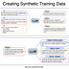](https://medium.com/@AMGAS14/list/natural-language-processing-0a856388a93a?source=read_next_recirc-----2b9caad41520--------------------------------)](https://medium.com/@AMGAS14/list/natural-language-processing-0a856388a93a?source=read_next_recirc-----2b9caad41520--------------------------------)

[[](https://medium.com/@AMGAS14/list/natural-language-processing-0a856388a93a?source=read_next_recirc-----2b9caad41520--------------------------------)](https://medium.com/@AMGAS14/list/natural-language-processing-0a856388a93a?source=read_next_recirc-----2b9caad41520--------------------------------)

[Natural Language Processing](https://medium.com/@AMGAS14/list/natural-language-processing-0a856388a93a?source=read_next_recirc-----2b9caad41520--------------------------------)

[1640 stories·1198 saves](https://medium.com/@AMGAS14/list/natural-language-processing-0a856388a93a?source=read_next_recirc-----2b9caad41520--------------------------------)

[[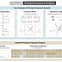](https://destingong.medium.com/list/practical-guides-to-machine-learning-a877c2a39884?source=read_next_recirc-----2b9caad41520--------------------------------)](https://destingong.medium.com/list/practical-guides-to-machine-learning-a877c2a39884?source=read_next_recirc-----2b9caad41520--------------------------------)

[[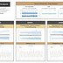](https://destingong.medium.com/list/practical-guides-to-machine-learning-a877c2a39884?source=read_next_recirc-----2b9caad41520--------------------------------)](https://destingong.medium.com/list/practical-guides-to-machine-learning-a877c2a39884?source=read_next_recirc-----2b9caad41520--------------------------------)

[[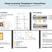](https://destingong.medium.com/list/practical-guides-to-machine-learning-a877c2a39884?source=read_next_recirc-----2b9caad41520--------------------------------)](https://destingong.medium.com/list/practical-guides-to-machine-learning-a877c2a39884?source=read_next_recirc-----2b9caad41520--------------------------------)

[Practical Guides to Machine Learning](https://destingong.medium.com/list/practical-guides-to-machine-learning-a877c2a39884?source=read_next_recirc-----2b9caad41520--------------------------------)

[10 stories·1738 saves](https://destingong.medium.com/list/practical-guides-to-machine-learning-a877c2a39884?source=read_next_recirc-----2b9caad41520--------------------------------)

[[](https://medium.com/@nicholas.michael.janulewicz/list/chatgpt-prompts-b4c47b8e12ee?source=read_next_recirc-----2b9caad41520--------------------------------)](https://medium.com/@nicholas.michael.janulewicz/list/chatgpt-prompts-b4c47b8e12ee?source=read_next_recirc-----2b9caad41520--------------------------------)

[[](https://medium.com/@nicholas.michael.janulewicz/list/chatgpt-prompts-b4c47b8e12ee?source=read_next_recirc-----2b9caad41520--------------------------------)](https://medium.com/@nicholas.michael.janulewicz/list/chatgpt-prompts-b4c47b8e12ee?source=read_next_recirc-----2b9caad41520--------------------------------)

[[](https://medium.com/@nicholas.michael.janulewicz/list/chatgpt-prompts-b4c47b8e12ee?source=read_next_recirc-----2b9caad41520--------------------------------)](https://medium.com/@nicholas.michael.janulewicz/list/chatgpt-prompts-b4c47b8e12ee?source=read_next_recirc-----2b9caad41520--------------------------------)

[ChatGPT prompts](https://medium.com/@nicholas.michael.janulewicz/list/chatgpt-prompts-b4c47b8e12ee?source=read_next_recirc-----2b9caad41520--------------------------------)

[48 stories·1881 saves](https://medium.com/@nicholas.michael.janulewicz/list/chatgpt-prompts-b4c47b8e12ee?source=read_next_recirc-----2b9caad41520--------------------------------)

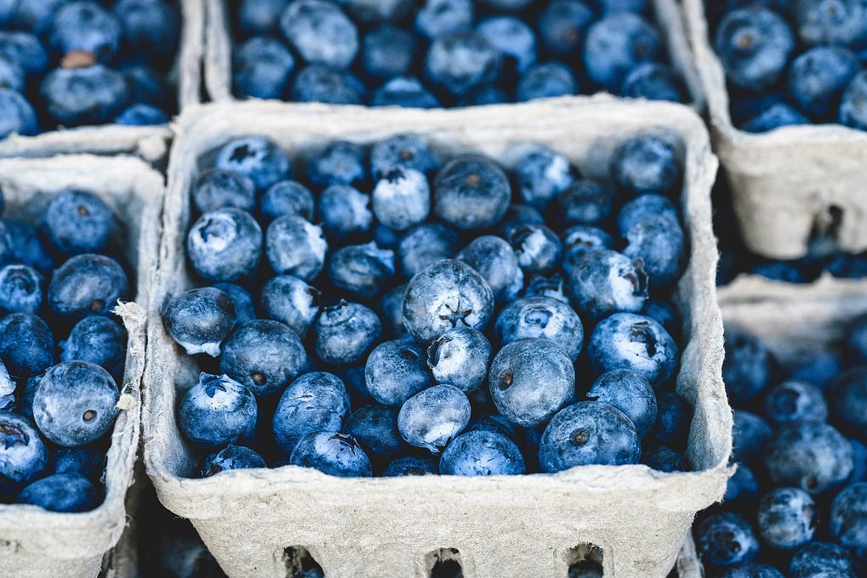

[[Rukshan Pramoditha](https://medium.com/@rukshanpramoditha?source=read_next_recirc-----2b9caad41520----0---------------------ee22d643_9ccb_4d40_b5e6_685efa379170-------)](https://medium.com/@rukshanpramoditha?source=read_next_recirc-----2b9caad41520----0---------------------ee22d643_9ccb_4d40_b5e6_685efa379170-------)

[Rukshan Pramoditha](https://medium.com/@rukshanpramoditha?source=read_next_recirc-----2b9caad41520----0---------------------ee22d643_9ccb_4d40_b5e6_685efa379170-------)

**[How Is Mean-Shift Clustering Better Than K-Means Clustering?](https://medium.com/@rukshanpramoditha/how-is-mean-shift-clustering-better-than-k-means-clustering-e6824beebba3?source=read_next_recirc-----2b9caad41520----0---------------------ee22d643_9ccb_4d40_b5e6_685efa379170-------)**

[No need to specify the number of clusters (k) as a hyperparameter!](https://medium.com/@rukshanpramoditha/how-is-mean-shift-clustering-better-than-k-means-clustering-e6824beebba3?source=read_next_recirc-----2b9caad41520----0---------------------ee22d643_9ccb_4d40_b5e6_685efa379170-------)

Aug 4



[[Shenggang Li](https://medium.com/@datalev?source=read_next_recirc-----2b9caad41520----1---------------------ee22d643_9ccb_4d40_b5e6_685efa379170-------)](https://medium.com/@datalev?source=read_next_recirc-----2b9caad41520----1---------------------ee22d643_9ccb_4d40_b5e6_685efa379170-------)

[Shenggang Li](https://medium.com/@datalev?source=read_next_recirc-----2b9caad41520----1---------------------ee22d643_9ccb_4d40_b5e6_685efa379170-------)

in

[Towards AI](https://medium.com/towards-artificial-intelligence?source=read_next_recirc-----2b9caad41520----1---------------------ee22d643_9ccb_4d40_b5e6_685efa379170-------)

**[Building and Extending Your Decision Tree: A Hands-On Guide](https://medium.com/towards-artificial-intelligence/building-and-extending-your-decision-tree-a-hands-on-guide-25c87f89ec15?source=read_next_recirc-----2b9caad41520----1---------------------ee22d643_9ccb_4d40_b5e6_685efa379170-------)**

[Unlocking the Secrets of Decision Trees: From Basic Concepts to Advanced Optimization Techniques and Practical Coding](https://medium.com/towards-artificial-intelligence/building-and-extending-your-decision-tree-a-hands-on-guide-25c87f89ec15?source=read_next_recirc-----2b9caad41520----1---------------------ee22d643_9ccb_4d40_b5e6_685efa379170-------)

Aug 5

[430](https://medium.com/towards-artificial-intelligence/building-and-extending-your-decision-tree-a-hands-on-guide-25c87f89ec15?source=read_next_recirc-----2b9caad41520----1---------------------ee22d643_9ccb_4d40_b5e6_685efa379170-------)

[11](https://medium.com/towards-artificial-intelligence/building-and-extending-your-decision-tree-a-hands-on-guide-25c87f89ec15?source=read_next_recirc-----2b9caad41520----1---------------------ee22d643_9ccb_4d40_b5e6_685efa379170-------)



[[Sweta Javkar](https://medium.com/@smj25?source=read_next_recirc-----2b9caad41520----2---------------------ee22d643_9ccb_4d40_b5e6_685efa379170-------)](https://medium.com/@smj25?source=read_next_recirc-----2b9caad41520----2---------------------ee22d643_9ccb_4d40_b5e6_685efa379170-------)

[Sweta Javkar](https://medium.com/@smj25?source=read_next_recirc-----2b9caad41520----2---------------------ee22d643_9ccb_4d40_b5e6_685efa379170-------)

**[Illuminating Machine Learning Models: ALE Plots Decoded for Enhanced Interpretability](https://medium.com/@smj25/illuminating-machine-learning-models-ale-plots-decoded-for-enhanced-interpretability-eaeb3ae8c031?source=read_next_recirc-----2b9caad41520----2---------------------ee22d643_9ccb_4d40_b5e6_685efa379170-------)**

[In the realm of machine learning, the interpretability of models is paramount for trust and understanding. The “black box” nature of…](https://medium.com/@smj25/illuminating-machine-learning-models-ale-plots-decoded-for-enhanced-interpretability-eaeb3ae8c031?source=read_next_recirc-----2b9caad41520----2---------------------ee22d643_9ccb_4d40_b5e6_685efa379170-------)

Mar 21

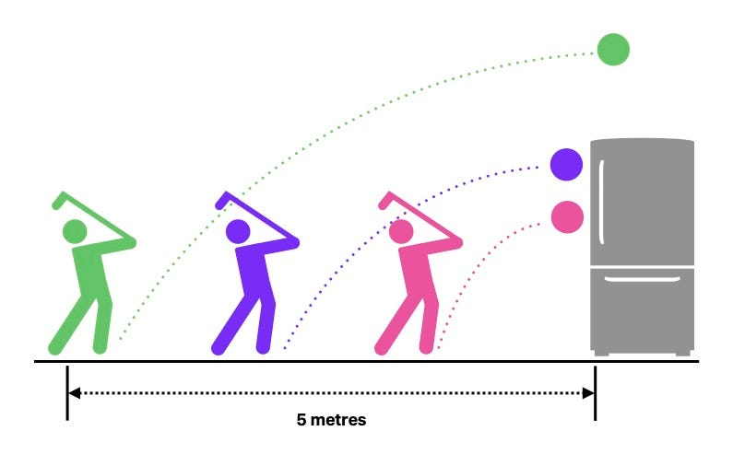

[[Tarek Amr](https://medium.com/@gr33ndata?source=read_next_recirc-----2b9caad41520----3---------------------ee22d643_9ccb_4d40_b5e6_685efa379170-------)](https://medium.com/@gr33ndata?source=read_next_recirc-----2b9caad41520----3---------------------ee22d643_9ccb_4d40_b5e6_685efa379170-------)

[Tarek Amr](https://medium.com/@gr33ndata?source=read_next_recirc-----2b9caad41520----3---------------------ee22d643_9ccb_4d40_b5e6_685efa379170-------)

**[When to use Survival Analysis instead of Regression?](https://medium.com/@gr33ndata/when-to-use-survival-analysis-instead-of-regression-94545aa7e0ce?source=read_next_recirc-----2b9caad41520----3---------------------ee22d643_9ccb_4d40_b5e6_685efa379170-------)**

[“And what is a Survival function?”, I heard you asking](https://medium.com/@gr33ndata/when-to-use-survival-analysis-instead-of-regression-94545aa7e0ce?source=read_next_recirc-----2b9caad41520----3---------------------ee22d643_9ccb_4d40_b5e6_685efa379170-------)

Mar 14

[537](https://medium.com/@gr33ndata/when-to-use-survival-analysis-instead-of-regression-94545aa7e0ce?source=read_next_recirc-----2b9caad41520----3---------------------ee22d643_9ccb_4d40_b5e6_685efa379170-------)

[9](https://medium.com/@gr33ndata/when-to-use-survival-analysis-instead-of-regression-94545aa7e0ce?source=read_next_recirc-----2b9caad41520----3---------------------ee22d643_9ccb_4d40_b5e6_685efa379170-------)

[See more recommendations](https://medium.com/?source=post_page-----2b9caad41520--------------------------------)

[Help](https://help.medium.com/hc/en-us?source=post_page-----2b9caad41520--------------------------------)

[Status](https://medium.statuspage.io/?source=post_page-----2b9caad41520--------------------------------)

[About](https://medium.com/about?autoplay=1&source=post_page-----2b9caad41520--------------------------------)

[Careers](https://medium.com/jobs-at-medium/work-at-medium-959d1a85284e?source=post_page-----2b9caad41520--------------------------------)

[Press](https://medium.com/data-and-beyond/pressinquiries@medium.com?source=post_page-----2b9caad41520--------------------------------)

[Blog](https://blog.medium.com/?source=post_page-----2b9caad41520--------------------------------)

[Privacy](https://policy.medium.com/medium-privacy-policy-f03bf92035c9?source=post_page-----2b9caad41520--------------------------------)

[Terms](https://policy.medium.com/medium-terms-of-service-9db0094a1e0f?source=post_page-----2b9caad41520--------------------------------)

[Text to speech](https://speechify.com/medium?source=post_page-----2b9caad41520--------------------------------)

[Teams](https://medium.com/business?source=post_page-----2b9caad41520--------------------------------)