**Sources**

Research Institute at Dallas College

Georgetown University Center on Education and the Workforce

U.S. Department of Education’s College Scorecard

**Purpose**

The Research Institute at Dallas College engages in projects aimed at creating a more equitable education system that promotes access and success for all North Texas. The purpose of the following visualizations and dashboards is to explore ROI of 2-year colleges and the equitable outcomes of gender, and household income levels.

**Methodology, Data, and Notes**

The Data used in this dashboard is from the most recent cohort file released from College Scorecard.

ROI is calculated using the same methodology as the Georgetown University Center on Education and the Workforce. Georgetown defines Net Present Value (NPV) as the future earnings minus their cost, where each year is discounted at a 2% annual rate following their first year after college entry. The length of college, is defined as the length of the program plus 1 additional year. Below is the mathematical representation:

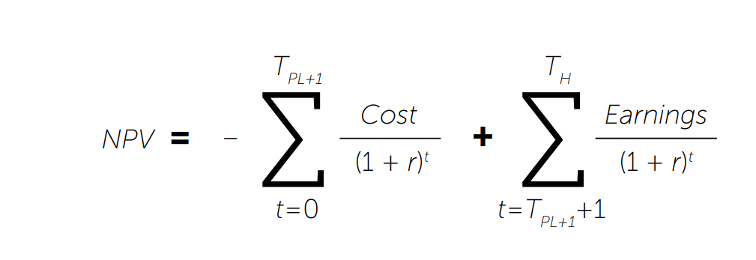

ROI is calculated in this dashboard through median outcomes (Earnings) as provided by College Scorecard. The 7th and 9th year median income after graduating are calculated by taking the average of the 5th and 6th years, and 8th and 10th years, respectively. Income levels prior to the 6th year, are assumed to be the same as the 6th year. Income levels while in college (years 1-3) are considered $0. Income levels are fixed after year 10 and do not account for future earning increases.

Gender subpopulations are calculated using the percent of the total population as provided by college scorecard and multiplied by the total population count.

Income Level subpopulations are defined by the college scorecard. The monetary boundaries can be located in the data dictionary.