**Romala Bhagya Sri**

**125 batch**

[**Bhagyasriyadav34@gmail.com**](mailto:Bhagyasriyadav34@gmail.com)

**Create 2 Buckets**

Create two buckets one is source and other is destinaton

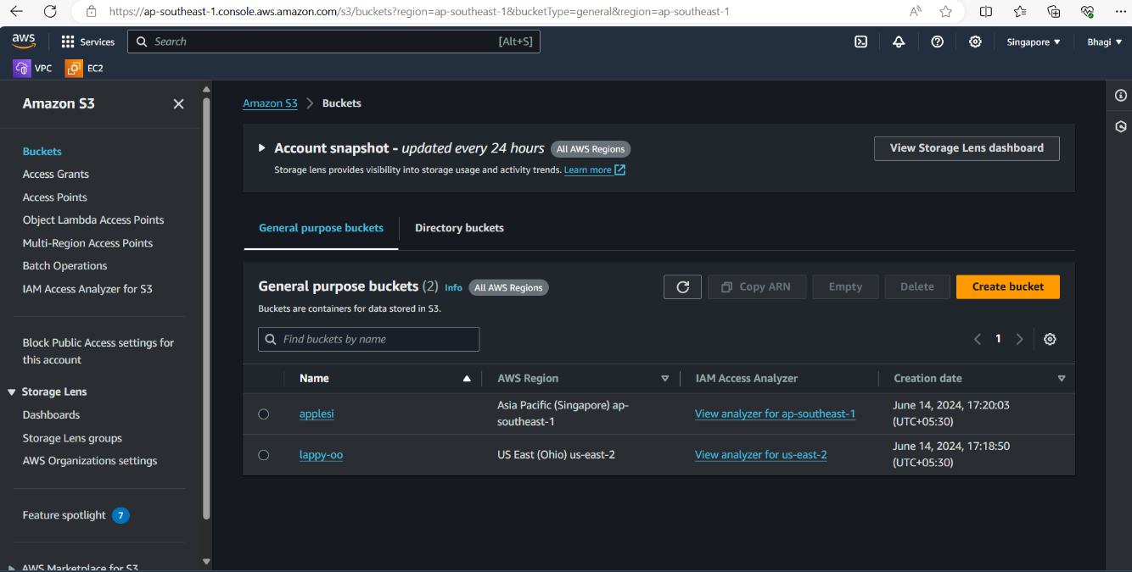

**Upload a file**

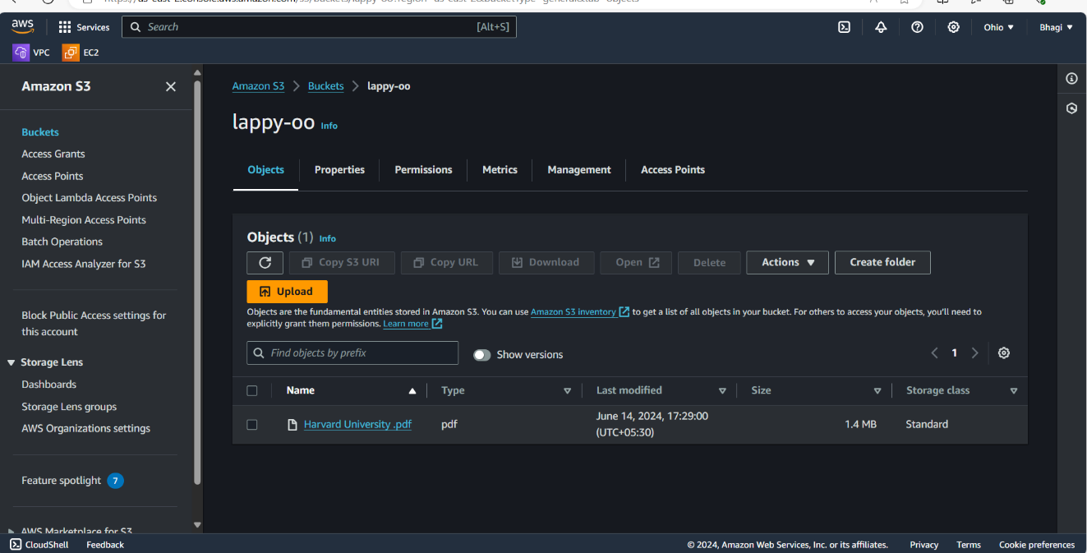

**Replication rule is successful**

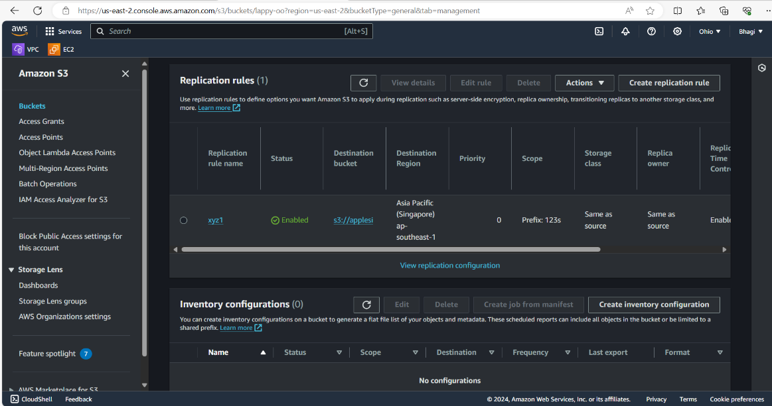**ile**