**PL/SQL THIRD ACTIVITY**

**TAST 1:**

**ACCESSING ORACLE 21C USING SQLPLUS**

We can have access to our oracle via the command line (cmd), for good practice we can run it as administrator if any window pops up to allow it.

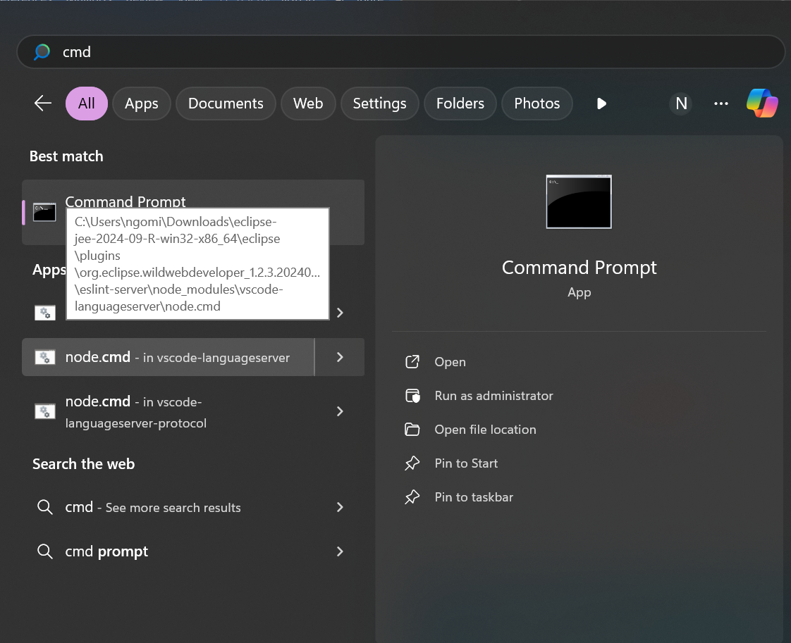

We log into our Oracle as system administrator by using our sqlplus as shown below.

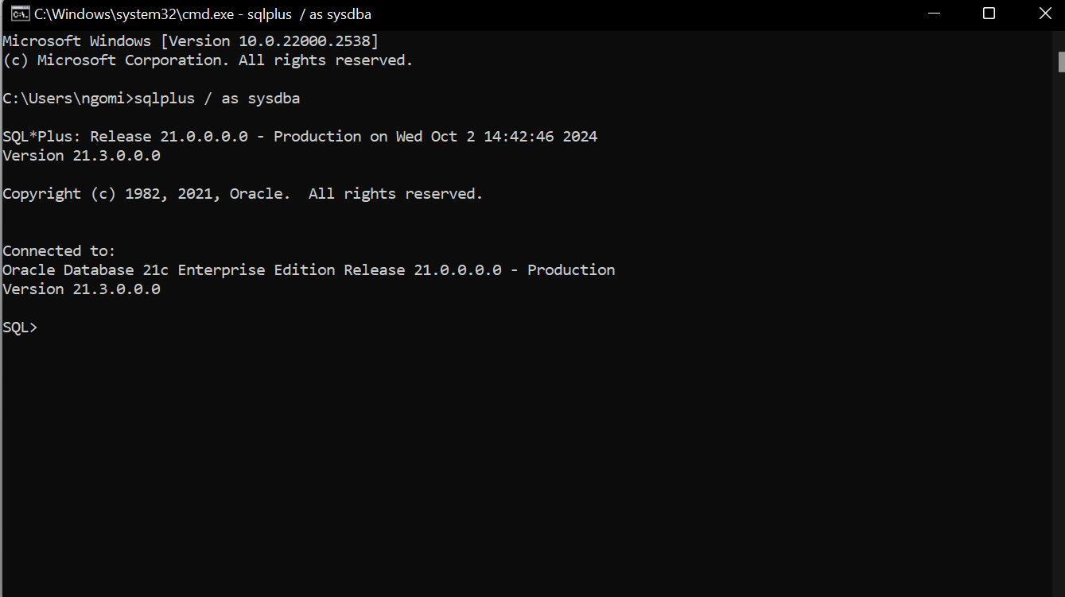

**TASK 1: CREATING A NEW PLUGGABLE DATABASES.**

Before creating a new pluggable database(pdb), we fist need to know some important information as container databases name, the pluggable database name, the path for our container database, and other information as we will show it in this documentation**.**

**DISPLAYING AVAILABLE PLUGGABLE DATABASES.**

The query we use to display all pdb is “show pdbs;”.

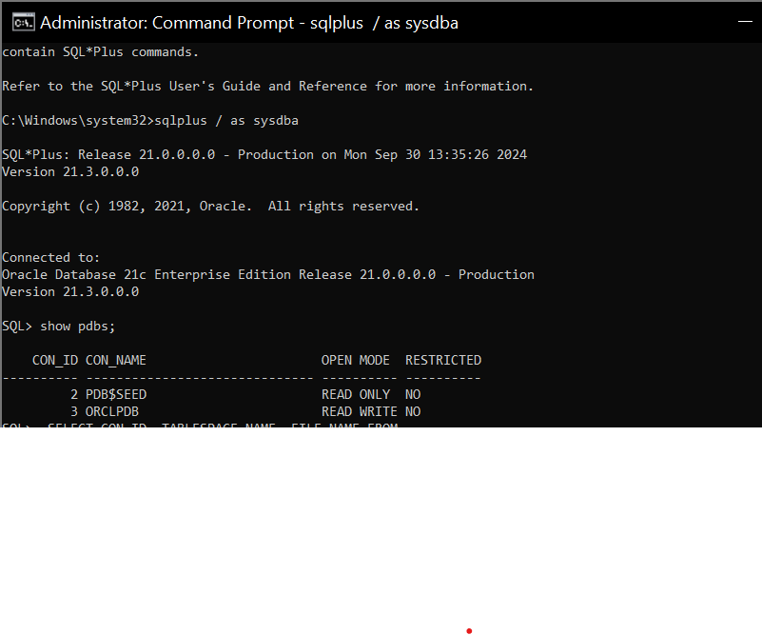

After this we need to displat the path of our container database in order to create our new

Pluggable database and we use pdbseed .

Pdbseed: this is the template we base one when creating our new pluggable database.

We use this query “SELECT CON_ID, TABLESPACE_NAME, FILE_NAME FROM

CDB_DATA_FILES WHERE CON_ID = 3;” the result is shown below

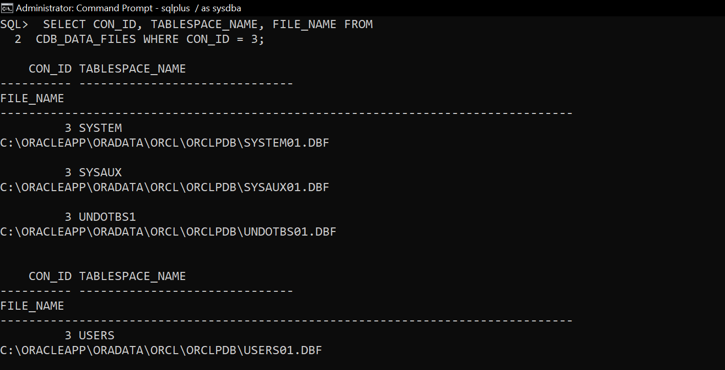

At this point we can now create our pluggable database using pdbseed, we can successfully achieve this by using this query : **“CREATE PLUGGABLE DATABASE PLSQL_CLASS2024DB**

**ADMIN USER ng_plsqlauca IDENTIFIED BY 1234**

**FILE_NAME_CONVERT = ('C:\ORACLEAPP\ORADATA\ORCL\pdbseed\',**

**'C:\ORACLEAPP\ORADATA\ORCL\ORCLPDB\PLSQL_CLASS2024DB\');”**

We firstly copy our path and we write the name of our new pluggable database in our case the new pluggable database is PLSQL_CLASS2024DB**.**

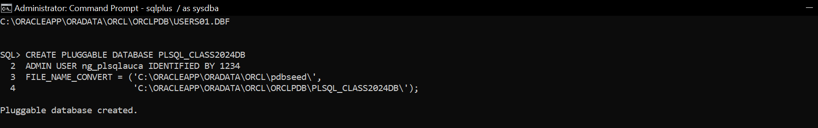

**CHECKING FOR THE CREATED NEW PLUGGABLE DATABASE**

**We use this query to verify it “SELECT pdb_name, status FROM cdb_pdbs;”.**

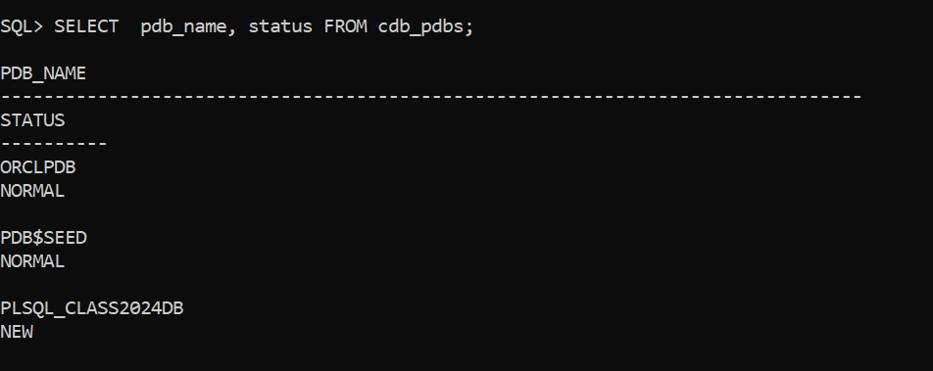

At this step we need to open our created pluggable device to our container database and save it in order to avoid re-opening again**.**

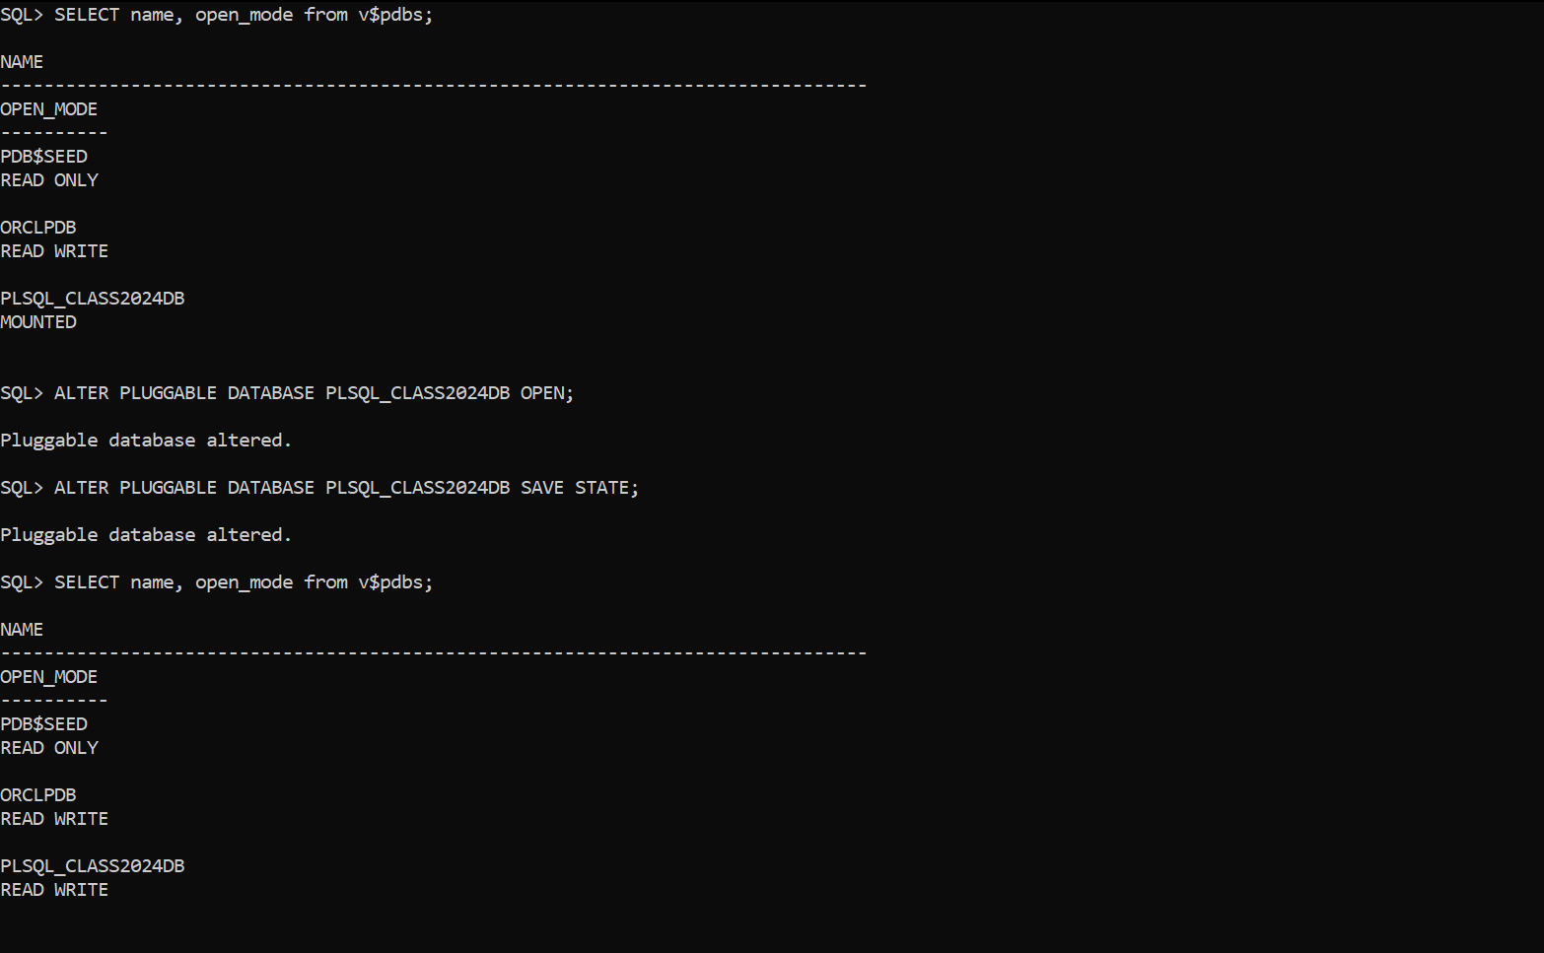

**CHECKING THE CURRENT INSTANCE NAME**

Checking the current instance name by using this query “alter session set container =PLSQL_CLASS2024DB;”, At this point, we link our constructed pluggable device to our container database and save it so that we won't need to manually input the password every time it connects.

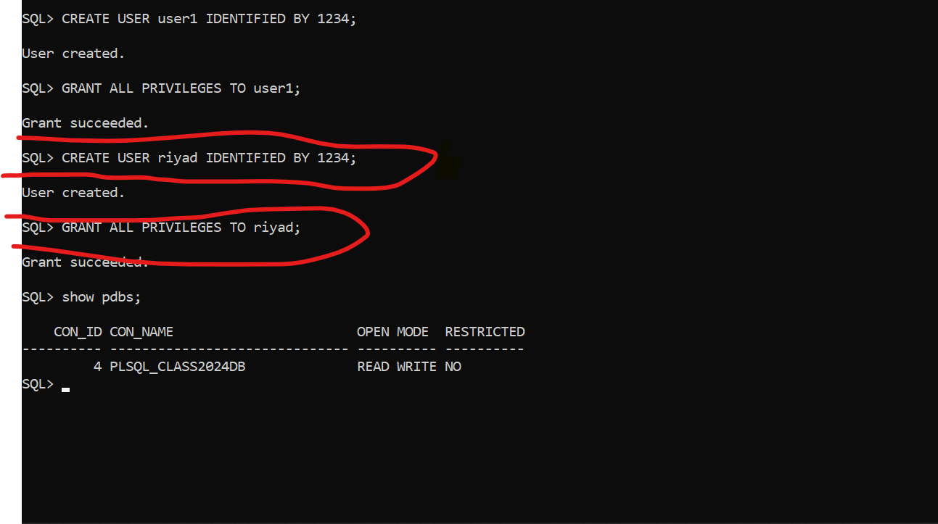

**SHIFTING TO SQL DEVELOPER**

Opening our sql developer, it shows up like this.

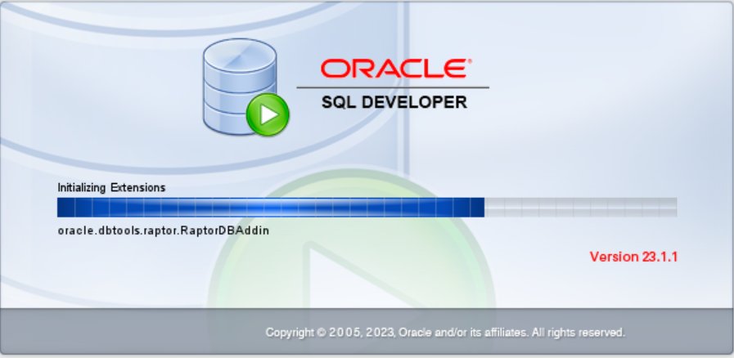

The landing page of our sql developer looks like this.

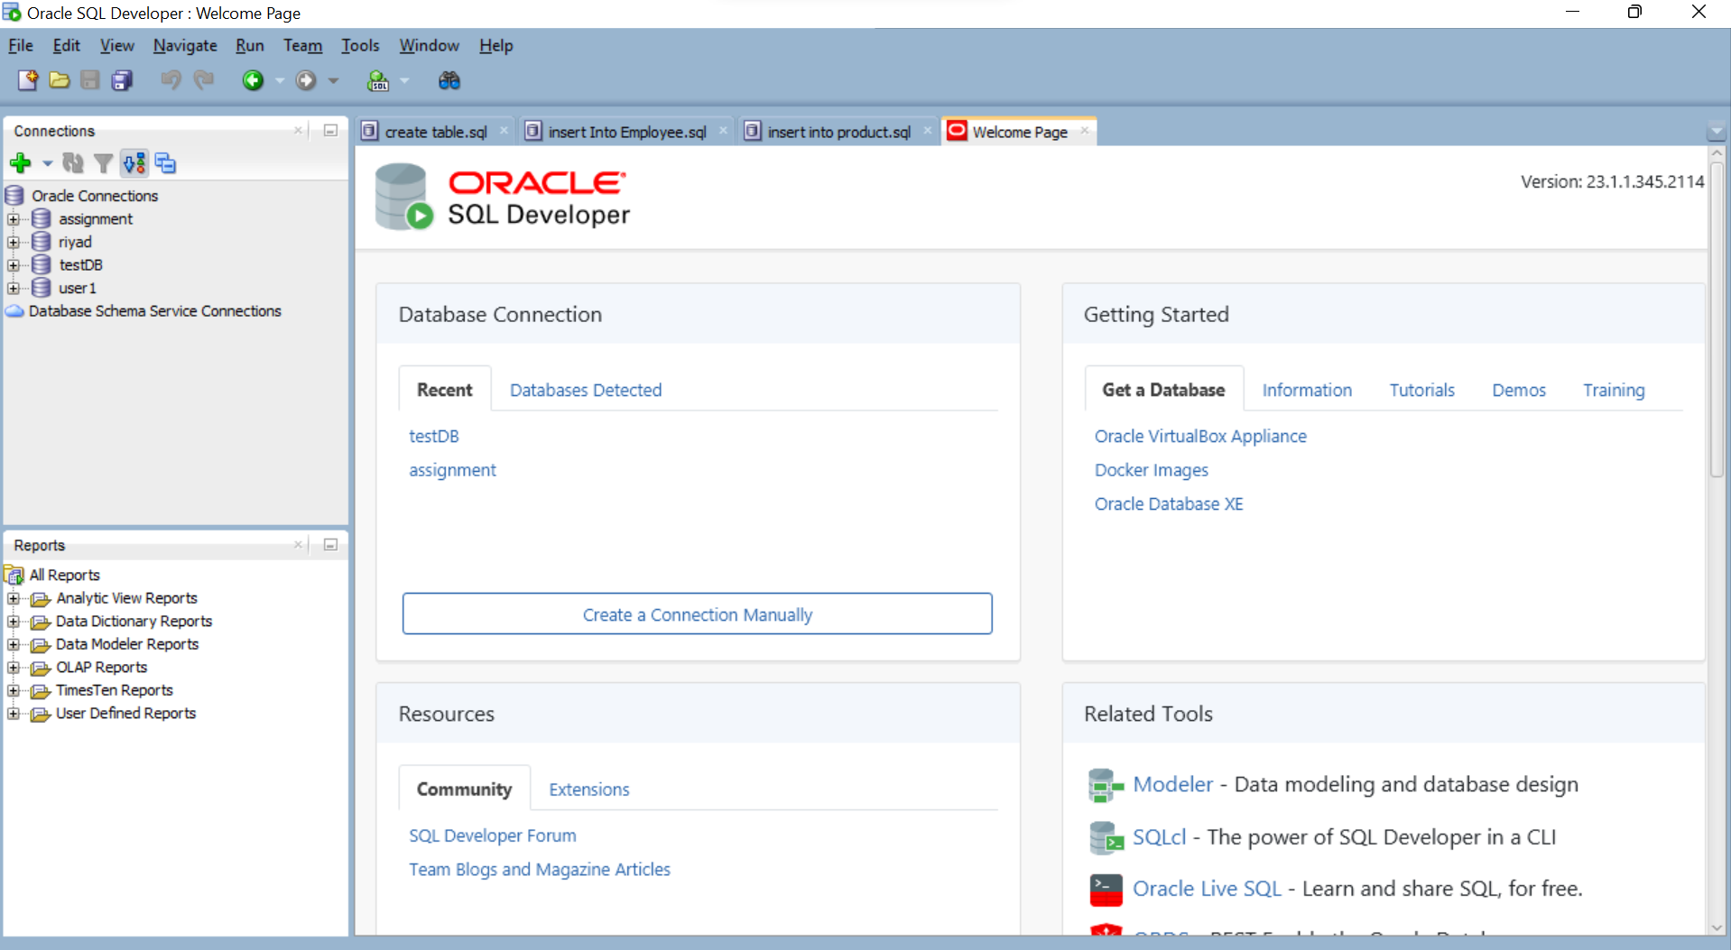

For creating new connection we can click on create a connection manually of click on the green plus sign

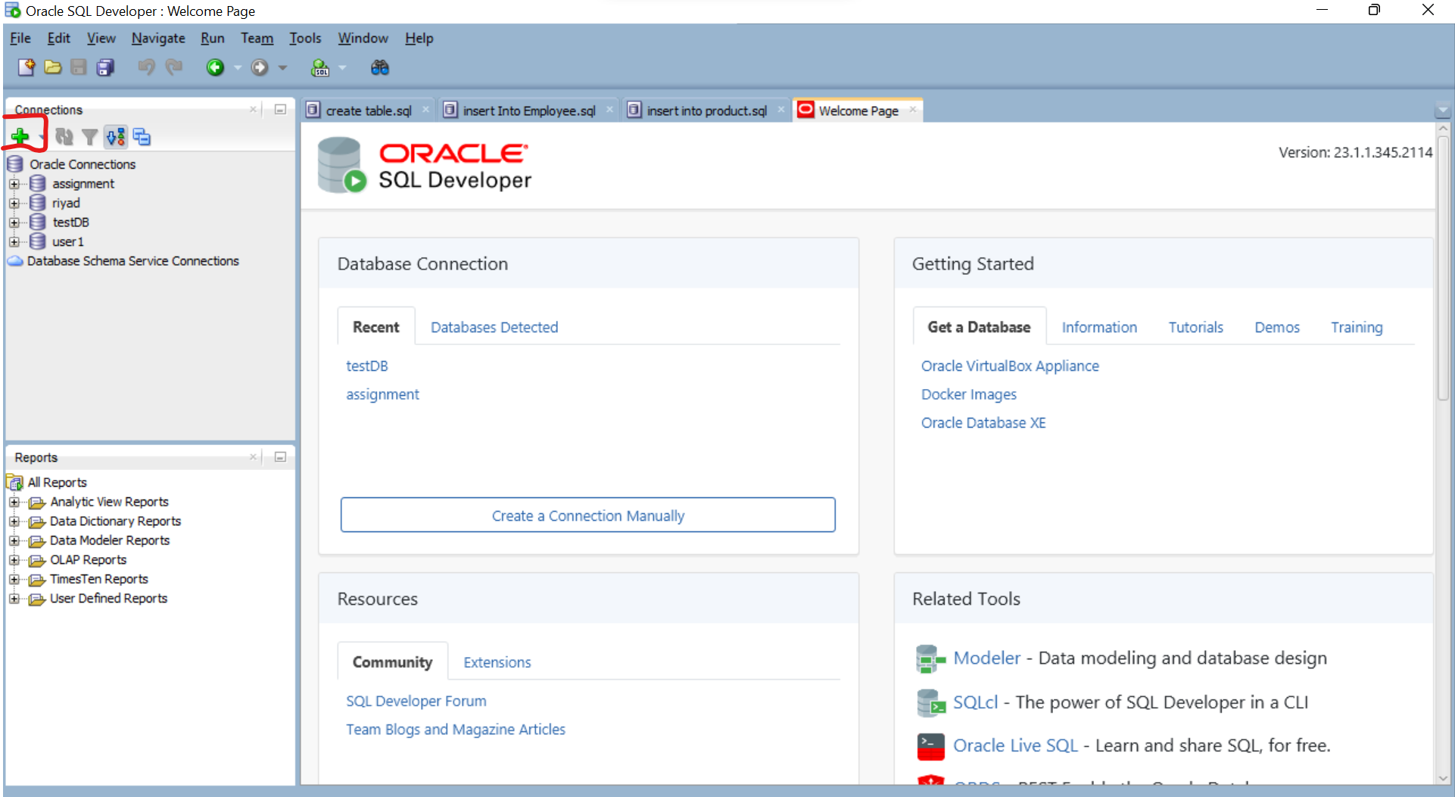

This is the what displays when we click for creating new connection**.**

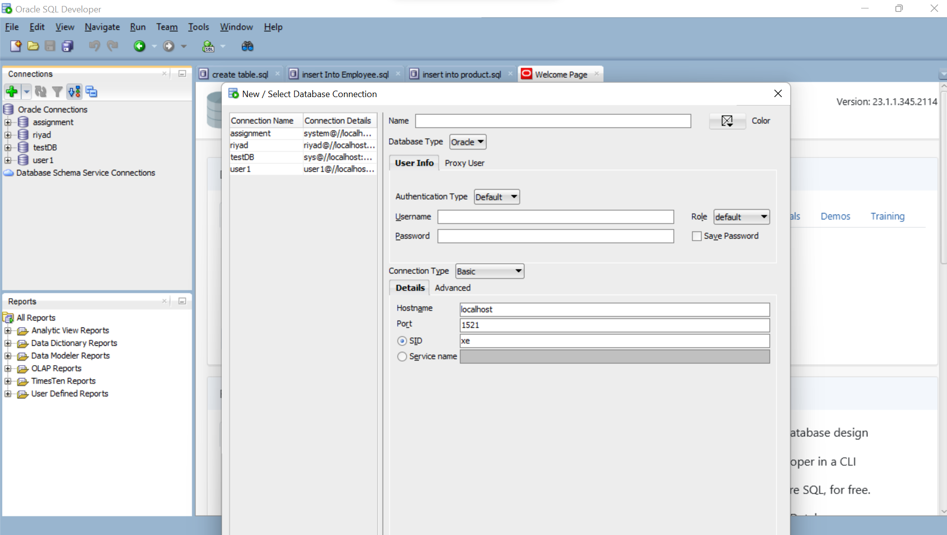

We insert the name of our new connection and we create the password, we click on save to avoid inserting the password when we are connecting back to that connection.

One service name we use the name of our created pluggable database, for us we are using PLSQL_CLASS2024DB.

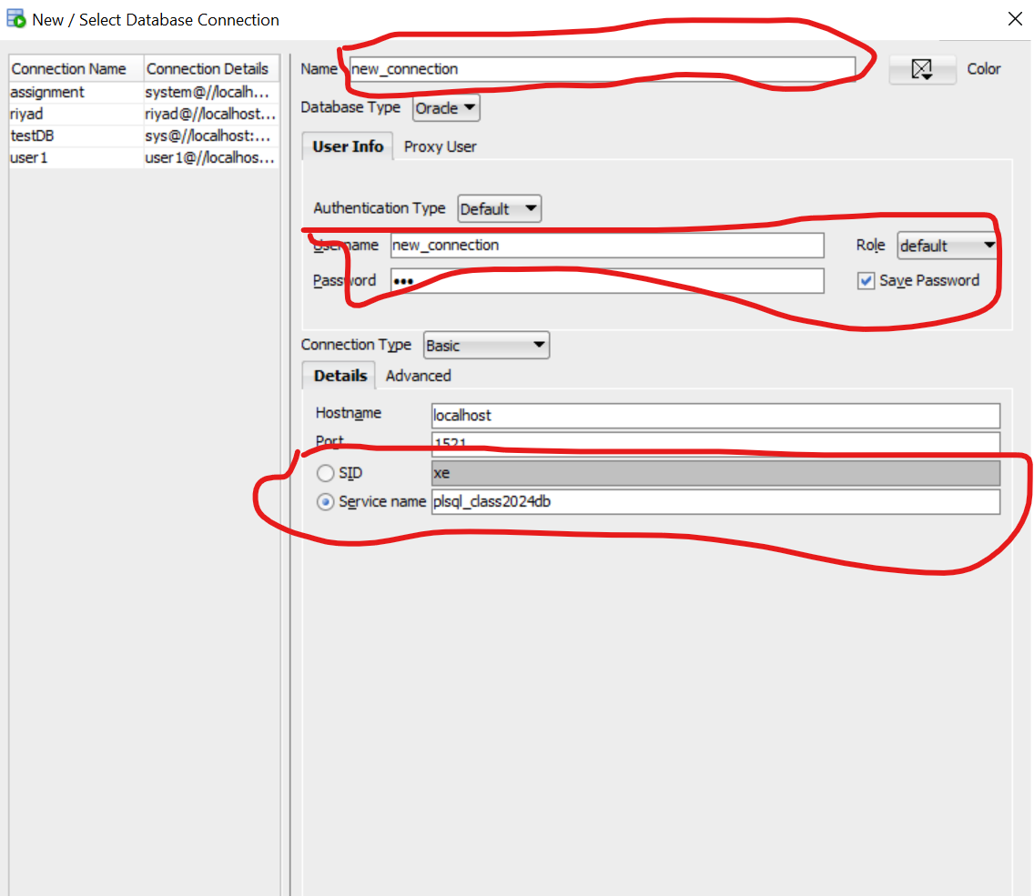

Later we access our ORACLE ENTREPRISE MANAGER, we can use any desired browser for us we are using chrome. We click on advance and click on “continue to localhost(unsafe)”

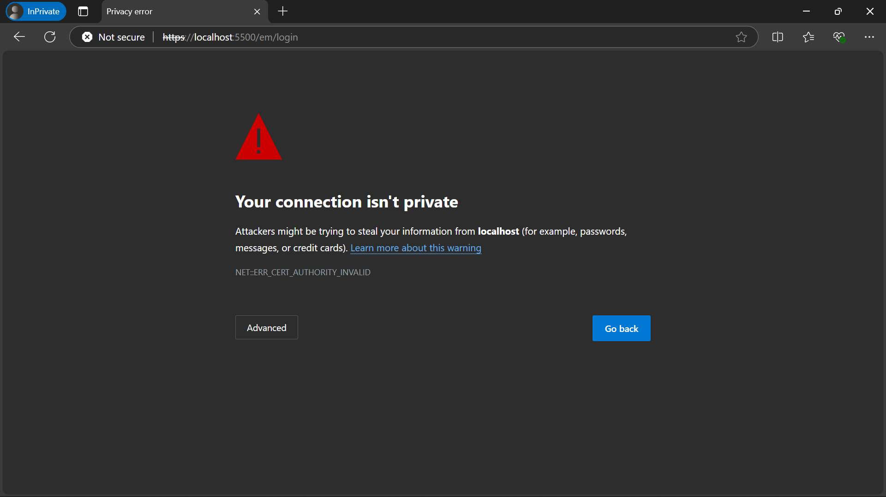

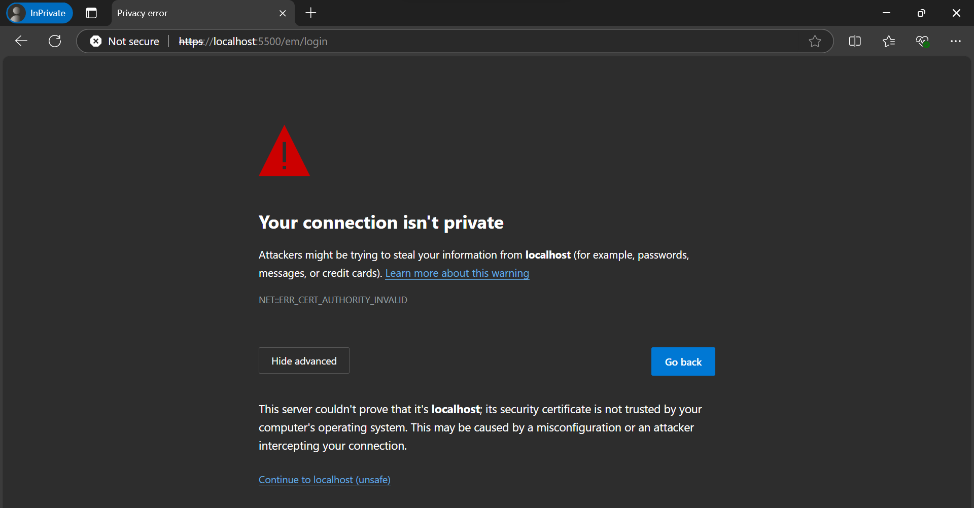

We use System as username and the password we use is the one configured during installation.

And all created pluggable databases can be seen there.

