**PLUGGABLE DATABASE FOR DELETING**

**Task 2:**

**Creating another pluggable database and later we will delete it.**

This documentation covers more information on how to create a pluggable database and other steps involved in changing instances, unplugging created pluggable devices, deleting pluggable databases, and many others as everything will be shown by their successful screenshots**.**

**Step 1. We first create a new pluggable database by typing :**

**“ CREATE PLUGGABLE DATABASE NG_TO_DELETE_PDB**

**ADMIN USER ng_plsqlauca IDENTIFIED BY 1234**

**FILE_NAME_CONVERT = ('C:\ORACLEAPP\ORADATA\ORCL\pdbseed\',**

**'C:\ORACLEAPP\ORADATA\ORCL\ORCLPDB\NG_TO_DELETE_PDB\');”**

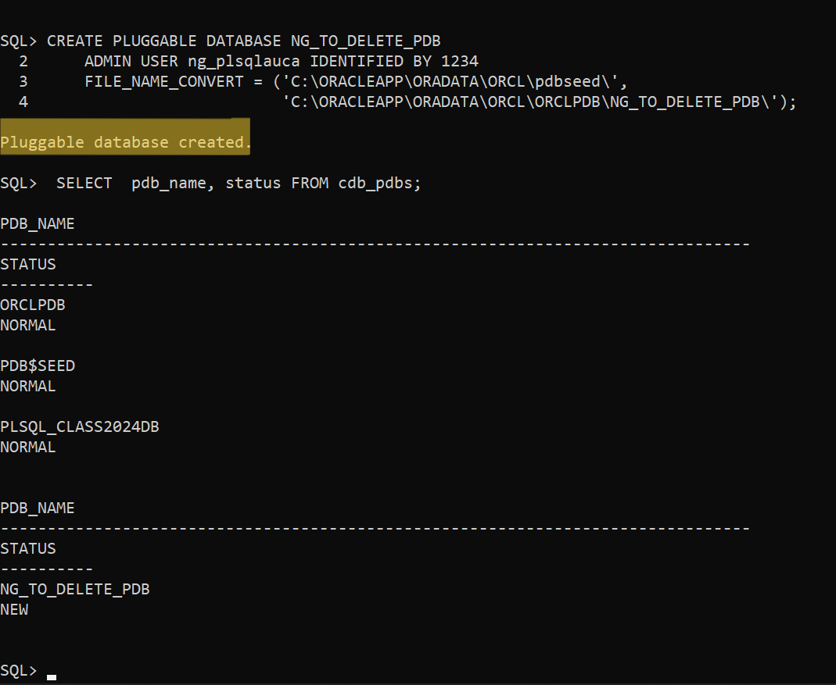

**STEP2: SHOWING THE CREATED PLUGGABLE DATABASE**

We simply use a single query to help us to determine whether we successfully created a new pluggable database using this query

**‘SELECT pdb_name, status FROM cdb_pdbs;’**

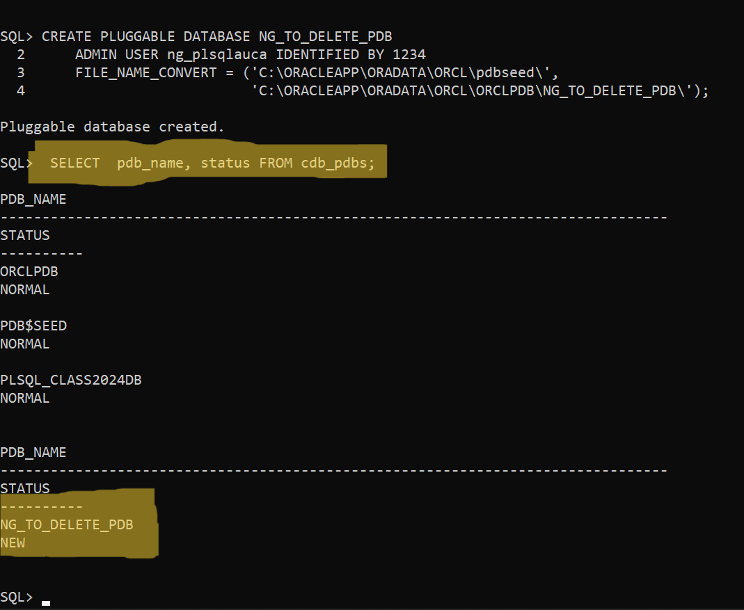

**STEP 3: OPENING THE CREATED PLUGGABLE DATABASE**

We first change the current pluggable databases to the one we want to use by using this query**;**

**ALTER PLUGGABLE DATABASE NG_TO_DELETE_PDB OPEN; “alter mean to change”**

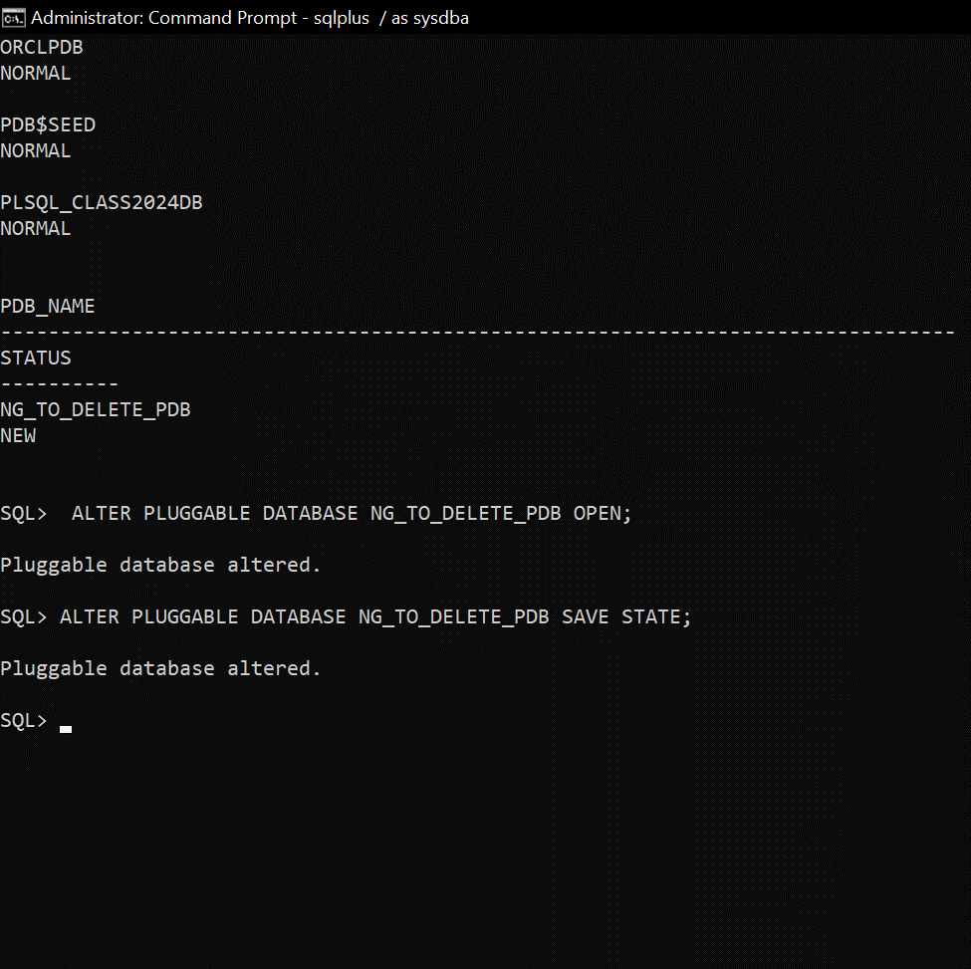

**STEP 4: SAVING STATE FOR THE CREATED PLUGGABLE DATABASE**

Using this query we successfully save the state of the pluggable database we want to use.

**ALTER PLUGGABLE DATABASE NG_TO_DELETE_PDB SAVE STATE;**

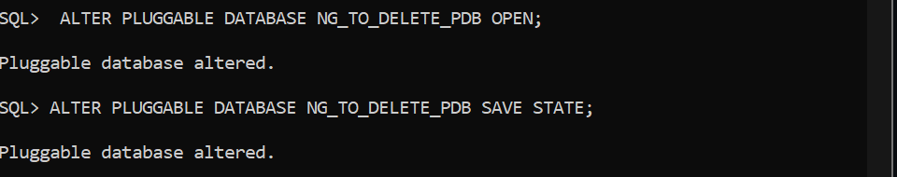

**STEP 5: CLOSE AND CHECK PATH FOR UNPLUGGING THE DATABASE**

In order to be able to perform any opearation on our pluggable database we are higly recommended to unplug it before anything else.

That is done by this query **: ‘ALTER PLUGGABLE DATABASE NG_TO_DELETE_PDB CLODE IMMEDIATE;’**

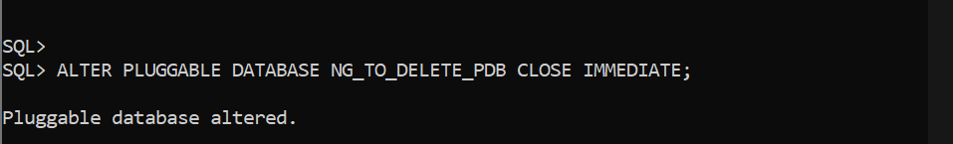

Here the sub_step is to determine the path for our pluggable database for supporting it deletion. This is the right query to use **‘SELECT directory_name, directory_path FROM dba_directories;’**

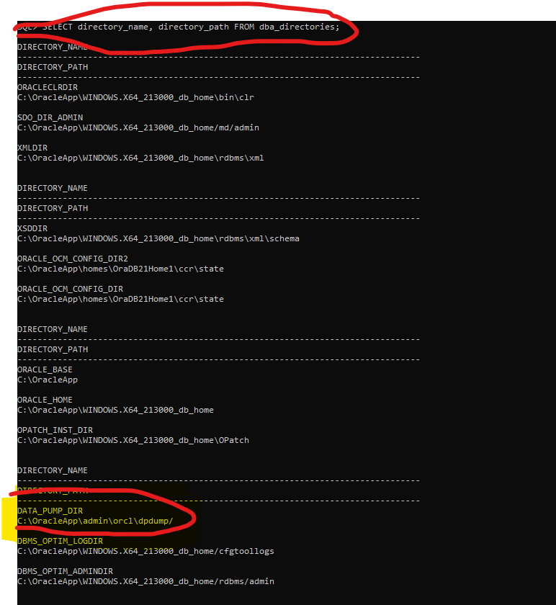

**STEP 6: UNPLUGGING THE DATABASE FOR DELETING IT**

**ALTER PLUGGABLE DATABASE NG_TO_DELETE_PDB UNPLUG into 'C:\OracleApp\admin\orcl\dpdump\NG_TO_DELETE_PDB.xml';**

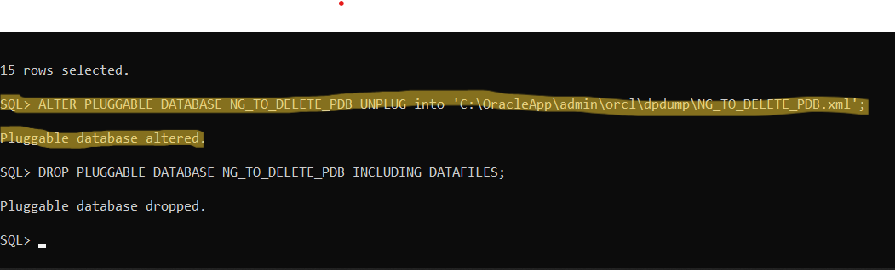

**STEP 7: DELETE OUR PLUGGABLE DATABASE WITH ALL DATAFILES.**

Deleting the pluggable database cannot be complete if we do not also delete it datafile, thus we use this query to remove all of it datafiles

**DROP PLUGGABLE DATABASE NG_TO_DELETE_PDB INCLUDING DATAFILES;**

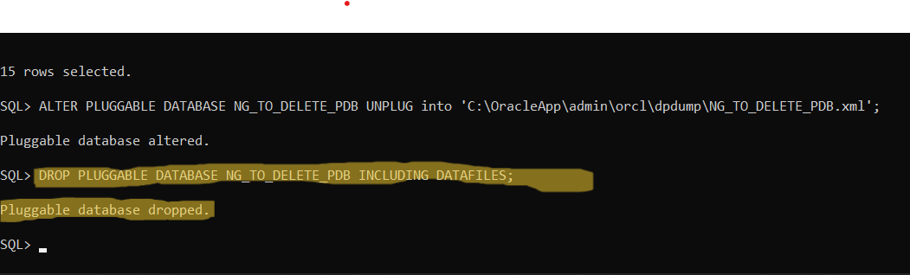

And at this stage we completed all needed steps for creating and deleting pluggable database.