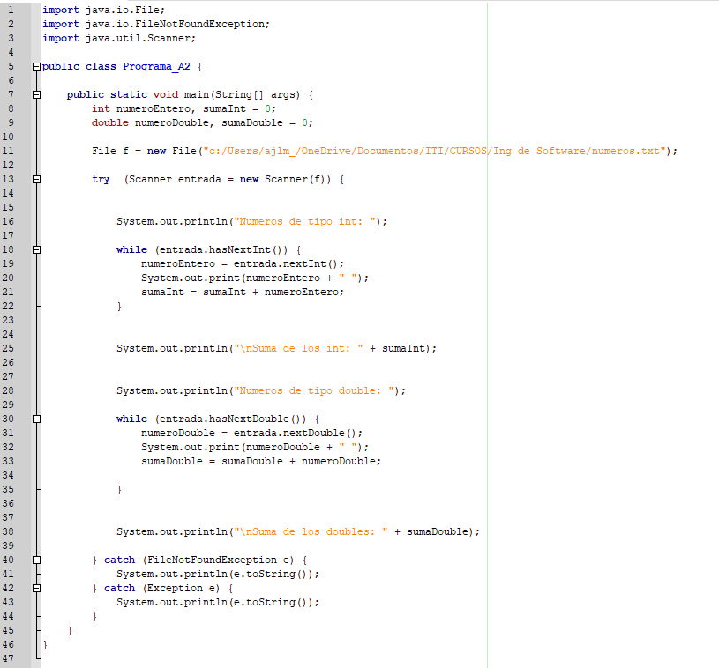

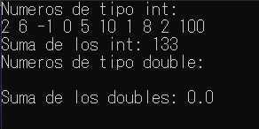

PSP0 PROJECT PLAN SUMMARY

Student: Roman Huerta Bernabe Date:12-06-21

Program: Programa A2 Program#: 1

Instructor: Juan Manuel González Calleros Language: Java

|  |  |  |  |  |
| --- | --- | --- | --- | --- |
| **Time in phase (min.)** | **Plan** | **Actual** |  |  |
| Planning | 10 min | 20 min |  |  |
| Design | 10 min | 10 min |  |  |
| Code | 120 min | 150 min |  |  |
| Compile | 1 min | 1 min |  |  |
| Test | 1 min | 1 min |  |  |
| Postmortem | 1 min | 1 min |  |  |
| Total | 145 | 185 min |  |  |
| **Defects Injected** |  | **Actual** |  |  |
| Planning | 0 | 0 |  |  |
| Design | 2 | 3 |  |  |
| Code | 5 | 6 |  |  |
| Compile | 2 | 1 |  |  |
| Test | 0 | 0 |  |  |
| Total Development |  | ______________ |  |  |
| **Defects Removed** |  | **Actual** |  |  |
| Planning | 0 | 0 |  |  |
| Design | 3 | 3 |  |  |
| Code | 6 | 6 |  |  |
| Compile | 1 | 1 |  |  |
| Test | 0 | 0 |  |  |
| Total Development |  | ______________ |  |  |
| After Development |  | ______________ |  |  |

TIME RECORDING LOG

|  |  |  |  |  |  |  |
| --- | --- | --- | --- | --- | --- | --- |
| Date | Start | Stop | Interruption Time | Delta Time | Phase | Comments |
| 11-06-21 | 6:00 | 9:00 | 1:00 | 0:55 | 1 | Vino un amigo a quedarse a dormir tuve que ser su afintrion |

DEFECT RECORDING LOG

|  |  |  |  |  |  |  |
| --- | --- | --- | --- | --- | --- | --- |
| Date | Number | Type | Inject | Remove | Fix Time | Fix Defect |
| 11-06-21 | 19 | unknown |  |  | 15 mins |  |

Description: javac "Programa_A2.java" (in directory:

C:\Users\ROMALDO-PC_\Descargas\ITI\verano2021\Ing de Software\Tareas)

Programa_A2.java:19: error: cannot find symbol

numeroEntero = entrada.sumaInt();

^

symbol: method sumaInt()

location: variable entrada of type Scanner

1 error

Compilation failed.

|  |  |  |  |  |  |  |
| --- | --- | --- | --- | --- | --- | --- |
| Date | Number | Type | Inject | Remove | Fix Time | Fix Defect |
| 10-06-21 | 21 | unknown | data |  | 20 min |  |

Description: javac "Programa_A2.java" (in directory:

C:\Users\ROMALDO-PC_\Descargas\ITI\verano2021\Ing de Software\Tareas)

Programa_A2.java:19: error: cannot find symbol

numeroEntero = entrada.sumaInt();

^

symbol: method sumaInt()

location: variable entrada of type Scanner

Programa_A2.java:21: error: cannot find symbol

sumaInt = nextInt + numeroEntero;

^

symbol: variable nextInt

location: class Programa_A2

2 errors

Compilation failed.**Process Improvement Proposal (PIP)**

|  |  |  |
| --- | --- | --- |
| **PIP Number** | | |
|  |  | **Problem Description:** | |
| 19 |  | Programa_A2.java:19: error: cannot find symbol | |
|  |  | numeroEntero = entrada.sumaInt(); | |
|  |  | numeroEntero = entrada.sumaInt(); | |
|  |  |  | |
| 21 |  | Programa_A2.java:19: error: cannot find symbol | |
|  |  | numeroEntero = entrada.sumaInt(); | |
|  |  | symbol: method sumaInt() | |
|  |  | location: variable entrada of type Scanner | |
|  |  | Programa_A2.java:21: error: cannot find symbol | |
|  |  | sumaInt = nextInt + numeroEntero; | |
|  |  | symbol: variable nextInt | |
|  | | |
| **PROPOSAL** | | |
| **PIP #** |  | **Proposal Description** | |
|  |  | Revisar la sintaxis de la operación y del código | |
|  |  |  | |
|  |  |  | |
|  |  |  | |
|  |  |  | |
|  |  |  | |
|  |  |  | |
|  |  |  | |
|  |  |  | |
|  |  |  | |
| **Notes and Comments:** | | |
|  |  |  | |
|  |  |  | |
|  |  |  | |
|  |  |  | |
|  |  |  | |
|  |  |  | |
|  |  |  | |
|  |  |  | |
|  |  |  | |
|  |  |  | |