Economic Freedom Index
A country-level composite indicator built from World Development Indicators and Worldwide Governance Indicators

Data Analysis and Visualisation – Continuous Assessment 1

Methodology follows the OECD Handbook on Constructing
Composite Indicators (OECD/JRC, 2008).

Table of Contents
Executive Summary 4
1. Introduction 5
1.1 What is a composite indicator? 5
1.2 Aim and scope of this project 5
1.3 Strengths and limitations of the approach 5
2. Theoretical Framework 7
2.1 The concept of economic freedom 7
2.2 Three provisional conceptual blocks 7
2.3 Why this framework is provisional 8
3. Data Selection 9
3.1 Data sources 9
3.2 Candidate indicators and their coverage 9
3.3 Time rule – strict 2024 vs latest available up to 2024 10
3.4 The raw master table 11
4. Imputation of Missing Data 12
4.1 The pattern of missingness 12
4.2 Remaining missing values and imputation choice 12
4.3 What is given up by the simple method 13
5. Multivariate Analysis 14
5.1 Correlation analysis 14
5.2 Principal Components Analysis 15
5.3 Cluster analysis 17
6. Normalization 19
6.1 Choice of method 19
6.2 Why percentile rank (and what is lost) 19
6.3 Direction handling 19
7. Weighting and Aggregation 21
7.1 Weighting – equal weights at every level 21
7.2 Aggregation – arithmetic (linear) means 21
7.3 Deciding which blocks to aggregate – the Limited Government decision 21
8. Link to Other Indices – External Validation 23
8.1 Why log GDP per capita PPP 23
8.2 Specification and results 23
8.3 Robustness interpretation 24
9. Results and Visualization 25
9.1 Distribution of the Index 25
9.2 Top and bottom performers 26
9.3 Institutional-openness structure 28
9.4 Regional and income-group breakdown 29
10. Version Control and Documentation 31
10.1 Version control 31
10.2 Reproducibility 31
10.3 Documentation 31
11. Conclusion and Limitations 32
11.1 Summary of findings 32
11.2 Limitations 32
Appendix. Full Country Ranking 33
References 41

Executive Summary
This report documents the construction of a country-level Economic Freedom Index built from raw local data files, following the ten-step methodology of the OECD Handbook on Constructing Composite Indicators (Nardo et al., 2008). The final index is produced for 189 countries using the latest observation available up to 2024 for each indicator.
The project began with a deliberately wider candidate set of nine indicators organised into three conceptual blocks — Institutions, Limited Government and Open Markets. A sequence of statistical diagnostics (correlation analysis, principal components analysis, k-means clustering and multiple linear regression against log GDP per capita PPP) was used to decide which blocks to keep and which to drop. Two indicators were removed as redundant duplicates, and the entire Limited Government block was removed after it consistently moved against the main freedom pattern on every diagnostic.
Final design: Economic Freedom Index = ½ × Institutions + ½ × Open Markets
Institutions = average of Rule of Law and Regulatory Quality.
Open Markets = average of Trade openness, Tariff rate, and Inflation.

The resulting Economic Freedom Index ranks Singapore, Denmark and Hong Kong SAR, China at the top (all above 90 out of 100), and Zimbabwe, Iran, and Syria at the bottom (all below 10). The cross-country pattern is consistent with existing international evidence: institutional quality is the strongest single correlate of development, and its standardised coefficient against log GDP per capita PPP (0.71) exceeds that of the openness block (0.23) by a factor of three.

1. Introduction

1.1 What is a composite indicator?
A composite indicator is a single aggregate measure built from two or more elementary indicators based on an underlying model of a multi-dimensional concept (Nardo et al., 2008). Composite indicators have become a central tool for benchmarking country performance in areas such as competitiveness, sustainable development, innovation, governance, and — as in this report — economic freedom.
The OECD Handbook identifies ten methodological steps for constructing a defensible composite indicator: (1) developing a theoretical framework; (2) selecting variables; (3) imputing missing data; (4) multivariate analysis; (5) normalisation; (6) weighting and aggregation; (7) robustness and sensitivity analysis; (8) back to the details; (9) links to other indices; and (10) presentation and dissemination. This report is organised around those ten steps.

1.2 Aim and scope of this project
The stated goal of this project is to build one simple country-level score from raw data — not to reproduce an existing commercial ranking such as the Heritage Foundation's Index of Economic Freedom or the Fraser Institute's Economic Freedom of the World. Every component is traceable back to a raw World Bank series, and every design decision is taken based on a data-driven diagnostic rather than a prior assumption about what economic freedom should look like.
The scope is deliberately narrow. Only two data sources are used:
- The World Development Indicators (WDI), the World Bank's primary collection of cross-country time-series on development (World Bank, 2024). In this report WDI supplies the economic variables — tariffs, trade openness, inflation, government consumption, and tax revenue.
- The Worldwide Governance Indicators (WGI), which publish country-level aggregate scores on six governance dimensions on a 0-100 percentile scale (Kaufmann & Kraay, 2024). In this report WGI supplies rule of law, regulatory quality and control of corruption.

1.3 Strengths and limitations of the approach
Composite indicators have well-known advantages and well-known drawbacks. Saltelli (2007) and Nardo et al. (2008) argue that they allow complex, multi-dimensional realities to be summarised in a way that attracts public and political attention; they facilitate comparisons over time and across countries; and they reduce the visible size of a set of indicators without dropping their underlying information. Their weaknesses are equally well documented: they can send misleading policy messages if poorly constructed, they invite simplistic conclusions, and the choice of weights and aggregation rules can be used to support predetermined political positions.
Three design choices in this report are explicitly intended to address these criticisms. First, the pipeline is fully documented and reproducible from raw data (Section 10). Second, weighting is equal at every level, removing one common vector of manipulation. Third, every block is tested against the other blocks before it is admitted to the final index — a block that moves in the wrong direction on every diagnostic is dropped.

2. Theoretical Framework
The first step in the OECD methodology is to develop a theoretical framework that gives the composite indicator a meaning beyond the aggregation of numbers. The framework should provide the basis for choosing the sub-indicators on which the index will be built.

2.1 The concept of economic freedom
Economic freedom is commonly defined, following Gwartney, Lawson and Hall (2022), as a state in which people are able to make their own economic decisions — to earn, to contract, to trade, to hold property and to keep the fruits of their labour — protected by enforceable and predictable rules. The concept has two conceptual faces: a negative face (absence of coercion — low tariffs, moderate taxes, containable inflation) and a positive face (presence of impartial rules — rule of law, regulatory quality, control of corruption).
Existing indices structure this concept in slightly different ways. The Heritage Foundation Index uses four pillars: Rule of Law, Government Size, Regulatory Efficiency and Open Markets (Heritage Foundation, 2024). The Fraser Institute uses five: Size of Government, Legal System and Property Rights, Sound Money, Freedom to Trade Internationally, and Regulation (Gwartney et al., 2022). Both agree on three things: (i) institutions matter, (ii) openness matters, and (iii) an over-dominant state matter.

2.2 Three provisional conceptual blocks
This report begins with a structure that is compatible with both the Heritage and Fraser approaches but simpler than either. Nine indicators are assigned to three provisional blocks:
Indicator | Source | Block | Expected direction
Rule of law | WGI | Institutions | Higher is better
Regulatory quality | WGI | Institutions | Higher is better
Control of corruption | WGI | Institutions | Higher is better
Government consumption (% of GDP) | WDI | Limited Government | Lower is better
Tax revenue (% of GDP) | WDI | Limited Government | Lower is better
Trade (% of GDP) | WDI | Open Markets | Higher is better
Tariff rate, all products (%) | WDI | Open Markets | Lower is better
Tariff rate, manufactured products (%) | WDI | Open Markets | Lower is better
Inflation, consumer prices (%) | WDI | Open Markets | Lower is better
Table 1. Nine candidate indicators assigned three provisional blocks.
The Institutions block is taken entirely from WGI and proxies the positive face of economic freedom. The Limited Government block uses two indicators of the fiscal footprint of the state, on the hypothesis that a larger state is negatively associated with economic freedom. The Open Markets block brings together trade openness, tariffs, and inflation to capture the macro-environment in which economic decisions are made. Expected directions are given in Table 1: some indicators (e.g., rule of law) move with freedom, others (e.g., tariffs) against it — they are sign-inverted before normalisation.

2.3 Why this framework is provisional
The word 'provisional' is used deliberately. The OECD Handbook advises starting with a wider candidate set than is likely to survive and using statistical diagnostics in Steps 3–7 to trim it. Section 5 of this report does exactly that: two near-duplicate indicators are removed based on correlation, and one entire block is removed based on PCA, clustering and external regression. The theoretical framework thus plays the role of a hypothesis, not a conclusion.

3. Data Selection

3.1 Data sources
The project uses two raw data files directly. No pre-built indices or third-party rankings are used as inputs. The WDI file is the standard World Bank time-series database in wide panel format (one row per country-indicator-year triple). The WGI 2025 release supplies the three governance indicators in long format, with one Excel sheet per indicator.
Source | Dataset | Reference | Role
WDI | World Development Indicators | World Bank (2024). WDI database, 2024 vintage. | Six WDI economic indicators (see Table 1).
WGI | Worldwide Governance Indicators (2025 release) | Kaufmann & Kraay (2024). | Three WGI institutional indicators on the 0-100 percentile scale.
WDI | GDP per capita, PPP (current international $) | World Bank (2024). | Used only for external validation in Section 8, never as an input.
Table 2. Raw data sources used in this report.

3.2 Candidate indicators and their coverage
Figure 1 shows how many of the 217 countries in the World Bank universe have at least one observation of each candidate indicator over the 2019-2024 window. The three institutional indicators from WGI have the highest coverage (205-207 countries). The two Limited Government indicators have the lowest coverage: government consumption is available for 176 countries, but tax revenue is only available for 142.
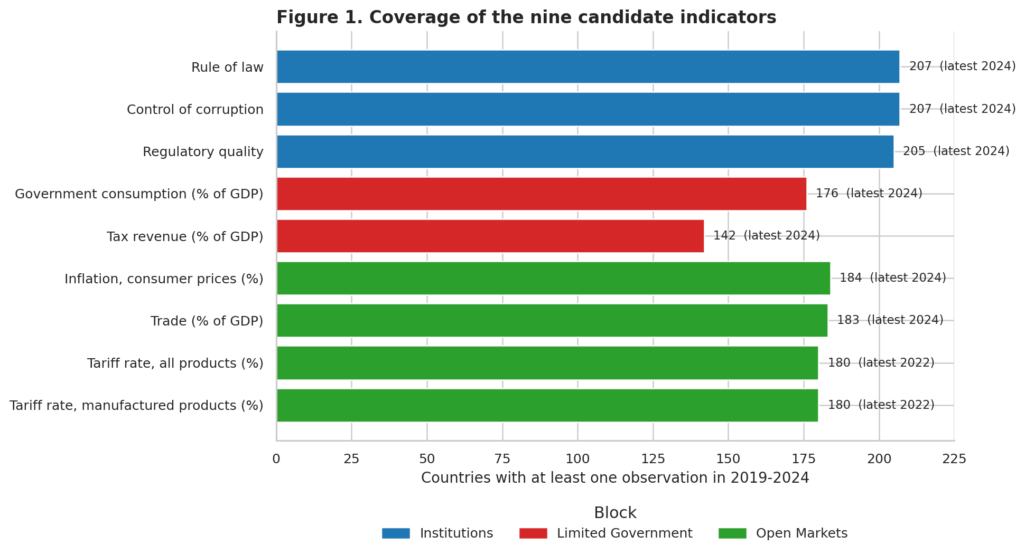
Figure 1. Coverage of the nine candidate indicators.
The weak coverage of tax revenue is an early signal in the analysis. It will reappear in Section 4 (many missing values requiring imputation) and Section 5 (the Limited Government block being the weakest on every diagnostic).

3.3 Time rule – strict 2024 vs latest available up to 2024
The choice of time rule has a substantial effect on the size of the usable sample. A strict 2024-only rule keeps only country-indicator pairs where a value is published for 2024. A 'latest available' rule, which walks backward through 2024→2019 and keeps the most recent non-missing observation, is more forgiving and makes the index robust to publication lags.
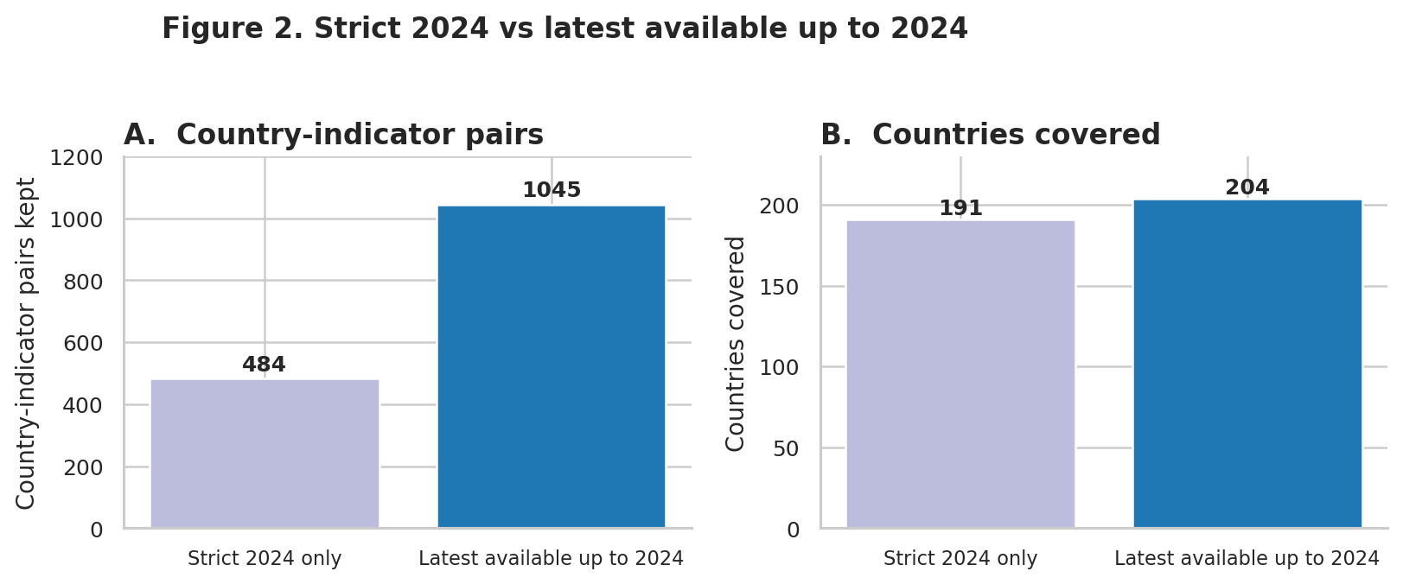
Figure 2. Trade-off between a strict 2024 rule and a rolling 'latest available up to 2024' rule.
Panel A of Figure 2 shows that a strict 2024 rule keeps 484 country-indicator pairs. Relaxing the rule to 'latest available up to 2024' more than doubles this to 1,045 pairs. Panel B shows that the country’s coverage also improved, from 191 to 204. On this basis, the rolling window rule is adopted for the rest of the analysis, with the year used recorded alongside each value so that the audit trail is not lost.

3.4 The raw master table
All data is brought into a single long-format 'master' table with one row per country-indicator observation. Rows carry the country code and name, the region and income group from WDICountry.csv, the indicator's short name, plain name, block and direction, the year used, and the observed value. A pivoted country-level wide table is then derived from the master for the statistical steps. The three institutional indicators are pulled from the 2025 release of WGI, the economic indicators from the latest WDI snapshot.
Quantity | Value
Rows in the raw master table | 1,664
Countries in the clean country table | 217
Countries with GDP data for validation | 199
Rows in the country-level wide table | 210
Table 3. Size of the raw and pivoted master tables.
210 countries appear in the wide table — thirteen countries in the clean country list have no observation at all in any candidate indicator and are dropped at this stage.

4. Imputation of Missing Data

4.1 The pattern of missingness
Imputation is Step 3 in the OECD Handbook. Before imputing anything, the analysis first trims the sample so that the imputed values never dominate the country's score. Two country-level rules are applied:
- Institutions: a country must have at least 2 of 2 non-missing WGI scores.
- Limited Government (provisional): at least 1 of 2 indicators present.
- Open Markets: at least 2 of 3 indicators present.
These rules are not about removing noise — they are about setting a minimum information threshold so that each country's block score is driven by real observations rather than by imputed medians. Applying them drops 33 of the 210 candidate countries, leaving 177 countries for the diagnostic stage.
sample_step | country_count
All countries in the clean country table | 210
Countries kept for three-block diagnostics | 177
Countries dropped at this stage | 33
Table 4. Countries kept after the three-block minimum-coverage rule.

4.2 Remaining missing values and imputation choice
Figure 5 shows, for each candidate indicator, the number of remaining missing values in the 177-country diagnostic sample, after the minimum-coverage rule is applied.
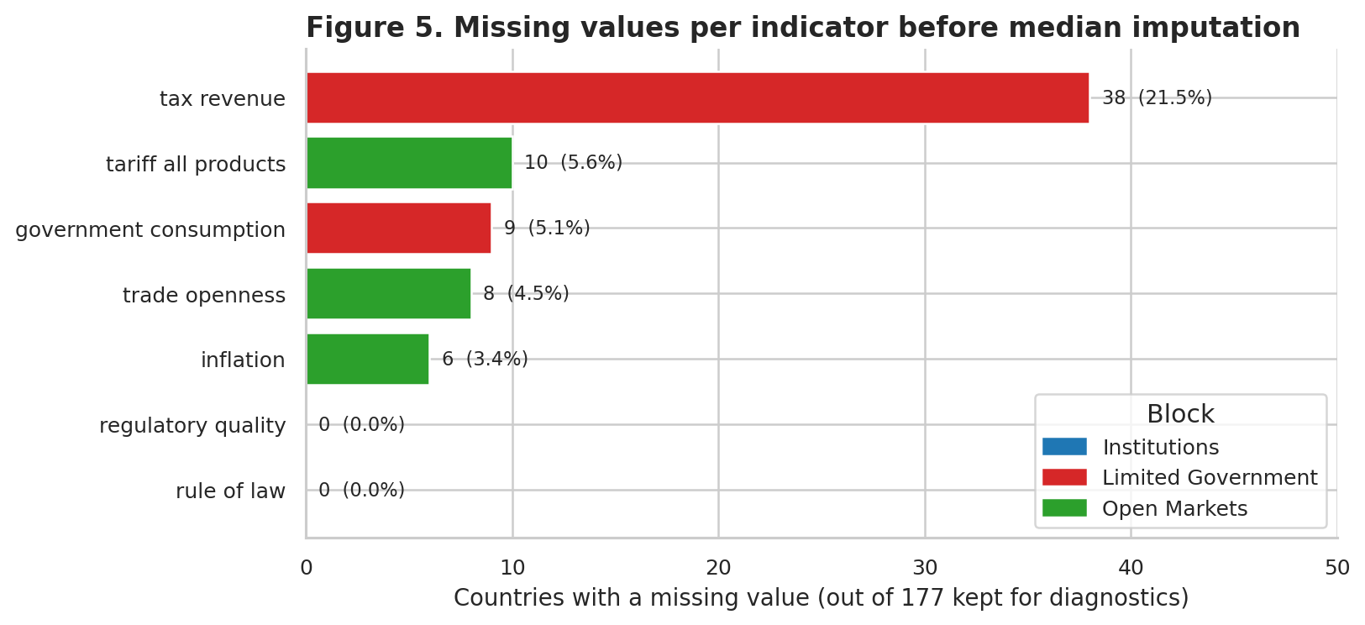
Figure 5. Missing values per indicator in the 177-country diagnostic sample, before imputation.
The Institutions block is fully covered by construction. Open Markets has light missingness (6-10 countries per indicator). The Limited Government block is noticeably worse: tax revenue is missing for 38 countries (about 21 % of the sample), a warning sign that reinforces the coverage issue seen in Figure 1.
The OECD Handbook reviews five classes of imputation method: (i) case deletion, (ii) single unconditional mean imputation, (iii) regression imputation, (iv) expectation-maximisation, and (v) multiple imputation. This report uses unconditional median imputation — the simplest option — on the following grounds:
- The remaining missingness, post-threshold, is at most 38 cases in any single indicator, and never exceeds 21 % of the sample. This is small enough that the choice of imputation method does not materially change the country ordering.
- Median imputation is robust to the heavy right tails typical of trade-openness and inflation variables. Mean imputation would drag the imputed values toward small-state outliers; regression imputation would require an explicit model of missingness and is harder to document.
- The imputation step is the final value-injection point: no country's block score is built from more than one or two imputed observations, given the coverage rules above.

4.3 What is given up by the simple method
The trade-off is transparent. Multiple imputation would propagate the uncertainty of the imputed values through to confidence intervals on the final score. Regression-based imputation might tighten the estimated tariff or tax values of small states by borrowing strength from similar economies. This report deliberately does not do either: the primary output is a point estimate per country, and the fact that 1-2 values were median-imputed is part of the country's metadata, not a feature of the score itself. A robustness-by-imputation-method sensitivity test is left as a direction for future work (Section 11).

5. Multivariate Analysis
Multivariate analysis is Step 4 in the OECD Handbook. Its function is diagnostic: before committing to a particular weighting and aggregation scheme, the analyst should verify that the candidate indicators measure a coherent underlying construct, and that any proposed block structure is consistent with what the data says. Three complementary techniques are used below — pairwise correlation, principal components analysis and k-means clustering — followed by a multiple linear regression against an external reference in Section 8.

5.1 Correlation analysis
Before the correlation is computed, each indicator is signed so that 'higher is better' for every variable: tariffs, inflation, government consumption, and tax revenue are multiplied by -1. Pearson correlations are then computed over the 177 countries that survived the coverage rule.
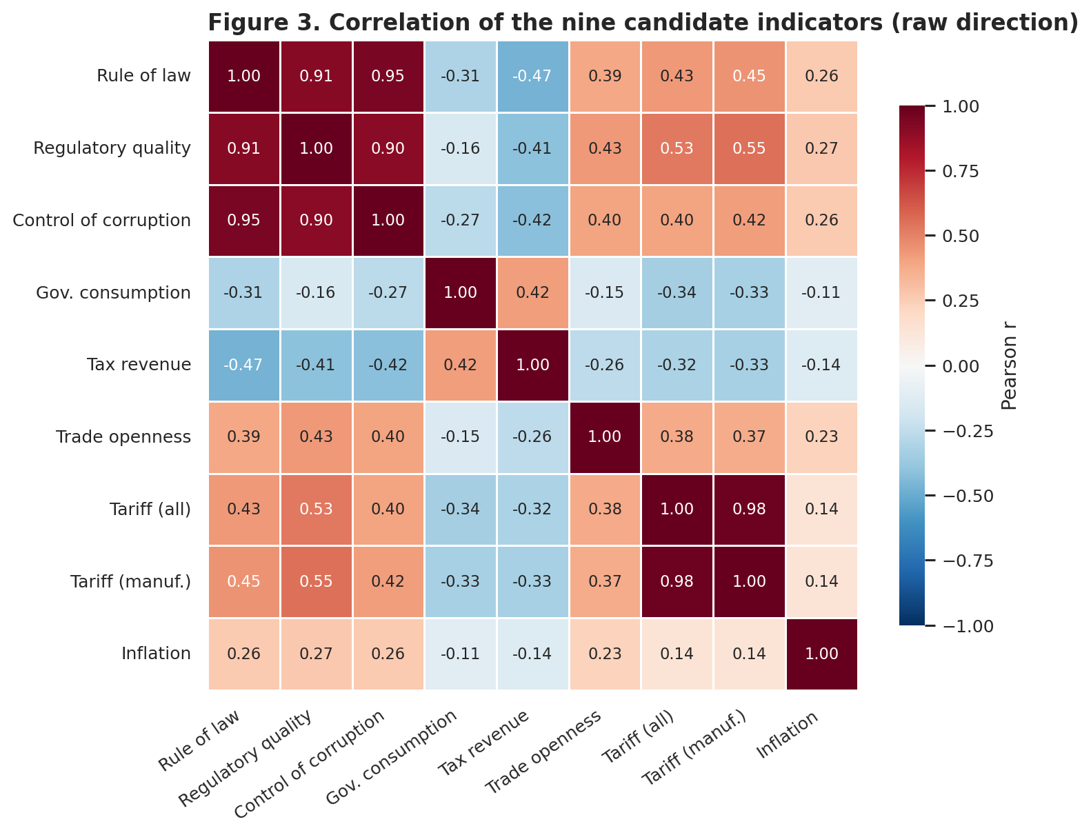
Figure 3. Correlation matrix of the nine candidate indicators (raw direction; no sign inversion).
The structure visible in Figure 3 is broadly reassuring: three large positive blocks along the diagonal, corresponding to the three conceptual groups. Two pairs, however, exceed the 0.90 threshold set in advance for 'almost-duplicate' indicators:
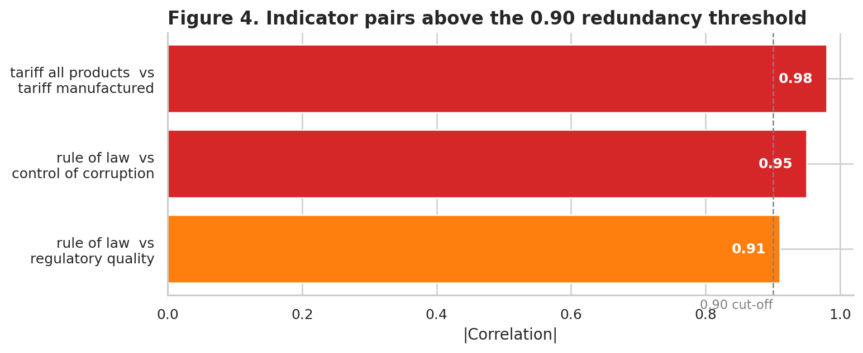
Figure 4. Three indicator pairs with |r| ≥ 0.90.
Three pairs exceed the 0.90 threshold; two distinct redundancies must be resolved. Rule of law, regulatory quality and control of corruption form a tightly linked institutional cluster, so the pair rule_of_law / control_of_corruption at r = 0.95 is resolved by dropping control of corruption and keeping rule of law as the primary institutional indicator. The pair tariff_all_products / tariff_manufactured at r = 0.98 is resolved by dropping tariff on manufactured products in favour of the more general 'all products' variant. After these two removals, seven indicators remain across the three provisional blocks.

5.2 Principal Components Analysis
With the indicators signed, percentile-scaled and averaged to block level, principal components analysis is run on the three block scores for the 177 countries. The input matrix is standardised before PCA (zero mean, unit variance per block).
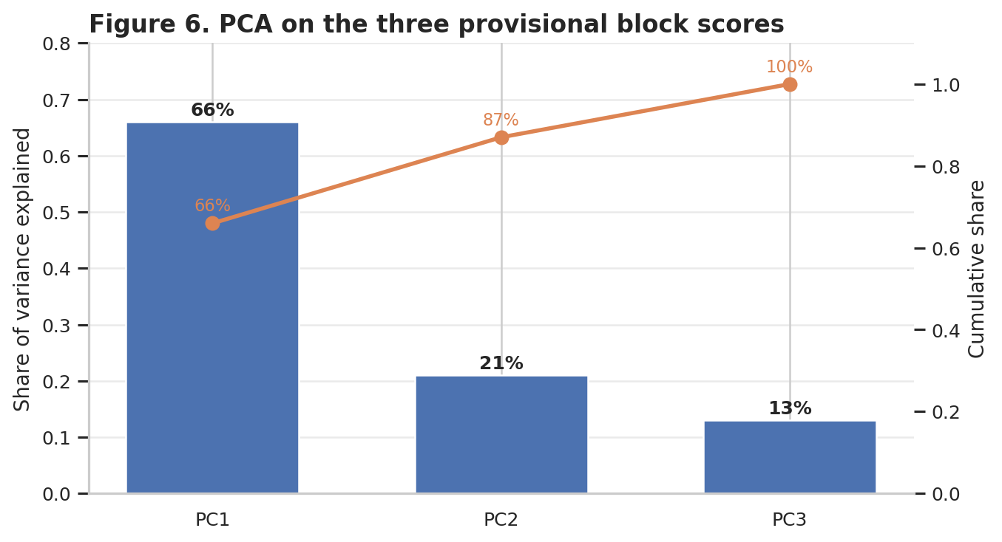
Figure 6. Explained variance by principal component.
PC1 captures 66 % of the total variance, PC2 adds another 21 %, and together they account for 87 %. This is a strong signal that the three blocks share a single dominant axis — exactly what the theoretical framework predicts for a 'common freedom' dimension.
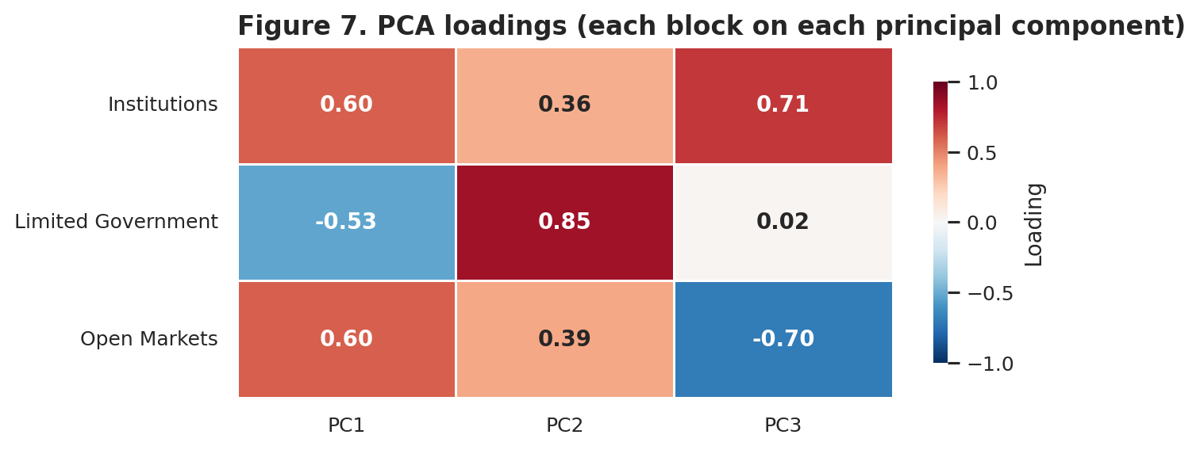
Figure 7. Loadings of each block on each principal component.
The loading structure in Figure 7, however, reveals a problem. On PC1 Institutions and Open Markets both loads positively (0.60 each), while Limited Government loads negatively (-0.53). This means that, in the dominant data pattern, a country scoring high on Limited Government tends to score low on the other two blocks. The biplot in Figure 8 makes this visual.
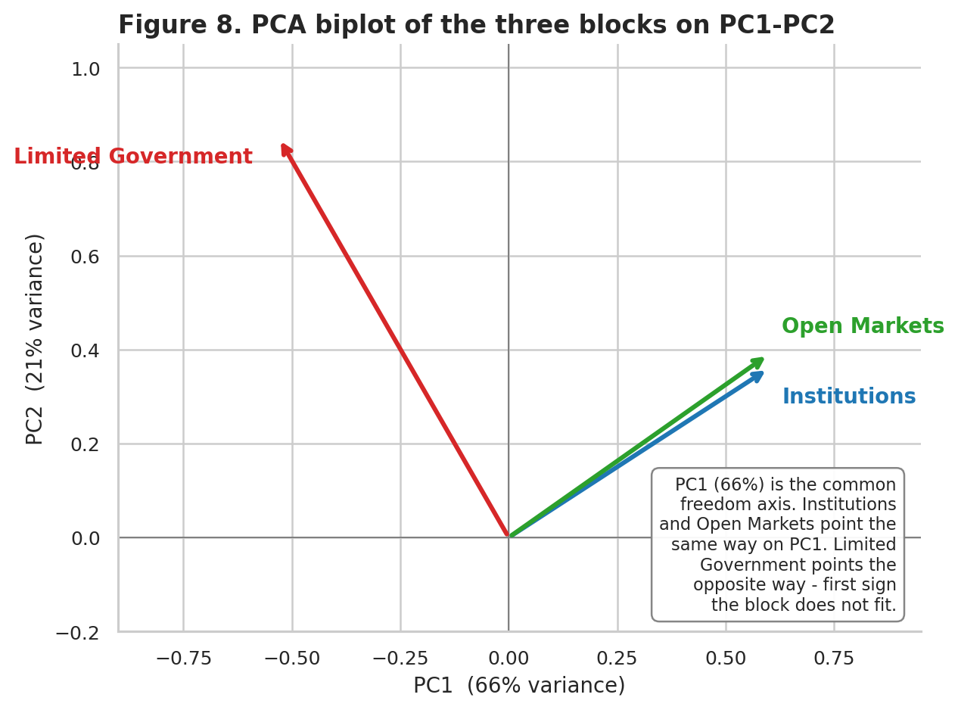
Figure 8. PCA biplot of the three blocks on PC1–PC2. Limited Government points in the opposite direction of Institutions and Open Markets.
This is the first hard signal that the Limited Government block is not well-behaved. The PCA is not saying that limiting the size of the state is bad for freedom — it is saying that, in the raw cross-country data for 2019-2024, countries with low government consumption and low tax revenue (the two chosen proxies) are not the same countries as those with strong institutions and open markets. An explanation is that many resource-rich or oil-exporting states report extremely low tax revenue while simultaneously scoring low on rule of law — the raw data captures this pattern, and PCA is faithfully reporting it.

5.3 Cluster analysis
K-means clustering is run on the three standardised block scores for values of k ∈ {2, 3, 4}. The silhouette score is used to select the best k.
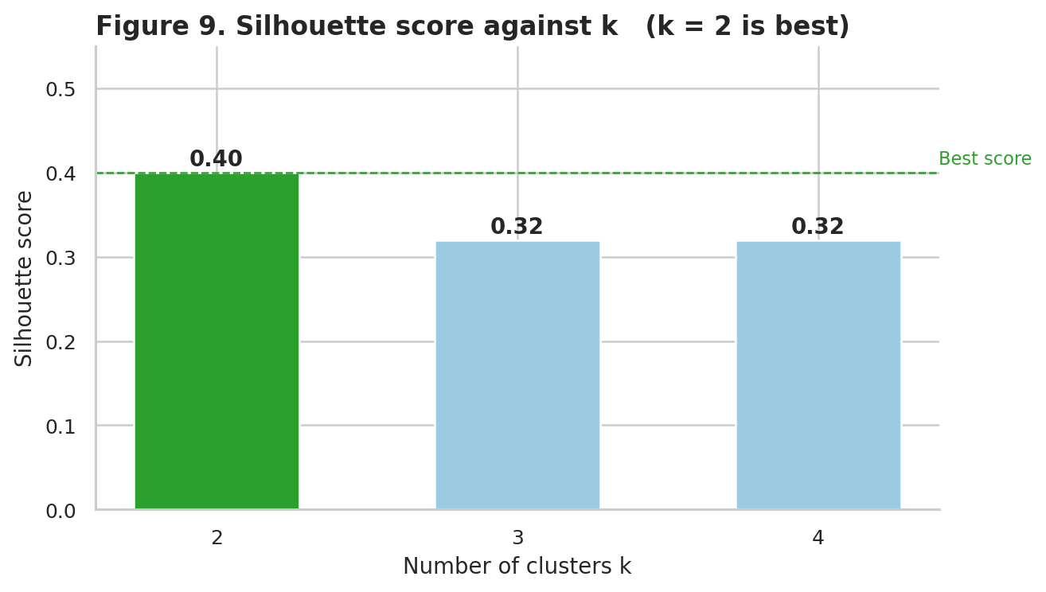
Figure 9. Silhouette score by k. Two clusters are the best grouping under the provisional three-block structure.
A two-cluster solution has the highest silhouette score (0.40), comfortably ahead of three or four clusters (both at 0.32). The two clusters are labelled Higher freedom and Lower freedom based on their mean block scores.
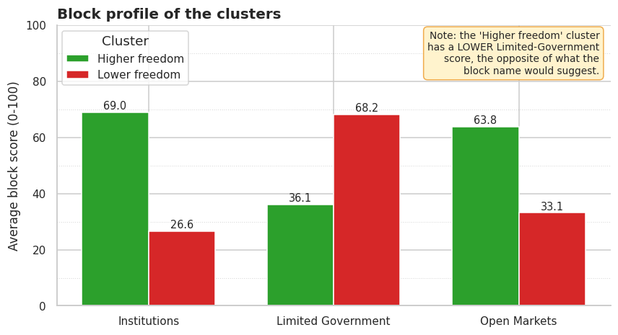
Figure 10. Profile of the two clusters on the three provisional blocks.
Figure 10 confirms the PCA reading. The 'Higher freedom' cluster — made up of countries one would intuitively expect (Albania, Armenia, Aruba, Australia, Austria, Azerbaijan appear in its first few entries) — has higher Institutions and higher Open Markets scores than the 'Lower freedom' cluster, as expected. However, it also has a lower Limited Government score (36 vs 68). The cluster profile is therefore giving the same message as the PCA: Institutions and Open Markets are moving together and in the expected direction; Limited Government is moving in the opposite direction.
At this point, the Limited Government block has two independent pieces of evidence against it. Section 8 will provide a third, using an external regression against development.

6. Normalization
Normalization is Step 5 in the OECD Handbook. Its job is to bring indicators that are measured on different scales onto a common scale, so that they can be averaged without any single indicator dominating by accident of units.

6.1 Choice of method
The Handbook reviews seven normalisation methods: ranking, standardisation (z-scores), min-max, distance-to-reference, above/below mean, cyclical methods and percentage of annual differences. This project uses a ranking variant — percentile rank — applied separately to each individual indicator after the indicators have been sign-corrected so that 'higher is better' for every variable.
Formally, for an indicator with values x₁, …, xₙ across the n surviving countries, each country's normalised score is:
s_i = 100 × rank(x_i) / n
where rank(x_i) is the dense rank of country i's value in the sign-corrected series. The resulting score lies in (0, 100].

6.2 Why percentile rank (and what is lost)
Percentile rank has three properties that are attractive in this setting:
- It is fully robust to extreme values. Inflation in 2023-2024 ranges from deflation of about -7 % in Afghanistan to hyper-inflation of over 200 % in Argentina. A min-max or z-score normalisation would let these two extreme observations pull every other country toward the middle of the scale. Percentile rank treats all 189 countries as equally spaced along the indicator axis, losing information about magnitude but protecting the ordinal structure.
- It is invariant to monotonic transformations (e.g., taking the log of GDP per capita would not change percentile ranks at all). This means the final index cannot be changed by a choice of level versus log that is orthogonal to the concept being measured.
- It is directly interpretable. A country with a block score of 75 is 'better than three quarters of the world' on that block. Min-max or z-scores need a further conversion step to read this way.
The cost of percentile ranking is the loss of cardinal information. A country whose inflation is twice as high as its neighbor’s appears to be only one rank lower. A composite indicator must pick one of the two: this project explicitly chooses robustness over cardinality.

6.3 Direction handling
Four of the seven surviving indicators have the 'lower is better' direction: tariffs, inflation, government consumption, and tax revenue. For these indicators, the raw value is multiplied by -1 before percentile-ranking, so that the resulting score of 100 corresponds to the lowest tariff, not the highest. This simple sign-flip is the only step of the pipeline where the direction metadata in the candidate plan is used operationally.

7. Weighting and Aggregation
Weighting and aggregation form Step 6 of the OECD Handbook. They are the two decisions most responsible for the political sensitivity of composite indicators, and they are the two most often used to fudge the ranking. This project takes the most conservative position on both.

7.1 Weighting – equal weights at every level
Equal weighting (EW) is used throughout: indicators are averaged inside each block with equal weight, and surviving blocks are averaged with equal weight at the top. Alternative weighting schemes reviewed in the Handbook — PCA-based weights, Data Envelopment Analysis, Benefit-of-the-Doubt, the Budget Allocation Process, Public Opinion, the Analytic Hierarchy Process, Conjoint Analysis — all share the property that they introduce a new judgement (either statistical or subjective) that can be contested. Equal weighting makes one explicit value judgement — that every indicator counts the same inside its block — and no other.
Equal weighting has a clear technical consequence: indicators within a block need to be 'of comparable importance' to the underlying concept. This is why the correlation-based duplicate removal in Section 5.1 is a pre-condition of EW — two near-identical indicators would otherwise be double-counted inside a block.

7.2 Aggregation – arithmetic (linear) means
Three aggregation rules are standard: the arithmetic mean (compensatory; a low score on one indicator can be offset by a high score on another), the geometric mean (partially non-compensatory; a score of zero on any one indicator pulls the entire index to zero), and multi-criteria decision analysis (strictly non-compensatory; no trade-offs between indicators).
The arithmetic mean is used here. It is the default for most internationally reported composite indices (HDI, Environmental Performance Index, Global Competitiveness Index); it is compatible with equal weights; and in this setting the percentile-rank normalisation bounds the inputs between 0 and 100, so the compensation is mild — no single indicator can fully offset another.

7.3 Deciding which blocks to aggregate – the Limited Government decision
By the time weighting is fixed, three independent diagnostics have been applied to the provisional three-block structure. Table 5 summarises what each one says about each block.
Block | PCA verdict (Section 5.2) | Cluster verdict (Section 5.3) | MLR verdict (Section 8) | Final
Institutions | Positive on PC1 (+0.60). | Clearly higher in Higher-freedom cluster (+42 pts). | Strongest external coefficient (+0.71). | Keep.
Open Markets | Positive on PC1 (+0.60). | Clearly higher in Higher-freedom cluster (+31 pts). | Second external coefficient (+0.23). | Keep.
Limited Government | Negative on PC1 (-0.53). | Lower (!) in Higher-freedom cluster (-32 pts). | Weakest external coefficient (+0.13), smallest VIF. | Drop.
Table 5. Three diagnostics on the three provisional blocks and the resulting decision.
The evidence is unanimous. Limited Government fails all three tests: PCA puts it on the opposite side of the main common axis; clustering puts the wealthier, more institutional cluster on the LOWER side of the block; and the MLR in Section 8 assigns it the smallest external coefficient despite ranking it first conceptually under the 'small-state' hypothesis.
Final aggregation equation:
Economic Freedom Index_i = ½ · Institutions_i + ½ · Open Markets_i
where Institutions_i is the mean of the two surviving WGI scores for country i, and Open Markets_i is the mean of trade openness, (negated) tariff rate and (negated) inflation — each percentile-ranked across the 189 countries in the final sample.

At the final step, 189 countries survive both the threshold rule (at least 2 of 2 Institutions indicators and at least 2 of 3 Open Markets indicators) and the data cleaning. 21 countries are dropped from the 210-country wide table because they have too little information for even a two-block index — most of these are micro-states and non-sovereign territories (Liechtenstein, Monaco, Marshall Islands, Nauru, Liechtenstein, San Marino is retained but several others are not).

8. Link to Other Indices – External Validation
The OECD Handbook dedicates an entire step to 'links to other variables' (Step 9). Its purpose is to test whether the composite indicator correlates in the expected direction with other measures it ought to correlate with and is thus a form of external validity check.

8.1 Why log GDP per capita PPP
The external reference used here is the logarithm of GDP per capita at purchasing-power parity (current international $, WDI indicator NY.GDP.PCAP.PP.CD). Four reasons motivate this choice:
- It is published for every country for which an Economic Freedom Index can be constructed (199 out of 204 in the extended sample).
- It is not an input to the index. None of the seven surviving indicators are constructed from GDP, so the MLR is not tautological.
- It is theoretically linked to economic freedom via an established literature (North, 1990; Acemoglu & Robinson, 2012) that predicts a positive association between institutional quality and long-run prosperity.
- Taking the log stabilises variance and reflects the multiplicative nature of growth.

8.2 Specification and results
The regression standardises both sides — the three provisional block scores and log-GDP — to zero mean and unit variance, so coefficients are directly comparable. OLS is used (no fixed effects, no heteroskedasticity correction — this is a sanity check, not a causal estimate).
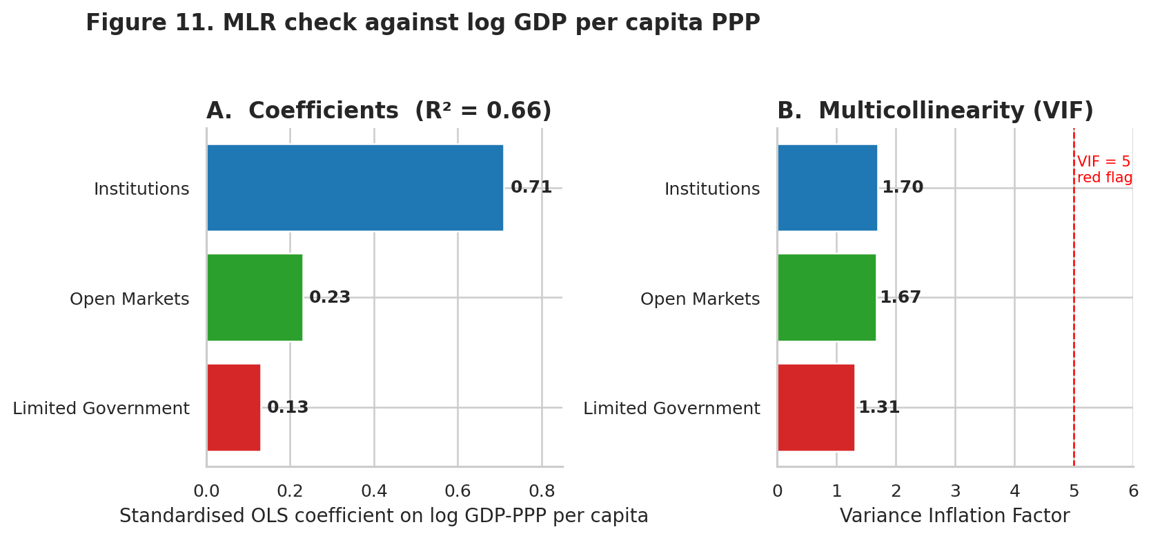
Figure 11. MLR of log GDP per capita PPP on the three provisional block scores, and the corresponding VIFs.
Three features of Figure 11 matter for the design decision:
- The overall fit (R² = 0.66) is high enough to indicate that the blocks, together, capture most of the cross-country variation in prosperity.
- The Institutions coefficient (0.71) is more than three times the Open Markets coefficient (0.23) and more than five times the Limited Government coefficient (0.13). This is the third piece of evidence that Limited Government is the weakest block.
- All three VIFs are comfortably below 2. Multicollinearity is not a concern — the blocks are distinct enough to stand alone in the regression, and the coefficient ordering is therefore meaningful.

8.3 Robustness interpretation
The MLR is not used to calibrate weights. If it were — i.e., if the weights in the final aggregation were set to the MLR coefficients — the index would become a GDP predictor, not an independent measure of freedom. Instead, the MLR is used only as a triangulation: along with the PCA (5.2) and clustering (5.3), it provides the third leg of the decision to drop Limited Government and keep equal weights on the two remaining blocks.

9. Results and Visualization
This section presents the final Economic Freedom Index across 189 countries. Every plot here is generated directly from the same tidy dataset used earlier in the pipeline.

9.1 Distribution of the Index
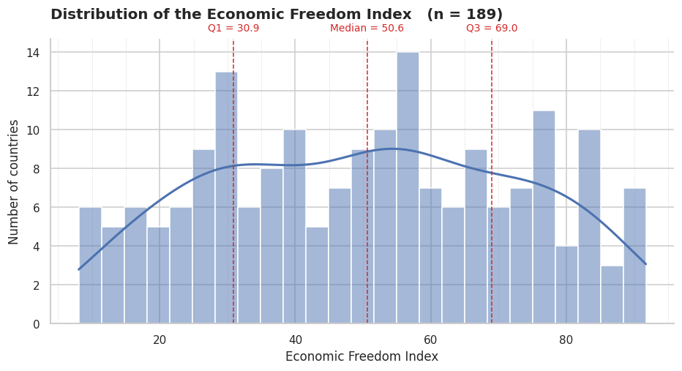
Figure 12. Distribution of the final Economic Freedom Index across 189 countries.
The distribution in Figure 12 is bimodal. There is a shoulder around scores of 25-35 dominated by African and Central Asian economies, and a second, larger, mode around scores of 65-80 populated by European and East Asian high-income countries. The median is 50.6, the inter-quartile range spans 30.9 to 69.0 — a 38-point spread that reflects the very wide cross-country variation in institutional quality and openness.
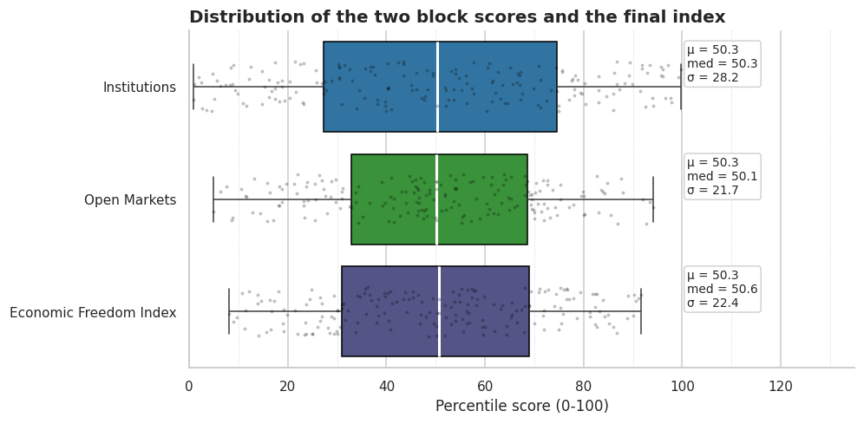
Figure 15. Distribution of the two block scores and the final index side by side.
Figure 15 shows that the Institutions block has a slightly wider spread than the Open Markets block, but both blocks individually span the full 0-100 range. The final index, as the mean of the two, has a slightly compressed range as averaging smooths extreme values.

9.2 Top and bottom performers
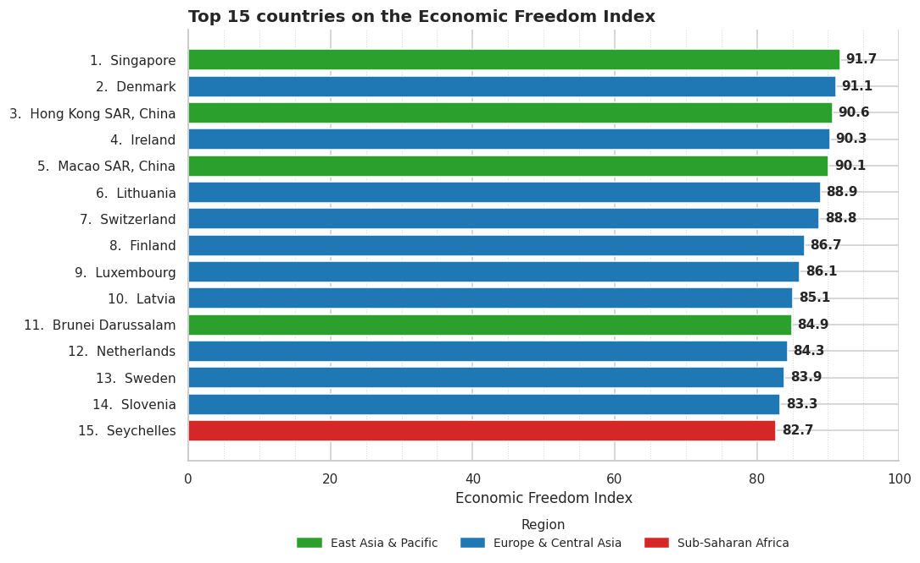
Figure 13. Top 15 countries on the Economic Freedom Index.
The top fifteen is dominated by Europe (11 countries) and East Asia (Singapore, Hong Kong SAR, Macao SAR, Brunei). Ireland appears at rank 4. Seychelles — a small island economy in Sub-Saharan Africa — is the only African country in the top fifteen, on the back of a strong Open Markets sub-score. The top score is 91.7 (Singapore); the gap between ranks 1 and 15 is just 9 points, indicating a tight upper tail of advanced, open economies.
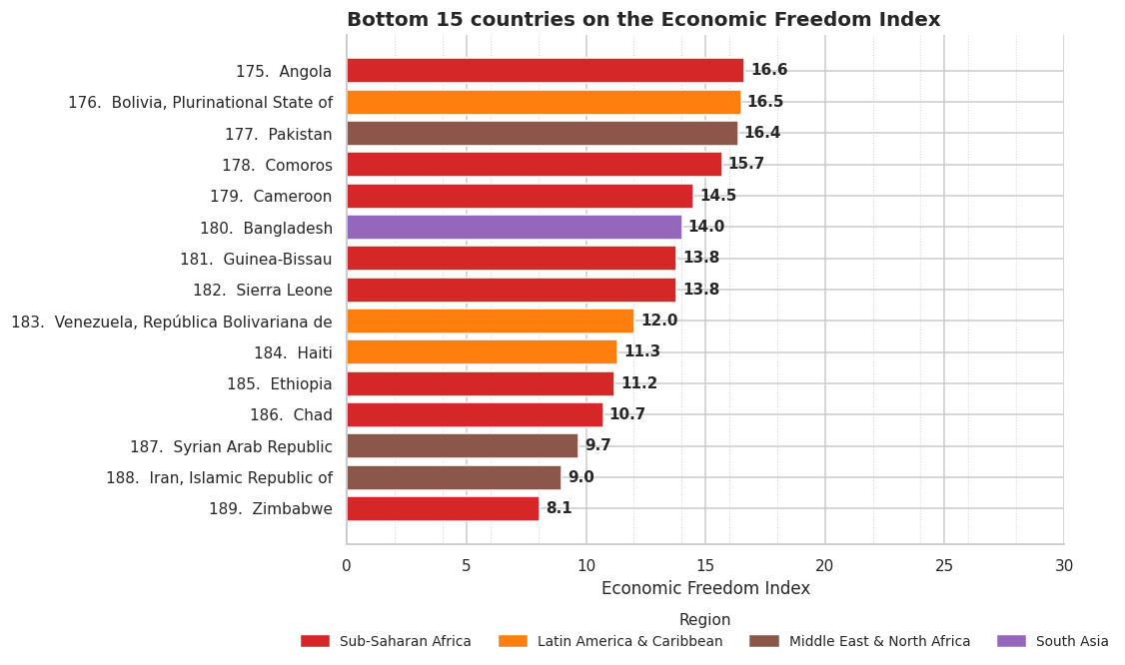
Figure 14. Bottom 15 countries on the Economic Freedom Index.
The bottom fifteen is dominated by Sub-Saharan Africa (7 countries) and the Middle East & North Africa (4 countries, including three sanctioned economies: Syria, Iran, and parts of Libya). Zimbabwe, Iran, and Syria occupy the final three places with scores below 10. Unlike the top, the bottom tail is long: the gap between ranks 175 and 189 is over 10 points, reflecting unusually weak institutions or, in some cases (Venezuela, Ethiopia), weak measurement.

9.3 Institutional-openness structure
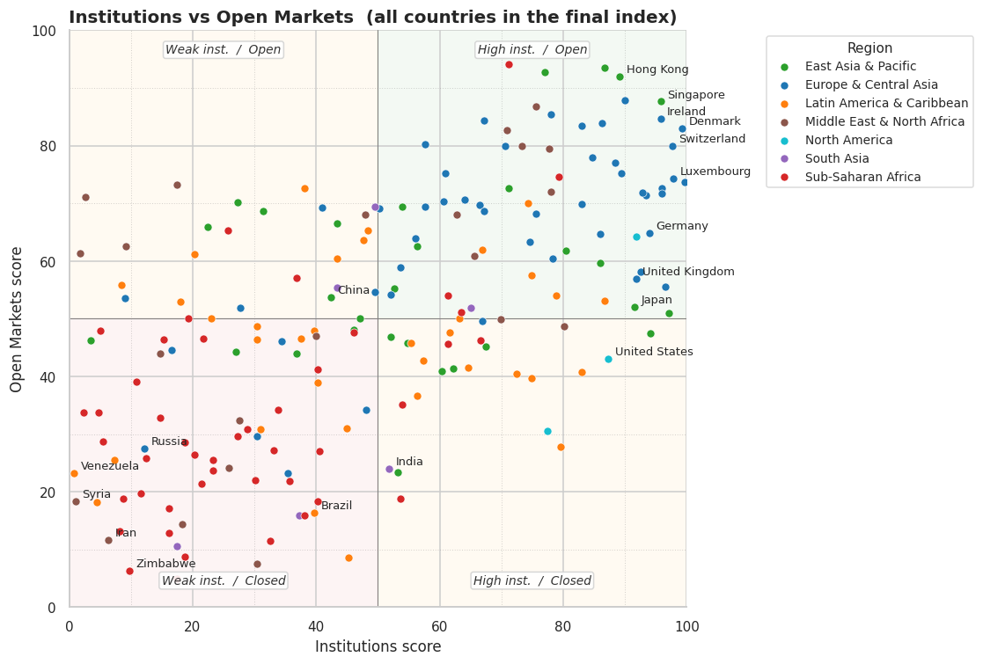
Figure 18. Institutions against Open Markets, all 189 countries, with selected countries labelled.
Figure 18 plots every country on the two final block scores. The most populous quadrant — upper-right, high institutions and open markets — contains the European core and the Asian 'tigers'. The lower-left quadrant captures the economies with both weak institutions and closed markets (Venezuela, Syria, Iran, Zimbabwe). The remaining two quadrants are sparser. The upper-left quadrant (weak institutions but open markets) is occupied by small island and trading states; the lower-right quadrant (strong institutions but closed markets) is the smallest, hosting, for example, the United States (strong institutions, low trade share of GDP) and Japan (similar profile).

9.4 Regional and income-group breakdown
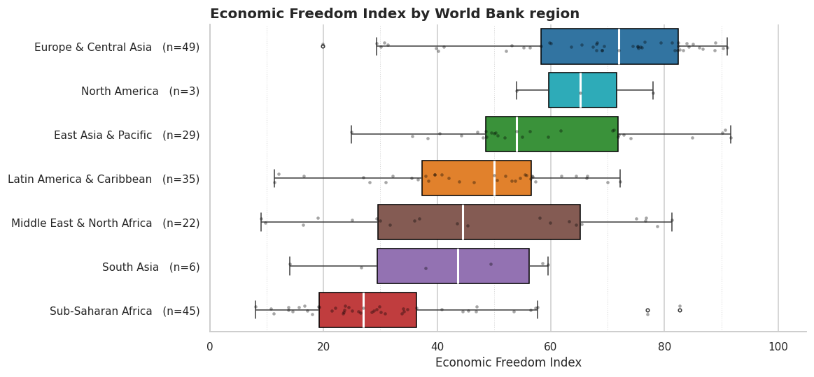
Figure 16. Economic Freedom Index by World Bank region.
The regional picture in Figure 16 is consistent with the existing international evidence. Europe & Central Asia has the highest median (around 76), followed by North America (~65) and East Asia & Pacific (~55). Sub-Saharan Africa has the lowest median (~27) but also the highest within-region spread, with Seychelles, Mauritius, and Rwanda well above the regional median and Zimbabwe, Chad, Sudan well below.
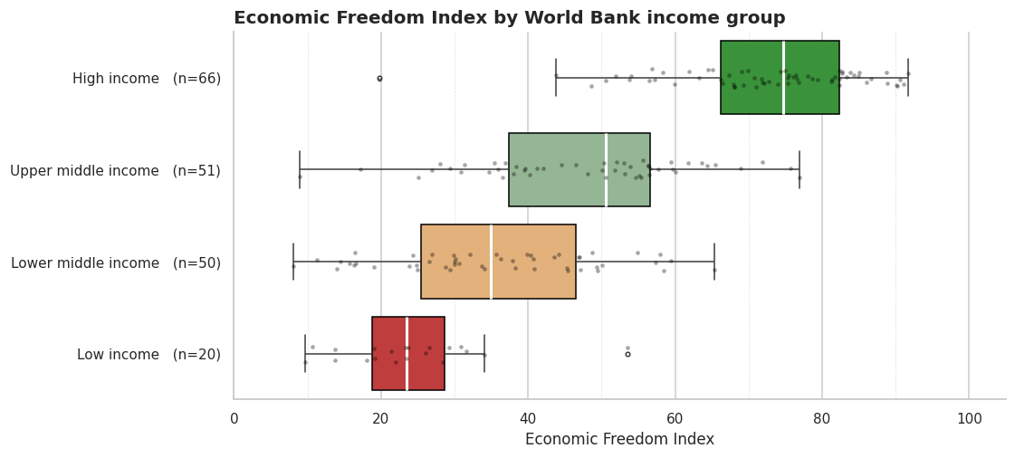
Figure 17. Economic Freedom Index by World Bank income group.
The income-group picture is even cleaner. The median score is monotonic in income group: High income (75+) > Upper middle income (52) > Lower middle income (38) > Low income (27). This is the expected pattern: the association between institutions, openness and development is one of the most robust findings in the applied growth literature (Acemoglu & Robinson, 2012), and a well-constructed composite indicator for economic freedom ought to reproduce it.
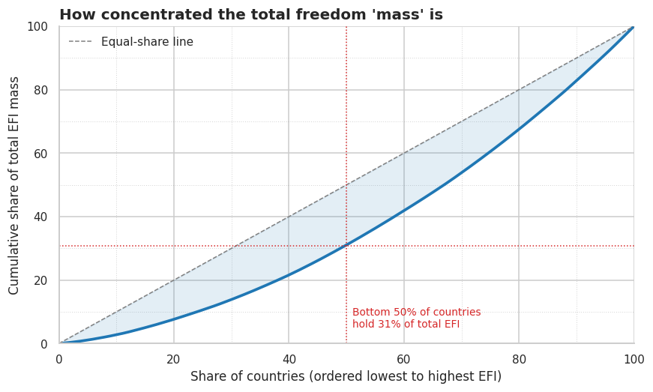
Figure 19. How concentrated the total freedom 'mass' is.
Figure 19 offers a different way to read the distribution. If the 189 countries are ordered from lowest to highest EFI and the cumulative sum of EFI is plotted against the cumulative number of countries, the bottom 50 % of countries account for only ~30 % of the total 'freedom mass'. The upper half of the distribution is disproportionately responsible for the global total — a pattern that is familiar from the distribution of income itself.

10. Version Control and Documentation

10.1 Version control
The entire project is kept under git version control. The repository contains exactly the files needed to reproduce every figure and every number in this report:
- CA.ipynb — the canonical Jupyter notebook.
- WDICSV.csv, WDICountry.csv, WDISeries.csv — the WDI 2024 data dump.
- wgidataset_with_sourcedata-2025.xlsx — the WGI 2025 release.
- economic_freedom_ranking.csv — the output file produced in the final cell.

10.2 Reproducibility
Two choices make the analysis reproducible end-to-end:
- A fixed random seed (random_state=42, n_init=20) is passed to the k-means clusterer. The silhouette score and the two cluster labels are therefore deterministic across re-runs.
- Every derived object (master_long, indicator_coverage, selected_plan, diagnostic_scores, final_scores, final_ranking) is displayed in the notebook. The pipeline is therefore auditable cell by cell — there is no hidden state.

10.3 Documentation
Documentation is layered at three levels: (i) inline comments in the notebook explaining micro-decisions (e.g. the ADO→AND country-code replacement in load_latest_wgi); (ii) the markdown cells at the top of each numbered section explaining what the section is about and what decision the section supports; and (iii) this report, which binds the entire story together around the OECD ten-step framework.

11. Conclusion and Limitations

11.1 Summary of findings
This report has built a country-level Economic Freedom Index for 189 countries using the latest World Bank data available up to 2024. The final index is the equal-weight average of two blocks, Institutions and Open Markets, made from five percentile-ranked indicators drawn from WDI and WGI. It places Singapore, Denmark, and Hong Kong at the top and Zimbabwe, Iran, and Syria at the bottom.
Three findings are worth highlighting:
- The data confirms the theoretical framework only partially. The two blocks that survive the diagnostics (Institutions and Open Markets) behave exactly as predicted — they move together on PC1, they separate the clusters in the expected way, and they correlate strongly with development. But the Limited Government block, which most existing indices include, fails all three diagnostics.
- The failure of Limited Government is a property of the proxies chosen (government consumption and tax revenue) and of the 2019-2024 window. It is not a theoretical rejection of the concept — indeed, the literature has long noted (Nardo et al., 2008) that crude state-size proxies are poor measures of the quality of state interference and can confuse tax-financed welfare states with dysfunctional states.
- Institutional quality dominates external validation. A single percentage-point increase in the Institutions block score is associated with three times as much variation in log GDP per capita PPP as the same increase in the Open Markets block.

11.2 Limitations
The index has four important limitations that future work should address:
- Point estimates only. No uncertainty intervals are produced. A multiple-imputation robustness study would enable confidence bands on each country's rank.
- Narrow indicator set. Five surviving indicators is light for a composite indicator claiming to capture 'economic freedom'. The omission of labour-market regulation, property-rights enforceability and sound money is deliberate (data coverage reasons) but noticeable.
- Static picture. The 2019-2024 window collapses to one value per country; no time-series element is reported. A panel version would open the possibility of a growth regression that is theoretically cleaner than the cross-sectional MLR used here.
- Sensitivity to the 'latest available' rule. The same country might contribute observations from different years to different indicators. A sensitivity study that compares the current rule to a strict 2023 rule and to a three-year average would quantify this source of error.

Appendix. Full Country Ranking
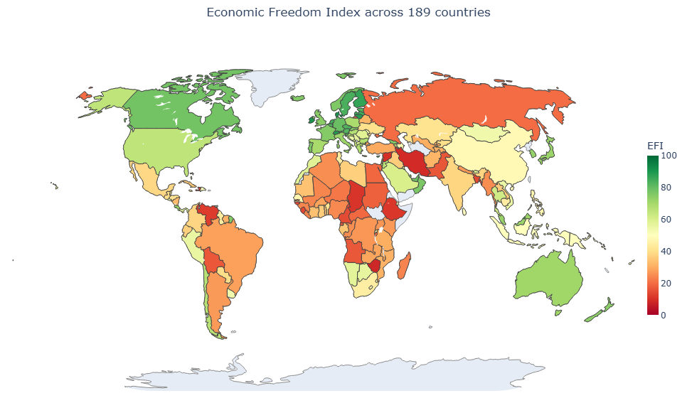
Table A.1. World map, sorted by Economic Freedom Index.

Table A.1 gives the complete 189-country ranking, sorted by Economic Freedom Index. The two block scores are shown alongside the final index. All scores are on a 0-100 percentile scale.
Rank | Country | ISO | Region | Institutions | Open Markets | EFI
1 | Singapore | SGP | East Asia & Pacific | 95.77 | 87.65 | 91.71
2 | Denmark | DNK | Europe & Central Asia | 99.21 | 82.98 | 91.09
3 | Hong Kong SAR, China | HKG | East Asia & Pacific | 89.15 | 92.06 | 90.61
4 | Ireland | IRL | Europe & Central Asia | 95.77 | 84.74 | 90.26
5 | Macao SAR, China | MAC | East Asia & Pacific | 86.77 | 93.47 | 90.12
6 | Lithuania | LTU | Europe & Central Asia | 89.95 | 87.92 | 88.93
7 | Switzerland | CHE | Europe & Central Asia | 97.62 | 79.98 | 88.80
8 | Finland | FIN | Europe & Central Asia | 99.74 | 73.63 | 86.68
9 | Luxembourg | LUX | Europe & Central Asia | 97.88 | 74.25 | 86.07
10 | Latvia | LVA | Europe & Central Asia | 86.24 | 83.86 | 85.05
11 | Brunei Darussalam | BRN | East Asia & Pacific | 76.98 | 92.77 | 84.88
12 | Netherlands | NLD | Europe & Central Asia | 96.03 | 72.57 | 84.30
13 | Sweden | SWE | Europe & Central Asia | 96.03 | 71.69 | 83.86
14 | Slovenia | SVN | Europe & Central Asia | 83.07 | 83.51 | 83.29
15 | Seychelles | SYC | Sub-Saharan Africa | 71.16 | 94.18 | 82.67
16 | Czechia | CZE | Europe & Central Asia | 88.36 | 76.98 | 82.67
17 | Austria | AUT | Europe & Central Asia | 93.39 | 71.34 | 82.36
18 | Estonia | EST | Europe & Central Asia | 92.86 | 71.87 | 82.36
19 | Belgium | BEL | Europe & Central Asia | 89.42 | 75.22 | 82.32
20 | Cyprus | CYP | Europe & Central Asia | 78.04 | 85.45 | 81.75
21 | San Marino | SMR | Europe & Central Asia | 84.66 | 77.95 | 81.31
22 | Malta | MLT | Middle East & North Africa | 75.66 | 86.86 | 81.26
23 | Germany | DEU | Europe & Central Asia | 93.92 | 64.81 | 79.37
24 | United Arab Emirates | ARE | Middle East & North Africa | 77.78 | 79.54 | 78.66
25 | Canada | CAN | North America | 91.80 | 64.20 | 78.00
26 | Mauritius | MUS | Sub-Saharan Africa | 79.37 | 74.60 | 76.98
27 | Bahrain | BHR | Middle East & North Africa | 70.90 | 82.63 | 76.76
28 | Oman | OMN | Middle East & North Africa | 73.28 | 79.89 | 76.59
29 | Portugal | PRT | Europe & Central Asia | 83.07 | 69.93 | 76.50
30 | Norway | NOR | Europe & Central Asia | 96.56 | 55.56 | 76.06
31 | Georgia | GEO | Europe & Central Asia | 67.20 | 84.30 | 75.75
32 | Iceland | ISL | Europe & Central Asia | 92.59 | 58.20 | 75.40
33 | Slovak Republic | SVK | Europe & Central Asia | 70.63 | 79.98 | 75.31
34 | France | FRA | Europe & Central Asia | 85.98 | 64.64 | 75.31
35 | Qatar | QAT | Middle East & North Africa | 78.04 | 71.96 | 75.00
36 | United Kingdom | GBR | Europe & Central Asia | 91.80 | 56.97 | 74.38
37 | New Zealand | NZL | East Asia & Pacific | 97.09 | 50.97 | 74.03
38 | Korea | KOR | East Asia & Pacific | 85.98 | 59.61 | 72.80
39 | Costa Rica | CRI | Latin America & Caribbean | 74.34 | 70.02 | 72.18
40 | Italy | ITA | Europe & Central Asia | 75.66 | 68.17 | 71.91
41 | Malaysia | MYS | East Asia & Pacific | 71.16 | 72.66 | 71.91
42 | Japan | JPN | East Asia & Pacific | 91.53 | 52.03 | 71.78
43 | Palau | PLW | East Asia & Pacific | 80.42 | 61.73 | 71.08
44 | Australia | AUS | East Asia & Pacific | 94.18 | 47.44 | 70.81
45 | Aruba | ABW | Latin America & Caribbean | 86.77 | 53.09 | 69.93
46 | Spain | ESP | Europe & Central Asia | 78.31 | 60.41 | 69.36
47 | Poland | POL | Europe & Central Asia | 74.60 | 63.40 | 69.00
48 | Armenia | ARM | Europe & Central Asia | 57.67 | 80.25 | 68.96
49 | Croatia | HRV | Europe & Central Asia | 66.40 | 69.75 | 68.08
50 | Bulgaria | BGR | Europe & Central Asia | 60.85 | 75.22 | 68.03
51 | Greece | GRC | Europe & Central Asia | 67.20 | 68.69 | 67.95
52 | Hungary | HUN | Europe & Central Asia | 64.02 | 70.63 | 67.33
53 | Chile | CHL | Latin America & Caribbean | 78.84 | 53.97 | 66.40
54 | Barbados | BRB | Latin America & Caribbean | 74.87 | 57.58 | 66.23
55 | Montenegro | MNE | Europe & Central Asia | 60.58 | 70.37 | 65.48
56 | Jordan | JOR | Middle East & North Africa | 62.70 | 68.08 | 65.39
57 | United States | USA | North America | 87.30 | 43.03 | 65.17
58 | Israel | ISR | Middle East & North Africa | 80.16 | 48.77 | 64.46
59 | St. Lucia | LCA | Latin America & Caribbean | 66.93 | 61.90 | 64.42
60 | Albania | ALB | Europe & Central Asia | 57.67 | 69.49 | 63.58
61 | Kuwait | KWT | Middle East & North Africa | 65.61 | 60.85 | 63.23
62 | Cayman Islands | CYM | Latin America & Caribbean | 83.07 | 40.74 | 61.90
63 | Thailand | THA | East Asia & Pacific | 53.97 | 69.49 | 61.73
64 | North Macedonia | MKD | Europe & Central Asia | 56.08 | 63.93 | 60.01
65 | Saudi Arabia | SAU | Middle East & North Africa | 69.84 | 49.91 | 59.88
66 | Kosovo | XKX | Europe & Central Asia | 50.26 | 69.14 | 59.70
67 | Kiribati | KIR | East Asia & Pacific | 56.35 | 62.61 | 59.48
68 | Maldives | MDV | South Asia | 49.47 | 69.49 | 59.48
69 | Bhutan | BTN | South Asia | 65.08 | 51.85 | 58.47
70 | Romania | ROU | Europe & Central Asia | 66.93 | 49.65 | 58.29
71 | Morocco | MAR | Middle East & North Africa | 47.88 | 68.08 | 57.98
72 | Cabo Verde | CPV | Sub-Saharan Africa | 61.38 | 53.97 | 57.67
73 | Namibia | NAM | Sub-Saharan Africa | 63.49 | 51.15 | 57.32
74 | Antigua and Barbuda | ATG | Latin America & Caribbean | 74.87 | 39.68 | 57.28
75 | Panama | PAN | Latin America & Caribbean | 48.41 | 65.26 | 56.83
76 | Grenada | GRD | Latin America & Caribbean | 63.23 | 50.09 | 56.66
77 | St. Kitts and Nevis | KNA | Latin America & Caribbean | 72.49 | 40.48 | 56.48
78 | Botswana | BWA | Sub-Saharan Africa | 66.67 | 46.21 | 56.44
79 | Serbia | SRB | Europe & Central Asia | 53.70 | 58.91 | 56.31
80 | Samoa | WSM | East Asia & Pacific | 67.46 | 45.15 | 56.31
81 | Peru | PER | Latin America & Caribbean | 47.62 | 63.67 | 55.64
82 | El Salvador | SLV | Latin America & Caribbean | 38.10 | 72.66 | 55.38
83 | Bosnia and Herzegovina | BIH | Europe & Central Asia | 41.01 | 69.31 | 55.16
84 | Viet Nam | VNM | East Asia & Pacific | 43.39 | 66.49 | 54.94
85 | Dominica | DMA | Latin America & Caribbean | 61.64 | 47.62 | 54.63
86 | Bermuda | BMU | North America | 77.51 | 30.51 | 54.01
87 | Mongolia | MNG | East Asia & Pacific | 52.65 | 55.20 | 53.92
88 | Uruguay | URY | Latin America & Caribbean | 79.63 | 27.87 | 53.75
89 | Rwanda | RWA | Sub-Saharan Africa | 61.38 | 45.59 | 53.48
90 | Moldova | MDA | Europe & Central Asia | 52.12 | 54.14 | 53.13
91 | St. Vincent and the Grenadines | VCT | Latin America & Caribbean | 64.55 | 41.53 | 53.04
92 | Azerbaijan | AZE | Europe & Central Asia | 49.47 | 54.67 | 52.07
93 | Trinidad and Tobago | TTO | Latin America & Caribbean | 43.39 | 60.49 | 51.94
94 | Tonga | TON | East Asia & Pacific | 62.17 | 41.45 | 51.81
95 | Fiji | FJI | East Asia & Pacific | 60.32 | 40.92 | 50.62
96 | Bahamas, The | BHS | Latin America & Caribbean | 55.29 | 45.86 | 50.57
97 | Indonesia | IDN | East Asia & Pacific | 54.76 | 45.86 | 50.31
98 | Dominican Republic | DOM | Latin America & Caribbean | 57.41 | 42.68 | 50.04
99 | Papua New Guinea | PNG | East Asia & Pacific | 31.48 | 68.61 | 50.04
100 | Micronesia, Federated States of | FSM | East Asia & Pacific | 52.12 | 46.91 | 49.51
101 | Sri Lanka | LKA | South Asia | 43.39 | 55.38 | 49.38
102 | Timor-Leste | TLS | East Asia & Pacific | 27.25 | 70.19 | 48.72
103 | Nauru | NRU | East Asia & Pacific | 47.09 | 50.09 | 48.59
104 | China | CHN | East Asia & Pacific | 42.33 | 53.79 | 48.06
105 | Philippines | PHL | East Asia & Pacific | 46.03 | 48.15 | 47.09
106 | Lesotho | LSO | Sub-Saharan Africa | 36.77 | 57.14 | 46.96
107 | Senegal | SEN | Sub-Saharan Africa | 46.03 | 47.62 | 46.83
108 | Jamaica | JAM | Latin America & Caribbean | 56.35 | 36.60 | 46.47
109 | Eswatini | SWZ | Sub-Saharan Africa | 25.66 | 65.26 | 45.46
110 | Djibouti | DJI | Middle East & North Africa | 17.46 | 73.19 | 45.33
111 | South Africa | ZAF | Sub-Saharan Africa | 53.97 | 35.10 | 44.53
112 | Cambodia | KHM | East Asia & Pacific | 22.49 | 65.96 | 44.22
113 | Guyana | GUY | Latin America & Caribbean | 39.68 | 47.97 | 43.83
114 | Tunisia | TUN | Middle East & North Africa | 39.95 | 47.09 | 43.52
115 | Belize | BLZ | Latin America & Caribbean | 37.57 | 46.56 | 42.06
116 | Kazakhstan | KAZ | Europe & Central Asia | 48.15 | 34.22 | 41.18
117 | Honduras | HND | Latin America & Caribbean | 20.37 | 61.20 | 40.78
118 | Benin | BEN | Sub-Saharan Africa | 40.21 | 41.27 | 40.74
119 | Solomon Islands | SLB | East Asia & Pacific | 36.77 | 44.00 | 40.39
120 | Ukraine | UKR | Europe & Central Asia | 34.39 | 46.03 | 40.21
121 | Kyrgyz Republic | KGZ | Europe & Central Asia | 27.78 | 51.85 | 39.81
122 | Paraguay | PRY | Latin America & Caribbean | 40.21 | 38.98 | 39.59
123 | Guatemala | GTM | Latin America & Caribbean | 30.42 | 48.68 | 39.55
124 | Mexico | MEX | Latin America & Caribbean | 30.42 | 46.38 | 38.40
125 | Vanuatu | VUT | East Asia & Pacific | 53.17 | 23.46 | 38.32
126 | Colombia | COL | Latin America & Caribbean | 44.97 | 31.04 | 38.01
127 | India | IND | South Asia | 51.85 | 23.99 | 37.92
128 | Libya | LBY | Middle East & North Africa | 2.65 | 71.08 | 36.86
129 | Ecuador | ECU | Latin America & Caribbean | 23.02 | 50.09 | 36.55
130 | Ghana | GHA | Sub-Saharan Africa | 53.70 | 18.87 | 36.29
131 | Iraq | IRQ | Middle East & North Africa | 9.26 | 62.61 | 35.93
132 | Lao PDR | LAO | East Asia & Pacific | 26.98 | 44.27 | 35.63
133 | Cuba | CUB | Latin America & Caribbean | 17.99 | 52.91 | 35.45
134 | Gabon | GAB | Sub-Saharan Africa | 19.31 | 50.09 | 34.70
135 | Mauritania | MRT | Sub-Saharan Africa | 21.69 | 46.56 | 34.13
136 | Togo | TGO | Sub-Saharan Africa | 33.86 | 34.22 | 34.04
137 | Côte d'Ivoire | CIV | Sub-Saharan Africa | 40.48 | 26.98 | 33.73
138 | Nicaragua | NIC | Latin America & Caribbean | 8.47 | 55.82 | 32.14
139 | Afghanistan | AFG | Middle East & North Africa | 1.85 | 61.38 | 31.61
140 | Belarus | BLR | Europe & Central Asia | 8.99 | 53.62 | 31.31
141 | Suriname | SUR | Latin America & Caribbean | 30.95 | 30.86 | 30.91
142 | Mozambique | MOZ | Sub-Saharan Africa | 15.34 | 46.38 | 30.86
143 | Tajikistan | TJK | Europe & Central Asia | 16.67 | 44.62 | 30.64
144 | Tanzania | TZA | Sub-Saharan Africa | 33.07 | 27.16 | 30.11
145 | Uzbekistan | UZB | Europe & Central Asia | 30.42 | 29.63 | 30.03
146 | West Bank and Gaza | PSE | Middle East & North Africa | 27.51 | 32.45 | 29.98
147 | São Tomé and Principe | STP | Sub-Saharan Africa | 28.84 | 30.86 | 29.85
148 | Türkiye | TUR | Europe & Central Asia | 35.45 | 23.28 | 29.37
149 | Lebanon | LBN | Middle East & North Africa | 14.81 | 43.92 | 29.37
150 | Malawi | MWI | Sub-Saharan Africa | 40.21 | 18.34 | 29.28
151 | Zambia | ZMB | Sub-Saharan Africa | 35.71 | 21.87 | 28.79
152 | Burkina Faso | BFA | Sub-Saharan Africa | 27.25 | 29.63 | 28.44
153 | Brazil | BRA | Latin America & Caribbean | 39.68 | 16.40 | 28.04
154 | Kenya | KEN | Sub-Saharan Africa | 38.10 | 15.87 | 26.98
155 | Argentina | ARG | Latin America & Caribbean | 45.24 | 8.64 | 26.94
156 | Nepal | NPL | South Asia | 37.30 | 15.87 | 26.59
157 | Congo, Democratic Republic of | COD | Sub-Saharan Africa | 5.03 | 47.97 | 26.50
158 | Uganda | UGA | Sub-Saharan Africa | 30.16 | 22.05 | 26.10
159 | Algeria | DZA | Middle East & North Africa | 25.93 | 24.16 | 25.04
160 | Congo, Republic of | COG | Sub-Saharan Africa | 10.85 | 39.15 | 25.00
161 | Myanmar | MMR | East Asia & Pacific | 3.44 | 46.30 | 24.87
162 | Nigeria | NGA | Sub-Saharan Africa | 23.28 | 25.49 | 24.38
163 | Guinea | GIN | Sub-Saharan Africa | 14.81 | 32.80 | 23.81
164 | Mali | MLI | Sub-Saharan Africa | 18.78 | 28.57 | 23.68
165 | Madagascar | MDG | Sub-Saharan Africa | 23.28 | 23.72 | 23.50
166 | Liberia | LBR | Sub-Saharan Africa | 20.37 | 26.46 | 23.41
167 | Gambia, The | GMB | Sub-Saharan Africa | 32.54 | 11.46 | 22.00
168 | Niger | NER | Sub-Saharan Africa | 21.43 | 21.34 | 21.38
169 | Russian Federation | RUS | Europe & Central Asia | 12.17 | 27.51 | 19.84
170 | Central African Republic | CAF | Sub-Saharan Africa | 4.76 | 33.69 | 19.22
171 | Burundi | BDI | Sub-Saharan Africa | 12.43 | 25.75 | 19.09
172 | Egypt, Arab Republic of | EGY | Middle East & North Africa | 30.42 | 7.58 | 19.00
173 | Sudan | SDN | Sub-Saharan Africa | 2.38 | 33.69 | 18.03
174 | Equatorial Guinea | GNQ | Sub-Saharan Africa | 5.56 | 28.75 | 17.15
175 | Angola | AGO | Sub-Saharan Africa | 16.14 | 17.11 | 16.62
176 | Bolivia, Plurinational State of | BOL | Latin America & Caribbean | 7.41 | 25.57 | 16.49
177 | Pakistan | PAK | Middle East & North Africa | 18.25 | 14.46 | 16.36
178 | Comoros | COM | Sub-Saharan Africa | 11.64 | 19.75 | 15.70
179 | Cameroon | CMR | Sub-Saharan Africa | 16.14 | 12.87 | 14.51
180 | Bangladesh | BGD | South Asia | 17.46 | 10.58 | 14.02
181 | Guinea-Bissau | GNB | Sub-Saharan Africa | 8.73 | 18.87 | 13.80
182 | Sierra Leone | SLE | Sub-Saharan Africa | 18.78 | 8.82 | 13.80
183 | Venezuela, República Bolivariana de | VEN | Latin America & Caribbean | 0.79 | 23.28 | 12.04
184 | Haiti | HTI | Latin America & Caribbean | 4.50 | 18.17 | 11.33
185 | Ethiopia | ETH | Sub-Saharan Africa | 17.46 | 4.94 | 11.20
186 | Chad | TCD | Sub-Saharan Africa | 8.20 | 13.23 | 10.71
187 | Syrian Arab Republic | SYR | Middle East & North Africa | 1.06 | 18.34 | 9.70
188 | Iran, Islamic Republic of | IRN | Middle East & North Africa | 6.35 | 11.64 | 8.99
189 | Zimbabwe | ZWE | Sub-Saharan Africa | 9.79 | 6.35 | 8.07
Table A.2. Full country ranking, sorted by Economic Freedom Index.

References
Acemoglu, D., & Robinson, J. A. (2012). Why Nations Fail: The Origins of Power, Prosperity, and Poverty. Crown Business.
Gwartney, J., Lawson, R., & Hall, J. (2022). Economic Freedom of the World: 2022 Annual Report. Fraser Institute.
Heritage Foundation. (2024). 2024 Index of Economic Freedom. Heritage Foundation, Washington D.C.
Kaufmann, D., & Kraay, A. (2024). Worldwide Governance Indicators, 2025 update. World Bank.
Nardo, M., Saisana, M., Saltelli, A., Tarantola, S., Hoffman, A., & Giovannini, E. (2008). Handbook on Constructing Composite Indicators: Methodology and User Guide. OECD / Joint Research Centre, European Commission. ISBN 978-92-64-04345-9.
North, D. C. (1990). Institutions, Institutional Change and Economic Performance. Cambridge University Press.
Saltelli, A. (2007). Composite indicators between analysis and advocacy. Social Indicators Research, 81(1), 65-77.
World Bank. (2024). World Development Indicators 2024. The World Bank Group, Washington D.C.

