1. **Subscribe for free to get the API key for https://openweathermap.org/**

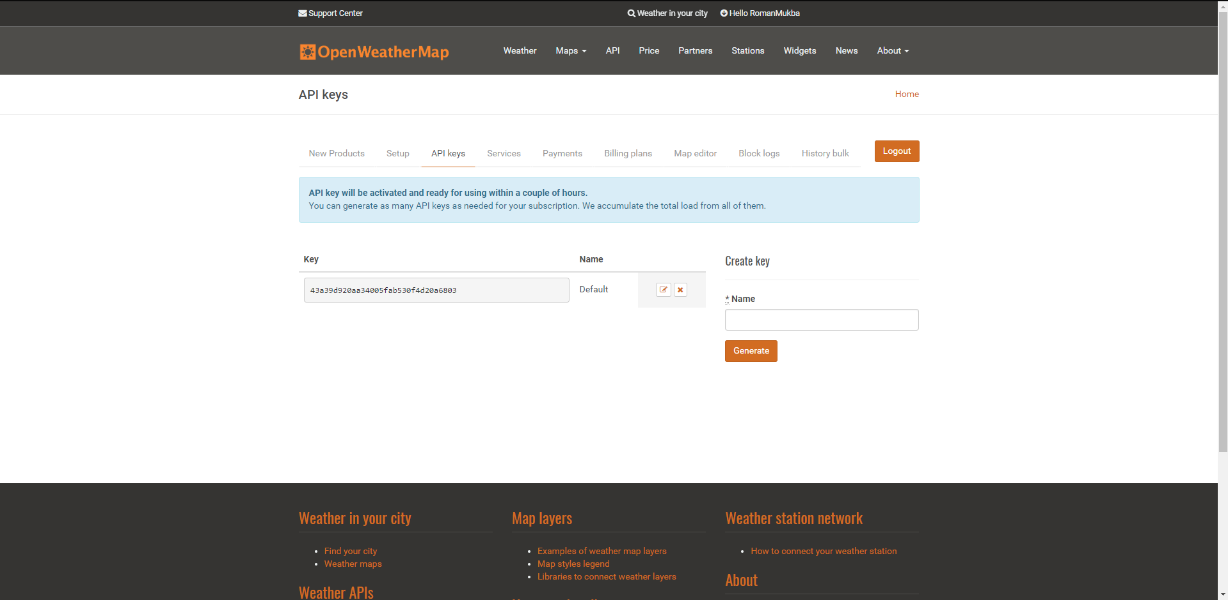

1. **GET current weather data for one location – Kharkiv**

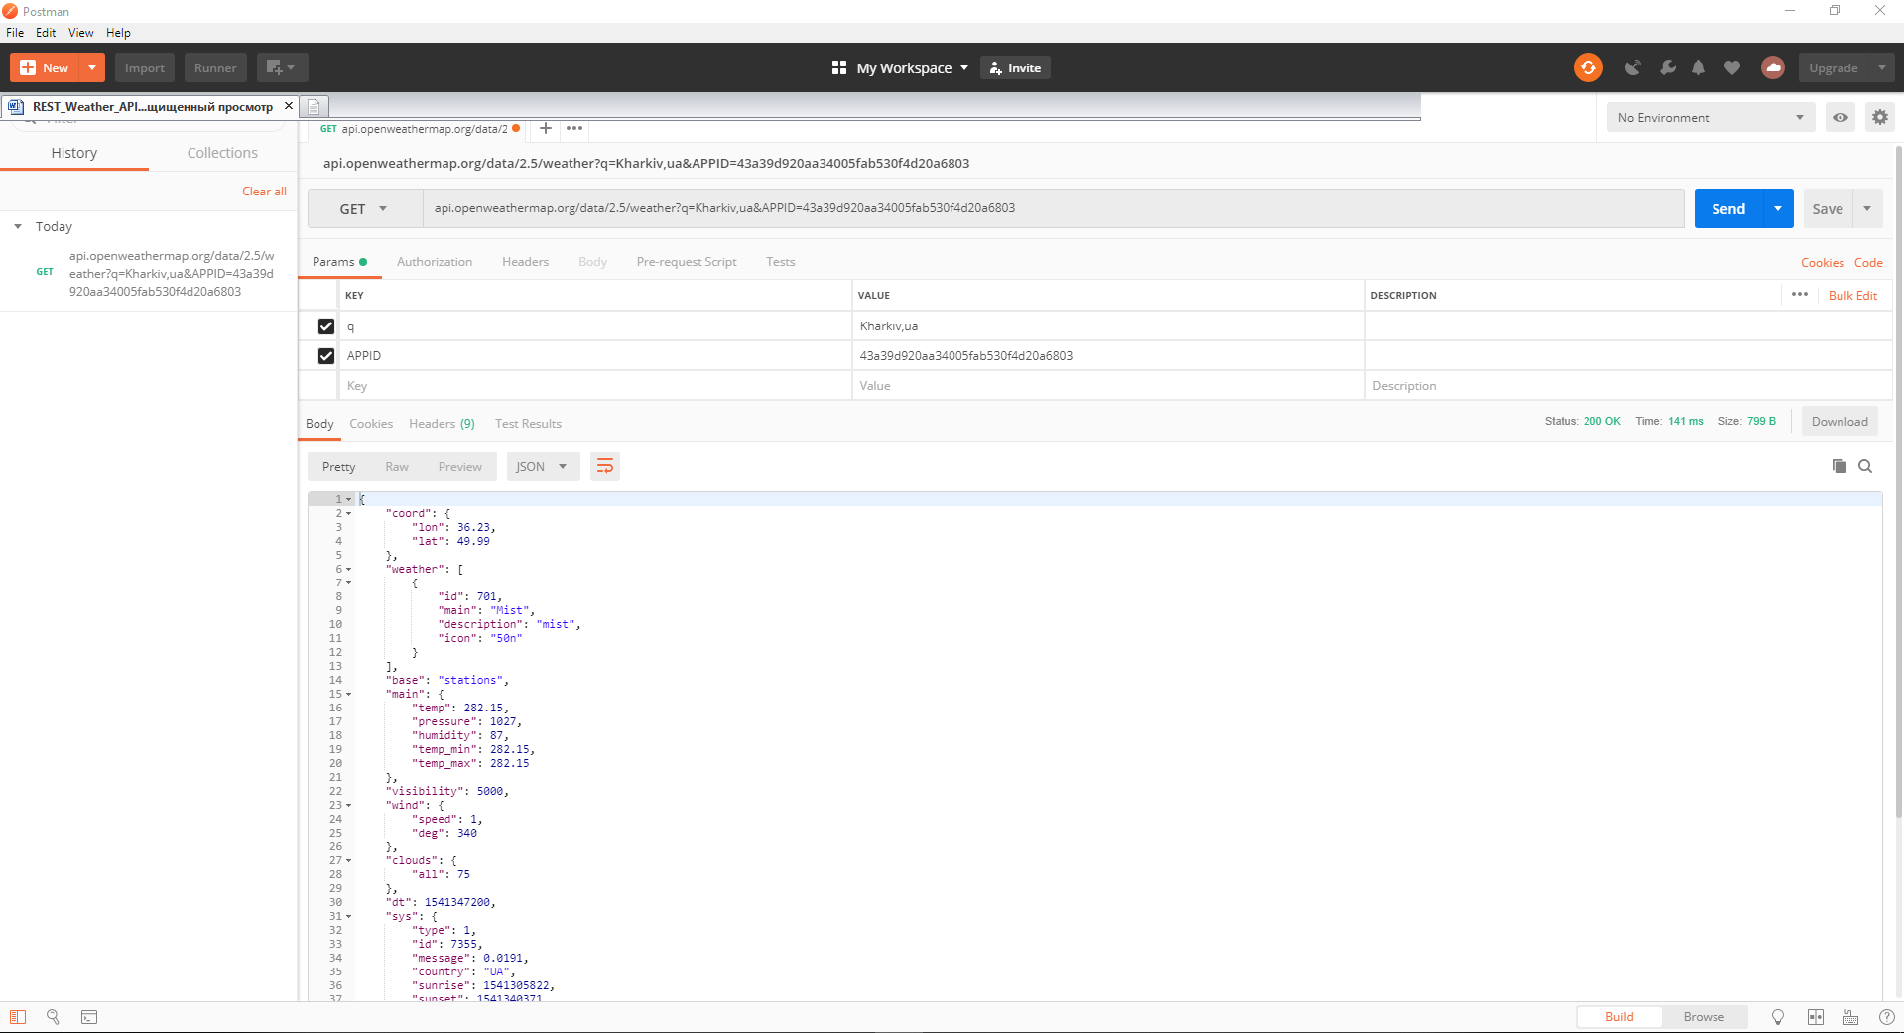

1. **POST /stations – In Kharkiv**

**This method is used to register a station in the OpenWeatherMap service. You need to pass a set of parameters: external identifier, station name and its geographical arrangement. In case of successful creation method returns an HTTP code 201.**

{

"external_id": "KH_TEST001",

"name": "Kharkiv Test Station",

"latitude": 37.76,

"longitude": -122.43,

"altitude": 150

}

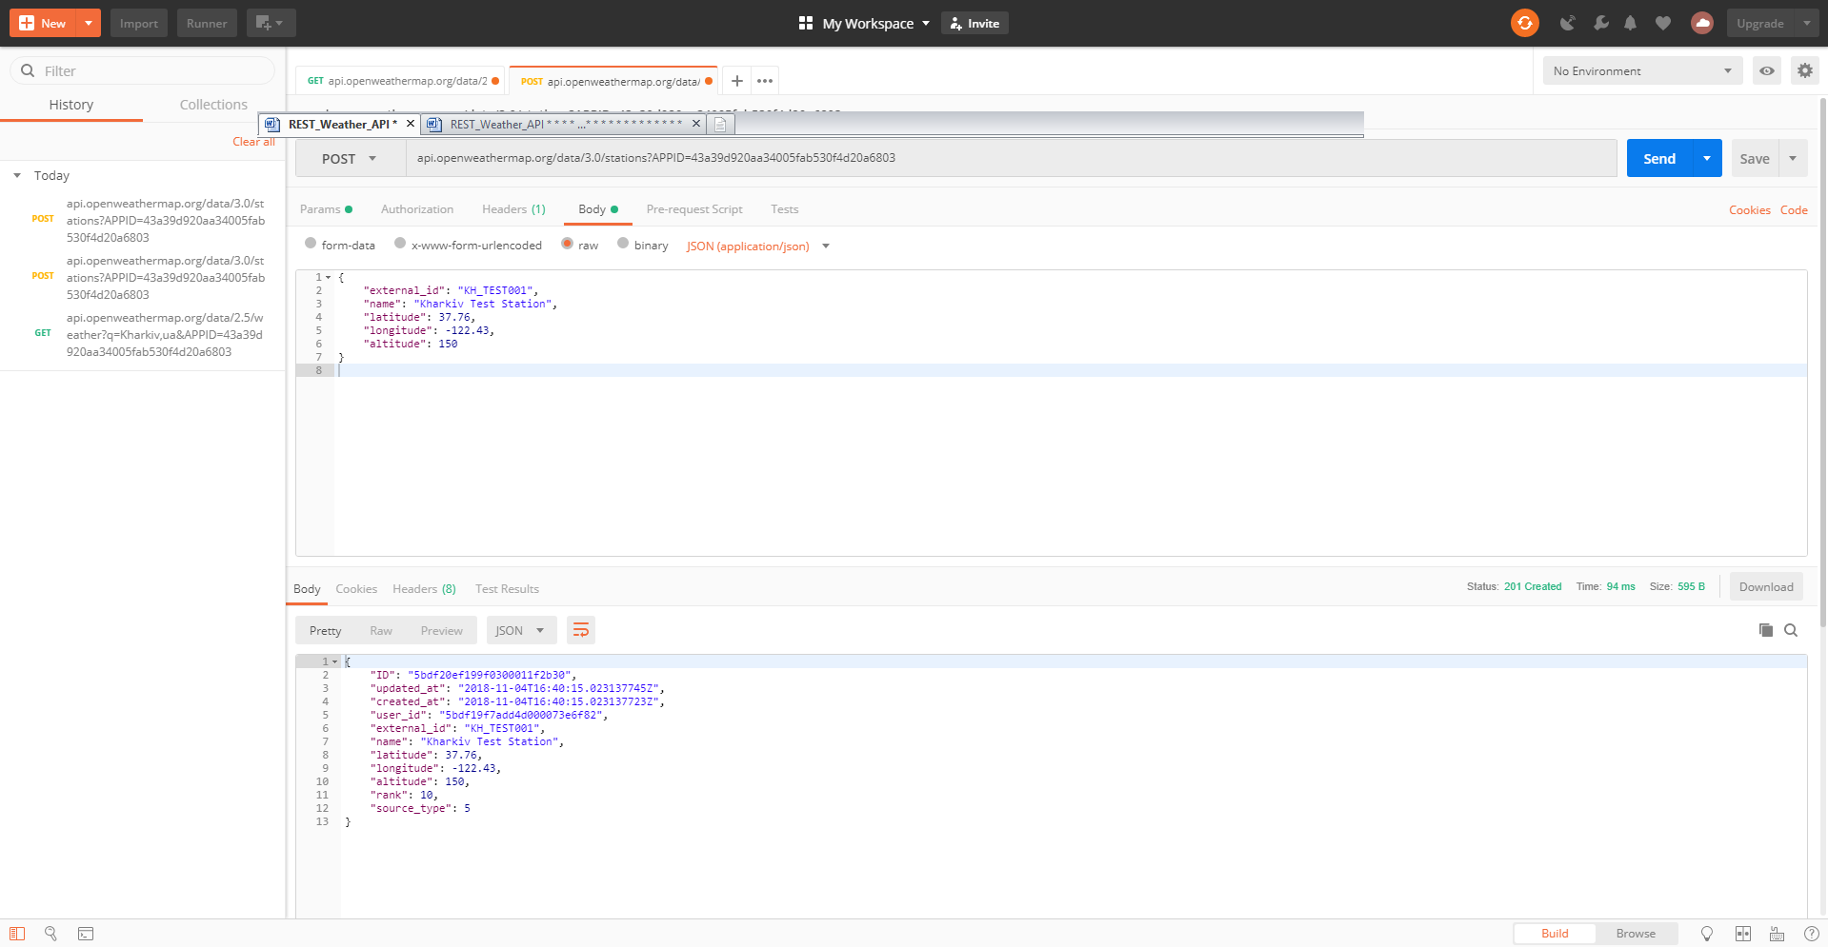

**GET the results after the POST new station - Kharkiv**

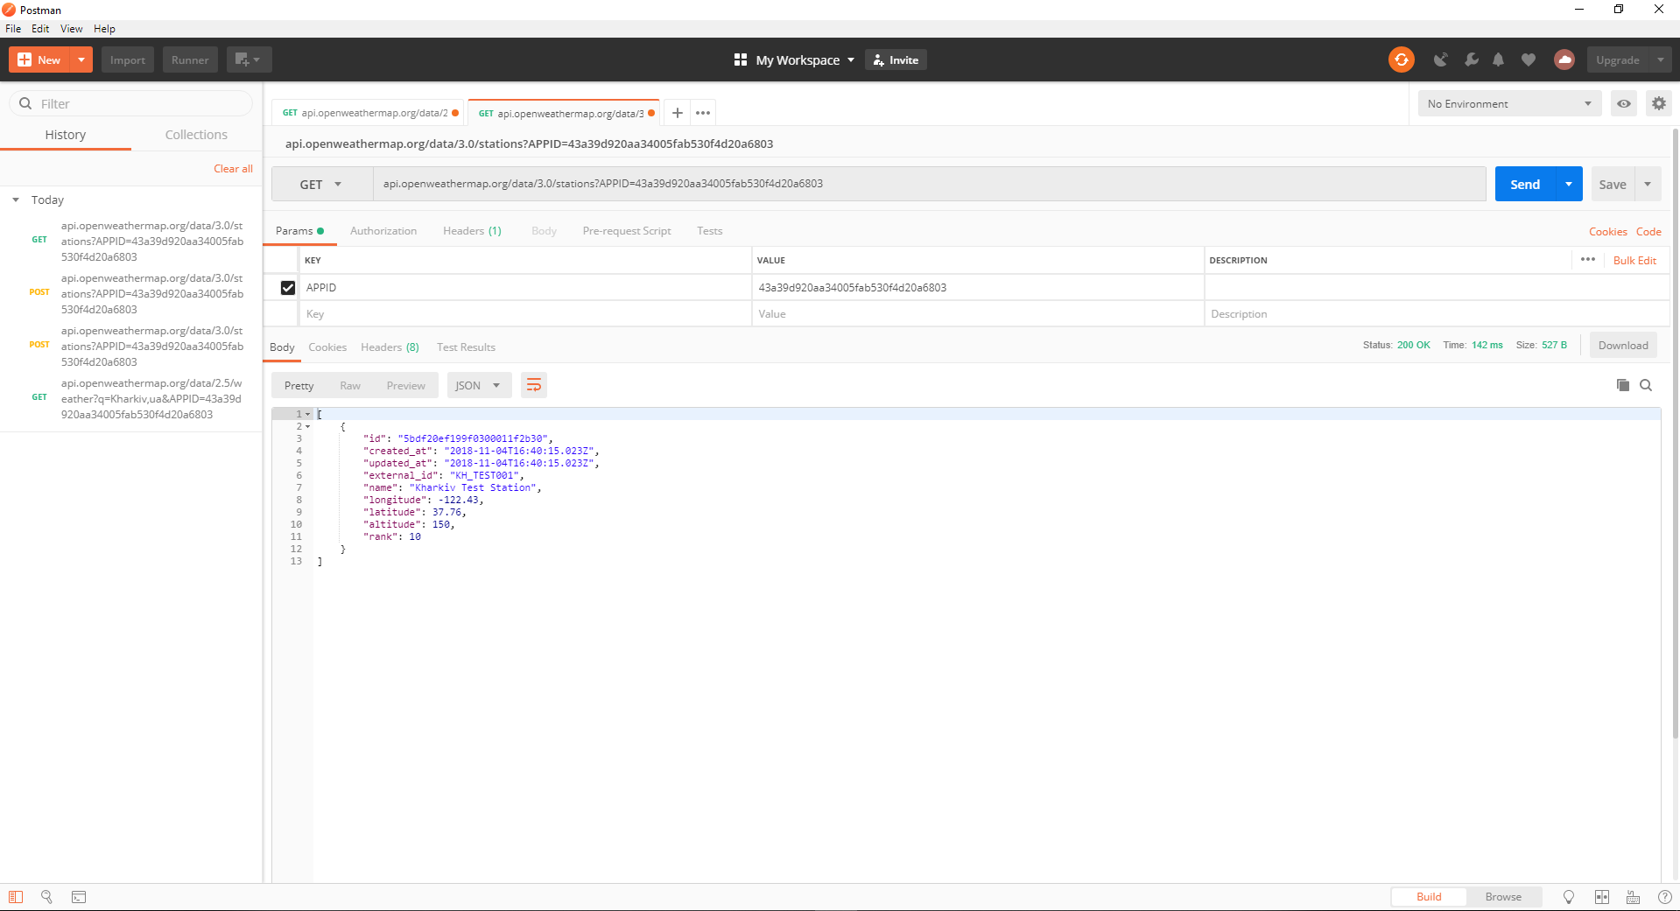

1. **PUT /stations/{:id}**

**This method is used to change information about the station. Parameters available for modification: external identifier, name, geographical arrangement, height above sea level. In case of successful change method returns an HTTP code 200.**

{

"external_id": "KH_TEST001",

"name": "Kharkiv Test Updation",

"latitude": 38.76,

"longitude": 12.43,

"altitude": 20

}

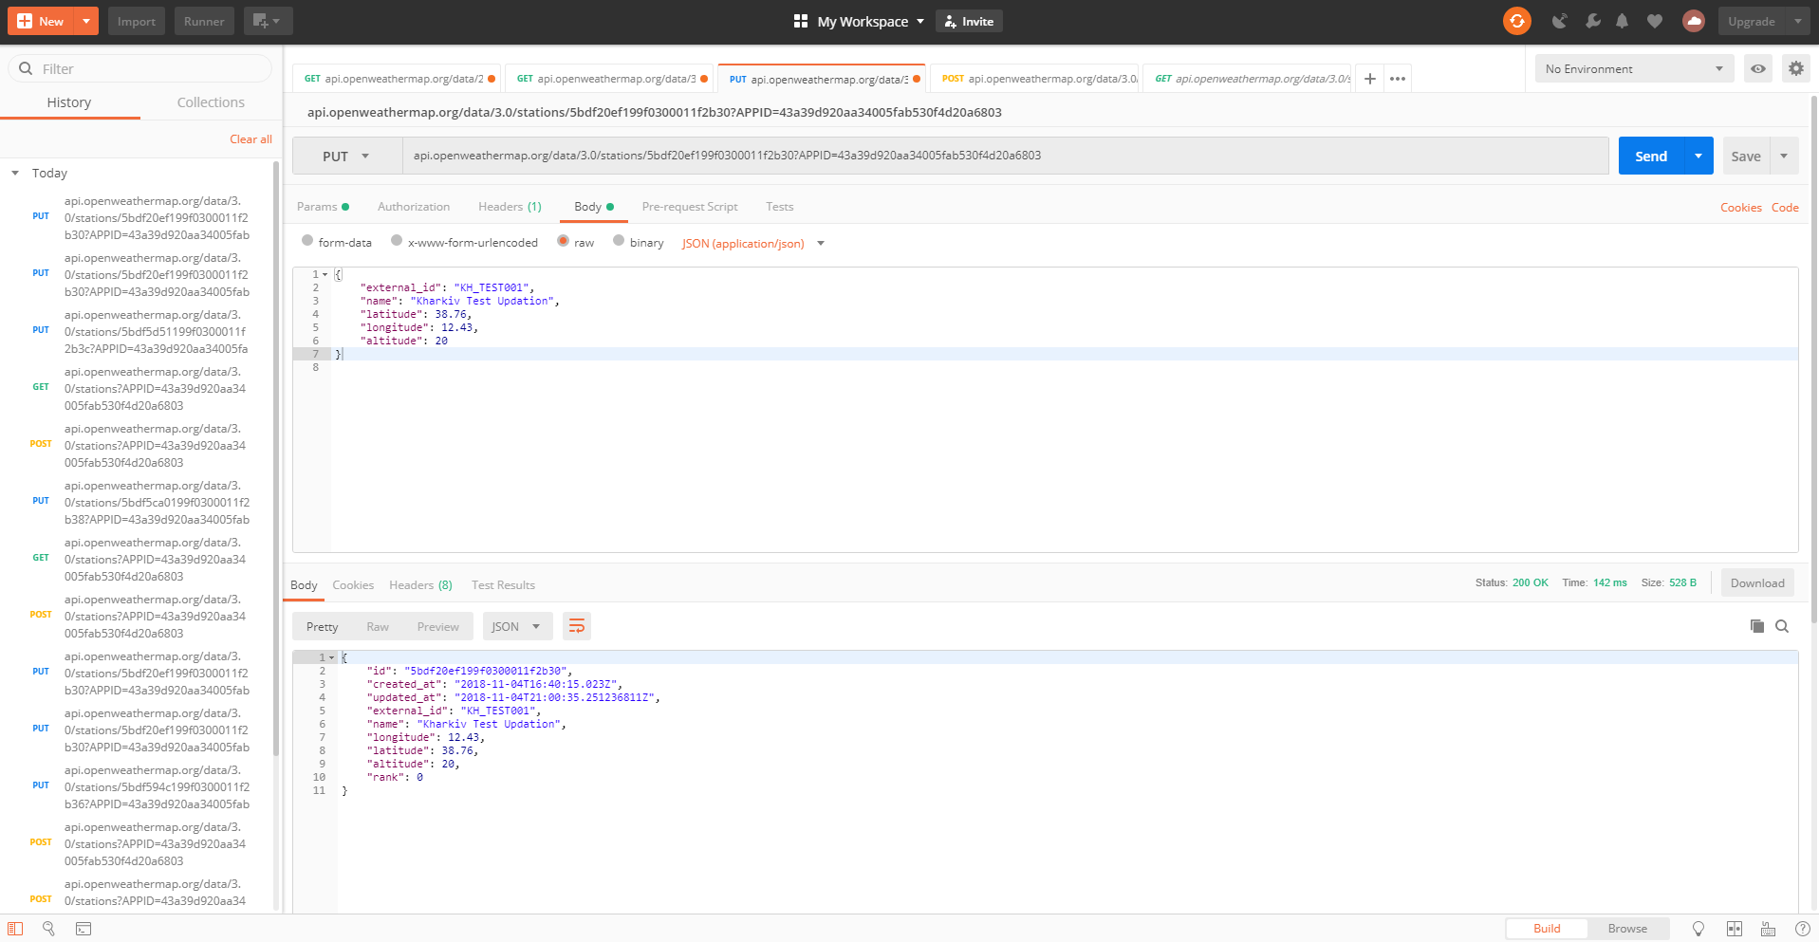

#### ****[DELETE] /stations/{:id}****

**This method is used to remove a station from your account. In case of successful removal method returns an HTTP code 204 (Successful answer). Be careful: after this operation all measurements received from the removed station are deleted permanently, so they couldn't be restored.**

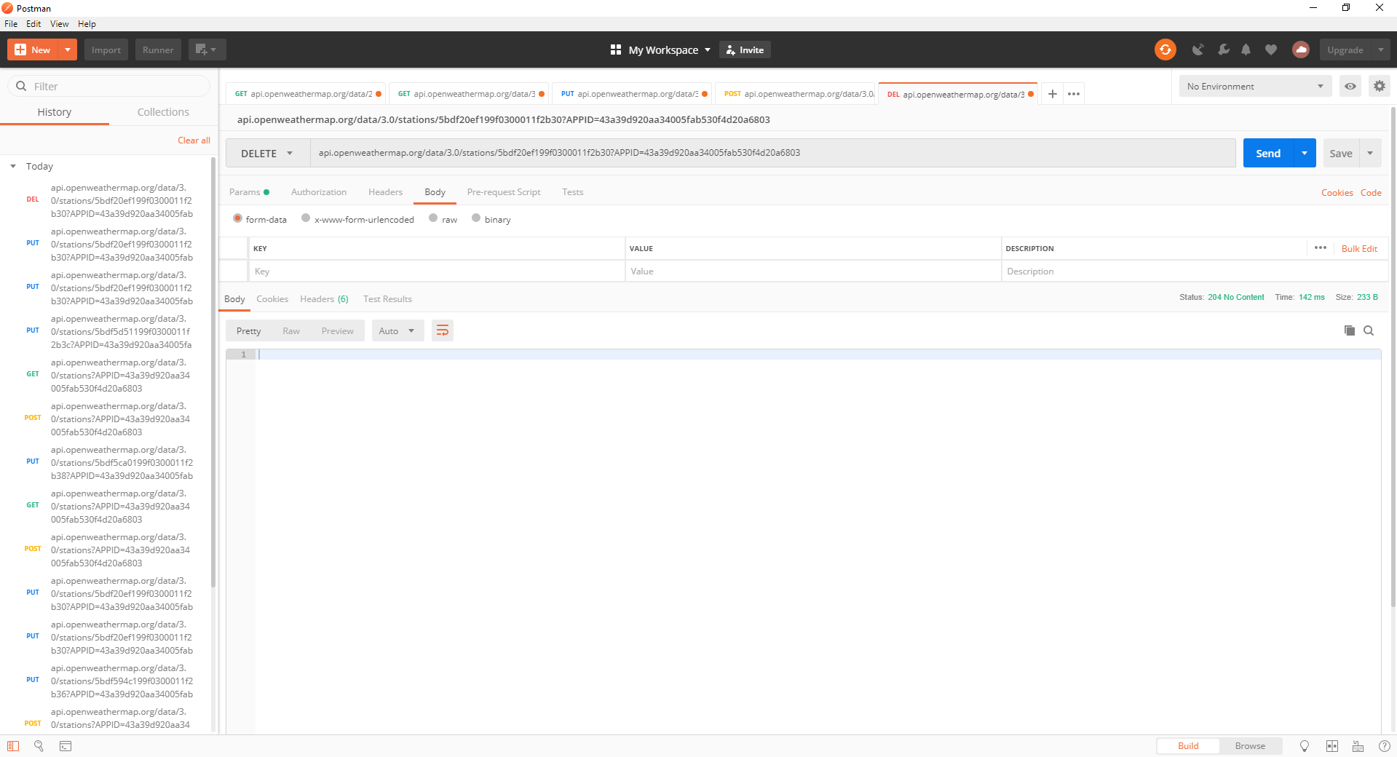

**GET the results after the DELETE station - Kharkiv**

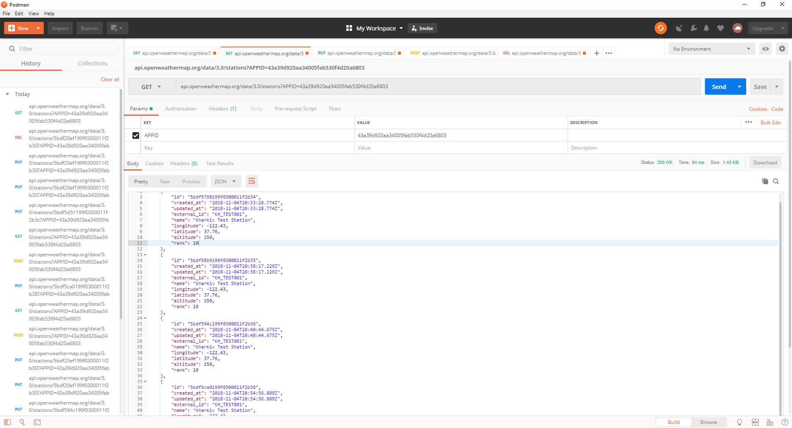

#### ****[PATCH] /stations/{:id}****

**This method is used to modify information about the station. Parameters available for modification: external identifier, name, geographical arrangement, height above sea level. In case of successful change method returns an HTTP code 200.**

