1. Activate **PERSONAL** project in Epam Cloud

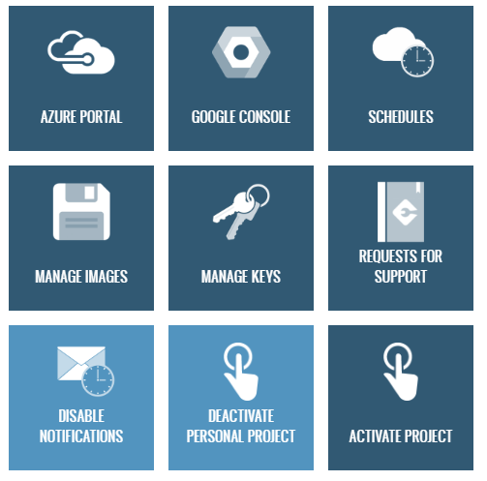

1. Download maestro-cli

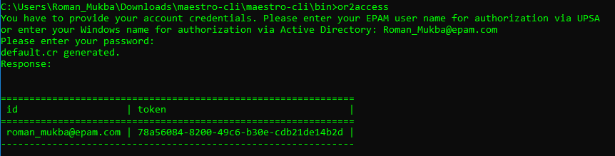

1. Execute describe regions command and choose region to run instance in it



1. Run Linux instance and Windows instances in it

Linux:

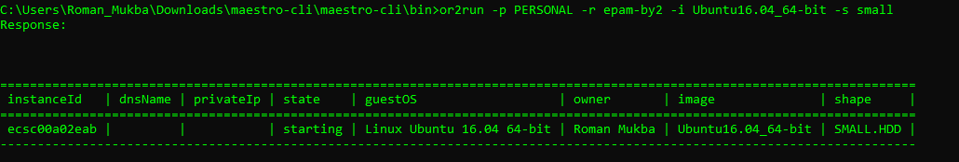

Windows:

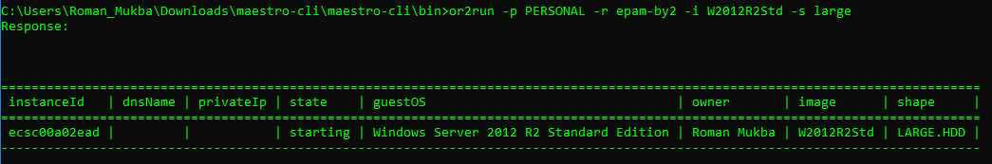

1. Execute describe instance command

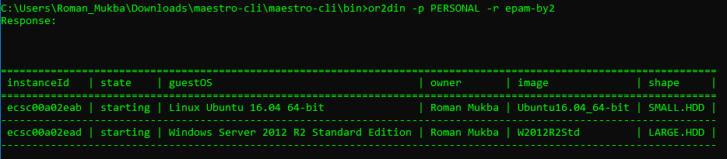

1. Login to Windows instance

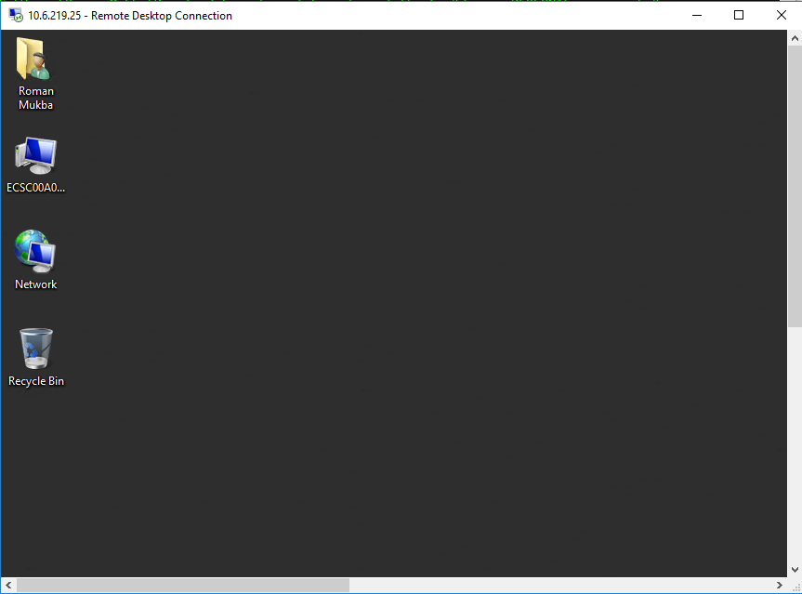

1. Login to Linux instance

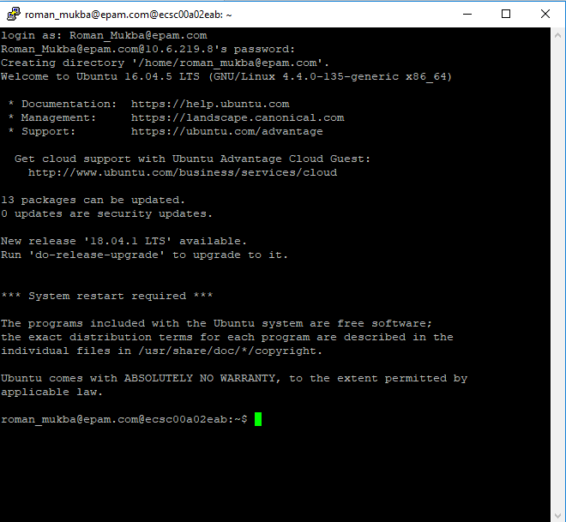

1. Reboot/suspend/stop instance

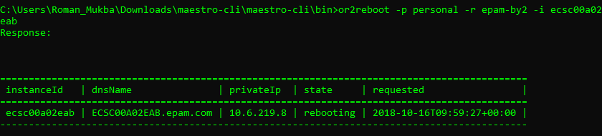



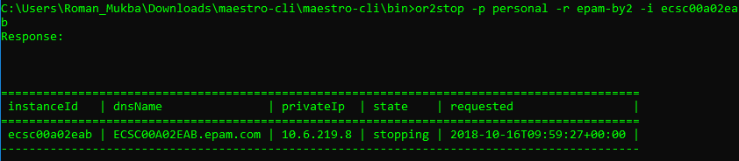

1. Change shape for instance



1. Create and attach volume. Write any information on attached volume (e.g. .doc file, .txt file, .jpg file, create any folder). Attach volume/detach volume

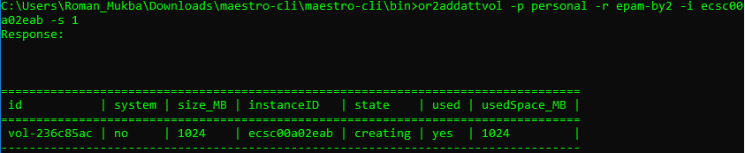

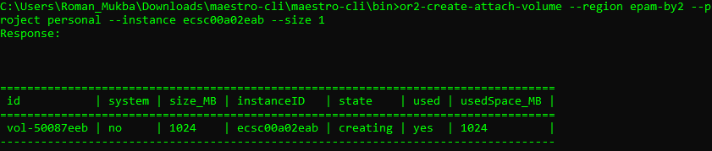

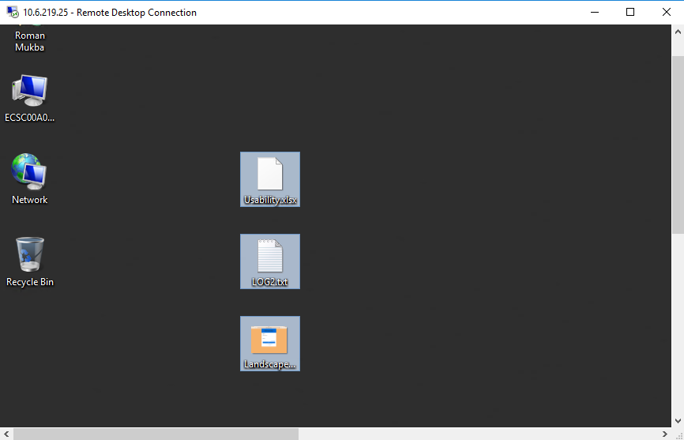

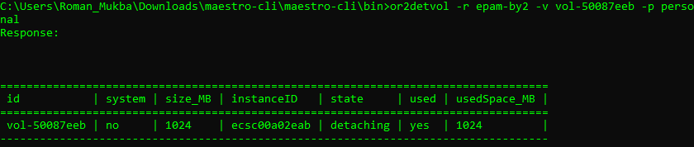

1. Create schedule for instance and check that it works

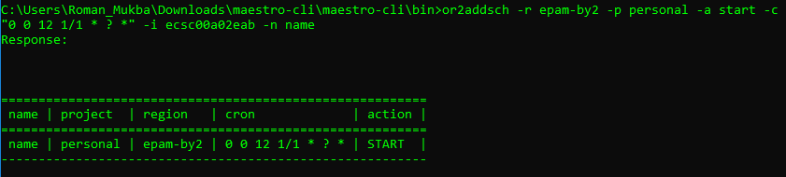

1. Add instance to schedule/remove instance from schedule

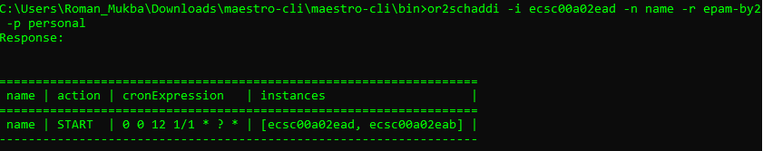

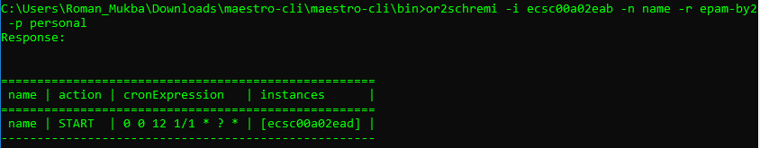

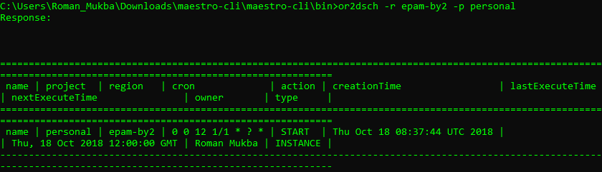

1. Create/describe/delete keypairs

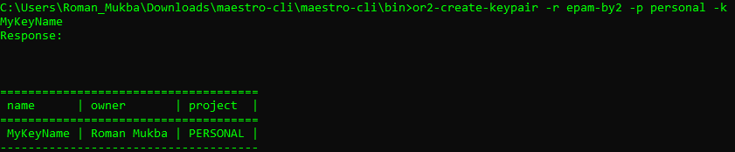

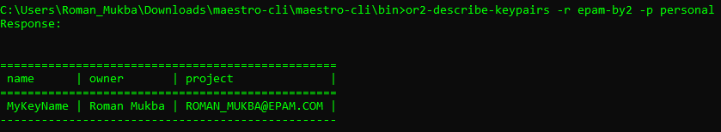

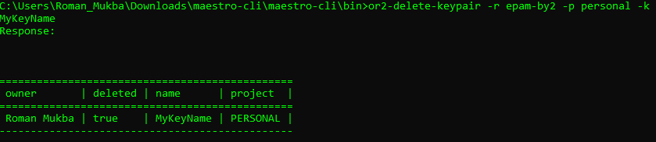

1. Set/describe tag for instance

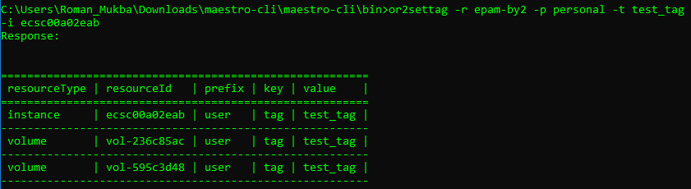

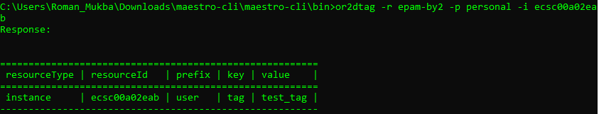

1. Set/describe instance property

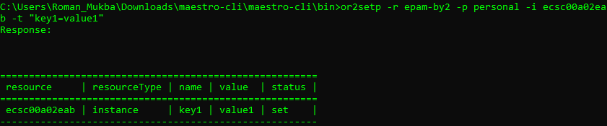

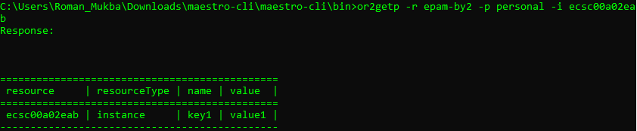

1. Retrieve instance/project audit

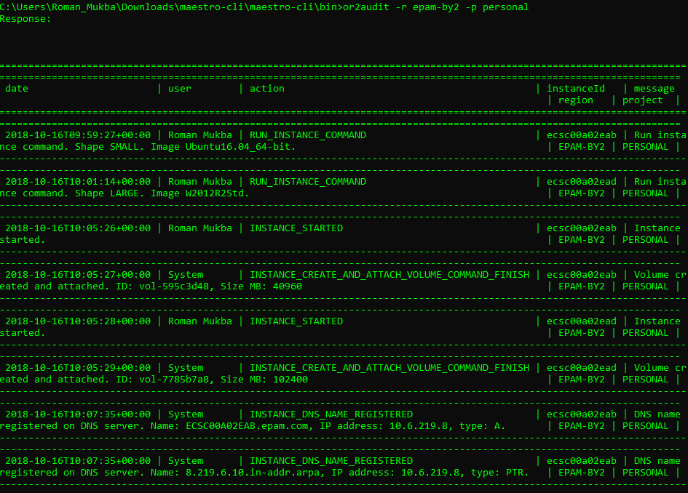

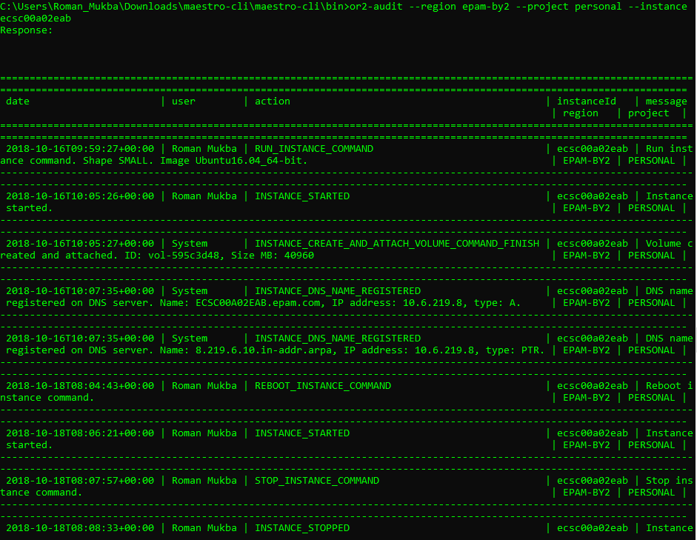

1. Generate different types of utilization report

