**Control statement or structure:**

The statement that alter or change the execution flow of program is called control statement. There are two type of control statement and they are:

**1.Branching or decision making**

**2.looping**

* **Branching or decision making**

We have seen that a c program is a set of statement which are normally executed sequentially in the order in which they appear. This happen when no option or no repetition of certain calculation are necessary. However, in practice, we have a number of situation where we may have to change the order of execution of statement based on certain conditions, or repeat a group of statement until certain specified condition are met. This involves a kind of decision making to see whether a particular condition has occurred or not and then direct the computer to execute certain statement accordingly.

**C language possesses such decision-making capabilities by supporting the following statement:**

**1.if statement**

the if statement is a powerful decision-making statement and is used to control the flow of execution of statement. It is basically a two-way decision statement and is used in conjunction with an expression.

**Syntax:**

If(<condition>)

{

//statement;

}

**2.if else statement**

the if else statement is an extension of the simple **if** statement.

**Syntax:**

If(<condition>)

{

//statement1;

}

Else

{

//statement;

}

**3.nested if else statement**

Nested if else statement is used when series of condition are test to execute particular statement

**Syntax:**

If(<condition1>)

{

If(condition2)

{

//Statement 1

}

Else

{

//statement 2

}

}

Else

{

If(condition3)

{

//Statement 3

}

Else

{

//statement 4

}

}

**4.else if ladder statement**

Else is ladder statement is used when multiple option are available to execute particular statement.

**Syntax:**

If (condition 1)

{

//statement 1

}

Else if (condition 2)

{

//statement 2

}

Else if (condition n)

{

//statement n

}

Else

{

//default statement

}

**5.Switch case**

It is multi-directional control statement.

**Syntax:**

Switch (expression or condition)

{

Case constant 1:

Statement 1:

Break;

Case constant 2:

Statement 2:

Break;

Case constant n:

Statement n:

Break;

Default:

Statement-default;

Break;

}

**Some example:**

**Q1)** **write a c program to calculate the absolute value of an integer using if statement.**

**Algorithm:**

Step1: start

Step2: input any integer and assign it to a

Step3: if a<0

a=(-1)*a

display the absolute value of an integer

step4: stop

**Program:**

/*c program to calculate the absolute value of an integer using if statement*/

#include <stdio.h>

int main()

{

int a;

printf("enter any integer=");

scanf("%d",&a);

if(a<0)

{

a=(-1)*a;

printf("\nabsolute value is=%d",a);

}

return 0;

}

**Output:**

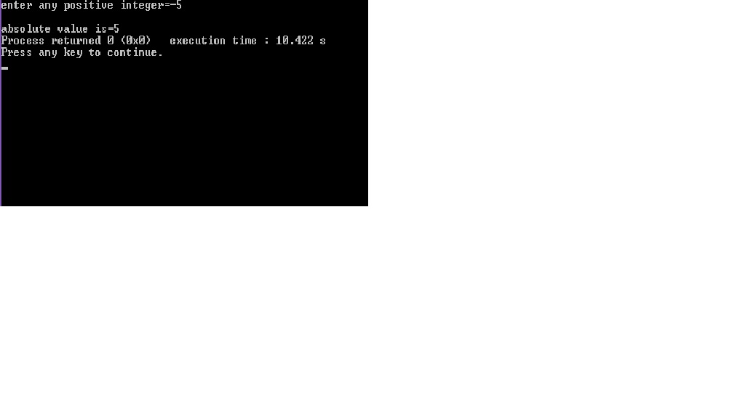

Enter any integer

If (a<0)

The absolute value is “a”

Yes

No

a=a*(-1)

a=(-1)*a

**Q2)** **write a c program to check whether person is eligible for work or not.**

**Algorithm:**

Step1: start

Step2: input a integer and assign it

Step3: if(a>59)

Display age is not eligible for work

Else if(a<19)

Display age is not eligible for work

Else

Display age is eligible for work

Step4: stop

**Program:**

/*c pgrgram to check wether person is eligible for work or not*/

#include <stdio.h>

int main()

{

int a;

printf("enter your age=");

scanf("%d",&a);

if(a>59)

{

printf("your age is not eligible for work");

}

else if(a<19)

{

printf("you are children so you are not eligible for work");

}

else

{

printf("you are eligible for work");

}

return 0;

}

**Output:**

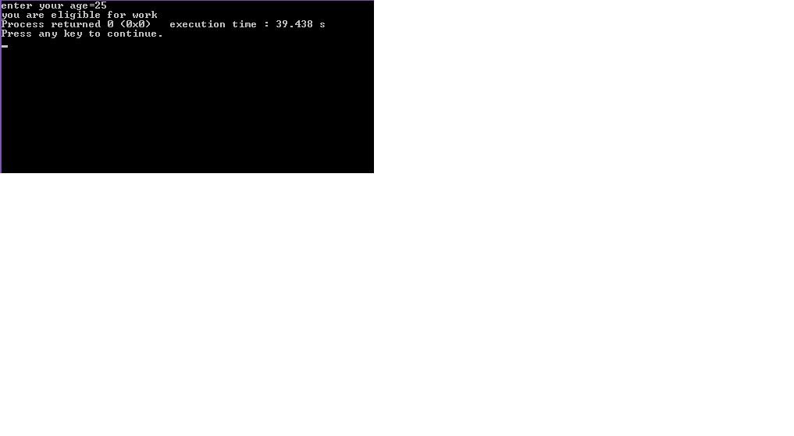

Enter Your age

If (a>59)

your age is not eligible for work

Yes

If (a<19)

Yes

you are children so you are not eligible for work

No

you are eligible for work

No

**Q3)** **write a c program to check whether the entered year is leap year or not using if statement.**

**Algorithm:**

Step1: start

Step2: input a integer and assign it

Step3: if(a%4==0)

Display year is leap year

if(a%100==0&&a%400==0)

display year is leap year

if(a%4!=0&&a%100!=0&&a%400!=0)

display year is not a leap year

step4: stop

**Program:**

#include <stdio.h>

int main()

{

int a;

printf("enter year=");

scanf("%d",&a);

if(a%4==0)

{

printf("entered year is leap year");

}

if(a%100==0&&a%400==0)

{

printf("\nentered year is leap year");

}

if(a%4!=0&&a%100!=0&&a%400!=0)

{

printf("entered year is not a leap year");

}

return 0;

}

**Output:**

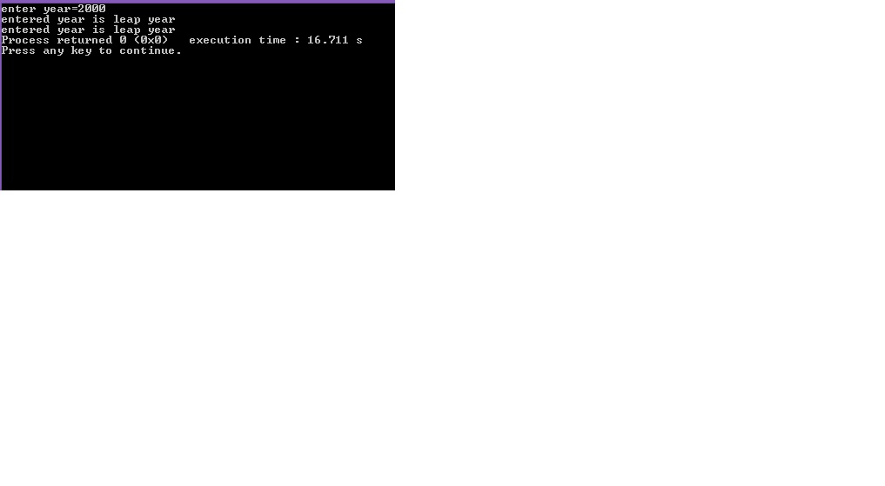

Enter any year

If (a%4=0)

Yes

It is not leap year

If (a%100=0) && If (a%400=0)

It is leap year

Yes

It is no

No

No

**Q4)** **write a c program to check whether the entered year is leap year or not using nested if**

**Algorithm:**

Step 1: Start

Step 2: Read year year

Step 3: if(a%4==0)

If(a%100==0)

If(a%400==0)

Display year is leap year

Else

Display year is not a leap year

Else

Display year is leap year

Else

Display year is not a leap year

Step 4: stop

**Program:**

/*c program to check whether the entered year is leap year or not using nested if statement*/

#include <stdio.h>

int main()

{

int a;

printf("enter year");

scanf("%d",&a);

if(a%4==0)

{

if(a%100==0)

{

if(a%400==0)

{

printf("entered year is leap year");

}

else

{

printf("entered year is not a leap year");

}

}

else

{

printf("entered year is leap year");

}

}

else

{

printf("entered year is not leap year");

}

return 0;

}

**Output:**

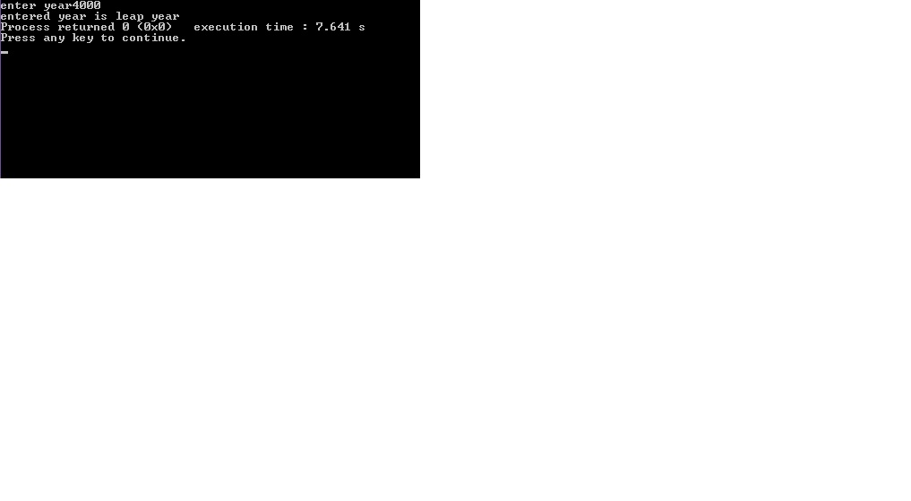

Enter any year

If (a%4=0)

Yes

**Q5)** **write a c program to print result (grade) of student using if else ladder statement.**

No

No

It is not leap year

If (a%400=0)

If (a%100=0)

It is leap year

Yes

It is no

No

**Algorithm:**

Step1: start

Step2: input a integer and assign it

Step3: if(p==a)

Display grade is distinction

Else if

Display grade is first division

Else if

Display grade is second division

Else if

Display grade is third division

Else if

Display result is fail

Else

Display invalid grade

Step4: stop

**Program:**

/*c program to print result (grade) of student using if else ladder statement*/

#include <stdio.h>

int main()

{

char p;

printf("enter your grade=");

scanf("%c",&p);

p=toupper(p);

if(p=='A')

{

printf("\nYour Grade :distinction" );

}

else if(p=='B')

{

printf("\nYour Grade :first division");

}

else if(p=='C')

{

printf("\nYour Grade :second division");

}

else if(p=='D')

{

printf("\nYour Grade :third division");

}

else if(p=='E')

{

printf("\nyour are fail");

}

else

{

printf("\nentered grade is invalid");

}

return 0;

}

**Output:**

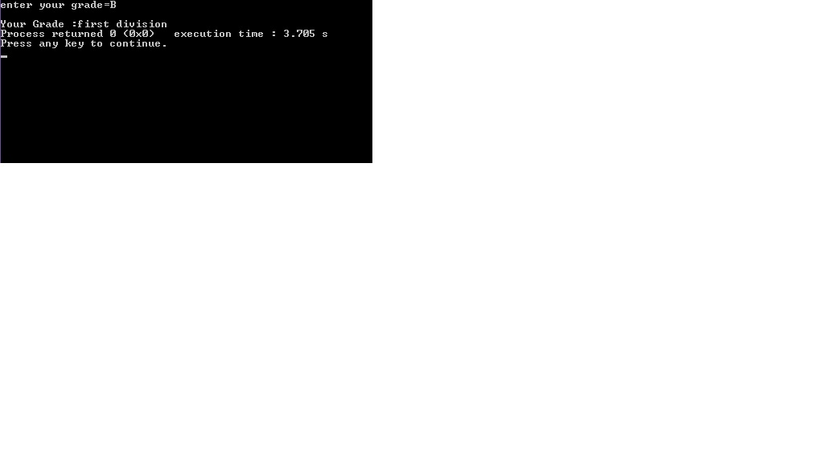

**Q6)** **write a c program to check entered character is vowel or not using switch case.**

**Algorithm:**

Step1: start

Step2: input a integer and assign it

Step3: make tolower for input integer

Step4: switch(v)

Case ‘a’, case ’e’, case ‘I’, case ‘o’, case ‘u’

Display character is vowel

Default:

Display character is not vowel

Step5: stop

**Program:**

/*c program to check entered charecter is vowel or not using switch case*/

#include <stdio.h>

int main()

{

char v;

printf("enter any charecter=");

v=getchar();

v=tolower(v);

switch (v)

{

case 'a':

printf("enter charecter is vowel");

break;

case 'e':

printf("enter charecter is vowel");

break;

case 'i':

printf("enter charecter is vowel");

break;

case 'o':

printf("enter charecter is vowel");

break;

case 'u':

printf("enter charecter is vowel");

break;

default:

printf("entered charecter is not vowel");

break;

}

return 0;

}

**Output:**

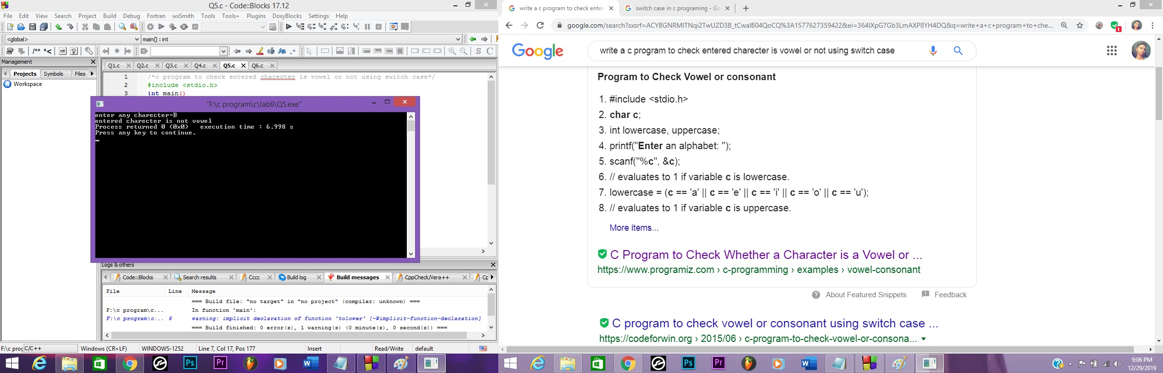

Yes

enter character is vowel

Case “a”

No 

Yes

enter character is vowel

Case “e”

No 

Yes

enter character is vowel

Case “i”

Yes

No 

enter character is vowel

Case “o”

No 

Yes

enter character is vowel

Case “u”

No 

enter character is not a vowel

**Q7)** **write a c program to print sum of square of first 10 natural number using goto statement**

**Algorithm:**

Step1: start

Step2: input two integer a=1, b=0 and assign it

Step3: input r as a goto path

Step3: if(a<11)

B=b+(a*b)

A++

Goto r

Step4: Display sum of square of 10 natural number

Step5: stop

**Program:**

/*c program to print sum of square of first 10 natural number using goto statement*/

#include <stdio.h>

int main()

{

int a=1,b=0;

r:

if(a<11)

{

b=b+(a*a);

a++;

goto r;

}

else

{

printf("sum of square of 10 natural number is %d",b);

}

return 0;

}

**Output:**

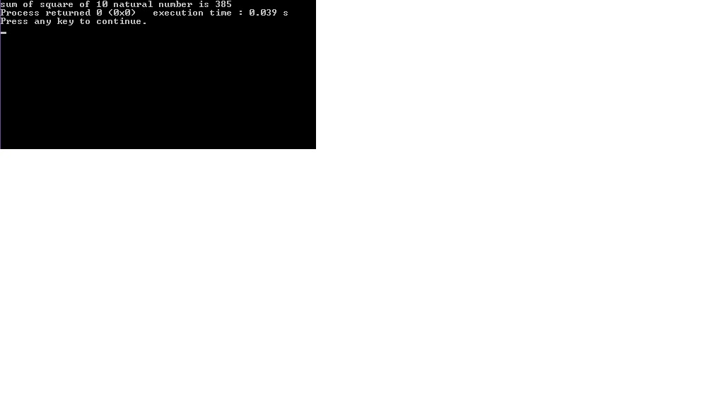

If (a<11)

Print the sum up to 10

No

Yes

**Conclusion:**

Now we have learned about the usage of Control statement or structure and learn how to Branching or decision making, looping in c program and also we learn how to use if statement, if else statement, nested if else statement, else if ladder statement, Switch case.