**Looping statement:**

Loop define the block of code or statement that can be executed repeatedly until certain criteria. (condition to be true)

C support following three type of looping statement.

1. While loop
2. Do_ _ _ while loop
3. For loop
4. **While loop**

C while loops statement allows to repeatedly run the same block of code until a condition is met. while loop is a most basic loop in C programming. The condition of the loop is tested before the body of the loop is executed; hence it is called an entry-controlled loop.

**Syntax:**

Initialization statement;

While(condition)

{

//statement;

//increment/decrement statement;

}

Rest of program

1. **Do_ _ _while loop**

In most computer programming languages, a do while loop is a control flow statement that executes a block of code at least once, and then repeatedly executes the block, or not, depending on a given Boolean condition at the end of the block

**Syntax:**

Initialization;

Do

{

//statement

//increment/decrement statement

} while (test condition);

1. **For loop**

A for loop is a repetition control structure that allows you to efficiently write a loop that needs to execute a specific number of times.

**Syntax:**

For (initialization; test condition; increment or decrement)

{

Body of loop;

}

**Some example:**

Q1) c program to print the sum of all even and odd number up to n.

Program:

/*c program to print the sum of all even and odd number up to n.*/

#include <stdio.h>

int main()

{

int n,i,odd=0,even=0;

printf("enter nth term=");

scanf("%d",&n);

for(i=1;i<=n;i++)

{

if(i%2==0)

{

even=even+i;

}

else

{

odd=odd+i;

}

}

printf("sum of all odd number is=%d\n",odd);

printf("sum of all even number=%d",even);

return 0;

}

**Algorithm:**

**Output:**

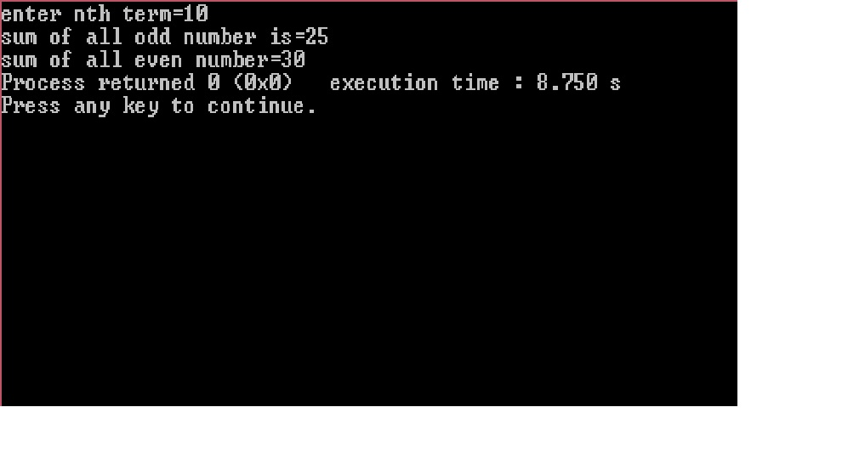

**Q2)** **c program to count number of digits in given integer.**

**Program:**

/*c program to count number of digit in given integer*/

#include<stdio.h>

int main()

{

int n,i;

printf("enter any number");

scanf("%d",&n);

for(i=0;n>0;n/=10)

{

i++;

}

printf("num of digit=%d",i);

return 0;

}

**Algorithm:**

**Output:**

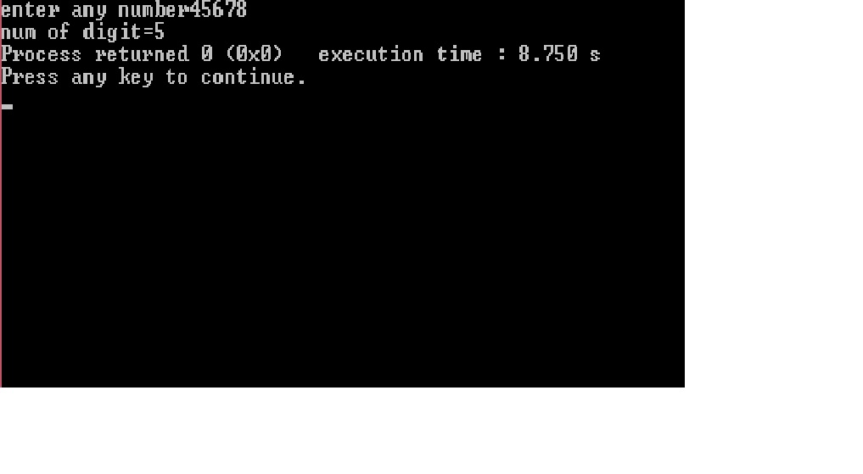

**Q3)** **c program to generate Fibonacci series up to nth term.**

**Program:**

/*c program to generate Fibonacci series up to nth term*/

#include<stdio.h>

int main()

{

int i,n,ft=0,st=1,tt;

printf("enter nth term=");

scanf("%d",&n);

printf("fabonacci series=\n");

for(i=1;i<=n;i++)

{

printf("%d\t",ft);

tt=ft+st;

ft=st;

st=tt;

}

return 0;

}

**Algorithm:**

**Output:**

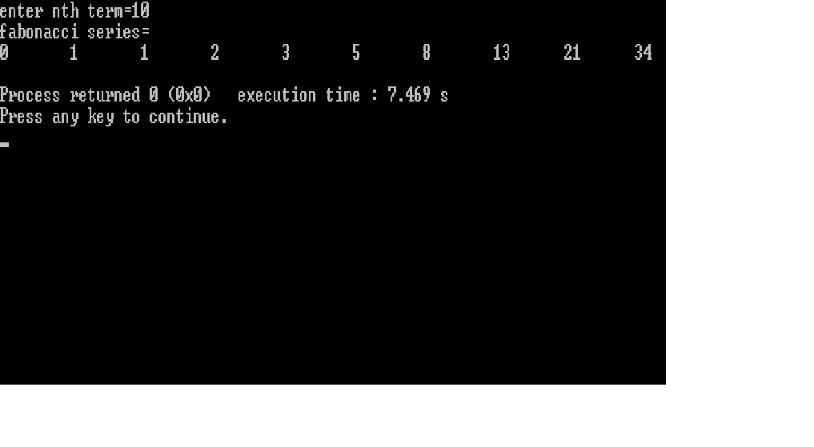

**Q4)** **c program to print prime number from 1 to 100.**

**Program:**

/*c program to print prime number from 1 to 100*/

#include<stdio.h>

int main()

{

int num,temp,d,p,a;

for(num=1;num<=100;num++)

{

p=0;

a=num;

for(temp=1;temp<=a;temp++)

{

if(a%temp==0)

{

p=p+1;

}

}

if(p==1||p==2)

{

printf("%d\t",num);

}

}

return 0;

}

**Algorithm:**

**Output:**

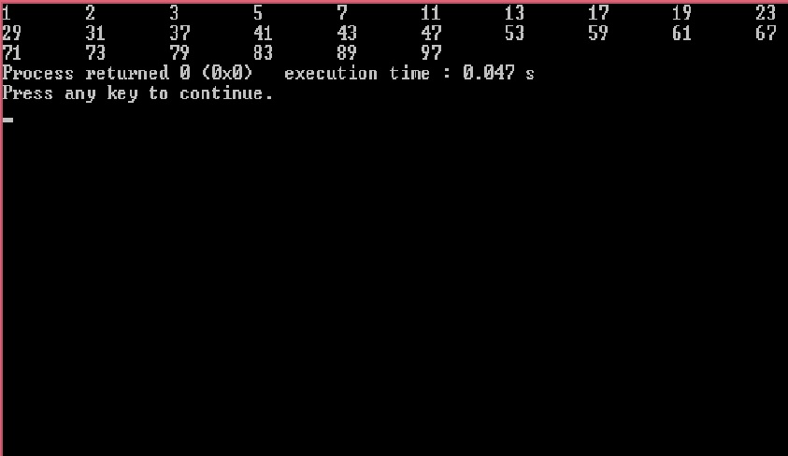

**Q5)** **c program to display: 1**

**1 4**

**1 4 9**

**1 4 9 16**

**1 4 9 16 25**

**Program:**

/*c program to display 1

1 4

1 4 9

1 4 9 16

1 4 9 16 25 */

#include<stdio.h>

int main()

{

int i,j,row=5,n;

for(i=1;i<=row;i++)

{

for(j=1;j<=i;j++)

{

n=j*j;

printf("%d\t",n);

}

printf("\n");

}

return 0;

}

**Algorithm:**

**Output:**

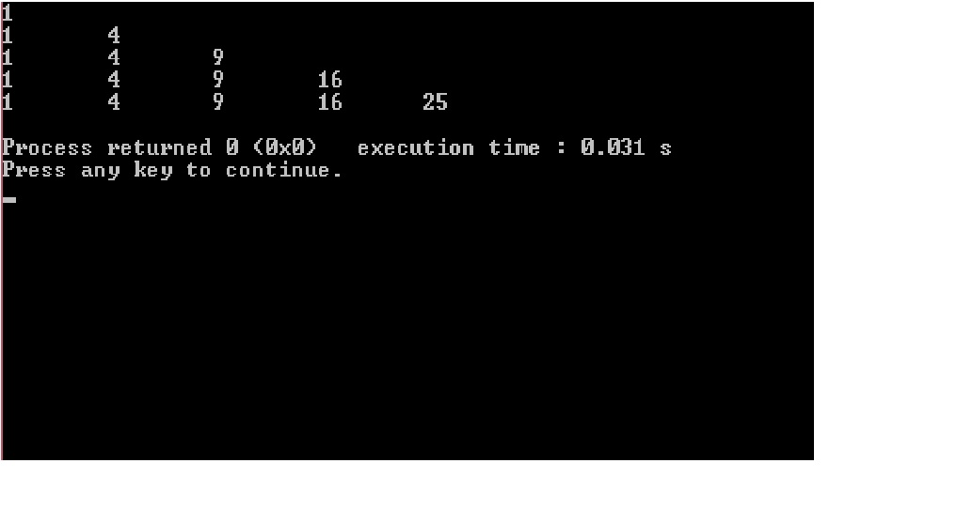

**Q6)** **c program to display: 1 6 10 13 15**

**2 7 11 14**

**3 8 12**

**4 9**

**5**

**Program:**

/*c program to display 1 6 10 13 15

2 7 11 14

3 8 12

4 9

5 */

#include<stdio.h>

int main()

{

int i,j,row=5,a,b=0;

for(i=1;i<=row;i++)

{

a=i;

for(j=5;j>=i;j--)

{

printf("%d\t",a);

a=a+j;

}

printf("\n");

}

return 0;

}

**Algorithm:**

**Output:**

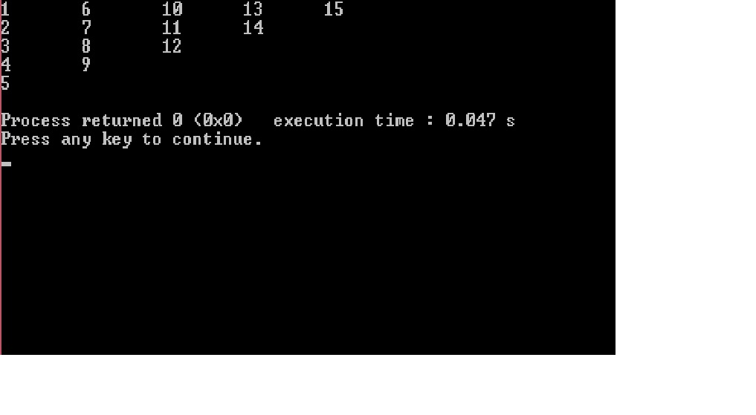

**Q7)** **c program to display 1**

**2 6**

**3 7 10**

**4 8 11 13**

**5 9 12 14 15**

**Program:**

/*c program to display 1

2 6

3 7 10

4 8 11 13

5 9 12 14 15 */

#include<stdio.h>

int main()

{

int i,j,row=5,a,b;

for(i=1;i<=row;i++)

{

a=i;

for(j=1,b=row-1;j<=i;j++,b--)

{

printf("%d\t",a);

a=a+b;

}

printf("\n");

}

return 0;

}

**Algorithm:**

**Output:**

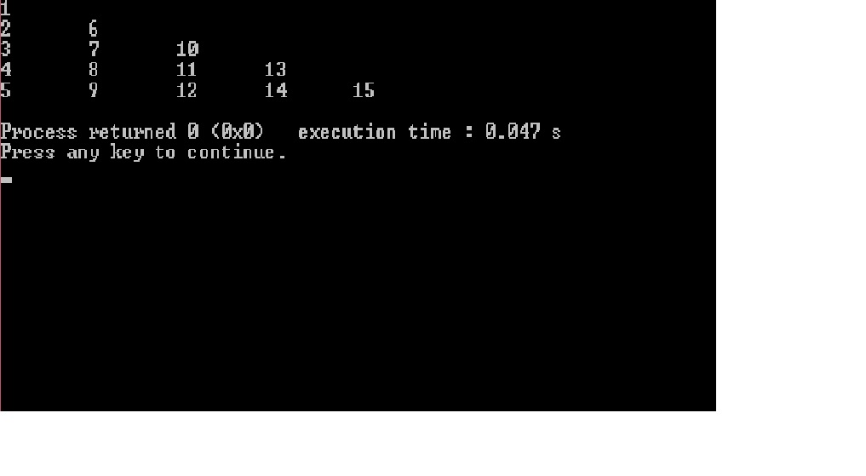

**Conclusion:**

Now we have learned about the usage of looping statement and learn how to loop any program and also we learn how to use while loop, do while loop, for loop.