**Introduction of array:**

Array is the collection of homogeneous data value called element of an array, store continuous in memory under signal variable name.

**Syntax:**

Data type<variable name>[size];

There are two type of array and they are:

1. Single array
2. Two dimension or multidimension

**1.signal dimension array:**

Conceptually you can think of a one-dimensional array as a row, where elements are stored one after another.

**Syntax:**

Data type<variable name>[size]={value}

**2.two dimension(2D) and multidimension array:**

an array of array is called multidimension array, 2D array is an instance of multidimension array.

**Syntax:**

<data type><array name>[row-size][column-size]={list of value}

**Introduction of string:**

string is group of character, digit and symbol enclosed with double quotation in another word string is also called array of character.

**Syntax:**

Char<string name>[size]

**Some Example:**

**Q1)** **write a c program to find the square of element on diagonal of square matrix.**

**Algorithm:**

**Step1: Start**

**Step2:**

**Step3:**

**Step4:**

**Step5:**

**Program:**

/*write a c program to find the square of element on diagonal of square matrix.*/

#include<stdio.h>

int main()

{

int num[3][3],sqr1,sqr2,i,j;

printf("Input elements 3*3 matrix:\n");

for(i=0;i<3;i++)

{

for(j=0;j<3;j++)

{

printf("element=[%d],[%d] : ",i,j);

scanf("%d",&num[i][j]);

}

}

printf("entered 3*3 matrix=\n");

for(i=0;i<3;i++)

{

for(j=0;j<3;j++)

{

printf("%d\t",num[i][j]);

}

printf("\n");

}

for(i=0;i<3;i++)

{

for(j=0;j<3;j++)

{

if(i==j)

{

printf("\nsuare of digonal[%d][%d]=",i,j);

sqr1=num[i][j]*num[i][j];

printf("%d",sqr1);

}

}

}

j=2;

for(i=0;i<3;i++)

{

printf("\nsuare of digonal[%d][%d]=",i,j);

sqr2=num[i][2-i]*num[i][2-i];

printf("%d",sqr2);

j--;

}

return 0;

}

**Output:**

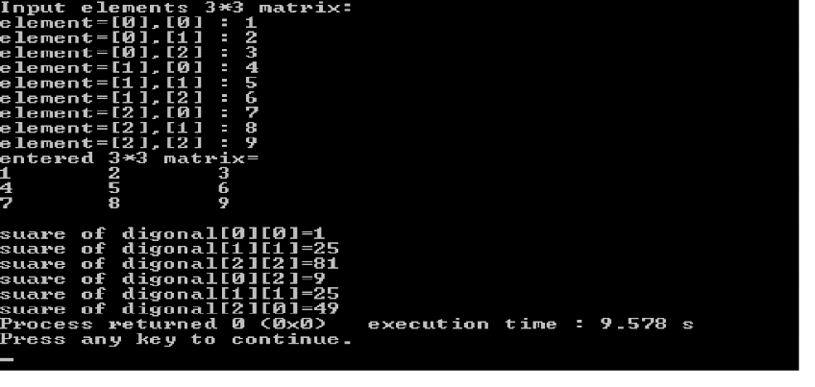

**Q2)** **write a c program to find transpose of any 2*3 matrix.**

**Algorithm:**

**Step1: Start**

**Step2:**

**Step3:**

**Step4:**

**Step5:**

**Program:**

/*write a c program to find transpose of any 2*3 matrix.*/

#include <stdio.h>

int main()

{

int a[2][3],b[3][2], i, j;

printf("\nEnter 3*3 matrix elements:\n");

for (i=0; i < 2; i++)

{

for (j=0; j < 3; j++)

{

printf("Enter element[%d][%d]: ", i, j);

scanf("%d", &a[i][j]);

}

}

printf("\nEntered 2*3 matrix: \n");

for (i=0; i <2;i++)

{

for (j=0; j <3;j++)

{

printf("%d\t",a[i][j]);

}

printf("\n");

}

for (i = 0; i < 2; i++)

{

for (j = 0; j < 3; j++)

{

b[j][i] = a[i][j];

}

}

printf("\nTranspose of the matrix:\n");

for (i=0;i<3;i++)

{

for (j=0;j<2;j++)

{

printf("%d\t",b[i][j]);

}

printf("\n");

}

return 0;

}

**Output:**

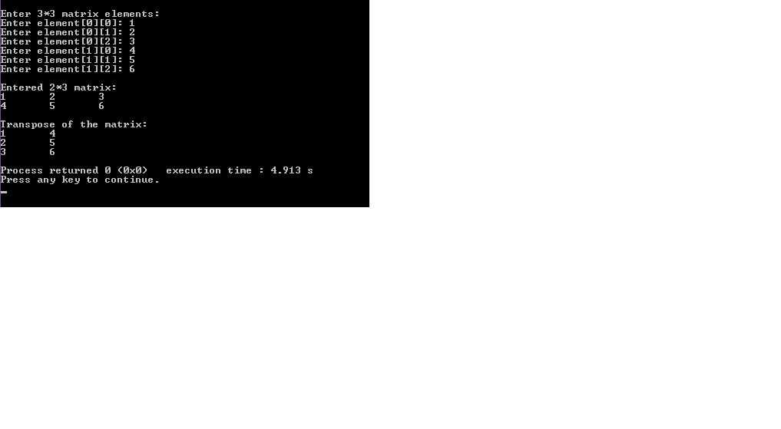

**Q3)** **write a c program to find product of two 3*3 matrix.**

**Algorithm:**

**Step1: Start**

**Step2:**

**Step3:**

**Step4:**

**Step5:**

**Program:**

/*write a c program to find product of two 3*3 matrix.*/

#include<stdio.h>

int main() {

int a[3][3], b[3][3], c[3][3], i, j, k;

int sum = 0;

printf("Enter First Matrix:\n");

for (i = 0; i < 3; i++)

{

for (j = 0; j < 3; j++)

{

scanf("%d", &a[i][j]);

}

}

printf("Enter Second Matrix:\n");

for (i = 0; i < 3; i++)

{

for (j = 0; j < 3; j++)

{

scanf("%d", &b[i][j]);

}

}

printf("The First Matrix is: \n");

for (i = 0; i < 3; i++)

{

for (j = 0; j < 3; j++)

{

printf(" %d ", a[i][j]);

}

printf("\n");

}

printf("The Second Matrix is : \n");

for (i = 0; i < 3; i++)

{

for (j = 0; j < 3; j++)

{

printf(" %d ", b[i][j]);

}

printf("\n");

}

for (i = 0; i <= 2; i++)

{

for (j = 0; j <= 2; j++)

{

sum = 0;

for (k = 0; k <= 2; k++)

{

sum = sum + a[i][k] * b[k][j];

}

c[i][j] = sum;

}

}

printf("Multiplication Of Two Matrices : \n");

for (i = 0; i < 3; i++)

{

for (j = 0; j < 3; j++)

{

printf(" %d ", c[i][j]);

}

printf("\n");

}

return (0);

}

**Output:**

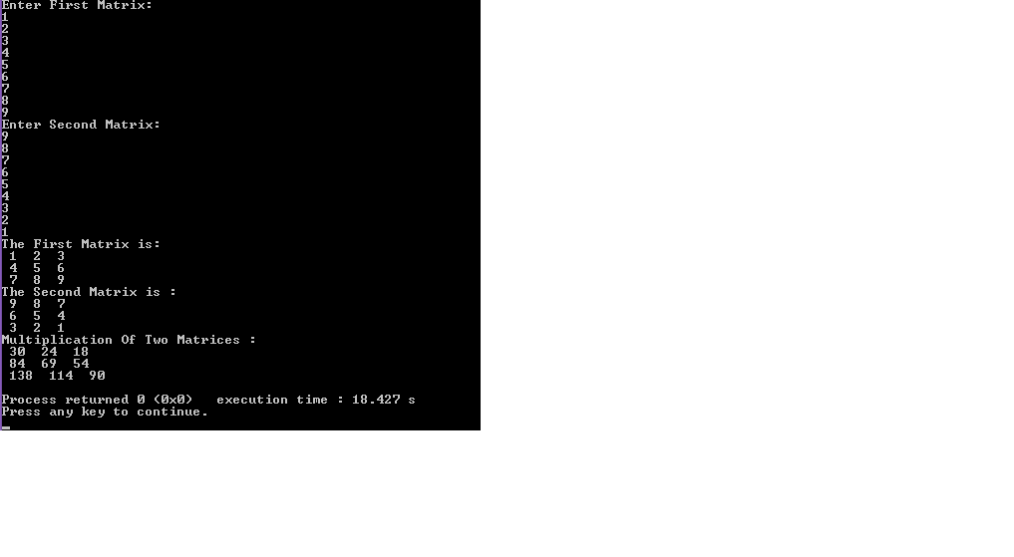

**Q4)** **write a c program to a read string and check for palindrome.**

**Algorithm:**

**Step1: Start**

**Step2:**

**Step3:**

**Step4:**

**Step5:**

**Program:**

/*write a c program to a read string and check for palindrome.*/

#include<stdio.h>

#include <string.h>

int main()

{

char s[30];

int i,n,c=0;

printf("Enter the string : ");

gets(s);

n=strlen(s);

for(i=0;i<n/2;i++)

{

if(s[i]==s[n-i-1])

{

c++;

}

}

if(c==i)

printf("string is palindrome");

else

printf("string is not palindrome");

return 0;

}

**Output:**

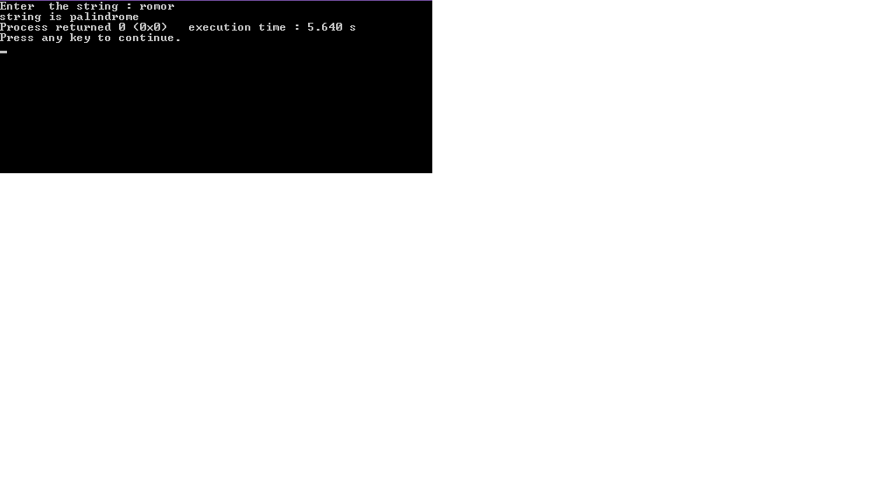

**Q5) write a c program to accept a string and delete all vowels from a string.**

**Algorithm:**

**Step1: Start**

**Step2:**

**Step3:**

**Step4:**

**Step5:**

**Program:**

/*write a c program to accept a string and delete all vowels from a string.*/

#include<stdio.h>

#include<string.h>

#include<stdlib.h>

int main()

{

char str[30],str1[30],c;

int i,count=0;

printf("\nEnter any string: ");

gets(str);

for(i=0;i<strlen(str);i++)

{

c=str[i];

if(c!='a' && c!='e' && c!='i' && c!='o' && c!='u')

{

str1[count++]=str[i];

}

}

str1[count]='\0';

printf("\nYou entered string is: %s",str);

printf("\nString without vowels is: %s",str1);

return 0;

}

**Output:**

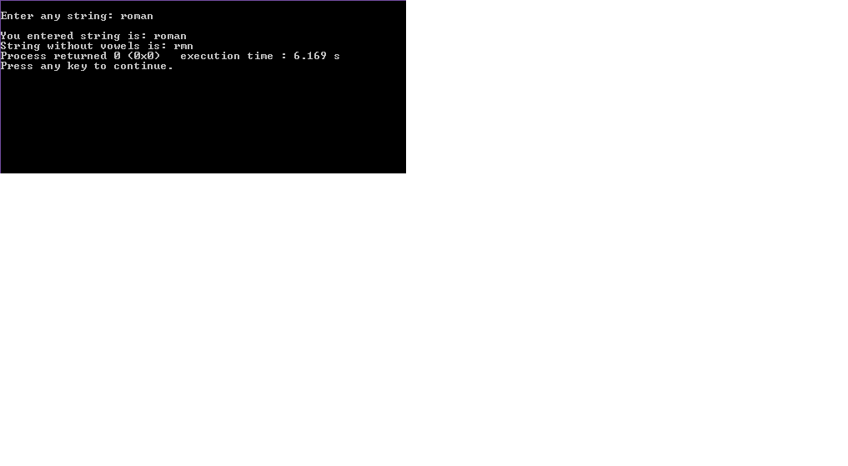

**Q6)** **write a c program to sort any five names alphabetically.**

**Algorithm:**

**Program:**

/*write a c program to sort any five names alphabetically.*/

#include <stdio.h>

#include <string.h>

int main()

{

char name[10][8], tname[10][8], temp[8];

int i, j, n=5;

printf("Enter 5 names=\n",n);

for (i = 0; i < n; i++)

{

scanf("%s", name[i]);

strcpy(tname[i], name[i]);

}

for (i = 0; i < n - 1 ; i++)

{

for (j = i + 1; j < n; j++)

{

if (strcmp(name[i], name[j]) > 0)

{

strcpy(temp, name[i]);

strcpy(name[i], name[j]);

strcpy(name[j], temp);

}

}

}

printf("Input NamestSorted names\n");

for (i = 0; i < n; i++)

{

printf("%s\t\t%s\n", tname[i], name[i]);

}

return 0;

}

**Output:**

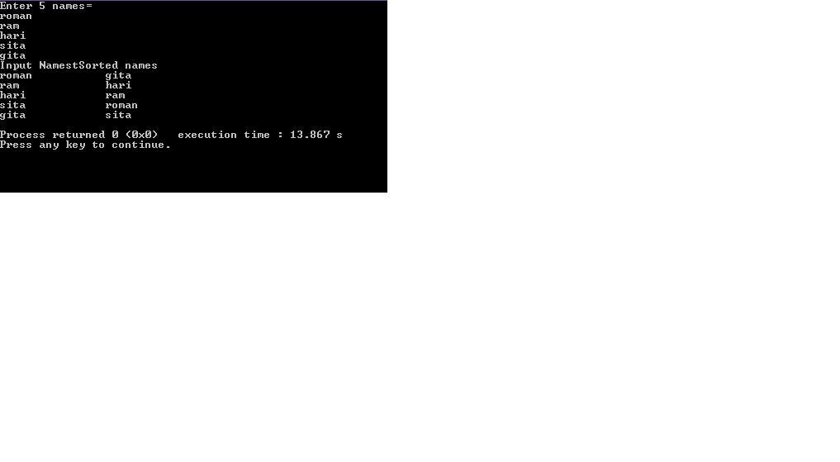

**Conclusion:**