**Gym Buddy App**

1. ***Background/ Problem Statement***

Taking out some time from your busy schedule to attend a gym daily for a workout seems difficult for working professionals & college students due to workload & studies. As a result of which many people prefer doing exercises or gym workouts at their home itself. However, a gym workout or exercise done without following the right procedure or positions and done without the proper guidance of a trainer can damage your muscles. Also, hiring a personal trainer may not fit everyone's budget. So, to tackle this issue we have developed an android based GYM Buddy application that will act as a virtual trainer. This application will guide the users on various body exercises with step-by-step positions with images. The users can keep a track of the data of day-to-day exercises. The Gym Buddy application contains a list of all exercises based on different types & categories (i.e., workout for Abs, Chest, Biceps, etc.). The users can also keep a track of how much sets or weights they used in one particular workout so that they can increase or decrease its capacity accordingly. Thus, this android-based gym workout application will act as a virtual guide to the users & will provide a user-friendly gym experience.

1. ***Working of the Project***

In this system, the user will be able to view all kinds of exercises based on type or category. Each Workout or exercise is well explained in details along with 2 photos showing the start and end pose, so that user can check his posture like in the photo and can imitate it properly. User can enter weight or set based on current date and can add multiple entries for each date. All the exercise data has to be directly added in the code, there are no modules to manage them and backend used is SQLite.

1. ***Advantages***
   * No need to create an account just proceed with a name.
   * All the exercises have a photo involved so that user can imitate the posture properly.
   * Date wise progress tracker.
2. ***System Description***

The system comprises of 1 major modules with their sub-modules as follows:

1. **User:**
   * **Login:** User can proceed with Just adding his name to use the App.
   * **Categories:** User will be able to select a category or type of exercises he wants, namely chest, triceps abs etc.
   * **Exercise:** Each exercise will have 2 photos showing the start and the end pose of it, along with a detailed description about the exercise which can consist of what kinds of muscle we are building and why is it important.
   * **Progress Tracker:** under each Exercise, the user can mark how much weights he used or how many sets he did on the particular date, so that he can refer and keep on increasing his mark.
2. ***Project Life Cycle***

The waterfall model is a classical model used in system development life cycle to create a system with a linear and sequential approach. It is termed as waterfall because the model develops systematically from one phase to another in downward fashion. The waterfall approach does not define the process to go back to the previous phase to handle changes in requirement. The waterfall approach is the earliest approach that was used for software development

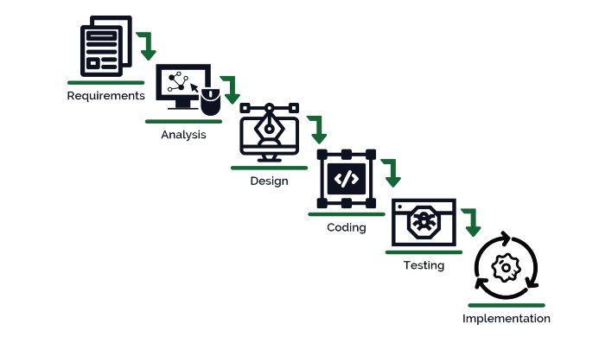

1. ***System Requirement***
2. ***Hardware Requirement***
3. **Laptop or PC**

* MacOS Sierra and above
* I3 processor system or higher
* 4 GB RAM or higher
* 100 GB ROM or higher

1. **iPhone (iOS 9 and above)**
2. ***Software Requirement***
3. **Laptop or PC**

* XCode (Latest version)

1. ***Limitation/Disadvantages***

* Wrong inputs will affect the project outputs.
* Phone dependent app.
* Single User app.

1. ***Application*** – This system can be used by any user who wants to self-train.
2. ***Reference***

* https://ieeexplore.ieee.org/document/7946559