**Title: Mobile payment adoption intention among consumers:**

**A developing country context**

**Introduction:**

Mobile payments, often abbreviated as m-payments, refer to the process of conducting financial transactions via mobile devices, such as smartphones and tablets. These transactions enable users to purchase goods and services, transfer money, and manage their finances with unprecedented convenience and security. Mobile payments are transforming the traditional financial landscape by providing a range of methods to suit different technological environments and user preferences.

There are several primary types of mobile payments:

1. ***SMS-Based Payments***: Transactions are executed through text messages, making it accessible even on basic mobile phones.

2. ***Mobile Web Payments***: These utilize mobile browsers to process transactions securely over the internet.

3. ***Near Field Communication (NFC) Payments:*** This technology allows for contactless payments through close-range wireless communication between devices.

4. ***Mobile Wallets :*** These are applications that store payment information securely on smartphones, integrating with various services and apps for easy transactions.

.

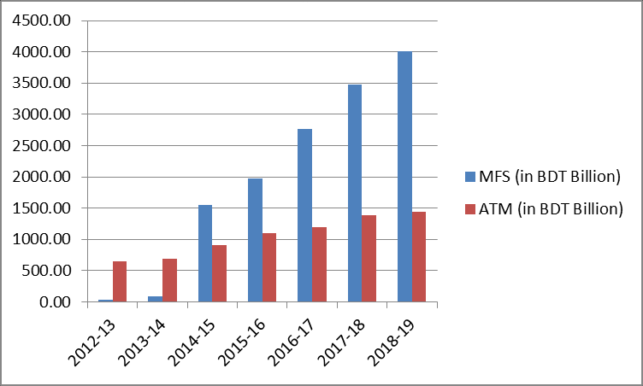

Fig.1. MFS and ATM transactions volume of Banking Industry of Bangladesh.

This graph shows the transaction volume of Mobile Financial Services (MFS) and ATMs for the 7 years of the Bangladeshi banking industry. Both the MFS and ATMs display an increasing trend.

In developing countries like Bangladesh, mobile payments are not just a matter of convenience but a pivotal tool for financial inclusion and economic empowerment. With increasing mobile phone penetration, services like bKash and Rocket have revolutionized financial transactions, particularly for the unbanked and underbanked populations. These Mobile Financial Services (MFS) facilitate a wide range of activities, from remittances and utility bill payments to microfinance and retail purchases. The adoption of mobile payments in Bangladesh highlights the transformative power of technology in bridging financial gaps, promoting economic participation, and enhancing financial literacy. By harnessing the potential of mobile payments, stakeholders can drive the development of a robust and inclusive financial ecosystem, fostering economic growth and stability in Bangladesh and other developing nations.

**Problem Statement :**

Mobile payments offer significant benefits, including convenience, security, and efficiency, which are crucial for economic growth. They streamline transactions, reduce the need for physical cash, and lower transaction costs. In developing countries like Bangladesh, the absence of mobile payments can lead to economic losses due to inefficiencies in traditional banking, increased transaction times, and higher costs associated with cash handling and manual processes. Without mobile payments, large segments of the population remain unbanked, limiting their access to financial services and hindering economic participation. Mobile payments are vital in Bangladesh for promoting financial inclusion, enabling swift and secure transactions, and supporting small businesses and remittances. By integrating mobile payments, Bangladesh can enhance financial literacy, drive economic development, and ensure that all citizens have the tools to participate in the economy effectively.

**Theory and hypothesis:**

1. We employed extended **UTAUT** model to address current issue regarding mobile payment adoption intention.
2. H1: Perceived usefulness has positive impact on mobile payment adoption intention.

H2: Ease of use has positive impact on mobile payment adoption intention.

H3: Social norm has positive impact on mobile payment adoption intention.

H4: Facilitating condition has positive impact on mobile payment adoption intention.

H5: Customer trust has positive impact on mobile payment adoption intention.

**Framework :** 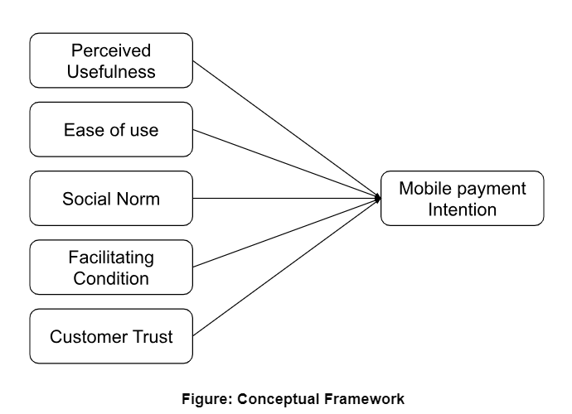

**Proposed Methodology :**

|  |  |  |  |  |
| --- | --- | --- | --- | --- |
| Sample | Unit of analysis | Data collection | Sampling technique | Analysis tools |
| Consumers | Individuals | Online | Purposive/convenience | SPSS, PLS |

**Conclusion :**

Mobile payments are essential for economic growth and financial inclusion in developing countries like Bangladesh. They offer convenience, reduce costs, and ensure secure transactions, bridging financial gaps and empowering the unbanked population. Embracing mobile payments is crucial for fostering economic development and enhancing financial literacy.