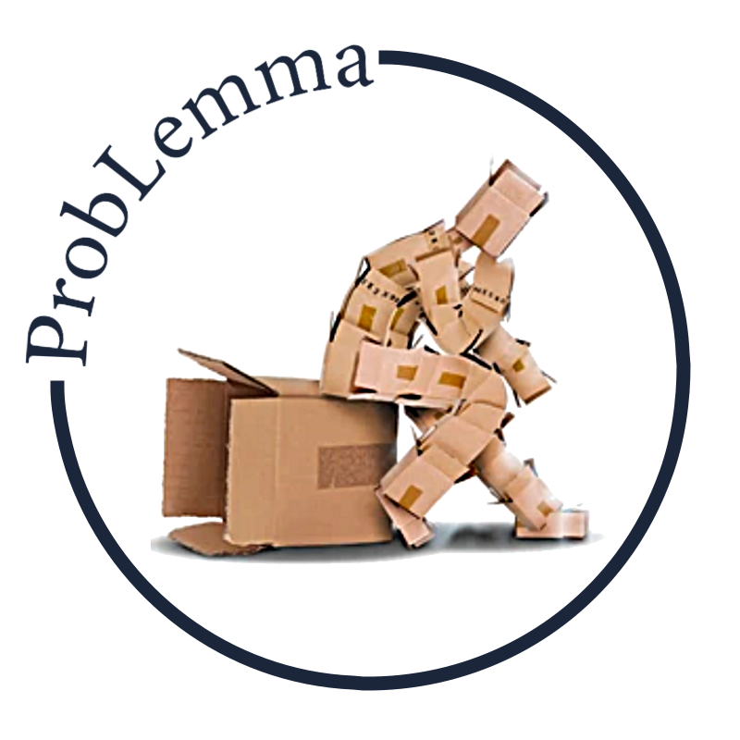
The ProbLemma Channel Products

This document links all the products evaluated on the ProbLemma channel to the episodes in which these evaluations were carried out.


In addition, all the products related episodes are collected in the “Products Are Us” play list.

1. Season 2 Episode 43 (S2M45): A Poisson Integral By The Book (Divide And Conquer)

2. Season

