Rest eyes open - Parkinsons Disease 64-Channel EEG
https://www.kaggle.com/datasets/anthonyylee/rest-eyes-open-parkinsons-disease-64-channel-eeg

64-channel BrainVision EEG of 100x Parkinsons and 49x controls = 149x subjects
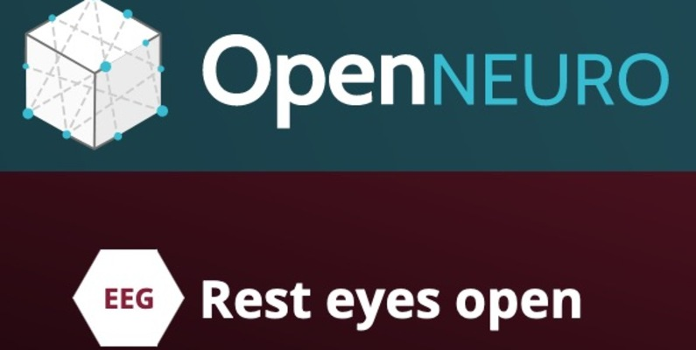
Data CardCode (2)Discussion (0)Suggestions (0)

About Dataset
This experiment includes 149 subjects: 100 individuals with Parkinsons disease, and 49 controls. EEG was recorded with a 64-channel BrainVision cap. Resting-state EEG was collected from patients sitting in a quiet room with their eyes open for two minutes.
Paper DOI: https://doi.org/10.1016/j.parkreldis.2020.08.001
BIDS Version: v1.2.1
License: CC0
Authors:
Arun Singh arun.singh@usd.edu
Rachel Cole rachel-cole@uiowa.edu
Arturo Espinoza arturo-espinoza@uiowa.edu
Jim Cavanagh jcavanagh@unm.edu
Nandakumar Narayanan nandakumar-narayanan@uiowa.edu
(2023). Rest eyes open. OpenNeuro. Dataset

Tutorial - How to read and use this data?

https://www.kaggle.com/code/anthonyylee/tutorial-how-to-read-and-use-this-data

Paper asociado:
https://www.prd-journal.com/article/S1353-8020(20)30667-2/abstract

