承 认 书
APPROVAL FOR SHEET

CUSTOMER 客 户： 鸿牛

P / N 料 号 ： 8207055191

MODEL 型 号 ： HK260-3010US

CATEGORY 种 类 ：MATEL PLATE五金底板

FORMAN COMPANY
公司签核：
 | Name |  |  | Date
Create制作
Consent审核
Approval批准
CUSTOMER APPROVAL
客户承认：
 |  | Name | Date
Consent审核
Consent审核
Approval批准

TEL:0755-29542655
FAX:0755-81720169
http://www.bow.cn
ADDRESS:Hangshi Technology Park,G Area,Democracy West Industry Park,
Shajing Town, Bao"an District, Shenzhen, China.
地址：深圳市宝安区沙井街道民主西部工业区航世科技园

Keyboard Product

Hangshi Model: HK260-3
Rev. A0

Revision History
Revision | Comment | Owner | Date
A0 | 初始文档 | QYM | 20235.8.5
A1
A2
A3
A4
B0
B1

Table of Contents
目录
1. Scope产品概述 5
2. Outline外观概要 5
3. Appearance外观图 6
4. Key Matrix矩阵图 7
5. Key Layout丝印图 7
6. Environmental Condition环境条件 8
6.1 Measurement Conditions 量测条件 8
7. Mechanical Characteristic机构特性 8
7.1 Key switch Structure 键芯结构 8
7.2 Material Specification 材质明细 9
7.3 Tactile Curve Graph 克重曲线 9
7.4 Travel 行程 10
7.5 Stop strength 最大键帽压力 10
7.6 Pull off force of keycap 拉拔力 10
7.7 Keycap Penphery Pressing 角落测试 11
7.8 Keyboard Warp 变形规格 13
7.9 Keycap shift 键帽偏移 13
7.10 Keycap twist 键帽旋转 13
7.11 Keycap slant 键帽倾斜 14
7.12 Keycap height alignment 相邻两键帽高度落差 14
7.13 Keycap alignment in the row 相邻两键帽落差 14
7.14 Keycap space 键帽间隙 14
8. Electrical Characteristic电气特性 14
8.1 Ratings 额定功率 14
8.2 Contact Resistance 接触阻抗 15
8.3 Insulation Resistance 绝缘阻抗 15
8.4 Key Switch Bounce 反馈讯号 15
9. Endurance（Keyboard Unit）可靠性测试（键芯单体） 16
9.1 Resistance to Low temperature 低温环测 16
9.2 Resistance to High temperature& High humidity 高温高湿环测 16
9.3 Operation life 操作寿命 16
9.4 Insertion/Pulling out of Membrane tail and connector 出线端插拔测试 16
9.5 Flexure strength of membrane tail 出线端弯曲强度测试 17
9.6 Hardness Test 硬度测试 17
9.7 Abrasion Resistance 耐摩擦测试 17
9.8 Alcohol Resistance 耐酒精测试 18
9.9 RCA Abrasion 纸带耐磨测试 18
9.10 Oil Resistance 耐油污测试 19
9.11 Resistance to Waterproof 防水测试 19
9.12 Drop test 跌落测试 20
10. Precaution for Handling预防操作 20

1. Scope产品概述
This specification will give a description on the HK260-3.The HK260-3 is an 80keys module for Notebook、Keyboard、or Other equipment. This is designed with excellent silent tactile feeling by switch-stroke up to 1.2 ±0.2mm full travel and feeling technology improvements.
此规格书描述HK260-3键芯的规格。键芯为80键位，可用作笔记本、键盘等输入设备的按键。键芯最大键程1.2±0.2mm。
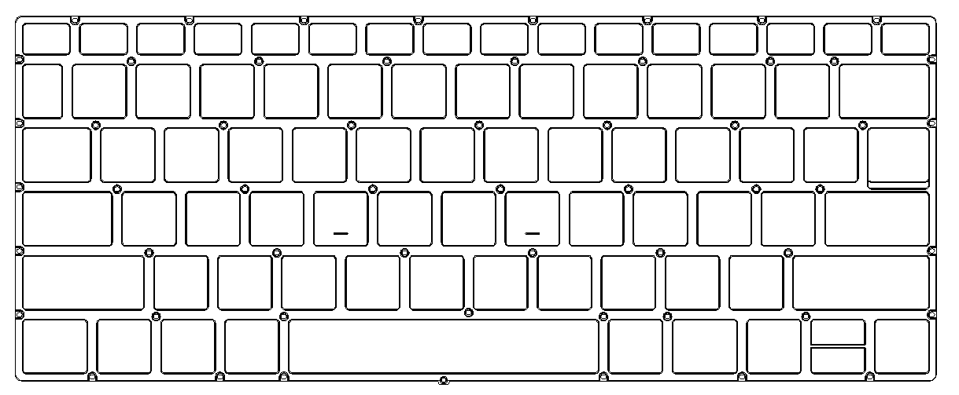
2. Outline外观概要
 |  | Unit
1 | Height 高度 | mm | 3.3±0.2（含背光板）
2 | Stroke 行程 | mm | 1.2±0.2
3 | Weight 重量 | g | XXX
4 | Key Pitch（Normal key）标准键键距 | mm | 18.0±0.2
5 | Dimension 外观尺寸 | mm | See Drawing参照图纸
6 | Membrane Tail 出线端尺寸 |  | See Drawing参照图纸
7 | Pitch of Membrane Connector PIN规格 | mm | 28PIN/1.0mm
8 | Number of keys 键数 |  | US=80
9 | Paint on Key Cap 键帽是否喷漆 |  | YES是
10 | Key Cap Color 键帽颜色 |  | Black黑
11 | Printing Method (Silkscreen or Laser) 印刷方式 |  | Laser镭雕
12 | Spill Resistance 是否防水 |  | Spill-Resistant防泡水
13 | Material and Thickness of Support panel 底板材质及厚度 |  | 五金底板 (t=0.2mm)
14 | Paint on support panel or not 底板是否喷漆 |  | No
15 | Market(JA/US/UK) 丝印文种 |  | 俄文
3. Appearance外观图
Us
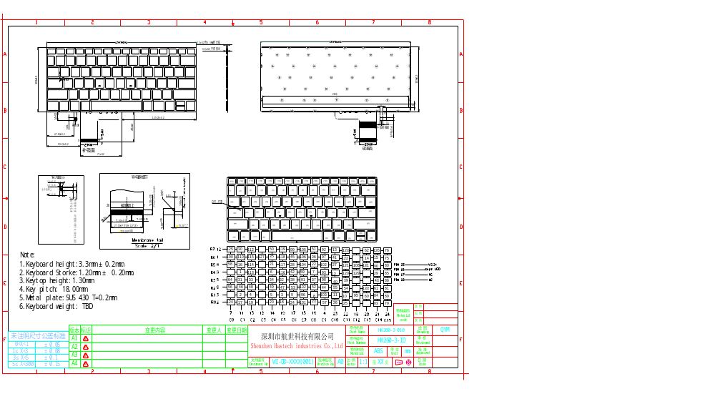

4. Key Matrix矩阵图
Us
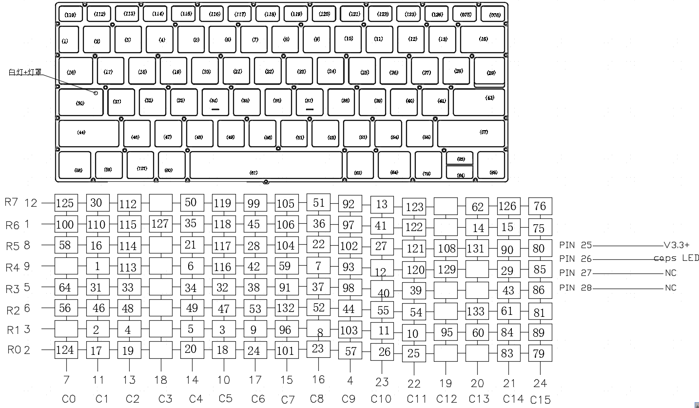
5. Key Layout丝印图
俄文：8509017529
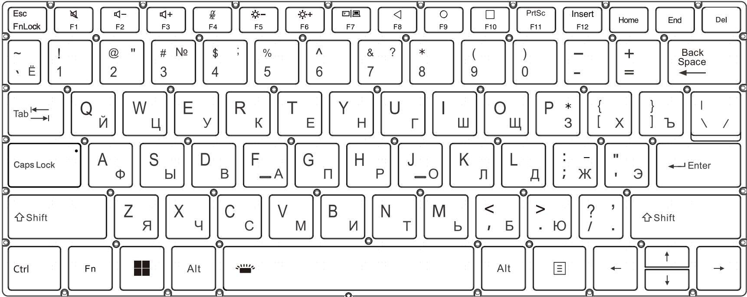
6. Environmental Condition环境条件
6.1 Measurement Conditions 量测条件
The measurements shall be made the following standard conditions.所有的量测应该在下面条件完成.
Temperature of measurements温度：5～35°C
Humidity of measurements湿度：45～85%Rh
Pressure of measurements压强：860～1060hPa
Should question arise from the judgment made, tests shall be conducted with the following Conditions. 所有的测试问题将以下面的条件来做判定
Temperature of measurements温度：20±2°C
Humidity of measurements 湿度：60～70%Rh
Pressure of measurements 压强：860～1060hPa
7. Mechanical Characteristic机构特性
 | Item
1 | Key switch  Structure  键芯结构 | 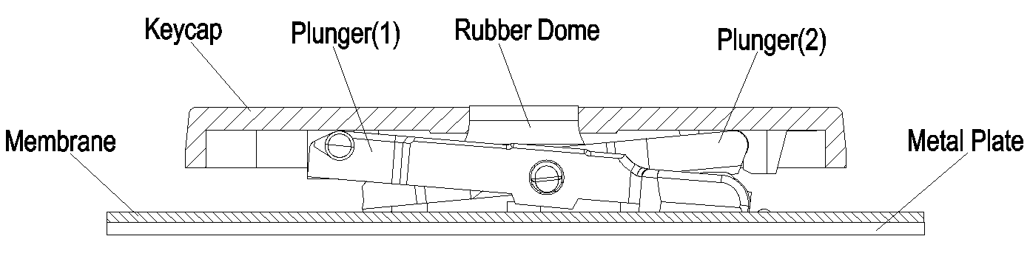
2 | Material  Specification  材质明细
  Parts name名称 | Material材料 | comment备注
  Keycap键帽 | ABS | Black黑色
  Plate底板 | SUS430 | T=0.2MM
  Membrane导电膜 | PET | 背黑/背白
  Rubber硅胶粒 | Silicone | White、semitransparent白色半透
  Plunger剪刀脚 | POM | White、semitransparent白色半透
  Backlight背光板 | PET | 白膜

 | Item
3 | Tactile Curve Graph  克重曲线 | Set the keyboard to keep the operating direction becomes vertical, and add load to the center of each keycap at a speed rate 5mm/min., force at 150g.  把键芯平放，并于中间垂直施以150g 下压速度5mm/min 的力量来进行曲线量测  Normal & Function Key force and stroke:  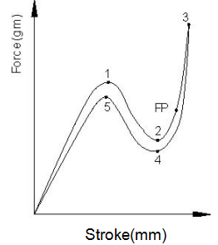
  Point | Position (mm) Initial | Force (Mark) | Force (g) Initial
  P1 | S1 =0.5± 0.20 | PF | 60 ± 20g
  P2 | S2 =0.9± 0.20 | CL | 40%~60%
  P3 | S3 =1.2± 0.20 | TM | Max 150 g
  P4 | S4 =P2 ± 0.20 | RF | Min 15 g
  Fire point | SFP=P2+0.2~0.5
  PF=Peak force, CL=Click feeling, TM=Travel to make ，RF=Return force, FP= Fire point
4 | Travel  行程 | Operating Travel(操作行程): 1.1± 0.2 mm  Maximum Travel(最大键程): 1.2± 0.2 mm(force at 150g)

 | Item | Conditions测试条件 | Specification判定标准
5 | Stop Strength  最大键帽压力 | Apply a force of 1Kgf vertically to the upper face of the keycap for 1 minute.  以1KG 压力垂直运用于键帽表面1分钟. | Mechanical and Electrical  characteristic.  机械及电气特性OK.
6 | Pull off force  of keycap  拉拔力 | Set keyboard such that the direction of keyboard operation is vertical. Pull the keycap in the direction opposite to the direction of keycap operation until it comes off and the load shall be measured.  将KB平放，并于垂直方向施以反向力于单个键帽上，观察并纪录键帽脱离的数据  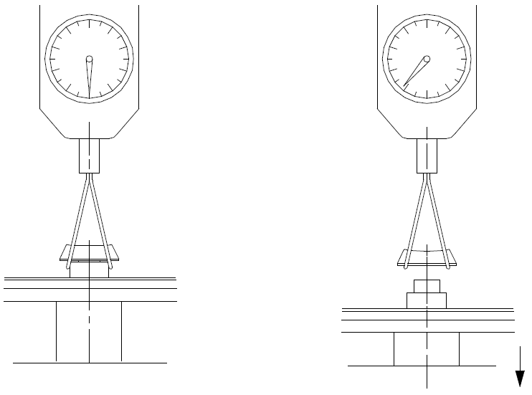 | F keys：  7.84N[800gf] or more.  F键四周拉拔力不小于7.84N.  Others：  9.8N[1000gf] or more.  四周拉拔力不小于9.8N.
7 | Keycap  Periphery  Pressing  角落测试 | Periphery of a keycap at a rate of free drop.  Key in test spec on the 4-corners area of the  keycap put 80g poise on each corner of keycap  to see if it can act.  将键芯平放然后以重量80g法码&直径6.0mm测  头，接触Key面时自由落下，进行角落测试  Note:  It is not permissible under any circumstances for adjacent keys to touch during normal operation;  任何情况下相邻键帽都不能触碰；  Must use Pin gauge φ6.0mm (not acicular).  夹具头必须是直径6mm的，不能用尖头  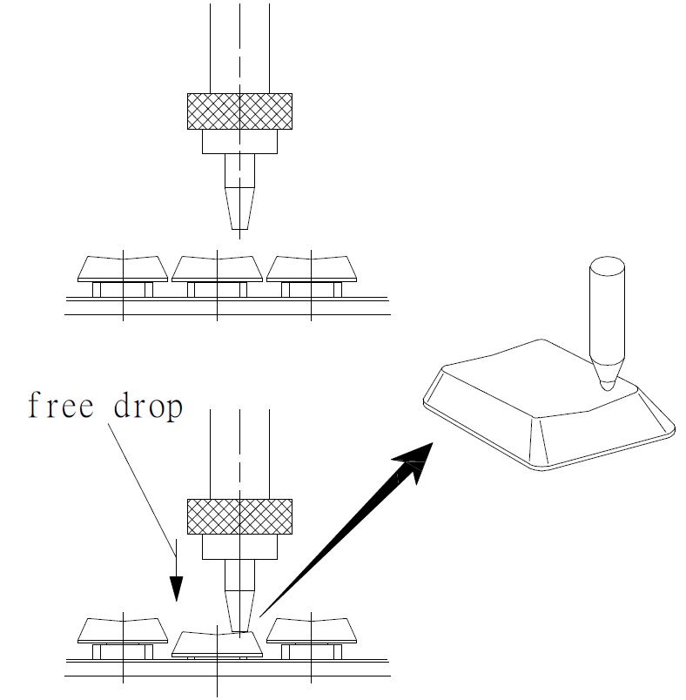 | Operating force：  Must be “ON” within the  maximum peak force of  keycap center pressing.  在规定的荷重下必须要能正常工作.  Click feeling：  Must be a click feeling.  必须要有段落感.
 | Item | Conditions测试条件 | Specification判定标准
7 | Keycap  Periphery  Pressing  角落测试 | 各种尺寸键帽角落测试圆心位置定义如下:  Normal key 标准键  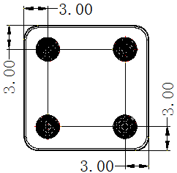  Space key 空格键  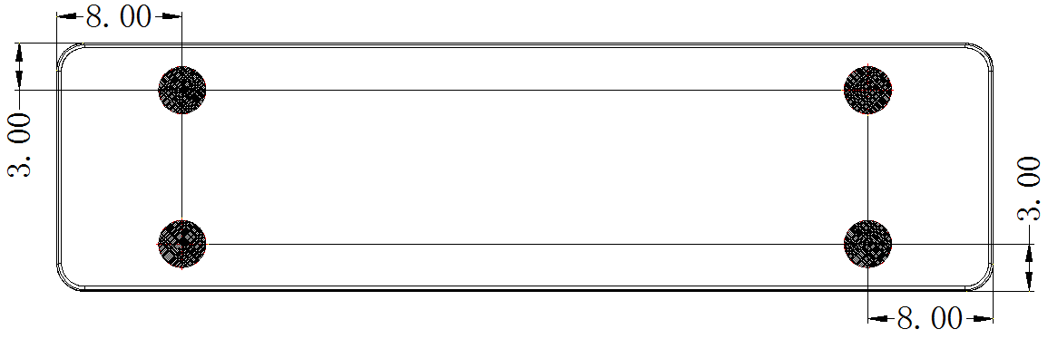  Enter key Enter键  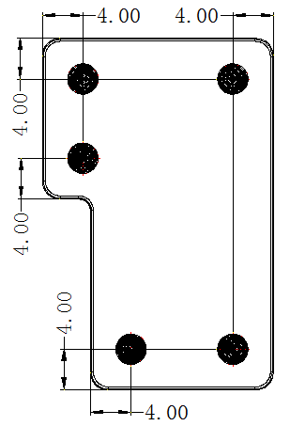  Other key bigger than normal key except  space bar 杂键  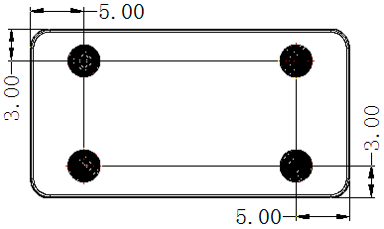  All the keys smaller than normal key F键  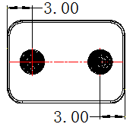  单位：mm

 | Item | Conditions测试条件 | Specification判定标准
8 | Keyboard Warp  变形规格 | There is no warp production for this model, but  curve condition can be acceptable.  没有板弯要求下,键芯自然变形如下需可被接受.  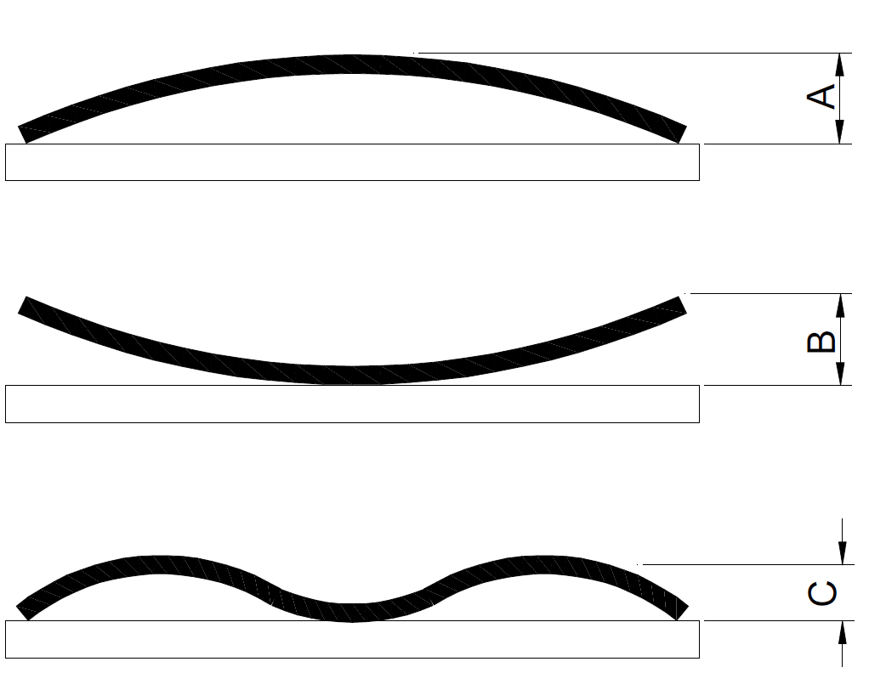 | Satisfy to the table as follows.  自然变形规格如下  Nature Distortion Size.
   | Long side | Short side
  A | Max. 2 mm | Max. 1mm
  B | Max. 2mm | Max. 1mm
  C | Max. 0.5mm | Max. 0.5mm
9 | Keycap shift  键帽偏移 | 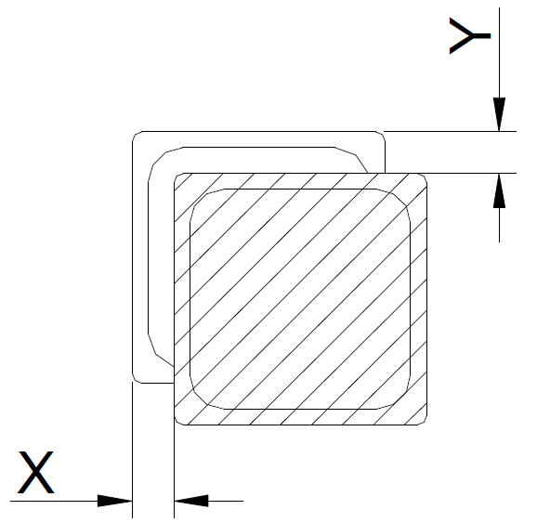 | Shall be no more than 0.4mm in either X or Y directions.  在X 方向和 Y方向均不得大于0.4mm.
10 | Keycap twist  键帽旋转 | 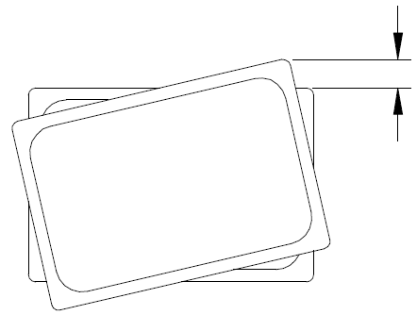 | Less than 0.4mm.

 | Item | Conditions测试条件 | Specification判定标准
11 | Keycap slant  键帽倾斜 | 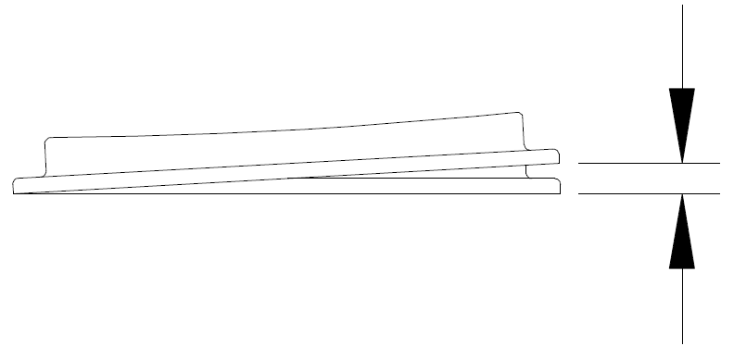 | Less than 0.4mm.
12 | Keycap height alignment  相邻两键帽高度落差 | 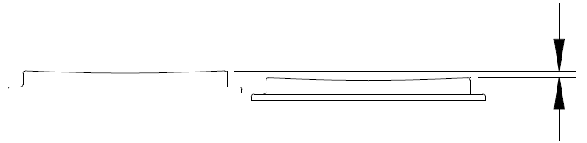 | Less than 0.5mm between neighboring keys.  相邻两键高度落差需小于  0.5mm.
13 | Keycap alignment in the row  相邻两键帽落  差 | 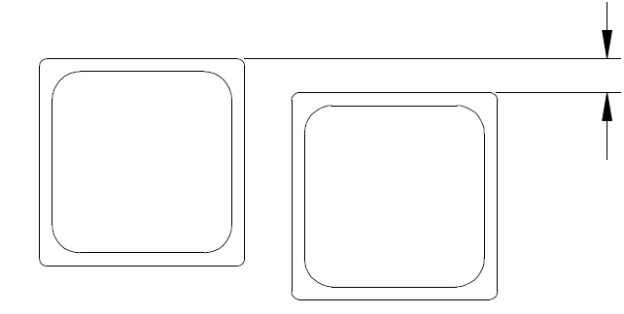 | Less than 0.5mm in  neighboring keys.  相邻两键落差需小于  0.5mm.
14 | Keycap space  间隙 | 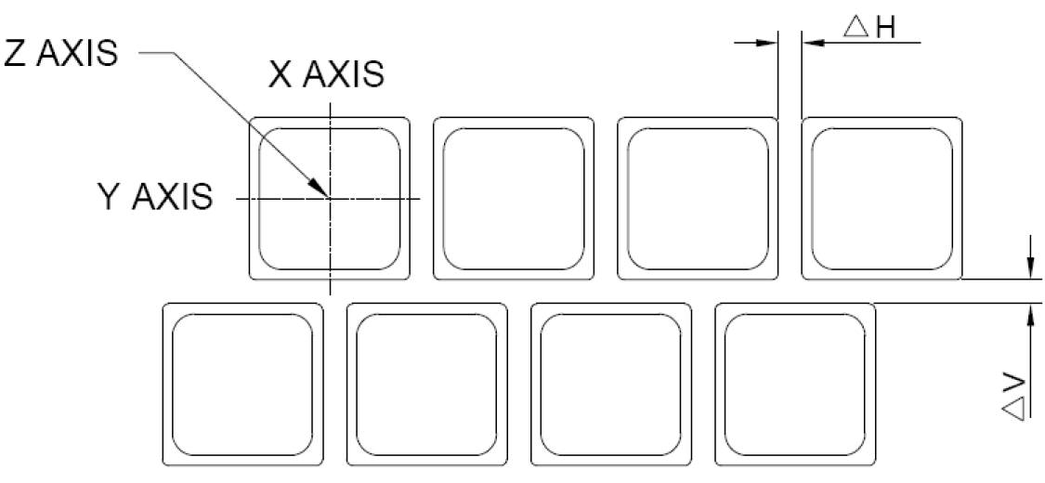 | Gap between keycaps and Keycap  键与键间隙规格为:  3.02±0.2mm(△V)  3.02±0.2mm(△H)

8. Electrical Characteristic电气特性
 | Item | Conditions测试条件 | Specification判定标准
1 | Ratings  额定功率 | Ratings of switch contacts  按键接触的额定功率 | DC 5V, 5mA

 | Item | Conditions测试条件 | Specification判定标准
2 | Contact  Resistance  接触阻抗 | Applying a static load 1.47N[150gf] to the center of the keycap measurement shall be made at the tip of the membrane tail.  在键帽中心施以150g的力,然后在出线端处量测电阻值 | Before test:Max.500Ω  After life test and environmental test:  Max.1KΩ  测试前小于500Ω  测试后小于1000Ω
3 | Insulation  Resistance  绝缘阻抗 | Applying DC 5V to terminal of Membrane tail  arbitrarily 2 Pin, the Resistance measurement shall be made.  施以5V直流电于导电膜出线端的任意2Pin，量测Pin与Pin之间的电阻值 | Before test:Min.100MΩ  After life test and environmental test:  Min.50MΩ  测试前不小于100MΩ  测试后不小于50MΩ
4 | Key Switch  Bounce  反馈讯号 | Push the center of the keycap to the full stroke  continuously 10 times by keystroke rate of 4  times/sec, and measurement maximum value.  以每秒4次按压键帽全行程10次,并且量测其讯号反馈波形  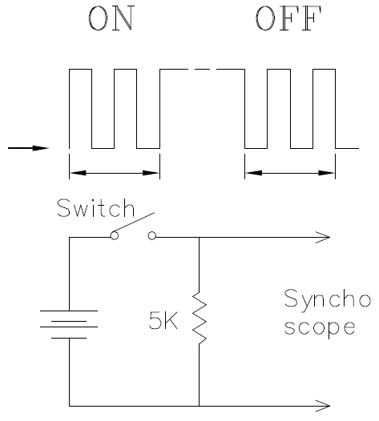 | 20 ms max. at 3-4key  operations per second.  每秒按压 3~4 次时其  on/off 的讯号弹跳必须  在20毫秒以内
9. Endurance（Keyboard Unit）可靠性测试（键芯单体）
 | Item | Conditions测试条件 | Specification判定标准
1 | Resistance to  Low temperature  低温环测 | Conduct the test under below conditions, and then measurement after leave it in room temperature and humidity condition 2 hours.  将样品放置在下面条件下，然后取出室温环境放置2H，再进行量测.  1.Temperature温度：-20℃±3℃  2.Duration持续时间：24 hours  3.Condition：Dew condensation shall be removed. | Mechanical and Electrical  characteristic.  机械及电气性能OK.
2 | Resistance to  High temperature &  high humidity  高温高湿环测 | Conduct the test under below conditions, and then measurement after leave it in room temperature and humidity condition 2 hours.  将样品放置在下面条件下，然后取出室温环境放置2H，再进行量测.  1.Temperature温度：65℃±3℃  2.Humidity湿度：90-95%RH  3.Duration持续时间：24 hours  4.Condition：Dew condensation shall be removed. | Mechanical and Electrical  characteristic.  机械及电气性能OK.
3 | Operation life  操作寿命 | The operation life cycle：  3 million cycles (Function key)  5 million cycles (Normal key)  按键操作寿命循环为:  标准300万次  标准500万次.  -Key stroke speed测试速度：240cycles/min.  -Pressing force测试克重：100±20gf.  -Load Point测试点：Vertically to center of keycap垂直于键帽中心 | F4 (Return force) is not less than 5 grams  回弹力需大于5g.  Electrical characteristic.  电气性能OK.
4 | Insertion/Pulling out of Membrane tail  and connector  出线端插拔测  试 | Measure it after examining insertion and pulling out of Membrane tail 5 times.  插拔5 次后进行量测  Connector type: Use connector that will be used on the MB side.  连接器型号需同各户使用一样 | This film of printing shall be no exposure.  印刷部位不能裸露底材.  Electrical characteristic.  电气性能OK.

 | Item | Conditions测试条件 | Specification判定标准
5 | Flexure strength of membrane tail  出线端弯曲强度测试 | To perform on the flat cable or other portion need winding shall withstand winding test on a mandrel1mm diameter of 180 angle ending 5 cycles with load 2Kg between the surfaces.  出线端必需能承受用2Kg荷重透过直径1.0mm的圆棒,反折180 度来回测试5次  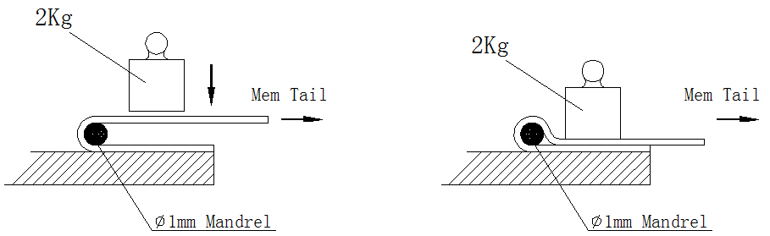 | The resistance shall be  within 150% of initial  value.  反折后电阻值量测不得大于初始值的150%.  Electrical characteristic  电气性能OK.
6 | Hardness Test  硬度测试 | 1. Coverage：Naked carbon  测试范围: 裸露的碳墨线  2. Taster: Pencil hardness tester  测试器 : 铅笔硬度测试仪  3. Test method: Put 2H pencil on the pencil hardness tester, 1Kg load, row 5 for 3 to 5mm line, then erase pencil brush with eraser.  测试方式: 在铅笔硬度测试仪上放置2H铅笔，施加1Kg的负荷，画5条3-5mm的线，再用橡皮擦将铅笔灰擦去.  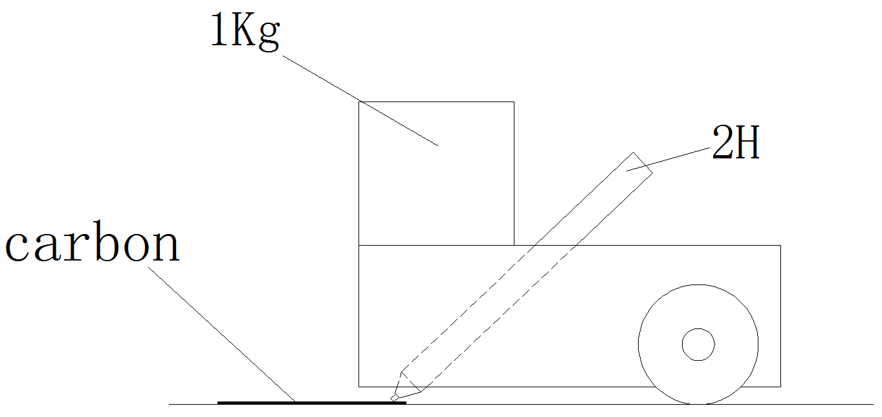 | Test surface can not have a obvious scratch, carbon no cutting.  测试完后不可有明显划痕，无划破现象.
7 | Abrasion Resistance  耐摩擦测试 | 1. Coverage：Printing surface with over coated  测试范围: 有上保护层的印刷面  2. Tester：Eraser tester  测试工具: 耐磨试验机  3. Eraser：SANFORD75215 eraser  测试机:SANFORD75215橡皮擦  4. Load：4.9N【500gf】  荷重 : 4.9N【500gf】  5. Stroke：Surface of keycap or equivalent.  行程 : 键帽表面距离  - Speed：40-60 round trips/min  速度 : 40-60 来回/分  7. Number of test：1000 times  测试次数 : 1000 times  8. Condition：The test shall be performed after it  leaves it in normal temperature for 48 hours or  more after it printed.  测试进行条件：印刷完后必须在室温静置48小时之后，才可以进行测试. | Printings or markings  shall be legible.  测试完后字体要可以被清楚的分辨.  Printing must not be removed.  测试完后不可露底材.
8 | Alcohol  Resistance  耐酒精测试 | 1. Coverage：All painting surface  测试范围: 所有喷漆面  2. Tester：A 500g weight.  测试器: 使用500g的重量  3. Cloth：Cotton doth(gauze) Absorbent cotton or equivalent  布料: 用棉质或薄纱等相同布料  4. Alcohol：Ethanol for 95%  酒精: 95%的乙醇  5. Load：4.9N【500gf】  荷重 : 4.9N【500gf】  6. Stroke：Surface of keycap or equivalent.  行程 : 键帽表面距离  - Speed：40-60 round trips/min  速度 : 40-60 来回/分  8. Number of test：1000 times  测试次数 : 1000 times  9. Condition：The test shall be performed after it  leaves it in normal temperature for 48 hours or  more after it printed.  测试进行条件：印刷完后必须在室温静置48小时之后，才可以进行测试. | Printings or markings  shall be legible.  测试完后字体要可以被清楚的分辨.  Printing must not be removed.  测试完后不可露底材.
9 | RCA Abrasion  纸带耐磨测试 | 1. Coverage：All painting surface  测试范围: 所有喷漆面  2. Taster: RCA tape tester  测试器 : RCA 纸带测试仪  3. Number of test：200 times  测试次数 : 200 times  4. Test method: Sample fixed on the tester, 175g load, drive the tape rubbing on the sample.  测试方式: 将样品固定在测试仪上，施加175g的负荷，带动纸带在样品表面摩擦. | Printings or markings  shall be legible.  测试完后字体要可以被清楚的分辨.  Printing must not be removed.  测试完后不可露底材.
10 | Oil Resistance  耐油污测试 | 1. Coverage：All printing surface  测试范围: 所有喷漆面  2. Hand cream：Vaseline  护手霜: 凡士林  3. Test method：Spread hand cream on a test  piece and leave it in the temperature & humidity  chamber for 12 hours. Then return it to room  temperature and rub out printing with a cloth  (cotton cloth gauze or absorbent cotton)  测试方式: 在特定的温度、湿度条件下,将护手霜涂抹在测试样品上静置12小时,然后将物品移置室温下,用绵布将护手霜擦拭掉  - Test Condition：65℃±5℃, 90-95%  测试条件: 65℃±5℃, 90-95% | No softened printing shall be observed on the surface.  产品表面无脱色、软化等现象.
11 | Test antibolle d'acqua  防泡水测试 | The testing conditions are as following:  测试条件如下：  Put the conductive film into a container with a normal temperature of 10mm, PIN the head out of the water, and the rest parts are completely immersed in the water. After soaking for30 minutes, take out the conductive film and place it on the table, let it stand for two hours and dry naturally, then test the function  导电膜放入正常温度10mm水深容器中，PIN头探出水面，其余部分完全浸泡在水里，浸泡30 minutes后将导电膜取出放在台面，静置两小时自然干后测试功能  Check the function of membrane.  检查导电膜功能. | Mechanical and Electrical  characteristic.  机械及电气性能OK.
12 | Drop test  跌落测试 | - Height to drop：76 cm  跌落高度：76 cm  - Direction for test ：2 sides  跌落位置：正反两面  - Number of tests：1 times each  跌落次数：每面各一次 | Mechanical and Electrical  characteristic.  机械及电气性能OK.

10. Precaution for Handling预防操作
Connection to the connector. 与连接器连接

1. Recommended connector is “ ZERO FORCE TYPE ”. 推荐使用无插拔连接器

Please be sure to avoid the connectors that scratch on the surface of flexible pattern. 避免连接器刮伤碳墨表面
- Excess force to the flexible pattern shall be prohibited at the time of insertion.
插拔时不可使用过度的力
- Allocation of connector is recommended to be as close to the edge as possible. If impossible, lease be sure to keep it apart from hot components.

建议连接器尽可能靠近边缘放置，并尽量使其远离热的组件
- Please consider the allocation of connector not to be as below. If unavoidable, please be sure to keep R3 Min.
连接器尽量不要按以下方式布置，如果实在无法避免，请保持最小R3

