Contact information

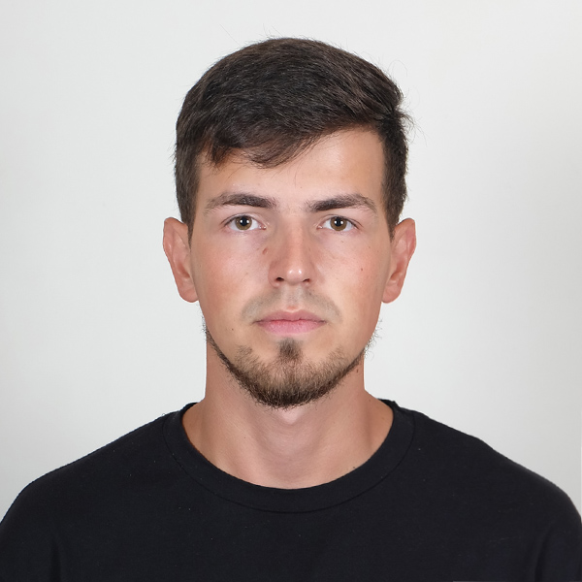

|  |  |  |  |  |
| --- | --- | --- | --- | --- |
| Phone: 093-893-8685  Email: romantuk@ukr.net  Skype: elrecktrorom | | | Roman Bilovus | |
|  | |  | | |
|  | | | | |
| Summary of Qualifications | High efficiency, persistence in achieving the goal, honesty, responsibility, communicability, creative thinking, striving for learning, the desire to personal and professional growth, the ability to self-education, rapid adaptation to new conditions. | | | |
|  | | | | |
| Skills | * Understanding CSS and HTML * Understanding the basics of HTTP * Understanding Client-Server Communication and Web Development * Practical skills and knowledge of JavaScript | | | * Team player * Responsible * [Leadership](https://www.thebalancecareers.com/leadership-skills-list-2063757) * Attention to detail * [Problem Solving Abilities](https://www.thebalancecareers.com/problem-solving-skills-with-examples-2063764) |
|  |  | | | |
| Experience / IT related educational practice | **Dedicated Dispatch Services**  Dispatcher **January 19 – November 19**  Booking loads for assigned drivers, instructing drivers with the load info, filling out the agreements between brokers and carriers, accepting load tenders, collecting proof of deliveries from drivers and uploading all paperwork, load searching, conducting calls with brokers | | | |
|  |  | | | |
|  | University related subjects. Soft Serve IT-Academy. Private lessons. Self-studying. Pet projects | | | |
|  |  | | | |
|  |  | | | |
| Languages | Ukrainian - native language | | | |
| Russian - fluent | | | |
| English - Intermediate(B1-B2) | | | |
|  |  | | | |
| Education | **L’viv Polytechnic National University** Electric machines and apparatus  Specialist's diploma. Professional qualification "Engineer - electrician"  **01.09.2010 — 31.12.2015** | | | |
|  | | | |
|

|  |  |  |
| --- | --- | --- |
| Additional education (courses, trainings) | HTML5/CSS3/JavaScript Fundamentals – SoftServe | IT-Academy  English courses, Private programming lessons | |
|  | | |
| Hobbies | Car Restoration, Crafts, Fishing, Skiing, Growing exotic plants |