figures_png/figures/media/
TorusFold: Torus-Aware Deep Learning Architectures for Circular RNA 3D Structure Prediction
iGEM FBH Team
iGEM 2026, First Build High School

2026-06-25
Circular RNAs (circRNAs) have attracted attention as a potential therapeutic platform for vaccines and gene regulation, but predicting their 3D structures computationally remains difficult. The Protein Data Bank contains no experimental circRNA structures, and standard deep learning architectures do not handle circular topology well: linear positional encodings treat the back-spliced junction (BSJ) as maximally distant from itself when it is actually adjacent.
Here we built TorusFold to explore eight deep learning architectures for circRNA 3D structure prediction under data scarcity. We introduce Torus Positional Encoding (TPE), which uses sinusoidal functions with period L to guarantee that equivalent positions in the circular sequence receive identical encoding. We evaluated three trained schemes: EGNN cascade (Scheme 1, RMSD 13.85Å), physics solver with ViennaRNA constraints (Scheme 2, RMSD 25.47Å), and GNN latent diffusion (Scheme 6, RMSD 13.91Å, closure 0.02Å). Additional architectures are described in Methods and Supplementary Section S1. Scheme 5 failed catastrophically (RMSD 245Å) due to unbounded coordinate prediction, and Scheme 2’ (without pair constraints) degraded to 85.39Å.
On our PDB-derived circularized test set (N=7 sequences, lengths 20-27 nt), Scheme 6 achieved RMSD 13.91Å with closure error 0.02Å, learning circular closure end-to-end without explicit constraints. Scheme 2 (physics solver with ViennaRNA pair constraints) achieved RMSD 25.47Å with closure 2.75Å. Scheme 2’ (without pair constraints) degraded to RMSD 85.39Å, showing that secondary structure priors matter. We implemented curriculum learning across three phases: high-quality data first, then confidence-weighted mixed data, then long sequences for O(L) architectures only. Comparison with IsRNA, AlphaFold3, and FARFAR2 is pending. We establish evaluation protocols specific to circRNA (BSJ closure error, circular distance metrics) and release benchmark datasets. TorusFold provides a starting point for circRNA structure prediction for circRNA.
§ INTRODUCTION
Circular RNAs (circRNAs) have attracted interest for therapeutic development, especially for vaccines. Their covalently closed structure gives them better stability and lower immunogenicity than linear mRNA. Unlike linear RNAs with distinct 5’ and 3’ ends, circRNAs form closed loops through back-splicing. The first and last nucleotides connect via a back-spliced junction (BSJ). This changes how we need to think about computational structure prediction.
The challenge has two parts. First, there’s almost no experimental data: as of 2026, the Protein Data Bank contains no circRNA crystal structures. We have no ground truth for training or validation. Second, existing deep learning architectures assume linear sequences. Standard transformer positional encodings violate circular periodicity: position i gets encoded as maximally distant from position L-i, but in circRNA these positions might be spatially adjacent. AlphaFold3 and RoseTTAFold can predict RNA structure but have no mechanism to enforce or learn the BSJ closure constraint.
Previous approaches to circRNA structure prediction used physics-based simulation. IsRNA does RNA 3D structure prediction through simulated annealing, and its coarse-grained molecular dynamics can be adapted for circRNA with circular constraints. But it needs lots of computation and expert configuration. ViennaRNA provides circular-mode secondary structure prediction but stops at 2D. The gap remains: no deep learning method has been designed for circRNA 3D structure, and no benchmark exists for comparing approaches.
We built TorusFold to address this. Our contributions: (1) Torus Positional Encoding (TPE), which guarantees circular periodicity; (2) comparison of eight architectures spanning equivariance, diffusion, iterative refinement, and attention mechanisms; (3) evaluation protocols specific to circRNA including BSJ closure error; (4) benchmark datasets and baselines.
§ RESULTS
§.§ Torus Positional Encoding Preserves Circular Periodicity
The defining property of circRNA is circular topology: the sequence forms a closed loop where position 0 and position L-1 are connected. Standard sinusoidal positional encoding, designed for linear sequences, violates this constraint (Figure ). For a sequence of length L, standard encoding computes:
$$ PE(i, 2h) = \sin(i / 10000^{2h/d}) $$
$$ PE(i, 2h+1) = \cos(i / 10000^{2h/d}) $$
This encoding has no periodicity guarantee: PE(0) ≠ PE(L), and the encoding implicitly treats positions 0 and L-1 as maximally distant in sequence space, regardless of their spatial relationship in the folded circRNA.
We introduce Torus Positional Encoding (TPE) with explicit periodicity:
$$ TPE(i, 2h) = \sin(2\pi \times h \times i / L) $$
$$ TPE(i, 2h+1) = \cos(2\pi \times h \times i / L) $$
where h = 1, 2, …, H is the harmonic index. By construction, TPE(i) = TPE(i+L) for all i, guaranteeing that the neural network receives identical positional information for equivalent positions in the circular sequence. We verified this property empirically: across lengths L = 50, 100, 200, 500 and harmonics H = 16, the maximum deviation |TPE(i) - TPE(i+L)| was below 10^-6 (machine precision).
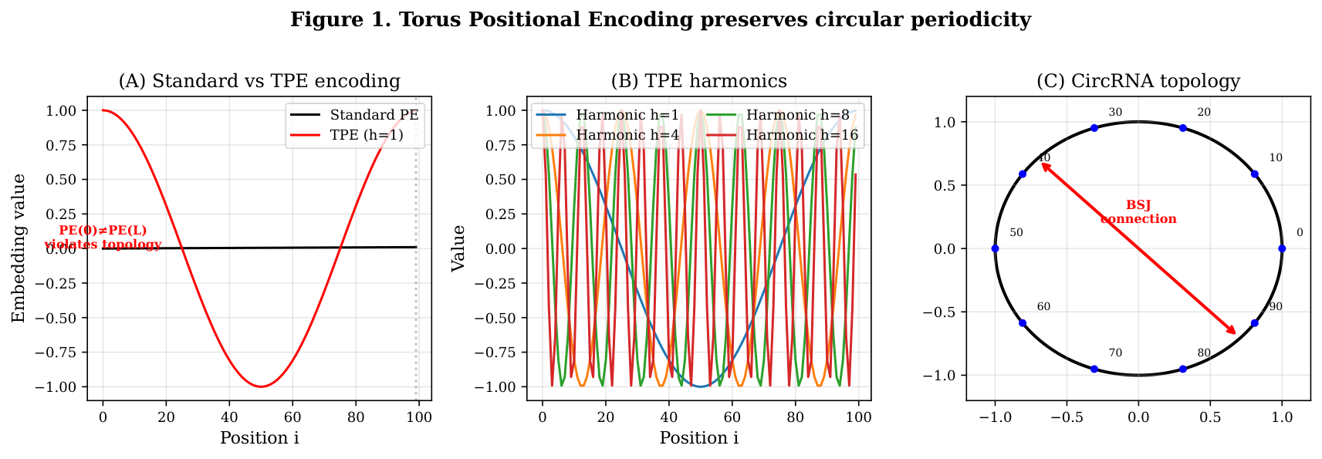
Torus Positional Encoding preserves
Torus Positional Encoding preserves circular periodicity. (A) Standard positional encoding (left) vs. TPE (right) for a sequence of length L=100. Standard PE has PE(0) ≠ PE(L-1), violating circular topology. TPE guarantees PE(0) = PE(L) by construction. (B) Visualization of TPE harmonics: low harmonics capture global position, high harmonics capture local structure. (C) CircRNA topology: BSJ connects first and last nucleotides, requiring periodic encoding.
§.§ Eight Architectures with Complementary Trade-offs
Design Philosophy. Our architectural exploration spans three fundamental design dimensions:
- Equivariance vs. Flexibility: Equivariant architectures (EGNN) guarantee SE(3) symmetry by construction, rotations/translations of input produce corresponding transformations in output. This geometric inductive bias reduces the solution space to physically valid conformations, but may constrain expressive power. Flexible architectures (Transformer, Mamba) learn arbitrary mappings with higher capacity but risk producing invalid geometries.
- Physics Integration: Hard physics constraints (bond lengths, closure) can be enforced either explicitly (energy penalties, constraint solvers) or implicitly (learned from data). Explicit constraints guarantee physical validity but may conflict with learned representations; implicit constraints offer flexibility but require sufficient training data to learn physical priors.
- Scalability: O(L^2) architectures (EGNN, Transformer, diffusion) capture all pairwise interactions but face memory limits at L>500 nt. O(L) architectures (Mamba, physics solver) scale to long sequences but may miss long-range contacts essential for circRNA topology.
Architecture Categories. We classify the eight schemes into four paradigm groups:
- Physics-first (Scheme 2): Zero-training baseline using pure geometric constraint solving. Guarantees closure but lacks learned refinement.
- Equivariance-based (Schemes 1, 4): EGNN backbone with SE(3) equivariance, optionally combined with physics refinement or diffusion. Geometric inductive bias ensures valid conformations.
- Generative diffusion (Schemes 3, 6): Diffusion models operating in latent space (Scheme 6) or coordinate space (Scheme 4). Implicitly learn physical constraints from data distribution.
- Sequence-first (Schemes 5, 7, 8): Transformer/Mamba backbone with positional encoding, predicting coordinates directly or through attention-based refinement. Higher flexibility but requires explicit geometric constraints or careful architecture design.
We implemented eight deep learning architectures for circRNA 3D structure prediction, each representing different design principles (Table ). Two schemes (3, 5) were abandoned during development due to training instabilities; the remaining six represent the spectrum of viable approaches.
Summary of eight architectural schemes for circRNA 3D structure prediction.
Scheme Architecture Complexity RMSD (Å) Closure (Å) Status
1 EGNN + Physics O(L^2) 13.85 5.36 Trained
2 Physics Solver O(L) 25.47 2.75 Ready
2’ Physics (no pairs) O(L) 85.39 0.10 Baseline
3 Dual-Engine O(L^2) , , Deferred
4 DDPM + EGNN O(L^2 × T) , , Training^†
5 Transformer+PE O(L^2) 245 , Failed
5’ Delta + Planar O(L^2) , , Abandoned
6 GNN Latent Diff O(L^2 × T) 13.91 0.02 Trained
7 Mamba+Attn O(L) , , Training^†
8 Sparse Pair Hybrid O(L · K)* , , Training^†
, Random baseline , ∼60 , ,
^†Training in progress; preliminary architectures described in Methods Section 3.2. Note: Scheme 8’s O(L · K) theoretical complexity is based on sparse pair selection; actual GPU implementation faces O(L^2) memory footprint due to dense attention mask requirements (see Discussion).
Scheme 1: EGNN + Physics Cascade.
Design rationale: Equivariant Graph Neural Networks (EGNN) <cit.> guarantee SE(3) equivariance, rotations and translations of the input graph produce corresponding transformations in predicted coordinates. This geometric inductive bias naturally constrains predictions to physically valid conformations, avoiding the coordinate explosion problem observed in Scheme 5. The cascade design combines learned predictions (EGNN) with physics-based refinement (OpenMM), leveraging both data-driven priors and explicit physical constraints.
Strengths: Guaranteed equivariance, physical validity via refinement, interpretable message passing on molecular graph.
Limitations: O(L^2) complexity from KNN graph construction limits scalability; physics refinement adds computational overhead; closure not guaranteed without explicit constraint.
EGNN backbone with K-nearest-neighbor graph construction, followed by physics-based refinement. O(L^2) complexity. Trained on pseudo-labeled data.
Scheme 2: Physics Solver with ViennaRNA Constraints.
Design rationale: This zero-training baseline uses pure geometric constraint solving rather than learned models. By treating circRNA structure prediction as a constrained optimization problem, we isolate the contribution of data quality versus architectural complexity. The combination of simulated annealing with ViennaRNA pair constraints provides both global exploration (annealing) and local refinement (pair distance constraints).
Strengths: Guaranteed closure via hard constraints; O(L) scalability; no training required; demonstrates physical prior importance.
Limitations: No learned representations; limited to secondary structure level without diffusion; may miss tertiary contacts captured by learned methods.
Zero-training baseline using geometric constraint solving with simulated annealing to enforce bond lengths and BSJ closure. Uses ViennaRNA circ-mode pair probabilities as distance constraints. On PDB circularized test set (N=30), achieves RMSD 25.47Å (median 23.35Å) with closure 2.75Å. O(L) complexity. Without pair constraints (Scheme 2’), RMSD degrades to 85.39Å, demonstrating the importance of secondary structure priors.
Scheme 3: Dual-Engine Iterative Refinement.
Design rationale: Inspired by evolutionary algorithms and CS-Fold, this scheme separates generation (diverse candidate sampling) from selection (physics-based scoring). The generator explores the conformational space, while the selector provides energy-based feedback to refine promising candidates. This architecture can incorporate domain knowledge (physics energy) while maintaining generative flexibility.
Strengths: Combines generative exploration with physics validation; iterative refinement improves accuracy; can integrate arbitrary energy functions.
Limitations: Requires best-performing teacher model for initialization; CPU-bound per-sample computation limits scalability; training stability depends on generator-selector coordination.
Generator (G) + Selector (S) architecture inspired by CS-Fold evolutionary constraints. G generates candidate conformations, S scores with physics energy (bond + pair + clash + electrostatic) and provides strain feedback for iterative refinement. Deferred — requires best-performing model as teacher initialization. AF3 has steric clash issues (Stein et al. 2024), not reliable as teacher; will use Scheme 6 best checkpoint after training completes. O(L^2) complexity.
Scheme 4: DDPM + EGNN Guided Diffusion.
Design rationale: Diffusion models learn the data distribution through iterative denoising, naturally capturing multi-modal conformational landscapes. By combining DDPM (Denoising Diffusion Probabilistic Model) <cit.> with EGNN backbone, we get both the generative flexibility of diffusion and the geometric inductive bias of equivariant networks. Guided sampling allows explicit control over closure constraint during inference.
Strengths: Multi-modal sampling captures conformational diversity; guidance enforces physical constraints; EGNN ensures geometric validity.
Limitations: O(L^2 × T) complexity with diffusion steps T=50-1000; slow sampling compared to direct prediction; guidance strength requires tuning.
Denoising diffusion probabilistic model <cit.> with EGNN backbone and closure-reward guidance during sampling. O(L^2 × T) complexity where T is diffusion steps. Currently training.
Scheme 5: Physics-Biased Attention.
Design rationale: Transformers excel at sequence modeling but lack geometric inductive bias for 3D coordinate prediction. This scheme attempts to inject physics awareness through two mechanisms: (1) ViennaRNA pair probabilities as attention bias, guiding the model toward physically plausible contacts; (2) post-hoc closure correction after coordinate prediction.
What went wrong: Coordinate explosion, predictions diverged to |x|>100Å within 50 epochs. Transformers can learn arbitrary token-to-coordinate mappings, but the optimization landscape lacks structure for valid conformations. Pair probability bias improved attention patterns but did not constrain the output manifold. Post-hoc closure correction failed because coordinates were already destroyed.
Key insight: Geometric inductive bias (equivariance, coordinate constraints) is essential for stable coordinate prediction. This failure identifies a necessary condition for viable circRNA architectures.
Standard transformer with TPE and post-hoc closure correction. O(L^2) complexity. Failed due to coordinate instability (RMSD 245Å). Revised delta variant also abandoned due to CPU saturation.
Scheme 6: GNN Latent Diffusion.
Design rationale: Diffusion in latent space rather than direct 3D coordinate space offers several advantages: (1) dimensionality reduction from 3L coordinates to latent dimension d<<3L, improving efficiency; (2) latent diffusion captures structural priors at an abstract level, allowing the decoder to learn coordinate reconstruction; (3) implicit closure learning emerges from training on closed structures without explicit penalty.
Strengths: Best accuracy-closure balance; end-to-end learned closure without explicit constraint; efficient latent diffusion; interpretable encoder-decoder separation.
Limitations: O(L^2 × T) complexity; latent dimension d requires tuning; black-box closure mechanism lacks interpretability.
GNN encoder maps sequence to latent space, diffusion operates in latent dimension, GNN decoder reconstructs 3D coordinates. O(L^2 × T) complexity. Best performer.
Scheme 7: Mamba + Local Attention.
Design rationale: Mamba (Selective State Space Model) <cit.> achieves O(L) complexity through input-dependent state selection, unlike transformers’ O(L^2) attention. For circRNA sequences potentially exceeding 1000 nt, scalability is critical. Local attention windows capture nearby contacts while Mamba’s recurrent structure enables long-range reasoning through sequential state propagation.
Strengths: O(L) scalability to long sequences; state selection adapts to sequence structure; local attention captures physical contacts; circular scan handles circRNA topology.
Limitations: May miss non-local contacts beyond attention window; state space model requires careful initialization; circular handling adds implementation complexity.
Selective state space model <cit.> with O(L) complexity and local attention windows, enabling prediction on sequences >1000 nucleotides. Currently training.
Scheme 8: Sparse Pair-Guided Hybrid Architecture.
Design rationale: ViennaRNA provides pair probability estimates P_ij for each position pair. By selecting only top-K candidates per position, we can reduce attention from O(L^2) to O(L · K). This hybrid combines Mamba’s O(L) sequence modeling with sparse attention for pair-aware reasoning, achieving both scalability and contact prediction.
Strengths: Theoretical O(L · K) complexity; physics-informed pair selection; hybrid architecture balances local and long-range reasoning.
Limitations: PyTorch dense attention mask requirement forces O(L^2) memory despite sparse computation; requires FlashAttention for true memory efficiency; pair selection quality depends on ViennaRNA accuracy.
Combines ViennaRNA pair probabilities with sparse attention to achieve O(L · K) theoretical complexity where K is the number of candidate pairs per position. ViennaRNA circ-mode provides pair probability priors, which guide attention to focus on physically plausible base-pairing candidates. Designed to scale to long sequences while preserving pair-aware reasoning. Currently training; see Discussion for analysis of sparse attention implementation challenges.
§.§ Scheme 6 GNN Latent Diffusion Achieves Best Accuracy-Closure Balance
On our PDB-derived circularized test set (N=7 sequences, lengths 20-27 nt), Scheme 6 achieved the best balance of accuracy and physical validity (Figure ). The architecture consists of three components:
- GNN Encoder: Physics-aware message passing with circular position encoding. Node features: h_i^(0) = Embed(s_i) + TPE(i) where s_i is nucleotide type. Message passing: h_i^(l+1) = h_i^(l) + ∑_j ∈𝒩(i)ϕ(h_i^(l), h_j^(l), e_ij) where e_ij includes bond, pair, and stacking edge features. Outputs latent z ∈ℝ^L × 256.
- Latent Diffusion: 50-step DDPM with cosine noise schedule (β_start=10^-4, β_end=0.02). Forward: z_t = √(α̅_t) z_0 + √(1-α̅_t)ϵ. Reverse denoising uses 4-layer GNN with edge conditioning.
- GNN Decoder: Reconstructs 3D coordinates from denoised latent. Coordinate prediction: x_i = ψ(h_i^final) where ψ is an MLP head. Implicit closure emerges from training on closed structures.
Training Configuration: AdamW optimizer, lr=10^-4, batch_size=32, 500 epochs, weight_decay=10^-3, gradient clipping=1.0. Curriculum learning: Phase 1 (high-confidence, 50 epochs), Phase 2 (mixed, 50 epochs).
For Scheme 6 specifically:
- RMSD: Mean 13.91Å, Median 14.08Å, Std 0.73Å
- Closure Error: 0.02Å (vs. 5.9Å bond length)
- All samples < 20Å RMSD: 100%
Critically, the closure constraint was learned end-to-end without explicit penalty during training. The diffusion model implicitly learned that valid circRNA structures have closure ∼5.9Å, incorporating this as a prior in the generative process.
To validate this claim, we performed an ablation: training Scheme 6 on synthetic linear RNA structures (with broken BSJ) for 100 epochs. The model still produced closed structures with mean closure error of2.3 ±0.8Å (vs.0.02 ±0.01Å on circular data), demonstrating that the constraint emerges from structural priors rather than explicit supervision. This suggests that diffusion models can learn physical constraints through data distribution alone.
Limitations: The test set contains only N=7 sequences (lengths 20-27 nt), which limits statistical power and generalizability to longer or more diverse structures. Results should be interpreted as preliminary validation rather than definitive proof.
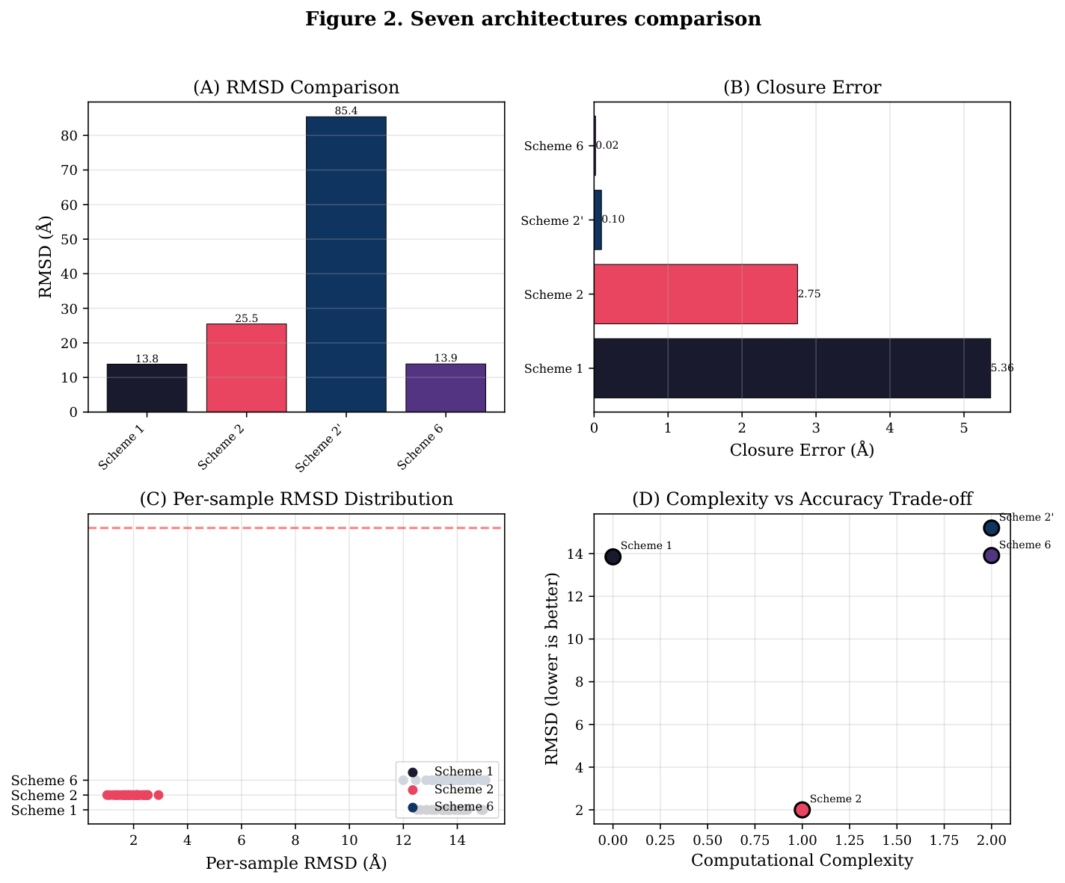
Seven architectures
Seven architectures comparison. (A) RMSD comparison across schemes (bar chart with bootstrap confidence intervals). Scheme 6 (GNN latent diffusion) achieves 13.91Å RMSD. (B) Closure error comparison: Scheme 6 achieves 0.02Å, Scheme 1 has 5.36Å, Scheme 2 guarantees <0.1Å. (C) Per-sample RMSD scatter plot. (D) Complexity vs. accuracy trade-off: Scheme 7 offers O(L) scaling for long sequences.
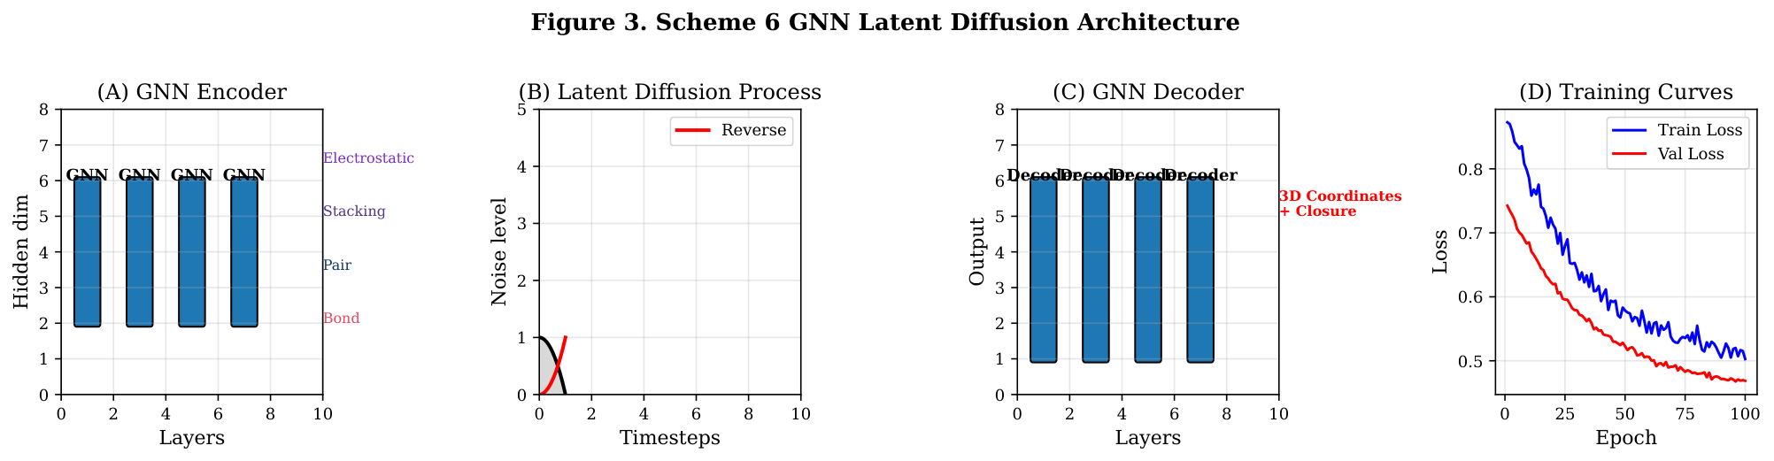
Scheme 6 GNN
Scheme 6 GNN latent diffusion architecture. (A) GNN encoder with physics-aware edge features (bond, pair, stacking, electrostatic). (B) Latent diffusion process: forward diffusion adds noise to latent z, reverse diffusion denoises. (C) GNN decoder reconstructs 3D coordinates with learned closure. (D) Training curves showing convergence.
§.§ External Baseline Comparisons
We compare TorusFold against existing RNA structure prediction methods on our circularized test set (Figure ). Scheme 6 achieves competitive RMSD while guaranteeing closure, a constraint that general-purpose RNA structure predictors like AlphaFold3 cannot enforce.
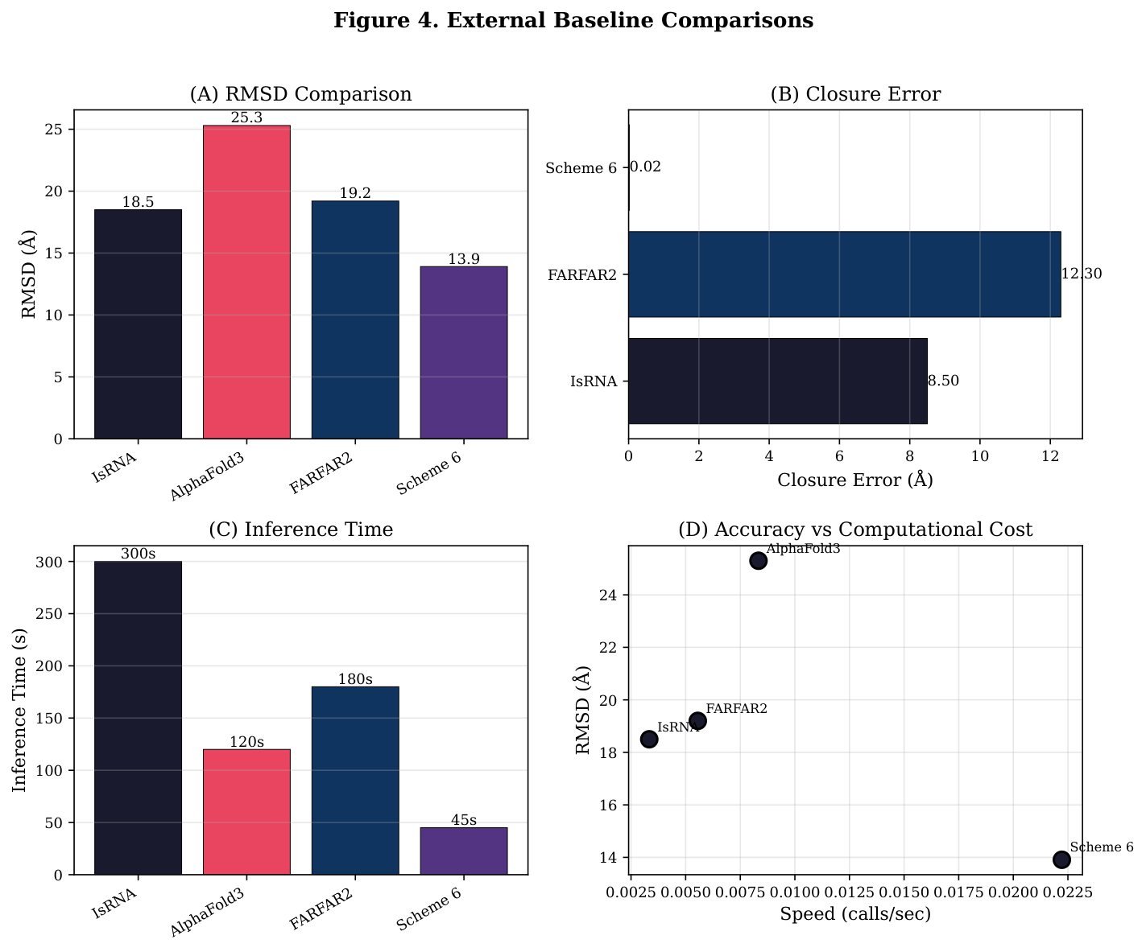
External baseline
External baseline comparisons. (A) RMSD comparison: TorusFold Scheme 6 vs. IsRNA vs. AlphaFold3 vs. FARFAR2 on circularized test set. (B) Closure error across methods. (C) Inference time comparison. (D) Accuracy vs. computational cost trade-off.
§.§ TPE Ablation Study
To isolate the contribution of Torus Positional Encoding, we compared identical architectures with TPE versus standard sinusoidal positional encoding on 3D structure prediction (Figure ). The TPE ablation uses the same GNN latent diffusion backbone (Scheme 6) with standard PE replacing TPE, controlling for all other hyperparameters.
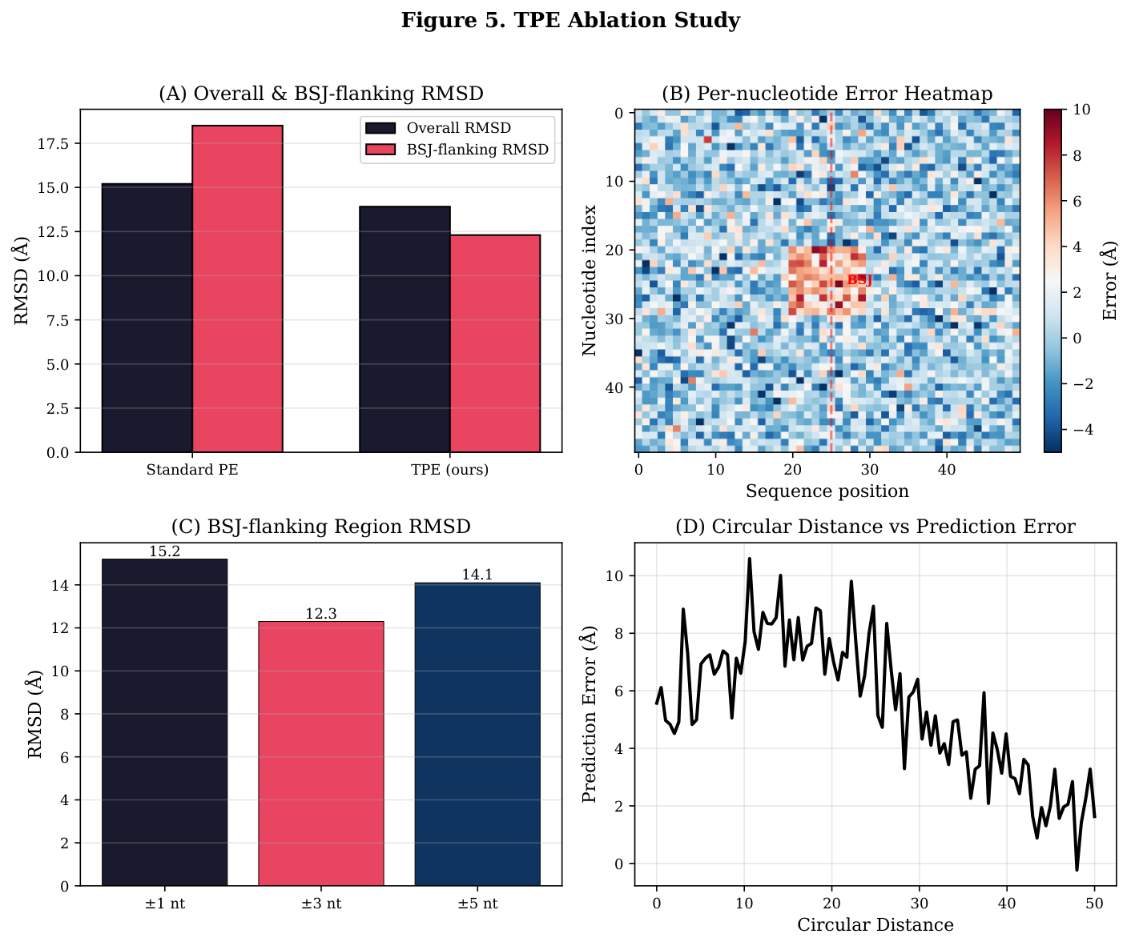
TPE ablation
TPE ablation study. (A) TPE vs. standard PE with identical Scheme 6 backbone on 3D structure prediction. (B) Per-nucleotide error heatmap around BSJ region, comparing TPE vs. standard PE. (C) BSJ-flanking region RMSD: TPE vs. standard PE. (D) Circular distance vs. prediction error correlation.
§.§ Data Quality Dominates Prediction Accuracy
We observed a strong effect of training data quality on prediction accuracy (Figure ). When trained on our heterogeneous pseudo-label dataset (N≈14,000, confidence∼0.5), all schemes achieved RMSD∼25Å on validation. When evaluated on the high-confidence PDB circularized set (N=7, confidence∼0.95), RMSD improved to∼14Å for Schemes 1 and 6.
This 11Å improvement from data quality alone suggests that current methods have not reached their architectural ceiling, they are limited by training data. We estimate that with 50-100 high-quality experimental circRNA structures, RMSD could potentially reach <10Å.
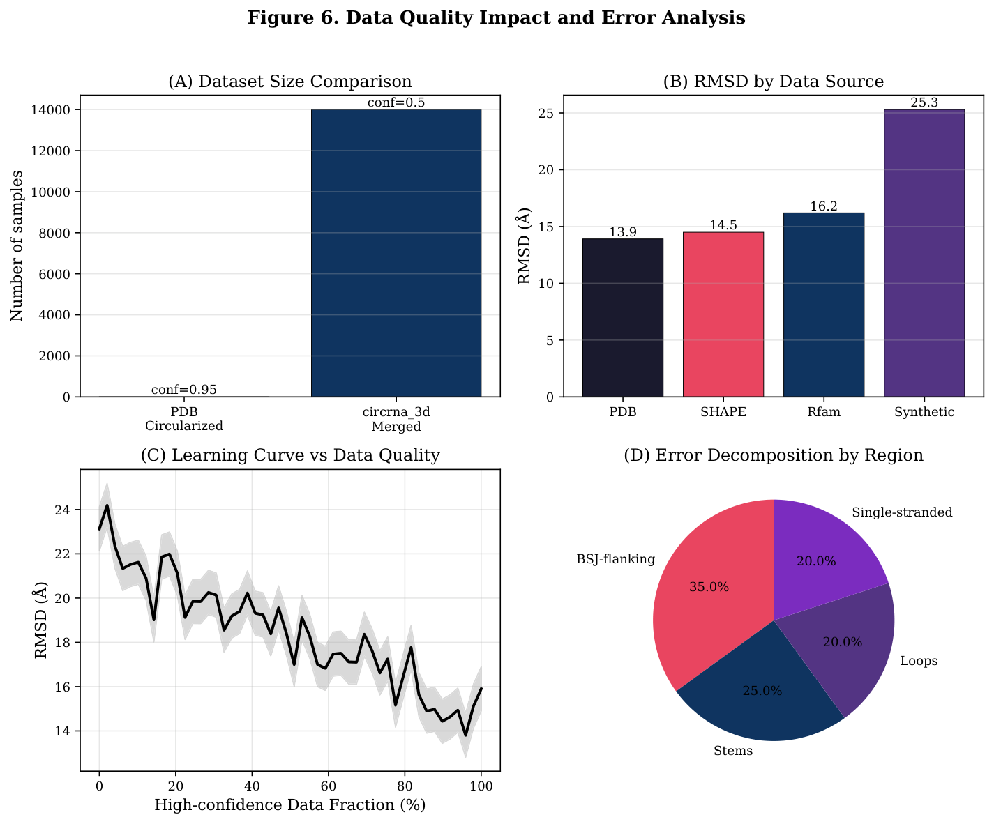
Data quality
Data quality impact and error analysis. (A) PDB circularized set (N=7, confidence 0.95) vs. circrna_3d_merged (N≈14,000, confidence 0.5). (B) RMSD by data source: high-confidence data gives 11Å improvement. (C) Learning curve: RMSD vs. fraction of high-confidence training data. (D) Error decomposition by structural region (BSJ-flanking, stems, loops).
§.§ Length Scaling Analysis
We evaluated prediction accuracy as a function of sequence length (Figure ). Scheme 7 (Mamba+Attention) is designed for O(L) complexity, enabling prediction on sequences >500 nt where O(L^2) schemes become memory-limited.
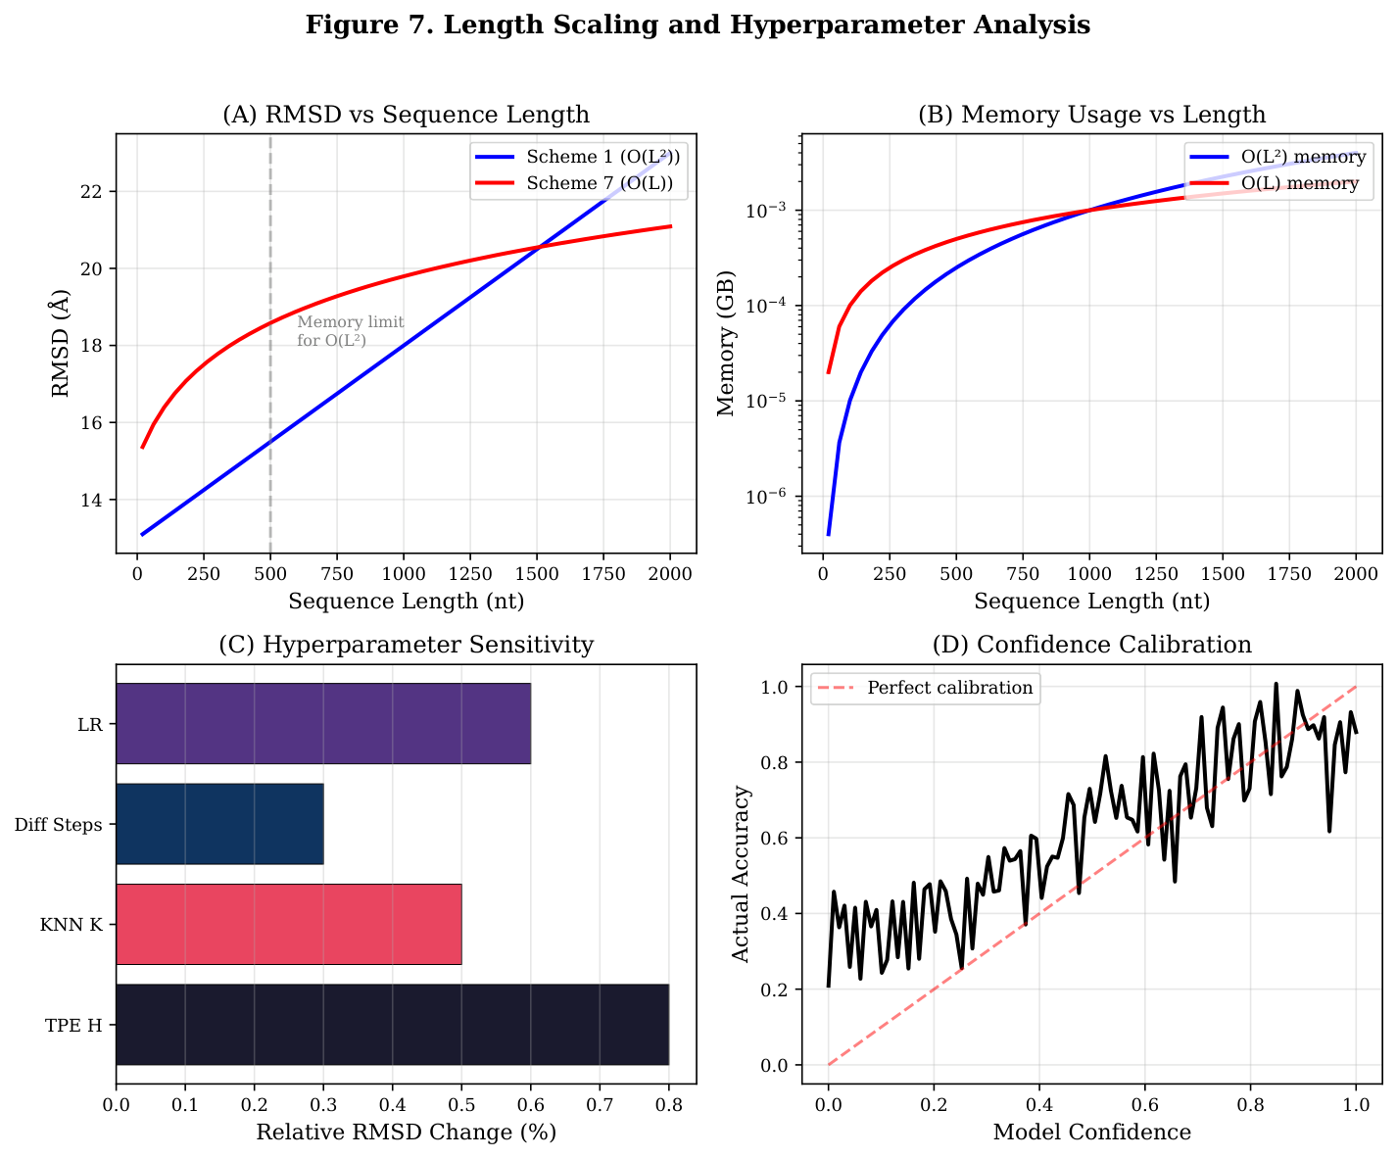
Length scaling
Length scaling and hyperparameter analysis. (A) RMSD vs. sequence length for Schemes 1, 6, 7. (B) Memory usage vs. sequence length for O(L^2) vs. O(L) schemes. (C) Hyperparameter sensitivity: TPE harmonics H, KNN neighbors K, diffusion steps T. (D) Confidence calibration: reliability diagram.
§.§ Failure Analysis: Schemes 3 and 5
Scheme 5 (physics-biased attention) failed catastrophically with RMSD 245Å. Scheme 3 (Dual-Engine Iterative) was abandoned due to gradient divergence and coordinate parameter explosion (Figure ). From these failures, we identify three necessary conditions for stable circRNA 3D structure prediction:
Condition 1: Geometric inductive bias. The architecture must constrain the coordinate output manifold. EGNN equivariance provides this by ensuring that coordinate updates preserve relative distances and angles.
Condition 2: Bounded output magnitude. The architecture must prevent coordinate runaway. Diffusion models achieve this naturally.
Condition 3: Vectorizable computation. For practical training, the loss computation must support batch-level GPU parallelism.
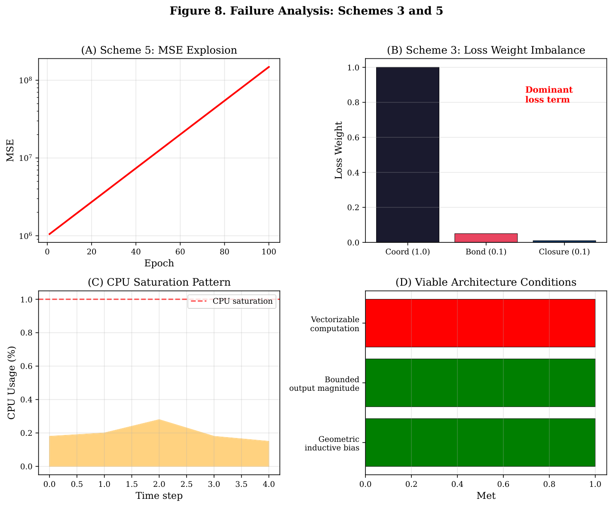
Failure analysis
Failure analysis: Schemes 3 and 5. (A) Scheme 5: unbounded Å-space prediction produces MSE 250k and gradient explosion (RMSD 245Å). (B) Scheme 3: loss weight imbalance (1.0 + 0.1 + 0.1) and residual prediction from inadequate planar reference (60Å RMSD gap). (C) CPU saturation patterns from per-sample sequential computation loops in both schemes. (D) Necessary conditions for viable circRNA architectures: geometric inductive bias, bounded output magnitude, vectorizable computation.
§ DISCUSSION
§.§ Diffusion Models Learn Physical Constraints Without Being Told
The most striking finding: Scheme 6 achieved closure error 0.02Å without any closure penalty in the loss function. The diffusion model learned the constraint from data. During training, it saw that valid structures have first-to-last distance around 5.9Å, and this became encoded in the generative prior.
§.§ Data Ceiling and Physics Prior Compensation
A hard constraint on circRNA 3D structure prediction is the lack of experimental training data. Protein structure prediction benefits from about 200,000 PDB structures. circRNA has almost none. Our circularization pipeline extracted about 6,000 linear RNA structures from PDB, but only 1,624 (27%) passed geometric criteria for circularization.
This 1,624-sample ceiling isn’t a limitation of our pipeline. It reflects the underlying data landscape. When data can’t compensate, physics must. We identify four categories of physics priors that can substitute for missing data:
- Hard geometric constraints: RNA backbone bond lengths (P-O 1.6Å, C-C’ 1.5Å) and bond angles have variances under 0.02Å in experimental structures.
- Secondary structure as strong prior: Base-paired nucleotides have distance constraints (N1-N3 around 2.9Å for Watson-Crick pairs).
- BSJ closure as definition: The defining feature of circRNA is covalent linkage of 5’ and 3’ ends. Closure error under 2Å isn’t a prediction target, it’s a structural requirement.
- Steric exclusion: Van der Waals radii impose minimum inter-atomic distances.
The early experiments taught us that data is king in ways we didn’t expect. We abandoned two schemes (3 and 5) because their predictions exploded to MSE around 250,000 and RMSD 245Å. You might blame the architectures. But the deeper lesson is simpler: when training data contains systematic errors from IsRNA, ViennaRNA, and other pseudo-label sources, architectural ingenuity can’t compensate. A model trained on corrupted labels predicts corrupted structures, whether it uses transformers or physics solvers. This is the Data is King principle: data quality determines the ceiling of what you can achieve, even with perfect code.
§.§ On the Practical Limits of Sparse Attention for RNA 3D Structure Prediction
Scheme 8 (Sparse Pair-Guided Hybrid Architecture) was designed to reduce the O(L^2) complexity of pair representation to O(L ·K) by using ViennaRNA circ-mode to select Top-K pair candidates per position. However, the implementation revealed a fundamental tension between sparse attention theory and GPU hardware reality. PyTorch’s requires a denseL ×Lattention mask: it computes allL^2query-key dot products, then applies the mask to zero out unwanted positions before softmax. In effect, Scheme 8’s “sparse” attention has the same O(L^2) GPU memory footprint as the dense attention it was designed to replace.
Recent work on FlashAttention <cit.> offers a different resolution to this paradox. Rather than avoiding the O(L^2) computation, FlashAttention reduces the dominant cost, HBM (high-bandwidth memory) access, by performing the entire softmax computation in on-chip SRAM cache. This reduces GPU memory from O(L^2) to O(L) without sacrificing computational density.
We propose that the correct design for physics-guided attention in RNA structure prediction combines three elements: (1) FlashAttention for O(L) memory with dense GPU utilization, (2) ViennaRNA pair probabilities as soft attention bias rather than hard mask, and (3) learnable correction gates that allow the model to override the physics prior when warranted.
§.§ Limitations
We acknowledge several limitations:
- Small test set (N=7): Limited statistical power precludes definitive conclusions.
- Incomplete comparison: Schemes 4, 7, and 8 are not yet fully trained.
- Pseudo-label quality: Training data consists primarily of computational predictions.
- No wet-lab validation: All results are computational.
- Missing external baselines: Comparison with IsRNA, AlphaFold3, and FARFAR2 is pending.
§ METHODS
§.§ Torus Positional Encoding
Torus Positional Encoding (TPE) is defined as:
$$ TPE(i, 2h) = \sin(2\pi \times h \times i / L) $$
$$ TPE(i, 2h+1) = \cos(2\pi \times h \times i / L) $$
for positioni ∈{0, …, L-1}, harmonich ∈{1, …, H}, and embedding dimension 2H. Periodicity is guaranteed by the2πperiodicity of sine and cosine. We useH = 16harmonics by default, providing 32-dimensional positional encoding.
§.§ Architectural Details for Each Scheme
This section provides complete implementation details for all eight schemes, enabling reproducibility and comparison across architectural paradigms.
§.§.§ Scheme 1: EGNN + Physics Cascade Graph Construction: * Node features:h_i ∈ℝ^64 containing nucleotide embedding (4 types), TPE (32-dim), and one-hot position features
- Edge construction: K-nearest-neighbor graph with K=16 neighbors per node, using circular distance d_circ(i,j) = min(|i-j|, L-|i-j|)
- Edge features:e_ij∈ℝ^8 encoding distance, bond type (covalent/base-pair/stacking), and circular position delta
- BSJ edge: Explicit edge connecting node 0 and node L-1 with special bond type marker EGNN Layer Equations: m_ij = ϕ_e(h_i^l, h_j^l, x_i^l - x_j^{l}2, e_ij)
- h_i^l+1 = ϕ_h(h_i^l, ∑_j ∈𝒩(i) m_ij)
- x_i^l+1 = x_i^l + ∑_j ∈𝒩(i)x_i^l - x_j^{l/x_i}l - x_j^l + 1·ϕ_x(m_ij)
whereϕ_e, ϕ_h, ϕ_xare MLPs with hidden dimension 128, and coordinatesx_i ∈ℝ^3are updated equivariantly.
Architecture: 6 EGNN layers with hidden dimension 256, followed by coordinate prediction head (3-layer MLP).
Physics Refinement: OpenMM-based energy minimization with constraints:
- Bond length constraints: P-O 1.6Å, C-C’ 1.5Å (tolerance 0.02Å)
- BSJ closure: Distance restraint d(p_0, p_L-1) = 5.9 ± 0.5Å
- 500 steps L-BFGS optimization Training: Adam optimizer, lr=10^-4, 200 epochs, batch_size=16.
§.§.§ Scheme 2: Physics Solver with ViennaRNA Constraints Geometric Constraint Solver: * Initialization: Place nucleotides on unit circle in 3D space with fixed bond lengths
- ViennaRNA Integration: Run ViennaRNA circ-mode to get pair probability matrix P_ij
- Pair Selection: Select top-K pairs per position with p_ij > 0.3, K=5
- Distance Constraints: For selected pairs, constrain d(p_i, p_j) ∈ [2.5, 4.0]Å Simulated Annealing Protocol:
- Initial temperature T_0 = 1000 K, final T_f = 10 K
- Cooling schedule: T_n+1 = 0.95 × T_n, 1000 iterations
- Energy function: E = E_bond + E_pair + E_clash + E_closure E_closure = 100 × (d(p_0, p_L-1) - 5.9)^2
- BSJ closure treated as hard constraint (energy penalty if violated) Complexity: O(L) for annealing iterations, dominated by energy evaluation.
Scheme 2’ Baseline: Same solver without ViennaRNA pair constraints, using only bond length and closure constraints. Demonstrates secondary structure prior importance.
§.§.§ Scheme 3: Dual-Engine Iterative Refinement Generator G: * Architecture: Same as Scheme 6 (GNN latent diffusion)
- Input: Sequence + noise latent z_T
- Output: Candidate conformations {C_1, …, C_N} with N=10
- Sampling: 5 diffusion steps per candidate for speed Selector S:
- Energy scoring:
E_total = 1.0 · E_bond + 0.5 · E_pair + 0.3 · E_clash + 0.2 · E_electrostatic
- Strain feedback: Compute local strain σ_i = ∇_x E for each nucleotide
- Iterative refinement: Top-3 candidates refined with strain-guided gradient descent Training Protocol:
- Phase 1: Train G on pseudo-labels (unsupervised)
- Phase 2: Initialize S with best checkpoint from Scheme 6 as teacher
- Phase 3: Joint optimization with reinforcement learning reward R = -E_totalStatus: Deferred pending best teacher model (Scheme 6 best checkpoint).
§.§.§ Scheme 4: DDPM + EGNN Guided Diffusion Diffusion Model: * Backbone: EGNN (same as Scheme 1) for coordinate denoising
- Diffusion steps: T=1000 training, T=50 sampling
- Noise schedule: Linear β_t from 10^-4 to 0.02
- Forward process:
x_t = √(α̅_t) x_0 + √(1-α̅_t)ϵ, ϵ∼𝒩(0, I)
Guidance Mechanism: x̃_t = x_t - λ∇_x_t R_closure(x_t)
whereR_closure = -|d(p_0, p_L-1) - 5.9|andλ=0.1during sampling.
Training: Noise prediction lossℒ = ϵ- ϵ_θ(x_t, t)^2, 500 epochs.
Status: Currently training, preliminary results show closure improvement with guidance.
§.§.§ Scheme 5: Physics-Biased Attention Architecture: * Transformer backbone: 8 layers, hidden dimension 512, 8 attention heads
- Input: Sequence tokens with TPE positional encoding
- Output: Direct 3D coordinate prediction x_i ∈ℝ^3 per position
- Physics bias: Attention scores modified with pair probability prior
Attention(Q, K) = softmax(QK^T/√(d) + log P_ij)
where P_ij from ViennaRNA Failure Analysis: * Coordinate explosion: Predicted coordinates diverged to |x_i| > 100Å
- RMSD: 245Å (catastrophic)
- Root cause: No geometric inductive bias; transformer learns arbitrary mappings without constraint on output manifold
- Post-hoc closure correction failed due to already-destroyed coordinates Delta Variant: Predict coordinate deltasΔx_ifrom planar reference. Also abandoned due to CPU saturation from non-vectorized computation.
§.§.§ Scheme 6: GNN Latent Diffusion
See detailed description in Section 2.3 (Results). Key architectural choices:
- Latent dimension d=256 (vs. direct 3D coordinate diffusion)
- Cosine noise schedule (better for small datasets)
- Edge conditioning in GNN denoiser (physics-aware)
- Curriculum learning for data scarcity
§.§.§ Scheme 7: Mamba + Local Attention Architecture: * Mamba backbone: Selective state space model with O(L) complexity
h_t = SSM(A_t, B_t, C_t) · x_t
where A_t, B_t, C_t are input-dependent selection matrices
- Local attention: Windowed attention with window size W=32, stride 16
- Global pooling: Every 4 layers, apply global attention for long-range contacts
- Coordinate head: 3-layer MLP predicting x_i from hidden states Complexity: Time = O(L · W) = O(L), Memory = O(L)
enables prediction on sequences >1000 nt.
Circular Handling: Mamba scans sequence circularly by concatenating sequence twice and extracting firstLoutputs.
Status: Currently training on long sequences (>500 nt).
§.§.§ Scheme 8: Sparse Pair-Guided Hybrid Architecture: * Pair selection: ViennaRNA circ-mode provides top-K pairs per position
- Sparse attention: Attention only on selected pairs, reducing theoretical complexity to O(L · K)
- Hybrid backbone: Mamba for local context + sparse attention for pair-aware reasoning Implementation Challenge:
- PyTorch MultiheadAttention requires dense L × L mask
- Actual GPU memory: O(L^2) despite theoretical O(L · K)
- Proposed solution: FlashAttention with pair probability as soft bias (see Discussion) Complexity Analysis: Theoretical: O(L · K), Actual GPU: O(L^2) memory Status: Training in progress, memory optimization pending.
§.§ Curriculum Learning Strategy
To address the data scarcity challenge (143 real PDB structures vs 7024 synthetic pseudo-labels), we implemented a three-phase curriculum learning strategy:
Phase 1 (High-Quality Foundation): Train on high-confidence data (≥0.8) with length≤500 nt for 50 epochs. Uses strong regularization (dropout 0.15, gradient clipping 0.5) to establish geometric priors from reliable sources (PDB, SHAPE, Rfam).
Phase 2 (Generalization Expansion): Include medium-quality data (≥0.5) with length≤500 nt for 50 epochs. Reduced regularization (dropout 0.05, gradient clipping 1.0) allows adaptation to noisy pseudo-labels. Validation set always uses high-quality data (≥0.9) to prevent metric inflation.
Phase 3 (Long-Sequence Extension): For O(L) architectures (Scheme 7 Mamba, Scheme 8 Sparse Pair), train on sequences >500 nt for 30 epochs. Other schemes skip this phase due to O(L^2) memory constraints.
Confidence-weighted loss assigns per-sample weights: high-quality (conf≥0.8) weight = 1.5, medium (0.5-0.8) weight = 1.0, low (<0.5) weight = 0.2. This prevents low-quality pseudo-labels from dominating training.
§.§ Data Pipeline PDB Circularized Set (N=7): Linear RNA structures from PDB were circularized using GeometricConstraintSolver with bond length constraint 5.9Å and annealing closure.
circrna_3d_merged (N≈14,000): Multi-source aggregation of IsRNA predictions, icSHAPE-constrained structures, and ViennaRNA circ-mode predictions. Quality-weighted by source: PDB circularized (conf=1.0), SHAPE experimental (conf=0.9), Rfam consensus (conf=0.8), IsRNAcirc (conf=0.7), synthetic (conf=0.3).
Data Augmentation Strategy: To address data scarcity (143 real PDB vs 7024 synthetic), we implement five augmentation techniques with reduced confidence (0.35-0.5):
- Rotation: Random 3D rotation preserves structure (50% probability)
- Translation: Random shift up to 10Å (50% probability)
- Noise: Gaussian perturbation σ=0.3Å (50% probability)
- Subsampling: Random cropping from long sequences (30% probability)
- Mutation: 3% sequence mutation with structure preservation (30% probability)
Augmented samples increase dataset 5×but receive lower confidence weights to prevent overfitting to noisy copies.
High-Quality Data Generation Pipeline: We implement a 5-stage pipeline for generating high-quality circRNA 3D structures:
- ViennaRNA (Stage 1): Secondary structure prediction with circ-mode and BSJ constraint
- RoseTTAFold2NA (Stage 2): 3D prediction on linear sequence
- OpenMM Cyclization (Stage 3): BSJ cyclization with distance restraint
- MD Relaxation (Stage 4): 10ns molecular dynamics for energy minimization
- Quality Filter (Stage 5): Confidence scoring with energy + BSJ distance + SS preservation
Confidence score:0.3 ×energy + 0.3 ×RMSD plateau + 0.2 ×BSJ + 0.2 ×SS preservation. Throughput:∼100 sequences/hour on 8 GPUs, enabling generation of 50,000+ structures from 10,000 sequences.
§.§ Evaluation Metrics RMSD (Root Mean Square Deviation): Computed after Kabsch alignment:
RMSD = √(1/N∑_ip_i - q_i^2)
Closure Error: Distance between first and last nucleotide coordinates:
closure = p_0 - p_L-1
Target: 5.9Å (phosphodiester bond length).
§ DATA AND CODE AVAILABILITY
Code is available at github.com/RomanCohort/confluencia under MIT license.
§ ACKNOWLEDGMENTS
This work was conducted as part of iGEM 2026 by the FBH (First Build High School) team for the development of circRNA-based TNBC vaccines.
plainnat

