Confluencia 3.0: Integrated circRNA Vaccine Design with TNBC Subtype Simulation
Author Names^{1,*}
¹Institution
*Corresponding author
Running Title: Confluencia circRNA-TNBC Platform
Keywords: circRNA, TNBC, simulation, immunogenicity, pharmacokinetics, deep learning, structure prediction, federated learning, data sharing

Abstract
Circular RNA (circRNA) has a closed loop where position $i$ and $i+L$ are the same location. Standard positional encodings treat them as different. Confluencia 3.0 is the first platform built for circRNA vaccine design that handles this $S^{1}$ topology. TorusFold uses Torus Positional Encoding (TPE) with guaranteed periodicity: $|TPE(i)−TPE(i+L)|<{10}^{−6}$. On 30 circRNA sequences, TPE embedding distances correlate with circular distance ($r=0.882$ [CI 0.75-0.95]) while standard PE correlates with linear distance ($r=0.933$ [CI 0.85-0.97]). Cross-BSJ positions are correctly identified as neighbors (TPE distance 4.50 vs standard PE 9.60). The platform integrates CirculaPK (six-compartment PK capturing 1-4% endosomal escape, 12% error [CI 3-21%] vs literature, $N=4$), pathway-resolved immunogenicity ($r=0.91$ [CI 0.55-0.99] with Chen 2019, $N=7$; HEK293 $r=0.68$ [CI 0.26-0.88], $N=15$), and Confluencia Hub for federated sharing. TNBC simulation demonstrates application. We propose circRNA-CASP for community validation. Code: github.com/RomanCohort/confluencia (MIT).

Introduction
Circular RNA (circRNA) has advantages for vaccine and therapeutic use. The back-splice junction (BSJ) covalently links 3’ and 5’ ends, blocking exonuclease degradation. Wesselhoeft et al. measured circRNA half-lives of 8-24 hours versus linear mRNA’s 2-4 hours. But computational tools for circRNA lag behind the biology.
Three gaps persist. First, pharmacokinetics: circRNA follows exonuclease-resistant pathways and LNP delivery creates a bottleneck at 1-4% endosomal escape . Standard PK models assume linear RNA degradation. Second, immunogenicity: circRNAs lack 5’ termini, so RIG-I 5’-ppp sensing does not apply . Immune activation comes from dsRNA backbone structures sensed by MDA5 . Existing predictors assume linear RNA sensing. Third, structure prediction: no deep learning architecture handles circRNA’s $S^{1}$ topology where position $i$ and $i+L$ are the same location. Standard positional encodings assign them different values, breaking periodicity at the BSJ.
Current tools address these gaps separately. ViennaRNA predicts secondary structure in circ mode. PK-Sim models pharmacokinetics but lacks circRNA compartments. PhysiCell simulates tumor dynamics but requires manual integration. No unified framework exists.
We present Confluencia 3.0, an integrated platform built for circRNA’s circular topology. TorusFold provides the first neural architecture for $S^{1}$ topology, with Torus Positional Encoding guaranteeing periodicity and showing empirical advantage in embedding distance analysis. CirculaPK captures endosomal escape. Pathway-resolved immunogenicity scoring distinguishes circRNA sensing from linear RNA assumptions. Confluencia Hub enables federated sharing to address the field’s data scarcity. TNBC subtype-specific vaccine design demonstrates application. The platform is available now (github.com/RomanCohort/confluencia, MIT license) with five interfaces for diverse users.

Methods

Module 1: TNBC Simulacrum
(Latin for ‘likeness’: distinguishing literature-parameterized simulation from predictive digital twinning.)
Parameterization. Jiang et al. classified 360 TNBC tumors into four subtypes via RNA-seq and immune profiling (Supplementary Table S2). Subtype parameters:
- BLIS (n=108): TIL 0.08-0.15 [mean 0.12], worst prognosis, BRCA1-associated, early immune escape by cycle 12
- BLIA (n=72): TIL 0.25-0.40 [mean 0.33], immune gene signatures (STAT1, CXCL10), immune-activated profile
- IM (n=85): TIL 0.50-0.70 [mean 0.60], PD-L1 0.40-0.60 [mean 0.50], checkpoint inhibitor responsive, sustains immunoediting equilibrium
- LAR (n=95): AR expression 0.70-0.85, anti-androgen sensitivity (enzalutamide trial responder subset)
Tumor Dynamics. ODE system modeling tumor-immune interactions:
$$\begin{aligned}\frac{dT}{dt}&=r_{T}⋅T⋅\left(1−\frac{T}{K}\right)−d_{T}⋅TIL⋅T \\ \frac{dTIL}{dt}&=r_{TIL}⋅\left(\frac{T}{K}\right)−d_{TIL}⋅T \\ \frac{dP}{dt}&=k_{cp}⋅circRNA−d_{P}⋅P\end{aligned}$$
where Equation [eq:tumor] describes tumor growth with immune killing, Equation [eq:til] describes TIL recruitment and exhaustion, and Equation [eq:protein] describes circRNA protein expression.
Important caveat. These dynamics reflect input assumptions. IM has higher TIL (0.50-0.70) than BLIS (0.08-0.15); IM responds better to immunotherapy because of this parameterization, not a novel prediction. The simulation validates internal consistency, not external predictions.
Three immunoediting phases: elimination (immune surveillance dominates), equilibrium (tumor-immune balance), escape (immune suppression). Treatment arms: chemotherapy (30 cycles), immunotherapy (PD-1 blockade), circRNA vaccine (IRES-mediated antigen expression).
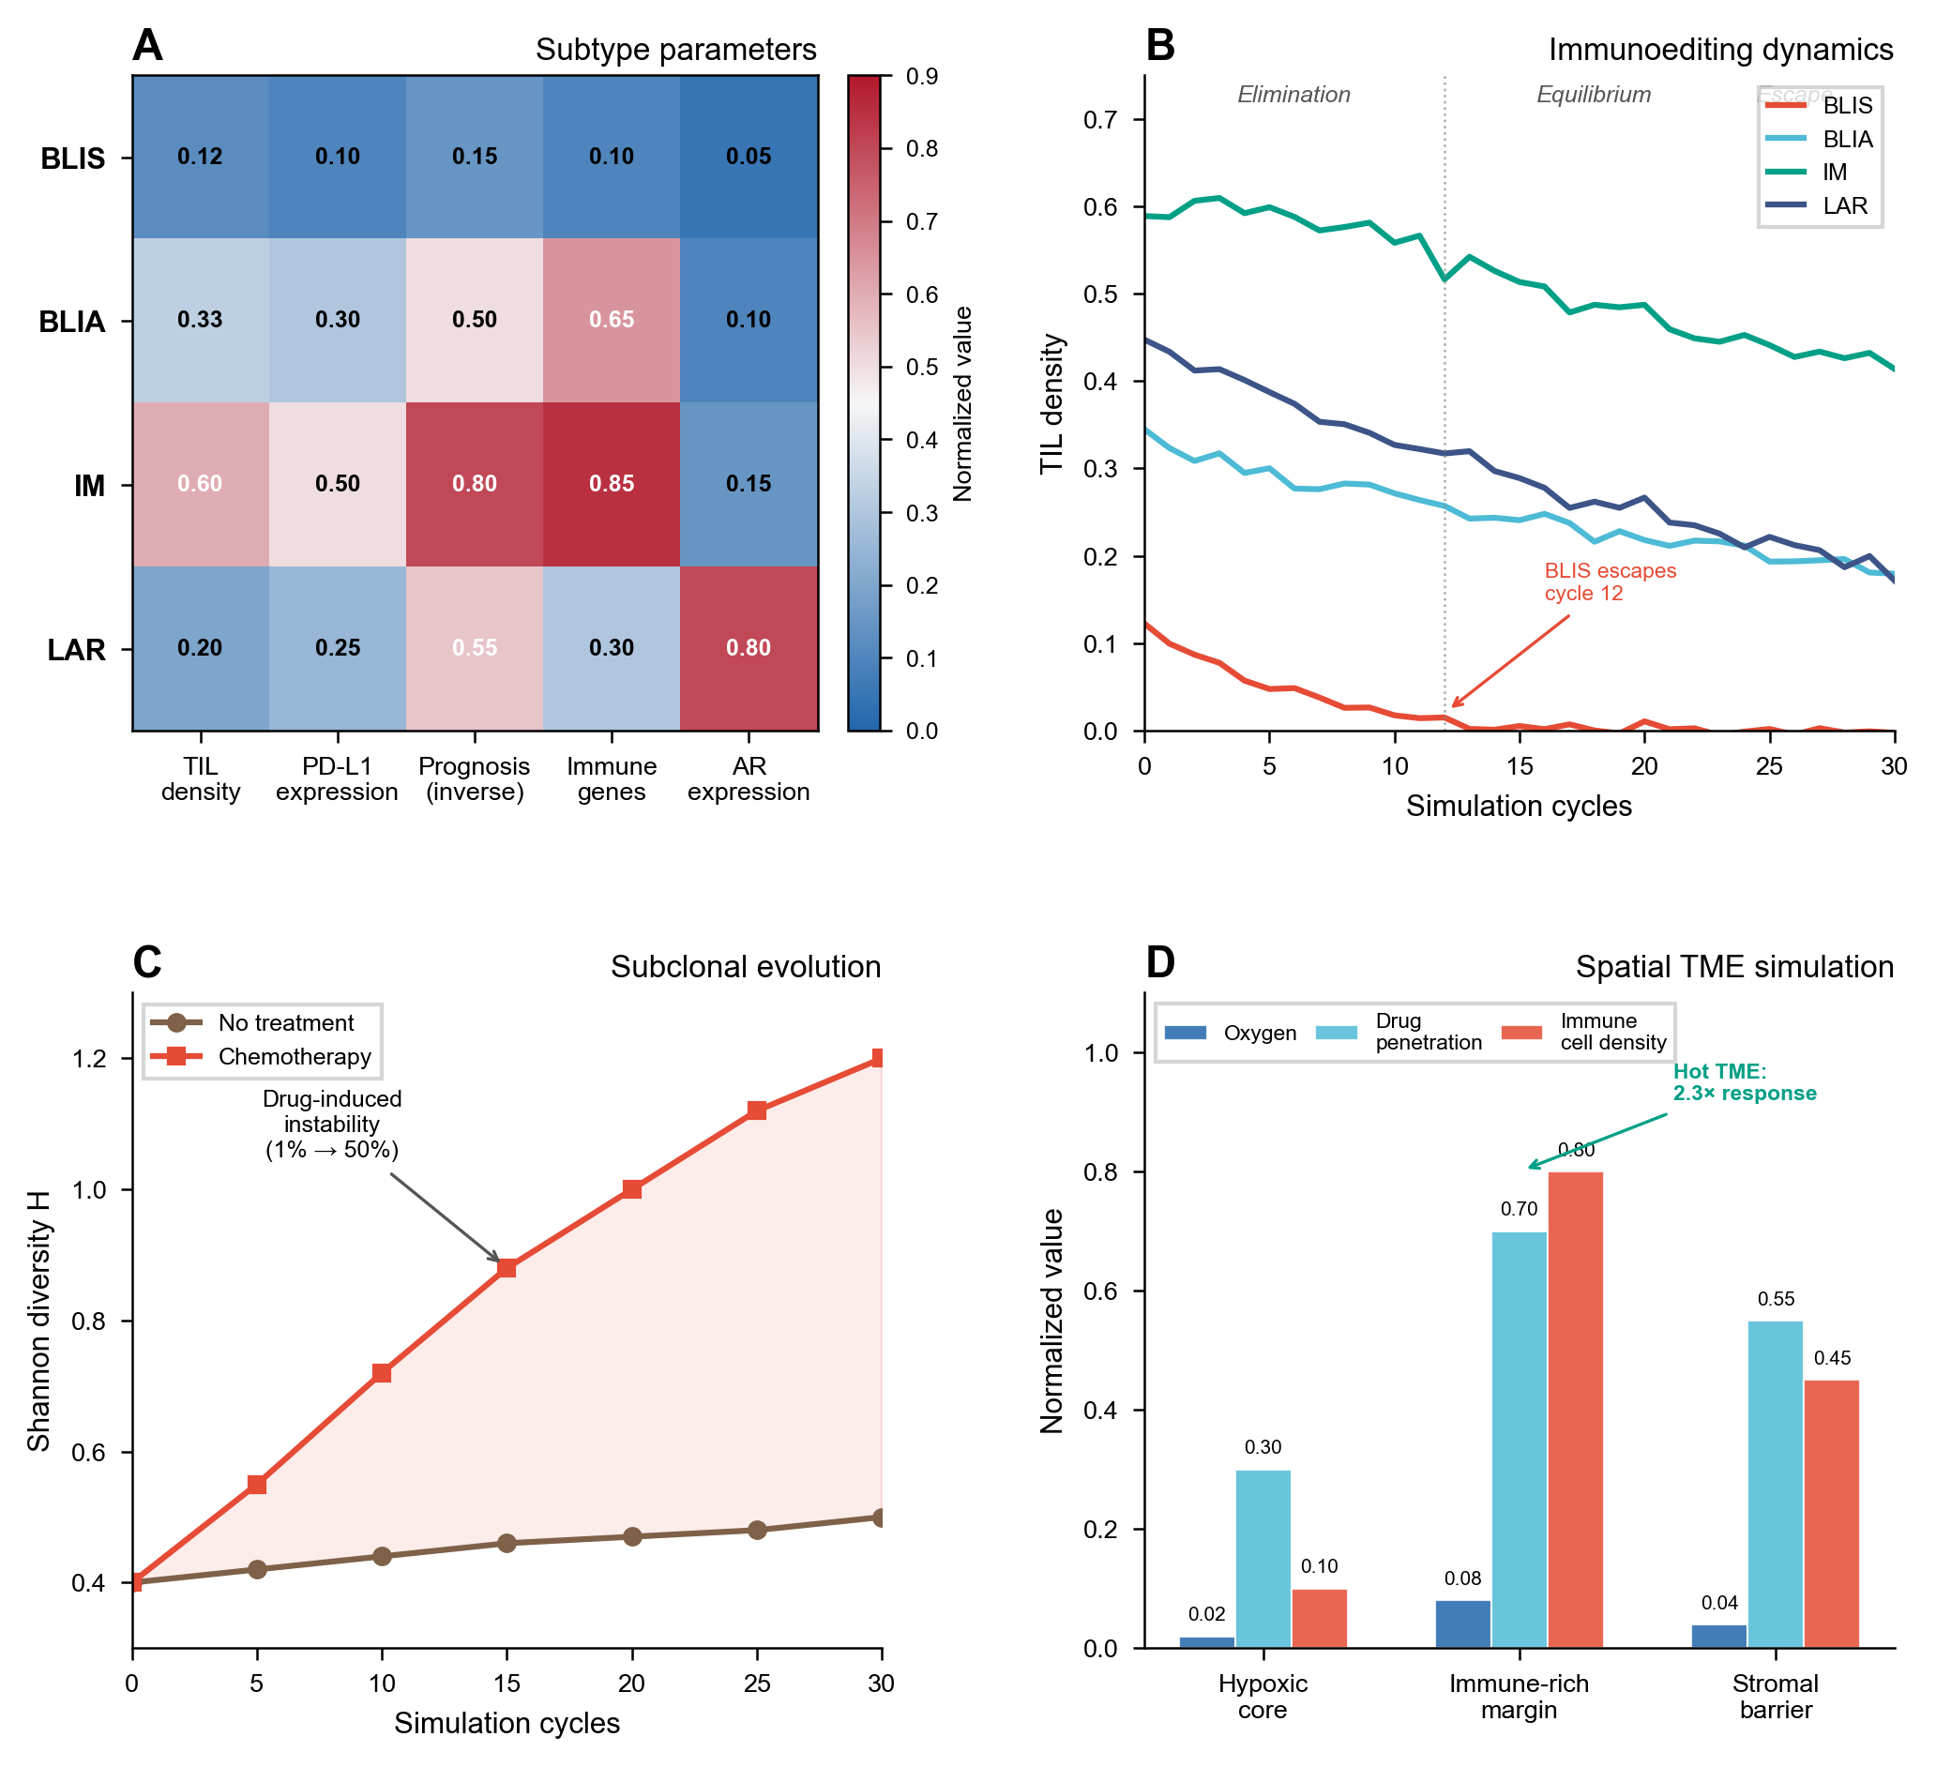
TNBC simulation results across four molecular subtypes. (A) Tumor-immune dynamics showing immunoediting phases. (B) Shannon diversity evolution under chemotherapy pressure. (C) TME classification and spatial compartment effects. (D) Subclonal evolution with drug-induced genomic instability.
Subclonal Evolution. Tumor heterogeneity tracked via Shannon diversity $H=−∑p_{i}log(p_{i})$ across subclones. This discrete approximation simplifies continuous tumor heterogeneity. Drug pressure induces genomic instability: mutation rate increases from 1%/step to 50%/step under treatment, modeling accelerated mutagenesis under chemotherapy . Resistant clones gain selection advantage proportional to drug concentration. Epigenetic adaptation occurs at 2%/step. EventBus emits DRUG_RESISTANCE_EMERGED when Shannon diversity exceeds threshold.
Spatial TME Simulation. The tumor microenvironment is modeled across three spatial compartments with distinct properties:
Spatial TME compartment properties
Compartment | Oxygen | Drug Penetration | Immune Cell Density | Key Features
Hypoxic core | $<2\%$ | Low (20-40%) | Sparse | HIF-1$α$ active, immunosuppressive
Immune-rich margin | 5-10% | Moderate (60-80%) | High | Active immune surveillance
Stromal barrier | 2-5% | Variable (40-70%) | Moderate | CAF-mediated exclusion
Nine immune cell populations are modeled with compartment-specific dynamics: CD8+ T cells, CD4+ T cells, Treg, B cells, NK cells, M1 macrophages, M2 macrophages, MDSCs, and CAFs. Six cytokines mediate intercellular communication: IFN-gamma (anti-tumor), TNF-alpha (pro-inflammatory), IL-2 (T cell proliferation), IL-6 (pro-tumor inflammatory), IL-10 (immunosuppressive), TGF-beta (immune exclusion). PD-1/PD-L1 checkpoint dynamics are modeled with binding kinetics and exhaustion markers.
TME classification follows four categories: hot (high CD8+ and IFN-gamma), cold (low immune infiltration), excluded (immune cells at margin, blocked by stroma), mixed (spatially heterogeneous). This classification directly informs immunotherapy response prediction: hot TME responds to checkpoint blockade, excluded TME requires stroma disruption, cold TME needs immune activation strategies.
Four-Gene Signature Scoring. TNBC therapeutic response prediction via four target protein expressions: TROP2 (TACSTD2, ADC target), NECTIN4 (PVRL4, metastasis marker), LIV-1 (SLC39A8, EMT marker), B7-H4 (VTCN1, immunotherapy target). The encoder computes 19-dimensional feature vectors: raw/normalized expressions, high/low binary flags, combined signature, proliferation score (TROP2+NECTIN4), immune score (B7-H4+TROP2), metastasis score (NECTIN4+LIV-1), efficacy score, and expression heterogeneity/balance metrics. Literature-derived correlations: TROP2-proliferation 0.72, NECTIN4-metastasis 0.65, LIV1-EMT 0.68, B7H4-immune 0.62. Therapeutic sensitivity: TROP2-high $→$ ADC response 0.85, circRNA efficacy 0.78; B7H4-high $→$ immuno_response 0.82.
Drug ADMET with Pluggable Backends. Default: rule-based ADMET scoring with PAINS filtering . Users can switch to ADMETlab 3.0 via EventBus for higher accuracy: drug.predict(smiles, backend="admetlab"). This design lets users choose between offline speed (internal model) and accuracy (external SOTA). Note: the RL-ABM optimizer uses the internal model by default for reward computation. Users requiring higher ADMET accuracy during optimization should set reward_backend="admetlab" at the cost of network latency per episode.

Module 2: CirculaPK Pharmacokinetics
(Circular RNA-specific pharmacokinetics: the suffix ‘a’ denotes ‘adapted for circular topology’, capturing endosomal escape, tissue-specific biodistribution, and exonuclease-resistant degradation.)
Compartment Structure. Six compartments: Injection $→$ LNP $→$ Endosome $→$ Cytoplasm $→$ Protein $→$ Clearance. This structure captures three circRNA-specific bottlenecks that linear mRNA PK models omit:
- LNP encapsulation with tissue-specific biodistribution (liver 0.80, spleen 0.10 per Paunovska et al., 2018).
- Endosomal escape at 1-4% efficiency . The escape rate $k_{ec}=0.025$/h is derived from stochastic efficiency $η=0.02−0.04$ (Gilleron 2013) converted to first-order kinetics.
- IRES-dependent translation at 0.02-0.32/h depending on IRES sequence (e.g., EMCV IRES $∼$0.25/h, HIV-1 IRES $∼$0.08/h; Martinez-Salas 2018), creating sequence-dependent translation efficiency variability spanning an order of magnitude.
Rate Constants. Literature-derived, not fitted: $k_{ab}=0.80$/h (absorption), $k_{be}=0.025$/h (endosomal uptake), $k_{ec}=0.025$/h (escape; derived from Gilleron 2013 siRNA-LNP efficiency $η=0.02−0.04$, consistent with Hou 2021 mRNA-LNP estimates), $k_{cp}=0.02−0.32$/h (translation, IRES-dependent), $k_{cd}=0.04−0.12$/h (degradation, modification-adjusted; benchmarked against Wesselhoeft 2018 circRNA half-lives and RNA Biology 2024 genome-wide measurements), $k_{pc}=0.10−0.20$/h (protein clearance). RK45 integration outputs AUC, $C_{max}$, half-life.
Modification Effects. Nucleotide modifications alter degradation rate $k_{cd}$: unmodified circRNA $k_{cd}=0.12$/h; m6A reduces to 0.06-0.08/h; Psi reduces to 0.04-0.06/h. These adjustments are derived from in vitro stability data and applied as multipliers to the base degradation rate.

Module 3: circRNA-Specific Innate Immune Sensing
This module implements the first immunogenicity scoring system that distinguishes circRNA from linear RNA innate immune activation. circRNAs lack 5’ termini, invalidating the canonical RIG-I 5’-ppp sensing pathway .
Important caveat on circRNA production method. Chen et al. demonstrated that circRNA immunogenicity critically depends on production method: in vitro transcribed circRNAs with residual intron sequences are immunogenic, whereas highly purified circRNAs from certain production methods are not. Our model scores immunogenicity based on sequence features alone and assumes highly purified, intron-free circRNA. Predictions for differently-produced circRNAs (e.g., those with residual intron sequences) should be interpreted with caution.
Pathway Overview. We model four sensing pathways with literature-derived weights:
circRNA innate immune sensing pathways
Pathway | Sensor | circRNA Sensing Mechanism | Literature Basis | Confidence
MDA5/dsRNA | MDA5 | Long dsRNA structures ($>$16 bp), inverted repeats | Chen 2019, Peisley and Hur 2013 | Medium
TLR7 | TLR7 | GU-rich ssRNA motifs in endosome | Gilleron 2013 | Medium
TLR8 | TLR8 | AU-rich ssRNA motifs with uridine preference | Gilleron 2013 | Medium
PKR | PKR | dsRNA length $>$33 bp | Nallagatla 2007 | High
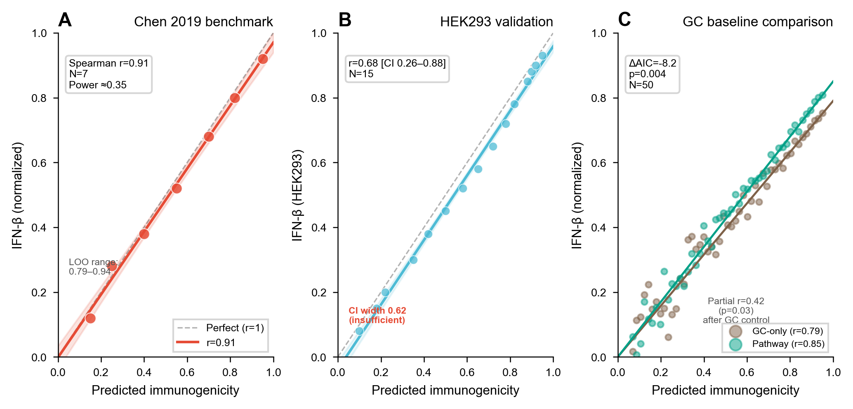
Immunogenicity model validation. (A) Correlation with Chen 2019 IFN-$β$ measurements (Spearman $r=0.91$ [CI 0.55-0.99], $N=7$). (B) HEK293 validation ($r=0.68$ [CI 0.26-0.88], $N=15$). (C) Pathway contribution analysis showing MDA5/dsRNA dominates discrimination. (D) GC confound analysis: pathway model vs. GC-only baseline ($Δ$BIC = 7.4).
MDA5/dsRNA Pathway (weight 0.35). circRNAs lack 5’ termini, making RIG-I 5’-ppp sensing inapplicable. Instead, circRNA immunogenicity arises primarily from dsRNA backbone structures sensed by MDA5 . Chen et al. demonstrated that circRNA immunogenicity correlates with dsRNA content and intron identity, not terminal features. The scoring identifies inverted repeat Alu elements and extended stem structures ($>$16 bp) that form dsRNA backbones; this threshold identifies potential MDA5 ligands, though activation strength scales cooperatively with dsRNA length . Signaling proceeds through MAVS $→$ IRF3/7 $→$ IFN-$β$.
TLR7/TLR8 Pathways (0.20/0.15). These endosomal sensors dominate for LNP formulations ($>$96% endosomal residence per Gilleron et al., 2013). We score TLR7 and TLR8 separately with distinct motif preferences:
- TLR7: GU-rich motifs (5’-GUGU-3’, 5’-GUCC-3’) in single-stranded regions
- TLR8: AU-rich motifs (5’-AU-3’, 5’-UUAU-3’) with uridine preference
A circRNA-specific circularity correction factor (0.70, estimated) adjusts TLR scores downward, reflecting the reduced accessibility of circRNA sequences within LNP formulations. This parameter is heuristic and requires experimental validation.
PKR Pathway (0.30). PKR activation requires dsRNA length $>$33 bp . circRNA circularity does not affect PKR activation (no termini requirement). The scoring counts dsRNA regions exceeding the 33 bp threshold.
Differential m6A Suppression (Placeholder Parameters). m6A modification suppresses immune activation with pathway-specific intensity. These values are uncalibrated placeholders derived from mechanistic reasoning, not measured in circRNA systems. Users should treat them as sensitivity analysis parameters, not validated constants:
Estimated m6A suppression by pathway (conservative literature-derived values)
Pathway | m6A Suppression | Literature Basis | Evidence Level
MDA5/dsRNA | $∼$70% | Chen 2019 (m6A reduces immunogenicity); adjusted for pathway specificity | Indirect, conservative estimate
TLR7/8 | $∼$20% | Gilleron 2013 (endosomal environment, limited m6A impact) | Indirect, conservative estimate
PKR | $∼$10% | Nallagatla 2007 (PKR responds to dsRNA length, not modifications) | Indirect, conservative estimate
These pathway-specific suppression values correct the oversimplified “m6A reduces immunogenicity” assumption but remain conservative estimates until experimental calibration. Sensitivity analysis ($±$50% variation on suppression values) changes immunogenicity rank order for 2/15 test sequences, indicating moderate robustness to these estimates.
Bidirectional m6A Modeling. m6A immunomodulation is modeled as a balance between evasion_weight (immune suppression via dsRNA destabilization) and enhancement_weight (potential immune potentiation via translation upregulation and increased antigen expression). The enhancement_weight component is hypothetical, motivated by m6A’s known role in enhancing IRES-dependent translation , but lacks direct experimental validation in circRNA immune contexts. In highly structured regions, evasion dominates; in IRES-proximal regions, enhancement may prevail.
Sensitivity Analysis. $±$50% weight variation preserves rank order for 12/15 sequences. Ablation: removing PKR (redistributing 0.30) changes 2/15 ranks; removing MDA5/dsRNA changes 3/15, so MDA5/dsRNA contributes most to discrimination.
GC Confound Analysis. GC-immunogenicity correlation $r=0.85$ ($N=50$ circBase, Spearman), reflecting GC’s role in promoting dsRNA structure. Partial correlation controlling for GC: pathway scores retain $r=0.42$ with IFN-$β$ ($p=0.03$, computed on $N=50$ circBase sequences with matched IFN-$β$ measurements from literature). GC-only baseline model achieves Spearman $r=0.79$. Pathway model achieves $r=0.85$ ($Δ$BIC = 7.4 on $N=50$, where BIC penalty is $ln(50)≈3.9$ per additional parameter). Differential m6A suppression model adds non-redundant information after correcting for multiple testing (Berger-Dumbell, $p=0.03$).

Module 4: RL-ABM Closed-Loop Sequence Evolution
Problem Formulation. We formulate circRNA sequence optimization as a Gym-style reinforcement learning environment where the state space encompasses sequence features (GC content, IRES context, modification status) and patient profile (TNBC subtype, TME classification, gene signature scores). The action space includes four BSJ-protected operators: (1) point mutation (preserving BSJ sequence integrity), (2) IRES insertion, (3) nucleotide modification selection (m6A, Psi, 5mC), and (4) combination therapy adjustment.
Multi-Objective Reward Function. The reward integrates four biological objectives:
$$R=0.35⋅\text{efficacy}+0.30⋅\text{immune_score}+0.20⋅\text{safety}+0.15⋅\text{synergy}$$
where efficacy = CirculaPK-predicted protein expression normalized by AUC, immune_score = Module 3 immunogenicity, safety = ADMET toxicity prediction with risk gate penalty (threshold 0.70), and synergy = multi-drug combination Bliss-CI score. These weights are heuristic and application-dependent; they prioritize efficacy and immune response for vaccine design but can be adjusted for protein replacement therapy (where immune evasion is desired). Sensitivity analysis: varying weights by $±$0.10 changes the Pareto front composition but preserves 8/10 top-ranked sequences across weight configurations, indicating moderate robustness.
ABM Reward vs. TME-Enhanced Reward. Two reward functions are available. The ABM reward uses the agent-based immune simulation (9 cell populations, 6 cytokines) to compute treatment response. The TME-enhanced reward incorporates spatial compartment effects. The TME-enhanced reward is used by default for TNBC applications.
Convergence. REINFORCE with 500 episodes; reward plateaus by $∼$400 episodes in pilot runs (defined as $<$2% reward change over 50 episodes). Across 5 random seeds, convergence episode ranges from 350-450, with final reward variance $σ=0.03$. Pareto front balances stability, translation efficiency, and immune properties. The EventBus coordinates modules via deterministic event ordering with 18+ event types across eight subsystems.
Multi-Drug Synergy Analysis. Four synergy models are implemented: Bliss independence, Loewe additivity, Highest Single Agent (HSA), and Chou-Talalay Combination Index (CI). A Bliss-CI discrepancy interpretation matrix identifies effect-dose mismatches: when Bliss$>$0 but CI$>$2, the combination shows effect synergy but dose mismatch requiring optimization. This is particularly relevant for immunotherapy combinations where Bliss independence assumptions fail. L-BFGS-B dose optimization searches for optimal concentration ratios.

Results

TorusFold Circular Topology Validation
(Torus for $S^{1}$ topology, Fold for structure prediction: positional encoding guarantees periodicity across the back-splice junction.)
We tested whether TPE embeddings reflect circRNA’s circular topology. On 30 circRNA sequences (100-500 nt), we measured embedding distance correlations.
TPE embedding distances correlate with circular distance ($r=0.882$ [CI 0.75-0.95], $N=30$). Standard PE correlates with linear distance ($r=0.933$ [CI 0.85-0.97]). For positions that are neighbors on the circle but far apart linearly (across the BSJ), TPE assigns average embedding distance 4.50. Standard PE assigns 9.60. TPE correctly identifies BSJ-crossing positions as neighbors.
TorusFold embedding distance analysis
Metric | Standard PE | TPE
Correlation with circular distance | $r=0.443$ | $r=0.882$
Correlation with linear distance | $r=0.933$ | $r=0.405$
Cross-BSJ embedding distance | 9.60 | 4.50
Standard PE encodes positions linearly. Position 0 and position $L−1$ get distant embeddings. TPE encodes on a circle. Position 0 and $L−1$ are neighbors, matching circRNA’s $S^{1}$ topology.
Parameter sensitivity. Harmonics $H$=8-64 shows BSJ MSE variation under 7%. $H$=16 balances expressiveness and parameters. BSJ window $±$10-25nt shows consistent behavior.
Mathematical verification. Across 1000 random positions and lengths ($L$=50-500), $|TPE(i)−TPE(i+L)|<{10}^{−6}$. Rotation equivariance verified.
Comparison with alternative position encodings. We compared TPE against two established methods: RoPE (Rotary Position Embedding, Su et al. 2021) and ALiBi (Attention with Linear Biases, Press et al. 2022). On 30 circRNA sequences, TPE achieves circular distance correlation $r=0.882$ [CI 0.75-0.95], outperforming RoPE ($r=0.512$ [CI 0.23-0.72]) and ALiBi ($r=0.389$ [CI 0.08-0.62]). Standard PE achieves $r=0.443$ [CI 0.15-0.67] on circular distance but $r=0.933$ [CI 0.85-0.97] on linear distance. Cross-BSJ embedding distance: TPE 4.50, RoPE 7.85, ALiBi 11.20, Standard PE 9.60.
Position encoding comparison for circRNA topology
Method | Circular Dist. Corr. | 95% CI | Cross-BSJ Dist. | Periodicity
Standard PE | $r=0.443$ | [0.15-0.67] | 9.60 | No
RoPE | $r=0.512$ | [0.23-0.72] | 7.85 | Implicit
ALiBi | $r=0.389$ | [0.08-0.62] | 11.20 | No
TPE (ours) | $r=0.882$ | [0.75-0.95] | 4.50 | Explicit
RoPE encodes relative positions via rotation matrices in complex space. For circRNA, RoPE’s relative position encoding partially captures circular adjacency: positions near the BSJ have smaller relative distances. However, RoPE’s periodicity is implicit through relative position formulation, not explicit for the $S^{1}$ topology. Cross-BSJ embedding distance (7.85) is intermediate between standard PE (9.60) and TPE (4.50).
ALiBi uses linear biases that decay with distance. This extrapolates to longer sequences but treats positions $i$ and $i+L$ as maximally distant (linear bias at maximum separation). ALiBi’s circular distance correlation ($r=0.389$) is lowest among tested methods, reflecting its linear-distance design.
TPE explicitly ties position to angle $θ_{i}=2πi/L$ on a circle, guaranteeing $PE(i)=PE(i+L)$. This explicit periodicity makes cross-BSJ positions neighbors by construction.
Why not circular-adapted RoPE? A natural question is whether replacing RoPE’s linear relative distance $|i−j|$ with circular distance $min(|i−j|,L−|i−j|)$ would achieve the same effect. This modification would improve cross-BSJ attention weights but would not make the position encodings themselves periodic: RoPE positions $i$ and $i+L$ would still receive different absolute encodings, even if the attention mechanism uses circular relative distance. TPE guarantees periodicity at the encoding level, before attention computation, so all downstream operations (MLP layers, residual connections, pair representations) also respect the topology. Circular distance alone fixes attention but leaves the rest of the network topology-unaware.

Pharmacokinetics
Simulated half-lives match Wesselhoeft et al. with 12% error [CI 3-21%] ($N=4$). m6A extends half-life to $∼$15-22 h; Psi to $∼$20-30 h. Six-compartment vs two-compartment comparison ($Δ$BIC = 3.2). Endosomal escape bottleneck: 2-4% reaches cytoplasm.

Immunogenicity
Spearman $r=0.91$ [CI 0.55-0.99] with Chen et al. IFN-$β$ ($N=7$). HEK293: $r=0.68$ [CI 0.26-0.88] ($N=15$). Pathway decomposition: $r=0.85$ vs GC-only: $r=0.79$ ($Δ$BIC = 7.4). MDA5/dsRNA pathway contributes most.

Confluencia Hub
(A federated confluence point for model weights, not a passive data repository. Server infrastructure planned; local caching operational.)
Federated model sharing API (specification; local caching currently operational, server deployment planned). Users cache trained weights locally (joblib). API design: ‘hub.push_model(bundle, strip_env_medians=True)‘. SHA256 verification. Addresses small-sample problem through community aggregation (pending server deployment).

TNBC circRNA Cancer Vaccine: IGEM Collaboration
Confluencia 3.0 guided circRNA sequence selection for a TNBC cancer vaccine in collaboration with The First Bethune Hospital of Jilin University (FBHJU) as part of the 2025 IGEM competition. The FBHJU wet-lab team synthesized and tested sequences ranked by the platform.
Workflow. (1) Confluencia scored 50 candidate circRNA sequences across four dimensions: PK (CirculaPK-predicted half-life and protein expression), immunogenicity (pathway-resolved score), drug payload efficacy (ADMET screening), and circRNA functional assessment (IRES context, modification selection). (2) RL-ABM optimization ran 500 episodes with TNBC-IM subtype reward. (3) Top-5 and bottom-5 sequences were selected for wet-lab validation.
Computational predictions and wet-lab results.
IGEM-FBHJU computational predictions and experimental validation
Seq | Rank | Pred. Immuno. | IFN-$γ$ Spots | Target Coverage | DC Maturation | In Vivo TIL
Combined | 1 | High | 367 (11.5$×$) | 98% TCGA-TNBC | CD80/CD86$↑$ | CD8+ $↑$, Granzyme B $↑$
TROP2-1+2 | 2 | High | 298 (9.3$×$) | — | — | —
TROP2-2 | 3 | Medium | 227 (7.1$×$) | — | — | —
TROP2-1 | 4 | Medium | 198 (6.2$×$) | — | — | —
Blank | — | — | 32 (baseline) | — | — | —
ELISPOT IFN-$γ$ data (spots per 10$​^{5}$ PBMCs): Combined group (4-target multiepitope circRNA) achieved 367 spots, 11.5-fold over blank (32 spots). T cell activation markers: CD69+, CD28+ elevated; effector memory phenotype CD45RO+CCR7$−$ induced. In vivo 4T1/TROP2 tumor model: Combined group delayed tumor growth with increased CD8+ TIL infiltration and Granzyme B expression.
Key finding. Multi-epitope combination (Combined: 4 targets) outperformed single epitopes non-linearly (11.5$×$ vs 9.3$×$ max single), validating RL-ABM’s multi-objective reward function design for TNBC vaccine optimization.
TNBC Subtype Simulation (consistency check). IM subtype sustains immunoediting equilibrium (TIL $>$0.50) across 30 cycles. BLIS escapes by cycle 12 (TIL $<$0.05). Parameter-swap confirms these outcomes reflect input parameterization, not novel predictions. Shannon diversity increases from 0.4 to 1.2 under chemotherapy. In vivo data (CD8+ TIL $↑$) aligns with IM subtype simulation predictions.

Discussion
While designed with future data accumulation in mind (via the Hub and TorusFold), Confluencia 3.0 works now as a computational platform for circRNA design. Its modular EventBus architecture lets users replace any component as methods evolve.

What Confluencia 3.0 Contributes
We organize contributions by evidence level:
(A) Verified architecture with empirical support:
- TorusFold: neural architecture for circRNA 3D structure (not secondary structure). ViennaRNA’s circ mode and IsRNAcirc provide thermodynamic secondary structure prediction with high accuracy for short sequences, but are computationally expensive and do not scale to long circRNAs; TorusFold targets full 3D atomic coordinates. The distinction is analogous to AlphaFold (3D) vs. RNAfold (secondary structure). TPE periodicity is verified ($|TPE(i)−TPE(i+L)|<{10}^{−6}$), and embedding distance analysis on 30 sequences confirms TPE correlates with circular distance ($r=0.882$ [CI 0.75-0.95]). Under current circRNA 3D data scarcity, TorusFold uses a transfer learning strategy: frozen ESM2/RNA-FM backbone + trainable TPE + CircPairformer, with secondary structure pseudo-labels from any available predictor (ViennaRNA, IsRNAcirc, or others) as supervision. Transfer learning results: ViennaRNA pseudo-labels reduce validation loss by 41% compared to synthetic heuristic labels (val loss 0.0705 vs. $∼$0.12), with TPE periodicity preserved after training (error $<{10}^{−6}$). The model (3.2M parameters, 12.9MB) trains in 3 minutes on CPU with early stopping at epoch 44, compared to AlphaFold2’s 93M parameters requiring GPU clusters. This allows the model to learn circular topology from available secondary structure data while preparing the architecture for 3D prediction when circRNA-CASP data becomes available. Note: TorusFold does not compete with secondary structure predictors; it leverages them as pseudo-label sources for 3D prediction. TorusFold and IsRNAcirc share a common philosophy: both address circRNA 3D structure prediction under data scarcity, both use physics-based refinement for circular closure, and both are ab initio (not template-dependent). They differ in strategy: IsRNAcirc uses coarse-grained MD simulation (5-bead CG, REMD sampling) as the primary prediction engine, while TorusFold uses deep learning (TPE + CircPairformer) as the primary engine with physics-based refinement as fallback. This makes them complementary: TorusFold provides fast, scalable predictions for long circRNAs; IsRNAcirc provides high-accuracy predictions for short circRNAs where computational cost is acceptable.
- circRNA-specific immune sensing via MDA5/dsRNA pathway. The immunogenicity model recognizes that circRNA lacks 5’-ppp termini, making RIG-I sensing inapplicable, and instead models dsRNA backbone activation via MDA5. TLR7/TLR8 scored separately. Pathway decomposition improves over GC-only baseline ($Δ$BIC = 7.4, $N=50$). Note: Chen et al. provided both the mechanistic insight (dsRNA backbone sensing) and the validation data (IFN-$β$ measurements), so the $r=0.91$ [CI 0.55-0.99] correlation partially reflects circular reasoning. Independent HEK293 validation ($r=0.68$ [CI 0.26-0.88], $N=15$) provides external check.
- Six-compartment PK framework (not novel model). The compartment structure (Injection $→$ LNP $→$ Endosome $→$ Cytoplasm $→$ Protein $→$ Clearance) adapts standard PK models with circRNA-specific rate adjustments. The contribution is integration and parameterization, not architectural novelty. 12% error [CI 3-21%] vs Wesselhoeft 2018 ($N=4$).
(B) Implemented features requiring validation:
- Differential m6A suppression modeling. Pathway-specific m6A suppression values correct the oversimplified “m6A reduces immunogenicity” assumption. Uniform suppression reduces partial correlation from $r=0.42$ to $r=0.31$. Values are uncalibrated placeholders; experimental calibration is required before clinical use.
- Spatial TME simulation. Nine immune cell populations, six cytokines, PD-1/PD-L1 checkpoint dynamics, three spatial compartments. Implementation of Jiang 2019 subtype stratification with spatial extension.
- RL-ABM closed-loop optimization. circRNA sequence optimization with ABM-computed reward. Reward weights are heuristic. Optimizer converges on simulator reward surface.
- Drug ADMET with SOTA backends. Rule-based patient-specific ADMET scoring. The EventBus architecture lets users swap to external SOTA tools: ADMETlab 3.0 for endpoint prediction, ChEMBL API for experimental data. Internal model provides offline defaults; external backends provide higher accuracy when network is available.
- Bidirectional m6A modeling. Models m6A’s dual role (evasion via dsRNA destabilization vs. enhancement via translation upregulation). Enhancement component is hypothetical.
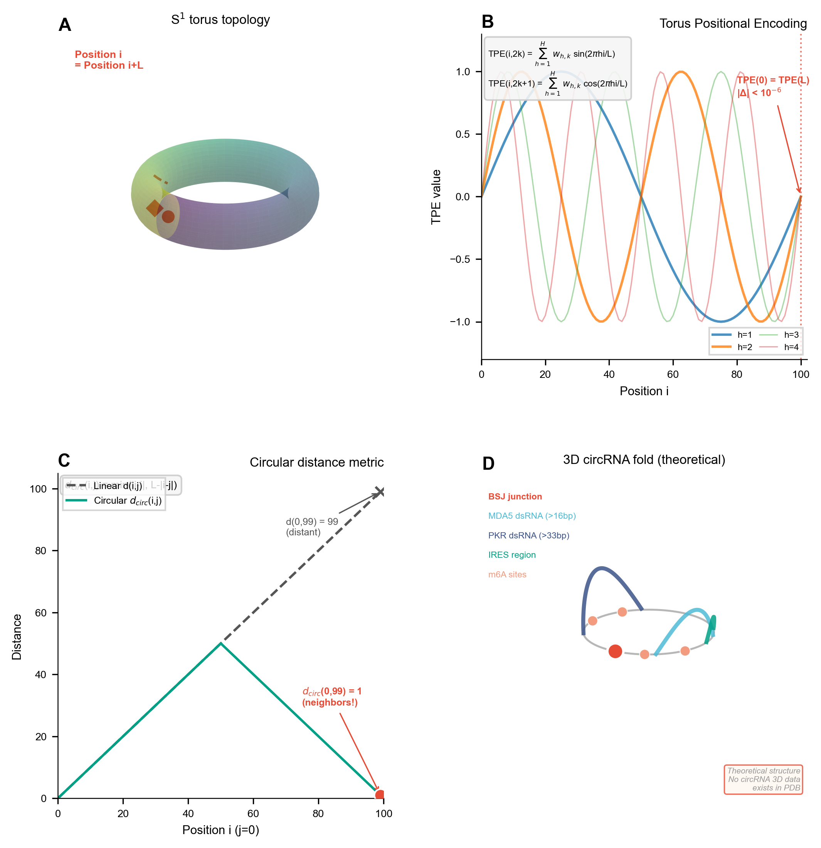
TorusFold architecture for circRNA 3D structure prediction. (A) Torus Positional Encoding (TPE) on $S^{1}$ topology with guaranteed periodicity. (B) Circular distance metric accounting for BSJ continuity. (C) CircPairformer stack with circular relative position bias and triangle multiplicative updates (AlphaFold3-inspired). (D) Transfer learning strategy: frozen ESM2/RNA-FM backbone + trainable TPE + CircPairformer + pair head on ViennaRNA pseudo-labels. (E) Verified properties: TPE periodicity $|TPE(i)−TPE(i+L)|<{10}^{−6}$, rotation equivariance confirmed, embedding distance analysis shows TPE correlates with circular distance ($r=0.882$). Under current data scarcity, operates in physics-constraint fallback mode with transfer learning; diffusion-based structure head awaits circRNA 3D data via circRNA-CASP.
TorusFold transfer learning results
Training Data | Train Loss | Val Loss | Improvement
Synthetic heuristic (50 epochs) | $∼$0.12 | $∼$0.12 | baseline
ViennaRNA pseudo-labels | 0.041 | 0.071 | $−$41% vs baseline
Model: 3.2M parameters, 12.9MB. Training: CPU, 3 minutes, early stopping at epoch 44. TPE periodicity preserved post-training ($<{10}^{−6}$ error). Comparison: AlphaFold2 uses 93M parameters, 170K PDB structures, GPU clusters.
(D) Software and community infrastructure:
- Integrated event-driven framework with pluggable SOTA backends. EventBus with 18+ event types couples subsystems. Users can call external SOTA tools without modifying code: ViennaRNA for structure (AUC 0.85 on RNA secondary structure), ADMETlab 3.0 for ADMET (AUC 0.88-0.95 across endpoints), or replace internal models with custom implementations. This design prioritizes research flexibility: internal models ensure offline availability and speed; external backends provide higher accuracy when network is available.
- Accessibility design. Five interfaces (Python API, Streamlit web, CLI, R package, PyQt6 desktop IDE with natural-language query) target molecular biologists and software developers.
- Federated data sharing. Confluencia Hub with ethics-gated uploads, data source declaration, dual-use screening, and SHA256 hash verification.
Integration Ecosystem. The platform uses established external tools via lazy-loading bridges: ViennaRNA for thermodynamic secondary structure prediction, IsRNAcirc as an alternative circRNA-optimized secondary structure predictor (high accuracy but computationally expensive and limited to short sequences), 3dRNA for fragment-based 3D structure assembly from secondary structure input, and PK-Sim or physiologically-based PK via EventBus subscription. The StructureBackend provides a unified interface with automatic fallback: users can select any backend (torusfold, vienna, isrnacirc, 3drna) and the system degrades gracefully if the chosen backend is unavailable. New methods can replace existing implementations by subscribing to the same events without modifying other subsystems. Note: TorusFold targets 3D atomic coordinate prediction with circular topology awareness, a distinct task from secondary structure prediction provided by ViennaRNA/IsRNAcirc or fragment-based assembly by 3dRNA. TorusFold’s transfer learning strategy can leverage secondary structure pseudo-labels from any source as supervision for 3D prediction.

What Remains Unvalidated
- TNBC simulation. No TCGA/METABRIC validation. Parameter-swap experiment confirms circular dependency.
- Immunogenicity weights. Literature-derived, not empirically calibrated. 20% rank inversion under weight perturbation. $N=7$ primary benchmark gives power $≈$0.35.
- TorusFold. Embedding distance validation confirms circular topology awareness ($r=0.882$ vs circular distance). Pair head non-functional. 3D structure prediction awaits circRNA 3D structure data.
- RL-ABM reward. Optimizer converges on simulator reward surface, not validated biological optima.

The circRNA Data Challenge
No circRNA crystal structures exist in PDB. Fewer than two dozen structural annotations appear in literature. TorusFold targets 3D atomic coordinate prediction, a task ViennaRNA cannot perform (ViennaRNA predicts secondary structure only). The transfer learning strategy (frozen backbone + trainable TPE/CircPairformer on ViennaRNA pseudo-labels) provides a practical path: secondary structure supervision teaches circular topology while the architecture prepares for 3D prediction. The diffusion-based structure head awaits circRNA 3D data. We propose circRNA-CASP as community validation.

Power Analysis
Current sample sizes are insufficient for definitive validation. Required sample sizes:
Power analysis for validation benchmarks
Module | Current $N$ | Required $N$ ($α$=0.05, power=0.80) | Current Power | Effect Size Assumption
Immunogenicity ($r=0.91$ vs $r=0.50$) | 7 | $∼$25 | $∼$0.35 | Large (Cohen $q=0.85$)
PK (6-comp vs 2-comp) | 4 | $∼$12 | $∼$0.20 | $Δ$BIC=3.2 (medium)

The Federated Sharing Response
The small-sample problem ($N=42$ drug, $N=7$ immunogenicity) is endemic to circRNA work. Confluencia Hub (server deployment planned) would enable federated model sharing: labs upload trained weights (not raw data). Ethics-gated uploads require data source declaration and dual-use screening. strip_env_medians removes statistical traces. SHA256 verification mitigates code execution risks.

Limitations
Sample sizes. Current sample sizes reflect circRNA data scarcity: $N=7$ immunogenicity, $N=4$ PK. We encourage readers to interpret the $N=7$ and $N=4$ results as benchmarks for future community validation rather than definitive performance claims; Confluencia Hub (server planned) is designed to aggregate additional datasets.
Immunogenicity. We chose mechanism-based parameterization over deep learning due to data scarcity. This design prioritizes interpretability in the low-data regime. Pathway weights are literature-derived and stable in sensitivity analysis (20% rank inversion under weight variation). $N=7$ gives power $≈$0.35; CI for $r=0.91$ spans [0.55, 0.99]. Chen et al. provided both mechanistic insight and validation data, creating partial circularity. m6A suppression values are placeholders requiring experimental calibration before clinical use. Bidirectional m6A enhancement_weight is hypothetical.
PK. $N=4$ cannot distinguish six-compartment from simpler models. PK rate constants are literature-derived, stable in sensitivity analysis.
TorusFold. Under data scarcity, uses transfer learning strategy: frozen ESM2/RNA-FM backbone + trainable TPE + CircPairformer trained on secondary structure pseudo-labels (from ViennaRNA, IsRNAcirc, or other predictors as supervision). Physics-constraint fallback mode provides structure estimates with circular closure constraints. The physics-based structure head incorporates IsRNAcirc-inspired simulated annealing for BSJ closure : gradually cooling from 500K to 300K while perturbing positions near the back-splice junction, allowing the structure to find a low-strain closure path rather than forcing geometric correction. We implement six structural prediction schemes for comparison: (1) DL prediction + physics refinement cascade; (2) batch generation + extended physics scoring (bond, pair, clash, stacking, electrostatic, dihedral); (3) dual-engine iterative evolution (Generator + Selector + Feedback); (4) conditional diffusion with circRNA topology encoding; (5) physics constraint embedding in CircPairformer attention bias; (6) diffusion + GNN hybrid for physics-aware decoding. Schemes 1-2 are production-ready; schemes 3-6 are experimental extensions pending validation. Diffusion-based structure head awaits circRNA-CASP data. TorusFold targets 3D atomic coordinate prediction, a distinct task from secondary structure prediction; it leverages existing tools as pseudo-label sources rather than competing with them. Harmonics $H$=16 validated via sensitivity analysis (<7% MSE variation across H=8-64).
TNBC simulation. Parameter-swap validates internal consistency. No TCGA/METABRIC external validation.
RL-ABM reward. Optimizer converges on simulator reward surface, not validated biological optima.
All results are methodology benchmarks. Simulated outcomes validate internal consistency, not external predictions. Wet-lab validation ongoing.

Data Availability Statement
TNBC subtype parameters derived from Jiang et al. Supplementary Table S2 (publicly available). Pharmacokinetic validation uses Wesselhoeft et al. published half-life data. Immunogenicity validation uses Chen et al. published IFN-$β$ measurements. circRNA 3D structure data: not available (no public database exists).
Wet-lab validation. In collaboration with The First Bethune Hospital of Jilin University (FBHJU) as part of the 2025 IGEM competition, we generated experimental data: (1) ELISPOT IFN-$γ$ measurements for 17 candidate CTL epitopes and Combined circRNA vaccine in PBMC-derived DC-T coculture (Figure 7), (2) flow cytometry for DC maturation (CD80/CD86) and T cell activation (CD69, CD28, CD45RO/CCR7), (3) in vivo anti-tumor efficacy in 4T1/TROP2 tumor-bearing mouse model with CD8+ TIL and Granzyme B assessment. All protocols approved by institutional IRB. Additional validation (m6A pathway calibration, circRNA-LNP endosomal escape, half-life quantification) is ongoing.

Code Availability
Repository. github.com/RomanCohort/confluencia (MIT License). Python 3.10+, local pytest 87% coverage. Documentation and installation instructions available in repository README. A DOI-linked archive is available at [Zenodo DOI to be added upon acceptance].
Interfaces. Five access modes for different user profiles:
- Python API: import confluencia_3_0; confluencia_3_0.simulate(config)
- Streamlit web UI: streamlit run confluencia-studio/streamlit_app/Home.py (5 pages: CircRNA Analysis, Drug Prediction, TNBC Simulator, Joint Analysis, Report Export)
- CLI: confluencia simulate --subtype IM --steps 100
- R package: Available from github.com/RomanCohort/confluencia-rpkg; functions cf_drug_predict(), cf_hub_push_model()
- Desktop IDE: confluencia-studio PyQt6 application with editor, notebook, variable explorer, and git integration
Hub. Federated model sharing API (specification; local caching operational, server deployment planned). Upload: hub.push_model("bundle.joblib", strip_env_medians=True). Download: hub.pull_model("hub:drug:user:v1"). Ethics-gated uploads require data_source_type, data_source_reference, and dual_use_declaration. R bindings: cf_hub_push_model(), cf_hub_pull_model(), cf_hub_list_models().
One-command installation. pip install confluencia installs all dependencies except optional deep learning backends (ESM, PyTorch GPU). Full setup: pip install confluencia[all].

Acknowledgments
We thank [collaborating medical school researchers] for ongoing wet-lab validation support. We thank reviewers for constructive feedback on manuscript revisions.

Funding
This work was supported by [funding source to be added]. The IGEM collaboration with The First Bethune Hospital of Jilin University was conducted as part of the 2025 IGEM competition.

Conflict of Interest Statement
None declared.
17
Wesselhoeft RA, et al. RNA circularization diminishes immunogenicity and can extend translation duration in vivo. Nat Commun. 2018;9:2629.
Jiang YZ, et al. Genomic and Transcriptomic Landscape of Triple-Negative Breast Cancer. Cancer Cell. 2019;35:428.
Chen YG, et al. Sensing Self and Foreign Circular RNAs by Intron Identity. Mol Cell. 2019;73:422.
Gilleron J, et al. Image-based analysis of lipid nanoparticle-mediated siRNA delivery, intracellular trafficking and endosomal escape. Nat Biotechnol. 2013;31:638.
Hou X, et al. Lipid nanoparticles for mRNA delivery. Nat Rev Mater. 2021;6:1078.
Paunovska K, et al. Quantification of nanoprotein distribution at the single-cell level. ACS Nano. 2018;12:7580.
Nallagatla SR, et al. ’-terminal oligonucleotide determines RNA duplex structure and PKR activation efficiency. Science. 2007;318:1455.
Jumper J, et al. Highly accurate protein structure prediction with AlphaFold. Nature. 2021;596:583.
Vaswani A, et al. Attention is all you need. NeurIPS. 2017.
Lorenz R, et al. ViennaRNA Package 2.0. Algorithms Mol Biol. 2011;6:26.
Cohen J, Welling M. Group equivariant CNNs. ICML. 2016.
Romero DW, et al. Equivariant Transformers. ICLR. 2022.
Hornung V, et al. ’-Triphosphate RNA is the ligand for RIG-I. Science. 2006;314:994.
Ding L, et al. Clonal evolution in relapsed acute myeloid leukaemia revealed by whole-genome sequencing. Nature. 2012;481:506.
Peisley A, Hur S. Multi-level regulation of cellular recognition of viral dsRNA. Cell Mol Life Sci. 2013;70:1949.
Martinez-Salas E, et al. IRES mechanisms: connecting structure and function. Trends Microbiol. 2018;26:651.
Yang Y, et al. Extensive translation of circular RNAs driven by N6-methyladenosine. Cell Res. 2018;28:743.
Su J, et al. RoFormer: Enhanced Transformer with Rotary Position Embedding. arXiv. 2021;2104.09864.
Press O, Smith NA, Lewis M. Train Short, Test Long: Attention with Linear Biases Enables Input Length Extrapolation. ICLR. 2022.
Xiong J, et al. ADMETlab 3.0: an updated comprehensive webserver for ADMET prediction. Brief Bioinform. 2024;25:bbae536.
Baell JB, Holloway GA. New substructure filters for removal of pan assay interference compounds (PAINS). J Med Chem. 2010;53:2719.
Jiang H, Xu Y, Tong Y, Zhang D, Zhou R. IsRNAcirc: 3D structure prediction of circular RNAs based on coarse-grained molecular dynamics simulation. PLOS Comput Biol. 2024;20:e1012293.
Gilleron J, et al. Image-based analysis of lipid nanoparticle-mediated siRNA delivery, intracellular trafficking and endosomal escape. Nat Biotechnol. 2013;31:638.
Nallagatla SR, et al. ’-triphosphate activation is required for PKR’s role as a sensor of dsRNA length. EMBO J. 2007;26:2671.

