Лабораторная работа 7

Задание A:

1)

CREATE TABLE startup_tree

(

id SERIAL NOT NULL PRIMARY KEY,

student_id INT NOT NULL REFERENCES student(id),

manager_id INT REFERENCES startup_tree(id)

);

INSERT INTO startup_tree(student_id, manager_id)

VALUES

(50, NULL),

(30, 1),

(40, 1),

(10, 3),

(20, 3);

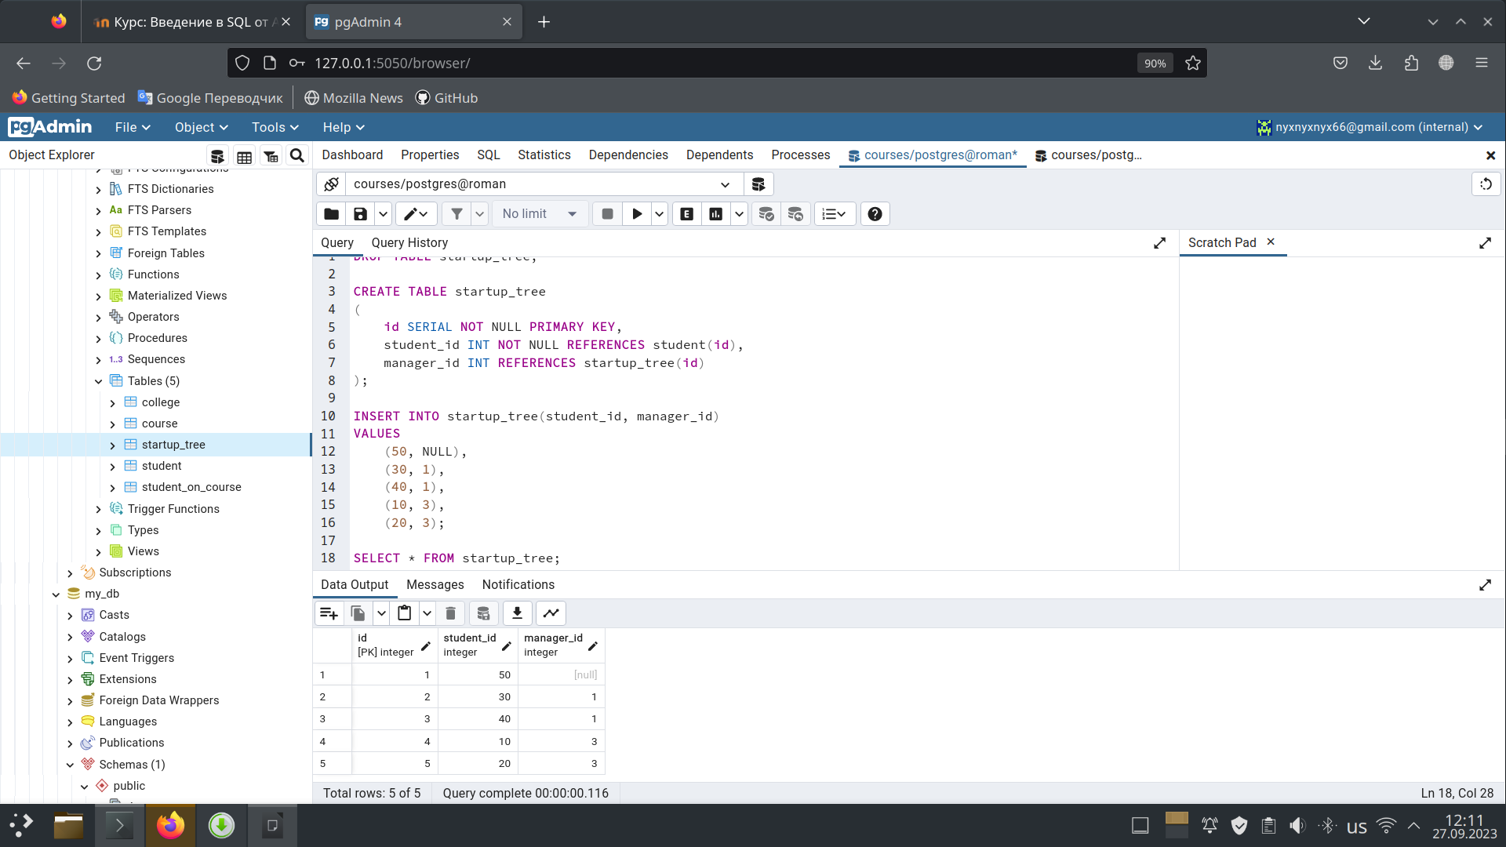SELECT * FROM startup_tree;

2)

CREATE TABLE startup_roles

(

student_id INT NOT NULL REFERENCES student(id),

student_role VARCHAR(20)

);

INSERT INTO startup_roles

VALUES

(50, 'project_leader'),

(40, 'dev_team_lead'),

(30, 'test_lead'),

(10, 'frontend'),

(20, 'backend');

SELECT *

FROM startup_roles;

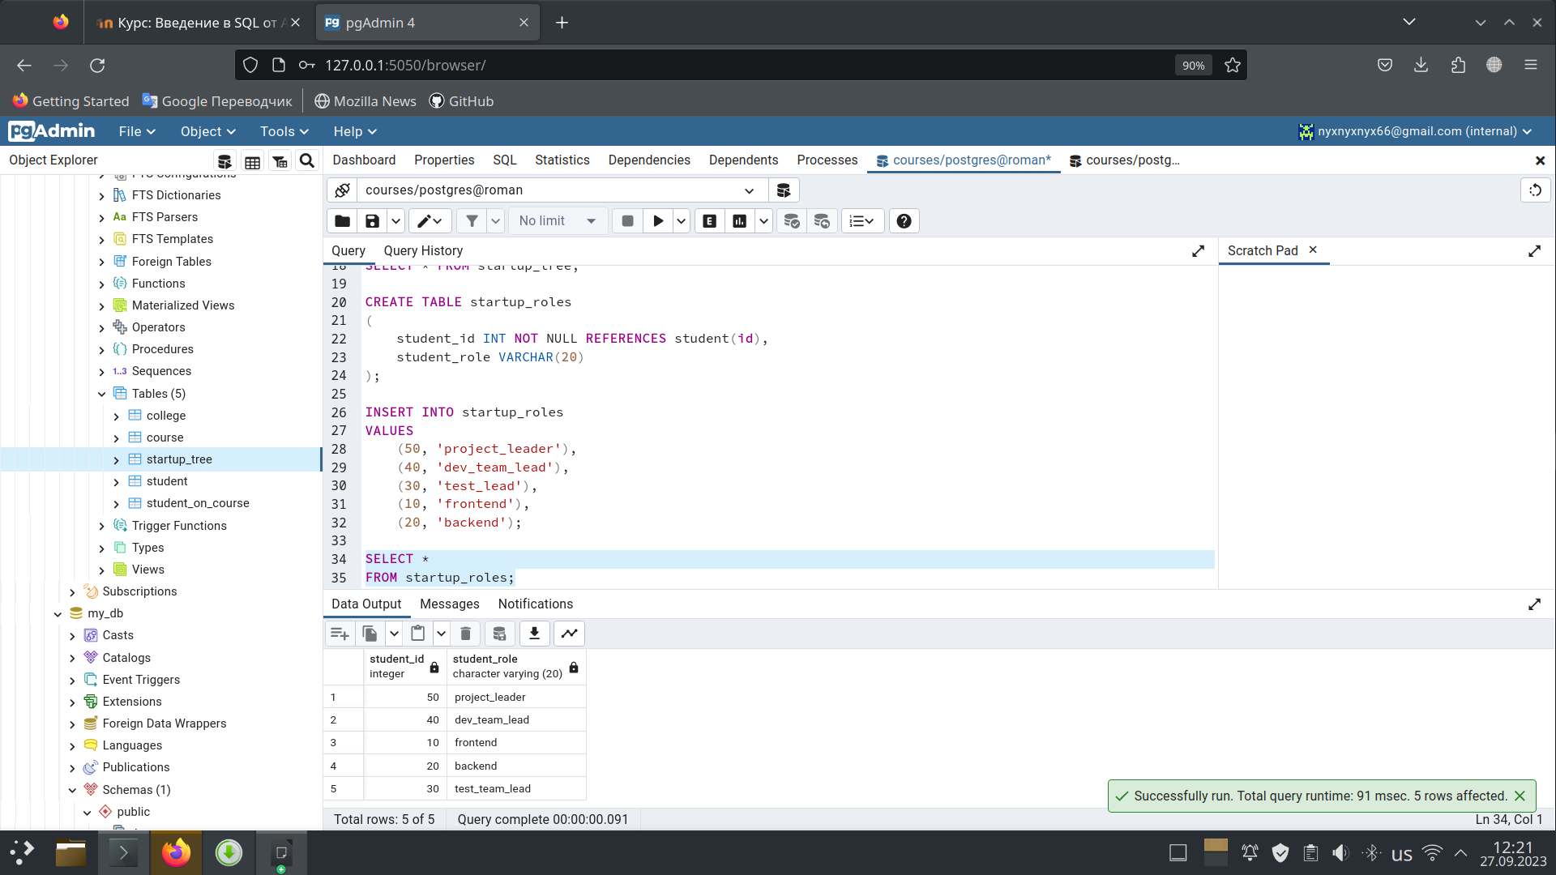

Задание Б

WITH RECURSIVE _students AS (

SELECT

startup_tree.student_id,

startup_tree.manager_id,

student.name,

1 AS level,

array[name] AS path

FROM student

INNER JOIN startup_tree

ON student.id = startup_tree.student_id

WHERE startup_tree.manager_id IS NULL

UNION

SELECT

st1.student_id,

st1.manager_id,

s1.name,

level + 1 AS level,

path || s1.name AS path

FROM student as s1

INNER JOIN startup_tree as st1

ON s1.id = st1.student_id

INNER JOIN _students

ON st1.manager_id = _students.student_id

)

SELECT

_students.name "студент",

startup_roles.student_role "роль",

_students.level "уровень",

_students.path "путь от лидера"

FROM _students

INNER JOIN startup_roles

ON _students.student_id = startup_roles.student_id

ORDER BY "уровень";

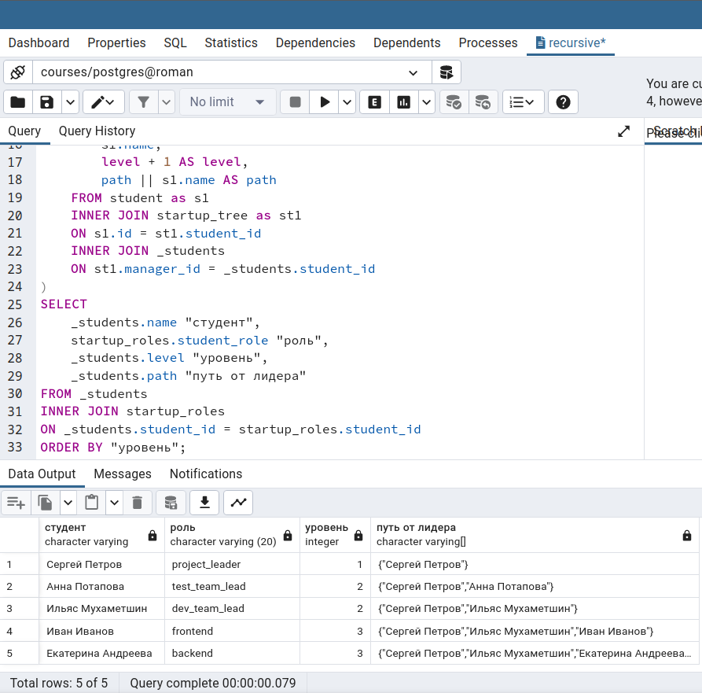

Задание С

WITH RECURSIVE _students AS (

SELECT

id,

manager_id,

student_name,

1 AS level,

array[student_name]::varchar[] AS path

FROM startup_tree

WHERE startup_tree.manager_id IS NULL

UNION

SELECT

st1.id,

st1.manager_id,

st1.student_name,

level + 1 AS level,

path || st1.student_name as path

FROM startup_tree as st1

INNER JOIN _students

ON st1.manager_id = _students.id

)

SELECT

_students.student_name as "студент",

roles.role as "роль",

_students.level as "уровень",

array_to_string(_students.path, '->') as "путь от лидера"

FROM _students

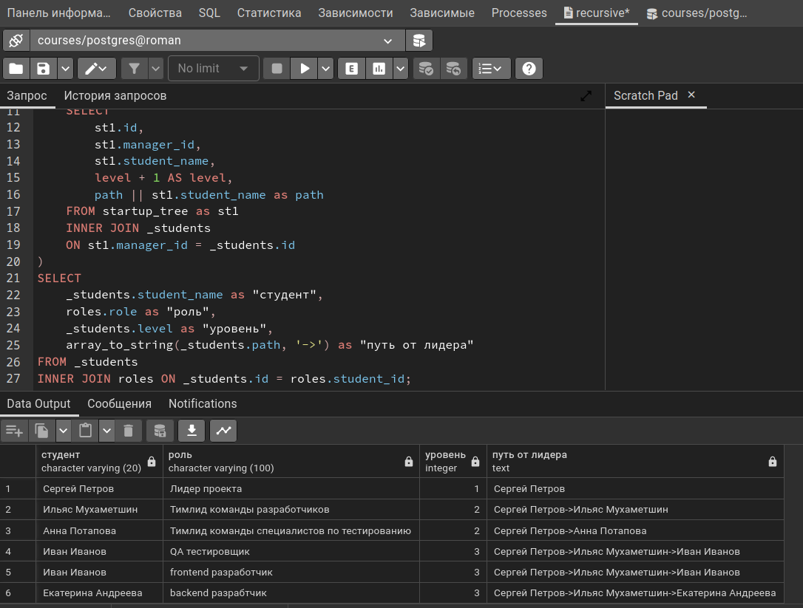INNER JOIN roles ON _students.id = roles.student_id;

Задание D

-- транзакция 1

begin;

update college

set size = size * 2

where id = 10

returning *;

--Транзакция 2

begin;

update college

set size = size * 2

where id = 20

returning *;

--Транзакция 1

update college

set size = size * 2

where id = 20

returning *;

--Транзакция 2

update college

set size = size * 2

where id = 10

returning *;

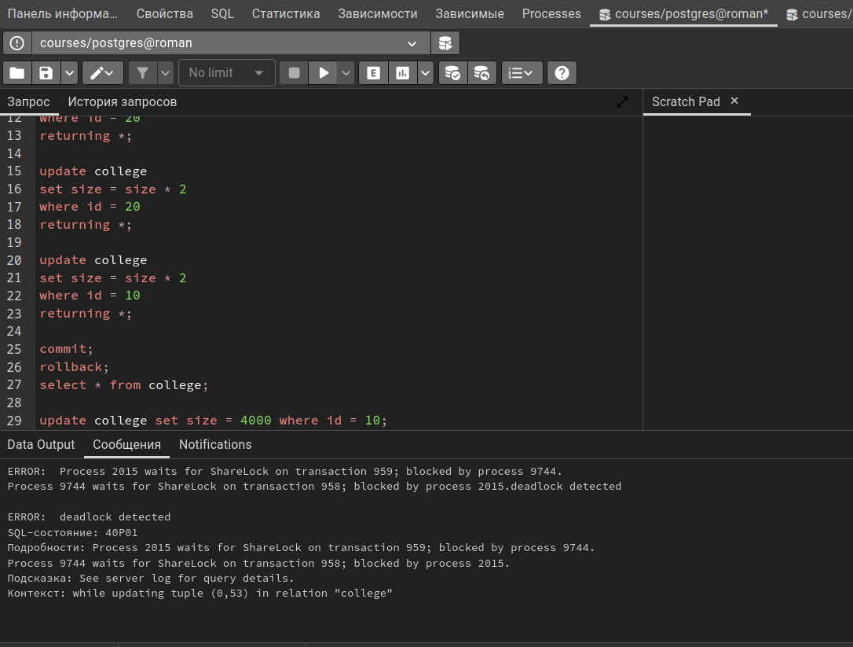--deadlock:

Задание E:

--Транзакция 1

begin transaction isolation level serializable;

update college

set size = size + 10

where id = 10;

--Транзакция 2

begin transaction isolation level serializable;

update college

set size = size + 10

where id = 10;

