1c)
The amount for computational work is equal among all threads for sufficiently large number of samples (generally, the workload is equal if the maximum iteration index can be divided by the number of threads; for N >> number of threads, this is approximately true). The workload will be dominated by the computations in the F function, which is called the same number of times from each thread.
For C1 and C3, the scaling is close to perfect since the threads access different cache lines. For C2 however, some threads might access the same cache line in which case communication between the threads is necessary such that all see the updated cache line. This limits the performance and is called false sharing.
For the serial code with a single random number generator and identical seed between the runs, the result will be the same.
For parallel code with multiple threads, each having its own seed, the result will differ between runs.

Intel® Core™ i7-8750H CPU
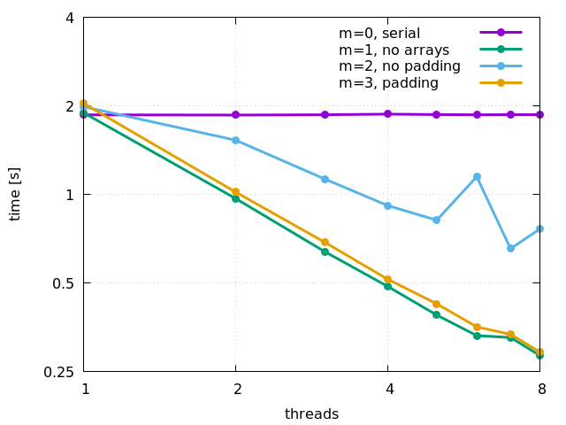

2)
There exists a race condition between updating good_members at position pos and the update of pos itself. Hence, following improvement is suggested:

...
void find_good_members()
{
#pragma omp parallel for
for(int i= 0; i< N; i++){
int pos2;
#pragma omp critical
{
pos2 = pos;
pos++;
}
good_members[pos2] = i;
}
}

