**Лабораторна робота №7**

# Тема: Створення блогу

**Хід роботи**

**Завдання для виконання ЛР:**

1) Створити БД з таблицями User, Post(Загаловок, текстовка,

категорія, хештеги),Category(Назва, напрям).

2) Реалізувати реєстрацію та авторизацію користувачів.

3) Організувати можливість перегляду постів, фільтрацію, пошук(за

датою, за категорію).

4) Додати до БД таблиці коментарів(коментар може залишати лише

авторизований користувач). За допомогою пагінації відображати

лише 2 останні коментаря, для решту розробити окрему сторінку.

5) Реалізувати зручний графічний інтерфейс(jQuery, Bootstrap)

6) * Розробити частину адміністратора. Адміністратор може

редагувати пости та коментарі(як модератор) усіх користувачів.

Змінювати дані користувача.

7) * Реалізувати можливість оцінки посту(лайки). Передбачити, що

один користувач може лише раз оцінити пост.

Виконання роботи:

**Index.php**

<?php

include("path.php");

include(ROOT_PATH . "/app/controllers/topics.php");

$posts = array();

$postsTitle = 'Recent Posts';

if (isset($_GET['t_id'])) {

  $posts = getPostsByTopicId($_GET['t_id']);

  $postsTitle = "You searched for posts under '" . $_GET['name'] . "'";

} else if (isset($_POST['search-term'])) {

  $postsTitle = "You searched for '" . $_POST['search-term'] . "'";

  $posts = searchPosts($_POST['search-term']);

} else {

  $posts = getPublishedPosts();

}

?>

<!DOCTYPE html>

<html lang="en">

<head>

  <meta charset="UTF-8">

  <meta name="viewport" content="width=device-width, initial-scale=1.0">

  <meta http-equiv="X-UA-Compatible" content="ie=edge">

  <!-- Font Awesome -->

  <link rel="stylesheet" href="https://use.fontawesome.com/releases/v5.7.2/css/all.css"

    integrity="sha384-fnmOCqbTlWIlj8LyTjo7mOUStjsKC4pOpQbqyi7RrhN7udi9RwhKkMHpvLbHG9Sr" crossorigin="anonymous">

  <!-- Google Fonts -->

  <link href="https://fonts.googleapis.com/css?family=Candal|Lora" rel="stylesheet">

  <!-- Custom Styling -->

  <link rel="stylesheet" href="assets/css/style.css">

  <title>Blog</title>

</head>

<body>

  <?php include(ROOT_PATH . "/app/includes/header.php"); ?>

  <?php include(ROOT_PATH . "/app/includes/messages.php"); ?>

  <!-- Page Wrapper -->

  <div class="page-wrapper">

    <!-- Post Slider -->

    <div class="post-slider">

      <h1 class="slider-title">Пости</h1>

      <i class="fas fa-chevron-left prev"></i>

      <i class="fas fa-chevron-right next"></i>

      <div class="post-wrapper">

        <?php foreach ($posts as $post): ?>

          <div class="post">

            <img src="<?php echo BASE_URL . '/assets/images/' . $post['image']; ?>" alt="" class="slider-image">

            <div class="post-info">

              <h4><a href="single.php?id=<?php echo $post['id']; ?>"><?php echo $post['title']; ?></a></h4>

              <i class="far fa-user"> <?php echo $post['username']; ?></i>

              &nbsp;

              <i class="far fa-calendar"> <?php echo date('F j, Y', strtotime($post['created_at'])); ?></i>

            </div>

          </div>

        <?php endforeach; ?>

      </div>

    </div>

    <!-- // Post Slider -->

    <!-- Content -->

    <div class="content clearfix">

      <!-- Main Content -->

      <div class="main-content">

        <h1 class="recent-post-title"><?php echo $postsTitle ?></h1>

        <?php foreach ($posts as $post): ?>

          <div class="post clearfix">

            <img src="<?php echo BASE_URL . '/assets/images/' . $post['image']; ?>" alt="" class="post-image">

            <div class="post-preview">

              <h2><a href="single.php?id=<?php echo $post['id']; ?>"><?php echo $post['title']; ?></a></h2>

              <i class="far fa-user"> <?php echo $post['username']; ?></i>

              &nbsp;

              <i class="far fa-calendar"> <?php echo date('F j, Y', strtotime($post['created_at'])); ?></i>

              <p class="preview-text">

                <?php echo html_entity_decode(substr($post['body'], 0, 150) . '...'); ?>

              </p>

              <a href="single.php?id=<?php echo $post['id']; ?>" class="btn read-more">Read More</a>

            </div>

          </div>

        <?php endforeach; ?>

      </div>

      <!-- // Main Content -->

      <div class="sidebar">

        <div class="section search">

          <h2 class="section-title">Search</h2>

          <form action="index.php" method="post">

            <input type="text" name="search-term" class="text-input" placeholder="Search...">

          </form>

        </div>

        <div class="section topics">

          <h2 class="section-title">Topics</h2>

          <ul>

            <?php foreach ($topics as $key => $topic): ?>

              <li><a href="<?php echo BASE_URL . '/index.php?t_id=' . $topic['id'] . '&name=' . $topic['name'] ?>"><?php echo $topic['name']; ?></a></li>

            <?php endforeach; ?>

          </ul>

        </div>

      </div>

    </div>

    <!-- // Content -->

  </div>

  <!-- // Page Wrapper -->

  <?php include(ROOT_PATH . "/app/includes/footer.php"); ?>

  <!-- JQuery -->

  <script src="https://cdnjs.cloudflare.com/ajax/libs/jquery/3.3.1/jquery.min.js"></script>

  <!-- Slick Carousel -->

  <script type="text/javascript" src="https://cdn.jsdelivr.net/npm/slick-carousel@1.8.1/slick/slick.min.js"></script>

  <!-- Custom Script -->

  <script src="assets/js/scripts.js"></script>

</body>

</html>

**Login.php**

<?php include('path.php'); ?>

<?php include(ROOT_PATH . "/app/controllers/users.php");

guestsOnly();

?>

<!DOCTYPE html>

<html lang="en">

<head>

  <meta charset="UTF-8">

  <meta name="viewport" content="width=device-width, initial-scale=1.0">

  <meta http-equiv="X-UA-Compatible" content="ie=edge">

  <!-- Font Awesome -->

  <link rel="stylesheet" href="https://use.fontawesome.com/releases/v5.7.2/css/all.css"

    integrity="sha384-fnmOCqbTlWIlj8LyTjo7mOUStjsKC4pOpQbqyi7RrhN7udi9RwhKkMHpvLbHG9Sr" crossorigin="anonymous">

  <!-- Google Fonts -->

  <link href="https://fonts.googleapis.com/css?family=Candal|Lora" rel="stylesheet">

  <!-- Custom Styling -->

  <link rel="stylesheet" href="assets/css/style.css">

  <title>Login</title>

</head>

<body>

<?php include(ROOT_PATH . "/app/includes/header.php"); ?>

  <div class="auth-content">

    <form action="login.php" method="post">

      <h2 class="form-title">Login</h2>

      <?php include(ROOT_PATH . "/app/helpers/formErrors.php"); ?>

      <div>

        <label>Username</label>

        <input type="text" name="username" value="<?php echo $username; ?>" class="text-input">

      </div>

      <div>

        <label>Password</label>

        <input type="password" name="password" value="<?php echo $password; ?>" class="text-input">

      </div>

      <div>

        <button type="submit" name="login-btn" class="btn btn-big">Login</button>

      </div>

      <p>Or <a href="<?php echo BASE_URL . '/register.php' ?>">Sign Up</a></p>

    </form>

  </div>

  <!-- JQuery -->

  <script src="https://cdnjs.cloudflare.com/ajax/libs/jquery/3.3.1/jquery.min.js"></script>

  <!-- Custom Script -->

  <script src="assets/js/scripts.js"></script>

</body>

</html>

**Logout.php**

<?php

include("path.php");

session_start();

unset($_SESSION['id']);

unset($_SESSION['username']);

unset($_SESSION['admin']);

unset($_SESSION['message']);

unset($_SESSION['type']);

session_destroy();

header('location: ' . BASE_URL . '/index.php');

**path.php**

<?php

define("ROOT_PATH", realpath(dirname(__FILE__)));

define("BASE_URL", "http://localhost/blog-php-mysql");

**register.php**

<?php include("path.php"); ?>

<?php include(ROOT_PATH . "/app/controllers/users.php");

guestsOnly();

?>

<!DOCTYPE html>

<html lang="en">

<head>

  <meta charset="UTF-8">

  <meta name="viewport" content="width=device-width, initial-scale=1.0">

  <meta http-equiv="X-UA-Compatible" content="ie=edge">

  <!-- Font Awesome -->

  <link rel="stylesheet" href="https://use.fontawesome.com/releases/v5.7.2/css/all.css"

    integrity="sha384-fnmOCqbTlWIlj8LyTjo7mOUStjsKC4pOpQbqyi7RrhN7udi9RwhKkMHpvLbHG9Sr" crossorigin="anonymous">

  <!-- Google Fonts -->

  <link href="https://fonts.googleapis.com/css?family=Candal|Lora" rel="stylesheet">

  <!-- Custom Styling -->

  <link rel="stylesheet" href="assets/css/style.css">

  <title>Register</title>

</head>

<body>

<?php include(ROOT_PATH . "/app/includes/header.php"); ?>

  <div class="auth-content">

    <form action="register.php" method="post">

      <h2 class="form-title">Register</h2>

      <?php include(ROOT_PATH . "/app/helpers/formErrors.php"); ?>

      <div>

        <label>Username</label>

        <input type="text" name="username" value="<?php echo $username; ?>" class="text-input" >

      </div>

      <div>

        <label>Email</label>

        <input type="email" name="email"  value="<?php echo $email; ?>" class="text-input">

      </div>

      <div>

        <label>Password</label>

        <input type="password" name="password"  value="<?php echo $password; ?>" class="text-input">

      </div>

      <div>

        <label>Password Confirmation</label>

        <input type="password" name="passwordConf"  value="<?php echo $passwordConf; ?>" class="text-input">

      </div>

      <div>

        <button type="submit" name="register-btn" class="btn btn-big">Register</button>

      </div>

      <p>Or <a href="<?php echo BASE_URL . '/login.php' ?>">Sign In</a></p>

    </form>

  </div>

  <!-- JQuery -->

  <script src="https://cdnjs.cloudflare.com/ajax/libs/jquery/3.3.1/jquery.min.js"></script>

  <!-- Custom Script -->

  <script src="assets/js/scripts.js"></script>

</body>

</html>

**Admin.css**

header {

    background: #01474a;

}

.admin-wrapper {

    display: flex;

    height: calc(100% - 66px);

}

.admin-wrapper .left-sidebar {

    flex: 2;

    height: 100%;

    background: #234a57;

}

.admin-wrapper .left-sidebar ul {

    list-style: none;

    margin: 0px;

    padding: 0px;

    color: aliceblue;

}

.admin-wrapper .left-sidebar ul li a {

    padding: 18px;

    display: block;

    border-bottom: 1px solid #004044;

}

.admin-wrapper .left-sidebar ul li a:hover {

    background: #004044;

}

.admin-wrapper .admin-content {

    flex: 8;

    height: 100%;

    padding: 40px 100px 100px;

    overflow-y: scroll;

}

.admin-content .page-title {

    text-align: center;

    margin-bottom: 1.5rem;

}

table {

    width: 100%;

    border-collapse: collapse;

    font-size: 1.1rem;

}

th,

td {

    padding: 15px;

    text-align: left;

    border-bottom: 1px solid #d3d3d3;

}

.edit {

    color: green;

}

.delete {

    color: red;

}

.publish {

    color: blue;

}

.edit:hover,

.delete:hover,

.publish:hover {

    text-decoration: underline;

}

form div {

    margin-bottom: 15px;

}

**Style.css**

* {

  box-sizing: border-box;

}

html,

body {

  height: 100%;

  padding: 0px;

  margin: 0px;

  background: #f6f6f6;

  font-family: "Lora", serif;

}

h1,

h2,

h3,

h4,

h5,

h6 {

  font-family: "Candal", serif;

  color: #5c5b5b;

  margin: 5px;

}

a {

  text-decoration: none;

  color: inherit;

}

.clearfix::after {

  content: "";

  display: block;

  clear: both;

}

.btn {

  padding: 0.5rem 1rem;

  background: #006669;

  color: white;

  border: 1px solid transparent;

  border-radius: 0.25rem;

  font-size: 1.08em;

  font-family: "Lora", serif;

}

.btn-big {

  padding: 0.7rem 1.3rem;

  line-height: 1.3rem;

}

.btn:hover {

  color: white !important;

  background: #005255;

}

.text-input {

  padding: 0.7rem 1rem;

  display: block;

  width: 100%;

  border-radius: 5px;

  border: 1px solid #e0e0e0;

  outline: none;

  color: #444;

  line-height: 1.5rem;

  font-size: 1.2em;

  font-family: "Lora", serif;

}

.msg {

  width: 100%;

  margin: 5px auto;

  padding: 8px;

  border-radius: 5px;

  list-style: none;

}

.success {

  color: #3a6e3a;

  border: 1px solid #3a6e3a;

  background: #bcf5bc;

}

.error {

  color: #884b4b;

  border: 1px solid #884b4b;

  background: #f5bcbc;

}

/* NAVBAR */

header {

  background: #008489;

  height: 66px;

}

header * {

  color: white;

}

header .logo {

  float: left;

  height: inherit;

  margin-left: 2em;

}

header .logo-text {

  margin: 9px;

  font-family: "Candal", serif;

}

header .logo-text span {

  color: #05f7ff;

}

header ul {

  float: right;

  margin: 0px;

  padding: 0px;

  list-style: none;

}

header ul li {

  float: left;

  position: relative;

}

header ul li ul {

  position: absolute;

  top: 66px;

  right: 0px;

  width: 180px;

  display: none;

  z-index: 88888;

}

header ul li:hover ul {

  display: block;

}

header ul li ul li {

  width: 100%;

}

header ul li ul li a {

  padding: 10px;

  background: white;

  color: #444;

}

header ul li ul li a.logout {

  color: red;

}

header ul li ul li a:hover {

  background: #d5d6d6;

}

header ul li a {

  display: block;

  padding: 21px;

  font-size: 1.1em;

  text-decoration: none;

}

header ul li a:hover {

  background: #006669;

  transition: 0.5s;

}

header .menu-toggle {

  display: none;

}

.page-wrapper {

  min-height: 100%;

}

.page-wrapper a:hover {

  color: #006669;

}

/* POST SLIDER */

.post-slider {

  position: relative;

}

.post-slider .slider-title {

  text-align: center;

  margin: 30px auto;

}

.post-slider .next {

  position: absolute;

  top: 50%;

  right: 30px;

  font-size: 2em;

  color: #006669;

  cursor: pointer;

}

.post-slider .prev {

  position: absolute;

  top: 50%;

  left: 30px;

  font-size: 2em;

  color: #006669;

  cursor: pointer;

}

.post-slider .post-wrapper {

  width: 84%;

  height: 350px;

  margin: 0px auto;

  overflow: hidden;

  padding: 10px 0px 10px 0px;

}

.post-slider .post-wrapper .post {

  width: 300px;

  height: 330px;

  margin: 0px 10px;

  display: inline-block;

  background: white;

  border-radius: 5px;

  box-shadow: 1rem 1rem 1rem -1rem #a0a0a033;

}

.post-slider .post-wrapper .post .post-info {

  height: 130px;

  padding: 0px 5px;

}

.post-slider .post-wrapper .post .slider-image {

  width: 100%;

  height: 200px;

  border-top-left-radius: 5px;

  border-top-right-radius: 5px;

}

/* CONTENT */

.content {

  width: 90%;

  margin: 30px auto 30px;

}

.content .main-content {

  width: 70%;

  float: left;

}

.content .main-content.single {

  background: white;

  padding: 20px 50px;

  font-size: 1.1em;

  border-radius: 5px;

}

.content .main-content.single .post-title {

  text-align: center;

  margin-bottom: 40px;

}

.content .main-content .post {

  width: 95%;

  height: 270px;

  margin: 20px auto;

  border-radius: 5px;

  background: white;

  position: relative;

}

.content .popular .post {

  border-top: 1px solid #e0e0e0;

  margin-top: 10px;

  padding-top: 10px;

}

.content .popular .post img {

  height: 60px;

  width: 75px;

  float: left;

  margin-right: 10px;

}

.content .main-content .post .post-preview i {

  color: #757575;

  font-size: 0.8em;

}

.content .main-content .post .preview-text {

  line-height: 1.5em;

  font-size: 1.03em;

  color: #444;

}

.content .main-content .post .read-more {

  position: absolute;

  bottom: 10px;

  right: 10px;

  border: 1px solid #006669;

  background: transparent;

  border-radius: 0px;

  color: #006669 !important;

}

.content .main-content .post .read-more:hover {

  background: #006669;

  color: white !important;

  transition: 0.25s;

}

.content .main-content .post .post-image {

  width: 40%;

  height: 100%;

  float: left;

  border-top-left-radius: 5px;

  border-bottom-left-radius: 5px;

}

.content .main-content .post .post-preview {

  width: 60%;

  padding: 10px;

  float: right;

}

.content .main-content .recent-post-title {

  margin: 20px;

}

.content .sidebar {

  width: 30%;

  float: left;

}

.content .sidebar.single {

  padding: 0px 10px;

}

.content .sidebar .section {

  background: white;

  padding: 20px;

  border-radius: 5px;

  margin-bottom: 20px;

}

.content .sidebar .section .section-title {

  margin: 10px 0px 10px 0px;

}

.content .sidebar .section.search {

  margin-top: 80px;

}

.content .sidebar .section.topics ul {

  margin: 0px;

  padding: 0px;

  list-style: none;

  border-top: 1px solid #e0e0e0;

}

.content .sidebar .section.topics ul li a {

  display: block;

  padding: 15px 0px 15px 0px;

  border-bottom: 1px solid #e0e0e0;

  transition: all 0.3s;

}

.content .sidebar .section.topics ul li a:hover {

  padding-left: 10px;

  transition: all 0.3s;

}

/* AUTH PAGES */

.auth-content {

  width: 30%;

  margin: 50px auto;

  padding: 20px;

  background: white;

  border-radius: 5px;

}

.auth-content .form-title {

  text-align: center;

}

.auth-content form div {

  margin-bottom: 10px;

}

.auth-content form p {

  text-align: center;

}

.auth-content form p a {

  text-decoration: underline;

}

/* FOOTER */

.footer {

  background: #303036;

  color: #d3d3d3;

  height: 400px;

  position: relative;

}

.footer .footer-content {

  height: 350px;

  display: flex;

}

.footer .footer-content .footer-section {

  flex: 1;

  padding: 25px;

}

.footer .footer-content h1,

.footer .footer-content h2 {

  color: white;

}

.footer .footer-content .about h1 span {

  color: #05f7ff;

}

.footer .footer-content .about .contact span {

  display: block;

  font-size: 1.1em;

  margin-bottom: 8px;

}

.footer .footer-content .about .socials a {

  border: 1px solid gray;

  width: 45px;

  height: 41px;

  padding-top: 5px;

  margin-right: 5px;

  text-align: center;

  display: inline-block;

  font-size: 1.3em;

  border-radius: 5px;

  transition: all 0.3s;

}

.footer .footer-content .about .socials a:hover {

  border: 1px solid white;

  color: white;

  transition: all 0.3s;

}

.footer .footer-content .links ul a {

  display: block;

  margin-bottom: 10px;

  font-size: 1.2em;

  transition: all 0.3s;

}

.footer .footer-content .links ul a:hover {

  color: white;

  margin-left: 15px;

  transition: all 0.3s;

}

.footer .footer-content .contact-form .contact-input {

  background: #272727;

  color: #bebdbd;

  margin-bottom: 10px;

  line-height: 1.5rem;

  padding: 0.9rem 1.4rem;

  border: none;

}

.footer .footer-content .contact-form .contact-input:focus {

  background: #1a1a1a;

}

.footer .footer-content .contact-form .contact-btn {

  float: right;

  font-size: 1.1em;

  font-family: "Lora", serif;

}

.footer .footer-bottom {

  background: #343a40;

  color: #686868;

  height: 50px;

  width: 100%;

  text-align: center;

  position: absolute;

  bottom: 0px;

  left: 0px;

  padding-top: 20px;

}

/* MEDIA QUERIES */

@media only screen and (max-width: 934px) {

  .content {

    width: 100%;

  }

  .auth-content {

    width: 50%;

  }

  .content .main-content .post {

    width: 100%;

  }

  .content .main-content {

    width: 100%;

    padding: 10px;

  }

  .content .sidebar {

    width: 100%;

    padding: 10px;

  }

  .content .sidebar .section.search {

    margin-top: 30px;

  }

  .footer {

    height: auto;

  }

  .footer .footer-content {

    height: auto;

    flex-direction: column;

  }

  .footer .footer-content .contact-form {

    padding-bottom: 90px;

  }

  .footer .footer-content .contact-form .contact-btn {

    width: 100%;

  }

}

@media only screen and (max-width: 770px) {

  header {

    position: relative;

  }

  .auth-content {

    width: 60%;

  }

  .main-content-wrapper {

    padding: 10px;

  }

  header ul {

    width: 100%;

    background: #0e94a0;

    max-height: 0px;

    overflow: hidden;

  }

  .showing {

    max-height: 100em;

  }

  header ul li {

    width: 100%;

  }

  header ul li ul {

    position: static;

    display: block;

    width: 100%;

  }

  header ul li ul li a {

    padding: 10px;

    background: #0e94a0;

    color: white;

    padding-left: 50px;

  }

  header ul li ul li a:hover {

    background: #006669;

  }

  header ul li ul li a.logout {

    color: red;

  }

  header .menu-toggle {

    display: block;

    position: absolute;

    right: 20px;

    top: 20px;

    font-size: 1.9em;

  }

  header .logo {

    margin-left: 0.5em;

  }

}

@media only screen and (max-width: 600px) {

  .content .main-content .post {

    height: auto;

  }

  .auth-content {

    width: 90%;

  }

  .content .main-content.single {

    padding: 10px 20px;

  }

  .content .main-content .post .post-image {

    width: 100%;

  }

  .content .main-content .post .post-preview {

    width: 100%;

  }

  .content .main-content .post .read-more {

    position: static;

    display: block;

    width: 100%;

    text-align: center;

  }

  .post-slider .next {

    right: 10px;

  }

  .post-slider .prev {

    left: 10px;

  }

}

**Script.js**

$(document).ready(function () {

    $(".menu-toggle").on("click", function () {

        $(".nav").toggleClass("showing");

        $(".nav ul").toggleClass("showing");

    });

    $(".post-wrapper").slick({

        slidesToShow: 3,

        slidesToScroll: 1,

        autoplay: true,

        autoplaySpeed: 2000,

        nextArrow: $(".next"),

        prevArrow: $(".prev"),

        responsive: [

            {

                breakpoint: 1024,

                settings: {

                    slidesToShow: 3,

                    slidesToScroll: 3,

                    infinite: true,

                    dots: true

                }

            },

            {

                breakpoint: 600,

                settings: {

                    slidesToShow: 2,

                    slidesToScroll: 2

                }

            },

            {

                breakpoint: 480,

                settings: {

                    slidesToShow: 1,

                    slidesToScroll: 1

                }

            }

            // You can unslick at a given breakpoint now by adding:

            // settings: "unslick"

            // instead of a settings object

        ]

    });

});

ClassicEditor.create(document.querySelector("#body"), {

    toolbar: [

        "heading",

        "|",

        "bold",

        "italic",

        "link",

        "bulletedList",

        "numberedList",

        "blockQuote"

    ],

    heading: {

        options: [

            { model: "paragraph", title: "Paragraph", class: "ck-heading_paragraph" },

            {

                model: "heading1",

                view: "h1",

                title: "Heading 1",

                class: "ck-heading_heading1"

            },

            {

                model: "heading2",

                view: "h2",

                title: "Heading 2",

                class: "ck-heading_heading2"

            }

        ]

    }

}).catch(error => {

    console.log(error);

});

**adminHeader.php**

<header>

    <a class="logo" href="<?php echo BASE_URL . '/index.php'; ?>">

        <h1 class="logo-text"><span>Блог </span>Роми</h1>

    </a>

    <i class="fa fa-bars menu-toggle"></i>

    <ul class="nav">

        <?php if (isset($_SESSION['username'])): ?>

            <li>

                <a href="#">

                    <i class="fa fa-user"></i>

                    <?php echo $_SESSION['username']; ?>

                    <i class="fa fa-chevron-down" style="font-size: .8em;"></i>

                </a>

                <ul>

                    <li><a href="<?php echo BASE_URL . '/logout.php'; ?>" class="logout">Logout</a></li>

                </ul>

            </li>

        <?php endif; ?>

    </ul>

</header>

**adminSlidebar.php**

<div class="left-sidebar">

    <ul>

        <li><a href="<?php echo BASE_URL . '/admin/posts/index.php'; ?>">Manage Posts</a></li>

        <li><a href="<?php echo BASE_URL . '/admin/users/index.php'; ?>">Manage Users</a></li>

        <li><a href="<?php echo BASE_URL . '/admin/topics/index.php'; ?>">Manage Topics</a></li>

    </ul>

</div>

**Footer.php**

<div class="left-sidebar">

    <ul>

        <li><a href="<?php echo BASE_URL . '/admin/posts/index.php'; ?>">Manage Posts</a></li>

        <li><a href="<?php echo BASE_URL . '/admin/users/index.php'; ?>">Manage Users</a></li>

        <li><a href="<?php echo BASE_URL . '/admin/topics/index.php'; ?>">Manage Topics</a></li>

    </ul>

</div>

**Header.php**

<header>

    <a href="<?php echo BASE_URL . '/index.php' ?>" class="logo">

      <h1 class="logo-text"><span>Блог </span>Роми</h1>

    </a>

    <i class="fa fa-bars menu-toggle"></i>

    <ul class="nav">

      <li><a href="<?php echo BASE_URL . '/index.php' ?>">Home</a></li>

      <?php if (isset($_SESSION['id'])): ?>

        <li>

          <a href="#">

            <i class="fa fa-user"></i>

            <?php echo $_SESSION['username']; ?>

            <i class="fa fa-chevron-down" style="font-size: .8em;"></i>

          </a>

          <ul>

            <?php if($_SESSION['admin']): ?>

              <li><a href="<?php echo BASE_URL . '/admin/dashboard.php' ?>">Dashboard</a></li>

            <?php endif; ?>

            <li><a href="<?php echo BASE_URL . '/logout.php' ?>" class="logout">Logout</a></li>

          </ul>

        </li>

      <?php else: ?>

        <li><a href="<?php echo BASE_URL . '/register.php' ?>">Sign Up</a></li>

        <li><a href="<?php echo BASE_URL . '/login.php' ?>">Login</a></li>

      <?php endif; ?>

    </ul>

</header>

**Messages.php**

<?php if(isset($_SESSION['message'])): ?>

  <div class="msg <?php echo $_SESSION['type']; ?>">

    <li><?php echo $_SESSION['message']; ?></li>

    <?php

      unset($_SESSION['message']);

      unset($_SESSION['type']);

    ?>

  </div>

<?php endif; ?>

**Post.php**

<?php

include(ROOT_PATH . "/app/database/db.php");

include(ROOT_PATH . "/app/helpers/middleware.php");

include(ROOT_PATH . "/app/helpers/validatePost.php");

$table = 'posts';

$topics = selectAll('topics');

$posts = selectAll($table);

$errors = array();

$id = "";

$title = "";

$body = "";

$topic_id = "";

$published = "";

if (isset($_GET['id'])) {

    $post = selectOne($table, ['id' => $_GET['id']]);

    $id = $post['id'];

    $title = $post['title'];

    $body = $post['body'];

    $topic_id = $post['topic_id'];

    $published = $post['published'];

}

if (isset($_GET['delete_id'])) {

    adminOnly();

    $count = delete($table, $_GET['delete_id']);

    $_SESSION['message'] = "Post deleted successfully";

    $_SESSION['type'] = "success";

    header("location: " . BASE_URL . "/admin/posts/index.php");

    exit();

}

if (isset($_GET['published']) && isset($_GET['p_id'])) {

    adminOnly();

    $published = $_GET['published'];

    $p_id = $_GET['p_id'];

    $count = update($table, $p_id, ['published' => $published]);

    $_SESSION['message'] = "Post published state changed!";

    $_SESSION['type'] = "success";

    header("location: " . BASE_URL . "/admin/posts/index.php");

    exit();

}

if (isset($_POST['add-post'])) {

    adminOnly();

    $errors = validatePost($_POST);

    if (!empty($_FILES['image']['name'])) {

        $image_name = time() . '_' . $_FILES['image']['name'];

        $destination = ROOT_PATH . "/assets/images/" . $image_name;

        $result = move_uploaded_file($_FILES['image']['tmp_name'], $destination);

        if ($result) {

           $_POST['image'] = $image_name;

        } else {

            array_push($errors, "Failed to upload image");

        }

    } else {

       array_push($errors, "Post image required");

    }

    if (count($errors) == 0) {

        unset($_POST['add-post']);

        $_POST['user_id'] = $_SESSION['id'];

        $_POST['published'] = isset($_POST['published']) ? 1 : 0;

        $_POST['body'] = htmlentities($_POST['body']);

        $post_id = create($table, $_POST);

        $_SESSION['message'] = "Post created successfully";

        $_SESSION['type'] = "success";

        header("location: " . BASE_URL . "/admin/posts/index.php");

        exit();

    } else {

        $title = $_POST['title'];

        $body = $_POST['body'];

        $topic_id = $_POST['topic_id'];

        $published = isset($_POST['published']) ? 1 : 0;

    }

}

if (isset($_POST['update-post'])) {

    adminOnly();

    $errors = validatePost($_POST);

    if (!empty($_FILES['image']['name'])) {

        $image_name = time() . '_' . $_FILES['image']['name'];

        $destination = ROOT_PATH . "/assets/images/" . $image_name;

        $result = move_uploaded_file($_FILES['image']['tmp_name'], $destination);

        if ($result) {

           $_POST['image'] = $image_name;

        } else {

            array_push($errors, "Failed to upload image");

        }

    } else {

       array_push($errors, "Post image required");

    }

    if (count($errors) == 0) {

        $id = $_POST['id'];

        unset($_POST['update-post'], $_POST['id']);

        $_POST['user_id'] = $_SESSION['id'];

        $_POST['published'] = isset($_POST['published']) ? 1 : 0;

        $_POST['body'] = htmlentities($_POST['body']);

        $post_id = update($table, $id, $_POST);

        $_SESSION['message'] = "Post updated successfully";

        $_SESSION['type'] = "success";

        header("location: " . BASE_URL . "/admin/posts/index.php");

    } else {

        $title = $_POST['title'];

        $body = $_POST['body'];

        $topic_id = $_POST['topic_id'];

        $published = isset($_POST['published']) ? 1 : 0;

    }

}

**Topics.php**

<?php

include(ROOT_PATH . "/app/database/db.php");

include(ROOT_PATH . "/app/helpers/middleware.php");

include(ROOT_PATH . "/app/helpers/validateTopic.php");

$table = 'topics';

$errors = array();

$id = '';

$name = '';

$description = '';

$topics = selectAll($table);

if (isset($_POST['add-topic'])) {

    adminOnly();

    $errors = validateTopic($_POST);

    if (count($errors) === 0) {

        unset($_POST['add-topic']);

        $topic_id = create($table, $_POST);

        $_SESSION['message'] = 'Topic created successfully';

        $_SESSION['type'] = 'success';

        header('location: ' . BASE_URL . '/admin/topics/index.php');

        exit();

    } else {

        $name = $_POST['name'];

        $description = $_POST['description'];

    }

}

if (isset($_GET['id'])) {

    $id = $_GET['id'];

    $topic = selectOne($table, ['id' => $id]);

    $id = $topic['id'];

    $name = $topic['name'];

    $description = $topic['description'];

}

if (isset($_GET['del_id'])) {

    adminOnly();

    $id = $_GET['del_id'];

    $count = delete($table, $id);

    $_SESSION['message'] = 'Topic deleted successfully';

    $_SESSION['type'] = 'success';

    header('location: ' . BASE_URL . '/admin/topics/index.php');

    exit();

}

if (isset($_POST['update-topic'])) {

    adminOnly();

    $errors = validateTopic($_POST);

    if (count($errors) === 0) {

        $id = $_POST['id'];

        unset($_POST['update-topic'], $_POST['id']);

        $topic_id = update($table, $id, $_POST);

        $_SESSION['message'] = 'Topic updated successfully';

        $_SESSION['type'] = 'success';

        header('location: ' . BASE_URL . '/admin/topics/index.php');

        exit();

    } else {

        $id = $_POST['id'];

        $name = $_POST['name'];

        $description = $_POST['description'];

    }

}

**Users.php**

<?php

include(ROOT_PATH . "/app/database/db.php");

include(ROOT_PATH . "/app/helpers/middleware.php");

include(ROOT_PATH . "/app/helpers/validateUser.php");

$table = 'users';

$admin_users = selectAll($table);

$errors = array();

$id = '';

$username = '';

$admin = '';

$email = '';

$password = '';

$passwordConf = '';

function loginUser($user)

{

    $_SESSION['id'] = $user['id'];

    $_SESSION['username'] = $user['username'];

    $_SESSION['admin'] = $user['admin'];

    $_SESSION['message'] = 'You are now logged in';

    $_SESSION['type'] = 'success';

    if ($_SESSION['admin']) {

        header('location: ' . BASE_URL . '/admin/dashboard.php');

    } else {

        header('location: ' . BASE_URL . '/index.php');

    }

    exit();

}

if (isset($_POST['register-btn']) || isset($_POST['create-admin'])) {

    $errors = validateUser($_POST);

    if (count($errors) === 0) {

        unset($_POST['register-btn'], $_POST['passwordConf'], $_POST['create-admin']);

        $_POST['password'] = password_hash($_POST['password'], PASSWORD_DEFAULT);

        if (isset($_POST['admin'])) {

            $_POST['admin'] = 1;

            $user_id = create($table, $_POST);

            $_SESSION['message'] = 'Admin user created';

            $_SESSION['type'] = 'success';

            header('location: ' . BASE_URL . '/admin/users/index.php');

            exit();

        } else {

            $_POST['admin'] = 0;

            $user_id = create($table, $_POST);

            $user = selectOne($table, ['id' => $user_id]);

            loginUser($user);

        }

    } else {

        $username = $_POST['username'];

        $admin = isset($_POST['admin']) ? 1 : 0;

        $email = $_POST['email'];

        $password = $_POST['password'];

        $passwordConf = $_POST['passwordConf'];

    }

}

if (isset($_POST['update-user'])) {

    adminOnly();

    $errors = validateUser($_POST);

    if (count($errors) === 0) {

        $id = $_POST['id'];

        unset($_POST['passwordConf'], $_POST['update-user'], $_POST['id']);

        $_POST['password'] = password_hash($_POST['password'], PASSWORD_DEFAULT);

        $_POST['admin'] = isset($_POST['admin']) ? 1 : 0;

        $count = update($table, $id, $_POST);

        $_SESSION['message'] = 'Admin user created';

        $_SESSION['type'] = 'success';

        header('location: ' . BASE_URL . '/admin/users/index.php');

        exit();

    } else {

        $username = $_POST['username'];

        $admin = isset($_POST['admin']) ? 1 : 0;

        $email = $_POST['email'];

        $password = $_POST['password'];

        $passwordConf = $_POST['passwordConf'];

    }

}

if (isset($_GET['id'])) {

    $user = selectOne($table, ['id' => $_GET['id']]);

    $id = $user['id'];

    $username = $user['username'];

    $admin = $user['admin'];

    $email = $user['email'];

}

if (isset($_POST['login-btn'])) {

    $errors = validateLogin($_POST);

    if (count($errors) === 0) {

        $user = selectOne($table, ['username' => $_POST['username']]);

        if ($user && password_verify($_POST['password'], $user['password'])) {

            loginUser($user);

        } else {

           array_push($errors, 'Wrong credentials');

        }

    }

    $username = $_POST['username'];

    $password = $_POST['password'];

}

if (isset($_GET['delete_id'])) {

    adminOnly();

    $count = delete($table, $_GET['delete_id']);

    $_SESSION['message'] = 'Admin user deleted';

    $_SESSION['type'] = 'success';

    header('location: ' . BASE_URL . '/admin/users/index.php');

    exit();

}

**Db.php**

<?php

session_start();

require('connect.php');

function dd($value) // to be deleted

{

    echo "<pre>", print_r($value, true), "</pre>";

    die();

}

function executeQuery($sql, $data)

{

    global $conn;

    $stmt = $conn->prepare($sql);

    $values = array_values($data);

    $types = str_repeat('s', count($values));

    $stmt->bind_param($types, ...$values);

    $stmt->execute();

    return $stmt;

}

function selectAll($table, $conditions = [])

{

    global $conn;

    $sql = "SELECT * FROM $table";

    if (empty($conditions)) {

        $stmt = $conn->prepare($sql);

        $stmt->execute();

        $records = $stmt->get_result()->fetch_all(MYSQLI_ASSOC);

        return $records;

    } else {

        $i = 0;

        foreach ($conditions as $key => $value) {

            if ($i === 0) {

                $sql = $sql . " WHERE $key=?";

            } else {

                $sql = $sql . " AND $key=?";

            }

            $i++;

        }

        $stmt = executeQuery($sql, $conditions);

        $records = $stmt->get_result()->fetch_all(MYSQLI_ASSOC);

        return $records;

    }

}

function selectOne($table, $conditions)

{

    global $conn;

    $sql = "SELECT * FROM $table";

    $i = 0;

    foreach ($conditions as $key => $value) {

        if ($i === 0) {

            $sql = $sql . " WHERE $key=?";

        } else {

            $sql = $sql . " AND $key=?";

        }

        $i++;

    }

    $sql = $sql . " LIMIT 1";

    $stmt = executeQuery($sql, $conditions);

    $records = $stmt->get_result()->fetch_assoc();

    return $records;

}

function create($table, $data)

{

    global $conn;

    $sql = "INSERT INTO $table SET ";

    $i = 0;

    foreach ($data as $key => $value) {

        if ($i === 0) {

            $sql = $sql . " $key=?";

        } else {

            $sql = $sql . ", $key=?";

        }

        $i++;

    }

    $stmt = executeQuery($sql, $data);

    $id = $stmt->insert_id;

    return $id;

}

function update($table, $id, $data)

{

    global $conn;

    $sql = "UPDATE $table SET ";

    $i = 0;

    foreach ($data as $key => $value) {

        if ($i === 0) {

            $sql = $sql . " $key=?";

        } else {

            $sql = $sql . ", $key=?";

        }

        $i++;

    }

    $sql = $sql . " WHERE id=?";

    $data['id'] = $id;

    $stmt = executeQuery($sql, $data);

    return $stmt->affected_rows;

}

function delete($table, $id)

{

    global $conn;

    $sql = "DELETE FROM $table WHERE id=?";

    $stmt = executeQuery($sql, ['id' => $id]);

    return $stmt->affected_rows;

}

function getPublishedPosts()

{

    global $conn;

    $sql = "SELECT p.*, u.username FROM posts AS p JOIN users AS u ON p.user_id=u.id WHERE p.published=?";

    $stmt = executeQuery($sql, ['published' => 1]);

    $records = $stmt->get_result()->fetch_all(MYSQLI_ASSOC);

    return $records;

}

function getPostsByTopicId($topic_id)

{

    global $conn;

    $sql = "SELECT p.*, u.username FROM posts AS p JOIN users AS u ON p.user_id=u.id WHERE p.published=? AND topic_id=?";

    $stmt = executeQuery($sql, ['published' => 1, 'topic_id' => $topic_id]);

    $records = $stmt->get_result()->fetch_all(MYSQLI_ASSOC);

    return $records;

}

function searchPosts($term)

{

    $match = '%' . $term . '%';

    global $conn;

    $sql = "SELECT

                p.*, u.username

            FROM posts AS p

            JOIN users AS u

            ON p.user_id=u.id

            WHERE p.published=?

            AND p.title LIKE ? OR p.body LIKE ?";

    $stmt = executeQuery($sql, ['published' => 1, 'title' => $match, 'body' => $match]);

    $records = $stmt->get_result()->fetch_all(MYSQLI_ASSOC);

    return $records;

}

**Connect.php**

<?php

session_start();

require('connect.php');

function dd($value) // to be deleted

{

    echo "<pre>", print_r($value, true), "</pre>";

    die();

}

function executeQuery($sql, $data)

{

    global $conn;

    $stmt = $conn->prepare($sql);

    $values = array_values($data);

    $types = str_repeat('s', count($values));

    $stmt->bind_param($types, ...$values);

    $stmt->execute();

    return $stmt;

}

function selectAll($table, $conditions = [])

{

    global $conn;

    $sql = "SELECT * FROM $table";

    if (empty($conditions)) {

        $stmt = $conn->prepare($sql);

        $stmt->execute();

        $records = $stmt->get_result()->fetch_all(MYSQLI_ASSOC);

        return $records;

    } else {

        $i = 0;

        foreach ($conditions as $key => $value) {

            if ($i === 0) {

                $sql = $sql . " WHERE $key=?";

            } else {

                $sql = $sql . " AND $key=?";

            }

            $i++;

        }

        $stmt = executeQuery($sql, $conditions);

        $records = $stmt->get_result()->fetch_all(MYSQLI_ASSOC);

        return $records;

    }

}

function selectOne($table, $conditions)

{

    global $conn;

    $sql = "SELECT * FROM $table";

    $i = 0;

    foreach ($conditions as $key => $value) {

        if ($i === 0) {

            $sql = $sql . " WHERE $key=?";

        } else {

            $sql = $sql . " AND $key=?";

        }

        $i++;

    }

    $sql = $sql . " LIMIT 1";

    $stmt = executeQuery($sql, $conditions);

    $records = $stmt->get_result()->fetch_assoc();

    return $records;

}

function create($table, $data)

{

    global $conn;

    $sql = "INSERT INTO $table SET ";

    $i = 0;

    foreach ($data as $key => $value) {

        if ($i === 0) {

            $sql = $sql . " $key=?";

        } else {

            $sql = $sql . ", $key=?";

        }

        $i++;

    }

    $stmt = executeQuery($sql, $data);

    $id = $stmt->insert_id;

    return $id;

}

function update($table, $id, $data)

{

    global $conn;

    $sql = "UPDATE $table SET ";

    $i = 0;

    foreach ($data as $key => $value) {

        if ($i === 0) {

            $sql = $sql . " $key=?";

        } else {

            $sql = $sql . ", $key=?";

        }

        $i++;

    }

    $sql = $sql . " WHERE id=?";

    $data['id'] = $id;

    $stmt = executeQuery($sql, $data);

    return $stmt->affected_rows;

}

function delete($table, $id)

{

    global $conn;

    $sql = "DELETE FROM $table WHERE id=?";

    $stmt = executeQuery($sql, ['id' => $id]);

    return $stmt->affected_rows;

}

function getPublishedPosts()

{

    global $conn;

    $sql = "SELECT p.*, u.username FROM posts AS p JOIN users AS u ON p.user_id=u.id WHERE p.published=?";

    $stmt = executeQuery($sql, ['published' => 1]);

    $records = $stmt->get_result()->fetch_all(MYSQLI_ASSOC);

    return $records;

}

function getPostsByTopicId($topic_id)

{

    global $conn;

    $sql = "SELECT p.*, u.username FROM posts AS p JOIN users AS u ON p.user_id=u.id WHERE p.published=? AND topic_id=?";

    $stmt = executeQuery($sql, ['published' => 1, 'topic_id' => $topic_id]);

    $records = $stmt->get_result()->fetch_all(MYSQLI_ASSOC);

    return $records;

}

function searchPosts($term)

{

    $match = '%' . $term . '%';

    global $conn;

    $sql = "SELECT

                p.*, u.username

            FROM posts AS p

            JOIN users AS u

            ON p.user_id=u.id

            WHERE p.published=?

            AND p.title LIKE ? OR p.body LIKE ?";

    $stmt = executeQuery($sql, ['published' => 1, 'title' => $match, 'body' => $match]);

    $records = $stmt->get_result()->fetch_all(MYSQLI_ASSOC);

    return $records;

}

**Зразки виконання:**

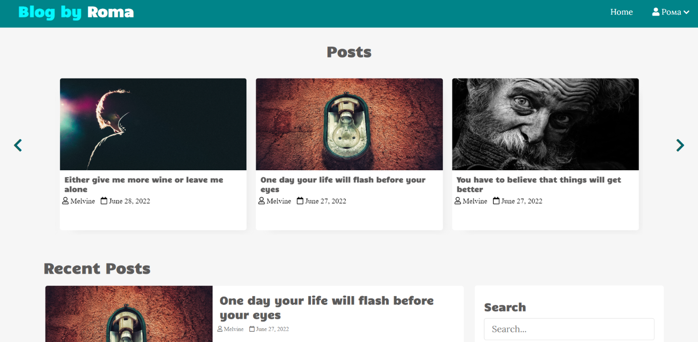

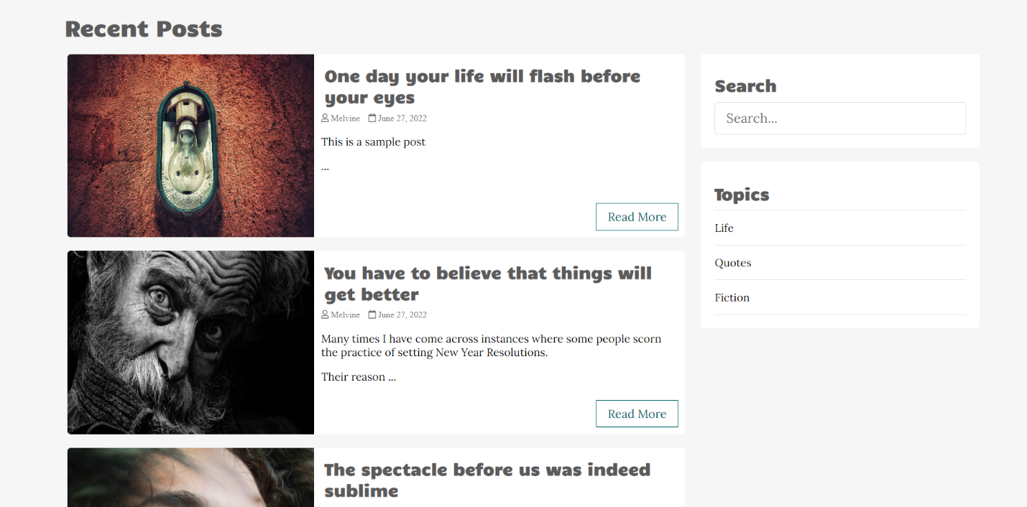

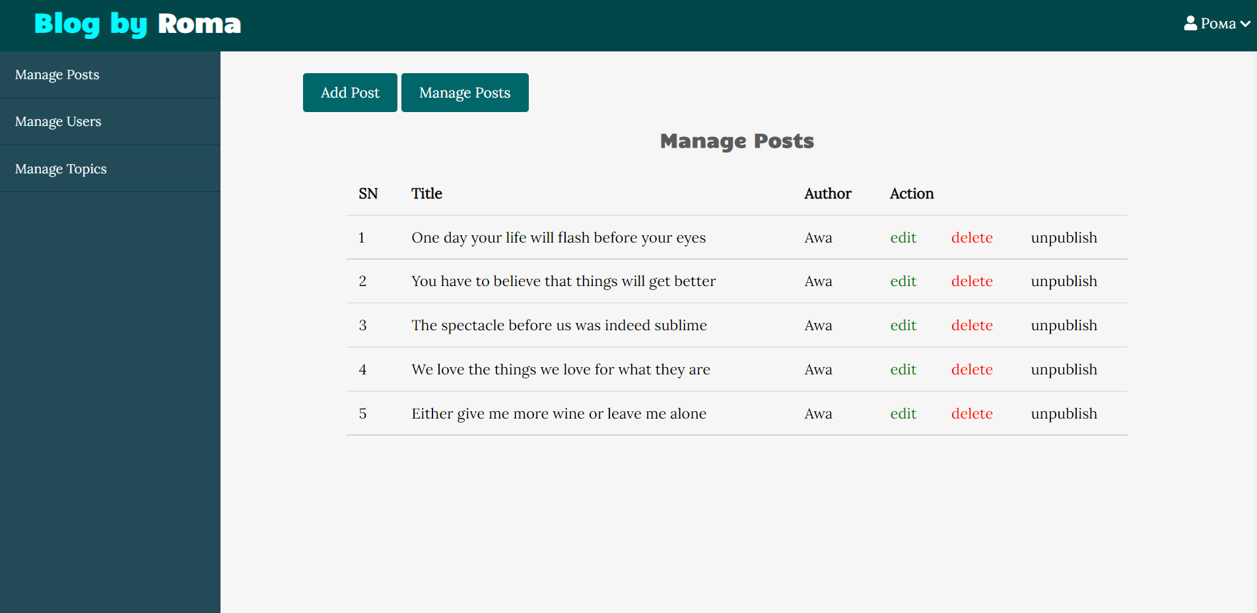

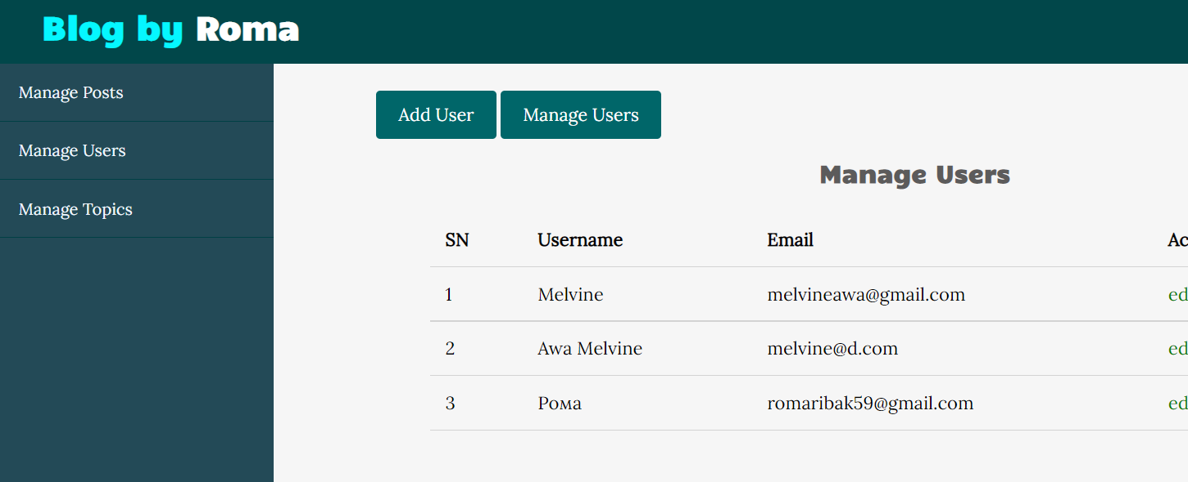

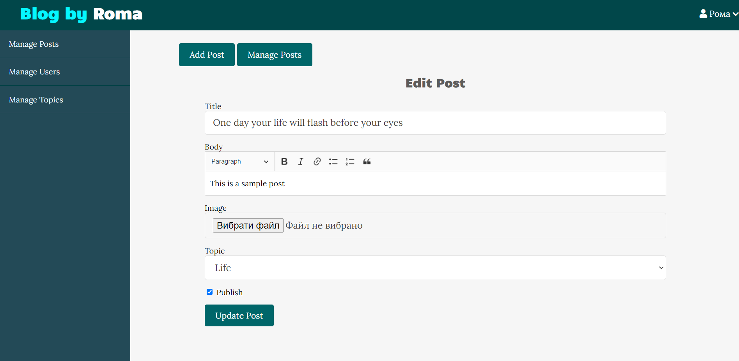

**Висновок:** На цій лабораторній роботі я пробував створювати власний блог на мові програмування PHP з підключенням до PHPMyAdmin.