Modern Methods of Data Analysis
Group Project — Report on Exploratory Data Analysis
Project: Cyberbullying Tweets Classification
Faculty of Computer Science — 1st year master students
Authors: Gorelskii Roman, Radaeva Karina, Plohotnyuk Valeria

1. Problem statement
The goal of the project is to build a supervised classifier that, given the raw text of a tweet, predicts whether the tweet is an instance of cyberbullying and, if so, of which type. The label space contains six mutually exclusive classes: age, ethnicity, gender, religion, other_cyberbullying, and not_cyberbullying. The task is therefore a multi-class single-label text classification problem on short, noisy, user-generated content from Twitter.
The motivation is practical: automated detection of harmful content is one of the core applications of NLP for online safety, and a fine-grained typology (rather than a binary bullying / non-bullying split) is useful for downstream moderation pipelines, where different categories may trigger different policies. Within this project, the research goals for the data-analysis pipeline are:
- to analyze and preprocess data,
- to extract per-class linguistic signal that can guide feature engineering,
- to find patterns and classify tweets by classes.

2. Dataset summary

2.1. Source and high-level overview
The dataset is publicly available Cyberbullying Classification corpus published by Larxel on Kaggle (https://www.kaggle.com/datasets/andrewmvd/cyberbullying-classification), originally collected and described in Wang, Fu, Lu (2020). SOSNet: A Graph Convolutional Network Approach to Fine-Grained Cyberbullying Detection (IEEE Big Data 2020). The data consists of mostly English tweets that were sampled and labelled into one of six categories of cyberbullying or non-cyberbullying.
The CSV file (cyberbullying_tweets.csv) contains 47,692 labelled tweets and two columns:
- tweet_text – raw textual content of a tweet (string).
- cyberbullying_type – class label (categorical, 6 levels).
There are no missing values in either column. The dataset is large enough to satisfy the assignment constraint of at least 50 objects with at least 7-10 (potentially engineered) features: although the raw schema has only one feature, vectorised text representations such as bag-of-words, TF-IDF n-grams, and tweet-level meta-features (length, hashtag/URL/mention counts, share of non-ASCII characters, etc.) easily supply hundreds of derived features, of which the ones used in this work are introduced in Section 3.
Property | Value
Number of tweets (rows) | 47,692
Number of columns | 2
Missing values | 0 in tweet_text, 0 in cyberbullying_type
Exact duplicate rows | 36
Duplicate tweet_text values | 1,675
Number of classes | 6
Unique tokens (regex tokenizer, lower-cased) | 62,663
Table 1. Basic dataset statistics.

2.2. Class distribution
The label distribution is almost perfectly balanced – every class contains between 7,823 and 7,998 tweets, i.e. each class accounts for approximately 16.4–16.8% of the total. This is a deliberate design choice of the original dataset's authors and is very convenient for modelling: it removes the need for class re-weighting, oversampling or stratified loss functions to combat class imbalance, and it allows accuracy-based metrics to remain meaningful. We will, however, still report macro-averaged precision, recall and F1 to make per-class behaviour explicit, since some classes (in particular other_cyberbullying) are likely to be linguistically less coherent than others.
Class | Count | Share, %
religion | 7,998 | 16.77
age | 7,992 | 16.76
gender | 7,973 | 16.72
ethnicity | 7,961 | 16.69
not_cyberbullying | 7,945 | 16.66
other_cyberbullying | 7,823 | 16.40
Table 2. Class distribution.
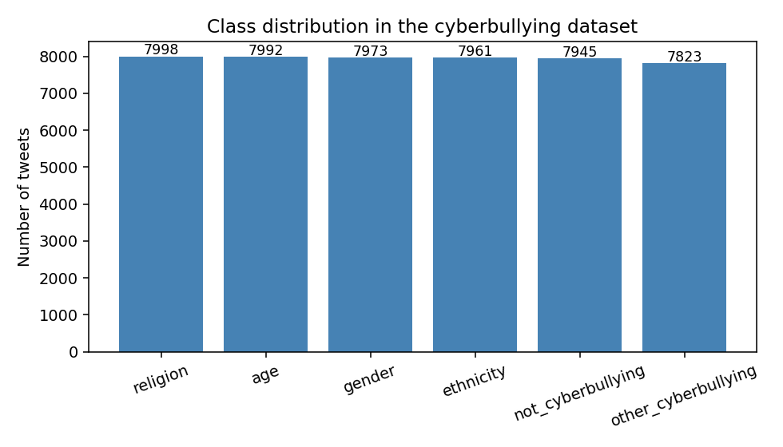
Figure 1. Class distribution of the cyberbullying dataset (almost balanced).

2.3. Tweet length
Two length statistics were computed on the raw text: number of characters and number of tokens (words + punctuation as defined by the regex tokenizer used in the notebook). Globally, tweets are short and have a strongly right-skewed length distribution, which is consistent with the platform's historical 140/280-character limit:
Statistic | Characters | Tokens
min | 1 | 0
25% | 78 | 13
median | 124 | 20
75% | 180 | 32
max | 5,018 | 912
mean | 136.3 | 23.7
std | 85.2 | 15.4
Table 3. Length statistics over all 47,692 tweets.
The maximum length (5,018 characters / 912 tokens) is most likely an outlier – the platform limit makes such values impossible for legitimate tweets, so these records are most likely concatenations of multiple tweets, retweet chains, or noise introduced during data collection. They will be flagged for inspection and possibly truncated or removed at the preprocessing stage.
Length is far from class-independent: per-class averages span a factor of more than two.
Class | Char mean | Char median | Tokens mean | Tokens median | Tokens std
age | 173.5 | 171 | 34.6 | 34 | 16.2
religion | 198.0 | 212 | 36.5 | 39 | 14.3
ethnicity | 139.3 | 126 | 27.0 | 24 | 15.6
gender | 136.4 | 129 | 26.0 | 23 | 14.1
other_cyberbullying | 85.7 | 83 | 16.0 | 16 | 17.1
not_cyberbullying | 83.1 | 81 | 15.2 | 15 | 8.5
Table 4. Per-class length statistics.
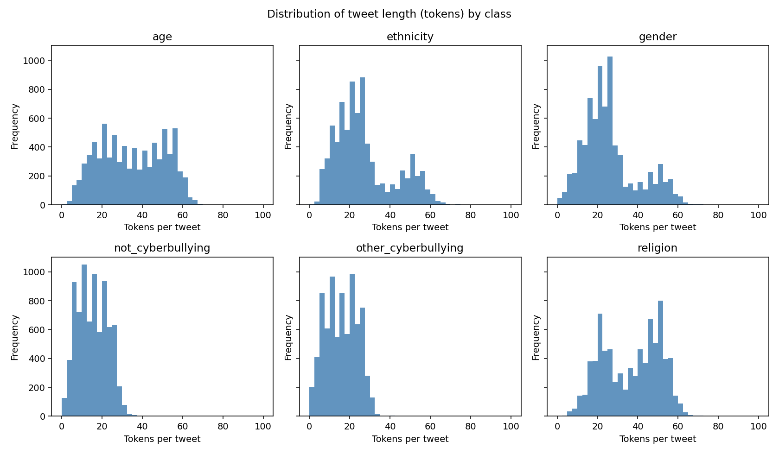
Figure 2. Distribution of tweet length (in tokens) per class.
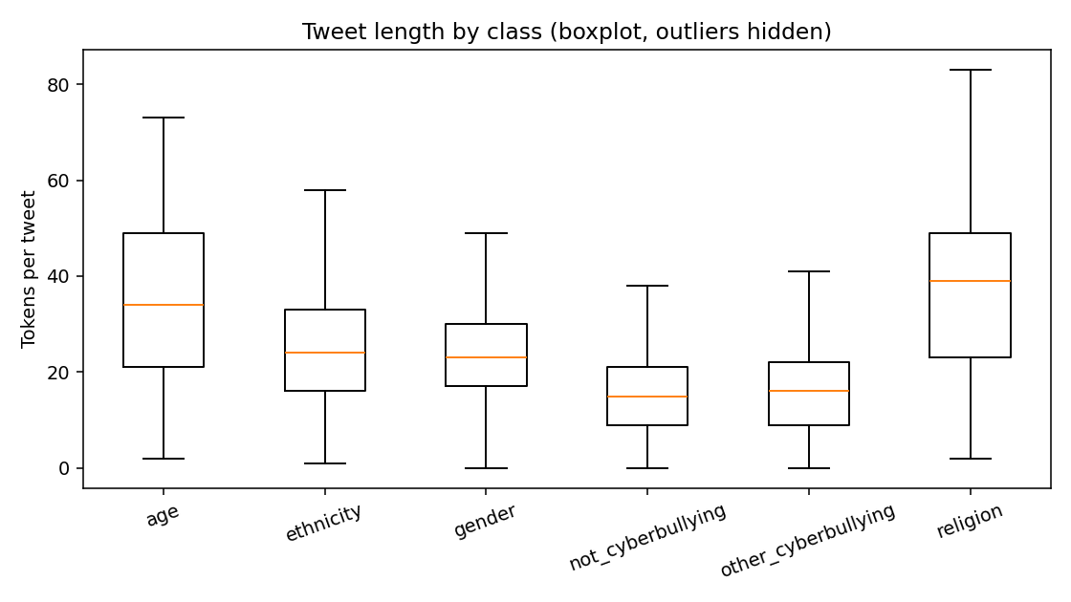
Figure 3. Tweet length per class (boxplot, outliers hidden).
Two patterns are visible. First, religion and age tweets are systematically longer (median 39 and 34 tokens), which reflects the fact that tweets in these classes often describe personal narratives or quote longer arguments. Second, not_cyberbullying and other_cyberbullying are the shortest (median ~15–16 tokens) and have the heaviest right tails (the std of other_cyberbullying token count is 17.1, larger than its mean), which we attribute to the residual nature of the other_cyberbullying class – it appears to absorb tweets that did not fit any of the four targeted categories and is therefore more heterogeneous. Length alone is already a moderately discriminative feature and will be added to the feature set as a numerical meta-feature.

2.4. Twitter-specific tokens (URLs, mentions, hashtags)
Twitter syntax leaves easily identifiable artefacts in the text. Across the corpus, 9.0% of tweets contain at least one URL, 38.0% contain at least one @mention, and 14.6% contain at least one #hashtag. Their per-class behaviour is informative:
Class | Mean URLs | Mean @mentions | Mean #hashtags
not_cyberbullying | 0.149 | 0.776 | 0.412
other_cyberbullying | 0.177 | 0.861 | 0.208
gender | 0.108 | 0.569 | 0.338
religion | 0.070 | 0.518 | 0.225
ethnicity | 0.044 | 0.616 | 0.140
age | 0.026 | 0.065 | 0.092
Table 5. Mean number of URLs, @mentions and #hashtags per tweet, by class.
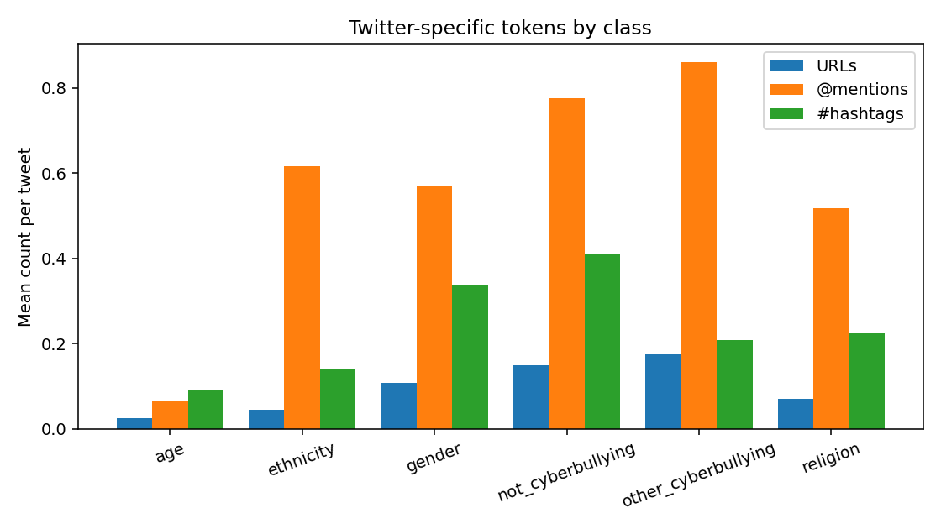
Figure 4. Mean number of Twitter-specific tokens per tweet, by class.
The non_cyberbullying and other_cyberbullying classes are by far the most "conversational" (more @mentions and URLs), whereas the age class is striking in the opposite direction – almost no @mentions (0.07 per tweet on average), which already hints that the data-collection query for this class targeted descriptive narratives ("in high school I was bullied …") rather than direct exchanges. URL/mention/hashtag counts will be retained as engineered numerical features.

2.5. Vocabulary and most frequent words
The corpus was tokenised with the same regular expression that is used in the notebook (sequences of word characters with hyphens and apostrophes, plus single punctuation symbols), and tokens were lower-cased. The full vocabulary consists of 62,663 distinct tokens. Per class, the type/token ratios reveal that not_cyberbullying and other_cyberbullying are lexically the most diverse:
Class | Tokens (total) | Unique tokens | TTR
religion | 292,105 | 19,691 | 0.067
age | 276,667 | 16,025 | 0.058
ethnicity | 214,595 | 18,017 | 0.084
gender | 207,035 | 17,548 | 0.085
other_cyberbullying | 125,072 | 16,031 | 0.128
not_cyberbullying | 120,769 | 19,201 | 0.159
Table 6. Vocabulary size and type/token ratio per class.
The two most lexically diverse classes (not_cyberbullying with TTR=0.16 and other_cyberbullying with TTR=0.13) are also the smallest in total token count, confirming that these classes are linguistically more open. Religion and age, on the contrary, are dominated by a comparatively narrow vocabulary.
The top-15 frequent words per class are dominated by stopwords, punctuation and URL fragments (. , the, a, to, i, http, t, co, …), which is expected. Once class-agnostic tokens are filtered out, distinctive content terms appear immediately:
- age – high, school, bullied, me, was, my (top bigrams: high school, in high, i was, bullied me, school bully). The class is dominated by autobiographical narratives about school bullying.
- religion – muslims, muslim, are, you (top bigrams: islamic terrorism, christian woman, you are, a christian). Tweets centre on Islam and Christianity.
- gender – rape, gay, jokes, joke, sexist, feminazi (top bigrams: rape jokes, rape joke, gay jokes, not sexist, sexist but, i'm not). Heavy presence of trolling templates such as "I'm not sexist but …".
- ethnicity – fuck, dumb, nigger, ass, black (top bigrams: dumb ass, ass nigger, fuck obama, dumb nigger). The class is dominated by racially-charged slurs and is by far the most lexically aggressive.
- not_cyberbullying – mkr, http, t, co (the show #MyKitchenRules dominates this class because of the way the dataset was sampled).
- other_cyberbullying – feminazi, blameonenotall, coon, plus a long tail of Twitter handles and hashtags; the class also concentrates ð characters from broken emoji encodings, which is a useful data-quality signal.

2.6. Language and data-quality observations
Although the dataset is described as English, the texts are not exclusively English. The notebook computes, for every tweet, an "English quota" (the share of regex tokens that belong to the NLTK English wordlist) and visualises its distribution. While the majority of tweets sit in the 0.5-1.0 range, there is a non-trivial mass with low English quota – tweets containing Portuguese, Spanish, Hindi/Urdu transliterations, Arabic, broken emoji encodings (sequences of ð and ã caused by encoding issues), and class-specific slang or hashtags. Two pieces of evidence support this:
- Across the whole corpus, 19.2% of tweets contain at least one non-ASCII character, which is a conservative proxy for non-English content (it ignores tweets that use the ASCII range to write transliterated non-English text).
- The class-specific top words include Portuguese forms ('é', 'não', 'por', 'você', 'mais', 'sofre') in not_cyberbullying and Hindi/Urdu/Indic-script related terms ('kashmir', 'pakistani', 'modi', 'kashmiri', 'hai') in religion.
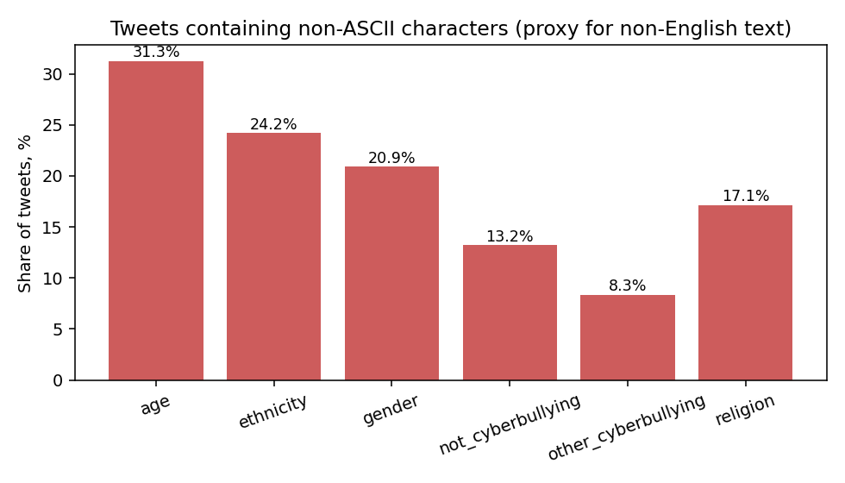
Figure 5. Share of tweets containing non-ASCII characters, by class.
Per-class non-ASCII shares are noticeably uneven (31% in age, 24% in ethnicity, 8% in other_cyberbullying), so any decision about non-English data has class-dependent consequences.
An obvious option would be to filter out tweets whose English quota falls below some threshold and analyse only the English subset. This was tested on the notebook level and rejected for the EDA stage: when the non-English tweets are dropped, the discriminative power of class-specific tokens (the words that occur only in one cyberbullying class and nowhere else) drops noticeably. In other words, a non-negligible share of the most class-characteristic vocabulary is in fact non-English or transliterated, and removing it throws away signal. We therefore keep all tweets at this stage and treat multilinguality as one of the open questions for the modelling phase, where the choice of preprocessing pipeline (e.g. NLTK English wordlist vs. language-id + per-language lemmatisation, or a multilingual embedding such as XLM-R) will be empirically compared.
Other data-quality issues identified during EDA:
- 1,675 tweets have a duplicated tweet_text value (3.5% of the corpus). 36 of those are exact duplicates of full rows. Some of the duplicates appear with different labels and will need to be deduplicated carefully (we will keep the row with the label that matches the majority vote within the duplicate group).
- A handful of tweets are extreme length outliers (up to 5,018 characters / 912 tokens), well above the platform limit; these will be inspected and likely truncated or excluded.
- Several tweets contain mojibake (broken emoji bytes such as ð, ã) coming from a non-UTF8 source; these will be normalised with ftfy or removed.
- The not_cyberbullying class is dominated by tweets about #MyKitchenRules ("mkr" is the 6th most frequent token there). This is a sampling artefact that may inflate apparent classification accuracy; we will check whether models pick up on the show-specific vocabulary by inspecting feature importances and by evaluating on hand-curated held-out subsets.
- URLs and @mentions, although they carry signal at the meta-feature level, will be replaced with stable placeholders (URL, USER) before tokenisation, to prevent the vectoriser from blowing up the vocabulary with unique IDs.

3. Implications for methodology
The findings of the EDA shape the methodology for the next stage of the project as follows.
- Preprocessing pipeline. Several configurations were tested in the proposal (regex vs. NLTK tokenization, with/without stopword removal, with/without stemming or lemmatization). Based on the EDA we will additionally include: lower-casing, replacement of URLs and @mentions with placeholders, normalisation of mojibake, deduplication of identical tweet_text values, and treatment of non-English content (either keep, language-tag, or translate).
- Feature engineering. In addition to TF-IDF over uni- and bi-grams (which directly capture the discriminative bigrams identified in 2.5, e.g. high school, rape jokes, dumb ass, christian woman), we will include numerical meta-features (token count, character count, URL/mention/hashtag counts, share of non-ASCII characters, English-quota score). EDA shows that all of these vary systematically across classes and should add signal at low computational cost.
- Model family. Because the classes are balanced and well-separated in lexical space, strong baselines (Logistic Regression and Linear SVM on TF-IDF) are expected to perform competitively. They will be compared with a non-linear ensemble baseline (gradient boosting on TF-IDF + meta-features) and with a transformer-based fine-tuned model. The use of more than two model families is explicitly rewarded by the assignment.
- Evaluation. Although accuracy is meaningful under balanced classes, we will report macro-averaged precision, recall and F1, plus the full confusion matrix, with a particular focus on the other_cyberbullying class, which we expect to be the most difficult one due to its lexical heterogeneity.
- Error analysis. We will sample misclassified tweets per class and link the errors back to the issues identified in this EDA (multilinguality, duplicates, sampling artefacts such as #MyKitchenRules dominance in not_cyberbullying), and report the fraction of errors attributable to each cause.

4. Conclusion of the EDA stage
The cyberbullying dataset is a balanced six-class corpus of 47,692 short, noisy English (but not exclusively English) tweets. There are no missing values, the labels are almost uniformly distributed, and there is a small but non-negligible share of duplicates and extreme-length outliers that will be cleaned during preprocessing. Several signals emerge naturally from the data – tweet length, number of @mentions and URLs, and the presence of class-specific n-grams (high school, rape jokes, dumb ass, islamic terrorism, christian woman) – and confirm that linear text-classification baselines should already perform well. The main open question for the modelling stage is how to handle the multilingual content: filtering it out is straightforward but costly in terms of class-specific signal, so language handling will be tested as a design dimension rather than fixed up-front. With these implications, the project is ready to move from EDA to methodology and experiments.

