**Pass by Value and Pass by Reference in Java**

Pass by Value and Pass by reference is the two ways by which we can pass a value to the variable in a function.

• **Pass by Value:** It is a process in which the function parameter values are copied to another variable and instead this object copied is passed. This is known as call by Value.

• **Pass by Reference:** It is a process in which the actual copy of reference is passed to the function. This is called by Reference.

Talking about Java, we can say that Java is Pass by Value and not pass by reference.

### Java Pass By Value Example

In this example, we will showcase how to pass a parameter by using pass-by-value which is also known as call-by-value.

Here we have initialized a variable ‘a’ with some value and used the pass-by-value technique to show how the value of the variable remains unchanged. In the next segment, we will try to show a similar example, but we will use non-primitives.

|  |
| --- |
| public class Example {        /*       *  The original value of a will remain unchanged in       *  case of call-by-value       */        int a = 10;      void call(int a) {            // this local variable a is subject to change in its value          a = a+10;      }        public static void main(String[] args) {            Example eg = new Example();          System.out.println("Before call-by-value: " + eg.a);            /*           * Passing an integer 50510 to the call() method. The value of           * 'a' will still be unchanged since the passing parameter is a           * primitive type.           */          eg.call(50510);          System.out.println("After call-by-value: " + eg.a);          }  } |

**Output:**

[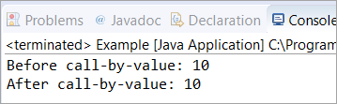](https://www.softwaretestinghelp.com/wp-content/qa/uploads/2021/04/Java-pass-by-value.png)

### Java Passing Object: Pass by Reference Example

In this example, we will see how to pass any object of a class using pass-by-reference.

As you can see, when we have passed the object reference as a value instead of a value, the original value of the variable ‘a’ is changed to 20. This is because of the changes in the called method.

|  |
| --- |
| public class Example {        /*       *  The original value of 'a' will be changed as we are trying       *  to pass the objects. Objects are passed by reference.       */        int a = 10;      void call(Example eg) {          eg.a = eg.a+10;      }        public static void main(String[] args) {            Example eg = new Example();          System.out.println("Before call-by-reference: " + eg.a);            // passing the object as a value using pass-by-reference          eg.call(eg);          System.out.println("After call-by-reference: " + eg.a);          }  } |

**Output:**

[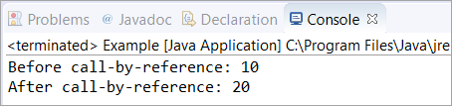](https://www.softwaretestinghelp.com/wp-content/qa/uploads/2021/04/Java-passing-Object-pass-by-Reference.png)