**Constructor**

Constructor is a block of code that initializes the newly created object. A constructor resembles an instance method in java but it’s not a method as it doesn’t have a return type. In short constructor and method are different(More on this at the end of this guide). People often refer constructor as special type of method in Java.

Constructor has same name as the class and looks like this in a java code.

public class MyClass{

//This is the constructor

MyClass(){

}

..

}

Note that the constructor name matches with the class name and it doesn’t have a return type.

**How does a constructor work**

To understand the working of constructor, lets take an example. lets say we have a class MyClass.  
When we create the object of MyClass like this:

MyClass obj = new MyClass()

The **new keyword** here creates the object of class MyClass and invokes the constructor to initialize this newly created object.

You may get a little lost here as I have not shown you any initialization example, lets have a look at the code below:

**A simple constructor program in java**

Here we have created an object obj of class Hello and then we displayed the instance variable name of the object. As you can see that the output is BeginnersBook.com which is what we have passed to the name during initialization in constructor. This shows that when we created the object obj the constructor got invoked. In this example we have used **this keyword**, which refers to the current object, object obj in this example. We will cover this keyword in detail in the next tutorial.

public class Hello {

String name;

//Constructor

Hello(){

this.name = "BeginnersBook.com";

}

public static void main(String[] args) {

Hello obj = new Hello();

System.out.println(obj.name);

}

}

**Output:**

BeginnersBook.com

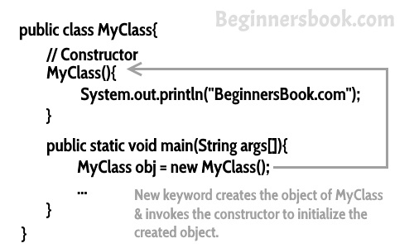

**Types of Constructors**

There are three types of constructors: Default, No-arg constructor and Parameterized.  
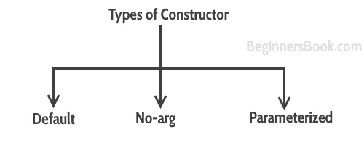

**Default constructor**

If you do not implement any constructor in your class, Java compiler inserts a [default constructor](https://beginnersbook.com/2014/01/default-constructor-java-example/) into your code on your behalf. This constructor is known as default constructor. You would not find it in your source code(the java file) as it would be inserted into the code during compilation and exists in .class file. This process is shown in the diagram below:  
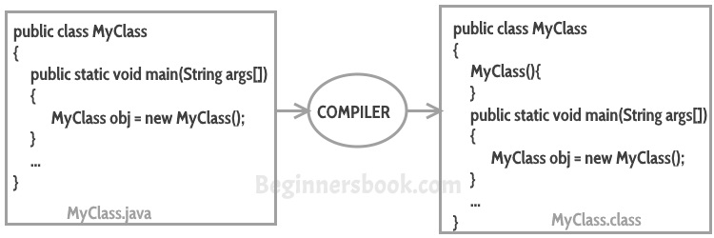

If you implement any constructor then you no longer receive a default constructor from Java compiler.

**no-arg constructor:**

Constructor with no arguments is known as **no-arg constructor**. The signature is same as default constructor, however body can have any code unlike default constructor where the body of the constructor is empty.

Although you may see some people claim that that default and no-arg constructor is same but in fact they are not, even if you write **public Demo() { }** in your class Demo it cannot be called default constructor since you have written the code of it.

**Example: no-arg constructor**

class Demo

{

public Demo()

{

System.out.println("This is a no argument constructor");

}

public static void main(String args[]) {

new Demo();

}

}

Output:  
This is a no argument constructor

**Parameterized constructor**

Constructor with arguments(or you can say parameters) is known as [Parameterized constructor](https://beginnersbook.com/2014/01/parameterized-constructor-in-java-example/).

**Example: parameterized constructor**

In this example we have a parameterized constructor with two parameters id and name. While creating the objects obj1 and obj2 I have passed two arguments so that this constructor gets invoked after creation of obj1 and obj2.

public class Employee {

int empId;

String empName;

//parameterized constructor with two parameters

Employee(int id, String name){

this.empId = id;

this.empName = name;

}

void info(){

System.out.println("Id: "+empId+" Name: "+empName);

}

public static void main(String args[]){

Employee obj1 = new Employee(10245,"Chaitanya");

Employee obj2 = new Employee(92232,"Negan");

obj1.info();

obj2.info();

}

}

**Output:**

Id: 10245 Name: Chaitanya

Id: 92232 Name: Negan

**Example2: parameterized constructor**

In this example, we have two constructors, a default constructor and a parameterized constructor. When we do not pass any parameter while creating the object using new keyword then default constructor is invoked, however when you pass a parameter then parameterized constructor that matches with the passed parameters list gets invoked.

class Example2

{

private int var;

//default constructor

public Example2()

{

this.var = 10;

}

//parameterized constructor

public Example2(int num)

{

this.var = num;

}

public int getValue()

{

return var;

}

public static void main(String args[])

{

Example2 obj = new Example2();

Example2 obj2 = new Example2(100);

System.out.println("var is: "+obj.getValue());

System.out.println("var is: "+obj2.getValue());

}

}

**Output:**

var is: 10

var is: 100

**What if you implement only parameterized constructor in class**

class Example3

{

private int var;

public Example3(int num)

{

var=num;

}

public int getValue()

{

return var;

}

public static void main(String args[])

{

Example3 myobj = new Example3();

System.out.println("value of var is: "+myobj.getValue());

}

}

**Output**: It will throw a compilation error. The reason is, the statement Example3 myobj = new Example3() is invoking a default constructor which we don’t have in our program. when you don’t implement any constructor in your class, compiler inserts the default constructor into your code, however when you implement any constructor (in above example I have implemented parameterized constructor with int parameter), then you don’t receive the default constructor by compiler into your code.

If we remove the parameterized constructor from the above code then the program would run fine, because then compiler would insert the default constructor into your code.

**Constructor Chaining**

When A constructor calls another constructor of same class then this is called constructor chaining. Read more about it [here](https://beginnersbook.com/2013/12/java-constructor-chaining-with-example/).  
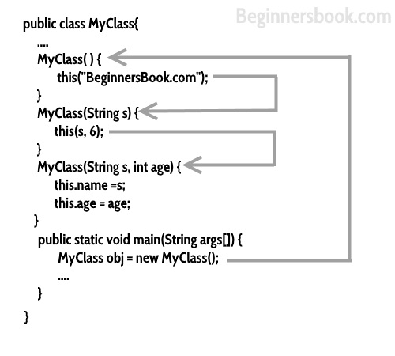

**Super()**

Whenever a child class constructor gets invoked it implicitly invokes the constructor of parent class. You can also say that the compiler inserts a super(); statement at the beginning of child class constructor.

class MyParentClass {

MyParentClass(){

System.out.println("MyParentClass Constructor");

}

}

class MyChildClass extends MyParentClass{

MyChildClass() {

System.out.println("MyChildClass Constructor");

}

public static void main(String args[]) {

new MyChildClass();

}

}

**Output:**

MyParentClass Constructor

MyChildClass Constructor

Read more about [super keyword here](https://beginnersbook.com/2014/07/super-keyword-in-java-with-example/).

**Constructor Overloading**

Constructor overloading is a concept of having more than one constructor with different parameters list, in such a way so that each constructor performs a different task.  
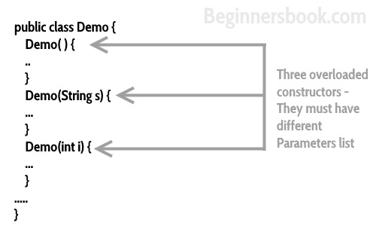

Refer [constructor overloading with example](https://beginnersbook.com/2013/05/constructor-overloading/) for more details with example.