This is Square Solver - the programm, which can solve quadratic equations.

This programm will be very useful for you, if you`re in seventh grade and don`t know what mathematics is.

How use the program?

1. Install the project zip-file. 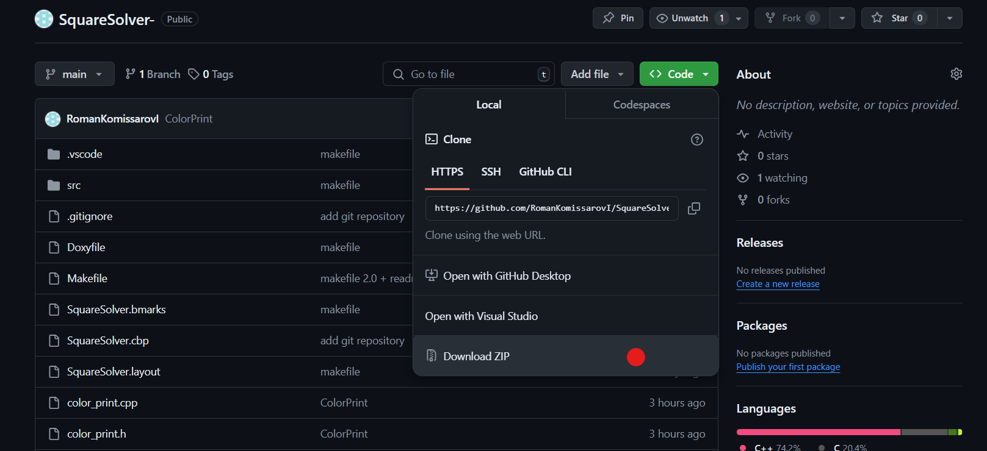
2. Unzip downloaded file.
3. Go to command line. For this in folder SquareSolver enter cmd. 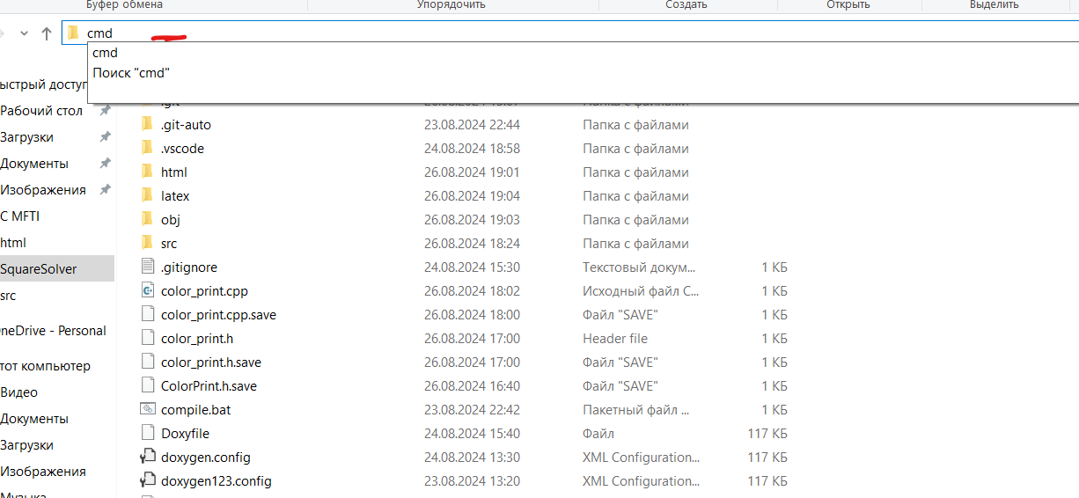
4. Type make and press Enter. 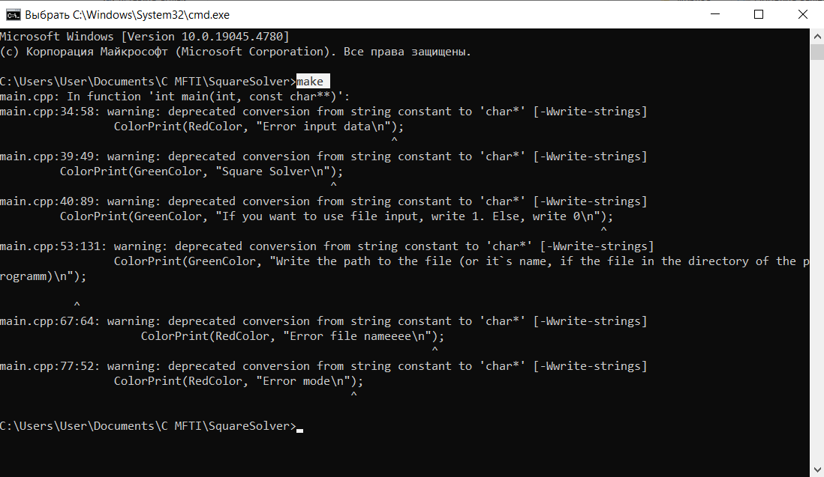
5. Find the main.exe file and open it. Then follow the instructions.

# Markdown README.md

## *bold* ...