Graph Neural Network Series | Part 1

Source: <https://www.youtube.com/watch?v=fOctJB4kVlM>

A simple Graph

Nodes : Can have futher attributes -> node features. Ex: Node is a person, the features could be age, sex, occupation etc.

Edges : Relationships between the Nodes -> further attributes -> edge features. Ex. How are people related to each other (social relationships)

The graph data can be represented in a adjency matrix

Ein Bild, das Text enthält.

Graph Data

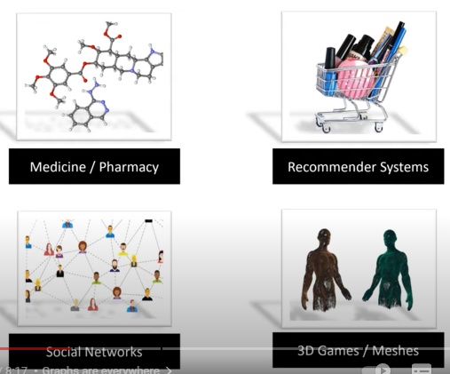

Examples of ML Problems on Graph Data

Node-level predictions: We want to predict attributes of a node. Ex. does this person somoke? The GNN will take the information from the surrounding nodes to make a prediction.

Edge-level prediction (link-prediction): We want to predict if there is a relationship between to nodes or not. Is used to predict wether a person is interested in a certain product or not. Next Neflix viedeo?

Graph-level prediction: The hole graph is used as input to predict a attribute of interest or to make a classification.

Problems with Graph Data

Size: Graphs have different sizes. Images as well but there we can apply some tricks to resize the image to a fixed size -> We need a method which can handle arbitrary input shapes

Isomorphism: Two graphs that look different can still have the same structure. The order of nodes and edges does not matter. If you flip an image you get a new image. If you flip a graph it’s still the same graph. Therefore the model must be permutation invariant. -> That’s the reason why we can’t use the adjacency matrix as input for the feedforward model. As it is sensitive to changes in the node order

Grid structure: The structure for graphs is non-euclidean. Images have a clearly defined structure which can be expressed by x and y coordinates. Graphs are dynamic structures. We can not really measure how close node A is to node B. -> This is why we the area around GNN is called geometric deep learning.

Fundamenta Idea of GNNs

“Learning a for neural networks suitable representation of graph data.” (=Representation learning).

Using all the informations of the graph including the node features and the connection between nodes. The GNN outputs representations (embeddings) for the nodes. These embeddings contain the structural as well as the feature information of the node and the surrounding nodes.

Similar nodes will lead to similar node embeddings. The size of embedding is a hyperparameter.

PART 2

How do GNNs work?

Message passing layers which combine information to the node embeddings in a compressed form

Ein Bild, das Text, Musik, Screenshot enthält.

What is happening in the MP Layer

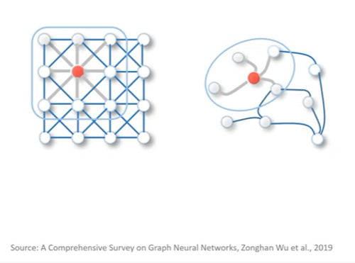

Idea of MP is similar to the one of CNN. The information from the neighbouring nodes are aggregated and passed to the current node. After one MP layer the embedding of each node contains information about itself and it’s direct neighbours. After a second MP layer the embeddings contain also information about the neighour neighbours. The local feature aggregation can be compared to learnable CNN kernels

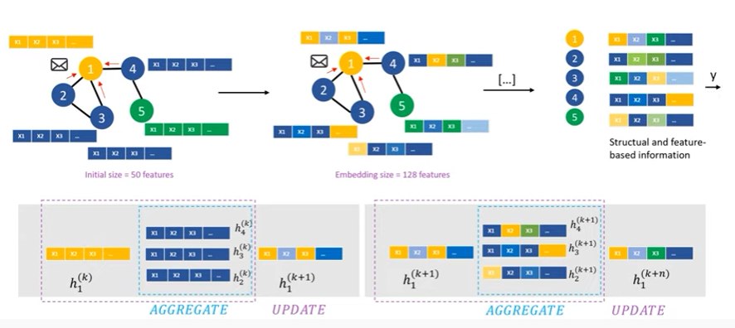

We can see how deep we dive into the graph by visualizing it (computational graph)

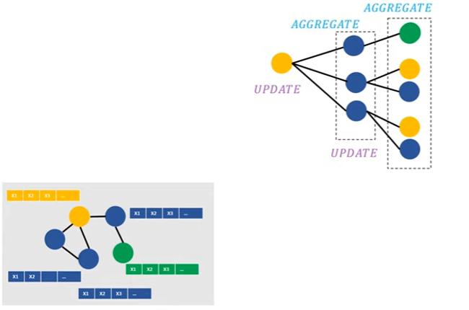

The number of MP layers defines how many neigbourhood hops we perform. For smaller graphs after just a few neighbourhood hops all the informations is contained. To much MP Layers could lead to oversmoothing.

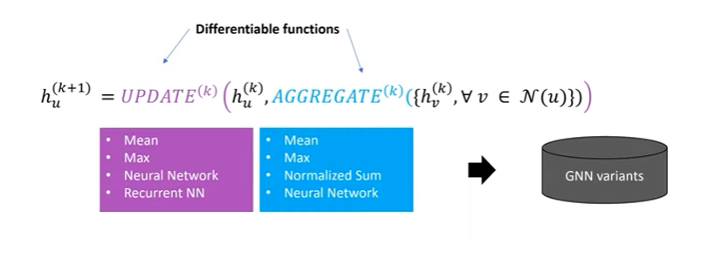

Different aggregation and update methods

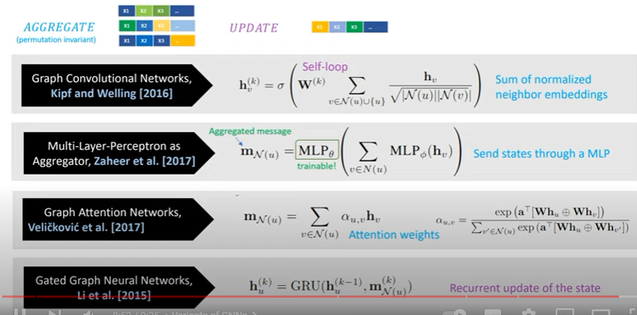

Additonal source:

Ein Bild, das Text enthält.

PART 3

Colab: <https://colab.research.google.com/drive/16GBgwYR2ECiXVxA1BoLxYshKczNMeEAQ?usp=sharing#scrollTo=BQnbktyWU3r3>

Recommendation systems

Types

* Content-base filtering: similarity between items. Idea: if a user is interested in item A he likely will also be interested in similar itmes to A
* Collaborative filtering: similiartiy between users. Idea: Users A bought item X. User B is very similar to user A and the probability that user B is interested in item X is high.  
    
  Collaborative filtering can be formulated as a matrix completion problem. The values represent recommendations from users to items  
  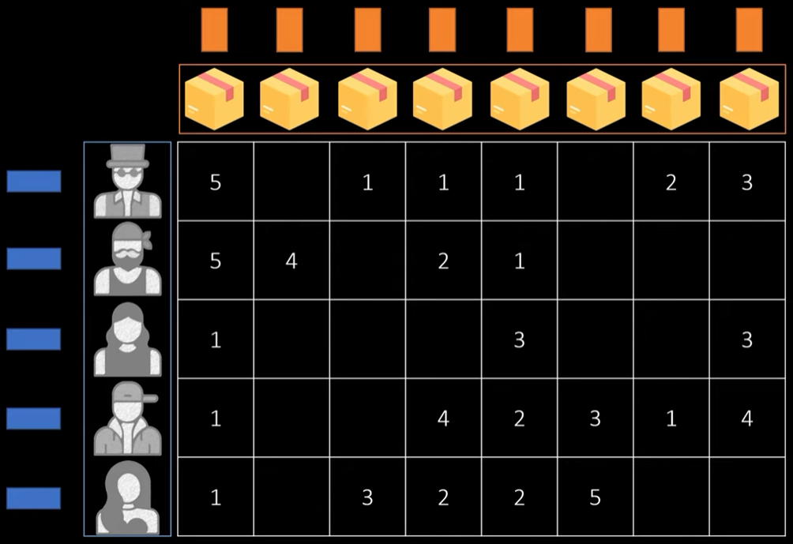  
    
  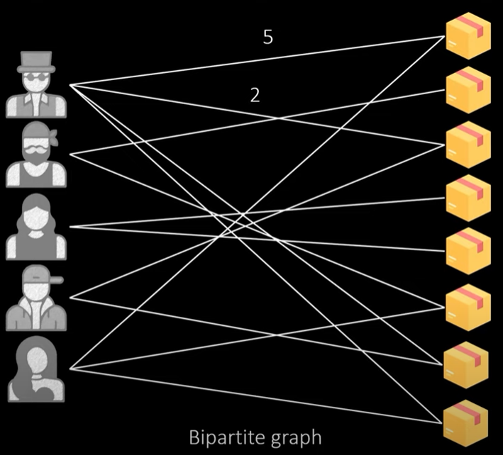

Advantage: multi-hop steps  
  
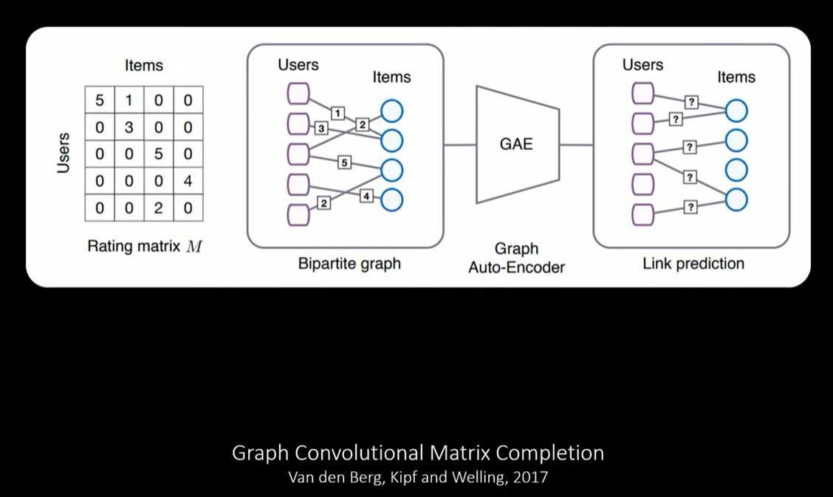

Social Recommendation

Ein Bild, das Text, Gerät enthält.

Sources:

LightGCN: Simplifying and Powering Graph Convolution Network for Recommendation: <https://arxiv.org/pdf/2002.02126.pdf>

Towards DAtascience:

<https://towardsdatascience.com/hands-on-graph-neural-networks-with-pytorch-pytorch-geometric-359487e221a8>

Bipartide graphs:

<https://freecontent.manning.com/creating-a-bipartite-graph-for-a-user-item-dataset/>

Link Prediction Recommendation Engines with Node2Vec

<https://towardsdatascience.com/link-prediction-recommendation-engines-with-node2vec-c97c429351a8>

Integrate Neo4j with PyTorch Geometric to create recommendations  
<https://towardsdatascience.com/integrate-neo4j-with-pytorch-geometric-to-create-recommendations-21b0b7bc9aa>