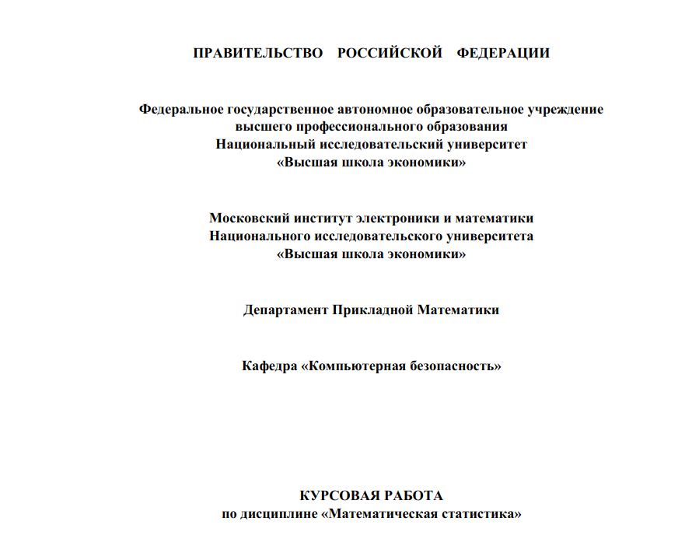

Выполнил:
Студент СКБ161
Матвеев Р.С

Проверил: доцент Иванов А.В

МОСКВА-2018
1. Теоретическая часть
1.1 Распределение Рэлея
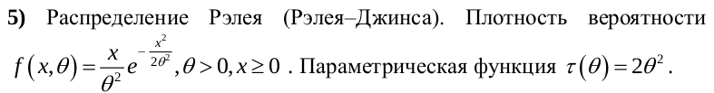
Основные формулы:

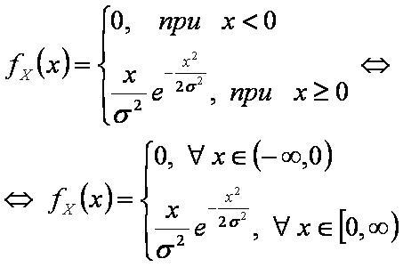
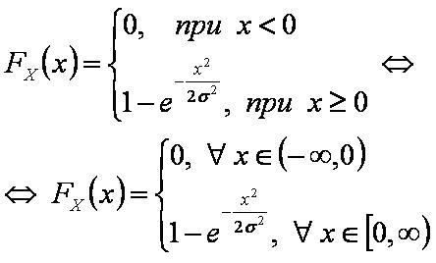
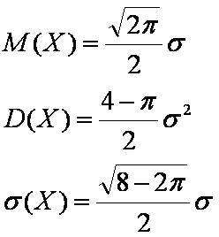

1.2 Критерий χ2
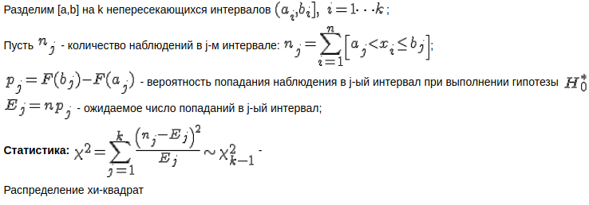
1.3 Оценка методом моментов

-несмещенная
2. Практическая часть
задание 2
import numpy as np
from scipy.stats import chi2
from scipy.stats import chisquare
from scipy.stats import chi2_contingency as c2
from bitstring import BitArray as bt
import os
import sys
import matplotlib.pyplot as plt
BYTE_READ=1
def readOne(file):
lis = list()
with open(file,'rb') as f:
lis=[]
while(True):
t = f.read(BYTE_READ)
if t!=b'':
lis.append(t)
else:
break
return lis

def readFiles(direc):
d = dict()
fileNames = [f for f in os.listdir(direc)]
for i in fileNames:
d.update({i:readOne(direc+'/'+i)})
return d

def emPlot(dic,n):
lx =[]
ly=[]
for key,value in dic.items():
lx.append(bin(int.from_bytes(key,byteorder='little')))
ly.append(value)
ly=np.array(ly)/n
plt.plot(lx,ly)
plt.show()

def analyseOne(lis):
n = len(lis)
s = sorted(set(lis))
d = dict()
for i in s:
count = 0
for j in lis:
if j<=i:
count = count+1
d.update({i:count})
return d,n
def mean(lis):
summ = 0
for i in lis:
summ +=int.from_bytes(i,byteorder='little')
return summ/len(lis)
def desp(lis):
summ = 0
for i in lis:
summ +=(int.from_bytes(i,byteorder='little')**2)
return summ/len(lis)-mean(lis)**2

def showAll(dic):
ordered = sorted(dic.items(), key=lambda kv:kv[0])
global BYTE_READ
b = BYTE_READ
BYTE_READ = b*8
chil=chi2.ppf(0.05,2**BYTE_READ)
chih=chi2.ppf(0.95,2**BYTE_READ)
print('name',' ','mean',' ','desp', ' ','chi2',' ','0.05',' ','0.95')
for i in ordered:
if BYTE_READ>1:
print(i[0],' ',format(mean(i[1]),'.2e'), ' ', format(desp(i[1]),'.2e'),' ',Chi((dic[i[0]])),' ',chil,' ',chih)
else:
print(i[0],' ',(mean(i[1])), ' ', (desp(i[1])),' ',Chi((dic[i[0]])),' ',chil,' ',chih)

def Chi(data):
d,n = elcounter(data)
s = set(data)
dim = len(s)
summ=0
con =(n/2**BYTE_READ)
for i in s:
summ+=((d[i]-con)**2) / (con)
return summ

def elcounter(lis):
n = len(lis)
s = sorted(set(lis))
d = dict()
s.sort()
lis.sort()
j=0
# print(lis[:10])
# print(s[:50])
for i in s:
count = 0
while j<n:
if i!=lis[j]:
break
if i==lis[j]:
j+=1
count+=1
d.update({i:count})
return d,n

print("Native byteorder: ", sys.byteorder)
showAll(data)

вывод для однобайтовыхвекторов для 10 неизмененных изображений и их зашифрованных и заархивированных версий
name mean desp chi2 0.05 0.95
61961_photo_manipulation_vaporwave.jpg 1.40e+02 5.99e+03 202992.3803682549 219.95242537967763 294.3206688843064
61961_photo_manipulation_vaporwave.jpg.bf-cfb 1.27e+02 5.46e+03 251.6469851654038 219.95242537967763 294.3206688843064
61961_photo_manipulation_vaporwave.jpg.bf-ofb 1.27e+02 5.44e+03 273.72965513716576 219.95242537967763 294.3206688843064
61961_photo_manipulation_vaporwave.jpg.zip 1.30e+02 5.48e+03 2433.9288911608314 219.95242537967763 294.3206688843064
A-Bachelors-Dog-painting.jpg 1.25e+02 5.30e+03 3113.1389974248737 219.95242537967763 294.3206688843064
A-Bachelors-Dog-painting.jpg.bf-cfb 1.27e+02 5.46e+03 274.62834868550175 219.95242537967763 294.3206688843064
A-Bachelors-Dog-painting.jpg.bf-ofb 1.28e+02 5.46e+03 271.370557138015 219.95242537967763 294.3206688843064
A-Bachelors-Dog-painting.jpg.zip 1.26e+02 5.35e+03 2006.8463092952627 219.95242537967763 294.3206688843064
Composition-8-kandinsky-painting.jpg 1.21e+02 5.47e+03 6372.48988448529 219.95242537967763 294.3206688843064
Composition-8-kandinsky-painting.jpg.bf-cfb 1.27e+02 5.48e+03 266.79668155711573 219.95242537967763 294.3206688843064
Composition-8-kandinsky-painting.jpg.bf-ofb 1.28e+02 5.46e+03 226.3075941289086 219.95242537967763 294.3206688843064
Composition-8-kandinsky-painting.jpg.zip 1.28e+02 5.42e+03 563.1353326441906 219.95242537967763 294.3206688843064
The-Birth-of-Venus-Painting.jpg 1.32e+02 5.52e+03 9832.974148105988 219.95242537967763 294.3206688843064
The-Birth-of-Venus-Painting.jpg.bf-cfb 1.28e+02 5.46e+03 263.9994767297516 219.95242537967763 294.3206688843064
The-Birth-of-Venus-Painting.jpg.bf-ofb 1.27e+02 5.48e+03 240.64203731642579 219.95242537967763 294.3206688843064
The-Birth-of-Venus-Painting.jpg.zip 1.29e+02 5.39e+03 1520.6781612728462 219.95242537967763 294.3206688843064
a-friend-in-need-painting.jpg 1.20e+02 5.80e+03 12690.272407680051 219.95242537967763 294.3206688843064
a-friend-in-need-painting.jpg.bf-cfb 1.27e+02 5.47e+03 289.1304791948323 219.95242537967763 294.3206688843064
a-friend-in-need-painting.jpg.bf-ofb 1.28e+02 5.44e+03 256.03929698062194 219.95242537967763 294.3206688843064
a-friend-in-need-painting.jpg.zip 1.27e+02 5.46e+03 614.3170282748426 219.95242537967763 294.3206688843064
pexels-photo-257840.jpeg 1.21e+02 5.50e+03 4958.357439418198 219.95242537967763 294.3206688843064
pexels-photo-257840.jpeg.bf-cfb 1.28e+02 5.49e+03 251.21327219946292 219.95242537967763 294.3206688843064
pexels-photo-257840.jpeg.bf-ofb 1.27e+02 5.50e+03 247.10160340758023 219.95242537967763 294.3206688843064
pexels-photo-257840.jpeg.zip 1.28e+02 5.47e+03 375.6127779835645 219.95242537967763 294.3206688843064
school-of-athens-raphael-painting.jpg 1.32e+02 5.60e+03 21661.579979425696 219.95242537967763 294.3206688843064
school-of-athens-raphael-painting.jpg.bf-cfb 1.28e+02 5.47e+03 286.4241380040212 219.95242537967763 294.3206688843064
school-of-athens-raphael-painting.jpg.bf-ofb 1.27e+02 5.46e+03 247.1601481638269 219.95242537967763 294.3206688843064
school-of-athens-raphael-painting.jpg.zip 1.32e+02 5.56e+03 12659.697631503206 219.95242537967763 294.3206688843064
the-bold-bluff.jpg 1.18e+02 5.75e+03 16717.63134698987 219.95242537967763 294.3206688843064
the-bold-bluff.jpg.bf-cfb 1.27e+02 5.44e+03 230.1271226493592 219.95242537967763 294.3206688843064
the-bold-bluff.jpg.bf-ofb 1.27e+02 5.46e+03 245.56636378765177 219.95242537967763 294.3206688843064
the-bold-bluff.jpg.zip 1.29e+02 5.44e+03 506.7525920340396 219.95242537967763 294.3206688843064
the-last-supper-mary-magdalene-painting.jpg 1.28e+02 5.51e+03 14946.111220184499 219.95242537967763 294.3206688843064
the-last-supper-mary-magdalene-painting.jpg.bf-cfb 1.28e+02 5.45e+03 259.7399320024182 219.95242537967763 294.3206688843064
the-last-supper-mary-magdalene-painting.jpg.bf-ofb 1.28e+02 5.46e+03 275.39326134864024 219.95242537967763 294.3206688843064
the-last-supper-mary-magdalene-painting.jpg.zip 1.29e+02 5.49e+03 4025.605145304812 219.95242537967763 294.3206688843064

вывод для двухбайтовыхвекторов для 10 неизмененных изображений и их зашифрованных и заархивированных версий
name mean desp chi2 0.05 0.95
61961_photo_manipulation_vaporwave.jpg 3.59e+04 3.92e+08 10233107.301942019 64941.638572299875 66132.63548188654
61961_photo_manipulation_vaporwave.jpg.bf-cfb 3.27e+04 3.58e+08 63281.483068370064 64941.638572299875 66132.63548188654
61961_photo_manipulation_vaporwave.jpg.bf-ofb 3.28e+04 3.57e+08 62643.05586106091 64941.638572299875 66132.63548188654
61961_photo_manipulation_vaporwave.jpg.zip 3.34e+04 3.60e+08 65763.14496044797 64941.638572299875 66132.63548188654
A-Bachelors-Dog-painting.jpg 3.23e+04 3.46e+08 88392.59048038755 64941.638572299875 66132.63548188654
A-Bachelors-Dog-painting.jpg.bf-cfb 3.28e+04 3.58e+08 42587.91018435581 64941.638572299875 66132.63548188654
A-Bachelors-Dog-painting.jpg.bf-ofb 3.29e+04 3.58e+08 42425.54327900588 64941.638572299875 66132.63548188654
A-Bachelors-Dog-painting.jpg.zip 3.24e+04 3.51e+08 63090.65439104586 64941.638572299875 66132.63548188654
Composition-8-kandinsky-painting.jpg 3.11e+04 3.59e+08 98495.9776405957 64941.638572299875 66132.63548188654
Composition-8-kandinsky-painting.jpg.bf-cfb 3.27e+04 3.60e+08 47123.874303786084 64941.638572299875 66132.63548188654
Composition-8-kandinsky-painting.jpg.bf-ofb 3.28e+04 3.58e+08 46790.75650093293 64941.638572299875 66132.63548188654
Composition-8-kandinsky-painting.jpg.zip 3.28e+04 3.55e+08 50522.13293915324 64941.638572299875 66132.63548188654
The-Birth-of-Venus-Painting.jpg 3.40e+04 3.62e+08 589820.6668121236 64941.638572299875 66132.63548188654
The-Birth-of-Venus-Painting.jpg.bf-cfb 3.29e+04 3.57e+08 47639.59292107259 64941.638572299875 66132.63548188654
The-Birth-of-Venus-Painting.jpg.bf-ofb 3.27e+04 3.60e+08 48094.25183124426 64941.638572299875 66132.63548188654
The-Birth-of-Venus-Painting.jpg.zip 3.31e+04 3.53e+08 80110.04024157737 64941.638572299875 66132.63548188654
a-friend-in-need-painting.jpg 3.09e+04 3.80e+08 181608.26530680107 64941.638572299875 66132.63548188654
a-friend-in-need-painting.jpg.bf-cfb 3.26e+04 3.59e+08 41322.40597843083 64941.638572299875 66132.63548188654
a-friend-in-need-painting.jpg.bf-ofb 3.27e+04 3.56e+08 41651.962354716896 64941.638572299875 66132.63548188654
a-friend-in-need-painting.jpg.zip 3.26e+04 3.58e+08 45203.82232376323 64941.638572299875 66132.63548188654
pexels-photo-257840.jpeg 3.11e+04 3.60e+08 153049.04818307754 64941.638572299875 66132.63548188654
pexels-photo-257840.jpeg.bf-cfb 3.29e+04 3.60e+08 44252.233919051556 64941.638572299875 66132.63548188654
pexels-photo-257840.jpeg.bf-ofb 3.28e+04 3.60e+08 44778.81876851662 64941.638572299875 66132.63548188654
pexels-photo-257840.jpeg.zip 3.27e+04 3.58e+08 46173.20138876516 64941.638572299875 66132.63548188654
school-of-athens-raphael-painting.jpg 3.40e+04 3.67e+08 534175.4971835415 64941.638572299875 66132.63548188654
school-of-athens-raphael-painting.jpg.bf-cfb 3.28e+04 3.59e+08 58561.030378243704 64941.638572299875 66132.63548188654
school-of-athens-raphael-painting.jpg.bf-ofb 3.27e+04 3.58e+08 59152.68741367145 64941.638572299875 66132.63548188654
school-of-athens-raphael-painting.jpg.zip 3.38e+04 3.64e+08 299461.2329381961 64941.638572299875 66132.63548188654
the-bold-bluff.jpg 3.05e+04 3.76e+08 191685.38938406733 64941.638572299875 66132.63548188654
the-bold-bluff.jpg.bf-cfb 3.27e+04 3.57e+08 42673.95766958852 64941.638572299875 66132.63548188654
the-bold-bluff.jpg.bf-ofb 3.28e+04 3.58e+08 41489.37518551492 64941.638572299875 66132.63548188654
the-bold-bluff.jpg.zip 3.32e+04 3.56e+08 42381.53428779049 64941.638572299875 66132.63548188654
the-last-supper-mary-magdalene-painting.jpg 3.30e+04 3.62e+08 187883.17353448714 64941.638572299875 66132.63548188654
the-last-supper-mary-magdalene-painting.jpg.bf-cfb 3.28e+04 3.58e+08 50928.41970919766 64941.638572299875 66132.63548188654
the-last-supper-mary-magdalene-painting.jpg.bf-ofb 3.27e+04 3.58e+08 50687.25331078501 64941.638572299875 66132.63548188654
the-last-supper-mary-magdalene-painting.jpg.zip 3.32e+04 3.59e+08 79122.3645761897 64941.638572299875 66132.63548188654

вывод для трехбайтовыхвекторов для 10 неизмененных изображений и их зашифрованных и заархивированных версий
name mean desp chi2 0.05 0.95
61961_photo_manipulation_vaporwave.jpg 9.20e+06 2.57e+13 52896148.60277113 16767689.127201537 16786745.146856386
61961_photo_manipulation_vaporwave.jpg.bf-cfb 8.38e+06 2.34e+13 16572366.402510112 16767689.127201537 16786745.146856386
61961_photo_manipulation_vaporwave.jpg.bf-ofb 8.39e+06 2.34e+13 16555325.384226307 16767689.127201537 16786745.146856386
61961_photo_manipulation_vaporwave.jpg.zip 8.55e+06 2.36e+13 16595172.89617904 16767689.127201537 16786745.146856386
A-Bachelors-Dog-painting.jpg 8.24e+06 2.27e+13 17007140.417402256 16767689.127201537 16786745.146856386
A-Bachelors-Dog-painting.jpg.bf-cfb 8.40e+06 2.34e+13 16722758.410916535 16767689.127201537 16786745.146856386
A-Bachelors-Dog-painting.jpg.bf-ofb 8.40e+06 2.34e+13 16728145.76623564 16767689.127201537 16786745.146856386
A-Bachelors-Dog-painting.jpg.zip 8.29e+06 2.29e+13 16788486.53738522 16767689.127201537 16786745.146856386
Composition-8-kandinsky-painting.jpg 7.99e+06 2.34e+13 16890756.56238807 16767689.127201537 16786745.146856386
Composition-8-kandinsky-painting.jpg.bf-cfb 8.37e+06 2.36e+13 16691585.03058285 16767689.127201537 16786745.146856386
Composition-8-kandinsky-painting.jpg.bf-ofb 8.43e+06 2.35e+13 16681547.813360805 16767689.127201537 16786745.146856386
Composition-8-kandinsky-painting.jpg.zip 8.38e+06 2.32e+13 16710231.741639711 16767689.127201537 16786745.146856386
The-Birth-of-Venus-Painting.jpg 8.69e+06 2.36e+13 17815083.360878088 16767689.127201537 16786745.146856386
The-Birth-of-Venus-Painting.jpg.bf-cfb 8.41e+06 2.34e+13 16687710.664064424 16767689.127201537 16786745.146856386
The-Birth-of-Venus-Painting.jpg.bf-ofb 8.37e+06 2.35e+13 16691170.962489594 16767689.127201537 16786745.146856386
The-Birth-of-Venus-Painting.jpg.zip 8.47e+06 2.32e+13 16778582.989000067 16767689.127201537 16786745.146856386
a-friend-in-need-painting.jpg 7.90e+06 2.48e+13 17207305.617636025 16767689.127201537 16786745.146856386
a-friend-in-need-painting.jpg.bf-cfb 8.36e+06 2.34e+13 16742254.251203235 16767689.127201537 16786745.146856386
a-friend-in-need-painting.jpg.bf-ofb 8.40e+06 2.33e+13 16747546.729847336 16767689.127201537 16786745.146856386
a-friend-in-need-painting.jpg.zip 8.34e+06 2.34e+13 16748952.025008287 16767689.127201537 16786745.146856386
pexels-photo-257840.jpeg 7.93e+06 2.36e+13 22192592.745984904 16767689.127201537 16786745.146856386
pexels-photo-257840.jpeg.bf-cfb 8.37e+06 2.39e+13 16758146.95943649 16767689.127201537 16786745.146856386
pexels-photo-257840.jpeg.bf-ofb 8.37e+06 2.36e+13 16751319.466658076 16767689.127201537 16786745.146856386
pexels-photo-257840.jpeg.zip 8.38e+06 2.35e+13 16796326.68537555 16767689.127201537 16786745.146856386
school-of-athens-raphael-painting.jpg 8.69e+06 2.40e+13 17686328.182125695 16767689.127201537 16786745.146856386
school-of-athens-raphael-painting.jpg.bf-cfb 8.41e+06 2.35e+13 16626075.192484833 16767689.127201537 16786745.146856386
school-of-athens-raphael-painting.jpg.bf-ofb 8.36e+06 2.35e+13 16615848.453944787 16767689.127201537 16786745.146856386
school-of-athens-raphael-painting.jpg.zip 8.67e+06 2.40e+13 17085906.411535684 16767689.127201537 16786745.146856386
the-bold-bluff.jpg 7.79e+06 2.47e+13 17199941.43898349 16767689.127201537 16786745.146856386
the-bold-bluff.jpg.bf-cfb 8.36e+06 2.35e+13 16730151.820848744 16767689.127201537 16786745.146856386
the-bold-bluff.jpg.bf-ofb 8.39e+06 2.35e+13 16726801.418198626 16767689.127201537 16786745.146856386
the-bold-bluff.jpg.zip 8.50e+06 2.33e+13 16735945.78948886 16767689.127201537 16786745.146856386
the-last-supper-mary-magdalene-painting.jpg 8.46e+06 2.36e+13 17066167.828428484 16767689.127201537 16786745.146856386
the-last-supper-mary-magdalene-painting.jpg.bf-cfb 8.38e+06 2.35e+13 16664675.85910418 16767689.127201537 16786745.146856386
the-last-supper-mary-magdalene-painting.jpg.bf-ofb 8.38e+06 2.35e+13 16671873.935608486 16767689.127201537 16786745.146856386
the-last-supper-mary-magdalene-painting.jpg.zip 8.53e+06 2.36e+13 16764090.326589063 16767689.127201537 16786745.146856386

Эмпирическая функция распределения
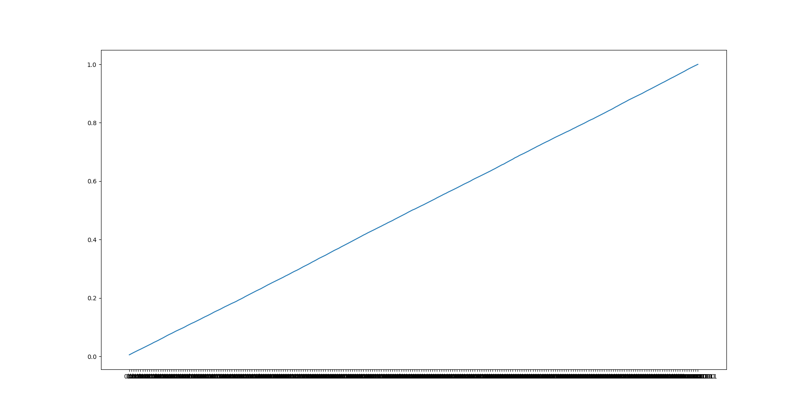

В приближении
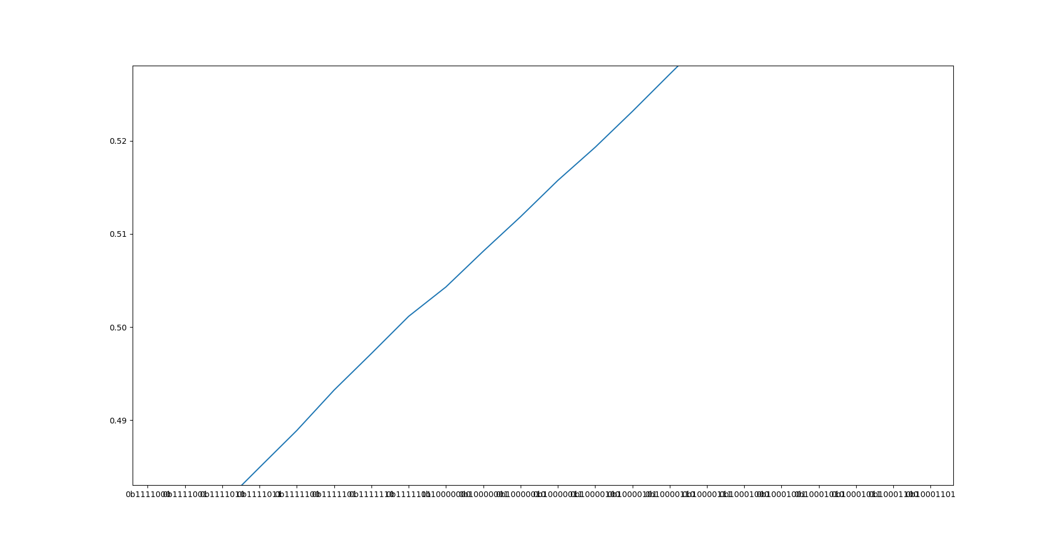

Вывод: в зашифрованных файлах распределение однобайтовых векторов распределенно равномерно с вероятностью 0.95. Для двух- и трехбайтовых векторов доверительный интервал меньше, но не намного, т.е. с высокой степенью вероятности можно утверждать, что вектора распределенны равномерно. С увелечением степеней свободы вероятность уменьшается.

Задание 4
import csv
from scipy.stats import chi2
import math
from struct import *
def readData(path):
with open(path,newline='') as file:
data = csv.reader(file,delimiter= ' ',quotechar='|',quoting=csv.QUOTE_NONE )
# print(data.__next__())
# k = 0
# for i in data:
# print(i)
# k=k+1
# if k==5:
# break
return data
def readByBytes(path):
with open(path,'rb') as f:
l = []
while(True):
t= f.read(4)
if t!='':
l.append(t)
else:
break
return l
def readByStruck():
data = open('5.data','rb').read()
f = unpack('>1000000f',data)
return f
def takeBorders(data):
return min(data), max(data)

def devide(data,k):
l=[]
n = len(data)
# m - max elements in one interval
m = n // k
count = 0
for i in range(k-1):
ll=[]
for j in range(m):
ll.append(data[count+j])
count = count+1
l.append(ll)
return l
teta=12.98
def pj(a,b):
return (-math.exp(-(b**2/(2*teta**2))) + math.exp(-(a**2/(2*teta**2))))
dsize = 1000000
def chi(data,k):
data= list(data)
data.sort()
summ=0
for i in range(k-2):
le = len(data)//(k)
summ+=(le-dsize*pj(data[i*le],data[(i+1)*le-1]))**2/(dsize*pj(data[i*le],data[(i+1)*le-1]))
return summ

def H0(data,k):
siz = len(data)
n = 0
l= []
if siz%k == 0:
n=siz/k
for i in range(k):
l.append(pj(data[n*k],data[n*2*k-1],n))
summ =0
for i in range(k):
summ+=(n-siz*l[i])**2/(siz*l[i])
return summ
else:
n = (siz+1)/k
nlast = len(data[siz*(k-1):])
for i in range(k-1):
l.append(pj(data[n*k],data[n*2*k-1],n))
l.append(pj(data[:-nlast],data[:-1],nlast))
summ =0
for i in range(k-1):
summ+=(n-siz*l[i])**2/(siz*l[i])
summ+=(nlast-siz*l[i])**2/(siz*l[i])
return summ

data=(readByStruck())
print(chi(data,50),chi2.ppf(0.05,2*32),chi2.ppf(0.95,2*32))
print(sum(data)/len(data)*2/(2*math.pi)**(0.5))

Вывод программы с комментариями: 58.92461038182035 – значение χ2 для 50 интервалов 46.59490522481397 - значение χ2 для заданной вероятности 0.05, 83.67526074272097 - значение χ2 для для заданной вероятности 0.95, 12.988955126069483 - оценка параметра тета соответсвенно.

Степень свободы = 2^32

102.57106787623171 – значение χ2 для 100 интервалов
153.36048842467795 – значение χ2 для 150 интервалов

