**JASHORE UNIVERSITY OF SCIENCE AND TECHNOLOGY**

**DEPARTMENT OF COMPUTER SCIENCE AND ENGINEERING**

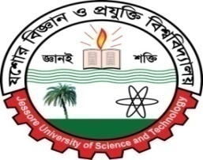

**A Project Report on: Restaurant management system**

**Course Title**: Simulation & Modeling Laboratory

**Course Code**: CSE- 4104

**Submitted By:**

Roll: 150116,150117,150118,150119,150120

Session: 2015-2016

4th year, 1st semester

Dept. of Computer Science and Engineering

Jashore University of Science & Technology

**Submitted To:**

Jannatul Ferdush

Lecturer,

Dept. of Computer Science and Engineering

Jashore University of Science & Technology

|  |
| --- |
| **Remarks** |
|  |

**Date of Submission: 06.04.19**