
Green University of Bangladesh
Department of Computer Science and
Engineering (CSE)
Faculty of Sciences and Engineering
Semester: (Fall, Year:2023), B.Sc. in CSE (Day)

Course Title: Computer Networking Lab
Code: CSE 312 Section: 212-D5

Project Name: Group Messaging Platform

Name | ID
Md. Shadikur Rahman Sheam | 211902020
Md. Roman Nihal | 211902003

Submission Date: 30th December, 2023
Course Teacher’s Name: Sudip Chandra Ghoshal

Lab Project Status
Marks: Signature:
Comments: Date:

Table of Contents

Introduction
Introduction
Design Goals

Implementation Of the Project
Relations among ‘Server’ and ‘Clients’
Implementation

Performance Evaluation
Simulation Environment
Results and Discussions

Conclusion
Introduction
Practical Implementation
Scope Of Future Work
References

Chapter 1: Introduction
1.1 Introduction
In the ever-changing realm of communication technologies, the demand for effective and smooth group messaging platforms has grown significantly. To meet this demand, our project presents a resilient "Group Messaging Platform" tailored for real-time communication among numerous users within a specified group. By harnessing the capabilities of socket programming, this platform facilitates immediate message sharing, promoting collaboration and interaction within a dynamic group context.
It's worth noting that in this project, users are confined to a single pre-defined group for their discussions. Notably, our platform supports the exchange of images and emojis, adding a rich multimedia dimension to the communication experience.

1.2 Design Goals
1. Real-Time Multimedia Communication:
- To enable instantaneous exchange of text, images, and emojis within the designated group.
- To optimize responsiveness, especially when sharing multimedia content, the project will focus on improving thread efficiency to minimize latency within the system.
2. Scalable and Modular Architecture:
- To design a scalable architecture that accommodates future enhancements, such as additional multimedia formats or new features.
- To maintain a modular structure to facilitate seamless integration of updates and expansions to the platform.
3. User-Friendly Multimedia Interface:
- To develop an intuitive and visually appealing interface that seamlessly integrates the exchange of images and emojis into the messaging experience.
- To allow users to easily navigate and interact with multimedia elements within the chat environment.
4. Message Persistence for Multimedia:
- To implement mechanisms for storing and retrieving multimedia messages, ensuring users can access shared images and emojis even after rejoining the group or logging in from another device.
- To manage multimedia content efficiently to prevent data loss and enhance the overall user experience.
By conscientiously embracing these meticulously defined design goals, our Group Messaging Platform aspires to create an environment that is not only secure, but also captivating and adaptable. This platform is dedicated to fostering real-time communication, ensuring users experience a seamless exchange of ideas within the confines of their designated group. Moreover, the incorporation of a feature-rich framework enables users to share images and emojis effortlessly, enhancing the overall depth and expressiveness of their interactions within the platform. Through a commitment to these design principles, we aim to provide a comprehensive and dynamic space for users to connect and collaborate with one another.

Chapter 2: Implementation of the Project
2.1 Relations among ‘Server’ and ‘Clients’
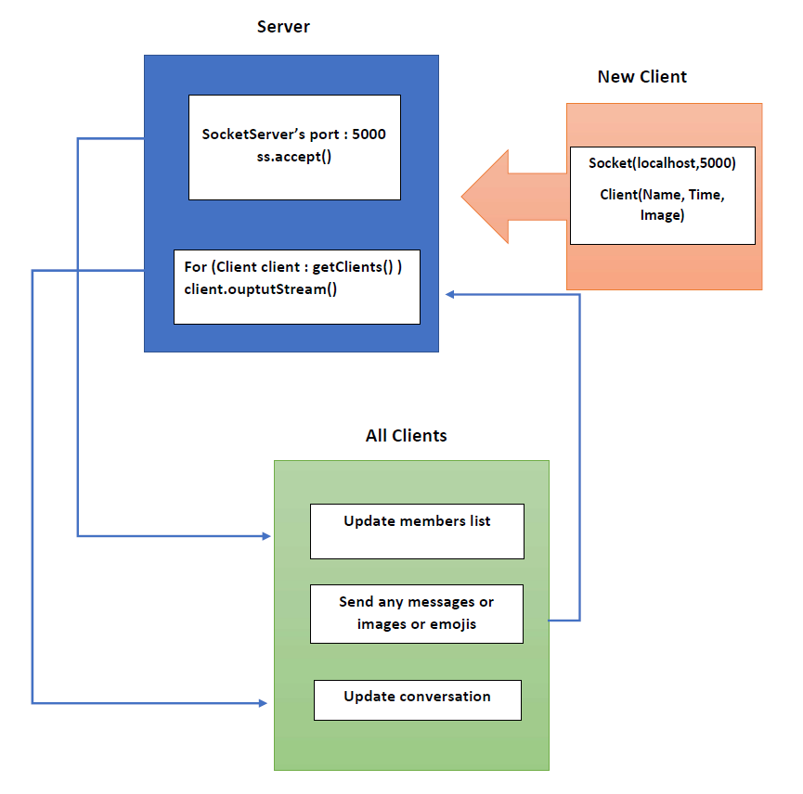

2.2 Implementation
Server.Main.startServer ( This is used for starting the server)
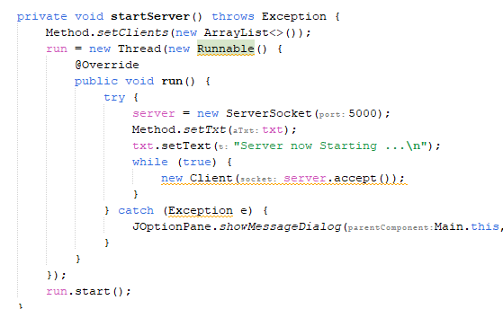

Server.Main.stopServer ( This is used for stopping the server)
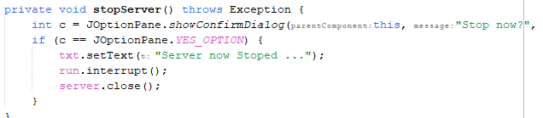

Server.Client (This class handles the new users(threads) and modify the members list of all users joined into the conversation)
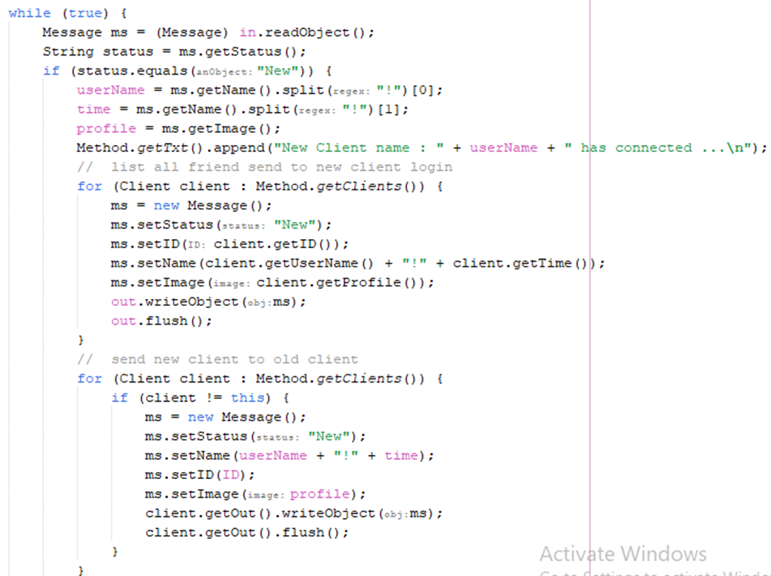


Client.Join/ New socket thread (This class is called when a user is going to join the group and it creates a new thread via ‘Client.Method.Connect()’ by connecting into the handshaking port, which is 5000 for this project)
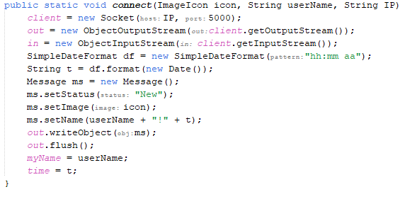
Client.Main (This class is for individual users. It is always in the listening mode, whenever an event is called (new member, text, image, emoji) it updates the members list or the conversation with the new event)
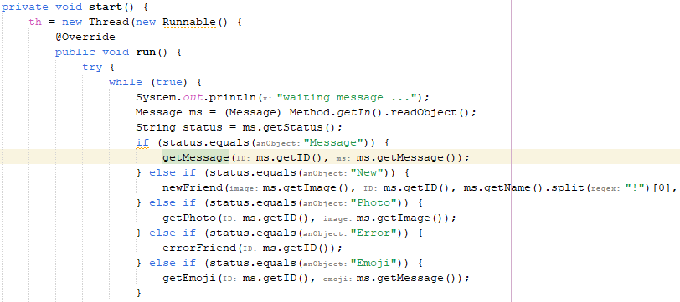
Here are the codes for updating the received messages, N.B. images, emojis works in the same way.
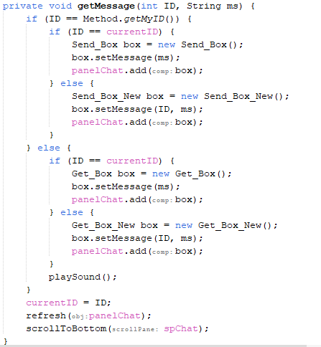

Client.Method for sending messages
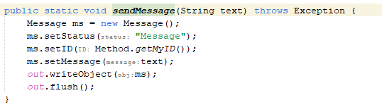
N.B. images and emojis works exactly in the same way.

Signing Out
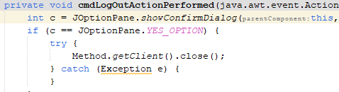
Chapter 3: Performance Evaluation
3.1 Simulation Environment
To evaluate the performance of the Group Messaging Platform, a simulated environment is set up. This environment includes a multiple users real-time chatting and sending images and emojis. The performance of the system is tested under various scenarios, including simultaneous user access.

3.2 Results and Discussions
The implementation of our Group Messaging Platform has yielded positive outcomes aligned with the defined design goals. Throughout the development process, we successfully achieved a responsive and real-time communication environment within designated groups. Users experienced minimal latency, particularly during the exchange of multimedia content, demonstrating the effectiveness of our focus on optimizing thread efficiency. The secure transmission of multimedia elements, including images and emojis, was established, contributing to a cohesive and engaging user experience. The platform's adherence to scalability objectives was evident in its ability to handle varying group sizes seamlessly. Users, confined to their predefined groups, could communicate efficiently without compromising the platform's performance. The incorporation of a modular and extensible architecture also proved beneficial, laying the foundation for future enhancements and feature integrations.

Server
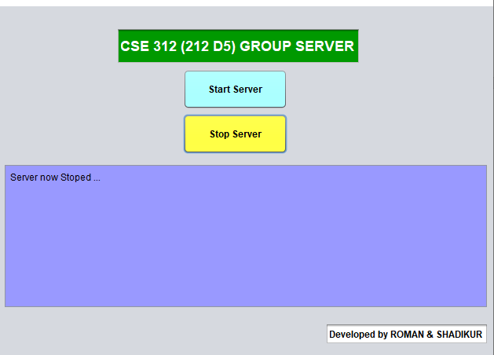
Log-In Page of a Client
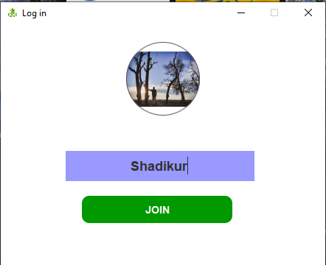
Conversation
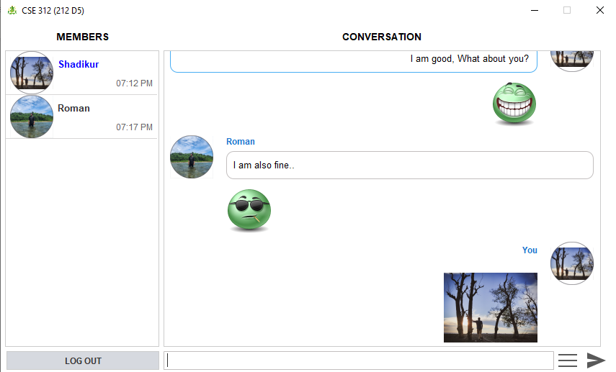

A new client joining in the conversation
- This new client can’t see the previous messages in the group.
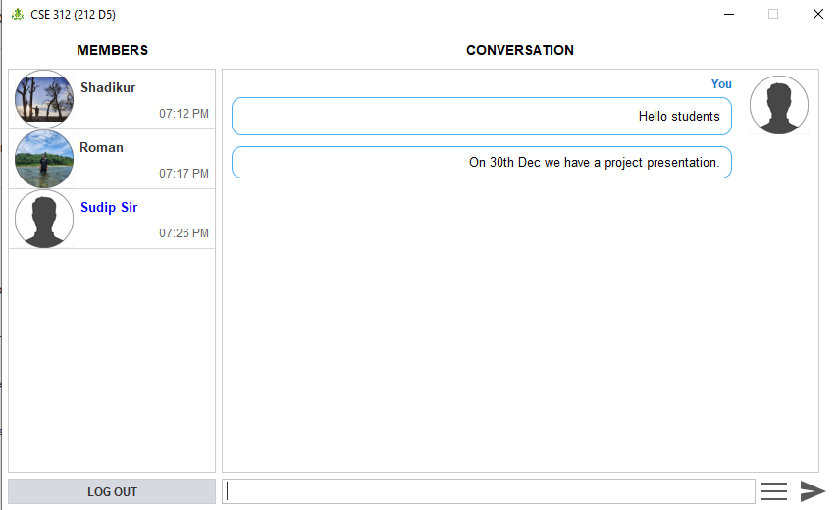
Previous client’s conversation
- On the other-hand other user’s conversation got updated
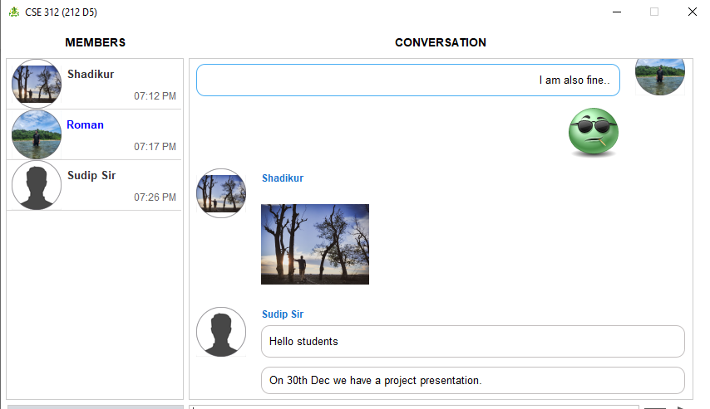
Server
- I signed out from ‘Roman’ account. Now the server looks like this-
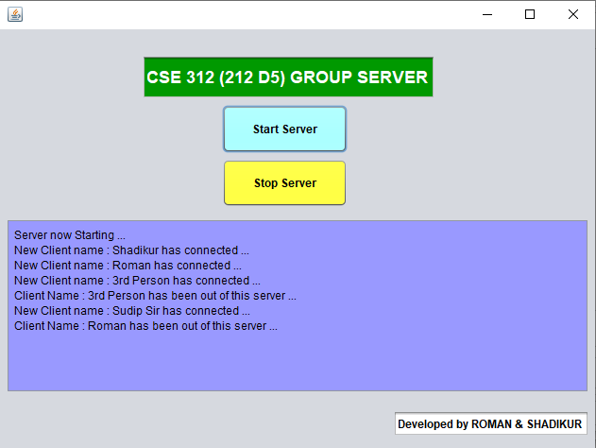

Chapter 4: Conclusion
4.1 Introduction
In conclusion, our Group Messaging Platform represents a significant stride towards fulfilling the evolving communication needs of users in a group setting. The amalgamation of robust socket programming techniques and carefully crafted design goals has resulted in a platform that prioritizes real-time, secure, and engaging communication. By confining users to designated groups and allowing the seamless exchange of images and emojis, we've not only created a focused environment but also enhanced the richness of user interactions. This project serves as a testament to the potential of modern networking technologies in providing dynamic and responsive group communication solutions.

4.2 Practical Implications
The practical implications of this project are far-reaching. Businesses, educational institutions, and social groups can leverage the Group Messaging Platform to streamline communication within their respective communities. The secure multimedia exchange capability enhances collaboration and engagement, making it a valuable tool for team projects, online learning environments, and social networking groups. The emphasis on real-time communication ensures that users can stay connected and informed, fostering a sense of unity and shared experience within the designated groups.

4.3 Scope of Future Work
Looking ahead, there are several avenues for future work and enhancements to further elevate the Group Messaging Platform. Some potential areas include:
- Advanced Multimedia Features:
  - Integrate additional multimedia features such as video sharing and document collaboration to expand the platform's capabilities.
- Enhanced Security Measures:
  - Implement advanced encryption techniques and authentication protocols to further fortify the security of the messaging platform.
- Integration with External Services:
  - Explore possibilities for integrating the platform with external services, allowing users to seamlessly share content from other applications.
- Multiple groups according to users:
  - Users can create and manage groups. For example, a user can create and add multiple clients to it.
- Cross-Platform Compatibility:
  - Develop dedicated applications for various operating systems and devices, ensuring a consistent and user-friendly experience across platforms.
By exploring these avenues and staying attuned to emerging technologies, our Group Messaging Platform has the potential to evolve into an even more comprehensive and indispensable tool for group communication in the digital era.

References
- Lab Manuals of ‘CSE 312’ course offered by Green University of Bangladesh
- ChatGPT - for many built in class uses. For example File, AudioStream etc.
- JavatPoint – for Java GUI

