## Test Case Scenario 1 – Merge smaller rowgroups into one

### Description:

Combine one or more compressed rowgroups such that total number of rows <= 1,024,576. For example, if you bulk import 5 batches of size 102400, you will get 5 compressed rowgroups. Now if you run REORGANIZE command, these rowgroups will get merged into 1 compressed rowgroup of size 512000 rows assuming there were no dictionary size or memory limitation.

### Steps taken to test the MERGE policy for smaller rowgroups:

1. Bulk load 5 batches of size 102400 and review the row groups physical stats:

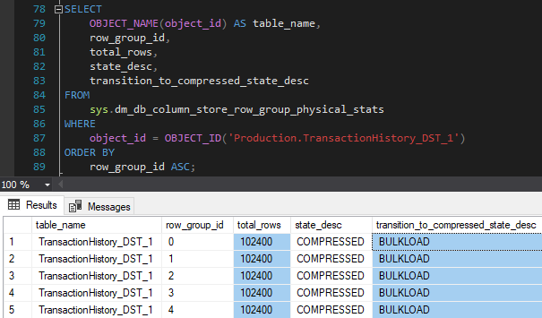

1. Let’s REORGANIZE the CCI index:



1. Immediately after REORGANIZE operation finished, let’s have a look at the row groups statistics again:

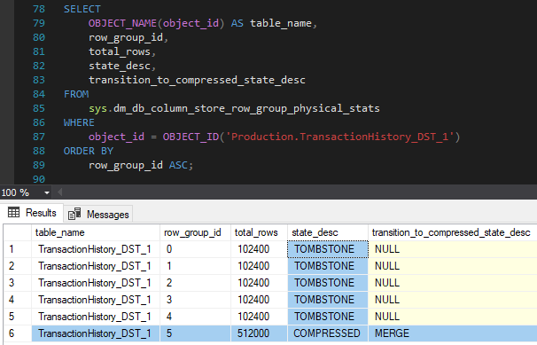

As we can see, the original rowgroups have been deallocated by tuple mover and marked as **‘TOMBSTONE’**.

1. Now, we can review the extended event session **‘Tuple_Mover_Xe’** and have a look what can we see there:

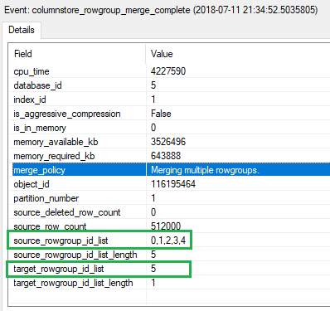

As we can see in the screenshot above, merge policy **‘Merging multiple rowgroups’** has been applied. We can also see that source rowgroups 0, 1, 2, 3, 4 have been merged into the rowgroup 5.

1. ‘Let’s wait a few minutes and review the rowgroups physical stats:

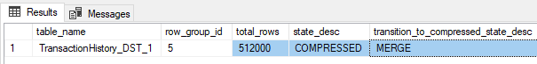

As we can see, the **‘TOMBSTONE’** rowgroups have been garbage collected and removed in the background by system.