Department of Electrical and Computer Engineering

Royal Military College of Canada

APEX

Lab 1: Windows API introduction

Lab Date and Time:  Student Name & ID: | 2025/03/04  Nester-007

Getting Started:
  - Download and unzip the provided starter code. Note that it compiles but is not functional

Part 1:
Complete the example “static_load_library.rs” to call message box

Conduct basic static analysis and build a list of evidence that message box will be called by this binary

Conduct basic dynamic analysis with API Monitor and list the APIs imported and called
____________________
1.) strings -u static_load_library.exe
Your message here
Title
main
2.) strings -n 10 static_load_library.exe
MessageBoxW
USER32.dll
WakeByAddressSingle
WaitOnAddress
WakeByAddressAll
api-ms-win-core-synch-l1-2-0.dll
CloseHandle
GetLastError
AddVectoredExceptionHandler
SetThreadStackGuarantee
GetCurrentThread
WaitForSingleObject
QueryPerformanceCounter
RtlCaptureContext
RtlLookupFunctionEntry
RtlVirtualUnwind
SetLastError
GetCurrentDirectoryW
GetEnvironmentVariableW
GetCurrentProcess
RtlNtStatusToDosError
GetStdHandle
GetCurrentProcessId
GetProcessHeap
HeapReAlloc
ReleaseMutex
NtWriteFile
GetConsoleMode
GetModuleHandleW
MultiByteToWideChar
WriteConsoleW
WideCharToMultiByte
GetModuleHandleA
GetProcAddress
WaitForSingleObjectEx
LoadLibraryA
CreateMutexA
kernel32.dll
SymGetOptions
SymSetOptions
SymInitializeW
SymGetSearchPathW
SymSetSearchPathW
EnumerateLoadedModulesW64
SymFromInlineContextW
SymGetLineFromInlineContextW
SymAddrIncludeInlineTrace
SymQueryInlineTrace
GetCurrentThreadId
GetSystemTimeAsFileTime
InitializeSListHead
IsDebuggerPresent
UnhandledExceptionFilter
SetUnhandledExceptionFilter
IsProcessorFeaturePresent

Dynamic analysis (API monitor)
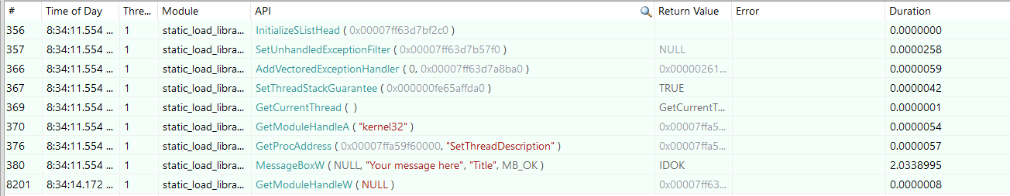
Part 2:
Complete the example “dynamic_load_library.rs” to call message box without static linking

Conduct the same analysis. What’s changed? Which binary behaviour is easier to identify?
Static analysis (strings)
user32.dll
Use32.dll was loaded properly
MessageBoxW
Your message here
Failed to load user32.dll
LoadLibraryA
GetProcAddress
FreeLibrary
KERNEL32.dll
WakeByAddressSingle
WaitOnAddress
WakeByAddressAll
api-ms-win-core-synch-l1-2-0.dll
CloseHandle
GetLastError
AddVectoredExceptionHandler
SetThreadStackGuarantee
GetCurrentThread
WaitForSingleObject
QueryPerformanceCounter
RtlCaptureContext
RtlLookupFunctionEntry
RtlVirtualUnwind
SetLastError
GetCurrentDirectoryW
GetEnvironmentVariableW
GetCurrentProcess
RtlNtStatusToDosError
GetStdHandle
GetCurrentProcessId
GetProcessHeap
HeapReAlloc
ReleaseMutex
NtWriteFile
GetConsoleMode
GetModuleHandleW
FormatMessageW
MultiByteToWideChar
WriteConsoleW
WideCharToMultiByte
GetModuleHandleA
WaitForSingleObjectEx
CreateMutexA
Dynamic analysis (API monitor)
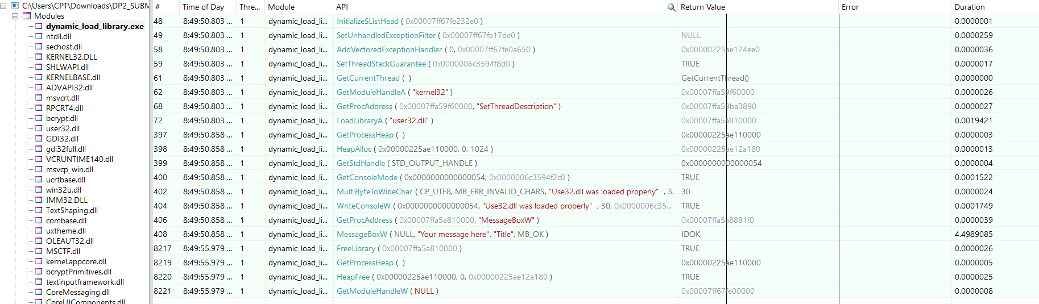
Not sure If I compile everything correct but static analysis for both binaries produce almost the same output. I’ve outputted the “strings” result for both in separate files and wrote simple script that supposed to show differences for both.

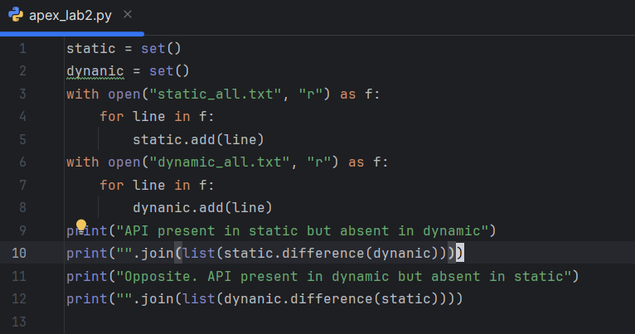
The strings that are present in output for dynamic but absent in static:
FreeLibrary
FormatMessageW
But as my peers advised me, even so there is MessageBoxW API present in strings output for dynamically loaded API version of binary, it’s just a string from source code, NOT in “imported” API section.
Then, I’ve the list of imported API called from “PEStudio” and with help of the same python script, here is the difference:
API present in static but absent in dynamic
MessageBoxW
Opposite. API present in dynamic but absent in static
FormatMessageWFreeLibrary

So we see the MessageBoxW is loaded at running time for dynamic version, at compile time for static version
Part 3:
Identify 2 key points where dynamic loading allows identifying the API being called
API monitor manage to identify call for MessageBoxW for both version.

Provide some suggestions on how those could be hidden
Not curtain how to achieve that.

